Addendum 2: Tools and Usage Overview
Monitoring and Observability for AI Workflows at CNB, Draft Architecture v0.1
Draft for discussion. Prepared by Muntaser Syed, September 17, 2026. Tools and their roles are as stated and verified in the main document dated September 16, 2026.
Figure B1 lists every tool in the recommended architecture, what it is used for, and its status at CNB. Columns follow the order in which telemetry moves; fill colour states whether a tool is in use today, has to be provisioned, enabled, or built, or is under evaluation; the RBC platform is the dashed strip at the bottom with the four interfaces CNB requests. Cards marked (confirm) are the Phase 0 checks from section 7 of the main document.
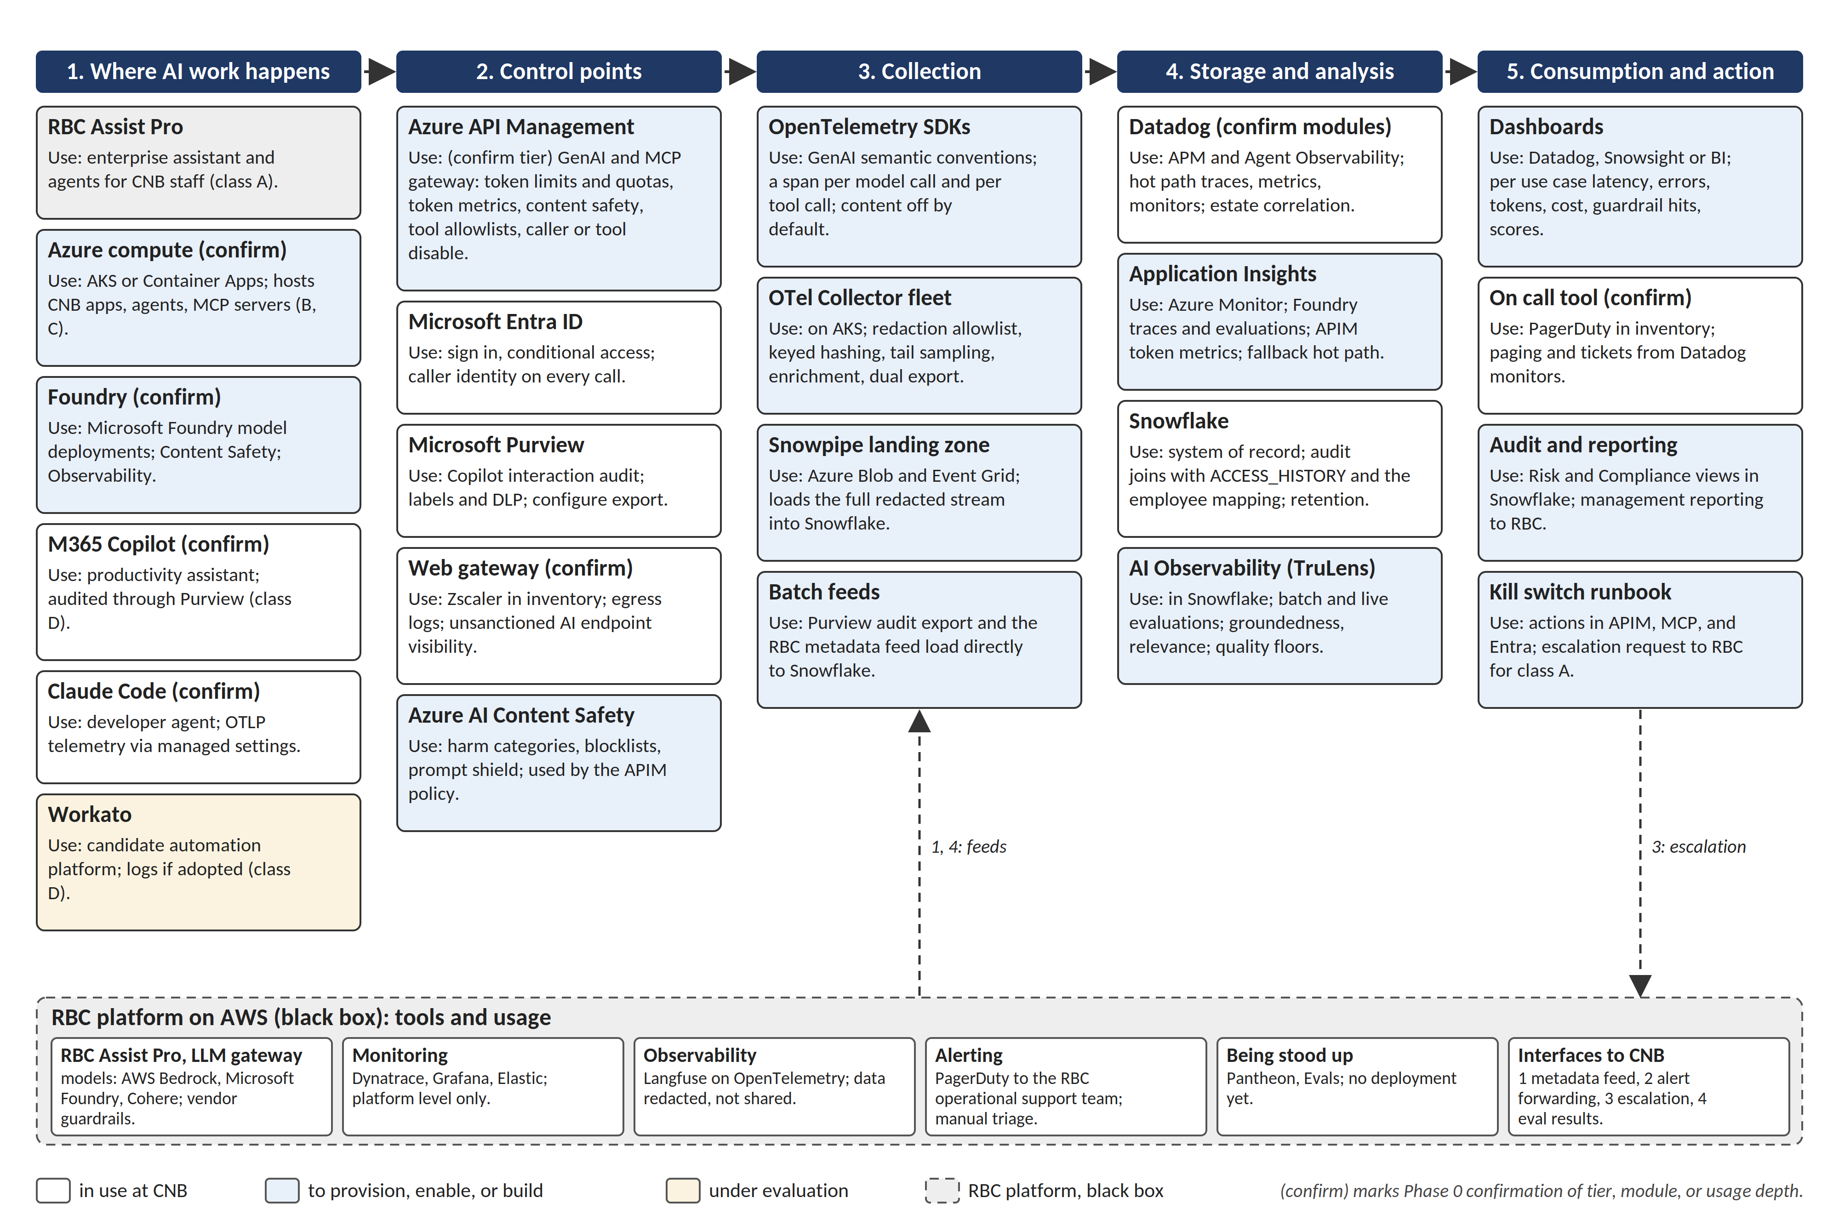
Figure B1. Tools and usage overview: each tool's role in the recommended architecture and its status at CNB, with the RBC platform as a black box.

