Jaluag, James
Kiah, Andre
Dr Choi
COSC 410

COSC 410 – Data Communications Project

Part 1 : Web Server Lab
File: server.py
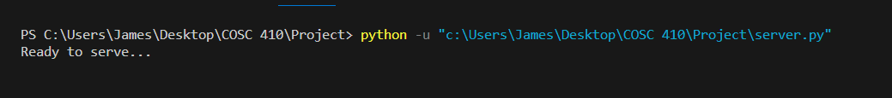
Console

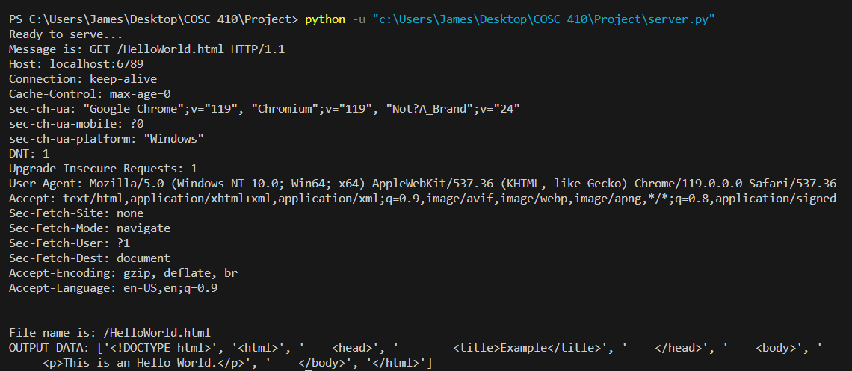
Retrieval of HelloWorld.html file

Web browser view
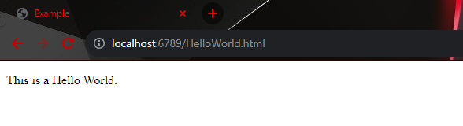

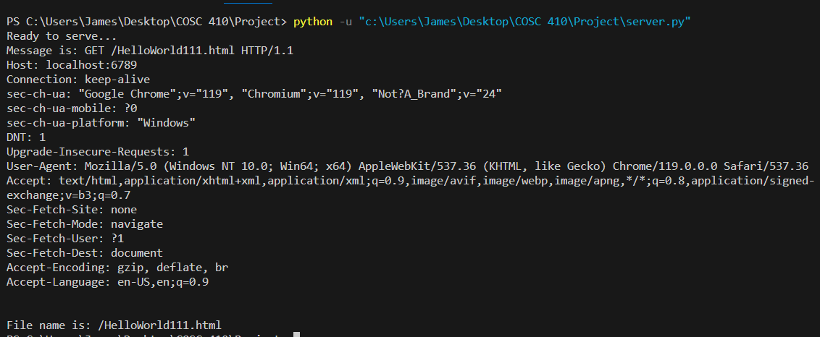
Entering a filename that does not exist in the server.

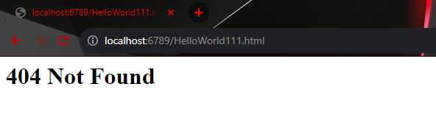
Web browser view

Part 2 : Multithreaded Web Server
File: multi2.py
Consecutive file requests to the server
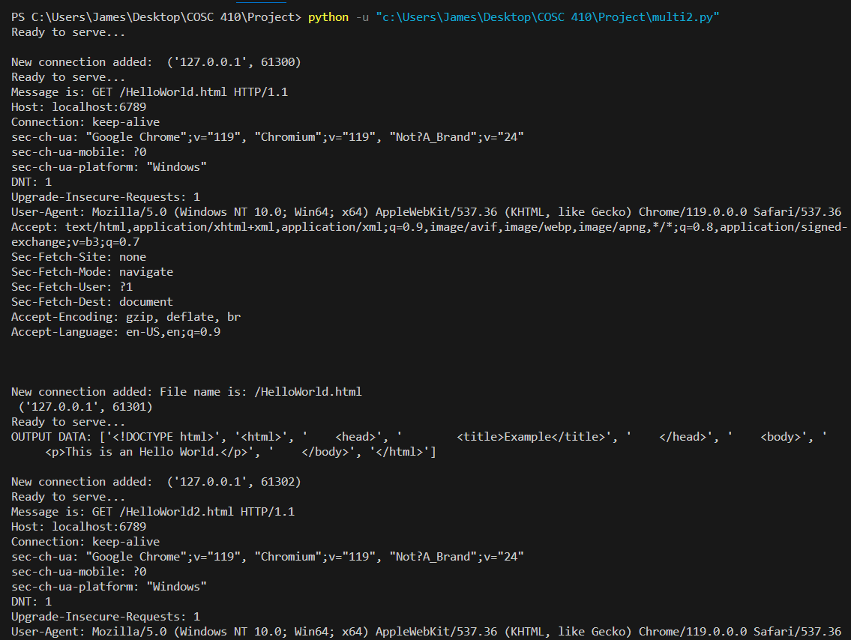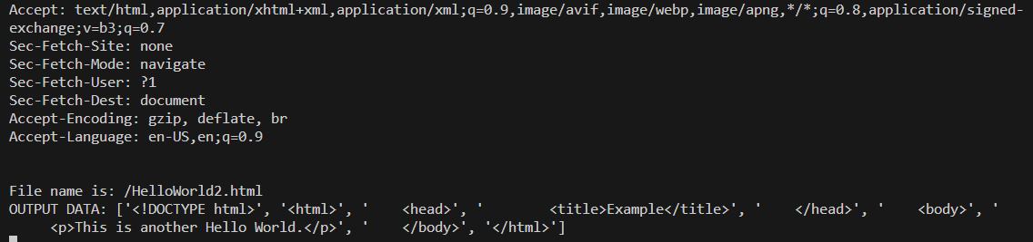

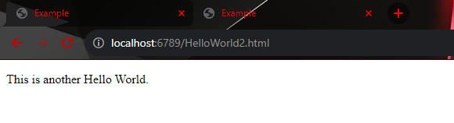
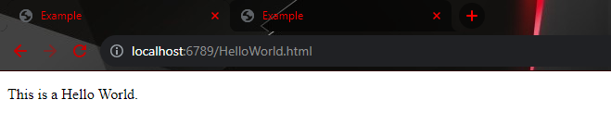
Web browser view

Part 3 : Web Client
File: client.py
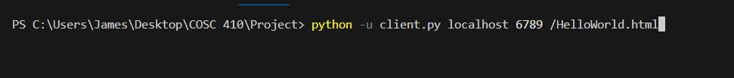
Running the client.py program and entering the arguments

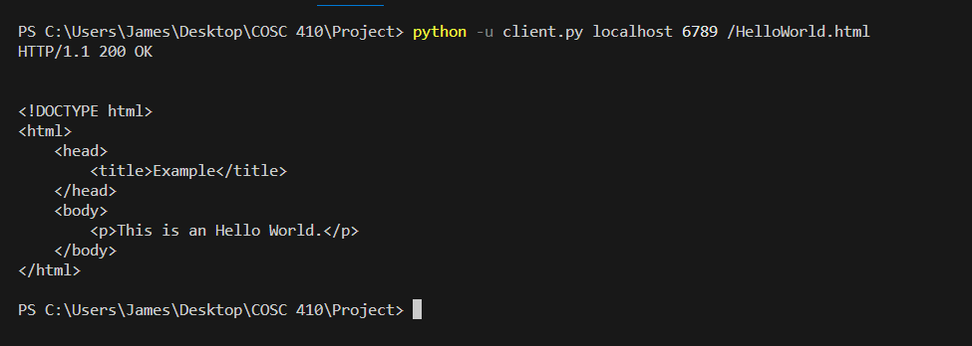
Receipt of the contents of HelloWorld.html file

