Comparison key: Red = 2024 guideline statement; Blue = updated statement; Pink highlight = new addition from the Middle East consensus (12), not in the 2024 guideline.
- Introduction:
Achondroplasia is the most common form of skeletal dysplasia. It’s inherited as a Mendelian autosomal dominant trait with complete penetrance. Approximately 80% of cases are due to a new (de novo) dominant mutation. The frequency is believed to be 1 case per 15,000-40,000 births worldwide, with an average worldwide frequency of 1 in 25,000 live births. ⁽¹⁾ The prevalence of Achondroplasia is 1:26,000-1: 28,000 live births. ⁽²⁾ The condition is caused by a common, recurring, gain-of-function mutation in FGFR3, the gene that encodes fibroblast growth factor receptor 3. This mutation leads to impaired endochondral ossification of the human skeleton. ⁽³⁾

- Average adult height 4 feet.
- Male average adult height 131 ± 5.6 cm.
- Female average adult height 124 ± 5.9 cm.

- Definitions:

  - Achondroplasia: is the most common dipropionate short stature characterized by a variety of medical, functional, and psychosocial challenges across the lifespan that require care from a multidisciplinary team. Affected individuals have rhizomelic shortening of the limbs, macrocephaly, and characteristic facial features with frontal bossing and midface retrusion. In infancy, hypotonia is typical, and acquisition of developmental motor milestones is often both aberrant in pattern and delayed. Intelligence and life span are usually near normal, although craniocervical junction compression increases the risk of death in infancy. Additional complications include obstructive sleep apnea, middle ear dysfunction, kyphosis, and spinal stenosis. ^{(2,3)}

  - Trident hand: The hand with increased distance between the 3rd and 4th fingers.

  - AGV (Annualized Growth Velocity) refers to the equivalent average rate of growth per annum that will give us the same growth rate as that observed over the entire time span.

- Guideline Scope and Purpose:
Scope: This Guidelines is designed for the diagnosis and management of pediatric cases in KSMC who are suspected and diagnosed to have achondroplasia.
Purpose:
- To have a basic Guidelines for the geneticist, pediatric endocrinologist, and other multidisciplinary healthcare providers.
- To standardize the diagnosis and management for the affected children with Achondroplasia.

- Target Population:
- Suspected cases with achondroplasia from age 0-18 years.
- Achondroplasia cases who are eligible for Vosoritide treatment from 4 months to 10 years of age.
- Achondroplasia cases already on treatment.

- Guideline specific Interventions practices and recommendations:
  - Diagnostic Method
- Clinical Findings:
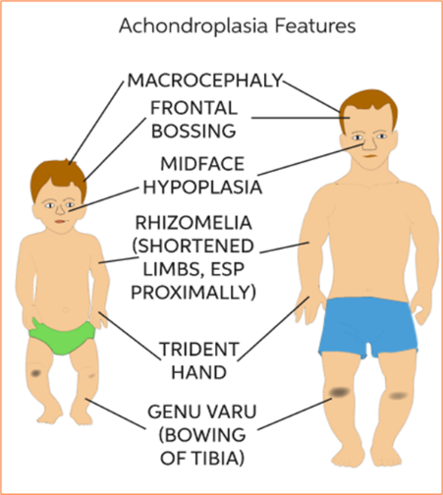
Disproportionate
Short Stature

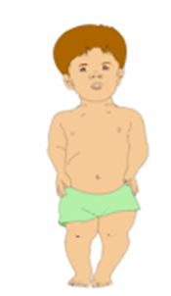

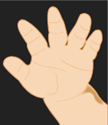
Short Fingers
Trident Hand

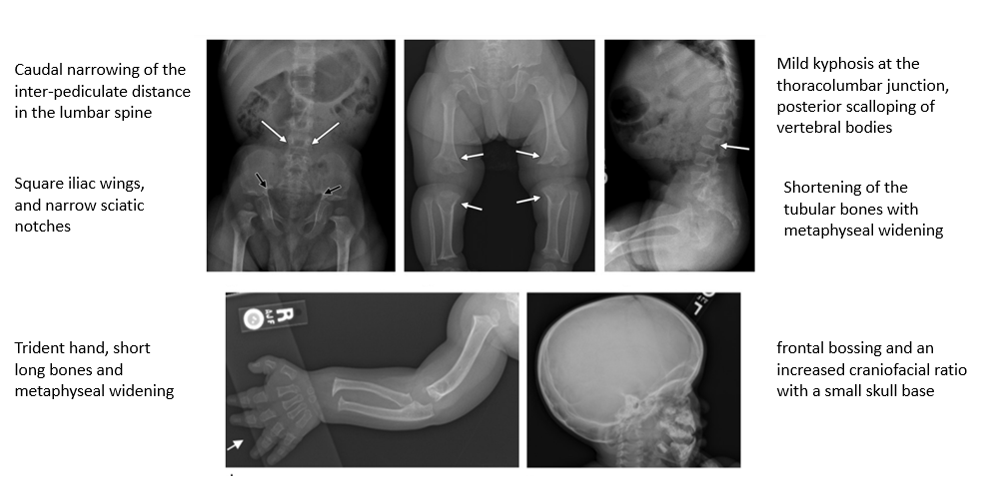
- Radiological

- Molecular Testing

- Targeted gene testing for the FGFR3 (Fibroblast growth factor receptor3) gene.

- Prenatal Diagnosis

Prenatal diagnosis by ultrasound and molecular testing should be offered when there is clinical suspicion or a positive family history; typical ultrasound features (rhizomelic limb shortening, macrocephaly with frontal bossing and midface hypoplasia) often become apparent after 24 weeks of gestation. Counselling should be clear and non-directive, providing balanced, evidence-based information, including education on safe positioning and handling of infants with achondroplasia. Parents who receive a prenatal diagnosis should be offered early psychological support and education (12).

  - Multi-System Co-Morbidities Associated with Achondroplasia

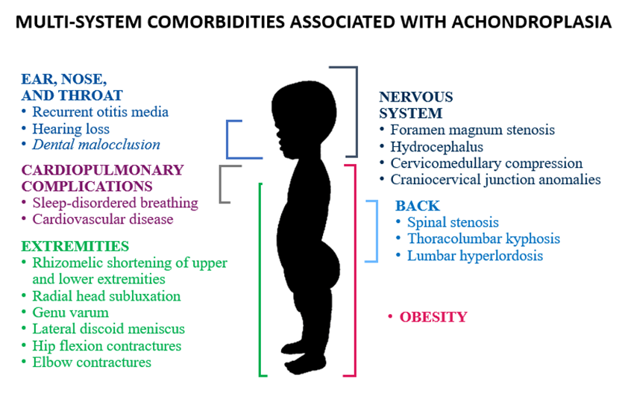

Screening in infancy: where available and clinically feasible, MRI of the craniocervical junction should be offered routinely in early infancy to screen for foramen magnum stenosis, with reports using standardised radiological scoring systems. Polysomnography should be performed routinely to detect sleep-disordered breathing, including central sleep apnoea, which may not be reliably identified on clinical assessment alone. Where these services are limited, clinicians should keep a low threshold for referral to a specialist centre. Regular screening and surveillance should continue for foramen magnum stenosis, sleep apnoea, ENT problems, neurological issues, orthopaedic complications and obesity (12).

Multidisciplinary care: a multidisciplinary care coordinator or lead clinician should be designated to ensure continuous care, effective communication and follow-up across specialties. Surgical interventions should only be performed by clinicians with expertise in achondroplasia, with decisions made in conjunction with the multidisciplinary team (see team in the clinical algorithm, section 6) (12).

  - Treatment
    - Updated: Vosoritide “Voxzogo”: The first and only therapy approved to increase linear growth in children with achondroplasia is called Vosoritide “Voxzogo”. In the European Union, vosoritide is indicated for the treatment of achondroplasia in patients 4 months of age and older whose epiphyses are not closed, (6) and the US FDA has approved it (October 2023) to increase linear growth in paediatric patients of all ages with achondroplasia and open epiphyses.(11) Vosoritide is given as a single daily dose of subcutaneous injection to prevent the inhibition of chondrocyte mineralization resulting from FGFR3 mutation and allows linear bone growth. Treatment should be initiated and directed by a physician appropriately qualified in the management of growth disorders or skeletal dysplasias. Safety and efficacy data in children younger than 4 months are limited, and no posology recommendation can be made for this group (6).

    - Inclusion Criteria:

- Follow up of achondroplasia cases aged 0-18 years whose clinical and radiological finding go with Achondroplasia.
- Vosoritide treatment will be started for selected cases from 4 months to10 years of age whose diagnosis had been confirmed by molecular testing, since the earlier the start of treatment (≤10 years of age) the better the outcome.
- Treatment will be indicated for:
- Legible children for expensive treatment of achondroplasia (Saudi nationality).
- Achondroplasia cases from 4 months to10 years of age and to be continued up to18 years of age or until the stopping criteria in 5.4 are met, regardless of gender.
- Achondroplasia children with normal cognitive function.
- Compliant to treatment.
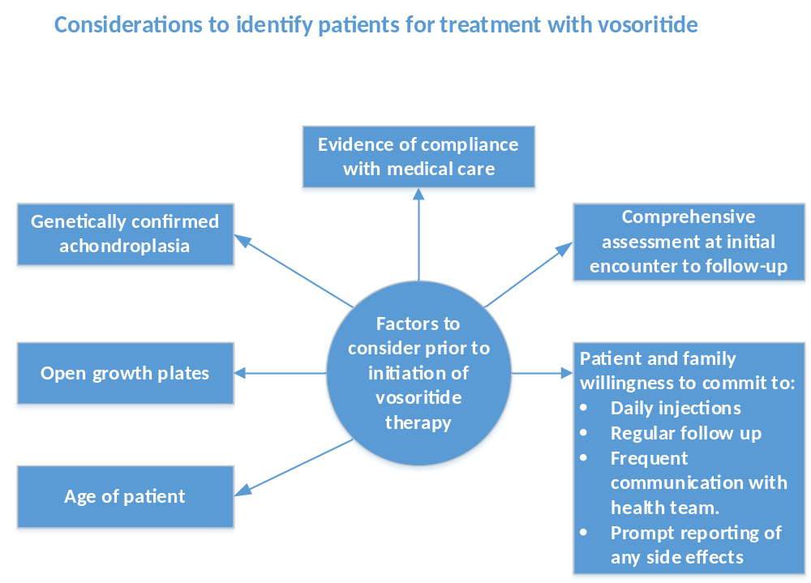

    - Exclusion Criteria:

- Vosoritide treatment will not be applicable for Achondroplasia cases who already > 10 years at the time of the diagnosis.
- Achondroplasia cases who sustained significant neurological insult that affect their cognitive function.
- Achondroplasia cases who don’t attend regular follow up of the multidisciplinary team care.

Shared decision-making: decisions to start vosoritide should be individualised and made jointly with the family, taking into account the available evidence, treatment burden, family preferences, and cultural, financial and healthcare-system considerations (12).

    - Side effects of Vosoritide:

The most common side effects of Vosoritide include:
- Updated: A temporary decrease in blood pressure in some patients. To reduce the risk of a decrease in blood pressure and associated symptoms, patients should be well hydrated, eat a light snack and drink an adequate amount of fluid (e.g., water, milk or juice) about 30 minutes before injecting (6).
- Old (2024): Injection site reactions (including redness, itching, swelling, bruising, rash, hives, and injection site pain) which is transient and resolved spontaneously.
- Old (2024): Vomiting, stomachache, joint pain in few cases.
- Updated (not in 2024): Vosoritide is contraindicated in hypersensitivity to the active substance or any excipient. Use during pregnancy should preferably be avoided, and it should not be used during breast-feeding. Patients may be advised not to drive, cycle or use machines for at least 60 minutes after injection (6).
Adverse reactions by frequency (SmPC) (6):
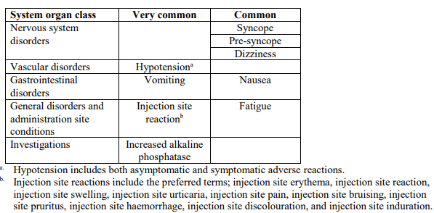

    - Dose, units and administration:
- Updated: The dose is based on body weight and is approximately 15–30 µg/kg, with the higher dose per kg given to the smallest children (see Table 12.1) (6).
- The dose can be measured with either mL-graduated or Unit (U)-graduated syringes; 0.1 mL = 10 Units (6).
- Body weight, growth and physical development should be assessed every 3–6 months and the dose adjusted to the current weight band (6).
- Administer within 3 hours of reconstitution, at approximately the same time each day. Rotate injection sites (front middle of the thighs, lower abdomen avoiding 5 cm around the navel, top of the buttocks, back of the upper arms); do not use the same area on two consecutive days or inject into red, swollen or tender skin (6).
- Missed dose: it may be given within 12 hours; if more than 12 hours have passed, the missed dose should not be given and the next dose is given the following day as scheduled (6).
- Before the first injection, caregivers should be trained by a healthcare professional, ideally a specialist nurse, in preparation and subcutaneous injection technique, injection-site rotation, and recognising and managing signs and symptoms of decreased blood pressure (6,12).
- The first dose should be given under medical supervision, with an observation period of approximately 1 hour to monitor for adverse reactions, particularly transient hypotension (12).

  - When to stop Vosoritide “Voxzogo” treatment:
Old (2024): It should be discontinued for Achondroplasia cases whose annual growth velocity is <1.5 cm after completing one year of vosoritide treatment or upon radiological confirmation of no further growth potential, when growth plates are closed.

  - Monitoring and follow-up protocols (See appendix 11.20)
    - Treatment-informing Assessment parameters
- Parental height considerations
- Annual skeletal survey for evaluation of growth plate and bone age
- Vitamin D level
    - Efficacy assessments
- Symptoms (headaches, vision changes, worsening joint pain)
    - Safety Assessment
- Discussion of other intervention

    - Baseline Assessment Before Starting Vosoritide
Updated: The following assessments should be completed and documented before the first dose (6,12–15):
Domain | Baseline assessment
Diagnosis and eligibility | Confirm achondroplasia clinically/radiologically and genetically by molecular testing of the FGFR3 gene (mandatory); verify eligibility and open growth potential according to applicable label.
Anthropometry | Length/standing height, weight, head circumference in younger children, BMI, sitting height; consider arm span and upper/lower segment measurements where feasible.
Growth history | Review reliable prior measurements and calculate pretreatment annualized growth velocity (AGV) when sufficient longitudinal data are available.
Puberty / skeletal maturity | Document Tanner stage when age appropriate; assess growth-plate status when clinically indicated.
Achondroplasia complications | Review neurologic/neurosurgical, sleep/respiratory, ENT/hearing, orthopedic/spinal, nutritional/weight and functional domains according to standard care.
Medication and health review | Document concomitant medications, intercurrent conditions, prior surgery, and factors that could independently affect growth.
Patient-centred outcomes | Record baseline functional status and patient/family-reported outcomes or QoL where feasible (18).

    - Follow-up Schedule by Age Group

Assessment | 0–2 years | Over 2 years to growth-plate closure | Reference
Visit interval | Every 3 months | Baseline (Day 0), Month 1, Month 3, then every 6 months | 0–2 y: 6,12,13; over 2 y: 2024 CPG (App. 11.20)
Length/height and weight | Every visit | Baseline, then every 6 months | 0–2 y: 12,13,17; over 2 y: 2024 CPG (App. 11.20)
Head circumference | Every visit | Every visit up to about 5 years; then not routine | 12,13
Annualized growth velocity | Every 6 months | Every 6 months; <1.5 cm after one year of treatment → stop (see 5.4) | 2024 CPG (App. 11.20)
Upper-to-lower segment ratio | Every 6 months | Every 6 months | 17; 2024 CPG (App. 11.20)
Dose check against weight band | Every 3 months | Every 6 months | 6,13
Neurological examination | Every visit | Every visit | 12,13
Sleep symptom review | Every visit; repeat sleep study if symptoms | Every visit; sleep study if symptoms | 12,19
Adverse events, injection sites, hypotension symptoms | Every visit | Every visit | 6,16,17
Tanner stage | No | From about 8 years, every 6 months | 13

    - Long-term Care and Transition
- Validated quality-of-life tools (e.g., PedsQL, QoLISSY) should be used to monitor patient wellbeing over time and guide individualised interventions (12).
- Transition from paediatric to adult care should be planned in a structured manner, ideally through transition clinics involving both paediatric and adult specialists, and should include guidance on employment and independent living (12).

  - Patients with renal and hepatic impairment
The safety and efficacy of vosoritide in patients with renal or hepatic impairment has not been evaluated. Based on the elimination mechanism, renal or hepatic impairment is not expected to alter the pharmacokinetics of vosoritide.

- Clinical Algorithm:
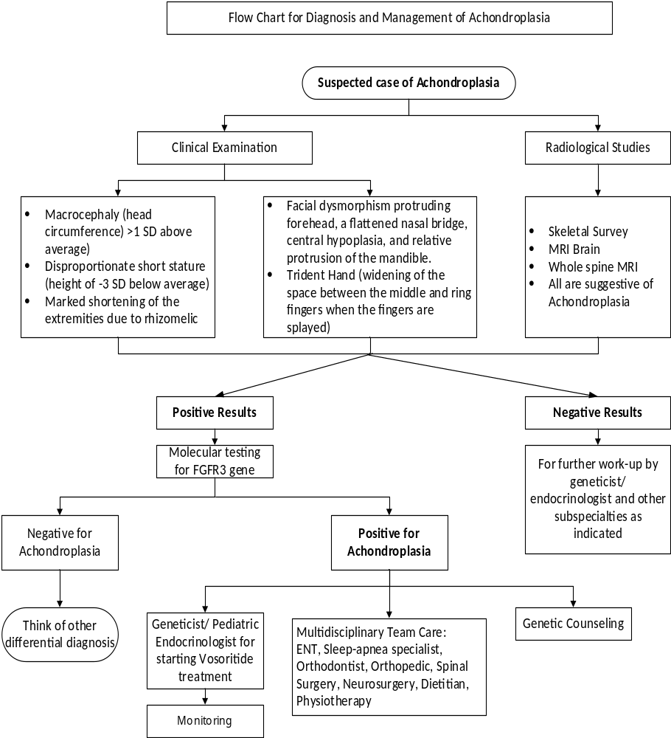

- Guideline measures (Quality measures):
- Patient medication(Vosoritide treatment) compliance rate for a given period of time
- Percentage physician compliance to developmental screening tool
- Compliance to monitoring parameters of growth charts
- Documentation (Implementation tools)
- Consent form
- Growth chart (male/Female)
- Developmental screening tool
- Assessment and follow-up protocols for children with Achondroplasia
- All relevant documentation in HIS(Watheeq)
- Bibliographic Source(s), List of references:
- Genetics of Achondroplasia Updated: Jan 10, 2022 Author: Germaine L Defendi, MD, MS, FAAP; Chief Editor: Maria D
https://emedicine.medscape.com/article/941280-overview
- Epidemiology of achondroplasia: A population-based study in Europe, Am J Med Genet A. 2019 Sep;179(9):1791-1798. doi: 10.1002/ajmg.a.61289. Epub 2019 Jul 11. https://pubmed.ncbi.nlm.nih.gov/31294928/
- Achondroplasia, NLM Citation: Legare JM. Achondroplasia. 1998 Oct 12 [Updated 2023
May 11]. In: Adam MP, Mirzaa GM, Pagon RA, et al., editors.
GeneReviews® [Internet]. Seattle (WA): University of Washington,
Seattle; 1993-2023. https://www.ncbi.nlm.nih.gov/books/NBK1152/pdf/Bookshelf_NBK1152.pdf
- The first and only therapy approved to increase linear growth in children with achondroplasia aged 5 years and over with open growth plates.
https://www.biomarin.com/our-treatments/products/voxzogo/
- European Commission Approves BioMarin's VOXZOGO® (vosoritide) for the Treatment of Children with Achondroplasia from Age 2 Until Growth Plates Close.
https://www.prnewswire.com/news-releases/european-commission-approves-biomarins-voxzogo-vosoritide-for-the-treatment-of-children-with-achondroplasia-from-age-2-until-growth-plates-close-301364307.html
- SUMMARY OF PRODUCT CHARACTERISTICS: Voxzogo (vosoritide) 0.4 mg, 0.56 mg and 1.2 mg powder and solvent for solution for injection. BioMarin International Limited; European Medicines Agency. Date of revision of the text: 10/2023. https://www.ema.europa.eu/en/medicines/human/EPAR/voxzogo
- Growth charts for Australian children with achondroplasia, Am J Med Genet A 2017 Aug;173(8): 2189-2200.doi: 10.1002/ajmg.a.38312. Epub 2017 Jun 9
https://onlinelibrary.wiley.com/doi/epdf/10.1002/ajmg.a.38312
- Achondroplasia: a comprehensive clinical review, Pauli Orphanet Journal of Rare Diseases (2019) 14:1
https://ojrd.biomedcentral.com/articles/10.1186/s13023-018-0972-6
- Clinical Practice Guidelines for Achondroplasia, Clin Pediatr Endocrinol. 2020; 29(1): 25–42.
https://www.ncbi.nlm.nih.gov/pmc/articles/PMC6958518/pdf/cpe-29-025.pdf
- https://www.chegg.com/learn/topic/achondroplastic-dwarfism
- BioMarin Pharmaceutical Inc. U.S. Food and Drug Administration approves BioMarin's VOXZOGO® (vosoritide) for children under 5 years with achondroplasia; expanded indication now includes children of all ages with open growth plates. Press release, 20 October 2023. https://www.biomarin.com/news/press-releases/u-s-food-and-drug-administration-approves-biomarins-voxzogo-vosoritide-for-children-under-5-years-with-achondroplasia/
- Thalange N, Ben Omran T, Alsagheir A, Hussain K, Faden M, Aglan M, Alremeithi S, Habeb A. Consensus statement on the management of Achondroplasia in the Middle East. Front Endocrinol (Lausanne). 2026;17:1888346. https://doi.org/10.3389/fendo.2026.1888346
- Savarirayan R, Hoover-Fong J, Ozono K, et al. International consensus guidelines on the implementation and monitoring of vosoritide therapy in individuals with achondroplasia. Nat Rev Endocrinol. 2025;21(5):314–324. https://doi.org/10.1038/s41574-024-01074-9
- Savarirayan R, Ireland P, Irving M, et al. International Consensus Statement on the diagnosis, multidisciplinary management and lifelong care of individuals with achondroplasia. Nat Rev Endocrinol. 2022;18(3):173–189. https://doi.org/10.1038/s41574-021-00595-x
- Barreda-Bonis AC, de Bergua Domingo JM, Galán-Gómez E, Guillén-Navarro E, Leiva-Gea I, Riaño-Galán I. Expert consensus for the management of patients with achondroplasia in treatment with vosoritide. An Pediatr (Engl Ed). 2024;101(6):401–410. https://doi.org/10.1016/j.anpede.2024.09.012
- Savarirayan R, Wilcox WR, Harmatz P, et al. Vosoritide therapy in children with achondroplasia aged 3–59 months: a multinational, randomised, double-blind, placebo-controlled, phase 2 trial. Lancet Child Adolesc Health. 2024;8(1):40–50. https://doi.org/10.1016/S2352-4642(23)00265-1
- Savarirayan R, Irving M, Wilcox WR, et al. Sustained growth-promoting effects of vosoritide in children with achondroplasia from an ongoing phase 3 extension study. Med. 2025;6(5):100566. https://doi.org/10.1016/j.medj.2024.11.019
- Savarirayan R, Irving M, Wilcox WR, et al. Persistent growth-promoting effects of vosoritide in children with achondroplasia are accompanied by improvements in physical and social aspects of health-related quality of life. Genet Med. 2024;26(12):101274. https://doi.org/10.1016/j.gim.2024.101274
- Guerdile MJ, et al. Sleep-disordered breathing in children with achondroplasia: 17 years' experience from a multidisciplinary team. J Pediatr Genet. 2025;14(1). https://doi.org/10.1055/s-0044-1791787

- Disclaimer Statement:
- This guideline is for the diagnosis and management of Achondroplasia cases, and it should not replace the clinical judgment of the physician.
- The contents of this document will be revised after every two years or as and when required based on adoption of new recommendations or interventions from latest/updated clinical practice guidelines by the clinical department/Speciality
- The ownership of this document lies with Head of department for any change in names involved in developing, reviewing and or revising it.

- Appendix

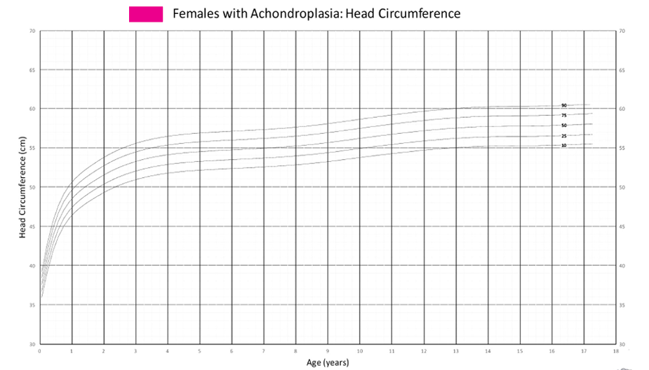
  - Growth Chart – Head Circumference (Female with Achondroplasia)

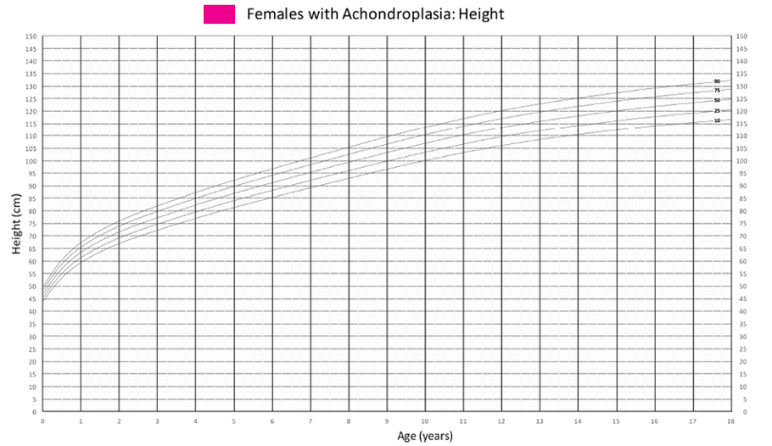
  - Growth Chart- Height (Female)

  - Growth Chart – Weight (Female)
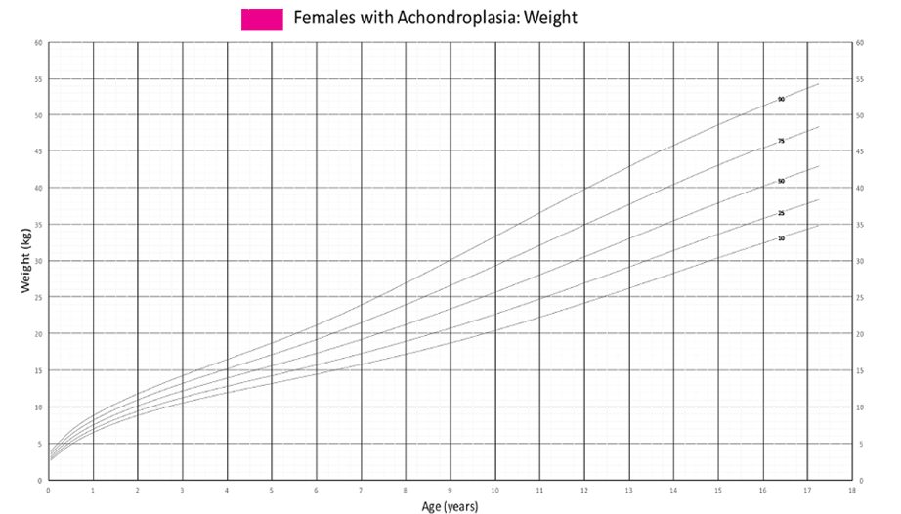

  - Growth Chart – BMI (Female)
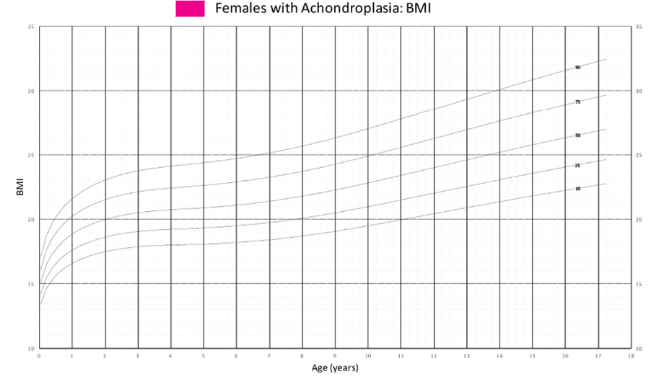

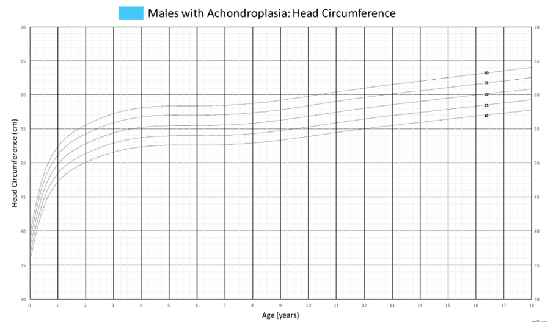
  - Growth Chart – Head Circumference (Male)

  - Growth Chart – Height (Male)
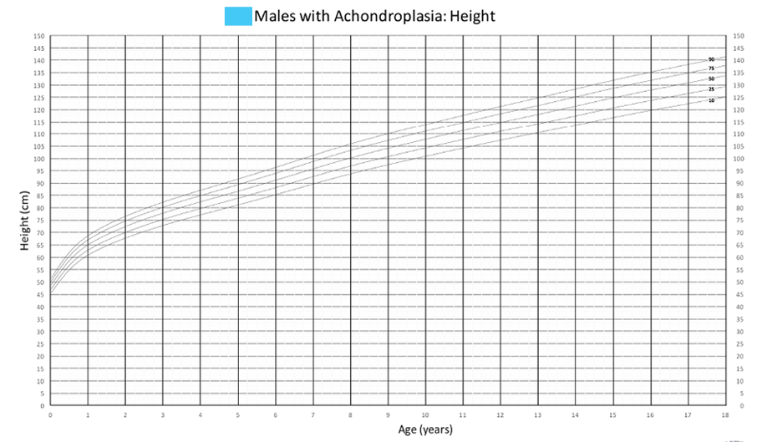

  - Growth Chart – Weight (Male with Achondroplasia)
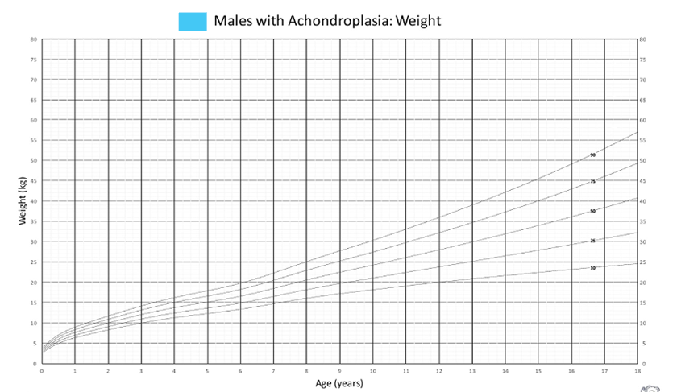

  - Growth Chart – BMI (Male with Achondroplasia)
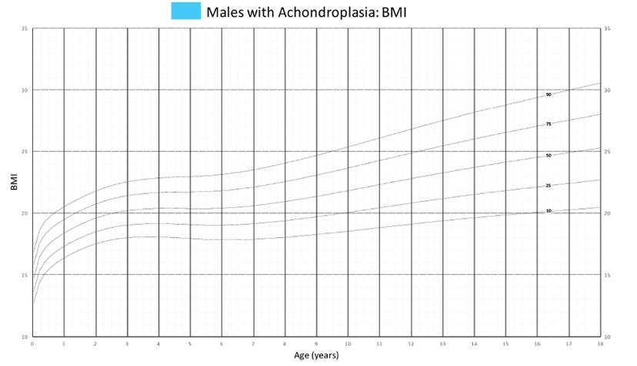

  - Developmental screening tool developed by Ireland et al. 2019
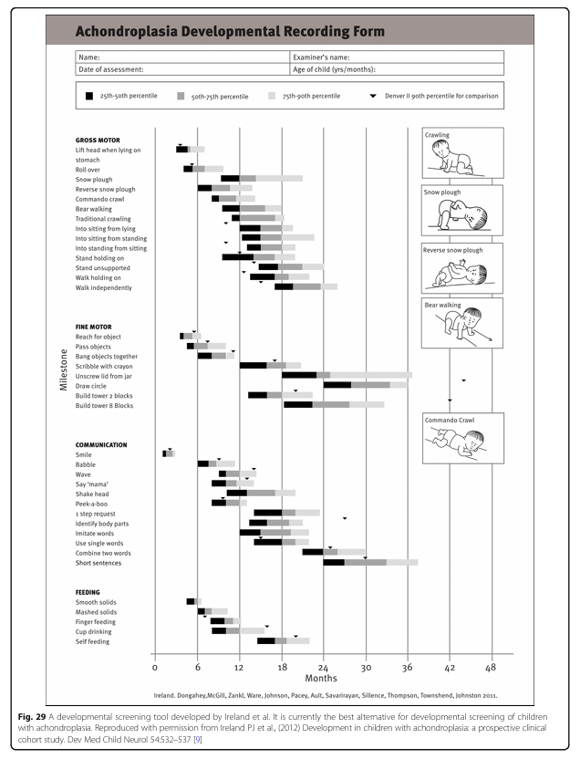

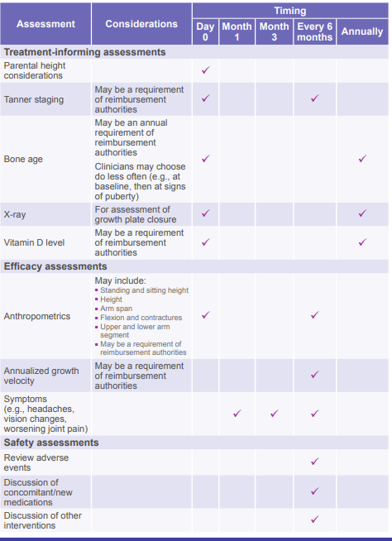
11.20. Assessment and follow-up protocols for children with Achondroplasia selected for Vosoritide treatment; these are in addition to routine monitoring.
Note: For children aged 0–2 years, the follow-up schedule in section 5.5.5 takes priority over this appendix (visits every 3 months, with height and weight at every visit, and no Tanner staging). For children over 2 years, the timings in this appendix apply.
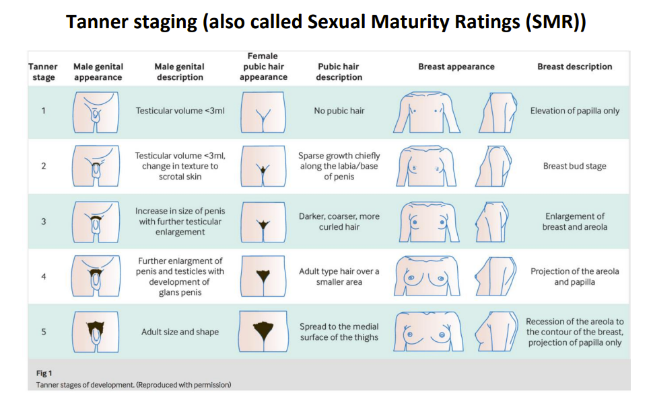
11.21. Puberty Charts Reference

- Tables

  - Updated: Vosoritide single dose volumes by body weight in mL and Units (SmPC Table 1) (6)
Body weight (kg) | Dose (mg) | Vial strength | Solvent (water for injections); concentration | Daily injection volume (mL) | Daily injection volume (Units)
4 | 0.12 mg | 0.4 mg | 0.5 mL; 0.8 mg/mL | 0.15 mL | 15 U
5 | 0.16 mg | 0.4 mg | 0.5 mL; 0.8 mg/mL | 0.20 mL | 20 U
6–7 | 0.20 mg | 0.4 mg | 0.5 mL; 0.8 mg/mL | 0.25 mL | 25 U
8–11 | 0.24 mg | 0.4 mg | 0.5 mL; 0.8 mg/mL | 0.30 mL | 30 U
12–16 | 0.28 mg | 0.56 mg | 0.7 mL; 0.8 mg/mL | 0.35 mL | 35 U
17–21 | 0.32 mg | 0.56 mg | 0.7 mL; 0.8 mg/mL | 0.40 mL | 40 U
22–32 | 0.40 mg | 0.56 mg | 0.7 mL; 0.8 mg/mL | 0.50 mL | 50 U
33–43 | 0.50 mg | 1.2 mg | 0.6 mL; 2 mg/mL | 0.25 mL | 25 U
44–59 | 0.60 mg | 1.2 mg | 0.6 mL; 2 mg/mL | 0.30 mL | 30 U
60–89 | 0.70 mg | 1.2 mg | 0.6 mL; 2 mg/mL | 0.35 mL | 35 U
≥ 90 | 0.80 mg | 1.2 mg | 0.6 mL; 2 mg/mL | 0.40 mL | 40 U

- Review & Approval section
 | Name | Title | Signature | Date
Prepared by: | Dr. Maha Faden | Consultant  Genetic & Metabolic Department
Reviewed by: | Dr. Sauzan Al Hameidi | Head of Genetic & Metabolic Department
Reviewed by: | Dr. Sauzan Haj-Kheder | Clinical Pharmacist
Reviewed by: | Dr. Aziza A. Dongues | Quality Officer  Children’s Hospital
Reviewed by: | Dr. Adil Hussain | Head Clinical Practice Guidelines, QMPSA
Reviewed by: | Mr. Ali Asmar | Director, Quality Management & Patient Safety Administration
Approved by: | Dr. Abdulwahab Al Ayoubi | Medical Director  Children’s Hospital
Approved by: | Dr. Yousef Al Otaibi | Hospital Director  Children’s Hospital

- CPG History:

Title: | Guidelines for the Diagnosis, Management, and Treatment of Children with Achondroplasia
Number and version: | CPG/DMT-A/332
Replaces number and version:
Effective Date:
Revision Date:

