PlutoPDF (M8) v0.1.3.0 Build 20090719
Roger.Yi (roger2yi@gmail.com)

PlutoPDF is a PDF Reader software to read PDF digital document on MeiZu’s M8 mobile. It is purpose to read the PDF document fast and easy, also provide a good viewing effect.

Third Party Software

- PlutoPDF use mupdf as the rendering engine, the early version used already compiled version from tk11, and the later version used the version from sumatrapdf.
- PlutoPDF use Qt4.5 CE as the application framework; only use MeiZu’s SDK in very minimal, so it will easy to porting to other CE mobile platform.
- The icons used in PlutoPDF are source from VisualStudio2008 UI resource package (VS2008ImageLibrary.zip).

License

PlutoPDF is Open Sources software, it follows the GPL license. PlutoPDF used mupdf under GPL and used Qt under LGPL. You, as the user, can get a copy of the GPL/LGPL licenses from the install package and can download the source from internet: http://code.google.com/p/pluto-hades/downloads/list。

Features

- Support landscape screen reading
- Support multi-languages, support Chinese and English at now, according to the OS language settings
- Support touch and double touch operations
- Support use volume (up/down) key to scroll screen
- Provide recent files list to select, also open the last reading file when AP startup
- Support cut left/right margin to maximize the viewing area
- Support page jumping (user input, next 10, next 100, previous 10, previous 100)
- Support zoom in the page (100%, 120%, 150%, 180%, 200% screen width)
- Thumb will show when scroll screen and page, convenient for location
- Status bar show battery info, time, page info, zoom info open file, progress, status message
- Support open/close show thumbnail and show status settings
- Support load different UI style file (*.qss, base on Qt’s stylesheet)
- Remember the opened document’s last reading page and margin cutting settings

Operations

- Touch：Touch screen for a little time (> 150ms), use to scroll screen, also hide the menu
  - Touch screen’s upon area to scroll screen up, touch the bottom area to scroll down
  - Touch screen’s four corners to direct locate the four corners of page
- Double touch：Quick touch twice among a limited area, use to scroll page, trigger shortcut or show menu
  - Double touch screen’s upon area to scroll previous page, touch screen’s bottom area to scroll next page
  - Double touch screen’s top-left corner to popup menu
  - Double touch screen’s top-right corner to open file, bottom-left corner and bottom-right corner to scroll pre/next 10 pages
Donate to PlutoPDF

PlutoPDF can download from internet and you do not need to pay for it at now. But, as the user, if you found the software is useful to you and love to donate to the author to support his following development, you can use支付宝 or PayPal to pay a little amount of money.
支付宝 Account：roger2yi@gmail.com PayPal Account：roger2yi@gmail.com
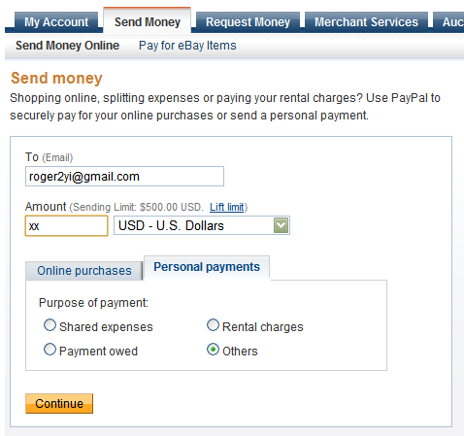

Usage

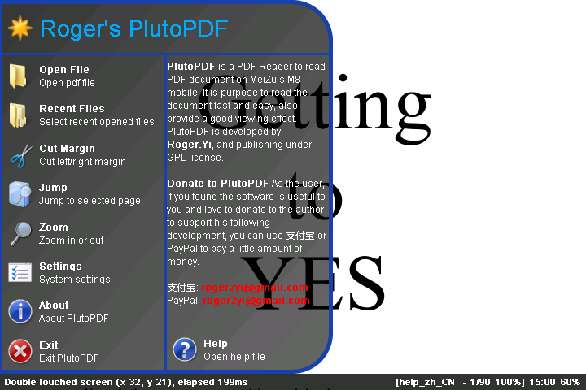
Double click the left-top corner will show the menu, the menu items are:

- Open File – Open PDF document
- Recent Files – View and select recent open files
- Cut Margin – Cut left/right margin
- Jump – Page jumping
- Zoom – Page zooming
- Settings – System settings
- About – PlutoPDF about information and open help file
- Exit – Exit PlutoPDF

