DWDM-MODEL EXAM

18BCS011

**SET:1**

**QUESTION:1**

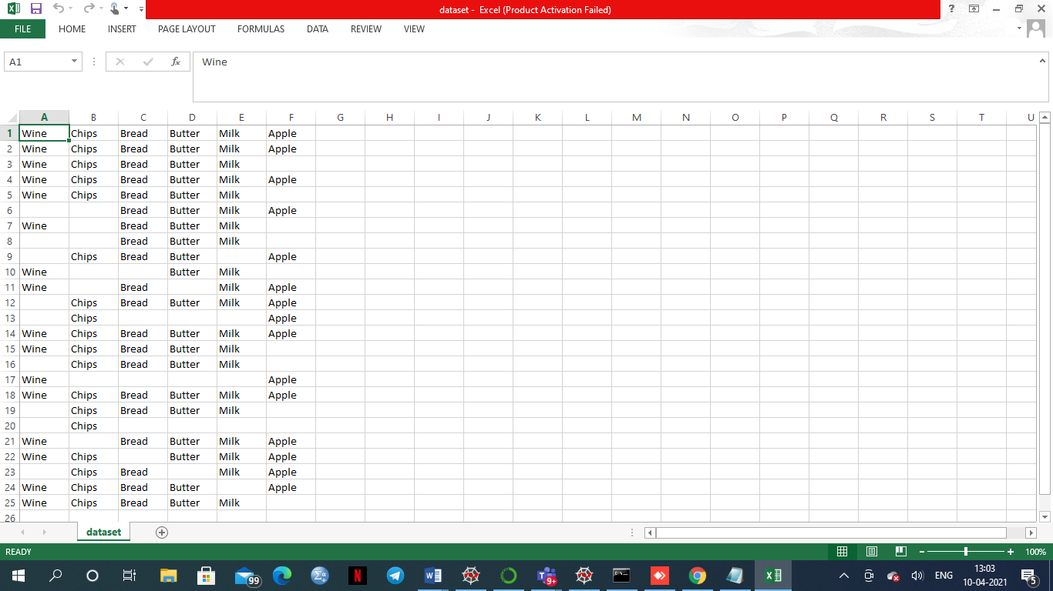

The attribute type is **NOMINAL**

**QUESTION:2**

**CODE**

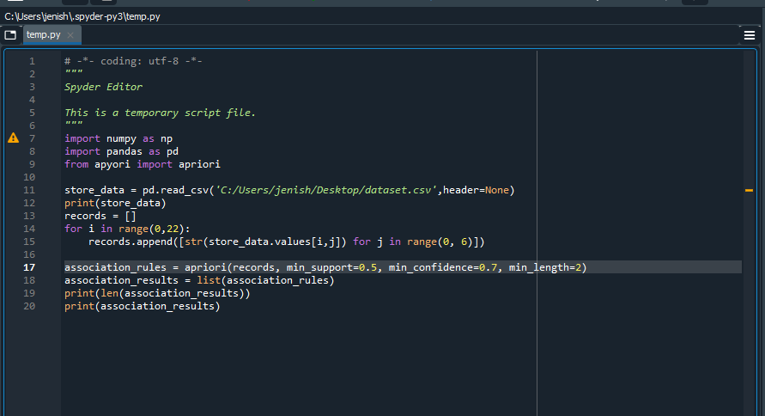

**OUTPUT**

