# **Uploading Course Content**

1. Create Units
2. Create Questions
3. Create Quizzes
4. Set Curriculum

## 1.Create Units

Go to LMS section and click on *All Units*. Click *Add New*.

* Enter unit title
* Insert unit content
* Set unit description

* Set *Unit Type, Unit Duration, Unit Duration Parameter*
* Attach any additional resources (word documents, etc.)

* Save Draft -> Preview
* When complete, Publish unit

## 2.Create Questions

Click on *All Questions*. Click *Add New*.

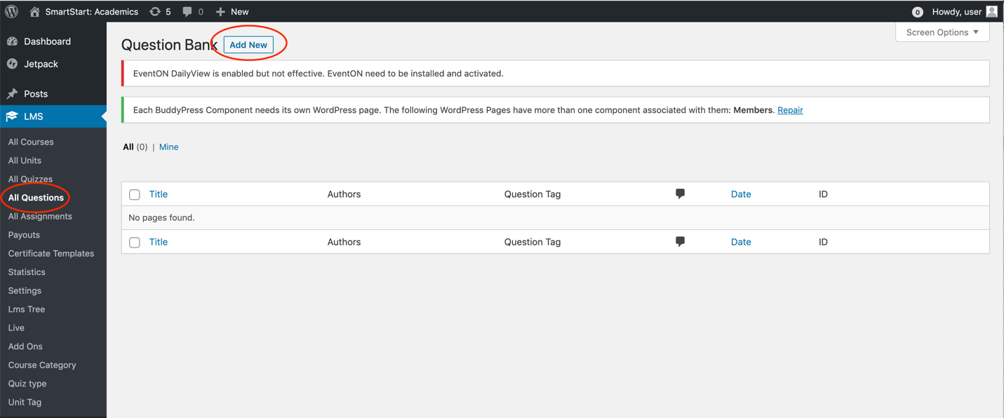

* Set question title (ex. BIO_Quiz1_Q1 – for Biology Quiz 1 Question 1). Important to name sequentially so that you can easily set up the quiz.
* Type question in box

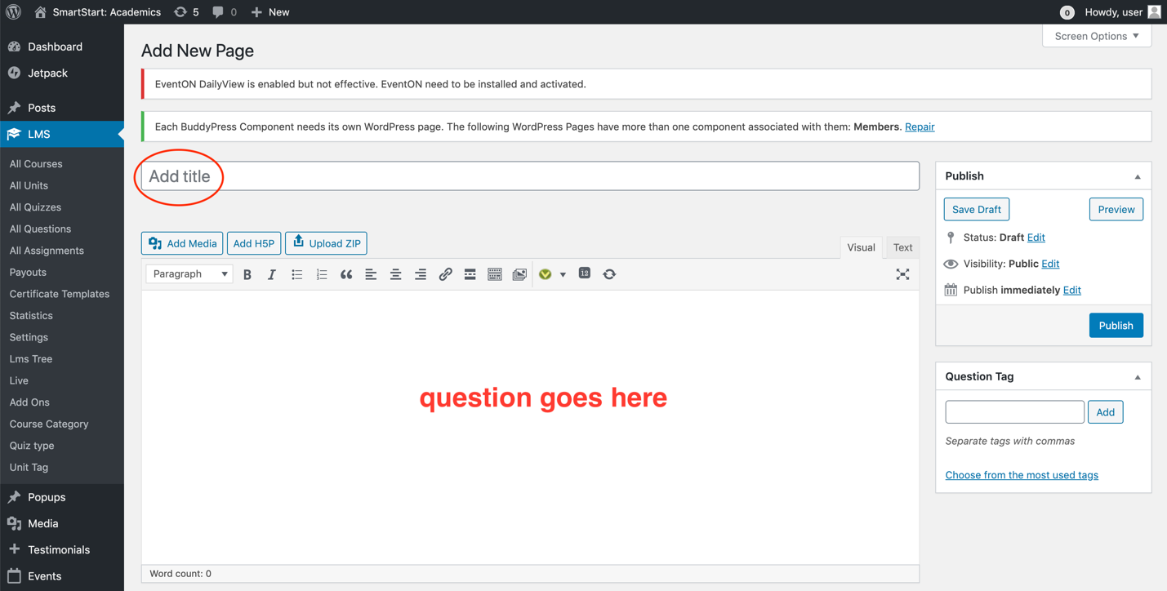

* Set *Question Type*
* Enter *Question Options* (if required)
* Enter *Correct Answer*
* Set *Answer Hint* (if applicable)
* Enter *Answer Explanation*

* Save Draft -> Preview
* When complete, Publish question

## 3.Create Quizzes

Click on *All Quizzes*. Click *Add New*.

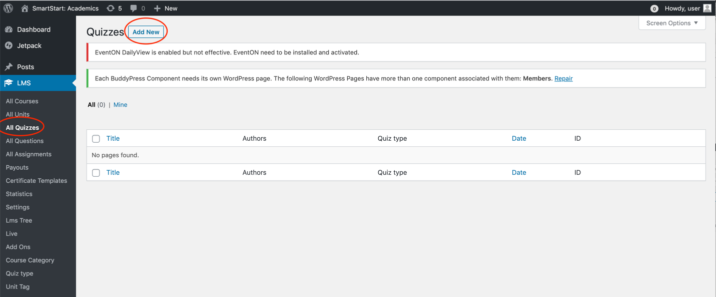

* Set Quiz title
* Enter quiz instructions into text box

Edit quiz settings

* Type pre-set question name to select question
* Set how many marks each question is worth

* Save Draft -> Preview
* When complete, Publish quiz

## 4.Set Curriculum

***Do not change any settings on course page other than *Course Curriculum*

Navigate to *LMS->All Courses*. Select your course.

* Scroll down page to *Course Settings->Course Curriculum*
* Add units and quizzes to each course section (module)
  + Use blue arrows to the left of section/unit/quiz title to drag elements up or down

* Preview Changes
* When complete, Update

## Misc - Changing Colour of Text

**Please change the colour of all links to Western Purple

Click on the underlined *A* in the content styling menu, then click *custom*

In the pop-up *Color* window, type 4f2683 in the box beside the #. This is the Hex Code for Western Purple.

## Additional Resources

How-to guide:

<https://vibethemes.github.io/WPLMS-Documentation/instructor-guide.html>

Support Forums:

<https://wplms.io/support/forums/>