**SALES MONITORING SYSTEM FOR POSH AND FAB CONCEPT STORE WITH ONLINE VIEWING**

A Project

Presented to

the Faculty of STI College Cebu

In Partial Fulfillment

of the requirements for the Degree of

Bachelor of Science in Information Technology

by

Cahimat, John Rey C.

Salva, Ryanjie E.

Naldoza, Jenalyn B.

Mr. Romar John Patindol

Project Adviser

**CHAPTER 1**

**INTRODUCTION**

Technology is vast nowadays, but still lots of establishments tend to use the traditional method and is hesitant to invest huge amounts financially in having computerized systems. As Information Technology students, we are taught to create that aid for companies in need, and one of the ways we could do this is by systematically, analyzing designing and implementing a computerized system that could improve their existing system.

Sales Monitoring System is a means of keeping an eye on how many sales a company is making, and how much profit is being earned. This system will improve in handling the products sold by just entering data required and the system would handle the calculation. Having an advanced and computerized system in running business makes more productive, efficient, secure and convenient both to the company and to its clients. Sales Monitoring System is meant to help businesses to increase sales and most importantly to increase profit of the company because it helps works faster and easier. Since money is the blood of a business, it is very important to have an exact and precise data for an accurate calculation of the sales in the business.

In this regard, we are proposing an improve automated computer system for Posh and Fab Concept Store. Posh and Fab Concept Store started last July 28, 2017, an establishment different from online sellers owned by Tricia Javier, was an online seller whose goal is to help co-online sellers to expand their own unique brand.

With the interviews and researches done, the team was able to point out the flaws and problems occurring in the business. We have been able to find out the problems and provide an alternative answer to their current business.

* 1. **Background of the Problem**

Through several interviews with the owner and selected staff, Posh and Fab Concept Store disclosed that they are currently using Microsoft Excel, and generate a report manually and send it via email, by relaying on their old method in handling may lead to several problems.

As a growing business, Posh and Fab Concept Store should provide a quality of work in making these processes more convenient and efficient to its staff and brand partners. Thus, the proponents have outlined the problems that the client had encountered in running their business daily.

* Tracking of damage product

The owner find really hard to keep track on the damage products

* Data redundancy

Transferring of data from paper to Microsoft excel is a tiresome work which is prone to human error and may lead to data redundancy.

* Discrepancy of daily sales

The owner only relies on the integrity of the sales staff to generate an accurate daily sales report.

* Tiresome analysis and generation of instant and up-to-date reports

To provide daily sales report, the staff will have to create their own excel document everyday in order to monitor the daily sales.

**1.2 Overview of the Current State of Technology**

*Figure 1.0 Microsoft Excel*

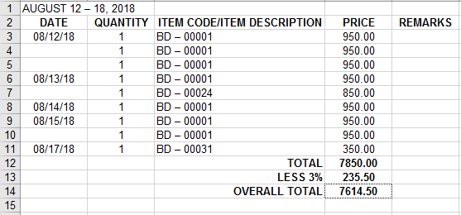

The proponents’ client does have a computerized system where in the data of their sales are entered in Microsoft Excel.

*Figure 2.0 Ingress Form*

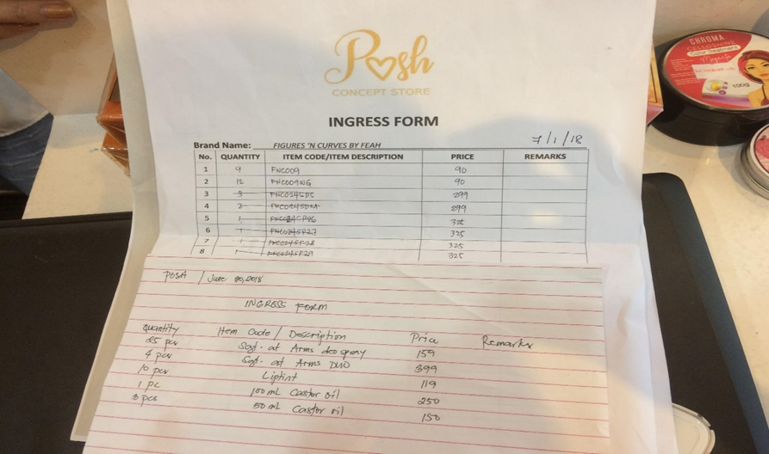

*Figure 2.0 Ingress Form*

Every product that is delivered in the store are only written on an ingress form that the store provided*.* Every transaction that is being completed are entered in Microsoft Excel. It takes time for them to input the data to Microsoft Excel in every product being purchased, as well as the inventorying of each product.

*Figure 3.0 Emporium*

**A screenshot of a cell phone

Description generated with very high confidence**

*Figure 3.0 Emporium*

There’s an existing system about online sales monitoring system that is used by Emporium, an online brands outlet in Cebu, however, their online monitoring could not view sales through graphs and charts.

**1.3 Objectives of the Study**

The proponents aim to build, design and implement an advance computerized sales monitoring system for Posh and Fab Concept Store that will increase the performance and save time from the current system being used, and finally minimize human errors from the employees. As for online sellers, they can have an access of the website wherein they could view the sales of their products respectively.

The general objective of the proposed system is narrowed down in a specific objective:

* Provide a sufficient data handling
  + Create a system that prevent sales redundancy.
* Provide an ease in data retrieval and data searching
  + Create a system that can help our client search and retrieve both archive and unarchive data easily.
* Provide an online viewing
* Create a website that the brand partners are capable of viewing their own sales and items.

**1.4 Scope and Limitations of the Study**

**1.4.1 Scope**

The study will focus on the improvement of the current system of our client and includes the following:

* A default username and password are given to the system administrator.
* As of cashier and brand partner’s accounts it is only provided by the system administrator.

**Desktop Application**

***For the administrator***

* + Item Form
  + Displays data in a table form of all products.
  + The admin has an access role of adding a product, editing a product, and archiving a product.
  + The admin can add a product category, edit a product category, view categories, and archive a product category.
  + The admin has an access role of branding a product during adding
* Product Information Form
  + Shows product’s information
  + The admin has an access role of branding a product during adding
* Cashier Accounts Form
  + The admin has an access role of viewing the cashier’s information at the cashier’s profile form.
  + A table of data is provided showing all cashiers’ account.
  + The admin can add cashier accounts, edit a cashier account information and, archive cashier account.
* Cashier’s Profile Form
  + Shows personal information of a cashier
* Brand Partners’ Accounts Form
  + The admin has an access role of viewing the brand partner’s information at the brand partners’ form.
  + A table of data is provided showing all brand partners’ accounts.
  + The admin can add a brand partner account, edit a brand partner account at the profile form, and archive brand partner account.
* Brand Partner’s Profile Form
  + Shows personal information of a brand partner.
* Sales Form
  + A table of data is provided showing all sales.
  + Generate sales by daily, monthly, annually or admin’s date preferences.

***For the Cashier***

* Transaction Form
  + The cashier has an access role of making transactions.
  + Generate sales invoice.

**Website**

***For the Brand Partners***

* View brand partner’s own sales
  + View brand partner’s own sales.
  + Generate sales by daily, monthly, annually or base on brand partner’s date preferences.
  + View sales records through charts and graphs.

**1.4.2 Limitations**

* Purchases are only available through walk-in.
* Payments only accepts cash.
* The system could not generate official receipt.
* The system requires internet connection to be accessible. No internet access means the system cannot be functional.
* The system does not have Secure Sockets Layer (SSL) Certificate that standardized security technology for establishing an encrypted link between a web server and a browser.
* Can’t prevent total sale and actual money inhand.

**1.5 Methodology**

In this study, the proponents decided to use Scrum Methodology to fulfill and reach the intended output. Scrum is an iterative framework and a leading [agile development methodology](https://www.slideteam.net/agile-methodology-process-diagram-flat-powerpoint-design.html) for handling rapidly evolving projects. Scrum emphasizes teamwork where we, the development team, works to achieve towards a well-define goal.

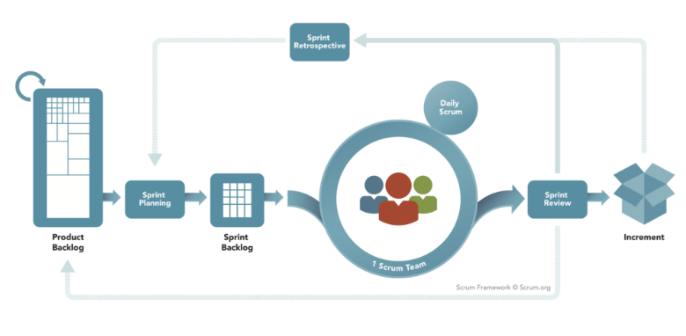*Figure 3.0 Scrum Methodology*

* **Product Backlog –** The product backlog contains a to-do list consisting of work items, to define the product backlog, proponents conducted an interview with the product owner. The product owner is the person responsible for prioritizing the product backlog.
* **Sprint Planning-** In sprint planning the proponents together with the scrum master are planning which product backlog items will be delivered into sprint backlog and how it will be achieved.
* **Sprint Backlog**- The sprint backlog is the set of the product backlog items selected for the sprint. In sprint backlog each member of the scrum team should choose a task to be done during the sprint.
* **Daily Scrum-** The daily scrum is a short everyday meeting (no more than 15 minutes) for the team.
* **Sprint Review-** The sprint review is held at the end of the sprint. Each member of the team presents their work being completed and not completed during the sprint.
* **Sprint Retrospective-** The sprint retrospective is the final meeting in the sprint to determine what went well during the sprint, what didn’t go well during the sprint and how the team can improve in the next sprint.
* **Increment-** the sum of all the product backlog items completed by the team during the sprint.

**CHAPTER 2**

**THEORETICAL FRAMEWORK**

**2.1 Introduction**

As stated, the company has been using the old-fashioned method of computing their purchases and monitoring their sales in Microsoft Excel. The proponents aim to implement an advanced computerized sales monitoring system for the company’s continuous growth.

In this chapter, the study will be expounded with the aid of these theories provided. Each theory will materialize that the proposed system can make it plausible on business or establishment to keep up with their needs.

**2.2 Decay Theory of Forgetting**

Decay theory proposes that memory fades due to the mere passage of time.

Information is therefore less available for later retrieval as time passes and memory, as well as memory strength, wears away. The longer the time, the more the memory trace decays, and as a consequence more information is forgotten.

In rental business like Posh and fab Concept Store, it is beneficial to track the customers who were not able to return the products to lessen the loss of the company.

Currently, the staffs of Posh and Fab Concept Store are tracing rentals manually. However, manual tracking may cause lapses and staffs might not be able to pay close attention to details. There might be information that has already been recorded before or worst forgotten. [BERM, 2009]

**2.3 Maslow’s Hierarchy of Needs**

Maslow’s Hierarchy of Needs identified how a person’s needs to dominate motivation and behavior and that there is a specific order in which they should be met. His theory suggested that the basic needs (physiological, safety, love and belonging) had to be met before the individual will desire and pursue higher levels of needs (esteem, self-actualization, and self-transcendence). Business owners found a similar hierarchy of needs among business owners. These are: Sufficient Sales (every sale is critical); Financial Management (costs and profitability are critical); Marketing Actions (marketing generates enough prospects for enough sales to occur); Personnel (ramp up — enough support to deliver the product and service); Government Compliance (concerns about regulations, personnel law and taxes predominate); Processes and Procedures (first step toward consistency and growth); Team Management (training need); Scalability (focus on how this leads to a profitable exit and transference strategy for the owner). It also stated that if you’re a business owner, this should help you in spending your money and time wisely. (<http://ownersview.com/business-owners-hierarchy-of-needs/>). With that being said, this theory supports the system in terms of time management and profitability. Sales are very crucial, and we need to have the right system to keep our business more competent.

**2.4 Innovation Theory** (Edward Elgar Publishing)

It stated that we can define innovation as the introduction of new elements or a new combination of old elements in industrial organizations (cf. Scumpeter 1934). In this analysis the main emphasis in the innovation concept will not be on the actual new idea or developing the new element for commercial use of innovation: ‘Innovation refers to the process of bringing any new idea into use’. In addition, the innovation process in the individual company are of great importance to the development and growth of the company and thus in turn to socioeconomic growth and national competitiveness.

In this theory, it’s stated that there is space to create something new to apply the improvements to certain things. It examines the emergence of different theories of innovation in different periods, and how they compete for dominance today. It addresses technology as a determinant of innovation, emphasizing the relations technology with organizational and social factors.

Innovation for the existing system in Posh and Fab Concept Store will surely benefit not just the store owner and the brand partners, but the whole operation as well. It is indeed a good idea to create an advanced computerized sales monitoring system that will enhance the store’s service to their brand partners.

**2.5 Summary**

These theories answer the need for improving the computerized system that is being used by the Posh and Fab Concept Store. Along with the development of this system, comes the theories that serves as a guide in determining its very aspect. These theories signify the importance of creating an advance computerized system to help in monitoring the company’s sales.

The implementation of this system would not only benefit to the store owner and the brand partners but also to the store itself, as a business organization.

**CHAPTER 3**

**SALES MONITORING SYSTEM FOR POSH AND FAB CONCEPT STORE WITH ONLINE VIEWING**

**3.1 Introduction**

This chapter showcase the development tools that involved in the proposed system. It defines the functions, concepts, flow of data involved, structure of its database and the design of its interface. Diagrams and Schema of the database is also showcased here to fully understand the relationship, flow and overall structure of the proposed system.

**3.2 System Design Specification**

This section will show the flow of all the diagrams that are made by the proponents for all the user of the proposed system. The desktop application is only accessible by the admin and the cashier with its exact role, while the website is accessible by the brand partners only. The admin can manage all the accounts of the cashiers and the brand partners and monitor the sales and the products. The cashier is capable of making transactions, and the brand partner are capable of viewing their own sales and products.

**3.3 Architectural Design**

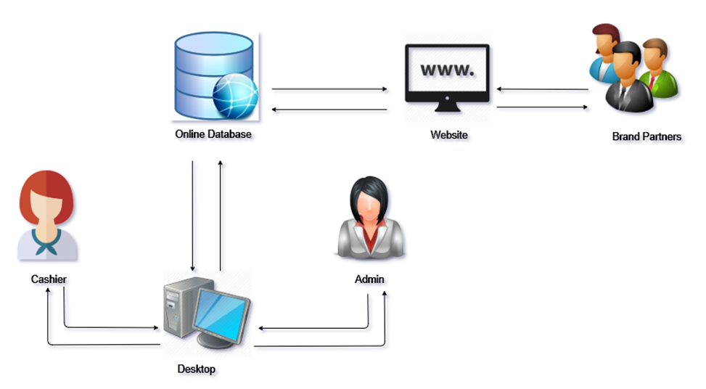

*General Architectural Design*

This section shows all the overall structure of the system including all the users (Admin, Cashier and Brand Partners). It explains the graphical representation of how the proposed system interacts to the database and the users. The admin and the cashier are users who can only access the system through desktop. Brand Partners on the other hand can directly access the system through website.

**3.3.1 Context Diagram**

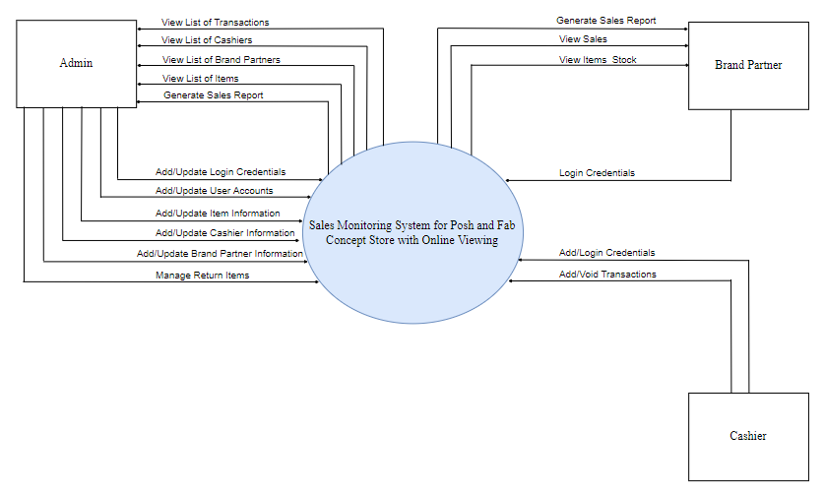

*Context Diagram*

This section shows the context-level of the proposed system. It provides the relationship that the system has with other external entities and shows the capabilities of the system by its three users (Admin, Cashier and Brand Partners).

**3.3.2 Data Flow Diagram**

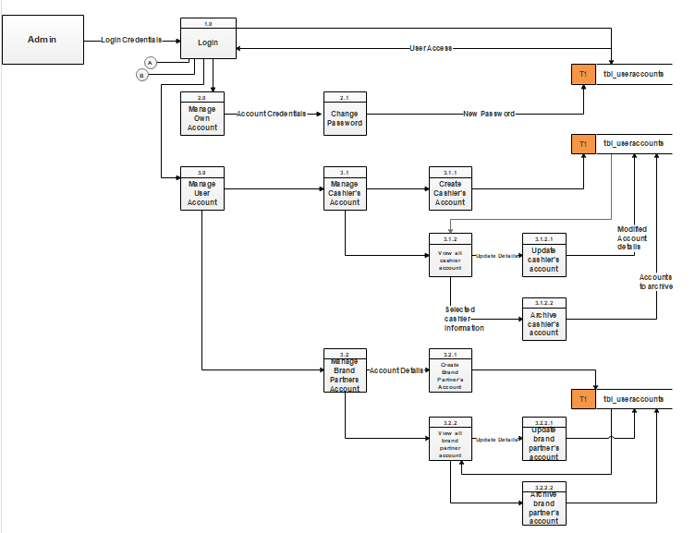

*Part 1. Data Flow Diagram for the System Admin*

The data flow diagram decomposes the context diagram into lower-level data flow diagrams. The figure above shows the supremacy of the administrator in the whole system structure over any other users.

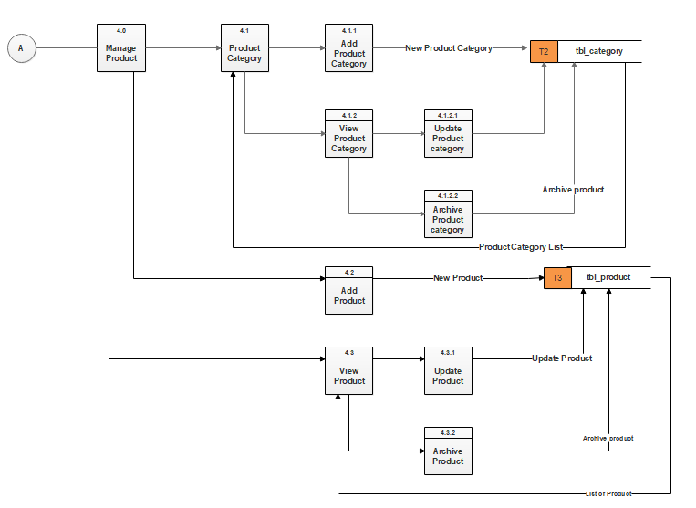

*Part 2. Data Flow Diagram for the System Admin*

Part 2 is a continuation of the system admin’s access to the system. In this figure, the admin is allowed to manage the addition of item, viewing and archiving the items.

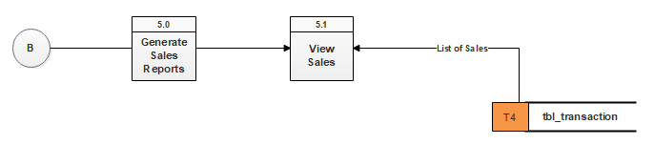

*Part 3. Data Flow Diagram for the System Admin*

The admin’s access is continued in Part 3 Data Flow Diagram for the system admin. Shown here is the process by which the admin is able to generate reports.

*Data Flow Diagram for the Cashier*

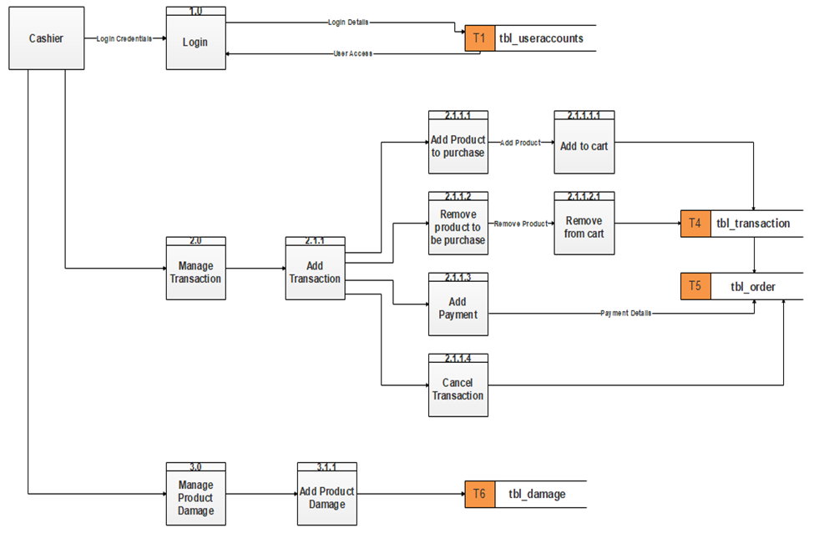

*Data Flow Diagram for the Cashier*

It shows here that the only function of the cashier aside from logging in is Manage Transactions.

*Data Flow Diagram for the Brand Partner*

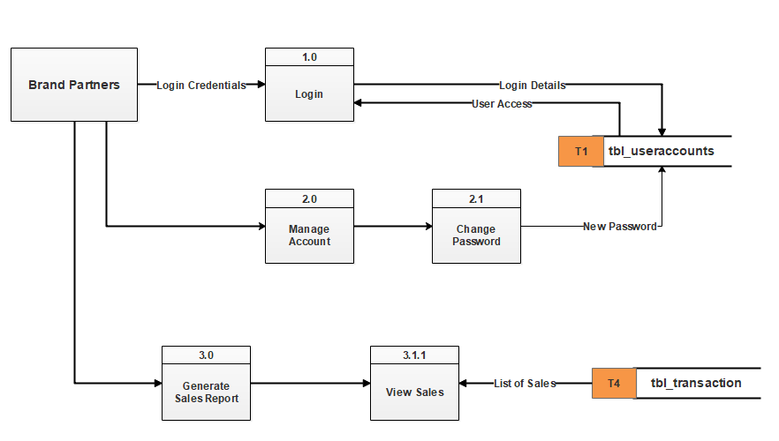

*Data Flow Diagram for the Brand Partner*

Figure above shows the designated access of the Brand Partner. This user can only access the system by logging in website. They can able to view their item stocks at website and able to generate their sales.

**3.3.3 Entity Relationship Diagram**

*Entity Relationship Diagram*

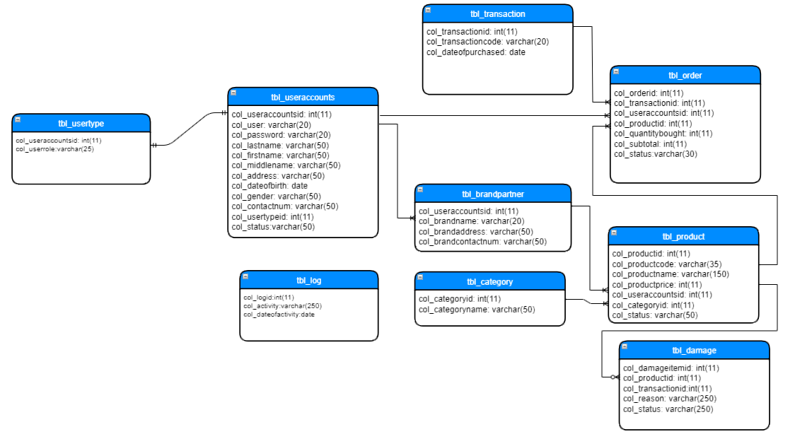

*Entity Relationship Diagram*

Figure above shows the proposed system’s database structure or schema. Here, the relations or commonly referred to as tables are specified as well as the attributes or columns they contain. This diagram shows the relationship between each table through their respective primary and/or foreign keys that serves as identifiers for a particular record.

**3.3.4 Hierarchical Input Process Output**

*Hierarchical Input Process Output Diagram for the System Admin*

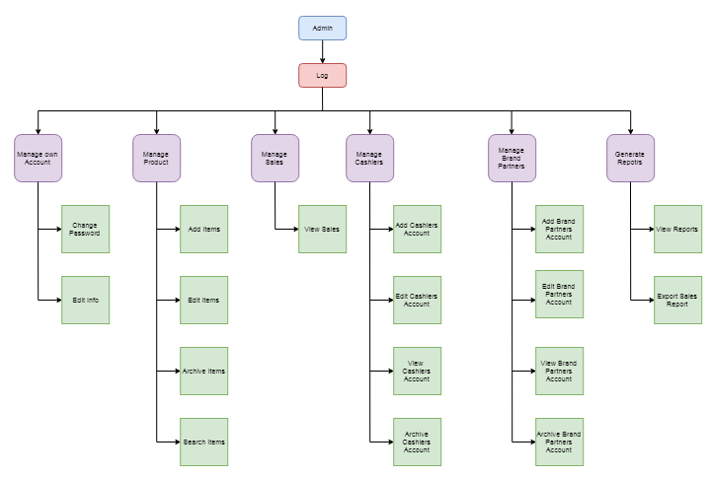

The diagram shows the administrator privilege. It shows that after the log-in the account, the administrator can view the home page; manage own account, manage product, manage sales, manage cashiers, manage brand partners, and generate reports.

*Hierarchical Input Output Process Diagram for the Cashier*

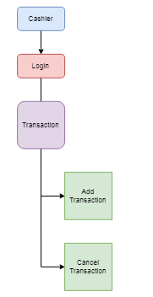

The diagram shows the cashiers privilege. The cashiers can log-in the accounts, manage transactions, can add transaction and cancel transaction.

*Hierarchical Input Output Diagram for Brand Partners*

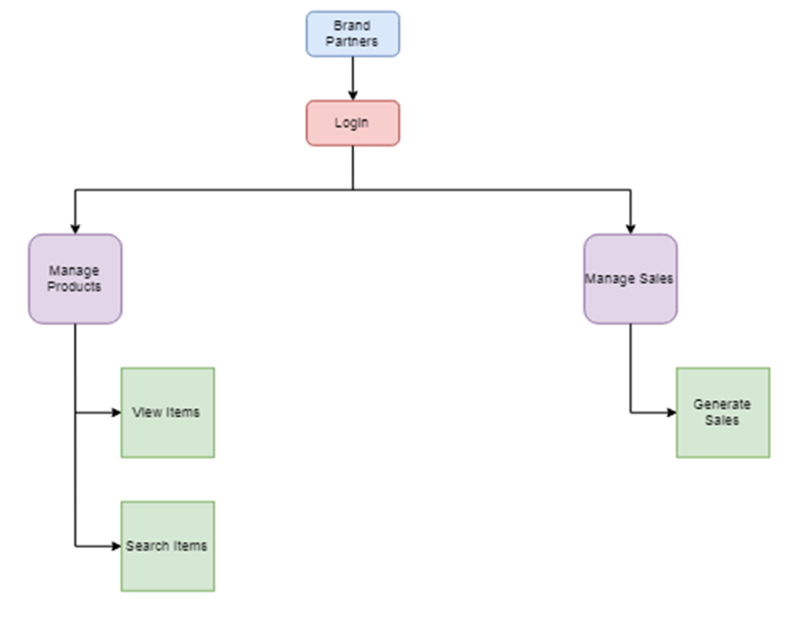

The diagram shows the Brand Partners privilege. The Brand Partners can log-in the accounts, manage products and manage sales.

**3.4 Development Tools**

In the course of system development, the proponents used the following hardware and software applications:

**3.4.1 Software**

* **Microsoft Visual Studio C#.net 2015**

To achieve the desired features of what the client asked, the proponents used this programming language in making the desktop application that is to be used by the administrator and for the cashier.

* **HTML, CSS and JavaScript**

The proponents used the programming languages to have a structure for the website that is to be used by the brand partners.

* **XAMPP**

A development tool used by the proponents to test their work locally without the use of internet.

* **Microsoft Word**

The proponents used this application for the documentation of the proposed system.

**3.2.1.2 Hardware**

* **Input Devices**
* Keyboard
* Mouse
* **Output Devices**
  + Monitor
  + Mobile Phones

**3.5 Summary**

The proponents used diagrams to provide a visual imagery of how the system works. This chapter made use of these diagrams to help the proponents in achieving the necessary functions as the actual application is created in a sequential and organized manner possible. These diagrams became backbone of the developed software and the guide to which the system is created.

**Chapter 4**

**PERFORMANCE ANALYSIS**

**4.1 Introduction**

The proposed system aims to help the users to be more organized and productive. The proponents determined the different major functions needed by the users and conducted series of test to make sure that everything is being met.

This chapter shows a series of experiments/test conducted by the proponents during the development of the proposed system. This further explains the errors of flaws encountered by the proponents and when they were able to resolve it.

**4.2 Experimental**

In conducting the experiment, the proponents ran each major function and were able to determine the errors and flaws of the proposed system. This was then properly noted and was able to find solutions on how to resolve the errors and flaws.

The table below shows the major functions of the system being run and their parameters.

|  |  |
| --- | --- |
| **Functions** | **Definition** |
| Login | User privilege after login  (admin/cashier/brand partners) |
| Limits controls of different users |
| Transactions | Identify whether product was sold or not |
| Real-time calculations |
| Products |  |
| Manage products |
| Accounts |  |
| Manage accounts |
| Reports | Daily, monthly, yearly sales report |

*Table 4.2.1 Functions and Definitions*

**4.3 Result and Analysis**

After the series of tests conducted by the proponents, though errors were encountered, the proponents were able to have satisfying result.

The table below are the lists of the test conducted by the proponents that shows the steps taken, and further discussed the expected and actual results.

|  |  |  |  |  |
| --- | --- | --- | --- | --- |
| **Test Name** | **Steps** | **Expected Result** | **Actual Result** | **Date Tested** |
|  |  |  |  |  |

**4.4 Summary**

**Chapter 5**

**CONCLUSION**

**BIBLIOGRAPHY**

**ACKNOWLEDGEMENTS**

The proponents’ proposed project would never have been completed if not for the help and support of multiple individuals. They would like to thank the assistance of the following:

• To their Thesis Coordinator, Mrs. Catherine P. Odiong, their ever-supportive Thesis Coordinator, for believing and keep pushing them that they can really make it;

• The proponents also extend their warmest gratitude to their thesis adviser, Mr. Romar John Patindol, who shared with them everything that he knows and for his patience during the times that they commit mistakes;

• To their parents and guardians, for the constant prayers and never failing support;

• To their friends and inspirations, for always there for them to inspire and to make them strong;

• To the Naldoza, Salva and Cahimat Family, for welcoming them in their home in their countless overnight encounters as they work their projects;

• Most of all, to God, for His unconditional love and blessings He is showering upon the proponents every single day. The proponents thank Him for making this thesis project a success; for the provision and wisdom He has given them, for giving the proponents’ enough strength to perform each task assigned to them.

**APPENDICES**

**A screenshot of a cell phone

Description generated with very high confidenceGantt Chart**