Team PML30-phi
Physics and Mathematics Lyceum №30, Saint-Petersburg, Russia
 | 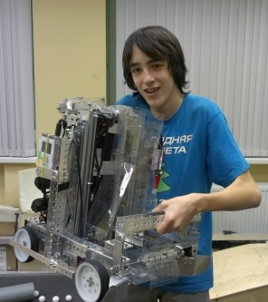 |  |  | 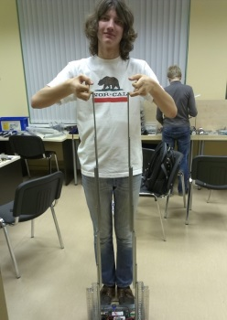
Georgiy Krylov  Captain, responsible for efficiency of working in the team | Evgeniy Maksimyshev  Operator №1,  engineer, responsible for programming | Nikita Safronov  Operator №2,  engineer, responsible for technical documentation | Ivan Fokin  Engineer,  responsible for purchasing materials | Maksim Radionov  Engineer, responsible for public relations

Strategy(number of scoring points is noted in brackets):
- Autonomus period (2 options):
  - Riding out from the ramp, scoring autonomus balls into 60 and 90 cm rolling goals and delivering them to the parking zone. (120)
  - Start from the parking zone, scoring autonomus balls into 30 and 90 cm rolling goals and delivering them to the parking zone. (100)
- Driver control period: carrying 90 cm rolling goal and filling it with balls (200 - 270). During end game scoring 4 big balls into central goal(180) or delivering rolling goals to the ramp (120).

Construction features(numbers of following pages in engineering notebook is noted in brackets):
- Strength:
  - Most of construction elements are made of metal (aluminum or steel).
  - Elevator works stable, because it is made of furniture rails. (pages 26 and 40)
  - Robot is heavy, so it’s hard to turn it over.
  - Robot is protected from collisions with Plexiglas.
- Mobility:
  - Robot has 6-wheel drive. Six motors and gear 2:1 for speed provide maximum power and maneuverability of moving. (page 197)
  - With standard TETRIX omniwheels robot easily turns, and because of special construction it has no problems with riding up to the ramp. (pages 168 and 199)
- Balls control:
  - Gripper for balls consists of two fast rotating vanes. (pages 25, 121 and 175)
  - The bucket for balls rises up with elevator and overturns backwards. (pages 102 and 177)
  - Balls from the bucket move to the guide with hole at the end of it. Balls fall down from the hole vertically, so they always get into the goal.(pages 81 and 107)
  - Robot captures the rolling goal with a special mechanism and carries it with itself. (pages 123, 201)

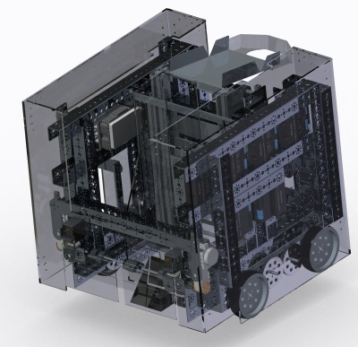 | We thank our sponsors:
 |    | 
 | Contact information:  Website:  http://school30.spb.ru/robot/  e-mail:  robodepartmentPML30@yandex.ru  Facebook:  https://www.facebook.com/pages/FTC-team-PML30-PHI/1410799752560522 | 

