CommPay: Suspense

The following topics will be created or updated:

Contents

Suspense Table of Contents 3

Current 3

Proposed 4

Suspense 5

To open the Suspense function 5

Suspense screen 5

To customise the records grid 6

Suspense Actions 7

Actions menu 7

*Edit 7

*Matching Options 8

*Auto Create Options 8

*Auto-create Estimate 9

*Net Revenue/Clawback Amount Exceeded 9

Account Code mismatch on linked Policy Options 9

*Adviser mismatch on linked Client Options 10

*Multiple Clients Exist with the same name 11

*Missing Revenue Type on Record 11

*Account Is Not Active Options 12

Does not Match Estimate Record 12

Failed to Find Client 12

Mapped Product is Unknown 12

Product mismatch on Linked Policy options 12

Potential Share Arrangement 13

Incorrect Supplier on Product 13

Client Opt-Out 14

Unauthorised Revenue 14

Refund to Supplier new 14

Client Review Incomplete 14

Reset 14

Suspense Reasons and Rules Explained 15

Suspense Rules 15

[NEW] Manage Suspense Records 21

[NEW] Resolve Suspense Records 22

View the Suspense Balance 23

To view the suspense balance 23

Manage Phased Revenue 24

To set a phasing schedule 24

View a statements progress 24

Policy Takeover on Suspense Records 26

Policy Takeover - Account Code Mismatch 26

To perform a policy takeover - account code mismatch 26

Policy Takeover - Account Is Not Active 27

To perform a policy takeover - account is not active 27

Analyse Suspense Data 28

To open the Suspense Analysis function 28

New Business 28

Ongoing 29

Supplier Trend 30

Administration Tools 31

Document Management 32

Topic list 32

CSHID Links 33

Microcontent 33

Keywords & Concepts 34

Concepts 34

Links 34

# 

# Suspense Table of Contents

[Miro: Mapping Suspense help topics to Suspense Actions menu](https://miro.com/app/board/uXjVPpQfAEk=/)

### Current

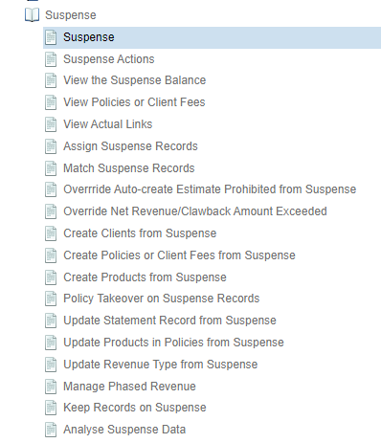

### Proposed

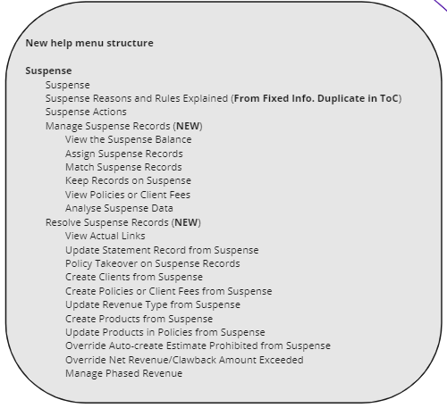

|  |  |
| --- | --- |
| **Topic info:** | |
| **Source** | Content/Suspense/Suspense.htm |
| **ToC** | CommPay Help > Core Help > Suspense > Suspense |
| **Concept terms** | Suspense - Manage CP;Suspense CP |
| **Keyword terms** | suspense |
| **Concept links (see also)** | Suspense Rules CP;Statements CP;Process Pd Paymt CP |
| **Alias ID (for new topics)** |  |
| **Conditions** |  |

# Suspense

When statements are loaded into CommPay, they are matched with existing CommPay information in the Policies / Client Fees screen and active suspense rules. Records that fail to match are listed in the Suspense screen with the reason they did not match displayed in the Status column.

Suspense records must be matched before statements can be processed.

undefined CommPay Statements

* The Manage Suspense Records section contains information about how to view the suspense balance, assign and match records, and keep records on suspense.
* The Resolve Suspense Records section contains information about how to resolve various suspense reasons.

### To open the Suspense function

There are two ways to access the Suspense screen:

##### From the navigation menu

* In the navigation menu, choose Suspense.

##### From the Statements function

* In the navigation menu, choose Statements > Suspense.

### Suspense screen

See the CommPay Basics section for more information about:

* CommPay screen elements
* how to display data using views, filters and the find function
* how to use the lookup function

The following display options are specific to the Suspense screen:

#### Filter list

You can use the suspense filters list to select which suspense records to display.

|  |  |
| --- | --- |
| All | Display all suspense records. |
| Assigned to me | Display all suspense records assigned to the current user. |
| Suspense Override | Display suspense records where the suspense reason has been configured to allow Suspense Override. undefined Suspense Override |
| Unassigned | Display suspense records with no assignee. |

#### Find function

In addition to the default find options, you can match on statement numbers and payment hierarchy on the Suspense screen.

|  |  |
| --- | --- |
| All | Display all suspense records. |
| Statement Number | Display all suspense records related to the selected statement number. By default the most recent statement number is selected. |
| Hierarchies | Display all suspense records related to the selected payment hierarchy. |

### To customise the records grid

1. In the **Views** menu, select **Customise**.   
   The **Select Columns** screen opens.
2. Use the **+** or **-** to add or remove columns.
3. Click **OK**.
4. To save a customised view, click the undefined icon.

|  |  |
| --- | --- |
| **Topic info:** | |
| **Source** | Content/Suspense/Suspense_Actions.htm |
| **ToC** | CommPay Help > Core Help > Suspense > Suspense Actions |
| **Concept terms** | Suspense - Manage CP; Suspense CP |
| **Keyword terms** | suspense |
| **Concept links (see also)** | Suspense Rules CP;Statements CP;Process Pd Paymt CP |
| **Alias ID (for new topics)** |  |
| **Conditions** |  |

# Suspense Actions

The Suspense Actions menu lists the various actions you can take on the entries displayed in the suspense records grid.

|  |  |
| --- | --- |
|  | **Note**: Depending on your CommPay configuration, you may not see all actions. |

|  |  |
| --- | --- |
|  | **Tip**: To view all Action menu options, click <icon> (**Expand all**) at the top of this page. |

## Actions menu

|  |  |
| --- | --- |
| Assign selected | Assign selected suspense records to a user. |
| [Assign all](https://community.iress.com/t5/Help-Guide-CommPay/Assign-Suspense-Records/ta-p/40573#Assign_Suspense_Records) | Assign all displayed suspense records to a user. |
| [Unassign selected](https://community.iress.com/t5/Help-Guide-CommPay/Assign-Suspense-Records/ta-p/40573#Unassign_Suspense_Records) | Unassign selected suspense records. |
| [Unassign all](https://community.iress.com/t5/Help-Guide-CommPay/Assign-Suspense-Records/ta-p/40573#Unassign_Suspense_Records) | Unassign all displayed suspense records. |

### *Edit

|  |  |
| --- | --- |
| Single Record | Modify a selected suspense record. |
| Update selected Records | Modify multiple selected suspense records. |
| Update all Records | Modify all suspense records in the grid. |

### *Matching Options

|  |  |
| --- | --- |
| Match Suspense Record | Match a single selected suspense record. |
| Match All For Statement | Match all records in suspense for a statement. |
| Match All for Multi Statements | Match all records in suspense for multiple statements. |
| Match All Filtered | |
| Match selected records | Match selected filtered records in the suspense records grid. |
| Match all records | Match all filtered records in the suspense records grid. |

### *Auto Create Options

|  |  |
| --- | --- |
| Create Policy/Client Fee | Create a Policy or Client Fee from a suspense record. |
| Create Multiple Policy/Client Fee | Create Policies or Client Fees from all or filtered suspense records. |
| Undo Auto Create Policies | Undo the auto-creation of policies from Suspense. |
| **Create Policy/Client Fee on existing Client's Adviser** | |
| Create Policy/Client Fee | Create a Policy or Client Fee on an existing client's account from a suspense record. |
| Create Multiple Policy/Client Fee | Create Policies or Client Fees on existing client's account from all or filtered suspense records. |
| Override Matched Account |  |
| Create Policy/Client Fee | Create a Policy or Client Fee on an existing client's adviser, overriding the account linked to the statement record. |
| Create Multiple Policy/Client Fee | Create Policies or Client Fees on an existing client's adviser from all or filtered suspense records, overriding the account linked to the statement record. |

### *Auto-create Estimate

|  |  |
| --- | --- |
| Update selected Records | For the selected suspense records with a status of 'Auto-create Estimate Prohibited', override and continue the matching process. |
| Update all Records | For all suspense records with a status of ‘Auto-create Estimate Prohibited', override and continue the matching process. |

### *Net Revenue/Clawback Amount Exceeded

|  |  |
| --- | --- |
| Update selected Records | For selected suspense records with a status of '’Net Revenue/Clawback Amount Exceeded', release the rule and continue the matching process.. |
| Update all Records | For all suspense records with a status of '’Net Revenue/Clawback Amount Exceeded', release the rule and continue the matching process. |
| Revenue Phasing | Set a period schedule to nominate how many CommPay periods revenue is scheduled and paid over. |

## 

|  |  |
| --- | --- |
| *View Policy/Client Fee (Policy/Invoice No.) | View the closest possible Policy or Client Fee match for a record in suspense. undefined View Policies or Client Fees |

### Account Code mismatch on linked Policy Options

|  |  |
| --- | --- |
| **Policy Takeover** | |
| Update selected Records | For the selected suspense records with a status of 'Account Code mismatch on linked Policy', perform a policy takeover. |
| Update all Records | For all suspense records with a status of 'Account Code mismatch on linked Policy', perform a policy takeover. |
| **Update Statement Record with Account Code** | |
| Update selected Records | For the selected suspense records with a status of 'Account Code mismatch on linked Policy', update the account code. |
| Update all Records | For all suspense records with a status of 'Account code mismatch on linked Policy', update the account code. |
| **Create Policy/Client Fee on existing client** | |
| Use Statement Record Adviser | |
| Create Policy/Client Fee | Create a Policy or Client Fee from a suspense record. |
| Create Multiple Policy/Client Fee | Create Policies or Client Fees from all or filtered suspense records. |
| **Create new Client and Policy/Client Fee** | |
| Create Policy/Client Fee | Create a Policy or Client Fee from a suspense record. |
| Create Multiple Policy/Client Fee | Create Policies or Client Fees from all or filtered suspense records. |

### *Adviser mismatch on linked Client Options

|  |  |
| --- | --- |
| **Create Policy/Client Fee on Existing Client** | |
| **Use Statement Record Adviser** | |
| Create Policy/Client Fee | Create a new Policy or Client Fee on an existing linked client, for the same account as the linked client, using the adviser details from the statement record. |
| Create Multiple Policy/Client Fee | Create multiple new Policies or Client Fees on existing linked clients, for the same account as the linked client, using the adviser details from the statement record. |
| **Use Client Adviser** | |
| Create Policy/Client Fee | Create a new Policy or Client Fee on an existing linked client, for the same account as the linked client, using the adviser details from the existing client record. |
| Create Multiple Policy/Client Fee | Create multiple new Policies or Client Fees on existing linked client, for the same account as the linked client, using the adviser details from the existing client record. |
| **Create new Client and Policy/Client Fee** | |
| Create Policy/Client Fee | Create a new Client and Policy or Client Fee for adviser mismatch. |
| Create Multiple Policy/Client Fee | Create multiple new Clients and Policies or Client Fees for adviser mismatches. |

### *Multiple Clients Exist with the same name

|  |  |
| --- | --- |
| Edit Suspense Record | Edit the suspense record where multiple clients exist with the same name. |
| **Create New Client and Policy/Client Fee** | |
| Create Policy/Client Fee | Create a new Client and Policy or Client Fee where multiple clients exist with the same name. |
| Create Multiple Policy/Client Fee | Create multiple new Client and Policy or Client Fee where multiple clients exist with the same name. |

### *Missing Revenue Type on Record

|  |  |
| --- | --- |
| **Update Revenue Type** | |
| Update selected Records | For the selected suspense records with a status of 'Missing Revenue Type on Record', apply the selected revenue type. |
| Update all Records | For all suspense records with a status of 'Missing Revenue Type on Record', apply the selected revenue type. |
| Update Schema Revenue Mappings |  |

### *Account Is Not Active Options

|  |  |
| --- | --- |
| Policy Takeover | Perform a policy takeover on suspense records that have a status of ‘Account Is Not Active’. |

### Does not Match Estimate Record

|  |  |
| --- | --- |
| View Actual Links | View the estimate details for suspense records with a status of 'Does not match Estimate record'. |

## 

|  |  |
| --- | --- |
| No Suitable Estimate | Open the ‘No Suitable Estimate - Suspense’ records grid. |

### Failed to Find Client

|  |  |
| --- | --- |
| **Create New Client and Policy/Client Fee** | |
| Create Policy/Client Fee | Create a new Client and Policy or Client Fee for a suspense record that has missing client information. |
| Create Multiple Policy/Client Fee | Create multiple new Clients and Policies or Client Fees for suspense records that have missing client information. |
| Update Blank Client | Update the client information for all records that have blank client information. |

### Mapped Product is Unknown

|  |  |
| --- | --- |
| Autocreate Unknown Products | Creates the product as per the statement details for all suspense records with unknown products. |

### Product mismatch on Linked Policy options

|  |  |
| --- | --- |
| **Update Product on Statement Record** | |
| Edit Suspense Record | Edit the suspense record where the statement record and policy have a product mismatch. |
| **Update Product on Policy** | |
| Update selected Policies | For the selected records, replace the product of the policy with the product of the statement record. |
| Update all Policies | For all records in 'Product mismatch on Linked Policy' status, replace the product of the policy with the product of the statement record. |

### Potential Share Arrangement

|  |  |  |
| --- | --- | --- |
| **Create Policy/Client Fee on existing Client** | | |
| Create Policy/Client Fee | Create a new Policy or Client Fee on an existing linked client, for the same account as the linked client, using the adviser details from the statement record. | |
| Create Multiple Policy/Client Fee | Create multiple new Policies or Client Fees on existing linked clients, for the same account as the linked client, using the adviser details from the statement record. | |
| **Create new Client and Policy/Client Fee** | | |
| Create Policy/Client Fee | | Create a new Client and Policy or Client Fee for a suspense record that has missing client information. |
| Create Multiple Policy/Client Fee | Create multiple new Clients and Policies or Client Fees for suspense records that have missing client information. | |

### Incorrect Supplier on Product

|  |  |
| --- | --- |
| Update Product | |
| Update selected Records | For the selected suspense records with a status of ‘Incorrect Supplier on Product’, apply the selected product. |
| Update all Records | For all suspense records with a status of ‘Incorrect Supplier on Product’, apply the selected product. |

### 

### Client Opt-Out

|  |  |
| --- | --- |
| Refund to Supplier | |
| Update Selected Statement | For the selected suspense records with a status of 'Client Opt-Out', refund the supplier. |
| Update All Statement | For all suspense records with a status of ‘Client Opt-Out', refund the supplier. |

### Unauthorised Revenue

|  |  |
| --- | --- |
| Refund to Supplier | |
| Update Selected Statement | For the selected suspense records with a status of 'Unauthorised Revenue', refund the supplier. |
| Update All Statement | For all suspense records with a status of ‘Unauthorised Revenue', refund the supplier. |

### Refund to Supplier new

|  |  |
| --- | --- |
| Update selected Records | For the selected suspense records, refund the supplier. |
| Update all Records | For all suspense records, refund the supplier. |

### Client Review Incomplete

|  |  |
| --- | --- |
| Dealer Payment |  |

|  |  |
| --- | --- |
| [View Suspense Balance](https://community.iress.com/t5/Help-Guide-CommPay/View-the-Suspense-Balance/ta-p/19448) | View the total amount of money for suspense records that have missing client information. |

### Reset

|  |  |
| --- | --- |
| Reset Record | Reset selected record for matching. |
| Reset All Keep on Suspense records | Reset records in 'Keep on Suspense' status to be included for matching. |

|  |  |
| --- | --- |
| Export to CSV | Export suspense records to a CSV file. undefined Export to CSV |

|  |  |
| --- | --- |
| **Topic info:** | |
| **Source** | Content/Fixed_Information/Suspense_Rules/Suspense_Reasons_and_Rules_Explained.htm |
| **ToC** | CommPay Help > CommPay Administration > Fixed Information > Suspense Reasons and Rules > Suspense Reasons and Rules Explained  CommPay Help > Core Help > Suspense > Suspense Reasons and Rules Explained |
| **Concept terms** | FixedInfo CP;Suspense Rules - Manage CP;Suspense Rules CP |
| **Keyword terms** | suspense rules |
| **Concept links (see also)** | Suspense Rules - Manage CP;Suspense CP;Suspense - Matching CP |
| **Alias ID (for new topics)** |  |
| **Conditions** |  |

# Suspense Reasons and Rules Explained

All suspense rules, excluding system suspense rules, can be activated for either or both statement types: Policy and Client Fee.  Change Statement Types linked to a Suspense Rule

A list of all suspense rules and an explanation of each rule is below.

### Suspense Rules

*Mandatory system suspense rules are marked with an asterisk (*).*

#### Account Code does not exist

* Statement record will be sent to suspense if a supplier reference code on the statement record has not been mapped against an adviser account.

#### Account Code mismatch on linked Policy

* Statement record will be sent to suspense if the adviser on the statement record is different to the adviser on the matched lodgement/policy in CommPay.  
   Policy Takeover on Suspense Records  Update Statement Record from Suspense

#### Account Is Not Active

* Statement record will be sent to suspense if the matched adviser account is not active.  
   Policy Takeover on Suspense Records

#### Account is On Hold - All policies

* Statement record will be sent to suspense if the statement item is matched to a policy where the primary account has the status of 'On hold - all policies'.

#### Adviser mismatch on linked Client

* Statement record will be sent to suspense if the adviser on the statement record is different to the adviser on the matched client in CommPay. This is for new policies only, existing policies will continue to match.  
   Create Policies or Client Fees from Suspense

#### Auto-create Estimate Prohibited

* Statement record will be sent to suspense if the statement item is matched to a policy without an estimate and meets the restrictions defined in this rule. The behaviour of this rule is dependent on the Auto-Create Estimate general config option being set to 'All' and the Auto Create Policy general config option being set to 'False'.   
   Manage Auto-create Estimate Prohibited Suspense Rule  Over-ride Auto-Create Estimate Prohibited from Suspense

#### Case Manager Required

* Statement record will be sent to suspense if the matched lodgement/policy has no Case Manager Benchmark.

#### Clawback revenue requires lapsed user prompt

* Statement record will be sent to suspense if the matched statement item where the revenue type is ‘Clawback’ and there is no recorded answer to the clawback prompt.

#### Client mismatch on linked policy

* Statement record will be sent to suspense if the client on the statement record is different to the client on the matched lodgement/policy.

#### Client Opt-Out

* Statement record will be sent to suspense if the statement item is matched to a client with an Xplan Opt-In status of ‘Opt-Out’ or ‘Opt-Out - No Client Response’ and has not been excluded by supplier or revenue type conditions in the suspense rule.

#### Client Review Incomplete

* Statement record will be sent to suspense if the review date of the linked client record is outside the review period set in the rule.

#### Does not match Estimate record

* Statement record will be sent to suspense if the net value on statement record does not match the estimated net value for the matched lodgement/policy. A tolerance level percentage can be added for the suspense rule.  Specify Tolerance for Does Not Match Estimate Record Suspense Rule  
   View Actual Links

#### Failed to Find Client

* Statement record will be sent to suspense if the client on the statement record does not exist in Xplan (for mandatory Xplan client), or the client is blank on the statement record.  
   Create Clients from Suspense  Update Statement Record from Suspense

#### First Revenue Must Be a Positive

* Revenue on statement record must be positive if matched against a lodgement/policy with no processed transactions.

#### First Revenue Must Be New Business

* Main revenue type on statement record must be mapped to New Business if matched against a lodgement/policy with no processed transactions.

#### Inception date different to suppliers settlement date

* Statement record will be sent to suspense if the inception date on the statement record is different to the settlement date on the matched lodgement/policy.

#### *Incorrect Supplier on Product

* Statement record will be sent to suspense if the supplier on the statement record is different to the supplier on the mapped product.

#### Incorrect Tax Percentage

* Statement record will be sent to suspense if it has not been paid the correct tax amount. An acceptable tax percentage range, a minimum net amount, and applicable statement types, suppliers, revenue types and contact categories can be nominated within the suspense rule.

#### Invalid Policy Status

* Statement record will be sent to suspense if there is a non-approved policy status on the matched lodgement/policy. The invalid policy statuses are nominated within the suspense rule.   
   Link Policy Statuses to Invalid Policy Status Suspense Rule

#### *Keep on Suspense

* Retain statement record on suspense so no match can occur.  
   Keep Records on Suspense

#### Lodgement Required

* Statement record will be sent to suspense if the contact category of the account on the statement record has been added to this rule. This rule allows contact categories to be flagged as requiring a lodgement in order for revenue to be paid. If statement record enters suspense for this reason, a policy cannot be automatically created. Once a record enters suspense due to this suspense reason, the user is required to create a lodgement in either Xplan or CommPay before it can be processed.

The contact categories are nominated within the suspense rule.

#### Mapped Product on Statement Record is Unknown

* Statement record will be sent to suspense if the product on the statement record does not exist in CommPay or has not been mapped, and is therefore unknown.  
   Create Products from Suspense

#### Match on Account Code if no matching Supplier Reference Code found

* Perform matching on supplier reference codes for the supplier/supplier group, and if no match is found then check account codes for a match.

#### Match on CommPay Contact

* If matched adviser has multiple accounts under their contact then perform matching on all underlying accounts, not just the adviser account the statement record is matched to.

#### Match on Linked Policy Numbers

* Perform matching on linked policy numbers under existing lodgements and policies, for example, members linked to a corporate super.

#### Match on name if no matching policy number found

* For statement records mapped to selected main revenue type (or all statement records if all main revenue types are selected), match on client name if policy number does not exist. The main revenue types can be nominated within the suspense rule.

#### Match on Pending Policy Status

* Perform matching on existing lodgements and policies that have a Pending status.

#### *Match Supplier on Supplier Group if different to the one on Policy

* Perform matching on all suppliers under the supplier group, not just the supplier the statement record is matched to.

#### *Missing account code on statement record

* Statement record will be sent to suspense if the account code is not mapped under the supplier schema used to load the statement record.

#### *Missing Policy Number on Statement Record

* Statement record will be sent to suspense if the policy number is not mapped under the supplier schema used to load the statement record.

#### Missing Revenue Type on Record

* Statement record will be sent to suspense if the revenue type on statement record is not mapped to an existing revenue type in CommPay.  
   Update Revenue Type from Suspense

#### *Missing Supplier on Product

* Statement record will be sent to suspense if product on statement record has an unmapped supplier.

#### Multiple Clients Exist with same name

* Statement record will be sent to suspense if multiple clients in CommPay exist with the same client name on the statement record.  
   Create Clients from Suspense  Create Policies or Client Fees from Suspense

#### Multiple policies exist with same policy number

* Statement record will be sent to suspense if multiple lodgements and policies in CommPay exist with the same policy number on the statement record.

#### *Multiple policies have been linked to blank policy number

* Statement record will be sent to suspense if there is no policy number on multiple potential lodgement or policy matches. This rule is generally used if matching on client name (see Match on name if no matching policy number found).

#### Net Revenue/Clawback Amount Exceeded

* Revenue/clawback on statement record must be below/above specified fixed net amounts. The fixed net amounts can be nominated within the suspense rule.  
   Over-ride Net Revenue/Clawback Amount Exceeded  Managed Phase Revenue

#### No suitable estimate

* Statement record will be sent to suspense if no estimate could be found to the matched statement item and auto-creation is not permitted.

#### *No Valid Policy exists with specified Policy Number

* Statement record will be sent to suspense if the policy number on the statement record does not match any policy number on existing lodgements or policies.  
   Create Policies or Client Fees from Suspense

#### Non-Xplan Product

* Statement record will be sent to suspense if a mapped product on the statement record is not a product created in Xplan.

#### Payment Withheld at Policy

* Statement record will be sent to suspense if the policy has been flagged as ‘Payment Hold’.

#### *Policy Has Been Edited (Needs rematching)

* CommPay has updated the statement record or original matched lodgement/policy, and it therefore needs re-matching.

#### Policy Market Value Equals Zero

* Statement record will be sent to suspense if the FUM/PMV on statement record is zero.

#### Policy Market Value Non Zero With Zero Payment Received

* Statement record will be sent to suspense if the FUM/PMV on statement record is non-zero and revenue amount on statement record is zero.

#### Potential share arrangement

* Statement record will be sent to suspense if the statement contains more than one statement record with the same Client Name, Policy Number, Supplier and Revenue Type.

#### Premium Equals Zero

* Statement record will be sent to suspense if the Premium Value on the statement record is zero.

#### Product mismatch on linked Policy

* Statement record will be sent to suspense if the product on the statement record is different to the product on the matched lodgement/policy.  
   Update Products in Policies from Suspense

#### Revenue not paid to Primary Account

* Statement record will be sent to suspense if the supplier reference code on the statement record is not mapped to the adviser’s primary account.

#### Revenue writeback is greater than 100% of original amount

* Statement record will be sent to suspense if revenue writeback statement items are more than the original amount.

#### Scientific Policy Number

* Statement record will be sent to suspense if the policy number on the statement record is in a scientific format (e.g. *1.23E+10*).

#### Supplier different to the one on Policy

* Statement record will be sent to suspense if the supplier of the mapped product on the statement record is different to the supplier on the matched lodgement/policy.

#### *Suspense Record Needs Rematching

* Statement record will be sent to suspense if a change has occurred to the statement record.  
  This reason will also be returned if a policy that a statement record has been matched to, but not processed, is modified as it needs to be matched again to ensure the modified policy is still a match for the statement record.

#### Unauthorised Revenue

* Statement record will be sent to suspense if the adviser is not authorised to receive specific revenue, as determined by the Contact Category, Revenue Type and Product Type options.

|  |  |
| --- | --- |
| **Topic info:** | |
| **Source** | Content/Suspense/Manage_Suspense_Records.htm |
| **ToC** | CommPay Help > Core Help > Suspense > Manage Suspense Records |
| **Concept terms** |  |
| **Keyword terms** |  |
| **Concept links (see also)** |  |
| **Alias ID (for new topics)** |  |
| **Conditions** |  |

# [NEW] Manage Suspense Records

The Manage Suspense Records section contains information about how to view the suspense balance, assign and match records, and keep records on suspense.

The section contains the following topics:

* View the Suspense Balance
* Assign Suspense Records
* Match Suspense Records
* Keep Records on Suspense
* View Policies or Client Fees
* Analyse Suspense Data

|  |  |
| --- | --- |
| **Topic info:** | |
| **Source** | Content/Suspense/Resolve_Suspense_Records.htm |
| **ToC** | CommPay Help > Core Help > Suspense > Resolve Suspense Records |
| **Concept terms** |  |
| **Keyword terms** |  |
| **Concept links (see also)** |  |
| **Alias ID (for new topics)** |  |
| **Conditions** |  |

# [NEW] Resolve Suspense Records

The Resolve Suspense Records section contains information about how to resolve various suspense reasons.

The section contains the following topics:

* View Actual Links
* Manage Phased Revenue
* Create Clients from Suspense
* Create Policies or Client Fees from Suspense
* Create Products from Suspense
* Policy Takeover on Suspense Records
* Update Statement Record from Suspense
* Update Products in Policies from Suspense
* Update Revenue Type from Suspense
* Override Auto-create Estimate Prohibited from Suspense
* Override Net Revenue/Clawback Amount Exceeded

|  |  |
| --- | --- |
| **Topic info:** | |
| **Source** | Content/Suspense/View_the_Suspense_Balance.htm |
| **ToC** | CommPay Help > Core Help > Suspense > Manage Suspense Records > View the Suspense Balance |
| **Concept terms** | Suspense - Balance CP;Suspense - Manage CP |
| **Keyword terms** | suspense;balance;viewing:suspense balance |
| **Concept links (see also)** | Suspense Rules - Manage CP;Suspense - Balance CP;Suppliers CP;Balance CP;Accounts CP |
| **Alias ID (for new topics)** |  |
| **Conditions** |  |

# View the Suspense Balance

View the suspense balance for individual accounts and/or suppliers. Access to the suspense balance is available from several different areas in CommPay, including:

* Suspense
* End-period processing
* CommPay Central.

### To view the suspense balance

1. Open suspense balance.

* In the Suspense > Actions menu, click View Suspense Balance.
* In the Processing > Payment Period screen, click .
* In CommPay Central, click .

The **Suspense Balance** dialog box opens, showing the total **Gross Amount**, **Net Amount** and **GST** for all items in suspense.

1. Select an Account **Name** and/or a **Supplier** to view specific suspense record amounts. You can click to search for and select an account.
2. Click **Re-Calculate**.   
   The **Gross Amount**, **Net Amount** and **GST** update for the selected suspense records.

|  |  |
| --- | --- |
|  | **Tip:** When you have viewed the suspense balance for one or more accounts, they are remembered in the **Account Name** list until you close the **Suspense Balance** dialog box. |

1. Click **Close**.

|  |  |
| --- | --- |
| **Topic info:** | |
| **Source** | Content/Suspense/Manage_Phased_Revenue.htm |
| **ToC** | CommPay Help > Core Help > Suspense > Manage Phased Revenue |
| **Concept terms** | Suspense CP;Phased Revenue - Manage CP |
| **Keyword terms** | accounts |
| **Concept links (see also)** | Stmt Schemas CP;Rem Models CP;Revenue Links CP;Accounts CP |
| **Alias ID (for new topics)** |  |
| **Conditions** |  |

# Manage Phased Revenue

For suspense records with a status of 'Net Revenue/Clawback Amount Exceeded' you can use the Revenue Phasing grid to set a period schedule.

Note: To access revenue phasing and schedules, the general config setting, Phased Revenue, must be set to True.

Only one scheduled payment per statement record can be processed per period. This means payments will be processed and paid to an advisor at the end of the payment period, except if a scheduled payment has been processed as part of an interim payment.

### To set a phasing schedule

1. Open the Suspense function.
2. Select the record you want to configure.
3. Open Actions > Net Revenue/Clawback Amount Exceeded > Revenue Phasing.  
   The Revenue Phasing grid opens.
4. Select the statement record.
5. Open **Actions** > **Set Period Schedule**  
   The set period dialog opens.
6. Enter the number of periods over which to phase the net value.
7. Click **OK.**The statement disappears from the **Revenue Phasing** grid.

**Note**: A statement with a status of 'Net Revenue/Clawback Amount Exceeded' is not obligated to be scheduled. If a dealer agrees to pay the advisor for the full amount then the **Allow Match** option can be used. This will remove the record from suspense without setting a payment schedule.

### View a statements progress

1. Open the Statements grid.  Statements
2. Open **Actions** > **View Schedule**.   
   The period schedule grid opens.

The grid displays all scheduled payment amounts, per period. You can also see pending or processed payments.

Statements will show a status of 'Partially Processed' until the final scheduled payment has been made, on the last outstanding statement record. Once the final payment has been made the statement status will revert to 'Processed.'

Scheduled revenue payments are subject to re-processing functions such as Account History, Revenue Links, and Policy Takeover. However, only statement records where the first scheduled payment aligns with the nominated re-processing period will be included.

|  |  |
| --- | --- |
| **Topic info:** | |
| **Source** | Content/Suspense/Policy_Takeover_in_Suspense.htm |
| **ToC** | CommPay Help > Core Help > Suspense > Resolve Suspense Records > Policy Takeover on Suspense Records |
| **Concept terms** | Suspense - Manage CP |
| **Keyword terms** |  |
| **Concept links (see also)** | Suspense CP;Suspense - Policy CP;Suspense - Balance CP;Policies CP;Pol Takeover CP |
| **Alias ID (for new topics)** |  |
| **Conditions** |  |

# Policy Takeover on Suspense Records

This topic explains how to perform a policy takeover for the following statuses:

* Account Code Mismatch
* Account Is Not Active

## Policy Takeover - Account Code Mismatch

Perform a policy takeover on suspense records that have a status of 'Account Code mismatch on linked Policy'. This function automatically transfers policies based on compulsory links on the supplier account. CommPay checks the supplier code, then the account code on the record. If no match is found then the record stays in suspense.

You can perform manual policy takeovers in the Policies / Client Fees function.  Policy Takeover

### To perform a policy takeover - account code mismatch

1. Open the Suspense function.
2. Do one of the following:

**Update selected records**

1. Select the records you want to update.
2. Choose **Actions > Account Code mismatch on linked Policy Options > Policy Takeover > Update selected Records**.

**Update all displayed records**

* Choose **Actions > Account Code mismatch on linked Policy Options > Policy Takeover > Update all Records**.

A confirmation message displays.

If a record selected for policy takeover has had a previous takeover involving the same two accounts, a further confirmation message displays.

1. Click **Yes**.   
   A confirmation message displays the number of policies that were transferred.
2. Click **OK** to match the records.   
   A confirmation message displays.
3. Click **OK**.

## Policy Takeover - Account Is Not Active

Perform a policy takeover based on suspense records that have a status of 'Account Is Not Active'. This function transfers policies linked to a selected inactive account that appears on the statement record. Once a policy takeover has completed, the status on the suspense record changes to 'Policy has been edited (Needs re-matching)'. You can then select the new account code on the suspense item to perform a match.

### To perform a policy takeover - account is not active

1. Open the Suspense function.
2. Choose **Actions > Account Is Not Active Options > Policy Takeover**.   
   The **Policy Takeover** dialog box opens.
3. Click the **To Account** box ellipsis and search for and select a new account.
4. Tick the **Select** checkbox for policies to take over.
5. Click **OK**.   
   A confirmation message displays.
6. Click **OK** to perform the takeover.   
   A Matching Statement message displays.
7. Click **OK**.

|  |  |
| --- | --- |
| **Topic info:** | |
| **Source** | Content/Suspense/Analyse_Suspense_Data.htm |
| **ToC** | CommPay Help > Core Help > Suspense > Manage Suspense Records > Analyse Suspense Data |
| **Concept terms** | Suspense - Analytics CP |
| **Keyword terms** | Suspense CP;Suspense - Policy CP;Suspense - Balance CP;Policies CP;Pol Takeover CP;suspense:analytics |
| **Concept links (see also)** | Suspense Rules - Manage CP;Suspense CP;Map - Clients CP;Revenue Links CP |
| **Alias ID (for new topics)** |  |
| **Conditions** |  |

# Analyse Suspense Data

You can use the pie charts and graphs on this page to display various analyses of suspense data. Use these analyses to identify problem providers and time periods, in terms of suspense volumes. These charts are based purely on transactions posted to suspense during the last 12 months. They are not representative of what is currently in suspense or posted out of suspense. Note that data for the full 12 months is not available immediately and must accumulate before it is reportable.

### To open the Suspense Analysis function

* On the CommPay menu, choose Administration Tools > Suspense Analysis.  
  The Suspense Analysis screen opens, displaying three data analysis tabs.

### New Business

The New Business pie chart starts by analysing postings of new business transactions to suspense in terms of the top five providers. Hover the mouse over each segment to see the value of items and the number of items posted to suspense for each displayed provider. The table on the right shows provider data in order of value.

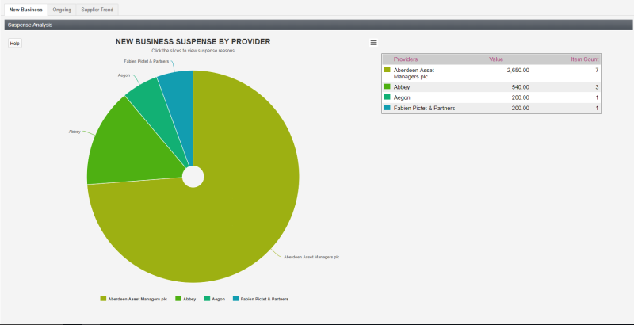

Click on a provider segment to drill down into the top five reasons for suspense postings for that provider. Hover the mouse pointer over each segment to see provider value and volume information.

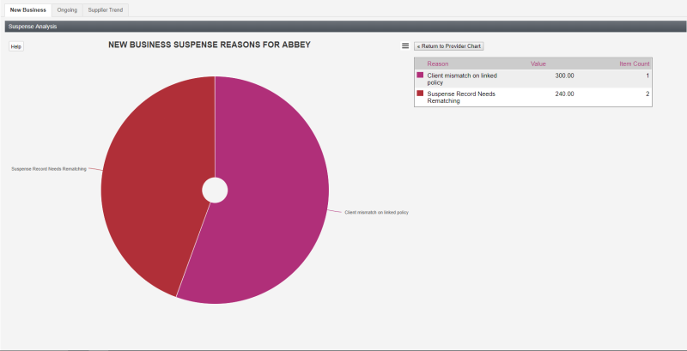

* Click **Return to Provider Chart** to go back to the pie chart displaying provider data.
* Use the context menu to access print and download options for the chart.

### Ongoing

The Ongoing pie chart starts by analysing the ongoing revenue type transactions posted to suspense in terms of the top five providers. Hover the mouse over each segment to see the value of items and the number of items posted to suspense for each displayed provider. The table on the right shows provider data in order of value.

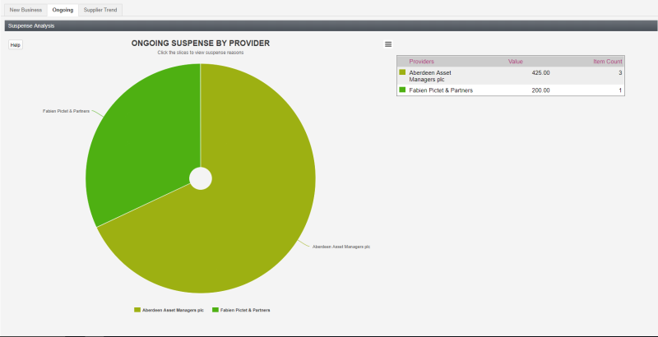

Click on a provider segment to drill down into the top five reasons for suspense postings for that provider. Hover the mouse pointer over each segment to see provider value and volume information.

### Supplier Trend

The Supplier Trend chart analyses postings to suspense during the last twelve months in terms of both value (bar chart) and volume (line chart). The table breaks down the total the figures for the entire period by provider.

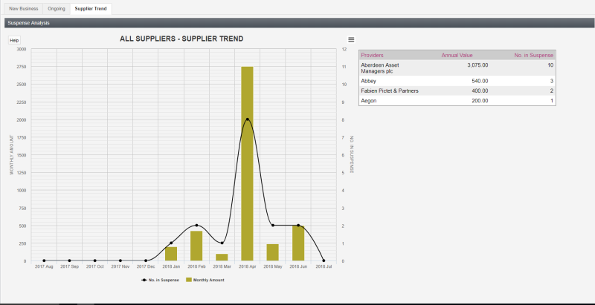

* Click a provider in the table to update the chart to display data for the selected provider.
* Click a bar or line to display a reason code breakdown for that month.
* Click **Return to Provider Chart** to reset the table.

|  |  |
| --- | --- |
| **Topic info:** | |
| **Source** | Content/Admin_Tools/Admin_Tools.htm |
| **ToC** | CommPay Help > CommPay Administration > Administration Tools > Administration Tools |
| **Concept terms** | Admin Tools CP;Admin CP |
| **Keyword terms** | administration |
| **Concept links (see also)** |  |
| **Alias ID (for new topics)** |  |
| **Conditions** |  |

# Administration Tools

From the Administration Tools menu you can perform the following actions:

* Configure CommPay users
* Apply user permissions
* Configure permission groups
* View the audit trail
* Import files
* View the user log
* View active contacts and accounts
* Clean up policies and clients
* Configure revenue links
* Configure multiple site setup
* Manage interface themes
* Manage Estimates
* Configure Onboarding Templates
* Manage client/adviser/policy mismatches
* Analyse Suspense Data

# Document Management

## Topic list

|  |  |  |  |
| --- | --- | --- | --- |
| **Topic** | **Reviewed** | **Edits** | **Flare Source** |
| Suspense | Yes | Yes | Done |
| Suspense Reasons and Rules Explained | Yes | Yes | Done |
| Suspense Actions | Yes | Yes | Done |
| **Manage Suspense Records** | N/A | New topic | Done |
| View the Suspense Balance | Yes | Yes | Done |
| Assign Suspense Records | Yes | No | N/A |
| Match Suspense Records | Yes | No | N/A |
| Keep Records on Suspense | Yes | No | N/A |
| View Policies or Client Fees | Yes | No | N/A |
| Analyse Suspense Data | Yes | Yes | Done |
| **Resolve Suspense Records** | N/A | New topic | Done |
| View Actual Links | Yes | No | N/A |
| Manage Phased Revenue | Yes | Yes | Done |
| Create Clients form Suspense | Yes | No | N/A |
| Create Policies or Client Fees from Suspense | Yes | No | N/A |
| Create Products from Suspense | Yes | No | N/A |
| Policy Takeover on Suspense Records | Yes | Yes | Done |
| Update Statement Records from Suspense | Yes | No | N/A |
| Update Products in Policies from Suspense | Yes | No | Done |
| Update Revenue Type from Suspense | Yes | No | N/A |
| Override Auto-create Estimate Prohibited from Suspense | Yes | No | N/A |
| Override Net Revenue/Clawback Amount Exceeded | Yes | No | N/A |
| Administration Tools | Yes | Yes | Done |
| ToC | Yes | Yes | Done |

## CSHID Links

[CommPay CSHIDs](https://docs.google.com/spreadsheets/d/12CBEdCemZfu6Tece-9gK7hoayrSE-ST5BIHH_oJiaLM/edit?usp=sharing)

| **CommPay Screen** | **ID** | **Topic Title** |
| --- | --- | --- |
| Suspense | 33 | Suspense |
| CommPay > Fixed Info > Suspense Reasons & Rules | 72 | Suspense Reasons and Rules |
| CommPay > Admin Tools > Suspense Analysis | 125 | Analyse Suspense Data |

## Microcontent

* Add *content*

|  |  |
| --- | --- |
| **Topic info:** | |
| **Source** | Content/x/x.htm |
| **ToC** | CommPay Help > CommPay Administration > Administration Tools > Import Files |
| **Concept terms** |  |
| **Keyword terms** |  |
| **Concept links (see also)** |  |
| **Alias ID (for new topics)** |  |
| **Conditions** |  |

# 

## Keywords & Concepts

| **Topic** |  |  |  |  |  |
| --- | --- | --- | --- | --- | --- |
| **Keywords** |  |  |  |  |  |
| **Concept terms** |  |  |  |  |  |
| **Concept links (See also)** |  |  |  |  |  |

### Concepts

|  |  |
| --- | --- |
| **Current** | **Create new** |
|  |  |

## Links

* Update links in <**x>** topics to **<x>** topics

|  |  |  |
| --- | --- | --- |
| **Topic** | **Linked from** | **Update link to:** |
|  |  |  |
|  |  |  |