**Create an application which contains login, registration and CURD operations with following requirements**.

1. In Home page should contain two text fields (email id and password), login and registration button.
2. On click registration, redirect to registration page which contains First Name, Middle Name, Last Name, Email, Mobile Number, Password, Confirm Password and Register Button.
3. After successful registration of user redirect to login page.
4. Validate user with email id as [user@gmail.com](mailto:user@gmail.com) and password as 123456.
5. After successful login, redirect to manage users dashboard page where CURD operations to be performed as shown in below figure.
   * 1. 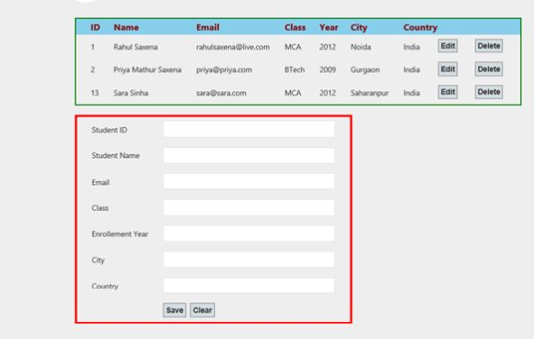
6. All operations to be implemented in single page (Display, Add, Edit and Delete) with form validations.
7. On Click Edit button, get all the respective values in the form and perform Edit operation.

**Validations**:

* Validation required for email Id, mobile number, Password and Confirm Password.
* Password and confirm password should be same.
* While signup all fields are mandatory except Middle Name and Mobile Number.
* While Login email id and password should be mandatory.

**Deliverables**:

* After completion of assignment, check-in the code to Github and share the link to the repository.

**Notes:**

* If you are not clear on the requirements, please feel free to draw your own assumptions and send then along with your test output.