I, Javier Enrique Navarro Ramirez give exclusive authorization to TEEMA Solutions Group to submit my resume to in consideration for the contract position of:

Position Title : 19541 - MPLS Telecom Design E4 Engineer - BC Hydro

My signature confirms that I have not been submitted by any other supplier to this position, nor have I signed, or do I intend to sign another Consent Form giving authorization to any other supplier to submit me to the position listed above.

If it is found that I signed another consent form with another supplier for this requisition, this consent and any other consent I've signed will be null and void and will result in being rejected from overall consideration by TEEMA.

Candidate Name: Javier Enrique Navarro
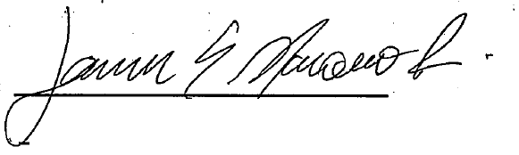

Candidate Signature: _________________________

Date: 10/26/2023

- I

