Team HIP will be analyzing the World Development Report 2014 which is compiled by the World Bank. It consists of data aggregated from various sources which comprises of 75 indicators that are relevant to the management of risk in the context of development. The prime purpose of this dataset is to get countries familiar with potential risks that work against its development.

The report consists of large amount of data from demography, natural disasters, education and income which makes it favorable to be analyzed for a global insurance service provider. Hypothetically, considering an American insurance company, Happy Insurance Partners (HIP) Inc., headquartered in College Park, Maryland looking to expand its business to a new region outside the United States. The company is really reserved with its investments and wants to make sure that the investment has to be safe with a good appreciation in the next decade.

Our team will work deliberately to choose the top 5 countries as most desired investment options based on the acquired dataset. The following are the research questions basis which the company can decide on the potential investment locations:

1. Which are the favorable countries in order of different macroeconomic factors such as trends in government surplus, gross public debt, international reserves and worldwide governance indicators?
2. Which are the favorable countries in order of Human Capital factors such as level and quality of education and their annual savings?
3. Which are the favorable countries considering safety of investment in order of frequency and death of natural disasters?

We estimate to complete the above tasks during the course of this semester. The project is divided into tasks and each task is allotted a fixed time period. The same is represented in the Gantt chart below.

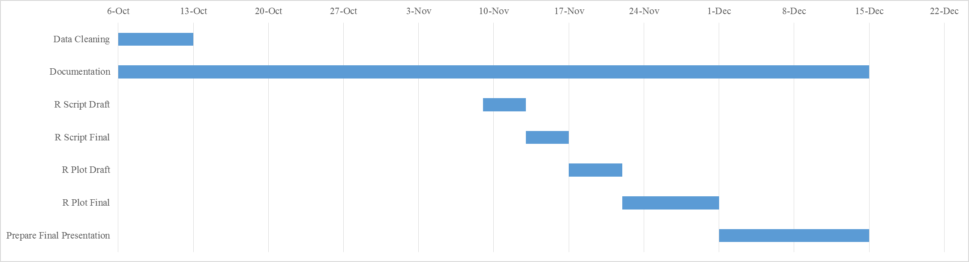

The effort allocation has been evenly distributed within our team on basis of each member’s previous field of study, work experience and are of expertise. This is a tentative effort allocation and can be modified with prior discussion between the team and course faculty.

|  |  |
| --- | --- |
| **Job to be done** | **Responsible Person** |
| Data Cleaning   *Rank favorable countries based on macroeconomic factors* | Tu |
| Data Cleaning *Rank favorable countries based on human capital factors* | Prerak |
| Data Cleaning *Rank favorable countries considering safety of investment* | Jency |
| Documentation : *1 and 2* | Tu |
| Documentation : *3 and 4* | Prerak |
| Documentation : *5 and 6* | Jency |
| R Script Draft | Tu, Prerak, Jency |
| R Plot Draft  *Title, Labels, details, a key, extra point for the team* | Tu, Prerak |
| R plot Draft *Description of the plot* | Jency |
| Presentation | Tu, Prerak, Jency |
| Git Package : *1 and 2* | Tu |
| Git Package : *3* | Prerak |
| Git Package : *4 and 5* | Jency |

Word Count: 442