INTRODUCTION TO MACHINE LEARNING
(NPFL054)
A template for Homework #1

Name: Lukáš Jendele
School year: 2016/17

- Provide answers for the exercises (1) - (6).
- For each exercise, your answer cannot exceed one sheet of paper.

1. Histograms of imdb_rating

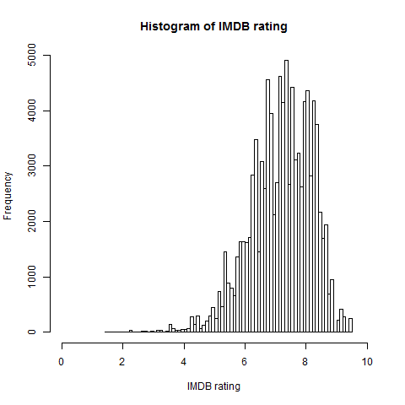
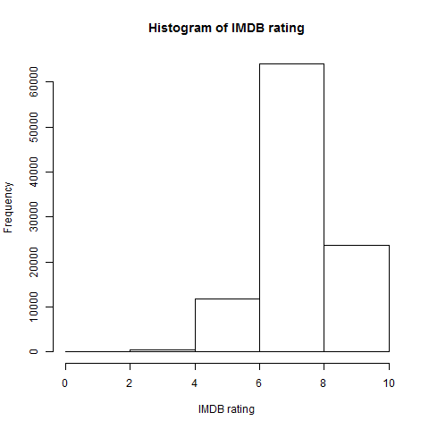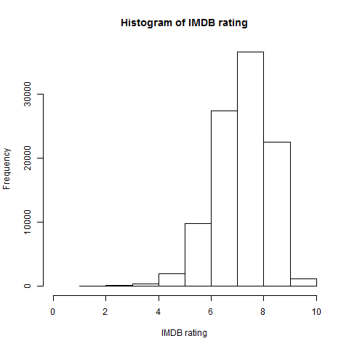
2. Scatterplot matrix of the IMDb rating and average rating

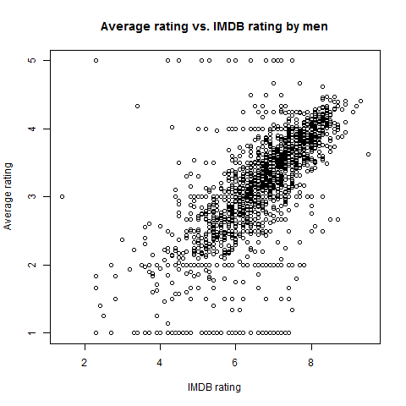
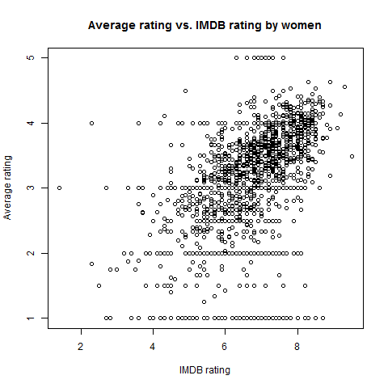
3. Boxplots of ratings of the movies rated 67 times

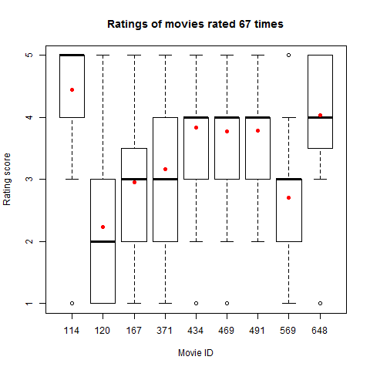
4. Voting periods

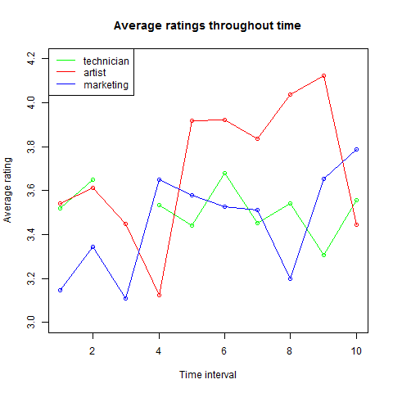
Program output:
Interval: 1 Duration: 18.68 days Number of movies rated: 1123
Interval: 2 Duration: 30.38 days Number of movies rated: 1206
Interval: 3 Duration: 9.53 days Number of movies rated: 1130
Interval: 4 Duration: 12.25 days Number of movies rated: 1120
Interval: 5 Duration: 22.94 days Number of movies rated: 1210
Interval: 6 Duration: 21.38 days Number of movies rated: 1192
Interval: 7 Duration: 27.38 days Number of movies rated: 1337
Interval: 8 Duration: 25.44 days Number of movies rated: 1303
Interval: 9 Duration: 24.83 days Number of movies rated: 1200
Interval: 10 Duration: 22.04 days Number of movies rated: 1343
5. Age groups

Age group: | Most frequent occupation | Number of votes
18-30 | Student | 18531
31-40 | Educator | 3331
41-50 | Educator | 2896

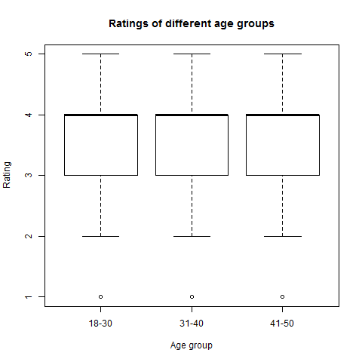
Interpretation of the boxplot below:
Feature age and target value (rating) are independent.

6. Feature frequency of genre_* features

Genre | Frequency
Action | 25589
Adventure | 13753
Animation | 3605
Children | 7182
Comedy | 29832
Crime | 8055
Documentary | 758
Drama | 39895
Fantasy | 1352
Filmnoir | 1733
Horror | 5317
Musical | 4954
Mystery | 5245
Romance | 19461
Scifi | 12730
Thriller | 21872
War | 9398
Western | 1854

