Melody Matcher
Project Proposal
All 480 documentation
Fall 2009

Jennifer Hughes

Melody Matcher 1
Abstract (System purpose and tasks to be performed): 4
Usage Domain and Environment: 4
Comparison to Existing Systems: 7
Specification: 7
User Feedback: 8
System Design: 10
Prototype and Implementation 10
Syllable Structure 10
Length and Weight of Individual Phones 10
Vowels 10
Consonants 11
Calculating Consonant Phone Length 12
Full Table of Phone Makeup and Length 14
This page was intentionally left blank because Word doesn’t like me being table-happy. 15
Structure of a Syllable 16
Examples 17
System Design: 19
Prototype and Implementation 20
Data Format 21
Fickle Phones in the Coda 27
Calculating Weight/Length of Independent Syllables 28
Psuedo Code Formula for Determining Semi-Stand-Alone Weight 28
Actual Excel Formula: 28
Calculating Length of Syllables in Relation to Each Other 30
Psuedo Code Formula for Determining Syllable “fit” with the music. 31
Patterns for Musical Emphases 32
Effect of Note Intervals on Musical Emphases 33
Parsible Phonetic Dictionary 35
Parsable Dictionary 35
Final Phonetic Dictionary Choice 37
Timeline: 39
(Modified) 39

Abstract (System purpose and tasks to be performed):
This project aims to facilitate semi-automated composition of melody and accompanying lyrics, by way of matching the musical emphases of a piece with the textual emphases of the lyrical phrases. The program will ultimately rely upon user input for "fitness" criteria, but will initially match lyrics with melodies based upon some rules.

Usage Domain and Environment:

This program will be used as a compositional aid by anyone who wants to write songs and make them sound good, technically. Its should allow the song writer to focus on more subjective criteria of what makes a song “good”, because it will make the structural rules of lyric composition immediately apparent. The first version of this will probably be only for users that already understand the structural rules, unfortunately, because the composer must be able to understand that there IS a need to properly place lyrics in songs.

The structural rules of lyric placement are important, because without them, lyrics can become muddled and/or unintelligible. For example, in the song “Groovin’ (on a Sunday Afternoon”, by the Young Rascals, there’s a part in the bridge that everyone always hears as “Life would be ecstasy, you an’ me an’ Leslie”. In fact, the line is “Life would be ecstasy, you and me endlessly”. The confusion lies with the last three syllables of the phrase. The pronunciation of each version, if spoken normally, is as follows:

and Les- lie | end- less- ly
@nd “lEs li | “End l@s li

A “ preceding a syllable means that syllable is emphasized.

So, in the first phrase, we see that the emphasis pattern goes something like dum-DUM-dum, where the first syllable of “Leslie” is emphasized. The second phrase’s emphasis pattern is “DUM-dum-dum”, so the first syllable of endlessly is emphasized.

When words are put to music, however, the musical emphasis basically overrides the textual emphasis. Sometimes, if a previously un-emphasized syllable becomes emphasized, or a previously emphasized syllable loses its emphasis, the meaning of the phrase can change.

For “Groovin’”, the lyrics match up to the music in the song as follows:

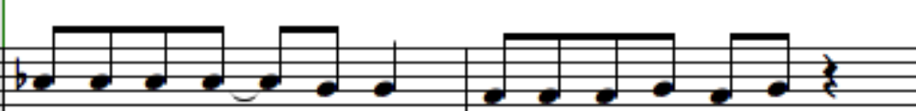
Life would be ec- sta- sy, You an’ me end- less- ly

In all music, the emphasis always goes on the first part of a beat.

In this case, in the first measure is emphasized for the notes that correspond to the lyrics, “Life”, “be”, “ec-”(as in ec-sta-sy) and “sy”(again, as in ec-sta-sy) (This is a vast oversimplification, but it works for now). So, the lyrics would be emphasized as such:

Life would be ec-sta-sy

This musical emphasis matches the spoken emphasis of the phrase, so it is intelligible as a lyric. (Though ecstasy’s first syllable doesn’t start on the first part of beat three, it is still on the first part of beat three, and therefore still emphasized. Alternatively, since the first part of beat two didn’t have a hard stop to it, the emphasis could have rolled over to the second part, “ec”, which does have a hard stop. These are the sorts of things I need to figure out formal rules for. I only know them by intuition right now.)

In contrast, take the second measure: the syllables “You”, “me”, and “less” are emphasized. This leads to conflicting musical and spoken phrasing:
Musical Phrasing: You and me endlessly
Spoken Phrasing: You and me endlessly

The singer is now singing the phrase, syllable by syllable, which they think of as syllable-note combinations:
YOU and ME end LESS lee
The singer, for his part, is doing what many singers are taught to do, to make it easier to sustain the singing of words that end with unsingable consonants: the unsingable consonant is displaced onto the front of the next word. In this case, the consonant “d” is not singable, so he displaces it onto the next syllable, when he can: “and ME” becomes “an dME”, and “end LESS” becomes “en dLESS”. So, the singer can effectively think of the sung phrase as:

YOU an dME en dLESS lee

This doesn’t cause confusion to listeners, because they’re used to hearing it. This does mean, however, that lyric placement does not provide an accurate barometer of where a word actually ends.

In addition, the singer is singing fudging his vowels, like singers are taught to do, so “and” and “end” sound almost indistinguishable. So, really, what listeners are hearing is this:
YOU en dME en dLESS lee

Now, the listener’s brain has to take this syllabic gobbldygook, and parse it into something useful. They’ve currently got this mess to deal with (represented in SAMPA syllables):
ju En dmi En dl@s li

They parse the first part just fine, because the emphases match:
you and me En dl@s li

But no one says endLESSly. People say ENDlessly. So, the listeners don’t recognize it. they have to work with what they have. They already turned one “En d” into an “and”, so they do it again:
you and me and l@s li

Now, they’re just left with LESS lee. And that fits Leslie, a proper noun that fits in context and in emphasis placement. So, the final heard lyric is:

you and me and Les- lie

The misunderstanding can be traced by to improper emphasis placement. The songwriter probably didn’t even think of that, and now he’s stuck: a one-hit-wonder with a misunderstood song. I bet that in interview after interview, someone asks him who Leslie is. It’s probably very frustrating—especially since he could have just moved the word an eight note later, and it would have been understood perfectly. That’s the sort of situation this program is going to help avoid.

Comparison to Existing Systems:

Tra-la-lyrics is the closest system that exists to the proposed system. It takes lyrics in Portuguese, and matches them via emphases to the music. This is different from our system, because our system will use English-language lyrics.

There are many systems that take lyrics and match them with notes, but very few use any sort of rhythmic rule set to do so. Karaoke systems match lyrics to music on a time-based system, which is inadequate for our purposes. However, the Wedelmusic model of a composition can be easily extended to include support for musical emphases, because of the way it separates out music and lyrics. Also, since it can be easily converted into an XML format, the composition can be transferred between programs, given the correct parser.

Specification:

A user must minimally be able to do the following
- Be able to import, compose and mutate a melody in a program
- Be able to import, compose, and mutate a lyric set in a program
- See which lyrics have emphases that are at odds with the musical emphases, based upon predefined rule sets.

Optional user functionality:
- A user should be able to add a word to a dictionary, giving each word an orthography, a part-of-speech, and a pronunciation using the symbols from the SAMPA ASCII translation of the IPA.
- A user should be able to develop multiple melodies and lyric phrases simultaneously, using a pseudo-genetic algorithm to generate new combinations.

The system shall include
- An interactive GUI interface, with music and lyric text, that allows the user to mutate both the notes and the lyrics
- A dictionary of words, with orthography(i.e. spelling), part of speech, and a pronunciation
- Functionality to save and import compositions.

User Feedback:
I have no new user feedback. I do, however, have some new requirements specification data from running my own trials on sample data.

Steps to Completion of Project:
(1) Acquire access to a linguistic database, where every word has at least the following attributes:
--emphasis placement
--part of speech
--synonyms
(Optional: "mood", if applicable)
(2)Find out precisely how to determine where the emphasis of a musical phrase lies, by emailing or asking some music professors at Cal Poly, and by independent research.
(3) Design parallel data structure representations for the textual and musical phrases. Figure out the best way to partition these so that they can still act independently, but so that they can still be compared.
(4) figure out how to compare the emphases in the text with the emphases in the music.
(5) Make sure that the music fits some constraints:
-----the number of syllables in a textual phrase cannot exceed the number of notes in a musical phrase
-----A word can have more than one note, but a note cannot have more than one word.
-----The phrase, if we're generating lyrics, creates a sentence that makes sense, grammaticality.
(5) Incorporate the interactive component, by allowing a user to (in no particular order):
-----modify the notes in a phrase, by making them longer, transposing them, or deleting them, etc (see DANCING NOTE COMPOSER)
-----allow selection of notes and note phrases
-----allow selection of words, and replacement with synonyms, or entered text
-----allow users to change the distribution of notes-to-words, giving some indication of whether or not the song is breaking the rules of emphases.

System Design:
Currently, my project prototype is a series of excel spreadsheets, partially generated from manual input and input from .csv files, which were partially generated by some command-line text parsing.

Prototype and Implementation

Syllable Structure
As a reminder, a syllable has a nucleus, a coda, and an onset. The nucleus consists of a vowel (or semivowel), the coda consists of zero to four consonant phones, and the onset consists of zero to three consonant phones.

Length and Weight of Individual Phones
I’ve developed several tables to determine the weight and length of individual phones, divided by type.

Vowels
Vowels, unlike consonants, do not have any sort of sub-variables to make extensive calculations necessary. A vowel can be long, short, a semivowel, or a diphthong. A long vowel weighs more than a short vowel, which weighs about the same as a semivowel. A diphthong’s weight/length is just the sum of its parts. A diphthong is a combination of two vowels or semivowels. You just add the lengths/weights of its members to get its value.
Vowel Type | Weighted Worth | Weight
semivowel | 0.25 | 0.5
short | 0.25 | 0.5
long | 0.75 | 1.5
diphthong | sum of parts

Consonants
Consonants have a few variables that affect their weight.
First, “manner of articulation”: plosives, affricates, and fricatives weigh the most, with plosives being the heaviest (effectively, though, they’re the same weight). Nasals, laterals, approximants, and semivowels are all effectively “weightless”, in and of themselves.
Second, voicing: to “voice” a phone means to cause the vocal chords to vibrate. “Voiced” phones are singable, whereas “voiceless” phones are not. “Voiceless” phones are really nothing more than a hiss, or directing streams of escaping air.
Third, the manner of starting and ending a sound has a bearing on weight. A “block” means that you must fully stop airflow through the mouth to make the correct noise to start the sound. A block is basically a buildup-then-release of a stream of air. “Continuous frication” is simply a continuous release of a directed air stream, without the primarily buildup. An “end”, which is the only type of start/end that I made up a name for, is a variation of a block without the full stop of airflow through the mouth. It’s a distinctive change in the sound of a phone, but does not “build up” the air stream; it just releases it. A “continuous” start or end is fully open, and does not require any sort of change in mouth position or air direction. A “redirect” is a combination of a continuous start/end and a block: it does not allow air to escape through the mouth, but does allow a continuous sound through the nose.
CONSTANTS | Type | Un-weighted worth | Weighted worth
Manner of Articulation | plosive | 7 | 1.000
Manner of Articulation | affricate | 7 | 1.000
Manner of Articulation | fricative | 7 | 1.000
Manner of Articulation | nasal | 0 | 0.000
Manner of Articulation | lateral | 0 | 0.000
Manner of Articulation | approximant | 0 | 0.000
Manner of Articulation | semivowel | 0 | 0.000
Voicing | voiceless | 2 | 1.000
Voicing | voiced | 0 | 0.000
Starts/ends as | block | 3 | 3.000
Starts/ends as | continuous frication | 1 | 1.000
Starts/ends as | end | 2 | 2.000
Starts/ends as | continuous | 0 | 0.000
Starts/ends as | redirect | 0.5 | 0.500

Calculating Consonant Phone Length
To figure out the length, based on all these variables, there’s a pretty complicated formula. It didn’t already exist, so I spent several days determining it via trial and error. Here’s the Excel formula for determining the length of a phone in line 2 of the spreadsheet, which will be followed by psuedocode that should explain it.
=IF($D2=$K$2,
$M$2,
IF($D2=$K$3,
$M$3,
IF($D2=$K$4,
$M$4,
IF($D2=$K$5,
$M$5,
IF($D2=$K$6,
$M$6,
IF($D2=$K$7,
$M$7,
IF($D2=$K$8,
$M$8,
0
) ) ) ) ) ) )
+ IF($E2=$K$9,
$M$9,
$M$10)
+ IF($F2=$K$12,
$M$12,
IF($F2=$K$13,
$M$13,
IF($F2=$K$14,
$M$14,
IF($F2=$K$16,
$M$16,
$M$15
) ) ) )
+ IF($G2=$K$12,
$M$12,
IF($G2=$K$13,
$M$13,
IF($G2=$K$14,
$M$14,
IF($G2=$K$16,
$M$16,
$M$15
) ) ) )

Psuedocode: (where this is a phone)
int sum = 0;
switch( this.MannerOfArticulation ){
case plosive:
case affricate:
case fricative:
sum += 1;
break;
}
if ( this.voice == voiceless) {
sum +=1;
}
switch( this.StartsAs ){
case block:
sum += 3;
break;
case continuousFrication:
sum += 1;
break;
case end:
sum += 2;
break;
case redirect:
sum += 0.5;
break;
}
switch( this.EndsAs ){
case block:
sum += 3;
break;
case continuousFrication:
sum += 1;
break;
case end:
sum += 2;
break;
case redirect:
sum += 0.5;
break;
}
return sum;

In the interest of space, I’ve not included conditions that would add zero to the sum.

Full Table of Phone Makeup and Length
SAMPA | Example | Type/  Manner of Articulation | Voiced/  Voiceless | Starts as | Ends as | Cat. | Weight
p | pen, spin, tip | plosive | voiceless | block | block | Con. | 8
b | but, web | plosive | voiced | block | block | Con. | 7
t | two, sting, bet | plosive | voiceless | block | block | Con. | 8
d | do, odd | plosive | voiced | block | block | Con. | 7
tS | chair, nature, teach | affricate | voiceless | block | cont fric | Con. | 6
dZ | gin, joy, edge | affricate | voiced | block | cont fric | Con. | 5
k | cat,kill,queen,thick | plosive | voiceless | block | block | Con. | 8
g | go, get, beg | plosive | voiced | block | block | Con. | 7
f | fool, enough, leaf | fricative | voiceless | cont fric | cont fric | Con. | 4
v | voice, have, of | fricative | voiced | cont fric | cont fric | Con. | 3
T | thing, breath | fricative | voiceless | cont fric | cont fric | Con. | 4
D | this, breathe | fricative | voiced | cont fric | cont fric | Con. | 3
s | see, city, pass | fricative | voiceless | cont fric | cont fric | Con. | 4
z | zoo, rose | fricative | voiced | cont fric | cont fric | Con. | 3
S | she,sure,emotion,leash | fricative | voiceless | cont fric | cont fric | Con. | 4
Z | pleasure, beige | fricative | voiced | cont fric | cont fric | Con. | 3
h | ham | fricative | voiceless | cont fric | cont fric | Con. | 4
m | man, ham | nasal | voiced | redirect | redirect | Con. | 1
n | no, tin | nasal | voiced | redirect | redirect | Con. | 1
N | singer, ring | nasal | voiced | redirect | redirect | Con. | 1
l | left, bell | lateral | voiced | continuous | continuous | Con. | 0
r | run, very | approximant | voiced | continuous | continuous | Con. | 0
w | we | semivowel | voiced | continuous | end | Con. | 2
j | yes | semivowel | voiced | continuous | end | Con. | 2
W | what (Scottish) | approximant | voiceless | continuous | end | Con. | 3
x | loch (Scottish) | fricative | voiceless | cont fric | cont fric | Con. | 4
A | father, not, law | short |  |  |  | Vow. | 0.25
I | city | short |  |  |  | Vow. | 0.25
E | bed | short |  |  |  | Vow. | 0.25
3`/`r | bird, winner | short |  |  |  | Vow. | 0.25
{ | lad, cat, ran | short |  |  |  | Vow. | 0.25
u | soon, through | short |  |  |  | Vow. | 0.25
@ | about | short |  |  |  | Vow. | 0.25
jU/ju | use, pupil | diphthong |  | semivowel | short | Dip. | 0.5
i | see | long |  |  |  | Vow. | 0.75
V | run, enough | short |  |  |  | Vow. | 0.25
U | put | long |  |  |  | Vow. | 0.75
e | day | long |  |  |  | Vow. | 0.75
O | or, shore | long |  |  |  | Vow. | 0.75
a | DNE in GenAm | long |  |  |  | Vow. | 0.75
aI | my, height | diphthong |  | long | short | Dip. | 1
OI | boy | diphthong |  | long | short | Dip. | 1
oU/ou | boat | diphthong |  | short | long | Dip. | 1
aU | now | diphthong |  | long | long | Dip. | 1.5
= | ridden | semivowel |  |  |  | Vow. | 0.25

This page was intentionally left blank because Word doesn’t like me being table-happy.

Structure of a Syllable
A syllable, defined here in the traditional, colloquial sense, is represented as such:
WORD | <syllable>
NOTE_LEN | <length of associated note>
EMPH | <syllable emphasis value>
SAMPSYL | <syllable in SAMPA>
SYL_PART | on | nu | cd
 | <-1> | <0> | <+1>
 | <-2> | <1> | <+2>
 | <-3> | <2> | <+3>
 |  |  | <+4>
WORD (required field) is the orthographic (regular-spelling) syllable. If this field only has a ^ in it, then it represents a rest.
NOTE_LEN (required field) is the length of the note that the syllable is associated with, represented as a number from 1 to N, where N is the denominator of the shortest note length. (for example, if the shortest note is an eighth note, then N would be 8.) N represents a whole note, and 1 would represent the shortest-length note. (In our previous example, an eighth note would be 1, and a whole note would be 8).
EMPH (conditionally-required field) is the emphasis value of the syllable, relative to the rest of the syllables in the word. It’s required only if the syllable is a part of a multi-syllable word. If the syllable is a rest or a single-syllable word, then this field should be left blank.
SAMPASYL (conditionally-optional field) is the SAMPA spelling of the syllable. This field can be left blank only if the syllable is a rest.
SYL_PART (conditionally-optional multi-part field) is a multi-part field, representing the parts of a syllable. All of the values are written in SAMPA. This field can be left completely blank only if the syllable is a rest.
on (optional array-like field-column) is a column of cells representing a syllable onset. It contains four cells, but only up to three may be used. Each cell has a single SAMPA phone/“letter” in it. The phone at the top of the column is closest to the syllable nucleus, and as you go further down, the closer you get to the beginning of the syllable. Not all fields must be filled out. Valid values are consonants (meaning plosives, affricatives, fricatives, nasals, laterals, approximants, and semi-vowels). Semi-vowels that are directly adjacent to the nucleus should be part of the nucleus, not the onset.
nu (conditionally-optional array-like field-column) is a column of cells representing the syllable nucleus. It contains four cells, but only up to three may be used. Each cell has a single SAMPA phone/“letter” in it. The phone at the top of the column is closest to the onset, and those further down are closer to the coda. At least one field must be filled out, unless the syllable is a rest. Valid values are vowels, semivowels (j in yes, w in we), nasals-with-semivowels (n= in “hidden”, .m= in “winsome"), and laterals-with-semivowels (l= in “waffle”).
cd (optional array-like field-column) is a column of cells representing a syllable coda. It contains four cells, all of which may be used. Each cell has a single SAMPA phone/“letter” in it. The phone at the top of the column is closest to the syllable nucleus, and as you go further down, the closer you get to the end of the word. Not all fields must be filled out. Valid values are consonants (meaning plosives, affricatives, fricatives, nasals, laterals, approximants, and semi-vowels). Semi-vowels that are directly adjacent to the nucleus should be part of the nucleus, not the coda.

Examples
For simplicity’s sake, the note length will not vary on all the following examples.

Example 1: “o”

(Single Syllable, Single Phone) .
o::IN/NNP/NN/LS: "ou :{o}
WORD | o
NOTE_LEN | 1
EMPH
SAMPSYL | ou
SYL_PART | on | nu | cd
 |  | ou

Example 3: “on”

(Single Syllable, No Onset, Single-Phone Nucleus and Coda)
on::IN/JJ: "An :{on}
WORD | on
NOTE_LEN | 1
EMPH
SAMPSYL | An
SYL_PART | on | nu | cd
 |  | A | n

Example 2: “no”

(Single Syllable, No Coda, Single-Phone Nucleus and Onset)
67992:no::DT/RB/UH: "nou :{no}
WORD | no
NOTE_LEN | 1
EMPH
SAMPSYL | nou
SYL_PART | on | nu | cd
 | n | ou

Example 4: “non”

(Single Syllable, Single-Phone Onset Nucleus and Coda)
non::FW/NN/NNP: "nAn :{non}
WORD | non
NOTE_LEN | 1
EMPH
SAMPSYL | nAn
SYL_PART | on | nu | cd
 | n | A | n

Example 5: “notes”

(Single Syllable, Single-Phone Onset and Nucleus, Double-Phone Coda)
notes::NNS/VBZ: "nouts :{note}>s>
WORD | notes
NOTE_LEN | 1
EMPH
SAMPSYL | nouts
SYL_PART | on | nu | cd
 | n | ou | t
 |  |  | s

Example 6: “yes”

(Single Syllable, No Onset, Double-Phone Nucleus, Single-Phone Coda)
yes::UH/NN: "jEs :{yes}
WORD | yes
NOTE_LEN | 1
EMPH
SAMPSYL | jEs
SYL_PART | on | nu | cd
 |  | j | s
 |  | E

Example 7: “stringy”

(Single Syllable, Multi-Phone Onset, Single-Phone Nucleus and Coda)
stringy::JJ: "strIN$i :{string}>y>
WORD | string- |  |  | y
NOTE_LEN | 1 |  |  | 1
EMPH | 1 |  |  | 0
SAMPSYL | strIN |  |  | i
SYL_PART | on | nu | cd | on | nu | cd
 | r | I | N |  | i
 | t
 | s

Example 8: “nonmembership” (Multi-Syllable Word with Two-Tier Emphases)
nonmembership::NN: nAn"mEm$b@`r%SIp :<non<{member}>ship>
WORD | non- |  |  | mem- |  |  | ber- |  |  | ship
NOTE_LEN | 1 |  |  | 1 |  |  | 1 |  |  | 1
EMPH | 0 |  |  | 2 |  |  | 0 |  |  | 1
SAMPSYL | nAn |  |  | mEm |  |  | b@`r |  |  | SIp
SYL_PART | on | nu | cd | on | nu | cd | on | nu | cd | on | nu | cd
 | n | A | n | m | E | m | b | @ | `r | S | I | p

System Design:
I will be using pre-existing music-composition data formats, modified to fit my needs. First, I will be using parts of the WEDELMUSIC music and lyrics format, with a few changes:
- I will modify the Syllable class to include two more fields: an enum emphasis, whose values can be PRIMARY, SECONDARY, TERTIARY, or NEUTRAL; and a string sampa, whose value is the SAMPA representation of the syllable.
- I will create a parent class Word for Syllable objects that belong in the same word.
- I will (likely) not be implementing a display mechanism for the multi-bar or multi-note-per-bar functionality inherent in the design. However, I’ll probably keep the functionality intact.
Specifically, I will be focusing on implementing the following classes:
  - MainScore
  - SquareBrk
  - Part
  - Measure
  - Figure (Abstract Class)
      - Note (subclassed into Note1_N, where 1/N is the note duration. EX: Note1, Note1_2, Note1_4, Note1_8, Note1_16)
      - Rest (similarly subclassed)
      - Anchor (represents a point between two Figures, like a breath.
      - Space (represents a symbol that takes up space, but has no duration, like a Clef or Key Signature)
      - Chord (contains a group of simple Notes with the same duration)
      - Beam (contains a sequence of Figures that should have a bar drawn across the top, i.e., consecutive Notes with a duration of 1/8 note or less.)
  - Header
  - Syllable
  - HorizontalSym (Abstract Class)
      - Slur
      - Tie
      - Tuple
      - Crescendo
      - Diminuendo
      - Wave
      - TrillAWave
      - Change8va
      - Arrow
  - KeySignature
  - Time

Overall, use-case specifications have not changed. much. Under “Specifications”-> ”Optimal User Functionality” on the preliminary proposal doc, I’ve dropped the second bullet point. This means the idea of developing multiple melodies has been removed, as well as multiple lyric phrases.

Prototype and Implementation

As per my original schedule for completion, I do not yet have a program prototype. I felt it was more important to get the data format nailed down, because it’s the majority of the problem. Also important at this point was finding a usable dictionary, separated by syllables and pronunciation.

Data Format
I first started to create my own composition format, but in my literature review, I stumbled upon a remarkable comprehensive data structure in the article “ Multilingual Lyric Modeling and Management”, found in the book, “Visual Perception of Music Notation: On-Line and Off-Line Recognition”. I have attached some relevant figures from this book below this paragraph. The only figure that I plan to change significantly is Figure 12, due to my modification of the Syllable object. I have drawn a new class diagram for that one in lieu of including the original in this document
The main object that contains all other objects is the MainScore (see Figure 5). It has a list of Parts (which represent different staffs), and a list of Brackets, which show which staves are to be played in parallel. I will most likely not be implementing multi-Part music for this project, but I plan to build in support for it anyway. Each part has a series of Measures (among other things, to be mentioned later).
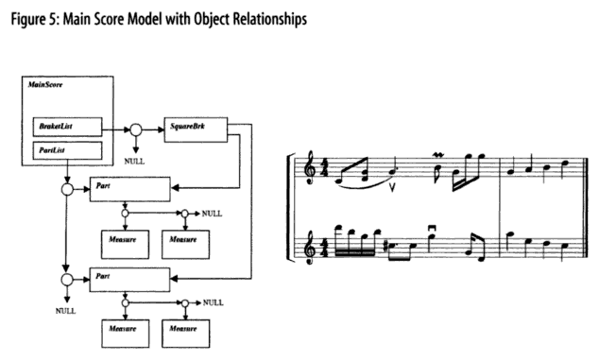
On the other side of the scale, the most granular object related to the transcription of music is a Figure. Figure is an abstract class that is a parent to the Note and Rest classes, among others. Figure 6 from the book shows the relationship very well:
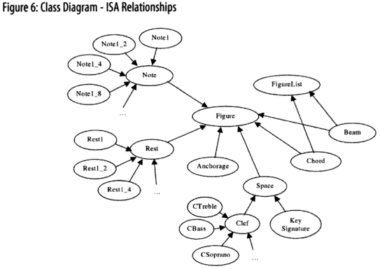

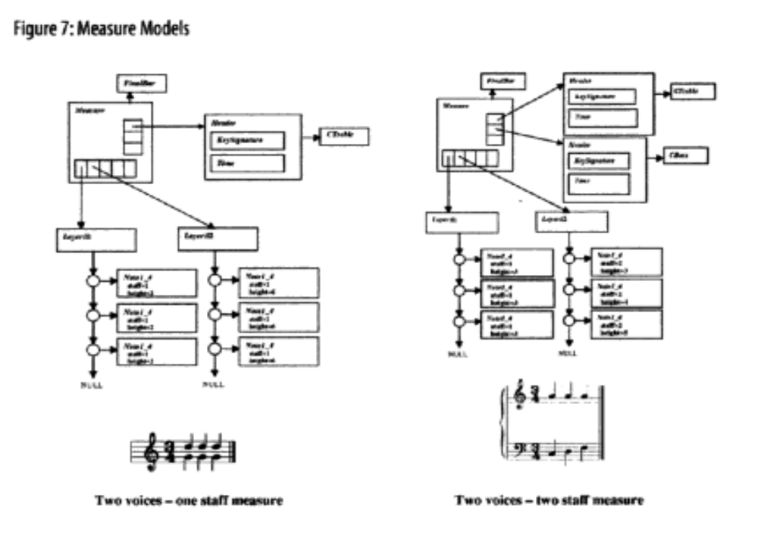The main building block of a composition is a Measure. A Measure has a HeaderList (where a Header includes the key signature and the time, i.e. tempo), and more importantly, a LayerList. A Layer contains a sequence of Figures (See Figure 7).
My addition to this model is in the Part object. A Part normally includes a HorizontalList (not important for this application), a MeasureList, and a Syllable List (See Figure 9, included here, and 12, which is in the book on page 182).
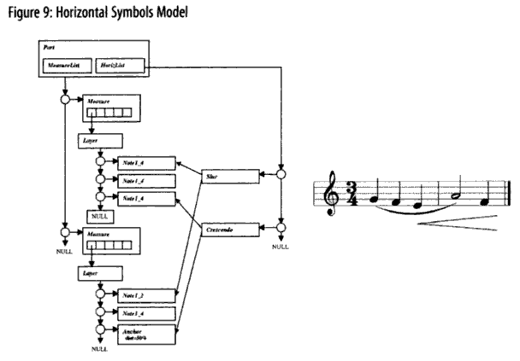

In addition to these three lists, I am adding a third list, WordList, which introduces a new object, Word. A Word contains:
- an orthographic spelling of the full word (ortho),
- a part of Speech code as defined by the UNISYN dictionary (PoS),
- an optional unique identifier, if needed (uniqID)
- a list of pointers to Syllables called “WordSyllableList”.
Each Syllable represents one traditional syllable of a word. For example, in the word “winter”, there would be two Syllable objects in the WordSyllableList: one for “win”, and one for “ter”. A Syllable object has the following fields (fields added by me are denoted with *):
  - text: the orthographic text of the syllable
- start: a pointer to the Figure where this Syllable starts being enunciated
- end (conditionally optional): a pointer to the Figure where enunciation should end. If it only spans one Figure, then this is not set. Otherwise, it is set to the point where the next Syllable’s start is positoned, or to the point where you’re supposed to stop enunciating it.
- sep: the separator to indicate how this syllable connects to the next
    - “n” means the syllable is a full word, or the end of a word, and is not extended to multiple Figures.
    - “ “ means the same as “n”.
    - “/” means the syllable is not the last in a word and is not extended.
    - “-“ means the syllable is not the last in a word and is extended.
    - “_” means the syllable is the last in a word and is extended.
- *sampa: the SAMPA representation of this syllable.
- *emph: the emphasis value placed on this syllable
    - PRIMARY means primary emphasis
    - SECONDARY means secondary emphasis
    - TERTIARY means tertiary emphasis
    - NEUTRAL means there is no extraordinary emphasis on the syllable.
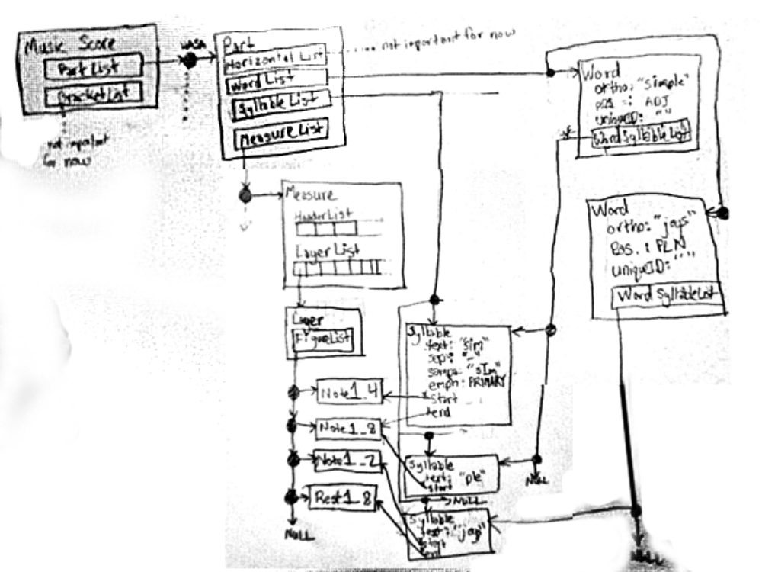
A rough diagram to show how these interact with the whole structure is below:
The class “Word” is needed, because otherwise, I would have no way to eventually extend my parser to include things like rhyme-matching, synonym-swapping, etc. I may still need to add fields to Word, as I think of them, but these are sufficient for now.

Fickle Phones in the Coda
Look, phones in the coda are like an easily-distracted dog. One moment, you think they’re with you, right behind you, and then next, you turn around, and notice that they’re less “behind you” than they are “in front of the person behind you”. You are the syllable in this metaphor, and the person behind you is the syllable that comes after you. Your dog is the last consonant in your coda. Certain “dogs” will go join the “person” behind you, while others will stick with you! Don’t judge—it’s just the way they are. But you need to know if your dog’s going to stick with you or not.

Phones That Stay In Coda:
“m” in “sam-ba”

Phones That Move to Next Syllable’s Onset:
“d” in “un-a-void-a-ble”

Calculating Weight/Length of Independent Syllables
The “Full Table of Phone Makeup and Length” table shows all the lengths and weights for all the phones, as stand-alone values. However, it does not take into account what effect that the surrounding phones might have on a phone’s length. To determine that, we need to figure out the length/ weight for the whole syllable.

Psuedo Code Formula for Determining Semi-Stand-Alone Weight

=IF(THIS.NUCLEUSWEIGHT==0,
0,
(SUM OF (THIS.ONSETVALS[1-2] )/ [( COUNT OF (ONSETVALS[1-2] ) * 8)]
)
+IF(THIS.CODAVALS[0]==0,
IF(THIS.NUCLEUSWEIGHT>1,
1,
THIS.NUCLEUSWEIGHT
),
THIS.NUCLEUSWEIGHT
)
+ [SUM OF(THIS.CODAVALS[1-4]) ] / [COUNT OF(THIS.CODAVALS[1-4])* 8]

- IF(NEXT.ONSETVALS[0] ==0,
IF( THERE IS ONLY ONE CODA VAL,
IF(THIS.NUCLEUSWEIGHT>1,
(THIS.NUCLEUSWEIGHT-1)+ [(THIS.CODAVALS[ last non-empty index ]) / 8 ],
[ (THIS.CODAVALS[ last non-empty index ]) / 8 ]
),
[ (THIS.CODAVALS[ last non-empty index ]) / 8 ]
),
0
)

Actual Excel Formula:

=IF(O2=0,
0,
(SUM(L2:M2)/(COUNT(L2:M2)*$AE$2))
)
+ IF(P2=0,
IF(O2>1,
1,
O2
),
O2
)
+(SUM(Q2:T2)/(COUNT(Q2:T2)*$AE$2))

-IF(N3=0,
IF(OFFSET(T2,0,-COUNTIF(P2:T2,0))=P2,
IF(O2>1,
(O2-1)+((OFFSET(T2,0,-COUNTIF(P2:T2,0)))/((COUNT(Q2:T2)-COUNTBLANK(Q2:T2))*$AE$2)),
OFFSET(T2,0,-COUNTIF(P2:T2,0))/ ((COUNT(Q2:T2)-COUNTBLANK(Q2:T2))*$AE$2)
),
OFFSET(T2,0,-COUNTIF(P2:T2,0))/((COUNT(Q2:T2)-COUNTBLANK(Q2:T2))*$AE$2)
),
0
)

Calculating Length of Syllables in Relation to Each Other
Just like the weight of phones cannot be fully quantified in isolation, syllable length/weight is affected by surrounding syllables.
If a syllable’s last phone is the same as the next syllable’s first phone, then it you can disregard the weight of one of them. Singers often only sing one of them, and use it for both words. For example: Bake cookies becomes : bay-cookies Stars shining becomes : star-shining. Yelp peppers becomes: yell-peppers.
There are several other rules, which I’ve put in the algorithm/formula, but haven’t written out yet. That’s on the menu for the Week 10 update.

Psuedo Code Formula for Determining Syllable “fit” with the music.

=IF(U18 > A18,
IF(D19=F18,
IF( (U18 - 1 <= A18 + A19 ) ,
1,
0
),
IF(D19 = 0,
IF(U18 <= A18 + A19,
1,
0
),
0
)
),
1
)
=IF(U18 >= A18, IF(D19=F18, IF( (U18 - 1 <= A18 + A19 ) , 1, 0), IF(D19 = 0, IF(U18 <= A18 + A19, 1, 0), 0) ), 1)

=IF(U18 > A18, IF(D19=F18, IF( (U18 - 1 < A18 + A19 ), 1, 0), IF(D19 = 0, IF(U18 < A18 + A19, 1, 0), 0), 1)

=IF(U18 > A18,
IF(N19 = 0,
IF(U18 < A18 + A19,
1,
0
),
0
),
1
)

Patterns for Musical Emphases

RULES:
Single syllable words are useful as “filler”, in that they can be used to fill emphasized or un-emphasized “slots” in the music.
Multi-syllable words must have their emphasized and unemphasized syllables match up with the emphasized or unemphasized “slots” in the music.

There are several other rules, which I’ve implemented, but haven’t written out yet. That’s on the menu for the Week 10 update.

Effect of Note Intervals on Musical Emphases
In my continued research for the rules of emphases calculation, I realized that there was another factor that influences emphasis patterns: Note intervals. “Intervals” are changes in note values: that is, not changes in length, but in the actual sound’s frequency. I will not be applying this in my algorithm for this project, which is okay, because I will attempt to only apply my algorithm to songs that only have a single note.
I realized my omission when attempting to apply my algorithm to the chorus of The Bloodhound Gang’s, “The Bad Touch”. The first threes clauses of the chorus are as follows:
“You and me” “baby ain’t” “nothing but mammals”
This breaks down like this:
WORD | You |  |  | and |  |  | me |  |  | ba- |  |  | by |  |  | ain’t
NOTE_LEN | 1 |  |  | 1 |  |  | 2 |  |  | 1 |  |  | 1 |  |  | 2
EMPH |  |  |  |  |  |  |  |  |  | 1 |  |  | 0
SAMPSYL | ju |  |  | @nd |  |  | mi |  |  | be |  |  | bi |  |  | ent
SYL_PART | on | nu | cd | on | nu | cd | on | nu | cd | on | nu | cd | on | nu | cd | on | nu | cd
 |  | ju |  |  | @ | n | m | i |  | b | e |  | b | i |  |  | e | n
 |  |  |  |  |  | d |  |  |  |  |  |  |  |  |  |  |  | t
WORD | no- |  |  | thing |  |  | but |  |  | mam- |  |  | mals
NOTE_LEN | 1 |  |  | 1 |  |  | 1 |  |  | 1 |  |  | 1
EMPH | 1 |  |  | 0 |  |  |  |  |  | 1 |  |  | 0
SAMPSYL | nV |  |  | TIN |  |  | bVt |  |  | m{ |  |  | ml=z
SYL_PART | on | nu | cd | on | nu | cd | on | nu | cd | on | nu | cd | on | nu | cd
 | n | V |  | T | I | N | b | V | t | m | { |  | m | l= | z
The main thing to notice here is the emphasis pattern:
you – and – me – ba – by – aint – no – thing – but – mam - mals
x – x – xx – 1 – 0 – xx – 1 – 0 – x – 1 – 0
( x is a wild-card syllable from a single-syllable word. 1 is an emphasized syllable in a multi-syllable word. 0 is an un-emphasized syllable in a multi-syllable word. )
Emphasis patterns should always be 1 – 0 – 1 – 0 , at least for the purposes of this project. With this pattern, though, there’s no way to make it fit that structure, because the two-syllable words “nothing” and “mammals” are only separated by a single syllable. This means that our emphasis pattern according to our current algorithm where we only look at syllable length and emphasis patterns, must be one of the following:
you – and – me – ba – by – aint – no – thing – but – mam - mals
1 – 0 – 10 – 1 – 0 – 10 – 1 – 0 – 1 – 1 – 0
OR
you – and – me – ba – by – aint – no – thing – but – mam - mals
1 – 0 – 10 – 1 – 0 – 10 – 1 – 0 – 0 – 1 – 0
Either way, in the third clause, “nothing but mammals”, we have two adjacent syllables of the same emphasis value. Under our current system of rules, this isn’t allowed. However, the song’s emphases still sound right, so there’s another factor affecting emphasis.
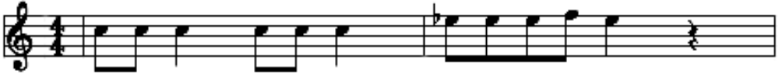
As it turns out, the music for this part sheds light on the situation:
You and me______ba- by, ain't_______ noth-ing but mam-mals

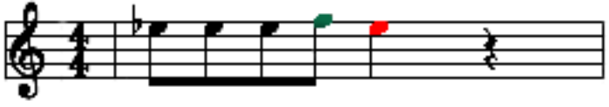
The first two clauses, “You and me”, and “baby, ain’t”, have no note intervals; that is, the note doesn’t change throughout the clause. In the third clause, there is a positive note interval between “but mam-”, and a negative note interval between “mam-mals”:
noth-ing but mam-mals
1 – 0 – 1 – 1 – 0

It appears, based upon this, that if two words clash such that the emphases are not alternating, it can be overcome by recreating the emphasis with note values: an emphasized syllable will be indicated by a positive note interval.
If time permits, I’ll work this into my algorithm, but as it stands now, I’d need to do a lot more research and try a lot more use cases to determine if this is a fully-generalizable rule. For now, I’ll only apply my algorithm to songs that do not have any interval changes in their lyric clauses.

Parsible Phonetic Dictionary

Parsable Dictionary
I started off by looking at MIT’s . Eventually, I was led to a paper that, while not really related to my topic, had a list of phonetic dictionaries in it: CMU dictionary, LC-STAR dictionary and UNISYN dictionary. I started out by looking at the LC-STAR dictionary, but I quickly decided that it wasn’t going to be as useful to me, because the LC-Star project is relatively focused on Speech-to-Speech or Text-to-Speech tech. Also, the website had not been maintained since 2006. I then tried the CMU dictionary, which, for a while, seemed like it was going to work. It had a very simple way of encoding words: first the word, then the identifier number in parents (if needed), then a space, then a one-to-two char code for each sound in the word, with the numbers 0, 1, 2 appended to indicate emphasis (if needed), separated by spaces:
ABBREVIATE AH0 B R IY1 V IY0 EY2 T
The problem that arose with this format, was that there was no explicit definition of where to hyphenate the word when splitting it up. This causes problems if I want to use the word in lyrics, where each note has is own syllable underneath it, and each syllable might have many different sounds.
The benefits of the CMU dictionary over some other dictionaries were that (1) it was actively maintained, (2) it included proper nouns, which are often found in lyrics, but not in dictionaries, and (3) it was ridiculously easy to read.
The downsides were that (1) it included no part of speech data or hyphenation data, and (2) it used non-standard symbols for its phonetic alphabet.
With the downsides and benefits in mind, the CMU dictionary could not be used in isolation, especially if I someday want to attempt generation of original lyrics (which part of speech data would be vital for).
The UNISYN dictionary is used primarily to phonetically translate words into multiple accents. It has its own formated dictionary, with a bunch of wildcards in it. They also provide some semi-functioning perl scripts that allow you to specify a dialect you’d like to use (For example, I would say “cooking” differently than someone from the Deep South, and we both would say it differently than someone from London. However, we’re all speaking English. The UNISYN dictionary facilitates this translation).
It had all the information I needed, and then some. However, it did not include proper nouns, like the CMU dictionary did. The obvious conclusion, then, was to combine them. I decided that anything that was in the CMU dictionary, but not in the UNISYN dictionary, would be counted as a proper noun. And with that, I started to massage both data sets into mergable forms.
However, I ran into a setback, mentioned in the very first article I found references to both dictionaries in: the dictionaries were inconsistent. They didn’t always put stresses in the same place, nor did they always have the same pronunciation. Because of this, it was difficult to match words—especially words that were homographic heteronyms (same writing, different sounds). For now, I have decided to use the UNISYN dictionary exclusively, and if I have time, I’ll try to parse out the proper nouns from the CMU dictionary. This removes added unnecessary complexity, but does not structurally prevent me from adding that complexity later, so its a good sacrifice.
Final Phonetic Dictionary Choice
I used the UNISYN dictionary, using General American SAMPA output, as the base for my phonetic dictionary.
First, I downloaded the dictionary and related files from the UNISYN website.
Once I’d extracted them, I attempted to run the provided perl scripts to turn the UNISYN phonetic symbols into SAMPA phonetic symbols, using the procedure specified in Section 6.1 of their Documentation1_3.pdf, and towncode “gam”.
There were a few errors in translation I fixed manually:
‘ d ’ instead of ‘ 4 ’
‘ 5 ’ instead of ‘ l ’
‘ `r\ ’ instead of ‘ r ‘
‘ 3 ‘ instead of ‘ 3` ‘
In the case of the last one, I actually didn’t fix it, and just decided to use a modified sampa. Similarly, with the second to last, I left the ` in, and ignored them as they came along during parsing.
Here is the format for the raw fields, after I was done with fixing the UNISYN output:
<ortho>:<uniqueID>:<partOfSpeech>:<SAMPAspelling>:<extendedOrtho>:<freq>
Example:
transfer:2:VB/VBP: tr{ns"f3`r :{trans==fer}:7184

<ortho> is the regular spelling of the word
<uniqueID> is a number (and optional string) used to differentiate homographs.
<partOfSpeech> is used to identify the specific part of speech
<SAMPAspelling> is the breakdown of the word, phonetically. It uses the SAMPA alphabet, and separators to show where breaks in the word are, and how they’re emphasized. If a separator is ' $ ', the following phones (until the next separator) are not emphasized. If it's ' % ', then they are the secondary emphasis. If it's ' " ', then they are the primary emphasis.
<extendedOrtho> and <freq> have no particular use to me, at this time. They are an alternate breakdown of the word's roots, and the frequency at which it occurs in language, according to UNISYN.

My next step, to get these into the format that I need for my program , was to split up the fields into sub-fields to make them into a .csv (but using tabs as the field delimeter). I decided to do that like this (I'm using | as the field delimeter here, because it looks better, even though I'm using tabs for parsing)

<ortho> | : | <uniqID#> | <uniqIDString> | : | <partOfSpeech> | : | <extendedOrtho> | : | <freq> | <FullSAMPAstring> | : | syllableBreakdown(see below)... | '\n' |

syllableBreakdown:
<charSeparator> | <sampaSyllableSubstring>

The end of each word entry will be indicated with a newline.
After I got the dictionary in this format, I opened it as a CSV in excel, inserted a column of commas between each field, a column of ' ));' after the last field, and a column with with string “dict.add(Word(“ before the first field.
This was my hack-y way of making constructors for all the words in my dictionary. All I had to do was highlight the table, then copy and paste it as plain text into my code's dictionary constructor.

Evaluation Plan:
At this time, evaluators should read through this document, and check out the Excel Spreadsheet with the examples in it.

Timeline:

(Modified)
Again, the research and development of the algorithm has taken much more time than I thought it would. At this point, my goal is to get some sort of demonstration of the algorithm together by Week 10, along with full documentation of how it works.

SAMPA (Speech Assessment Methods Phonetic Alphabet) is a computer-readable phonetic “alphabet” that uses 1-2 ASCII characters to represent all the sounds in words. It’s based upon the symbols found in the more-standard-but-not-easily-computer-readable IPA (International Phonetic Alphabet).
Though the current implementation of this program does not use the pronunciation data at this time, I’d like to eventually get it working so that the program can also evaluate rhyme scheme. It was easier in the long term to find a dictionary with both, instead of having to add pronunciations later.
[1] P. Bellini, I. Bruno, and P. Nesi, Multilingual Lyric Modeling and Management, Visual Perception of Music Notation: On-Line and Off-Line Recognition, edited by Dr. Susan E. George, press, 2003.
T. Polyakova and A. Bonafonte, “Fusion of dictionaries in voice creation and synthesis task,” Proc. of the 12th International conference on Speech and Computer, SPECOM, 2007.
“LCStar.”, http://www.lc-star.com/schedule.htm
T. Polyakova and A. Bonafonte, “Fusion of dictionaries in voice creation and synthesis task,” Proc. of the 12th International conference on Speech and Computer, SPECOM, 2007.
The number of “SyllableBreakdown“s corresponds to the number of syllables in the word.
BIBLIOGRAPHY: ? H.R. Oliveira, F.A. Cardoso, and F.C. Pereira, “Tra-la-Lyrics: An approach to generate text based on rhythm,” Proceedings of the 4th. International Joint Workshop on Computational Creativity, London, UK, 2007.
P. Bellini, I. Bruno, and P. Nesi, Multilingual Lyric Modeling and Management, Visual Perception of Music Notation: On-Line and Off-Line Recognition, edited by Dr. Susan E. George, press, 2003.
“SAMPA computer readable phonetic alphabet.” <http://www.phon.ucl.ac.uk/home/sampa/index.html>, Accessed 9-29-09
INCLUDE THE PARTS OF SPEECH TABLE!

