R_12C 400 MeV/nucleon 550 MeV/nucleon 650 MeV/nucleon 800 MeV/nucleon 1000 MeV/nucleon

400 550 650 800
-------------------------------------------------------------------------------------------------------
Empty 0.99998(1) 0.99996(2) 0.99997(2) 0.99997(1) 0.99998(1)
thin 0.99962(3) 0.99948(2) 0.99943(2) — 0.99975(2)
medium 0.99945(1) 0.99926(2) 0.99920(1) 0.99930(3) 0.99960(3)
thick 0.99938(1) 0.99922(1) 0.99908(2) 0.99921(2) 0.99945(3)

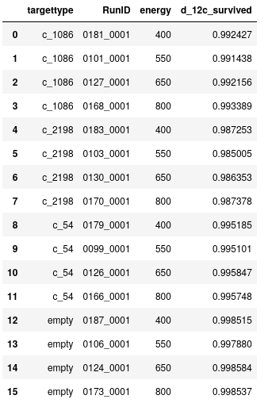

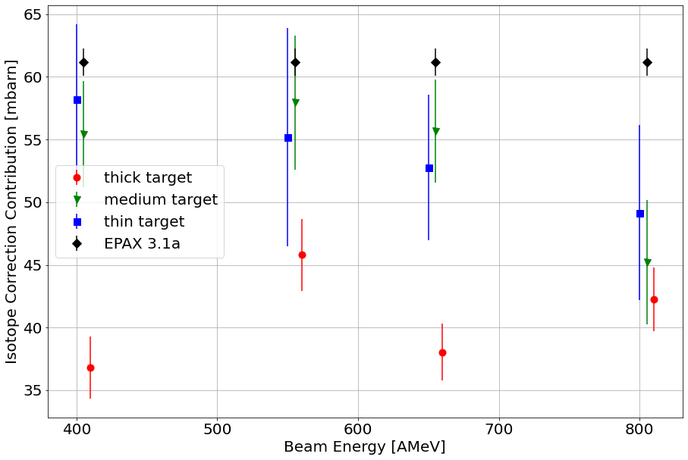
Only cut on MW1 & MW2 X correlation plot

