1) Can you include the resolution in the positions for each of the MWPC layer ? I guess you discuss the total tracking resolution later but it would be good to mention the specific of the detectors here.
Resolutions for MWPCS:
X resolution (FWHM) 200 um (MWPC0,1,2) and 300 um for MWPC3
Y resolution (FWHM) 1.5 mm (MWPC1,2,3) (100um for MWPC0)

Source:
Martin, Julie-Fiona. Coulex fission of 234U, 235U, 237Np, and 238Np studied within the SOFIA experimental program. No. FRCEA-TH--6893. Universite de Paris XI, 15 Rue Georges Clemenceau, 91400 Orsay (France), 2014.

I will add these values on the table with specifications.

2) I don’t know if you discuss it later but it is also important for the reader to know the global time resolution of the detector to understand the maximal data rate.

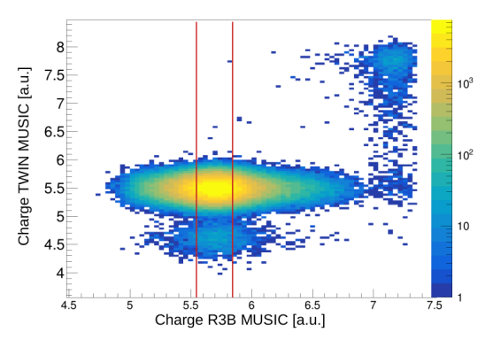
For the TWIN MUSIC we have for the rate capability: up to ~50kH for light ions
readout over MDPP (see:https://www.mesytec.com/products/nuclear-physics/MDPP-16.html) , shaping time 100 ns.
However - important - efficient pile-up rejection is already ensured in the selection of incoming ions by applying a strict ±1σ charge cut on the R3B-MUSIC detector. As shown in the figure below, the tighter charge selection in R3B-MUSIC—enabled by its longer shaping time compared to the TWIN-MUSIC detector—provides effective suppression of pile-up events. This figure is also included in Appendix A and referenced accordingly in the main text.

The rate capabilities I have summarized in 4) and will be added to the text.

3) The music does also trackint right? Traks are matched to the MWPX C hits, what is the MUSIC resolution in space and matching efficiency to the MWPC?

It is correct that a multi-step calibration can be used to reconstruct the fragment angle from the electron-drift time in the TWIN-MUSIC detector, as was done in the “Fission via QFS” analysis (see Subsection 5.6.1). This procedure is required, especially for unambiguous mass resolution of heavy isotopes.
For carbon isotopes, however, the differences in A/q are sufficiently large that isotope identification can be reliably achieved using the horizontal (x) positions measured in MWPC2 (upstream of GLAD) and MWPC3 (downstream of GLAD). In addition, MWPC2 provides the vertical (y) position, which can be correlated with the y-position in MWPC3 to confirm the fragment trajectory.
Across all runs, the carbon isotopes (12C, 11C, 10C) were clearly separated, and the extracted isotope yields agreed with the expectations from the EPAX parametrization formula. Therefore, for this analysis there was no need to perform an angular reconstruction using TWIN-MUSIC.
Moreover, it should be noted that for charges in the region of Z = 5-6 the best achievable position resolution in TWIN MUSIC is ΔX ~ 300 um, while the MWPCs reach ΔX ~ 200 um. Therefore for light ions it is advised to use the MWPC position instead.
More info:
TWIN MUSIC resolutions ( for heavy ions ):
ΔE/E < 5% FWHM per anode , < 2% FWHM total
ΔX ~60 um FWHM per anode
The matching efficiency to MWPC1 and MWPC2 is 99.94% at beam energy 800 AMeV (at lower beam energies, e.g. 400 AMeV TWIN was suffering from geometric acceptance limitations).

4) Use should maybe break down the rate capability of each detector component

Rate capabilities:
TWIN MUSIC: ~50kHz
MWPCs: slightly higher than the TWIN MUSIC
R3B MUSIC: same order as TWIN MUSIC

Since the event rate for the S444 experiment was in the range of 10 kHz , well below rate capabilities.

5) In general it would be good to write in the thesis which are the detector component built in Munich and when

The TUM group is fully responsible for the development, implementation, and operation of the readout electronics. This includes the design of the preamplifiers in close collaboration with the manufacturer Mesytec, the production of all data and power-delivery cables as well as custom in-house connectors, and essential developments of the FEBEX firmware for pulse-shape analysis. In particular, the extension of the firmware to enable particle identification was carried out by Max Winkel (cite). Additional key contributions—especially regarding the scalability, DAQ integration, and slow-control infrastructure of CALIFA—were provided by Philipp Klenze.
I will add a corresponding sentence to inform the reader that the TUM group is responsible for the readout electronics and its operation.

6)”For an experimental setup with full detector efficiency and no interactions in the
setup material the cross section could simply be deduced from Eq. 54. To account for
reactions of the projectile that occur within the setup material...”
what you mean here ? 4pi coverage and 100% efficiency ?

What I meant with the original expression is that the cross section could, in principle, be obtained directly from Eq. 54 if the detector system had full geometrical acceptance and a detection efficiency of 100% for surviving carbon fragments. This does not necessarily require a literal 4π coverage - only that all surviving carbon ions are detected with perfect efficiency and no losses.
I will modify the sentence to:
“For an experimental setup with full geometrical acceptance and 100% detection efficiency for all surviving carbon ions and no interactions in the setup material, the cross section could be directly obtained from Eq. 54. , …”

7) “the setup-specific detection efficiency epsilon_setup and transmission factor t setup are assumed to be identical for both the empty and target runs”
why should they be different ?

Indeed, the setup-specific detection efficiency (ε_setup) and transmission factor (t_setup) should be the same for both the empty and target runs. This is particularly valid because all runs were carried out in a timely sequence under essentially identical experimental conditions.
(Significant differences could only arise if external factors changed between runs—for example, a different day with variations in atmospheric pressure - which might slightly affect the response of the ionization chambers (R3B-MUSIC, TWIN-MUSIC). Since such conditions were controlled during the experiment, it is reasonable to assume identical efficiency and transmission for both types of runs.)

8) what is the purity of this selection (incoming ions) ? Or the signal to background ratio?

In the S444 experiment, we used a primary ¹²C beam, and therefore the contamination from reactions occurring upstream of Cave C is very low. As shown in Fig. 22, the contribution of ions with Z<6 remains below 10⁻³. The purpose of the corresponding analysis step is thus not primarily to improve isotopic purity, but to ensure efficient pile-up rejection and to select ions that impinge on the target at a central position.
We do not provide a quantitative purity value for the incoming-beam selection because no detailed simulation of the S444 beamline was available. Nevertheless, since the beam consisted of primary 12C, we can assume an incoming-beam purity of essentially 100%.
Note: I will point it out in the incoming event selection step, that we have primary ¹²C beam.

9) Background ?
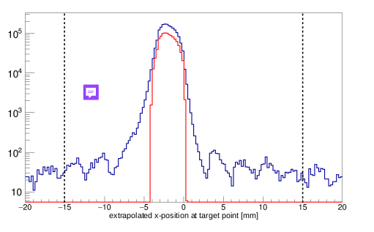

The well-defined bumps with a width of approximately 3 mm reflect the readout-pad geometry of the MWPC, whose pad pitch is 3.125 mm. The position reconstruction is performed by selecting the pad with the maximum charge deposition (Qmax) together with its left (QL) and right (QR) neighboring pads (as described in Appendix B) . Because we operate with light 12C ions, the overall energy deposition in the detector is low, and consequently the charge sharing between adjacent pads is limited. And therefore we resolve here the pad edges.
As shown in Fig. 24, the small bumps observed outside the main peak originate from random coincidences and represent detector-response artefacts rather than true particle signals. MWPC0, which is typically optimized for heavy-ion detection, was operated at high gain in this experiment to ensure sufficient signal amplitude for 12C.

10)What is not very clear up to now is which part of the work you did
Did you develop the event selection cuts or someboedy else in the collaboration did it ?
What about the TWIN calibation?
Maybe you can choose a color code for the parts you did your self int he title or so

For both analyses, 12C+12C and the QFS 12C(p,2p)11B, all event-selection cuts, tracking algorithms (as discussed in Section 5.1), TWIN-MUSIC calibrations, and subsequent analysis steps were developed by myself.
I only relied on the default MWPC calibration parameters (for pedestal subtraction), the standard CALIFA calibration, and the R3B-MUSIC calibration parameters, as mentioned in the text. The data extraction and processing were performed using the R3BRoot software framework.

11) “The energy resolution of the TWIN MUSIC detector is limited by statistical (Poissonian) fluctuations in ionisation,….”
I do not understand this statement. Shouldnt the reaction cross section decrease with increasing energy ? Here you describe it as a detector effect

According to Teixeira et al. 2022,( https://doi.org/10.1140/epja/s10050-022-00849-w), the reaction cross section is expected to increase with beam energy. This trend is also reproduced in Fig. 9, which includes results from previous experiments.
In this section, I describe how we determine the most appropriate and consistent fit range in the two-dimensional energy-loss plots (see Figs. 27 and 29). At higher beam energies, the energy loss in the TWIN-MUSIC detector decreases, leading to a broader Z-distribution. As a consequence, the charge states Z=6 and Z=5 become less well separated. If the fit range around the Z=6 peak is chosen too wide, the tails of the Z=5 distribution would artificially contribute to the Z=6 yield. This would bias the extracted charge-changing cross section. Therefore, selecting an appropriate fit range is essential to avoid contamination from Z=5 fragments.

12) “As a result the deposited energy decreases with increasing beam energy, leading to a degradation of the energy resolution at higher beam energies”
how much ?
Is the energy dependence of the cross section only due to the Music resolution ?

The deposited energy decreases with increasing beam energy, approximately following the 1/β2 dependence of the Bethe formula. When increasing the beam energy from 400 AMeV (β=0.714) to 800 AMeV (β=0.843), the relative energy-loss resolution worsens by roughly 15%. This degradation arises because the mean energy loss decreases faster (∝1/β2) than the intrinsic straggling (∝1/β).
Importantly, the observed energy dependence of the reaction cross section is a physical effect and should not be influenced by the MUSIC energy-loss resolution. This is precisely why the fit-range analysis is performed: by choosing a consistent and physically motivated fit range, we ensure that the extracted charge-changing cross sections remain unbiased by the detector resolution.

13) “The observed decrease in cross section values with increasing fit range is attributed to the
energy dependence of the ionization energy loss. At higher fit ranges, the contribution
from tails of the energy loss distribution of lighter fragments (e.g., Z = 5) becomes in-
creasingly included in the integration window for heavier fragments (e.g., Z = 6), leading
to an underestimation of the charge-changing cross section. This effect becomes more
pronounced at higher beam energies”

can you exaplin to me why is that so ?
I dont say it is not explained in the text but I didnt get it
is it really only a resolution effect ?

At higher beam energies, as discussed in the previous section, the energy-loss distributions for both Z=5 and Z=6 become broader, and the two distributions may partially overlap. If we were to integrate events over a preselected fit range that is too wide, some Z=5 events would be incorrectly counted as carbon (Z=6) ions. This would lead to an overestimation of the number of surviving carbon ions, which in turn would artificially reduce the measured charge-changing cross section, since σ∼ln(N₂/N₁).
To avoid this bias, I carefully determine the optimal fit range for each energy, as illustrated in Fig. 29.

14) “A precise correction for the limited geometric acceptance of the TWIN MUSIC detector
presents a notable challenge, as the true distribution of carbon fragments in the x- and
y- coordinates at the position of MWPC1 is not directly measurable. The expected
true distribution results from a convolution of the primary
12C beam profile and the Gaussian-like angular broadening caused by multiple scattering processes within the target material and the reaction dynamics.”

I dont understand: cant you use Geant simulation to evaluate this acceptance precisely ?
Do you have a full scale Geant simulation package of the detector

A Geant4 simulation of this detector package exists as a standalone model. However, it is not integrated into a full simulation of the S444 experiment with the precise relative positioning of all detectors. Using a simulation to determine the geometric correction would require a complete model of all upstream detectors before TWIN, including their exact positions and an accurate beam profile. Such a detailed simulation was not available for this study.

15) About geo corr: is this correction really at most a 3 per mille factor ??
why do you care ?

Indeed this is a small correction factor. It’s largest effect in on the 400 AMeV datapoints where we see a reduction of the charge changing cross section of ~10 mbarn, see Fig. 33. Neglecting this effect would already introduce an uncertainty of about 1.4%. Since our final objective is to determine the cross section with high precision and to keep the total uncertainty well below 2%, it is necessary to include even such comparatively small correction terms.

16) I dont understand this plot .
This is the contribution to the C+C total cross section due to the isotope ?
60 mB out of 700 for such small isotopes contributins as seen in fig, 37? How does it come together ?

To obtain a rough, first-order estimate, one can proceed as follows. For the thick target, we observe a 15% loss of carbon isotopes, which corresponds to a cross section of approximately 730 mb. The isotope correction for this target is about 1%, see all contributions in Table.7 . Using the approximation ln(1+x)≈x for small x, this gives a correction of roughly 730/15≈50 mb.
This relatively large contribution arises because the factor 1/Nt is large (e.g., for the thick target N_t=4913), so even a small change in the ln(N2/N1) factor leads to a non-negligible contribution to the cross section.

17)
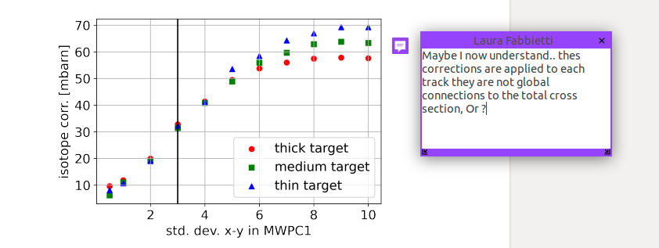
Absolutely. To point it down, this Subsub- Section emphasizes the importance how high geometric acceptance detectors for high precision measurements as we do at R3B.

18)CALIFA angular reconstruction, partly filled: Dont you have simulations with the same detector coverage as in real experiment ? To compare apple to apple ?

For this specific CALIFA configuration – with only a partially filled forward-geometry GEANT4 simulation - would have been available. However, analyses performed by colleagues in the subsequent S467 experiment showed that the two CALIFA halves were slightly shifted and tilted with respect to their nominal positions. A precise comparison between simulation and experimental data under these conditions would have required a dedicated detector-geometry study and was therefore beyond the scope of this work.
Given that S444 was a commissioning experiment, our focus was on demonstrating the feasibility of the analysis rather than achieving full simulation–data consistency. The experience gained here was subsequently used to refine CALIFA positioning procedures etc. for the follow-up experiments.

19) The result of the Doppler corrected Gamma spectrum is only a proof of concept ? there is no comparison to theoretical calculations ?

Indeed, this result should be understood as a proof of concept. The detector configuration used in S444 was optimized for the subsequent S467 experiment with Ca isotopes, not for a precision γ-spectroscopy analysis of the 11B channel. Obtaining accurate cross sections would have required multiple correction steps based on detailed simulations.
Furthermore, the SOFIA ToF-Wall is optimized for medium- to heavy-ion detection, with only 3 mm of plastic; isotopes of ¹¹B lie at the identification threshold of this detector. The efficiency of the TWIN-MUSIC also decreases significantly for Z=4, which affects reliable fragment identification. In addition, see Q18 above, a precise geometric reconstruction of the CALIFA array would have been necessary for a quantitative analysis. These limitations justify restricting the γ-spectrum result to a proof-of-concept demonstration rather than a comparison with theoretical predictions.

