1. Download **tech-challenge.jar** in local directory.

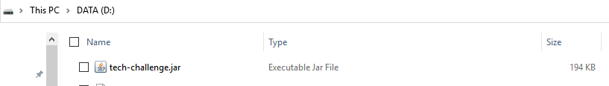

1. Open a command window and set location to where tech-challenge.jar is saved by issuing sample below command  
     
   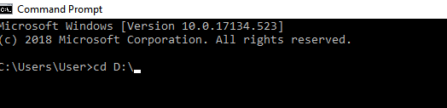

1. Run the jar file by issuing below command: java -jar tech-challenge.jar

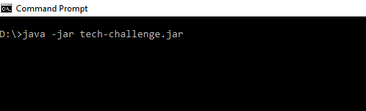

1. Enter customer ID and chosen month year following format yyyy-MM (e.g. 2019-01)

