**TC#1:**

AFTERNOON PERSON - Makes over 50% of their transactions in the month after midday (count of transactions)

BIG TICKET SPENDER - Makes one or more withdrawals over $1000 in the month.

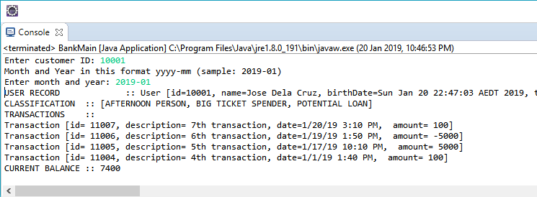

**TC#2:**

If a person is identified as both a **Big Spender** and a **Fast Spender** then they should be classified as a **Potential Loan** customer instead.

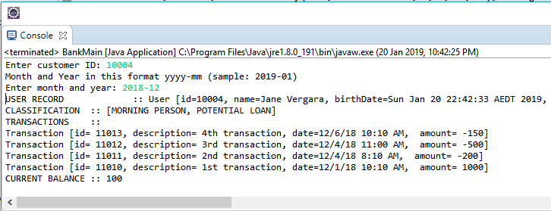

**TC#3:**

Get Current Balance as of date

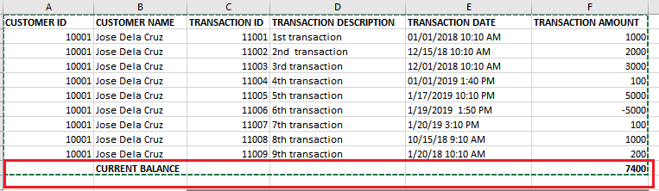

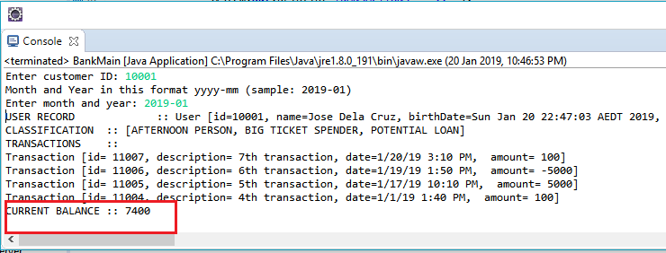

**TC#4:**

Retrieve only the chosen month year transactions

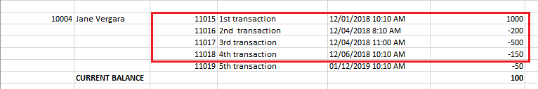

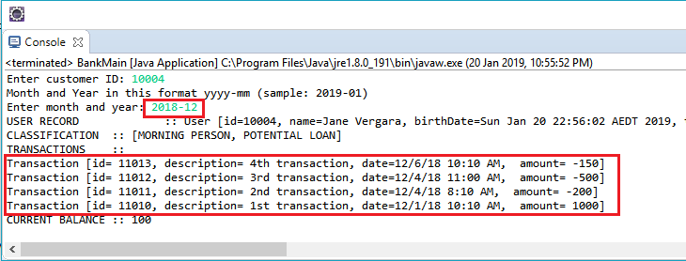

**TC#5**

Invalid input

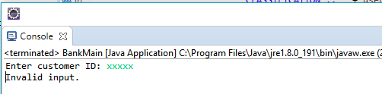

**TC#6**

No user found

