Notes written by Prof. J. Stedinger, 2003

INTRODUCTION TO PROBABILITY AND STATISTICS (C&C PT 5.2)
Reference: J. L. Devore, Probability and Statistics for Engineering and the Sciences, Duxbury Press, Brooks/Cole Publishing Co., 6th Edition, 2004 [on reserve for CEE 304]

Probability Theory: Given the specific population from which a sample will be drawn, and a sampling procedure, probability theory describes the relative likelihood that different events will occur.

Population → Possible Samples

Statistics: The method for inferring (as best one can) the characteristics of the real world (some population) and to make decisions based upon observed events.

Observed Sample → Characteristics of Population

Descriptive Statistics (See C&C PT5.2.1)

Describing a distribution: A histogram is often used to describe the frequency that an experiment yields different outcomes. If n outcomes are assigned numerical values x_{i}, then one can plot the frequency f_{i} that the x_{i} fall in different ranges.

Measures of central tendency: Mean or average 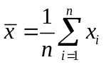

Measures of variability: Sample variance 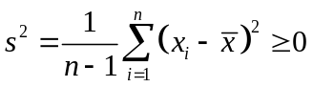
s² = 0 only if all x_{i} equal the average value
“Shortcut” formula: 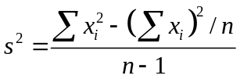

Range: Maximum – Minimum

Probability

Probability is the language of uncertainty, variability, and imprecision. It is how we describe the likelihood of different events. Engineers must consider what events might occur as well as their relative likelihood and consequences.

Some basic terms used in Probability
Experiment – a procedure that generates a sample point x in the sample space according to some probabilistic law.

Examples: Experiment rolling a die once.
Experiment counting the number of students in a single row, 5 minutes after class starts.

Sample point, x – a single outcome of an experiment

Examples: Experiment rolling a die once. Possible samples are:
x₁ = {1}
x₂ = {5}
Experiment counting the number of students in a single row.
Possible samples are:
x₁ = {8}
x₂ = {0}

Sample Space,  – the set of all the possible outcomes of an experiment

Examples: Experiment rolling a die once:
Sample space  = {1,2,3,4,5,6}
Experiment counting the number of students in a single row with 12 seats per row:
Sample space  = {0,1,2,3,4,…,12}

Event, E – a subset of  -- any collection of outcomes of an experiment

Examples: Experiment rolling a die once:
Event A = ‘score < 4’ = {1,2,3}
B = ‘score is even’ = {2,4,6}
C = ‘score equals 5’ = {5}
Experiment counting the number of students in a single row:
Event A = ‘all seats are taken’ = {12}
B = ‘no seats are taken’ = {0}
C = ‘fewer than 6 seats are taken’ = {0,1,2,3,4,5}

Probability, P(.), is a function that maps subsets of  into [0,1]. Some examples:

dots on die | 1 | 2 | 3 | 4 | 5 | 6 | SUM
Probability | 1/6 | 1/6 | 1/6 | 1/6 | 1/6 | 1/6 | 1.0
Students in row | 0 | 1 | 2 | 3 | 4 | 5 | 6 | 7 | 8 | 9 | 10 | 11 | 12 | SUM
Probability | 0.016 | 0.032 | 0.069 | 0.121 | 0.168 | 0.188 | 0.168 | 0.121 | 0.069 | 0.032 | 0.012 | 0.003 | 0.001 | 1.0

Percentiles

Let p = probability

The value of X that has 100p% of the distribution below it, is called the (100p)^{th} percentile

The median is the 50th percentile
Independence
Definition: When knowledge that one event A occurred has no impact on the probability that another event B will or will not occur.

If events A and B are independent then the probability they both occur is the product of the probability that each occurs: 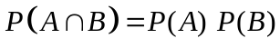
(Where AB is the intersection of A and B.)

Example: The probability of flipping a fair coin and getting heads twice in sequence with independent tosses is:

The probability of flipping a fair coin and getting heads three times in sequence with independent tosses can be computed by considering the independent events first obtaining two heads in sequence, followed by the event of obtaining a head on the third toss:

Axioms for Probability
P(.) is a function that maps subsets of  into [0,1]
- For every event A in the sample space , P(A) ≥ 0.

- For the whole sample space , P() = 1.

- If { A_{i} | i = 1, . . . , n } is a finite collection of mutually exclusive events, then 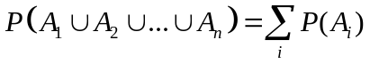. (Where AB is the union of A and B.)

Events A and B are mutually exclusive if 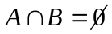.

Properties of Probability that follow from Axioms
i) For 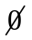 = the empty set, then 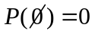.

ii) For every event A and its complement A', P(A) = 1 – P(A')

iii) For any two events, A and B: 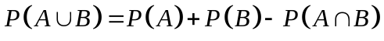
Example:
Consider the tossing of two coins.
A = Event 1st is a head
B = Event 2nd is a head
What is the probability that one sees at least one head: 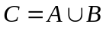?
From axiom iii:
That this is correct can be seen because C is the complement of
D = {one obtains two tails}, so from axiom ii:
P(D) = (0.5)(0.5) = 0.25 => P(C) = 1 - P(D) = 0.75

Random Variables

A Random Variable (RV) X(s) is a real-valued function which assigns a real number X(s) = x to every sample point s ∈ .

Engineers often deal with numbers rather than physical outcomes: flow rate (m³/sec), velocity (m/sec), weight (kg), force (N), density (g/m³)

Example: Inspect vehicles coming off an assembly line, and let E_{n} be the event that n of 100 cars fail. Consider two possible ways to define the random variable:

X(E_{n}) = n number of failures
X(E_{n}) = 100 – n number of successes

Discrete Random Variables take on a finite or countably-infinite number of values, i.e., 0, 1, 2, 3, ...

Continuous Random Variables take on an uncountably-infinite number (continuum) of values, i.e. (0,1), [0,1), [0,1], [0,∞), etc. => different math than discrete RV’s. Here, we emphasize the description of continuous RV’s.

Examples of Random Variables
Discrete Continuous
Number of orders wind speed
number of failures flow rate
cars at signal width of material
happy students in class material strength
people with disease max infiltration rate
Bacterial cultures on petri dish reliability of a machine
days until accident contaminant concentration

Describing Continuous Random Variables
A random variable X describes numerically the outcome of an experiment. The probability distribution of X can be summarized using either of the following two functions. Here X is the random variable, and x is a threshold or possible value of X.

Cumulative Distribution Function (CDF): F(x) = P[ X(s) < x ]

Probability density function (pdf): f(x) = dF(x)/dx

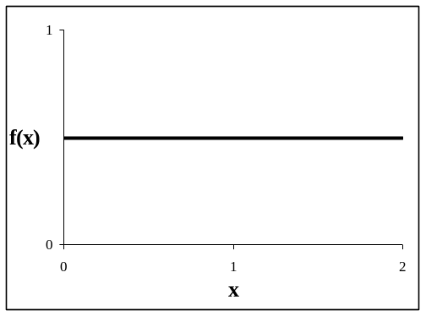
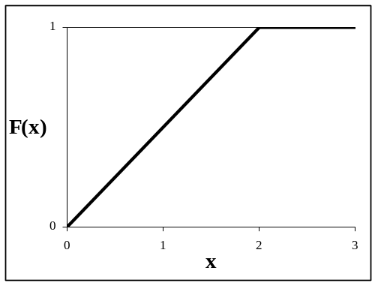
Example: Uniform pdf and CDF:

Properties of CDFs for continuous RV:

- 0 ≤ F[x] ≤ 1

- F[x + δ] > F[ x ] for all δ > 0, so F(x) is monotone increasing.

- F[b] – F[a] = P( a ≤ X ≤ b ) for a < b

Properties of pdf for continuous RV:

- f(x) ≥ 0

- 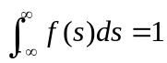

Combining the two one also has:

Describing the Average
If an experiment is repeated many times, consider the expected or average value of the random variable:
Expected value of a random variable = mean =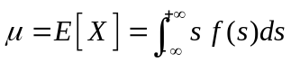
More generally for any function h(X), one can compute its expected value equal to its average value in a large number of trials as:
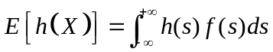

Useful property of expectations: E[ a + b X ] = a + b E[X]
How to Describe Variability
Mean, E[X]: Measure of central tendency; center of mass
Variance: Measure of dispersion, variability, uncertainty, or imprecision
Var[ X ] = 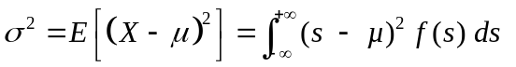
Another definition: σ = Standard Deviation

Computation of the Variance (a useful formula):
Variance = σ² = Var[ X ] = E{ [X – µ]² }
= E{ X² – 2µX + µ² } = E{ X² } – E{ 2µX } + E{ µ² }
= E{ X² } – 2µ E{ X } + µ² = E{ X² } – 2µ² + µ² = E{ X² } – µ²
σ² = E{ X² } – µ²

Useful property of variances: Var[ a + bX ] = b² Var[X]

Percentiles: The 100p percentile x_{p} for a continuous random variable satisfies

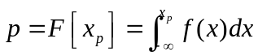

Normal Random Variables (See C&C PT5.2.2)
Most famous and commonly used continuous distribution is
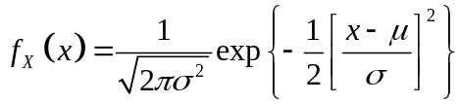
As a short hand, one often writes X ~ N [ µ, σ² ], where “~” means “distributed as.” This distribution X not only exhibits the usual properties of a pdf (p. X-5) but also has a fixed “bell” shape (C&C Fig. PT5.3) that:
- is symmetric,
- is unbounded both above and below, and
- has mean µ and variance .

Example: The following chart shows three normal pdf’s:
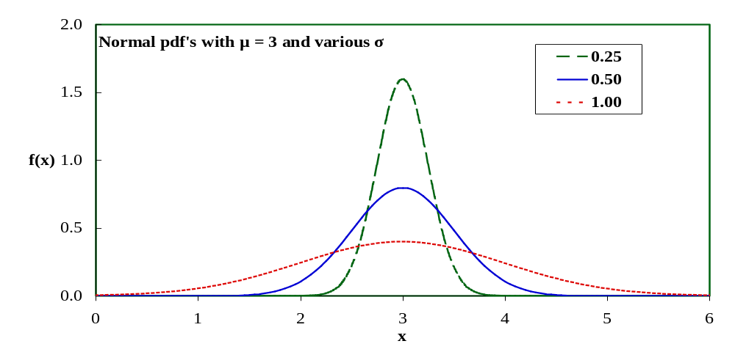
Standard Normal Distribution is a special case of the normal distribution with zero mean µ = 0, and unit standard deviation σ = 1. If X is a random variable with mean µ and standard deviation σ, then the “standard normal random variable” is defined as 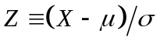.
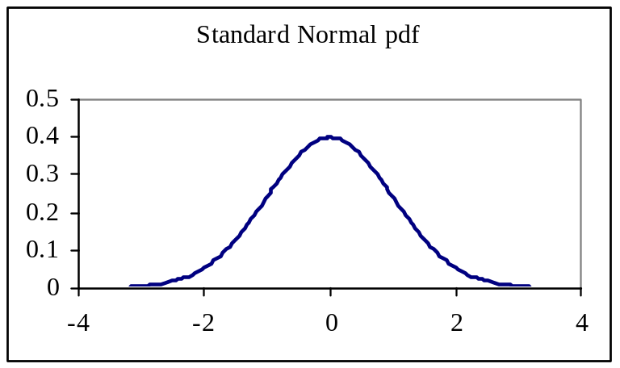
The CDF of the standard normal distribution is denoted 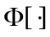. Φ-values are given in commonly available tables, and is a special function in MATLAB and Excel (see NORMDIST, NORMSDIST, NORMINV, NORMSINV).
The Normal CDF is not available in closed-form, but the CDF of any normal random variable can be computed using 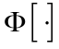:
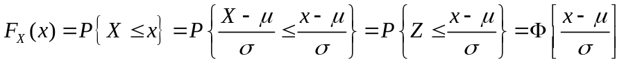

The normal distribution has been found to describe a wide range of phenomena including loads, weights, densities, test scores, and measurement errors. It has many unique properties including:

- If X is normally distributed, then Y = a + b X is normally distributed. Hence one can obtain percentiles: x_{p} = µ_{x} + σ_{x} z_{p} where p = Φ(z_{p}). Some tabulated values are:
Percentiles of the Standard Normal Distribution:
p 0.5 0.6 0.75 0.8 0.9 0.95 0.99 0.998 0.999
z_{p} 0.000 0.253 0.675 0.842 1.282 1.645 2.326 2.878 3.090

- If X & Y are normal & independent, then W = X+Y is normally distributed.

- If one sums a large number of independent random variables X_{i}, then in the limit of large n the mean and the sum 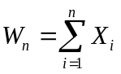 will both have a normal distribution. This is called the Central Limit Theorem (CLT) and is used to justify adoption of the normal distribution as a description of the variability in many phenomena. (See C&C Box PT5.1 in Section PT5.2.3.)
Another Continuous Random Variable: The Gamma Distribution
The gamma distribution is a very convenient “mathematical” distribution for describing strictly positive random variables.
Need to use the Gamma function: 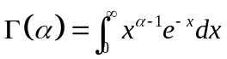
  - for α > 0 , Γ(α+1) = α Γ(α)
  - for integer k, Γ(k+1) = k!
  - 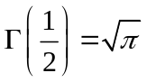

If X ~ Gamma(α, β), then it has probability density function:
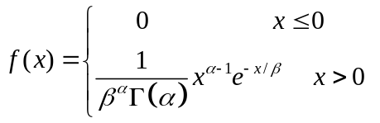
in which α = shape parameter > 0; β = scale parameter > 0

E[X] = α β Var[X] = α β ²

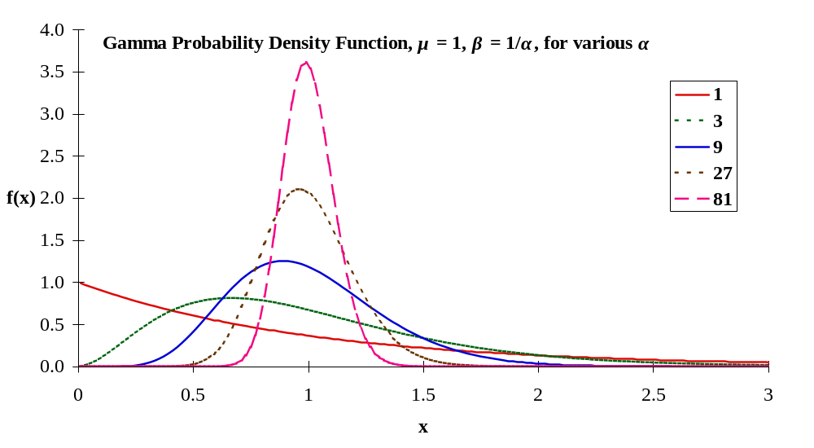
The following figure illustrates the shape of the pdf of the Gamma distribution for five values of α, all with β = 1/α so that the mean is always unity:

With Excel use GAMMADIST(x, alpha, beta, cum),
or GAMMAINV(prob, alpha, beta).
Exponential distribution
The exponential distribution is an important special case of the gamma distribution corresponding to α = 1. The exponential distribution has CDF and pdf

F(x) = 1 - exp(-x/ β) for x > 0
f(x) = (1/ β)e^{-x/β} for x > 0

with moments E[X] = β and Var[X] = β ²

The exponential distribution is the “waiting time” distribution. It describes the probability distribution of the waiting time until the first event if a process has no memory. Examples are the waiting time until the first injury on a job, an atom decomposes due to radio active decay, an emergency call comes into the fire department, or a defect appears in a wire or pipe.

Probability versus Statistics

Probability
Given the sample space and a sampling procedure (experiment), one determines the likelihood of different events that may occur.

Characteristics of Population → Probabilities of Events

Statistics
Methods for inferring (as best one can) the characteristics of the real world (some population) and making decisions based upon observed events. Statistics attempts to determine distributions used by nature from observations:

Observed Sample → Characteristics of Population

Types of questions one tries to answer using statistics:
- What distribution is nature using?
- Do materials meet specifications?
- Have pollutant levels increased?
- What is a good model to describe ...?
- What is the best way to collect data to determine if ...?

Statistics

Common Statistical Notation
Random variables: upper case letters X, Y, Z, X_{i}, Y_{i}, etc.
Observed values: lower case letters x, y, z, x_{i}, y_{i}, etc.
Greek letters: true parameters of distributions 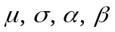
Greek letters with hats: parameter estimators 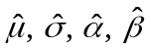
Numerical Example for use with following discussion of Confidence Intervals
Generated n = 25 numbers from normal distribution µ = 10, σ = 2. Here they are:

9.07 10.80 8.98 10.91 7.51
10.08 9.95 10.52 9.34 8.69
9.36 11.87 8.11 8.94 10.74
11.61 14.50 11.69 9.82 10.20
10.64 8.65 11.07 11.14 14.09

min = 7.51, max = 14.5, sample average, = 10.33, s = 1.65

Confidence Intervals (See C&C Section 5.2.3)
is the estimator of the mean µ of a normal distribution. Unfortunately:
P[ = µ ] = 0.
Thus this estimator is almost surely wrong. For the data above, we know the sample average, in this case 10.33, has zero probability of exactly equalling the true mean, 10.00. To construct an estimator that is frequently right, one can use an interval 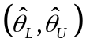 estimator. For fixed but unknown µ, the interval should cover µ with a specified probability, such as 95%. I(X₁,...,X_{n}) = is called a confidence interval.

How do we construct such estimators?
The Central Limit Theorem (p. X-7) states that, for large n: 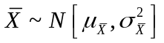where 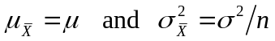
Thus 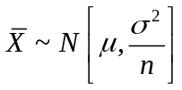 so that 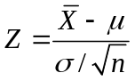 has a standard normal distribution N [0,1]. Hence
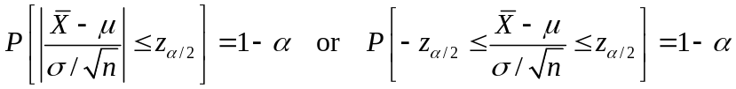

in which P[ Z ≥ z _{α /2} ] = α/2 where z_{α /2} is called a “critical value.” (This notation is like percentiles but uses the complement of p.) Thus it follows that
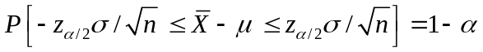
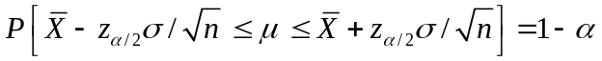
A 100 (1 – α)% confidence interval for the mean µ of the random variable X is
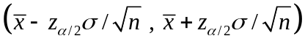
In repeated sampling, 100 (1 – α)% of such intervals will contain the true µ.
Mean of NORMAL data with UNKNOWN variance σ² (C&C PT 5.2.3)
The analysis above implicitly assumes the population standard deviation is known. In practice this is seldom the case. To overcome this problem statisticians have studied the distribution of
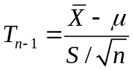
T_{n-1} has what is called a (Student) t distribution with mean zero and variance ν/(ν-2) where ν is the number of degrees of freedom in the sample variance s²;
ν = n–1 in this case. T_{n-1} has a distribution that is similar to a standard normal distribution, except that it has thicker tails (see C&C Fig. PT5.4). Using Student t tables [or TINV(alpha, d_of_f) and TDIST(x, d_of_f,tails) in Excel], one can find t_{α/2,n-1} so that:
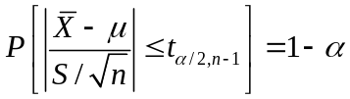
From the relationship above, it follows that
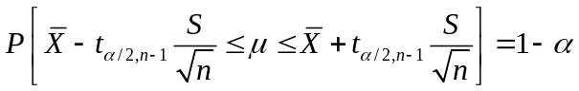
so a 100(1 – α)% confidence interval for the mean µ of X is
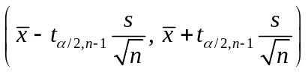

Example:
For the sample data above, a 90% confidence interval is
Thus we can be 95% confident that the true mean is between 9.65 and 11.01. The value of 2.064 was read from a full table like the following for α = 0.025 and v = 24. (It could also be calculated with Excel for these values.)

Critical Values for the (Student) t Distribution t_{α,ν}
ν α/2 = 0.10 0.05 0.025 0.01 0.005
100(1-α) = 80% 90% 95% 98% 99%

10 1.372 1.812 2.228 2.764 3.169
20 1.325 1.725 2.086 2.528 2.845
30 1.310 1.697 2.042 2.457 2.750
∞ 1.282 1.645 1.960 2.326 2.576 <— Standard Normal, z_{α/2}

The standard deviation of equal to σ/ is called its Standard Error.
In practice, one uses the Sample or Estimated Standard Error = s/.

Hypothesis Testing
How to make decision with data that exhibit variability.
A student-built robot should be able to navigate a difficult course and place a pin 12 meters from its starting location. Unfortunately, the distances vary from trial to trial. Your team manager suspects the robot is systematically underestimating distances, so that perhaps it gets the pin a distance of only 11 meters away, on average.
Imagine that distances in different trials can come from two possible distributions
Target, or Null Hypothesis: X ~ N [ 12.0, 1² ]
Alternative Hypothesis: X ~ N [ 11.0, 1² ]
Or we might say that X ~ N [ µ, σ² ] where either
State #1 - H_{o}: µ = 12 (σ = 1)
State #2 - H_{a}: µ = 11 (σ = 1)
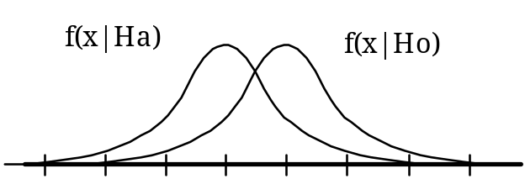
8 9 10 11 12 13 14 15
Here the expression f(x|H) is called the conditional probability. It is the probability that x occurs given that H is true.
You can run n trials, and then decide which is true.
How will we decide?
Accept H_{o}: µ = 12 if > c_{x}
Accept H_{a}: µ = 11 if ≤ c_{x .} This is rejection region for H_{o}.
c_{x} = critical or cut-off value x-value for test.

Type I error:
Type II error:
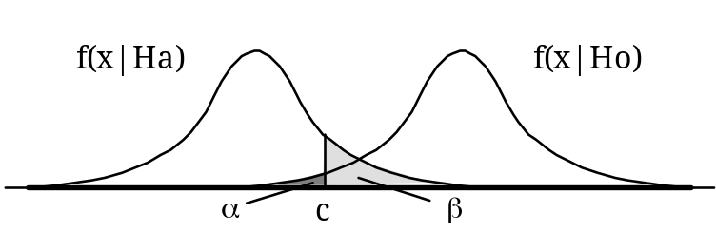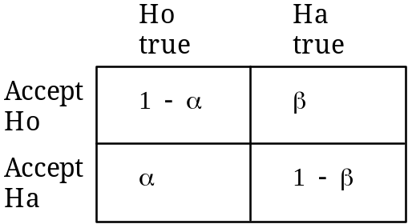
Formal Testing Procedure

Test Statistic: appropriate when σ is unknown
T is dimensionless and allows many problems to be formulated in a common framework.

If H_{o} is true, T_{n-1} ~ (Student) t-distribution with degrees of freedom υ = n – 1

Choice of Hypothesis
"Statistical tests are predisposed to accept H_{o}. A test is only effective if one collects sufficient data to reject the null hypothesis." Upon which hypothesis should burden of proof be placed?

Decision Rules
The null hypothesis is H_{o}: µ = µ_{o}

The test statistic value is 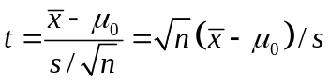
We construct a rejection region such that the Type I error probability is controlled to a desired level, i.e., we select an α.

If alternative hypothesis is | Then the rejection region for a level a test is
H_{a}: µ > µ_{o} | t ≥ t_{α,υ}
H_{a}: µ < µ_{o} | t ≤ –t_{α,υ}
H_{a}: µ ≠ µ_{o} | |t| ≥ t_{α/2,υ}

If H_{a} is true, then the type II error β can be computed from the type I error α, the degrees of freedom ν, and the standardized distance 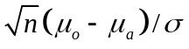

Example: On a national test the average is 75. We think Cornell students are smarter! So we randomly select 7 Cornell students and they take the test.

Obtain: = 81.3; s_{x} = 6.83; n = 7

Null Hypothesis: H_{o}: µ = 75
Alternative Hypothesis H_{a}: µ > 75

Compute t = 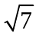 (81.3 - 75)/6.83 = 2.45. Use α = 1% ⇒ t_{0.01,6} = 3.143.
Because t < t_{α,υ}, we should not reject the Null Hypothesis. Maybe Cornell students are not so smart after all? But what if one used α = 2.5%, 5%, or 10%? Or if we took a larger sample?
P-Value is the smallest value of the type I error α such that the observed results would be sufficient to reject the null hypothesis. It is a convenient summary of the statistical significance of the observed result. For H_{o}: µ = µ_{o}, the P-values for each of the three alternative hypothesis above are
µ > µ_{o} P-value = Pr{T > t_{obs }} upper tailed-test
µ < µ_{o} P-value = Pr{T < t_{obs }} lower tailed-test
µ ≠ µ_{o} P-value = 2 Pr{T > | t_{obs}| } two tailed-test
in which t_{obs} is the observed value of the t-statistic.

Statistical Treatment of Least Squares Regression
(See C&C Sections 17.1.3 & 17.4.3 & 19.8.1; see also Lecture Notes 5)
Statistical analysis issues
Linear models are perhaps the most useful tool in the traditional statistical tool box. They can be used to address many common concerns, such as:
- does the phenomena described by the variable X affect some other process described by Y, or,
- knowing the value of X, what is the best prediction of the value of Y?
Questions of concern
How to predict Y best?
How best to estimate model parameters?
How accurately can we predict Y?
How accurately can parameters be estimated?
Does β have an anticipated value?
Does X affect Y (β = 0)?
Statistical model for observations Y_{i} given independent variable x_{i}
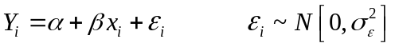
Engineer picks x_{i} and then observes Y_{i}.
Y_{i} = measured “dependent” variable.
x_{i} = fixed “independent” variable.
ε_{i} = independent measurement error & randomness associated with i^{th} observation.
Three key assumptions about the errors ε_{i}
Errors are assumed to be
(i) independently distributed,
(ii) normally distributed, with
(iii) zero mean and common (constant) variance 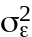.
Then conditional upon fixed values of the x_{i}:
E[ Y_{i} | x_{i} ] = E[α + β x_{i} + ε_{i} ] = α + β x_{i}
Var[ Y_{i} | x_{i} ] = Var[α + β x_{i} + ε_{i} ] =

Parameter Estimators and their Distribution
If the assumptions of independent, normally distributed errors with constant variance hold, then the most statistically efficient unbiased estimators of the model parameters result from minimizing the sum of squared errors:
min 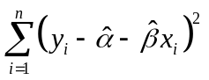
which yields the estimators of α,   β, and :
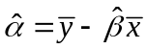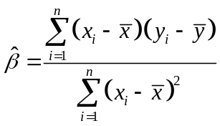
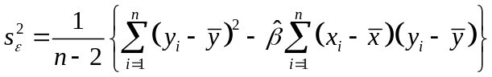
Here hats are used to distinguish the estimators from the true values of α and β.

Using the three key assumptions about the errors, one can derive the sampling distributions of the estimators 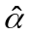 and 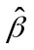 of the two model parameters α and β. The estimators and are normally distributed with means and variances:
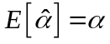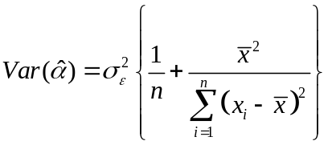
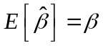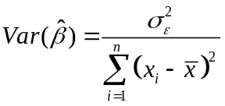
As a result of dividing by (n-2), 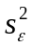 is an unbiased estimator of the error variance . (Actually, has a gamma distribution with α_{g} = υ/2 and β_{g} = 2/υ.) C&C Section 17.4.3 provides more general expressions for multivariate regression.
The variances of the 2 parameters depend upon the unknown value of σ_{ε}² which generally must be estimated from the data. As a result, hypothesis tests and confidence intervals pertaining to α and β need to use a Student t-distribution (with degrees of freedom n – 2 in this case) rather than a normal distribution. Statistical packages will compute the standard errors of and , which are just the square root of their variances above with s_{ε}² substituted for σ_{e}². (See C&C Section 17.4.3, Example 17.4; and Example 19.4)

Goodness-of-Fit for a Regression
Goodness-of-Fit is often measured by the proportion of the observed variance in the y_{i} explained by the fitted regression line:
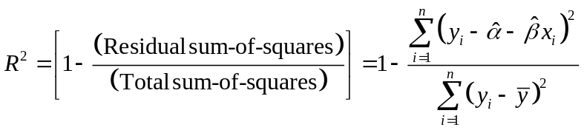
This is called the coefficient of determination. An alternative is adjusted ²:
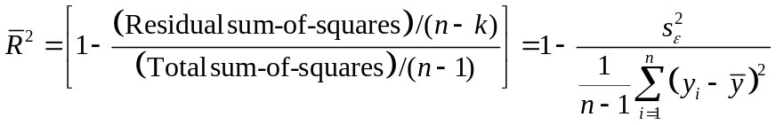
in which k is the number of parameters estimated, in our case k = 2. R² never decreases when a variable is added to a model. ² increases only if the residual mean square error decreases. As a result ² is more useful than R² for comparing models with different numbers of parameters. ² is a re-expression of the estimated error variance in a dimensionless and easy-to-understand form. Large ² corresponds to small

Sampling Characteristics of Predictions
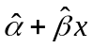 is the natural estimator of the mean value of Y for any value of x. Because and are unbiased, is also an unbiased estimator of the value of Y associated with a fixed x. Of concern is how accurate is as an estimator of a future value of Y associated with a specified x. One finds that:
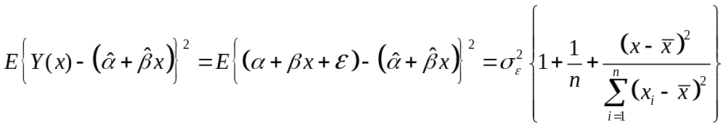where in most cases the second two terms are relatively small, so that
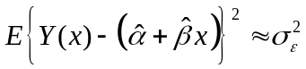, which is estimated by .
Example: Use of Excel for Regression
C&C in Table 17.2 present data used as an example of regression in Section 17.4.3. Here that example is analysed with the Regression algorithm in the Excel Toolpack (C&C Section 19.8) to illustrate typical regression statistics. C&C report a ridiculous number of digits, as does Excel. Results here are rounded – one should present data so as to honestly reflect its precision.

_{SUMMARY OUTPUT}
_{Regression Statistics}
_{Multiple R} _{0.998}
_{R Square} _{0.996}
_{Adjusted R Square} _{0.995}
_{Standard Error} _{0.863}
_{Observations} ₁₅
_{ANOVA}
_{df} _{SS} _{MS} _{F} _{Significance F}
_{Regression} ₁ _{2286.94} _{2286.94} _{3067.8} _{8.0E-17}
_{Residual} ₁₃ _{9.69} _{0.75}
_{Total} ₁₄ _{2296.64}
_{Coeff} _{St Error} _{t Stat} _{P-value} _{Lower 95%} _{Upper 95%}
_{Intercept} _{-0.859} _{0.716} _{-1.20} _{0.25} _{-2.406} _{0.689}
_{v(meas)} _{1.032} _{0.019} _{55.39} _{8.0E-17} _{0.991} _{1.072}

The first table with Regression Summary statistics reports the values of R and R², the value of adjusted ², and finally the estimated standard deviation of the residuals s_{ε} called the standard error. The summary shows that there were n = 15 observations.

The second ANalysis Of VAriance (ANOVA) table reports the sum-of-squared (SS) values of the Regression-Sum-of-Squares, Residual-Sum-of-Squares and Total-Sum-of-Squares used to compute R², and the degrees of freedom (df) associated with each; Reg-df = 1 for the slope parameter, Residual-df = n – 2 and Total-df = n – 1 because the total sum of squares is computed around the sample mean. (Also Regress-SS + Residual-SS = Total-SS). These are accompanied by the Mean Square (MS) error equal to , and an F statistic used to determine whether the regression overall is statistically significant. The “significance of F”, equal to Pr[ F > 3067.8 ], is also reported.

The last table reports the least-squares estimates of the two coefficients b_{i} called the intercept and the coefficient of v(meas). For each coefficient the table reports the estimated standard deviation SE(b_{i}) called the standard error, the t statistics computed as b_{i}/SE(b_{i}), and the two-tailed P-value equal to twice Pr[ T > | b_{i}/SE(b_{i})| ]. Finally the table gives a 95 percent confidence for the true but unknown value of each coefficient. That is a lot of information!
Statistical Analysis with Excel
Excel is a very power computational environment, which includes capabilities for many statistical operations. Excel 2000 has 81 statistical and 59 mathematical functions. [Look under menu item INSERT>Statistics... ] You should use EXCEL help feature to find out more about statistical features in EXCEL, and exactly how each function works.

Basic statistical functions include:
- AVERAGE(array)
- GAMMADIST( x_value, alpha, beta, cumulative? )
- GAMMAINV(probability, alpha, beta )
- MAX( array )
- MIN( array )
- NORMDIST( x_value, mean, st_dev, cumulative? )
- NORMINV( probability, mean, st_dev )
- RANK( number, array, order? )
- STDEV (array )
- TDIST( x_value, degrees_of_freedom, tails? )
- TINV( probability, degrees_of_freedom ) (two tails: probability/2 in each tail)
- TTEST( x_array, y_array, tails?, type )
- TREND( y_array, x_array, new_x_array, constant? )
- See also SLOPE, INTERCEPT, GROWTH, LOGEST
- VAR(array)
Here “array” would be an expression such as A1:A25, or the name of an array.

Excel can also perform more sophisticated analysis as part of its Data Analysis Toolpack. Look under menu item Tools>Data Analysis... There you will find:
- Descriptive Statistics
- Histogram
- Random Number Generation
- Rank and Percentile
- Regression
- Sampling
Each of these choices generates a dialog box that prompts the user for the needed input information, and provides output options. These functions are not immediately re-invoked when data changes, as happens when the basic spreadsheet functions are included in a cell. The Tools>Data Analysis... procedure must be repeated with each new set of data. C&C Section 19.8.1 illustrates use of the Excel Toolpack Regression option.

