**Milestone #1**

GVSU Philanthropy Application

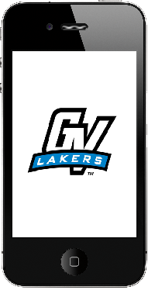

Developers: Daniel Newell, Nicholas Workman, Thomas Peterson, Joshua Walker

Professor: Jonathon Engelsma

* **Data Collection and Entry**

Our data collection has been going very well. We have collected much of the information that we will use to drive our application. The most time consuming piece of the data collection was obtaining the GPS coordinates of all of the buildings on all three of Grand Valley State University Campuses. We have successfully collected all of the information for our application now. This includes all of the information about the donors as well as the physical locations of the buildings.

We have decided not to use a dynamic database for this application because the information that is used to drive our application is not changed very often. And since the database does not need to be updated, with the exception of renaming or constructing a new building, it made more sense from an application standpoint to use core data.

We are currently in the process of putting all of our data into the core data function of the application this will allow us to test the overall functionality of the application. From a UI standpoint this information is needed to be able to test overall functionality.

* **User Interface**
* **Setbacks and Learning Difficulties**

We have had a few setbacks that have prohibited us from reaching where we would like to be at this moment. One major goal is just getting time to work on the application. Only one group member in our team has a MAC, the rest of us have had to get virtual machines or physically get to the downtown lab to work on the project. This is something we knew about going in and is just something we have to flat out overcome as a group. It is important that we continue to work together to make as much progress as possible as a team.

Other setbacks that we have had are physical such as getting time where we can meet together as well as inclement weather.

One of the major learning difficulties we have had as a group is learning to use XCode and to program in C# which is the IOS development language. This is all new to everyone in our group so it is taking us a little longer then we would have liked to familiarize ourselves with the new languages and development environments.

With all that being said we are still confident that we can continue to make the progress that we would like to on this application by the next Milestone.

* **Moving Forward**
* **Gnatt Chart**