ImageGear Extensions: A Primer


This document has been written to help you understand Extensions and the relationship between ImageGear and its Extensions.

Extensions are exactly what their name implies. They are not a stand-alone product, but an extension of an existing product; in this case, ImageGear. By themselves, the Extensions can do nothing. But attached to ImageGear, they add new functionality and expanded possibilities to the original base product. Sometimes extensions are referred to as “plug-ins”.


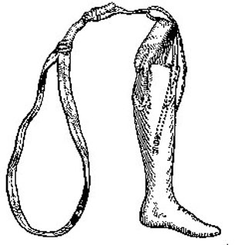
Think of an Extension as a prosthetic. A false leg can’t do anything by itself. But attach it to a working body and now that body can stand, walk, run and do things it couldn’t do without the artificial limb. The body doesn’t need the limb to basically function, but by adding the limb the body can do a whole lot more than it could do without the limb.
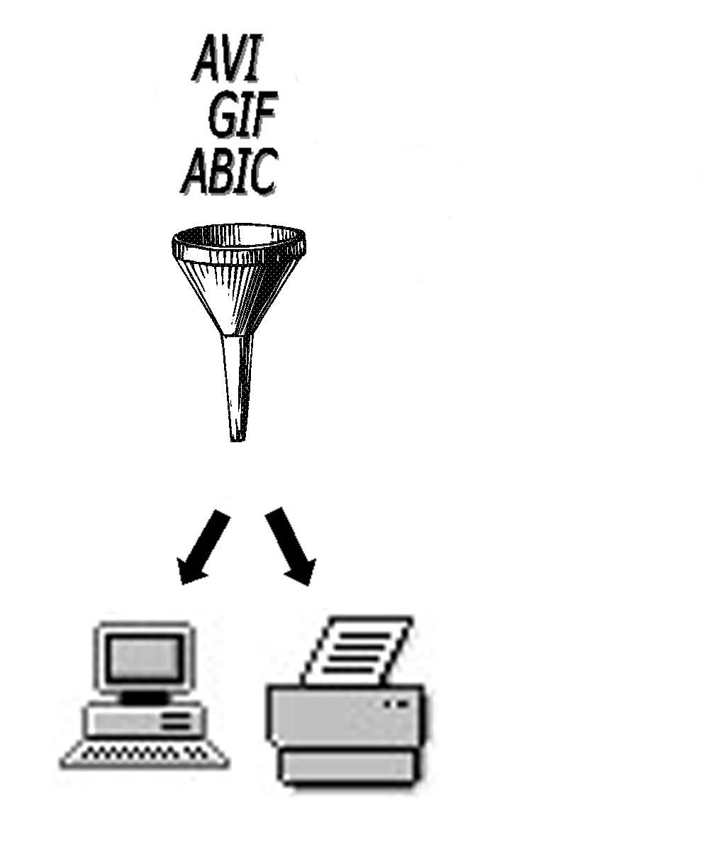

Some of the Extensions function as file format filters. This means that they allow ImageGear to read and/or write a certain type of file format (e.g. GIF). Some of the Extensions have an extensive API (Application Programmer’s Interface), which allows the user access to functionality not present in the base product (ImageGear). Some of the extensions are both format filters and APIs.

Most of our Extensions were designed to work with both the DLL and the OCX products. Basically, everything comes from the DLL. We can make it work with the OCX by taking the DLL functionality and “wrapping” an OCX around it, thereby creating a new layer of commands, called “properties” and “methods”, to access the DLL functions. In some cases there are no OCX versions of an Extension because the OCX can load and use the DLL as it is. This is how it works for the basic file format filters (LZW, AVI). Only if there is an API in the extension would an OCX version need to be created for OCX users to be able to access the Extension’s functionality, for example ART 2.0.
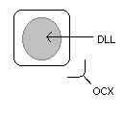

Copyright
ImageGear is a registered trademark of AccuSoft Corporation. Information in this document is subject to change without notice. No part of this document may be reproduced or transmitted in any form or by any means, electronical or mechanical, for any purpose, without the express written permission of AccuSoft Corporation.
©1999 AccuSoft Corporation. All rights reserved.

