### SIENA COLLEGE

**25th Annual**

### High School Programming Contest

##### April 20, 2012

###### **Problem #4: Calculator Palindromes**

Background Information: A number which is palindromic is a number which is the same when read either from left to right or from right to left. For example, 9, 11 and 121 are numeric palindromes, while 10 is not (no leading zeroes allowed). A *calculator palindrome* is a number which is the same when read left to right on a calculator as well as left on a calculator inverted (upside-down). Flip this page upside down to see what each digit is converted to when turned upside down.

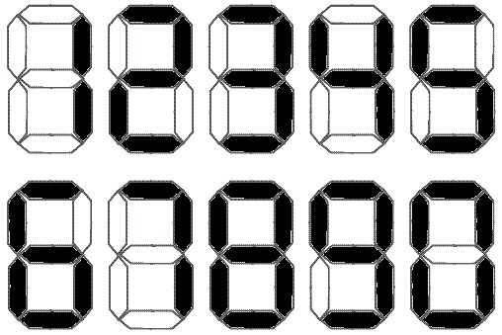

In this problem, you will write a program that calculate the number of calculator palindromes between two input numbers x and y inclusive, where x ≤ y. As a clarification, a one digit (“1”) upside down is still a one digit, even though it is not exactly its inverted image. For example, 62258011085229 is a calculator palindrome.

###### Programming Problem:

Input: Two non-negative numbers x, y at most 1 million.

Output: The number of calculator primes on the interval [x, y].

###### Example 1: Input: **0 2**

###### Output: 3

###### Example 2: Input: **10 100**

###### Output: 6

Example 3: Input: **1000 10000**

Output: 42

Example 4: Input: **36748 41221**

Output: 0

