CanOE

1. Download a sample DB from sample configuration and save the database from simulation setup
2. Open a default configuration and give a name

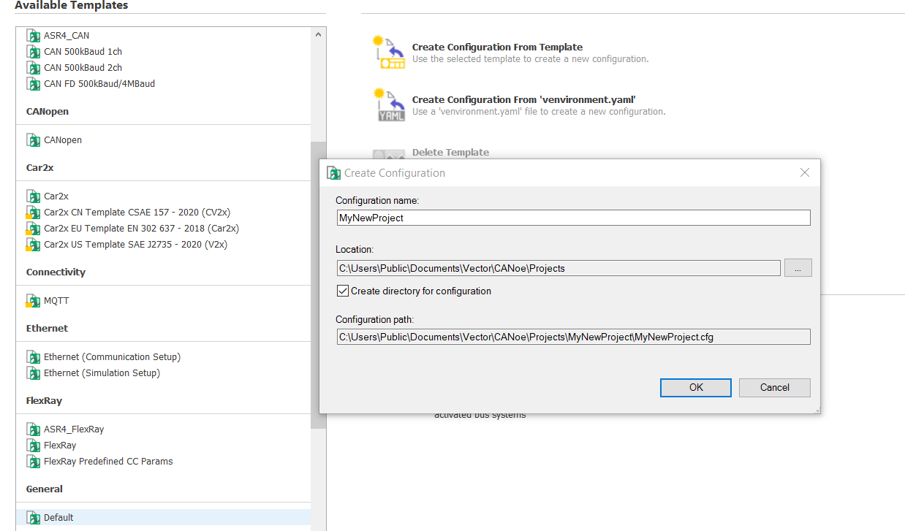

1. Go to simulation setup add the insert network node
2. Add the Sample DB in the simulation setup

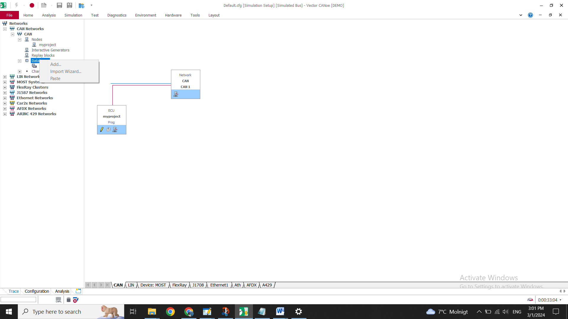

1. Using the edit button in your network node navigate to CAPL studio

CAPAL SCRIPITING

It is divided into : system variable,environmental variables,Event ptocedure

In event procedures we have diffent events

* Onstart() and stop()
* Can message to react of that message and signal
* User shortcuts onkey()
* Timeout of a timer
* User i/p via graphic panel

1. CAPL DATATYPES

* Variable,int,string,float
* Msg variable(system and environmental variable)
* Timer variable(millisecond or second)

1. System variables

* Predefined and read only variables

Envronmental Variables

* User defined values

1. We can start CAPL scripting using declaring the variables

message 0x207 ControlMsg;//for message 0x207 we give a name as ControlMsg

msTimer Timer_ControlMsg;

1. We can also add the event like this system---->New event Handler

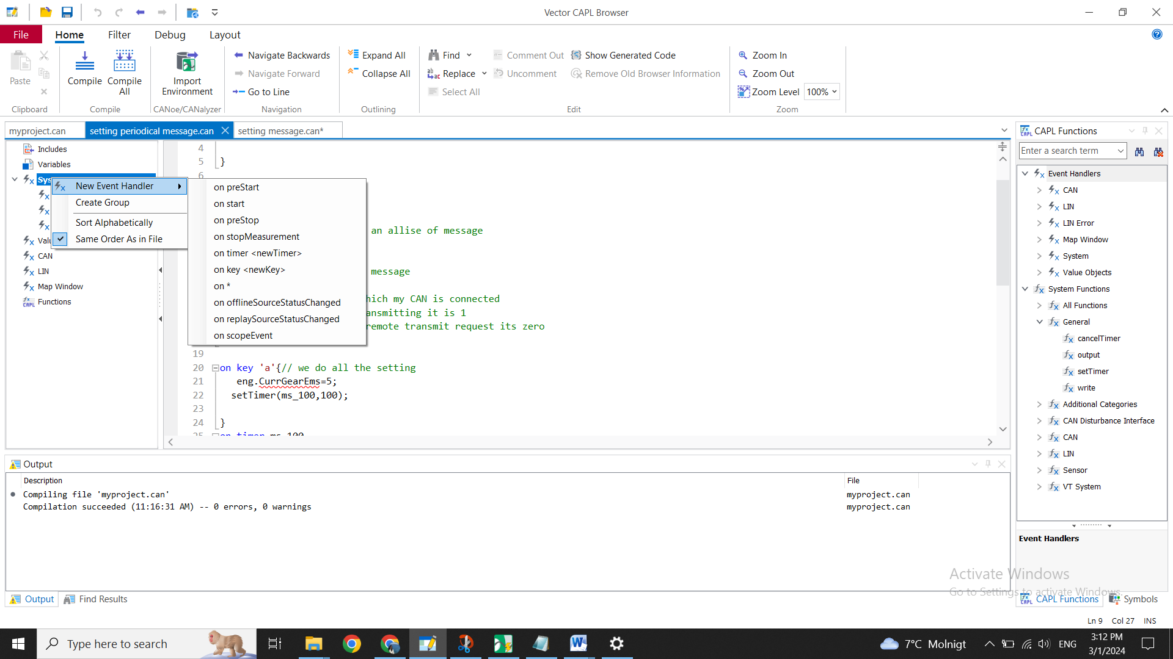

1. We start with onstart() method

setTimer(Timer_ControlMsg,10);//setTimer(Name of the timer,Length of the timer)

1. Then we give on Timer <Name of the timer decalared as a varaible>

on timer Timer_ControlMsg

ControlMsg.HeightAdjustmentDown=1//messagename.signal name from DB and set a value

output(ControlMsg);//display the output

setTimer(Timer_ControlMsg,10);//periodically to call the timer message //this on timer will be called periodically because setTimer is again setting the timer value of 10 whenever the timer is expiring

1. On key event to declare user keyboard entry from we press a particular key it will be peform a particular event

on key 'a'

{

cancelTimer(Timer_ControlMsg);

}

1. To call the system variables we have to define go to environment tab and click on the system variable
2. Right click and give new

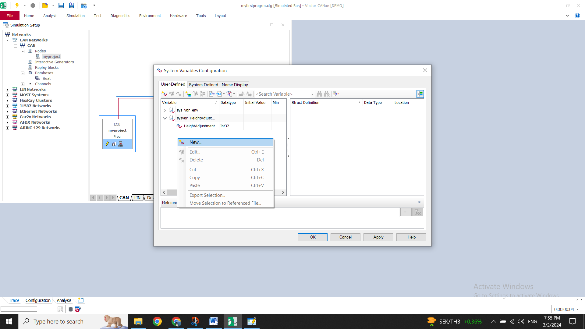

1. Give the system variable and name and assign the required datatype

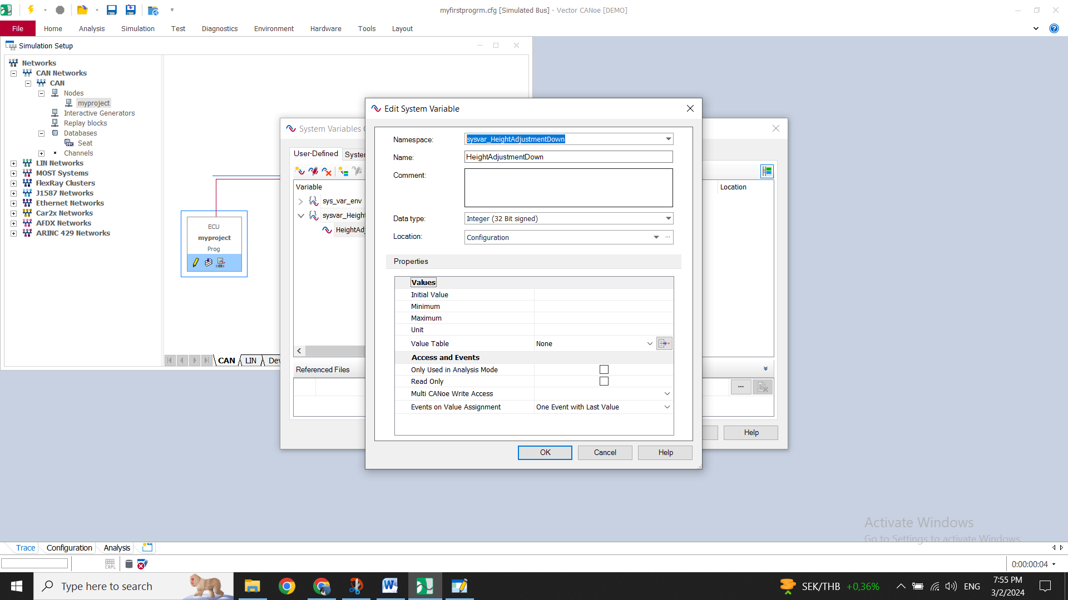

1. Save the changes in canoe and in CAPL give the following code

Systemvariable::name assigned in the signal varibla

=@sysvar_HeightAdjustmentDown::HeightAdjustmentDown;

1. To view it in the graphic trace go and add the system variable to the graphic trace

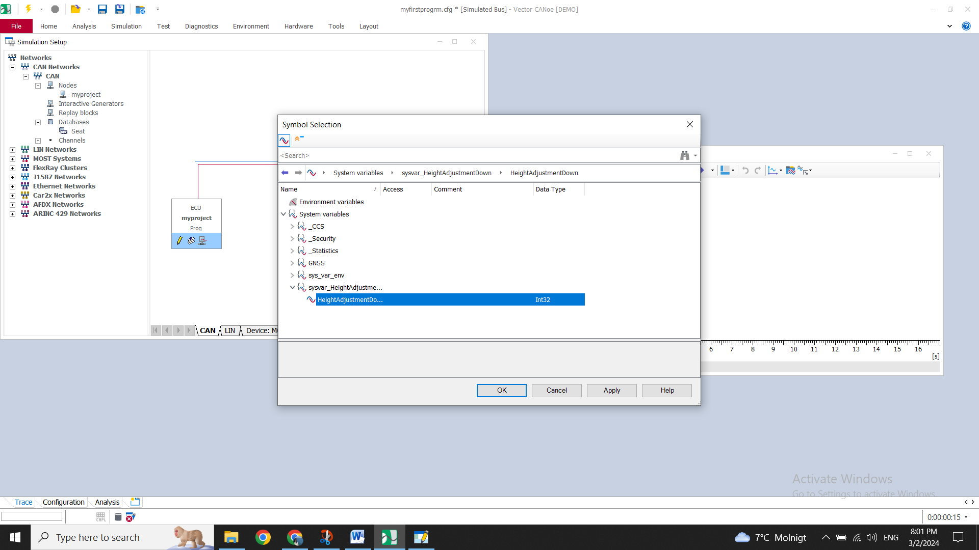

1. In home go to panel and new panel
2. Pick and drop i/o box
3. Drag and drop the system variable signal value into the box and save the panel
4. The panel will be saved in .xvp file
5. Close the tool and view in the canoe tool panel-🡪 open panel which was created

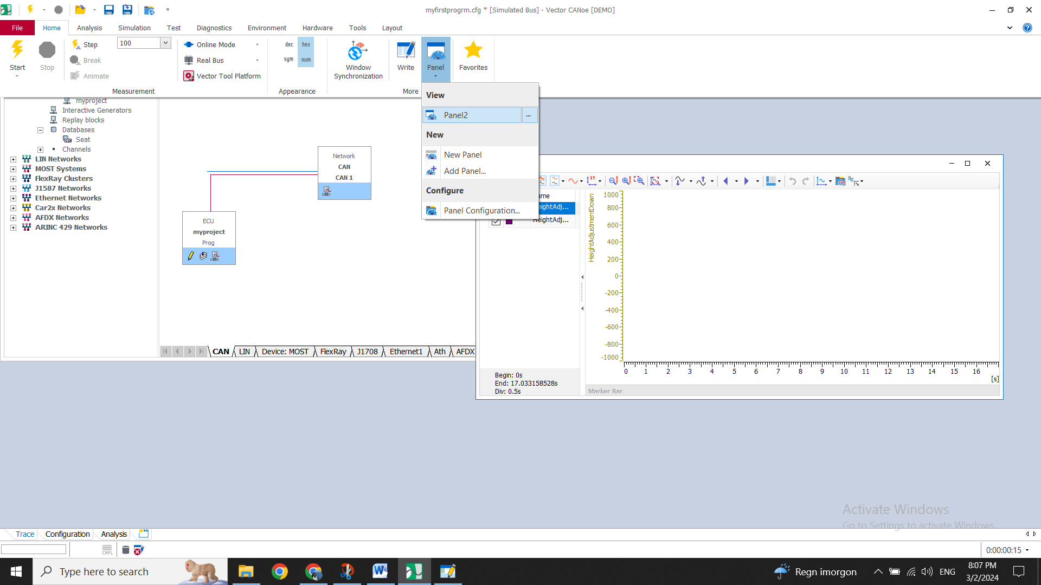

1. We can open the panel and start the simulation
2. You can give the value in the panel and check if its reflected in the trace window

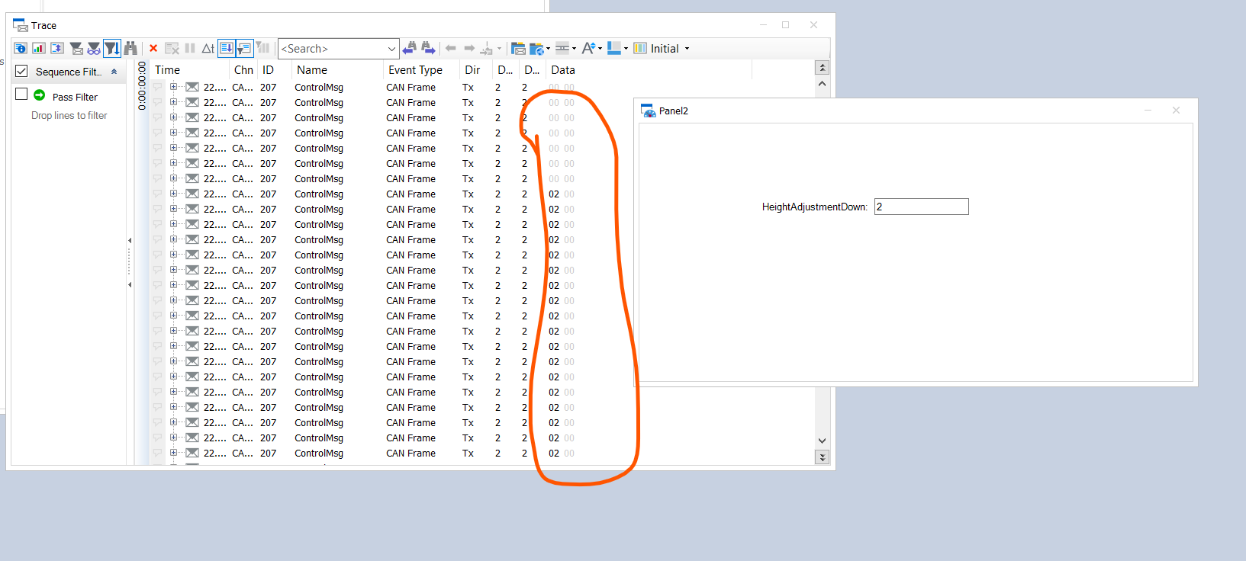

1. The data value being changed when you change in the panel
2. You can also write this to see that its reflected in write panel

on message ControlMsg{

HeightAdjustmentDown=this.HeightAdjustmentDown //we declare HeightAdjustmentDown as a float value at the variable declaration

write("Can message is recived");

write("Height:%h",HeightAdjustmentDown);}

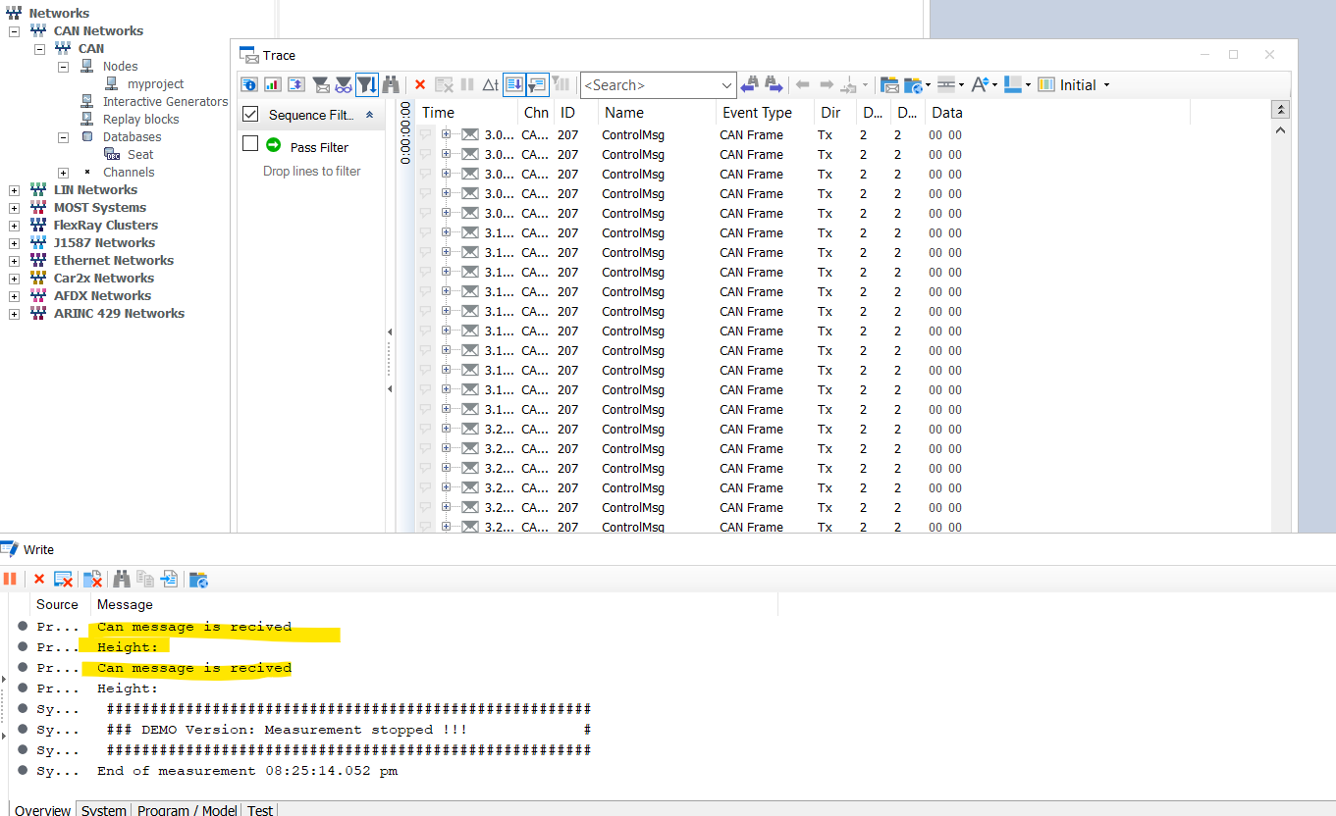

1. If you want to increament the signal you can add like this

@sysvar_HeightAdjustmentDown::HeightAdjustmentDown +=1

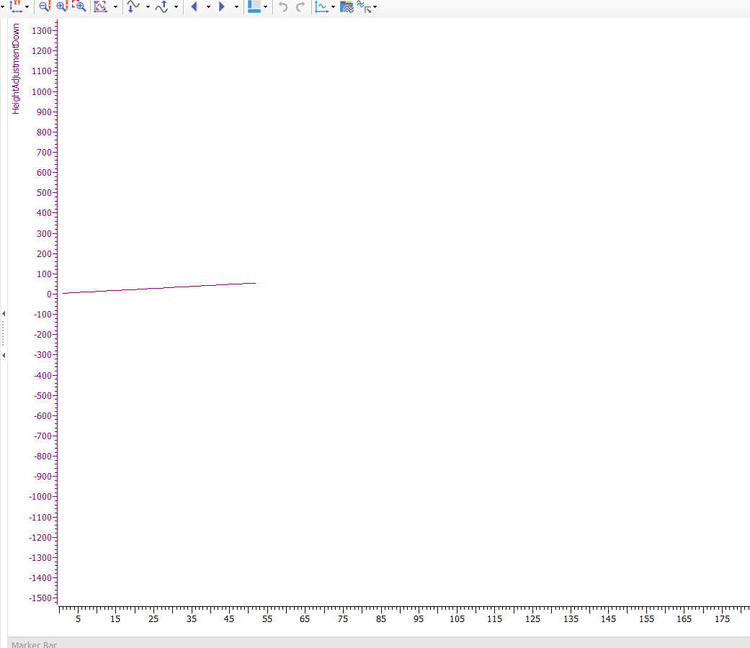

1. If you want to increment to a particular point and then make it to zero

if( @sysvar_HeightAdjustmentDown::HeightAdjustmentDown == 200)

{

@sysvar_HeightAdjustmentDown::HeightAdjustmentDown =0;

}

else

{

@sysvar_HeightAdjustmentDown::HeightAdjustmentDown +=1;

}

