**A. Admin Agents QR Code**

1. Login to Admin module.

2. Go to Agents module.

3. Get the QR code and scan to redirect with agent member registration page.  
  
 **B. Admin Agents using code**

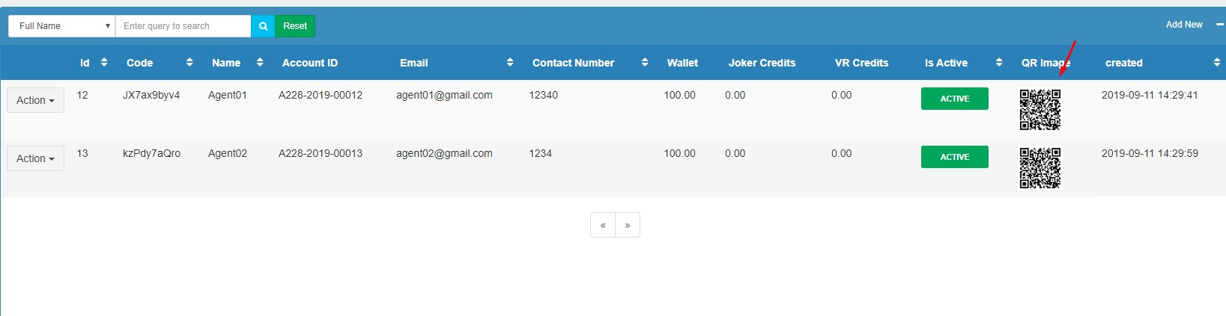

1. Login to Admin module.

2. Go to Agents module.

3. Get the code of the agent in the list and use the code in the url   
 Eg. <http://staging.asia228.net/member_registration/your-agent-code>  
  
**C. Agent Module**

1. Login to your agent account.

2. Go to Account Profile and scan QR image.

