Key word: Change over time , Line chart , <4 categories

1.1.
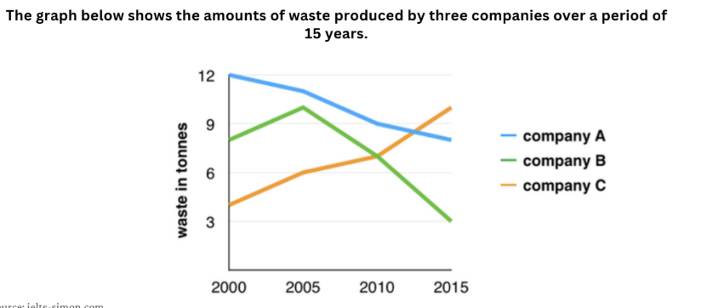

Dưới 4 categories chia đôi theo thời gian:
Body 1: 2000 – 2005, body 2: 2010 – 2015

Introduction
The graph illustrates how much waste was produced by three companies over a period of 15 years.
Overview
Overall, there was a decline in the amount of waste produced by company A and company B, while an opposite trend was seen in company C. In addition, company A generally had the highest figures throughout the period.
Body 1: From 2000 to 2005
In 2000, the amount of waste produced by company A started at 12 tonnes, after which it experienced a decline to 11 tonnes in 2005. The figure for company B started at 8 tonnes in 2000, before rising to reach a peak at 10 tonnes in 2005. Conversely, the amount of waste for company C started at 4 tonnes, going up to 6 tonnes in 2005.
Body 2: From 2005 to 2015
From 2005 to 2015, the figure for company A continued to decrease, ending the period at 8 tonnes. Similar changes, but to a greater extent, were seen in the figure for company B, which dropped significantly to end the period at 3 tonnes in 2015. Conversely, the amount of waste produced by company C went up significantly to reach the highest point at 10 tonnes in the final year.
💡 Tóm tắt các cấu trúc bạn đã dùng trong bài:
- Intro: how much + [N không đếm được] + [was/were + V3/ed] + [Mô tả] + [Thời gian]
- Overview: Overall, there was a decline in... in [Group 1], while an opposite trend was seen in [Group 2]. In addition, [Category] generally had the highest figures throughout the period.
- Body 1: A started at... after which it experienced a decline to... / B started at... before rising to reach a peak at...
- Body 2: Similar changes, but to a greater extent, were seen in the figure for B, which [hành động], ending the period at... / Conversely, C went up significantly to reach the highest point at... in the final year.

Keyword: change overtime, bar chart, >5 categories

1.2.
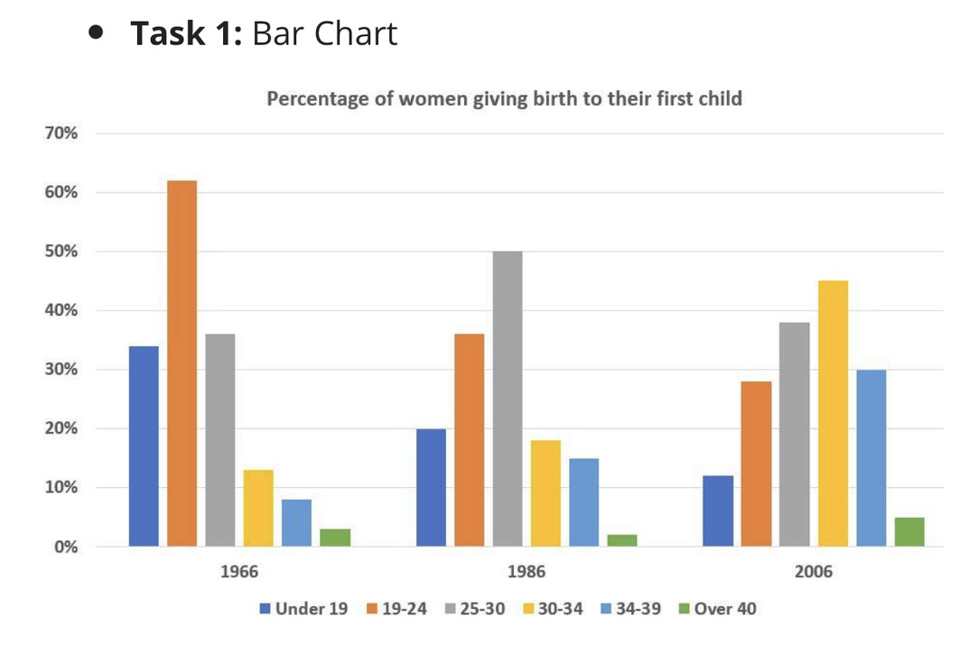
ntroduction
The chart illustrates how many women in six age groups gave birth to their first child between 1966 and 2006.
(Mẹo: Tỷ lệ phần trăm % nhưng biểu đồ thể hiện nhóm đối tượng phụ nữ [women] nên áp dụng cấu trúc đếm được: how many + [Danh từ số nhiều] + [Verb] + [Thời gian] rất chuẩn xác!)
Overview
Overall, there was a decline in the proportion of young mothers under 25, while an opposite trend was seen in the older age groups. In addition, women aged 19-24 consistently had the highest figures in 1966, but they were surpassed by the 30-34 group in the final year.
Body 1: Nhóm giảm (Under 19 & 19-24)
The proportion of women aged 19-24 started at 62% in 1966, after which it experienced a decline to 36% in 1986, before decreasing to end the period at 28% in 2006. Similar changes, but to a lesser extent, were seen in the figure for the under 19 group, which dropped from 34% in 1966 to 20% in 1986, followed by a final decrease to 12% in 2006.
Body 2: Nhóm tăng & biến động (30-34, 34-39, Over 40 & 25-30)
Conversely, the figure for women aged 30-34 started at 13% in 1966, going up significantly to 18% in 1986, and reaching the highest point at 45% in 2006. A similar upward trend was recorded in the 34-39 and over 40 groups, ending at 30% and 5% respectively in the final year. On the other hand, the proportion of mothers aged 25-30 started at 36%, rose to reach a peak at 50% in 1986, before decreasing to 38% in 2006.
💡 Tóm tắt các cấu trúc đã chọn lọc và áp dụng từ dàn bài của bạn:
- Intro: The chart illustrates how many women... between 1966 and 2006.
- Overview:
  - Overall, there was a decline in... while an opposite trend was seen in...
  - In addition, [Group A] consistently had the highest figures... but was surpassed by [Group B]...
- Body 1 (Cấu trúc 1 & 3):
  - A started at..., after which it experienced a decline to..., before decreasing to end the period at...
  - Similar changes, but to a lesser extent, were seen in the figure for B, which [hành động], followed by [kết thúc].
- Body 2 (Cấu trúc 2, 4 & 5):
  - Conversely, the figure for C started at..., going up significantly to... and reaching the highest point at... in [năm cuối].
  - D started at..., rose to reach a peak at... in [năm], before decreasing to [số cuối] in [năm cuối].

Key word: change over time, table, <4 categories

1.3.

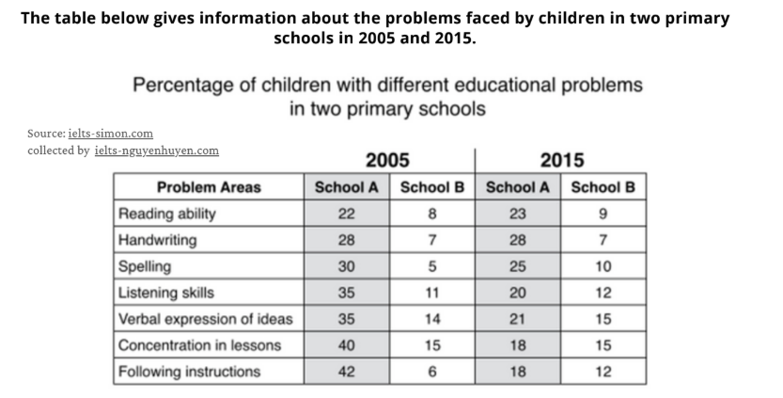
Introduction
The table illustrates how many children experienced educational problems in two primary schools in 2005 and 2015.
Overview
Overall, there was a decline in the proportion of children facing most educational problems in School A, while an opposite trend was seen in School B. In addition, School A consistently recorded higher figures for almost all problem areas compared to School B throughout the period.
Body 1: In 2005
In 2005, the percentage of students having difficulties with following instructions in School A started at 42%, making it the highest figure in this school. High figures were also recorded for concentration in lessons, listening skills, and verbal expression, all ranging between 35% and 40%. Conversely, School B recorded much lower figures for all problem areas in 2005, with concentration in lessons reaching the highest point at only 15%, while spelling was the lowest figure at just 5%.
Body 2: In 2015
In 2015, the figure for following instructions in School A dropped significantly to end the period at 18%. Similar changes were seen in concentration, listening skills, and verbal expression, which decreased to around 18%-21% in the final year. Conversely, the figures for most problem areas in School B experienced slight increases, with spelling and following instructions going up to 10% and 12% respectively, while concentration in lessons remained unchanged at 15% in 2015.
💡 Tóm tắt cấu trúc áp dụng:
- Intro: The table illustrates how many + [N số nhiều] + [Verb] + [Mô tả] + [Thời gian].
- Overview: Overall, there was a decline in... in [Group 1], while an opposite trend was seen in [Group 2]. In addition, [Group A] consistently recorded higher figures...
- Body 1 (So sánh mốc đầu):
  - A started at [số liệu], making it the highest figure...
  - Conversely, B recorded much lower figures..., with [tiêu chí] reaching the highest point at...
- Body 2 (So sánh mốc cuối & xu hướng):
  - A dropped significantly to end the period at [số liệu].
  - Similar changes were seen in..., which decreased to...
  - Conversely, the figures for... experienced slight increases..., while... remained unchanged at...

Key word: change overtime, line chart, 4 categories

1.4.
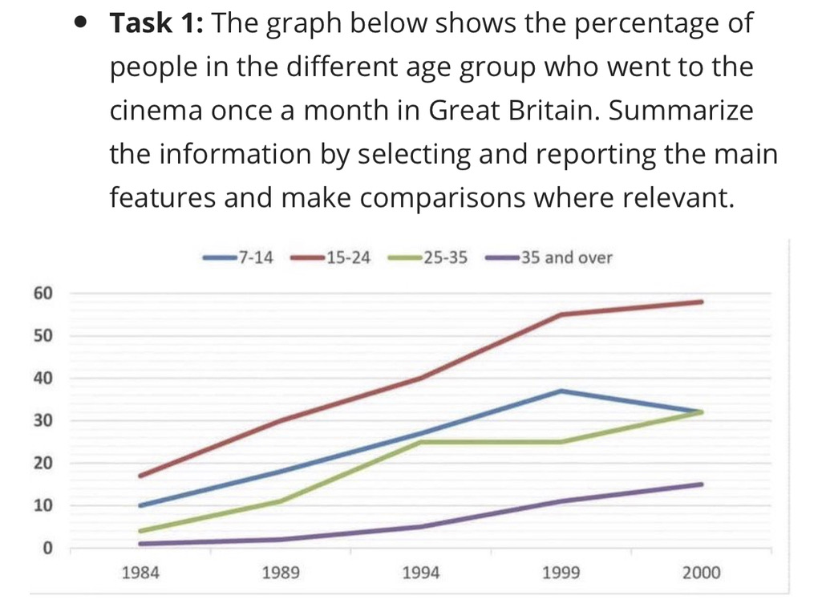

Introduction
The graph illustrates how many people in four age groups went to the cinema at least once a month in Great Britain between 1984 and 2000.
Overview
Overall, there was an increase in the proportion of cinema-goers in all four age categories examined. In addition, people aged 15-24 consistently recorded the highest figures, while the 35 and over group maintained the lowest figures throughout the period.
Body 1: Nhóm 15-24 và Nhóm 35 and over
The proportion of people aged 15-24 started at 17% in 1984, going up significantly to 55% in 1999, and reaching the highest point at 58% in 2000. Conversely, the figure for the 35 and over group started at only 1% in 1984, before increasing steadily to end the period at 15% in the final year.
Body 2: Nhóm 7-14 và Nhóm 25-35
The figure for children aged 7-14 started at 10% in 1984, after which it saw a steady rise to reach a peak at 37% in 1999, before decreasing to end the period at 32% in 2000. Meanwhile, the proportion of people aged 25-35 started at 4% in 1984, grew to 25% in 1994, with a subsequent levelling off until 1999, and a final rise to 32% in 2000.
💡 Tóm tắt các cấu trúc đã áp dụng từ dàn bài của bạn:
- Intro: The graph illustrates how many + [N số nhiều] + [Verb] + [Mô tả/Địa điểm] + [Thời gian].
- Overview (Option A):
  - Overall, there was an increase in... in all four categories examined.
  - In addition, [Category A] consistently recorded the highest figures, while [Category B] maintained the lowest figures throughout the period.
- Body 1 (Cấu trúc 4 & 5):
  - A started at..., going up significantly to... in [năm], and reaching the highest point at... in [năm cuối].
  - Conversely, the figure for B started at..., before increasing... to end the period at...
- Body 2 (Cấu trúc 2 & Cấu trúc Body 2 cơ bản):
  - C started at..., after which it saw a steady rise to reach a peak at... in [năm], before decreasing to end the period at... in [năm cuối].
  - Meanwhile, D started at..., with a subsequent levelling off... and a final rise to...

Key word: change over time, bar chart, 4 categories

1.5.

Introduction
The bar graph illustrates how much money was spent on four types of digital games globally between 2000 and 2006.
Overview
Overall, there was an increase in global sales in three categories examined, while an opposite trend was seen in Console Games. In addition, Handheld Games consistently recorded the highest figures throughout the period.
Body 1: Handheld Games & Console Games
The amount of money spent on Handheld Games started at 11 billion dollars in 2000, going up significantly to 15 billion dollars in 2005, and reaching the highest point at nearly 18 billion dollars in 2006. Conversely, the figure for Console Games started at around 6 billion dollars in 2000, after which it experienced a decline to 4 billion dollars in 2003, before decreasing to end the period at only 3 billion dollars in 2006.
Body 2: Mobile Phone Games & Online Games
There were no recorded sales for Mobile Phone Games and Online Games in 2000. However, the figure for Online Games started at under 1 billion dollars in 2001, with a subsequent increase to around 6 billion dollars in 2005, and a final rise to 9 billion dollars in 2006. Similar changes were seen in the figure for Mobile Phone Games, which grew steadily to around 3.5 billion dollars in 2004, before rising to end the period at nearly 7 billion dollars in the final year.
💡 Tóm tắt các cấu trúc đã áp dụng từ dàn bài của bạn:
- Intro: The [chart/graph] illustrates how much + [N không đếm được: money spent / sales] + [was/were + V3] + [Địa điểm] + [Thời gian].
- Overview (Trend + Option A):
  - Overall, there was an increase in... in three categories examined, while an opposite trend was seen in [Console Games].
  - In addition, [Handheld Games] consistently recorded the highest figures throughout the period.
- Body 1 (Cấu trúc 4 & Cấu trúc 3 - Đối lập & Đạt đỉnh):
  - [Handheld Games] started at..., going up significantly to... in [năm], and reaching the highest point at... in [năm cuối].
  - Conversely, the figure for [Console Games] started at..., after which it experienced a decline to..., before decreasing to end the period at...
- Body 2 (Cấu trúc Body 2 & Cấu trúc 1 - Tăng trưởng tương tự):
  - Online Games started at..., with a subsequent increase to... and a final rise to...
  - Similar changes were seen in the figure for Mobile Phone Games, which grew... before rising to end the period at...

Key word: change over time, table, >4 categories

1.6.
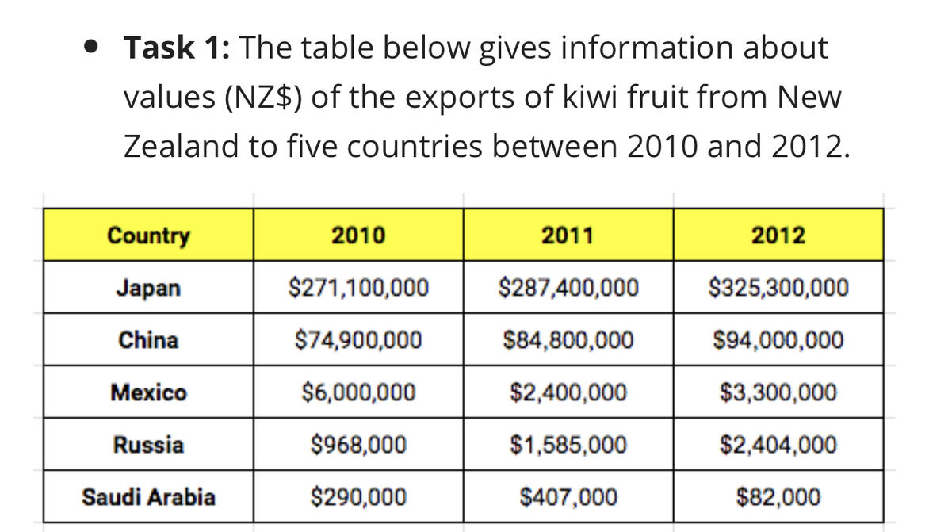
Introduction
The table illustrates how much money New Zealand earned from exporting kiwi fruit to five countries between 2010 and 2012.
Overview
Overall, there was an increase in the value of kiwi exports to Japan, China, and Russia, while a decline was seen in Mexico and Saudi Arabia. In addition, Japan consistently recorded the highest figures throughout the period.
Body 1: Japan & China
The amount of money earned from kiwi exports to Japan started at $271,100,000 in 2010, going up significantly to $287,400,000 in 2011, and reaching the highest point at $325,300,000 in 2012. Similar changes, but to a lesser extent, were seen in the figure for China, which grew from $74,900,000 in 2010 to $84,800,000 in 2011, before ending the period at $94,000,000 in the final year.
Body 2: Russia, Mexico & Saudi Arabia
Regarding the remaining countries, the figure for Russia started at $968,000, after which it experienced a steady rise to $1,585,000 in 2011, before reaching $2,404,000 in 2012. Conversely, export values to Mexico started at $6,000,000, after which it saw fluctuations until 2011, before decreasing to end the period at $3,300,000. A similar downward trend was seen in Saudi Arabia, which rose to $407,000 in 2011, followed by a final drop to $82,000 in 2012.
💡 Tóm tắt các cấu trúc đã áp dụng từ dàn bài của bạn:
- Intro: The table illustrates how much + [N không đếm được: money] + [was/were + V3/ed] + [Địa điểm/đối tượng] + [Thời gian].
- Overview (Trend + Option A):
  - Overall, there was an increase in... in [Japan, China, Russia], while a decline was seen in [Mexico, Saudi Arabia].
  - In addition, [Japan] consistently recorded the highest figures throughout the period.
- Body 1 (Cấu trúc 4 & Cấu trúc 1):
  - [Japan] started at..., going up significantly to... in 2011, and reaching the highest point at... in 2012.
  - Similar changes, but to a lesser extent, were seen in the figure for [China], which grew from... to..., before ending the period at...
- Body 2 (Cấu trúc 3 & Cấu trúc 1):
  - [Russia] started at..., after which it experienced a rise to..., before reaching...
  - Conversely, [Mexico] started at..., after which it saw fluctuations until 2011, before decreasing to end the period at...
  - ...followed by a final drop to... in 2012.

Key word: 2 years, pie chart

1.7.
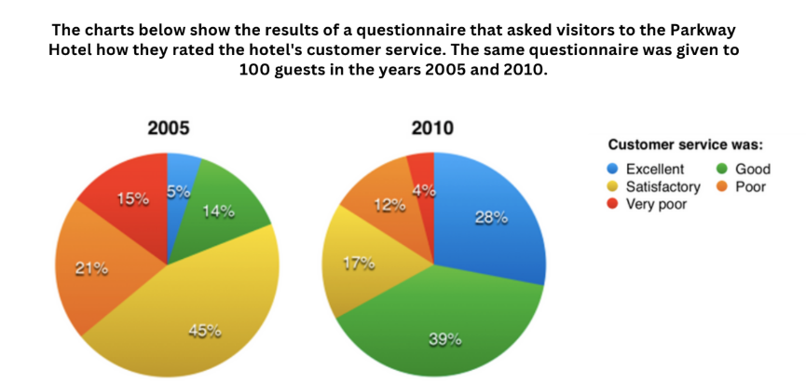
Dàn ý & Phân tích số liệu từ biểu đồ
- Dạng bài: Change over time (2 mốc thời gian: 2005 và 2010).
- Đơn vị: Phần trăm (%) (được khảo sát từ 100 khách hàng mỗi năm).
- Xu hướng chính (Overview):
  - Tỷ lệ đánh giá tích cực (Excellent, Good) tăng lên rõ rệt.
  - Tỷ lệ đánh giá tiêu cực (Satisfactory, Poor, Very poor) đồng loạt giảm.
  - Đánh giá Satisfactory chiếm tỷ lệ cao nhất năm 2005, nhưng sang năm 2010 thì Good vươn lên dẫn đầu.
Bài viết hoàn chỉnh (Band 6.5 - 7.0)
Introduction:
The pie charts illustrate how many visitors rated the customer service of Parkway Hotel in two different years, 2005 and 2010.
Overview:
Overall, there was an increase in the proportion of positive ratings, while an opposite trend was seen in the negative categories over the 5-year period. In addition, "Satisfactory" generally had the highest figures in 2005, but it was surpassed by "Good" in the last year of the period.
Body 1 (Các nhóm có xu hướng tăng: Excellent & Good):
The proportion of guests who rated customer service as "Good" started at 14% in 2005, after which it experienced a significant growth to 39% in 2010. Similar changes, but to a lesser extent, were seen in the figure for "Excellent", which grew from 5% in 2005 to 28% at the end of the period.
Body 2 (Các nhóm có xu hướng giảm: Satisfactory, Poor & Very poor):
Data for "Satisfactory" started at 45% in 2005, before decreasing to end the period at 17% in 2010. Conversely, the figures for "Poor" and "Very poor" ratings also dropped. The percentage of visitors choosing "Poor" decreased from 21% to 12%, while that of "Very poor" fell from 15% to a final 4% in 2010.
Một số lưu ý về cấu trúc đã áp dụng:
- Introduction: Áp dụng công thức The [chart] illustrates how many + [N số nhiều] + [V]....
- Overview:
  - Áp dụng Trend dạng 2: there was an increase in..., while an opposite trend was seen in...
  - Áp dụng cấu trúc vượt mặt dạng 3: ...surpassed by [Category] in the last year of the period.
- Body 1: Sử dụng cấu trúc so sánh hai đối tượng cùng xu hướng tăng nhưng mức độ khác nhau: A + [hành động]. Similar changes, but to a lesser extent, were seen in the figure for B....
- Body 2: Áp dụng cấu trúc tương phản: Conversely, the figures for [X] and [Y] dropped...

Key word: 2 years, pie chart

1.8.
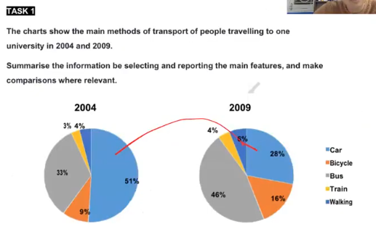
Dàn ý & Phân tích số liệu từ biểu đồ
- Loại biểu đồ: Pie charts (So sánh sự thay đổi qua thời gian: 2004 và 2009).
- Đối tượng: 5 phương tiện giao thông (Car, Bicycle, Bus, Train, Walking).
- Đơn vị: Phần trăm (%).
- Phân tích xu hướng (Overview):
  - Tăng: Bus (33% $→$ 46%), Bicycle (9% $→$ 16%), Train (3% $→$ 4%), Walking (4% $→$ 6%).
  - Giảm mạnh: Car (51% $→$ 28%).
  - Vị trí dẫn đầu: Car cao nhất năm 2004, nhưng bị Bus vượt qua vào năm 2009.
Bài viết hoàn chỉnh (Band 6.5 - 7.0)
Introduction:
The charts illustrate how many people used five main methods of transport to travel to one university in 2004 and 2009.
Overview:
Overall, there was an increase in the proportion of people travelling by bus, bicycle, train, and walking, while an opposite trend was seen in the figure for car users. In addition, "Car" generally had the highest figures in 2004, but it was surpassed by "Bus" in the last year of the period.
Body 1 (Phương tiện giảm mạnh: Car):
Data for the proportion of people using cars started at 51% in 2004, before decreasing to end the period at 28% in 2009.
Body 2 (Các phương tiện có xu hướng tăng: Bus, Bicycle, Train, Walking):
The proportion of people travelling by bus started at 33% in 2004, after which it experienced a significant growth to 46% in 2009. Similar changes, but to a lesser extent, were seen in the figure for bicycles, which grew from 9% to 16% over the period. Conversely, the figures for walking and train were much lower. The percentage of people walking started at 4%, with a subsequent increase to 6% in 2009, while the figure for train saw a slight rise from 3% to 4%.
Chi tiết các cấu trúc từ bài mẫu của bạn đã được ứng dụng:
- Introduction:
The charts illustrate how many + [Danh từ số nhiều] + [Verb] + [Mô tả/Địa điểm] + [Thời gian].
$→$ The charts illustrate how many people used five main methods of transport to travel to one university in 2004 and 2009.
- Overview (Áp dụng Trend + Cấu trúc vượt qua):
Overall, there was a decline in..., while a rise / an opposite trend was seen in... In addition, [Category A] was surpassed by [Category B]...
$→$ Thể hiện sự đối lập giữa xu hướng tăng của bus/bicycle/walking/train và xu hướng giảm của car.
- Body 1 (Sử dụng cấu trúc giảm rồi chốt số cuối kỳ):
Data..., before decreasing to end the period at...
$→$ Mô tả phương tiện duy nhất bị giảm (Car từ 51% xuống 28%).
- Body 2 (Sử dụng cấu trúc so sánh cùng chiều + cấu trúc tiếp theo):
  - A + started at..., after which it experienced a rise/growth to... in...
  - Similar changes, but to a lesser extent, were seen in the figure for B, which grew from... to...
  - Data..., with a subsequent increase...

Key word: future, 4 categories , line chart

1.9.
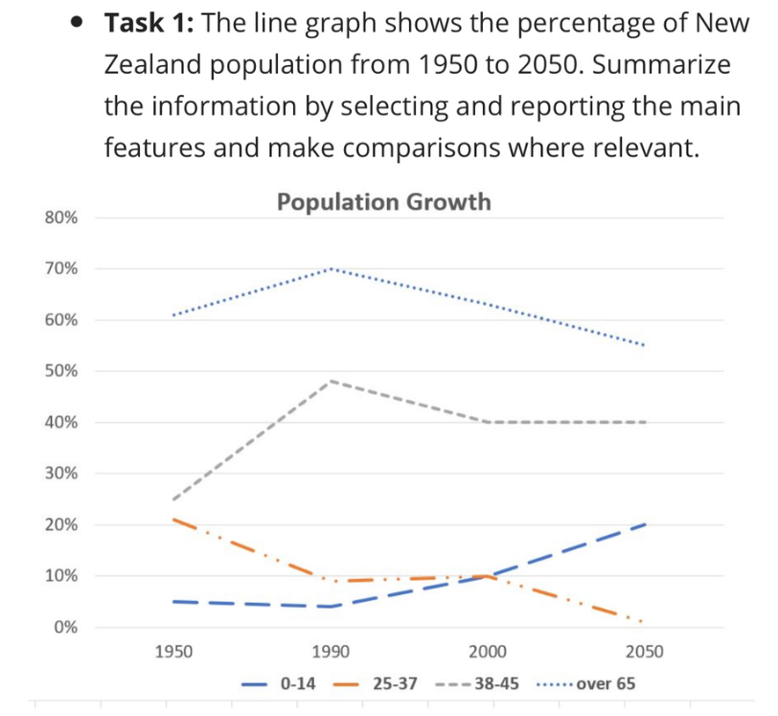
Introduction:
The line graph illustrates how many people in four age groups made up the New Zealand population between 1950 and 2050.
Overview:
Overall, there is a prediction of a decline in the proportions of people aged over 65, 38-45, and 25-37 by 2050, while an opposite trend is expected in the figure for the 0-14 group. In addition, the over 65 category consistently had the highest figures throughout the period.
Body 1 (Khổ lớn: Nhóm Over 65 và 38-45):
The proportion of New Zealand population aged over 65 started at around 61% in 1950, after which it experienced a rise to reach a peak at 70% in 1990, before being expected to decrease to 55% in 2050.
Similarly, 25% of the people in New Zealand belonged to the 38-45 age group in 1950, with a steady growth to a peak of 48% in 1990, and a prediction of a slight decline to 40% at the end of the period.
Body 2 (Khổ nhỏ còn lại: Nhóm 25-37 và 0-14):
The percentage of people aged 25-37 decreased from 21% in 1950 to 10% in 1990, followed by a projection of a continuous drop to nearly 1% in 2050.
Conversely, the figure for children aged 0-14 remained relatively stable at around 5% between 1950 and 1990, before being forecasted to increase significantly to 20% in the final year.
Phân tích cách điều chỉnh theo đúng ví dụ của bạn:
- Cách 1: Dung ...before being expected to + V...
  - Mẫu của bạn: ...experienced a steady rise to about 88% in 2010, before being expected to reach 90% in 2030.
  - Áp dụng vào nhóm Over 65: ...experienced a rise to reach a peak at 70% in 1990, before being expected to decrease to 55% in 2050.
  - Áp dụng vào nhóm 0-14: ...remained relatively stable at around 5%..., before being forecasted to increase significantly to 20% in the final year.
- Cách 2: Dùng ...with a [growth] to..., and a prediction of a [growth/decline] to... at the end of the period.
  - Mẫu của bạn: 70% of the people... chose to reside..., with a steady growth to about 88% in 2010, and a prediction of a slow growth to 90% at the end of the period.
  - Áp dụng vào nhóm 38-45: 25% of the people... belonged to the 38-45 age group in 1950, with a steady growth to a peak of 48% in 1990, and a prediction of a slight decline to 40% at the end of the period.
- Cách 3: Dùng ...increased/decreased from... to..., followed by a projection of a [rise/drop] to... in [future year].
  - Mẫu của bạn: ...increased steadily from 70% in 1970 to about 88% in 2010, followed by a projection of a slow rise to 90% in 2030.
  - Áp dụng vào nhóm 25-37: The percentage of people aged 25-37 decreased from 21% in 1950 to 10% in 1990, followed by a projection of a continuous drop to nearly 1% in 2050.

Key word: future, 4 categories , line chart

1.10.
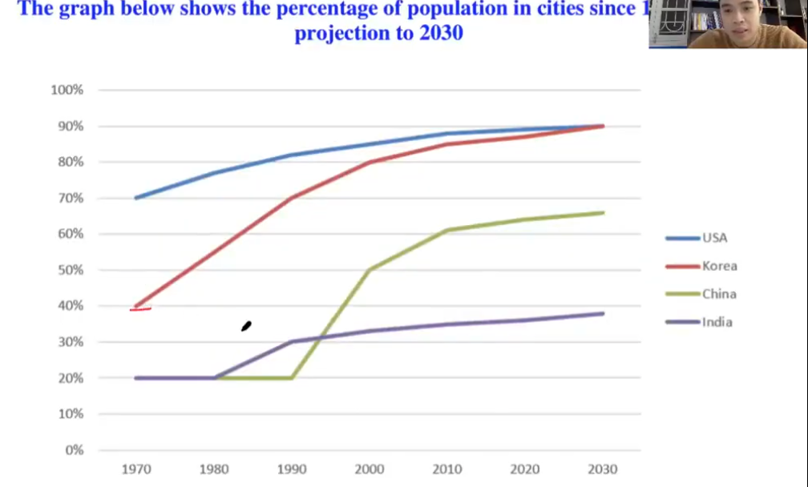
Dàn ý & Phân tích số liệu từ biểu đồ
- Loại biểu đồ: Line graph (Có số liệu quá khứ từ 1970 và dự báo tương lai đến 2030).
- Đối tượng: Tỷ lệ dân số đô thị ở 4 quốc gia: USA, Korea, China, India.
- Đơn vị: Phần trăm (%).
- Xu hướng chính (Overview):
  - Tất cả 4 quốc gia đều có xu hướng tăng tỷ lệ dân số sống ở thành thị trong suốt giai đoạn.
  - USA luôn giữ vị trí dẫn đầu từ 1970 nhưng dự kiến sẽ bị Korea bắt kịp/bằng ở mức 90% vào năm 2030.
- Phân nhóm Body (Theo quy tắc khổ lớn/khổ nhỏ):
  - Body 1 (Khổ lớn): USA và Korea (đều đạt mức rất cao ~90% năm 2030).
  - Body 2 (Khổ nhỏ còn lại): China và India.
Bài viết hoàn chỉnh (Band 6.5 - 7.0)
Introduction:
The line graph illustrates how many people in four countries lived in cities between 1970 and 2030.
Overview:
Overall, there is a prediction of an increase in the proportions of urban population in all four countries examined by 2030. In addition, USA consistently recorded the highest figures throughout most of the period, but it is expected to be reached by Korea in the final year.
Body 1 (Khổ lớn: USA & Korea):
The proportion of US citizens living in urban areas started at 70% in 1970, after which it experienced a steady rise to about 88% in 2010, before being expected to reach 90% in 2030.
Similarly, 40% of the people in Korea lived in cities in 1970, with a rapid growth to 85% in 2010, and a prediction of a slow rise to 90% at the end of the period.
Body 2 (Khổ nhỏ còn lại: China & India):
The percentage of China’s population residing in cities remained stable at 20% from 1970 to 1990, followed by a projection of a continuous growth to about 66% in 2030.
Conversely, the figure for India started at 20% in 1970 and grew slightly to 35% in 2010, before being forecasted to increase gradually to around 38% in the final year.
Phân tích thống kê chi tiết bài viết:
- Tổng số từ: 174 từ (Nằm trong khoảng cực kỳ an toàn và chuẩn mực 160 – 180 từ).
- Mức độ áp dụng cấu trúc ví dụ:
  - USA: Áp dụng ...before being expected to reach 90% in 2030.
  - Korea: Áp dụng ...with a rapid growth to..., and a prediction of a slow rise to 90% at the end of the period.
  - China: Áp dụng ...followed by a projection of a continuous growth to...
  - India: Áp dụng ...before being forecasted to increase gradually to... in the final year.

Key word: No change over time, pie chart

1.11.
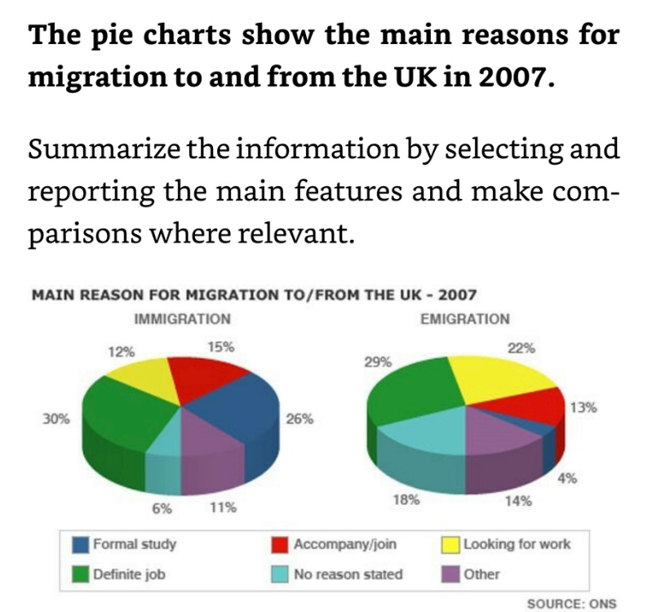
Dàn ý & Phân tích số liệu từ biểu đồ
- Loại biểu đồ: Pie charts - Static (chỉ có 1 mốc thời gian năm 2007, không có xu hướng tăng/giảm).
- Chủ đề: Lý do di cư đến (Immigration) và rời khỏi (Emigration) Vương quốc Anh.
- Đơn vị: Phần trăm (%).
- Phân tích Overview (Differences + Similarity):
  - Immigration: "Definite job" là lý do lớn nhất (30%), theo sau là "Formal study" (26%).
  - Emigration: "Definite job" cũng là lý do cao nhất (29%), theo sau bởi "Looking for work" (22%).
  - Similarity/Difference: Lý do liên quan đến công việc (Definite job) chiếm tỷ lệ cao nhất ở cả hai hướng di cư, trong khi tỷ lệ đi học (Formal study) ở người di cư đến cao hơn hẳn người rời đi.
- Bố cục Body:
  - Body 1 (Immigration): Nhóm các lý do chính/cao nhất của người nhập cư vào UK.
  - Body 2 (Emigration): Nhóm các lý do của người xuất cư rời khỏi UK + So sánh tương quan.
Bài viết hoàn chỉnh (Band 6.5 - 7.0)
Introduction:
The pie charts compare the main reasons why people migrated to and from the UK in 2007.
Overview:
Overall, having a definite job was the primary reason for both immigration and emigration. In addition, formal study accounted for a significantly higher percentage among immigrants than emigrants, whereas looking for work was more common for those leaving the UK.
Body 1 (Immigration to the UK):
Regarding immigration, the proportion of people moving to the UK for a definite job was highest, at 30%, followed by formal study (26%). In contrast, accompanying or joining family members stood at 15%, while the figure for looking for work was slightly lower, at 12%. Meanwhile, other reasons and no reason stated accounted for far less of the total, at 11% and 6% respectively.
Body 2 (Emigration from the UK):
Looking at emigration, the percentage of people leaving for a definite job (29%) far exceeded that of looking for work and formal study, with respective figures being 22% and 4%. About 18% of emigrants left without stating a reason, compared to 14% for other reasons and 13% for accompanying or joining family. Notably, the proportion of immigrants coming to the UK for formal study was more than six times as high as that of emigrants leaving for the same purpose.
Chi tiết các cấu trúc đã được áp dụng từ tài liệu của bạn:
- Dàn ý Lesson 7 & 8:
  - Intro - paraphrase
  - Overview - Differences + Similarity (Vừa chỉ ra điểm giống ở Definite job, vừa nêu sự khác biệt ở Formal study & Looking for work).
  - Body 1 & Body 2: Viết theo từng biểu đồ/nhóm, miêu tả số liệu lớn nhất trước rồi tới các số liệu còn lại.
- Áp dụng các cấu trúc quan trọng (Important structures):
  - ... was highest, at 30%, followed by formal study (26%)
  - ... and the figure for looking for work was lower, at 12%
  - ... accounted for far less of the total, at ... and ... respectively
  - ... far exceeded that of ... and ..., with respective figures being ...
  - About 18% ..., compared to 14% ... and 13% ...
  - ... was more than six times as high as that of ... (Biến tấu nâng cao từ cấu trúc so sánh gấp nhiều lần: twice/three times as much as).

Key word: No change over time, bar chart

1.12.
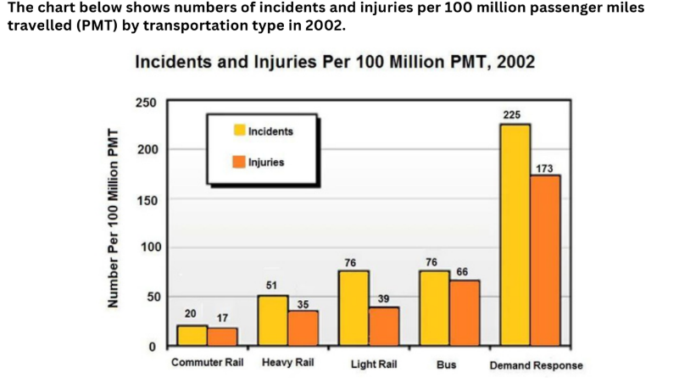
Dàn ý & Phân tích số liệu từ biểu đồ
- Loại biểu đồ: Bar chart - Static (chỉ có 1 mốc thời gian năm 2002).
- Chủ đề: Số lượng Incidents (sự cố) và Injuries (thương vong) tính trên 100 million PMT ở 5 loại hình giao thông: Commuter Rail, Heavy Rail, Light Rail, Bus, Demand Response.
- Đơn vị: Số lượng per 100 million PMT.
- Phân tích Overview (Differences + Similarity):
  - Incidents: Số lượng sự cố ở tất cả phương tiện luôn cao hơn số lượng thương vong tương ứng.
  - Highest: Demand Response có số liệu cao nhất vượt trội ở cả 2 chỉ số.
  - Lowest: Commuter Rail có số liệu thấp nhất ở cả 2 chỉ số.
- Bố cục Body (Khổ lớn / Khổ còn lại là nhỏ hơn):
  - Body 1 (Phương tiện cao vượt trội): Demand Response (Incidents: 225, Injuries: 173).
  - Body 2 (Các phương tiện còn lại): Light Rail, Bus, Heavy Rail và Commuter Rail.
Bài viết hoàn chỉnh (Band 6.5 - 7.0)
Introduction:
The chart compares five types of transportation in terms of the numbers of incidents and injuries per 100 million passenger miles travelled (PMT) in 2002.
Overview:
Overall, Demand Response far exceeded all other categories in both incidents and injuries. In addition, the figures for incidents were consistently higher than those for injuries across all five modes of transport, with Commuter Rail recording the lowest numbers.
Body 1 (Phương tiện cao vượt trội - Demand Response):
Regarding Demand Response, the number of incidents was highest, at 225 per 100 million PMT, followed by injuries at 173. Notably, the figure for incidents in Demand Response was nearly three times as high as that of Bus and Light Rail.
Body 2 (Các phương tiện còn lại):
Looking at the remaining transportation types, the figures for Bus and Light Rail were similar in terms of incidents, at 76 each. However, Bus recorded a higher number of injuries than Light Rail (66 compared to 39). Meanwhile, the number of incidents for Heavy Rail was lower, at 51, with its injuries standing at 35. Finally, Commuter Rail was the safest mode, with only 20 incidents and 17 injuries.
Các cấu trúc đã được áp dụng từ tài liệu của bạn:
- Dàn ý Static (Lesson 7 & 8):
  - Intro - paraphrase
  - Overview - Differences + Similarity (Chỉ ra đối tượng cao nhất vượt trội + quy luật Incidents luôn lớn hơn Injuries ở tất cả các cột).
  - Body 1 (Highest) & Body 2 (The rest).
- Áp dụng các cấu trúc quan trọng (Important structures):
  - ... far exceeded all other categories...
  - ... was highest, at 225 ..., followed by injuries at 173
  - ... was nearly three times as high as that of ... (Cấu trúc so sánh gấp nhiều lần: three times as much/high as).
  - ... (66 compared to 39) (Biến tấu từ cấu trúc compared to / in comparison to).
  - ... and the figures for ... were lower, at ...
  - ... was the same / similar ...

Key word: mixed chart

1.13.
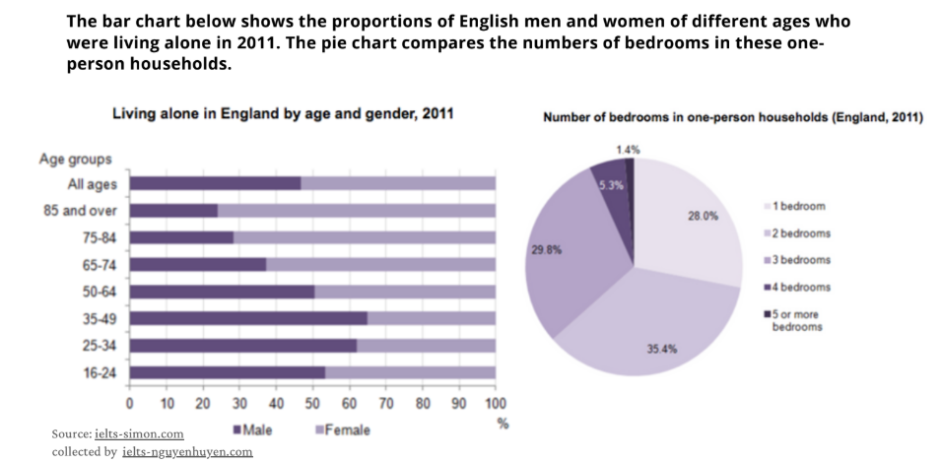
Dàn ý & Phân tích số liệu từ biểu đồ
- Loại biểu đồ: Mixed Chart (Bar chart + Pie chart) - Static (1 mốc thời gian năm 2011).
- Chiến thuật chia đoạn (Solution):
  - Introduction: 1 đoạn ghép bao gồm paraphrase lại 2 biểu đồ.
  - Overview: 2 câu (1 câu nêu đặc điểm chính của Bar chart + 1 câu cho Pie chart).
  - Body 1: Tập trung hoàn toàn cho Bar Chart.
  - Body 2: Tập trung hoàn toàn cho Pie Chart.
- Phân tích thông tin chính:
  - Bar Chart (Giới tính & Tuổi):
    - Nhìn chung tổng thể (All ages), nam giới chiếm tỷ lệ thấp hơn nữ giới (khoảng 47% nam vs 53% nữ).
    - Nhóm tuổi trẻ/trung niên (16-64): Nam giới chiếm tỷ lệ cao hơn nữ giới (đạt đỉnh ở nhóm 35-49 với khoảng 65% nam).
    - Nhóm tuổi già (65 trở lên): Nữ giới áp đảo hoàn toàn (nhóm 85+ nữ chiếm tới gần 76%).
  - Pie Chart (Số phòng ngủ):
    - Căn hộ 2 phòng ngủ chiếm tỷ lệ cao nhất (35.4%), theo sau là 3 phòng (29.8%) và 1 phòng (28.0%).
    - Căn hộ từ 4 phòng trở lên chiếm tỷ lệ rất nhỏ (5.3% và 1.4%).
Bài viết hoàn chỉnh (Band 6.5 - 7.0)
Introduction:
The bar chart illustrates the proportions of English men and women across various age groups who lived alone in 2011, while the pie chart compares the numbers of bedrooms in these one-person households.
Overview:
Overall, in the bar chart, living alone was more common among men in younger age groups, whereas women accounted for a higher proportion in older categories. Meanwhile, the pie chart shows that two-bedroom housing was the most popular choice for single occupants, while households with four or more bedrooms made up the smallest figures.
Body 1 (Bar Chart - Living alone by age and gender):
Regarding the bar chart, overall ("All ages"), the proportion of men living alone was lower than that of women, at around 47% compared to 53%. In the younger groups aged 16 to 64, men outnumbered women. Specifically, the percentage of males in the 35–49 age group was highest, at approximately 65%, followed by the 25–34 group at nearly 62%. Conversely, an opposite trend was seen in older categories. Women comprised around 63% of single households in the 65–74 group, and this figure far exceeded that of men in the 85-and-over category, where females accounted for nearly 76%.
Body 2 (Pie Chart - Number of bedrooms):
Looking at the pie chart, two-bedroom households were highest, at 35.4%, followed by three-bedroom homes at 29.8% and one-bedroom properties at 28.0%. In contrast, large households were much less common. The figure for four-bedroom homes stood at only 5.3%, while five or more bedrooms accounted for far less of the total, at just 1.4%.

Key word: Maps

1.14.
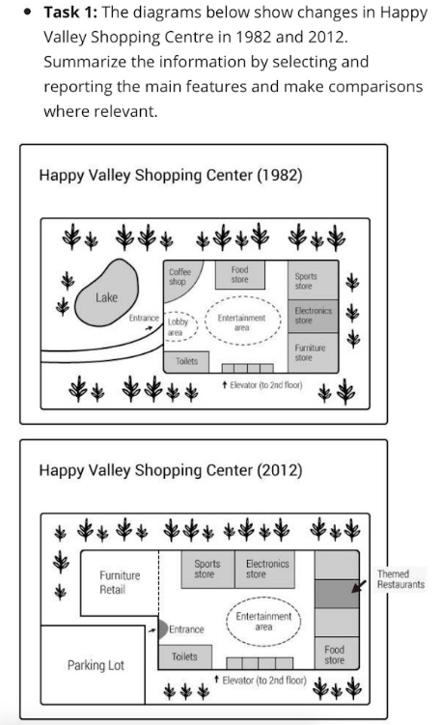
Dàn ý & Phân tích sự thay đổi từ bản đồ
- Loại bài: Maps / Diagram (Sự thay đổi theo thời gian: 1982 và 2012).
- Bố cục (Lesson 10):
  - Introduction: Paraphrase đề bài.
  - Overview: Nêu 2–3 thay đổi nổi bật nhất (Mở rộng khu mua sắm/tiện ích, hồ nước bị lấp làm bãi đỗ xe & cửa hàng nội thất mới, khu vực giải trí vẫn giữ nguyên).
  - Body 1 (Phía Tây & Trung tâm - West-Center):
    - Hồ nước (Lake) bị loại bỏ để nhường chỗ cho Parking Lot và Furniture Retail.
    - Coffee shop bị dời/thay thế; lối vào (Entrance) được chuyển sang vị trí mới.
    - Entertainment area, Toilets, và Elevator giữ nguyên vị trí ở trung tâm.
  - Body 2 (Phía Bắc, Đông & Nam - North, East-South):
    - Food store, Sports store, Electronics store thay đổi vị trí.
    - Thêm mới Themed Restaurants ở khu phía Đông.
    - Furniture store cũ ở phía Đông biến mất; Food store được dời xuống góc Đông Nam.
Bài viết hoàn chỉnh (Band 6.5 - 7.0)
Introduction:
The maps illustrate the changes that took place between 1982 and 2012 in Happy Valley Shopping Centre.
Overview:
Overall, the shopping centre underwent significant modernization, the most important of which was the removal of the lake to make way for a parking lot and new retail space. In addition, while the central entertainment area remained unchanged, a number of stores were relocated and expanded.
Body 1 (Khu vực Phía Tây & Trung tâm - West & Center):
In the western section of the shopping centre, there used to be a lake in 1982, but it was then cleared to make way for a large parking lot and a new furniture retail area. The coffee shop and the old lobby area were demolished, replacing them with a redesigned entrance leading directly into the shopping complex. Meanwhile, no changes were made to the central entertainment area, toilets, and elevators, all of which remained in their original positions.
Body 2 (Khu vực Phía Bắc & Phía Đông - North & East):
The northern and eastern parts also saw a number of changes. Along the northern wall, the former food store was replaced by sports and electronics stores, which were relocated from the eastern side. Furthermore, the original furniture store on the east was removed, with a new themed restaurant area being constructed in its place. Finally, the food store was moved to the south-eastern corner of the shopping centre.
Chi tiết các cấu trúc & từ vựng Lesson 10 đã được sử dụng:
- Introduction:
The maps illustrate the changes that took place between [1982] and [2012] in [Happy Valley Shopping Centre].
- Overview:
  - ... the most important of which was...
  - While [A remained unchanged], [B...].
  - ... cleared to make way for ...
- Body 1 (West-Center):
  - There used to be a [lake]..., but it was then cleared to make way for [a parking lot]...
  - ... were demolished, replacing them with ...
  - ... no changes were made to [the central entertainment area]...
  - ... remained in their original positions.
- Body 2 (North & East):
  - The ... also saw a number of changes, with A being turned into/replaced by B...
  - ... was constructed in its place.
  - ... was relocated / moved to ...

Key word: Maps

1.15.
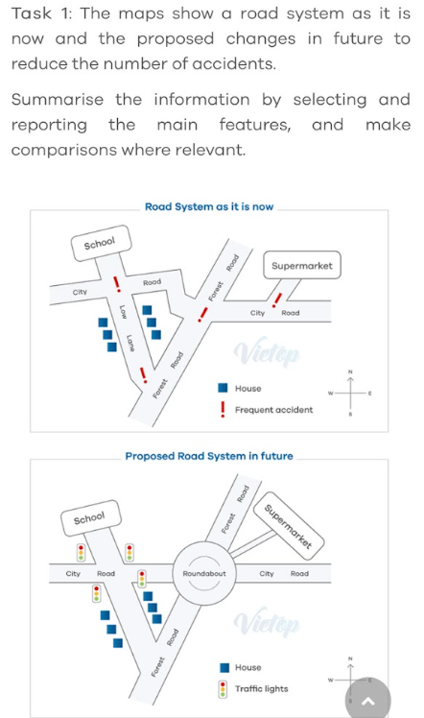
Dựa trên hình ảnh bản đồ (Map) so sánh hệ thống giao thông hiện tại (Road System as it is now) và kế hoạch đề xuất trong tương lai (Proposed Road System in future), dưới đây là bài viết hoàn chỉnh targeted Band 6.5 - 7.0.
Bài viết áp dụng đúng dàn ý Lesson 10 (Map) cùng các cấu trúc dự đoán tương lai (Future Language) và từ vựng chuyên dụng cho giao thông/bản đồ mà bạn đã học ở các lượt trước:
Dàn ý & Phân tích sự thay đổi từ bản đồ
- Loại bài: Map - Proposed Future Changes (So sánh Hiện tại vs Đề xuất Tương lai).
- Thì sử dụng:
  - Hiện tại: Thì hiện tại đơn (is, currently exists).
  - Tương lai: Cấu trúc dự báo/đề xuất (is proposed to be, is expected to, will be built/installed).
- Bố cục (Lesson 10):
  - Introduction: Paraphrase đề bài.
  - Overview: 2 thay đổi cốt lõi nhất: Xây dựng một bùng binh (Roundabout) ở nút giao trung tâm và lắp đặt các đèn giao thông (Traffic lights) để loại bỏ các điểm hay xảy ra tai nạn (Frequent accident spots).
  - Body 1 (Khu vực phía Tây & Nam - West & South):
    - Lắp đặt các bộ đèn giao thông (traffic lights) tại các ngã ba gần School, Low Lane và giao lộ với City Road.
    - Các ngôi nhà (Houses) và trường học (School) vẫn giữ nguyên vị trí.
  - Body 2 (Khu vực trung tâm & phía Đông - Center & East):
    - Một bùng binh (Roundabout) lớn sẽ được xây dựng tại điểm giao giữa City Road, Forest Road, và Low Lane.
    - Đoạn Forest Road phía Bắc được nắn thẳng nối trực tiếp vào bùng binh.
    - Lối vào Supermarket được điều chỉnh nối thẳng vào bùng binh thay vì nối ra City Road như hiện tại.
Bài viết hoàn chỉnh (Band 6.5 - 7.0)
Introduction:
The maps illustrate a road system as it currently exists and the proposed changes planned for the future to improve traffic safety.
Overview:
Overall, the road network is expected to undergo major developments, the most important of which is the construction of a central roundabout. In addition, traffic lights will be installed at several key intersections to reduce frequent accidents.
Body 1 (Khu vực phía Tây & Nam - West & South):
In the western section of the map, traffic lights are proposed to be installed at the junction near the school, as well as at the intersections of Low Lane, Forest Road, and City Road. Meanwhile, the positions of the school and the residential houses along Low Lane will remain unchanged.
Body 2 (Khu vực Trung tâm & phía Đông - Center & East):
Looking at the central and eastern areas, a large roundabout is forecasted to be constructed at the main intersection, replacing the current dangerous layout. Connected to this roundabout, the northern branch of Forest Road will be realigned to join it directly. Furthermore, two new access roads will be built to link the supermarket directly to the roundabout, with a prediction that the old access point on City Road will be removed.
Chi tiết các cấu trúc & từ vựng đã được sử dụng:
- Introduction:
The maps illustrate [a road system] as it currently exists and the proposed changes...
- Overview:
  - Overall, [the road network] is expected to undergo major developments, the most important of which is [the construction of a central roundabout].
  - In addition, [traffic lights] will be installed at several key intersections to...
- Body 1 (Thì tương lai & Cấu trúc Map):
  - ... are proposed to be installed at the junction near ...
  - ... will remain unchanged.
- Body 2 (Thì tương lai & Cấu trúc nối các điểm):
  - ... is forecasted to be constructed at the main intersection, replacing ...
  - ... will be realigned to join it directly.
  - ... with a prediction that [the old access point] will be removed.

Key word: process

1.16.
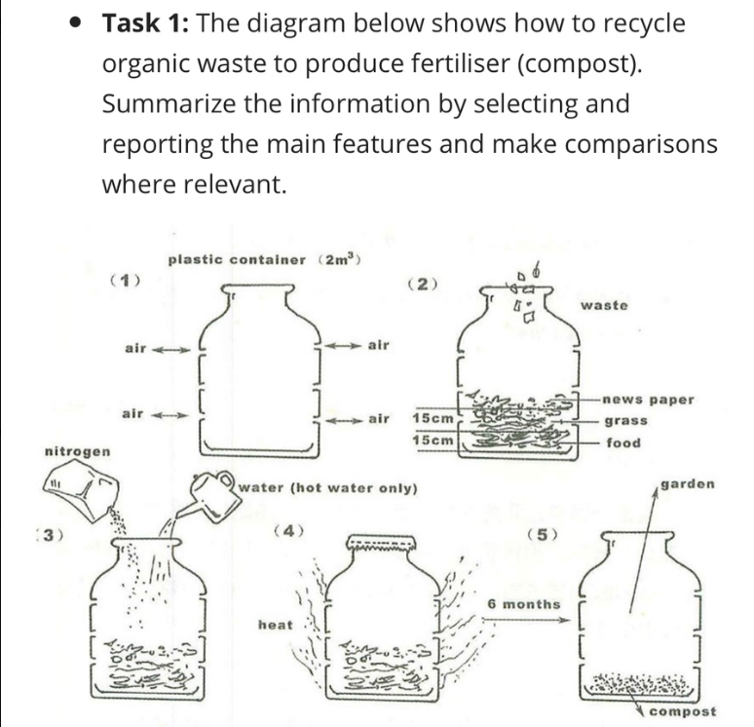
Dựa trên hình ảnh sơ đồ quy trình (Process) tái chế rác thải hữu cơ thành phân bón (compost), dưới đây là bài viết hoàn chỉnh đạt Band 6.5 - 7.0, áp dụng chính xác dàn ý, từ nối và toàn bộ các cấu trúc ngữ pháp bạn đã liệt kê:
Dàn ý & Phân tích quy trình (Process)
- Loại bài: Quy trình nhân tạo (Man-made Process - 5 bước chính).
- Đơn vị / Vật liệu: Thùng nhựa ($2{\text{ m}}^{3}$), không khí (air), thực phẩm (food - 15cm), cỏ (grass - 15cm), báo cũ (newspaper), rác thải (waste), nitơ (nitrogen), nước nóng (hot water), nhiệt (heat).
- Bố cục (Process Template):
  - Introduction: Paraphrase đề bài dùng công thức The diagram describes the process of + V-ing....
  - Overview: Công thức Overall, the process comprises 5 main steps, beginning with preparing the container and ending with using the compost in the garden.
  - Body 1 (Các bước chuẩn bị & xếp lớp - Steps 1, 2, 3):
    - Bước 1: Dùng thùng nhựa $2{\text{ m}}^{3}$ có các lỗ thông khí.
    - Bước 2: Xếp các lớp rác thải (thực phẩm 15cm, cỏ 15cm, báo cũ và các rác thải khác).
    - Bước 3: Cho thêm nitơ và nước nóng.
  - Body 2 (Các bước phân hủy & sử dụng - Steps 4, 5):
    - Bước 4: Đậy nắp thùng lại để tạo nhiệt và phân hủy trong 6 tháng.
    - Bước 5: Phân bón hoàn thành được đem sử dụng cho mục đích làm vườn.
Bài viết hoàn chỉnh (Band 6.5 - 7.0)
Introduction:
The diagram describes the process of recycling organic waste to produce fertiliser, also known as compost.
Overview:
Overall, the process comprises five main steps, beginning with the preparation of a plastic container and ending with the application of the finished compost in the garden.
Body 1 (Các bước chuẩn bị & xếp lớp - Bước 1 đến Bước 3):
At the beginning of the process, a plastic container with a volume of two cubic metres is prepared, with holes on its sides to allow air circulation. Next, various organic materials are placed inside the container in layers. A 15-centimetre layer of food is added at the bottom, which is followed by a 15-centimetre layer of grass, a layer of newspaper, and other organic waste on top. Once these ingredients are assembled, nitrogen and a small amount of hot water are poured into the mixture to accelerate the decomposition process.
Body 2 (Các bước ủ phân & thành phẩm - Bước 4 và Bước 5):
The process continues with sealing the container using a lid. During this stage, heat is generated inside the container, after which the organic waste is left to ferment over a period of six months. Finally, at the final stage of the process, the organic waste is fully converted into compost, which can then be used to nourish plants in the garden.
Chi tiết các cấu trúc & Từ nối đã áp dụng từ bài dạy của bạn:
- Introduction:
The diagram describes the process of + V-ing...
$→$ The diagram describes the process of recycling organic waste...
- Overview:
Overall, the process comprises a number of steps, beginning with... and ending with...
$→$ ...beginning with the preparation of a plastic container and ending with the application of the finished compost...
- Từ nối (Linking Words):
  - At the beginning of the process...
  - Next,...
  - The process continues with...
  - Finally / At the final stage of the process...
- Cấu trúc ngữ pháp quan trọng (Important Structures):
  - ... which is followed by a 15-centimetre layer...
  - Once S+V, S+V $→$ Once these ingredients are assembled, nitrogen and... are poured...
  - To ensure that / In order to $→$ ...to accelerate the decomposition process.
  - ... after which... $→$ ...heat is generated inside..., after which the organic waste is left to ferment...
  - Thì bị động (Passive voice): is prepared, are placed, is added, are poured, is generated, is converted, can be used.

Key word: Process

1.17.
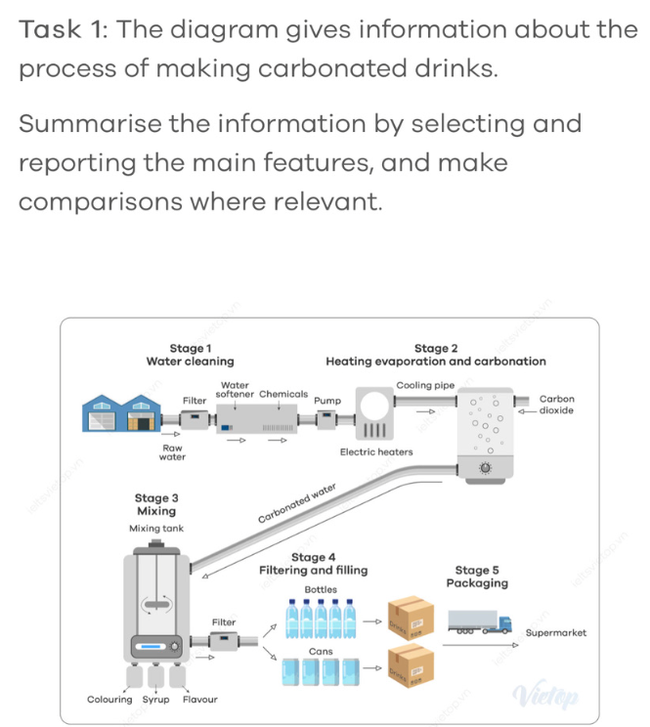
Dựa trên hình ảnh sơ đồ quy trình sản xuất nước giải khát có ga (carbonated drinks) gồm 5 giai đoạn chính (Stage 1: Water cleaning, Stage 2: Heating, evaporation and carbonation, Stage 3: Mixing, Stage 4: Filtering and filling, Stage 5: Packaging), dưới đây là bài viết hoàn chỉnh targeted Band 6.5 - 7.0.
Bài viết áp dụng chính xác dàn ý, từ nối và toàn bộ các cấu trúc ngữ pháp Process từ bài trước của bạn:
Dàn ý & Phân tích quy trình (Process)
- Loại bài: Man-made Process (5 giai đoạn đã được gắn nhãn sẵn trên sơ đồ).
- Các giai đoạn chính (Stages):
  - Stage 1 (Water cleaning): Nước thô (Raw water) được lọc qua Filter, làm mềm nước (Water softener), xử lý hóa chất (Chemicals) và bơm (Pump) sang giai đoạn 2.
  - Stage 2 (Heating, evaporation and carbonation): Nước đi qua máy đun điện (Electric heaters), ống làm mát (Cooling pipe) và được bơm khí Carbon dioxide để tạo ra Carbonated water.
  - Stage 3 (Mixing): Nước có ga được dẫn vào bình trộn (Mixing tank) cùng chất tạo màu (Colouring), siro (Syrup) và hương liệu (Flavour).
  - Stage 4 (Filtering and filling): Nước ngọt sau khi trộn được lọc qua Filter và đóng vào chai (Bottles) hoặc lon (Cans).
  - Stage 5 (Packaging): Sản phẩm được đóng thùng (Drinks boxes) và vận chuyển bằng xe tải đến siêu thị (Supermarket).
- Bố cục:
  - Introduction: Paraphrase đề bài dùng công thức The diagram describes the process of + V-ing....
  - Overview: Công thức Overall, the process comprises 5 main stages, beginning with water cleaning and ending with packaging and distribution.
  - Body 1: Giai đoạn 1 và Giai đoạn 2 (Xử lý nước & Tạo ga).
  - Body 2: Giai đoạn 3, 4 và 5 (Pha chế, đóng gói & vận chuyển).
Bài viết hoàn chỉnh (Band 6.5 - 7.0)
Introduction:
The diagram describes the process of manufacturing carbonated drinks through five distinct stages.
Overview:
Overall, the process comprises five main stages, beginning with water cleaning and ending with the packaging and transportation of the finished products to supermarkets.
Body 1 (Giai đoạn 1 & Giai đoạn 2 - Xử lý nước và tạo ga):
At the beginning of the process, raw water is passed through a filter and a water softener before being treated with chemicals to remove impurities. Once the water is cleaned, it is pumped into electric heaters, which is followed by passing through a cooling pipe. Subsequently, carbon dioxide is added to the water in order to produce carbonated water.
Body 2 (Giai đoạn 3, 4 & 5 - Pha chế, đóng chai và vận chuyển):
The process continues with the carbonated water being transferred to a mixing tank, where colouring, syrup, and flavouring are added. After the mixture is thoroughly combined, it goes through a filter once again before being filled into bottles or cans. Finally, at the final stage of the process, the packaged drinks are placed into cardboard boxes, after which they are loaded onto trucks and delivered to supermarkets.
Chi tiết các cấu trúc & Từ nối đã áp dụng:
- Introduction:
The diagram describes the process of + V-ing...
$→$ The diagram describes the process of manufacturing carbonated drinks...
- Overview:
Overall, the process comprises a number of steps, beginning with... and ending with...
$→$ ...beginning with water cleaning and ending with the packaging and transportation...
- Từ nối (Linking Words):
  - At the beginning of the process,...
  - Subsequently,...
  - The process continues with...
  - Finally / At the final stage of the process,...
- Cấu trúc ngữ pháp quan trọng:
  - Before V-ing / S+V $→$ ...before being treated with chemicals... / ...before being filled into...
  - Once S+V, S+V $→$ Once the water is cleaned, it is pumped...
  - ... which is followed by V-ing... $→$ ...which is followed by passing through...
  - In order to $→$ ...in order to produce carbonated water.
  - ... after which S+V... $→$ ...after which they are loaded onto trucks...
  - Thì bị động (Passive voice): is passed, is pumped, is added, is transferred, are placed, are loaded.

Key word: Natural Process

1.18.
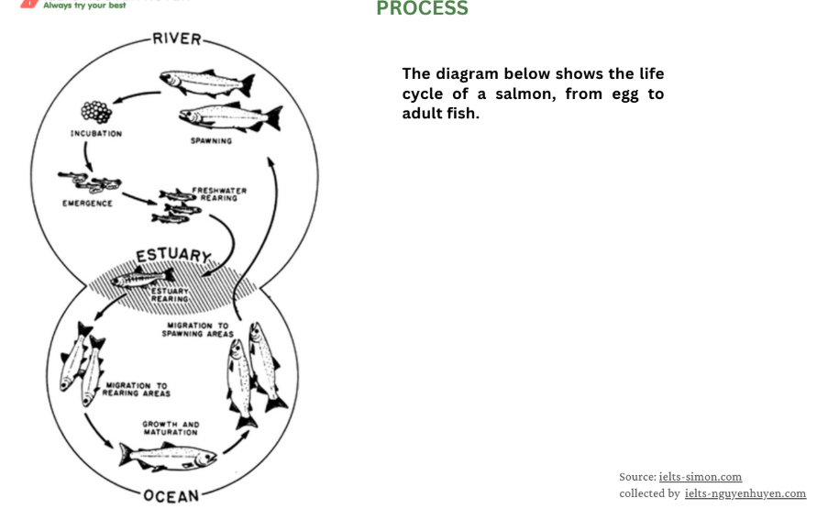
Dàn ý & Phân tích quy trình tự nhiên (Life Cycle)
- Loại bài: Natural Process / Life Cycle (Chu trình khép kín, động từ chủ động).
- Các giai đoạn chính:
  - Sông (River - Nước ngọt): Trứng (Incubation) $→$ Nở (Emergence) $→$ Nuôi dưỡng ở nước ngọt (Freshwater rearing).
  - Cửa sông (Estuary - Nước lợ): Nuôi dưỡng ở cửa sông (Estuary rearing).
  - Biển / Đại dương (Ocean - Nước mặn): Di chuyển đến khu vực nuôi dưỡng (Migration to rearing areas) $→$ Tăng trưởng và trưởng thành (Growth and maturation) $→$ Di chuyển ngược lại khu vực đẻ trứng (Migration to spawning areas).
  - Trở lại Sông: Đẻ trứng (Spawning) và chu trình bắt đầu lại.
- Bố cục:
  - Introduction: Paraphrase đề bài.
  - Overview: Khẳng định đây là một chu trình tự nhiên khép kín (cyclical process) gồm nhiều giai đoạn diễn ra ở 3 môi trường nước khác nhau (River, Estuary, Ocean). (Lưu ý: Không viết "ending with").
  - Body 1: Các giai đoạn ở Sông và Cửa sông (River & Estuary).
  - Body 2: Các giai đoạn ở Đại dương và quay trở lại đẻ trứng (Ocean & Return).
Bài viết hoàn chỉnh (Band 6.5 - 7.0)
Introduction:
The diagram describes the life cycle of a salmon from the egg stage to an adult fish.
Overview:
Overall, the process is a continuous cyclical cycle comprising several distinct stages, which take place in three main environments: rivers, estuaries, and the ocean.
Body 1 (Giai đoạn ở Sông và Cửa sông - River & Estuary):
At the beginning of the cycle, adult salmon lay eggs in the river, after which the eggs undergo an incubation period. Once the eggs hatch, young salmon emerge and enter the freshwater rearing stage, where they stay and grow for a period of time. Subsequently, these small fish migrate downstream towards the estuary, at which point they adapt to the brackish water during the estuary rearing phase.
Body 2 (Giai đoạn ở Đại dương & Quay lại đẻ trứng - Ocean & Return):
The process continues with the fish migrating further out into the open ocean. During this phase, they move to main rearing areas, where they experience rapid growth and maturation to become fully grown adult salmon. After reaching maturity, the adults begin their journey back to their birthplace in the river in order to spawn. Once the new eggs are laid, the cycle begins all over again.
Chi tiết các cấu trúc đã được áp dụng theo yêu cầu của bạn:
- Thay đổi trong Overview:
  - Không dùng ending with... mà dùng Overall, the process is a continuous cyclical cycle... để nhấn mạnh tính vòng tròn khép kín.
- Dùng động từ chủ động (Active Voice):
  - lay eggs, hatch, emerge, stay and grow, migrate downstream, adapt, move, experience, reach maturity, begin their journey.
- Cấu trúc nối câu (Important Structures) được áp dụng:
  - ... , after which ... $→$ ...lay eggs in the river, after which the eggs undergo an incubation period.
  - Once S+V, S+V $→$ Once the eggs hatch, young salmon emerge...
  - ... , at which point ... $→$ ...migrate downstream towards the estuary, at which point they adapt to...
  - After V-ing / S+V, S+V $→$ After reaching maturity, the adults begin their journey...
  - In order to $→$ ...in order to spawn.
  - Once S+V, S+V $→$ Once the new eggs are laid, the cycle begins all over again.

