GEN AI · DATA ANALYTICS SPECIALIZATION
LEVEL 1 — FOUNDATIONS
Level 1 Completion Report · Day 1 – Day 3

STUDENT NAME | Jenifer Mercy
DAY RANGE COVERED | Day 1 – Day 3
DOMAIN | Automotive Industry – Used Car Market Price Prediction & Depreciation Analysis
DATASET SOURCE | Kaggle – Master Automotive Industry Data (98 rows × 11 columns)
TOOLS USED | Excel (Power Query) · Python (pandas, seaborn, matplotlib, scikit-learn)
DATE OF SUBMISSION | 01 July 2026

STEP 1 WHAT YOU BUILT
Completed a 3-day foundational analytics sprint on the Used Car Market Price Prediction and Depreciation Analysis project. The pipeline covered the full ETL lifecycle (Day 1), comprehensive exploratory analysis (Day 2), and RFM-adapted vehicle segmentation with machine learning validation (Day 3).
DAY | TOPICS COVERED | DELIVERABLE
Day 1 | Data Integration & Preprocessing (ETL) using Power Query in Excel — data loading, column standardization, null handling, derived columns (Car_Age, Depreciation_Percentage), Pivot Table summaries | Cleaned_Car_Data.xlsx with Cleaned_Data sheet + Pivot summaries
Day 2 | Descriptive Statistics & EDA using Python — summary stats, skewness, kurtosis, distribution histograms, IQR-based outlier detection, boxplots, correlation heatmap, categorical analysis | DA_Day2_EDA.ipynb with all visualizations and insights
Day 3 | RFM-Inspired Vehicle Segmentation using Python — adapted RFM scoring (Recency→Car Age, Frequency→Owner Count, Monetary→Selling Price), K-Means clustering (k=4), elbow method, segment labelling | DA_Day3_RFM_Segmentation.ipynb with cluster visualizations and segment breakdown

STEP 2 APPROACH & STEPS TAKEN
Detailed step-by-step breakdown for each day:
DAY | STEPS TAKEN
Day 1 | - Downloaded the Master_Automotive_Industry_Data.csv dataset from Kaggle (98 records, 11 columns including Car_Name, Year, Selling_Price_Lakhs, Present_Price_Lakhs, Kms_Driven_KM, Fuel_Type, Seller_Type, Transmission, Owner)  - Imported the CSV into Excel and connected it to Power Query for ETL processing  - Standardized column names, corrected data types, and identified/removed null values and duplicate entries  - Engineered two derived columns: Car_Age = 2024 – Year, and Depreciation_Percentage = ((Present_Price – Selling_Price) / Present_Price) × 100  - Loaded the cleaned data into the Cleaned_Data sheet and created Pivot Table summaries for Fuel Type, Transmission, and average Selling Price breakdown
Day 2 | - Loaded Cleaned_Car_Data.xlsx into a pandas DataFrame and performed initial inspection (shape, dtypes, describe)  - Computed descriptive statistics including mean, median, std, skewness and kurtosis for all numeric columns  - Plotted KDE-overlaid histograms for all numeric features to understand distributions  - Detected outliers using the IQR method (Q1 − 1.5×IQR to Q3 + 1.5×IQR) and visualized with boxplots  - Generated a correlation heatmap to identify which features most strongly predict Selling_Price_Lakhs  - Performed categorical analysis (bar charts) for Fuel_Type, Seller_Type, and Transmission
Day 3 | - Adapted the RFM framework to vehicle data: Recency → Car_Age (lower = fresher asset), Frequency → Owner count (fewer = less wear), Monetary → Selling_Price_Lakhs (higher = more valuable)  - Scored each vehicle 1–5 on each dimension using pd.qcut() (quantile binning) and computed a composite RFM_Score (sum of three scores, range 3–15)  - Labelled vehicles into four business segments: Premium – Low Mileage (≥12), Good Value (9–11), Average (6–8), Budget – High Usage (<6)  - Applied K-Means clustering (k=4) on the scaled R, F, M scores and used the Elbow Method to validate the optimal cluster count  - Visualized cluster assignments in a scatter plot (Monetary Score vs Recency Score) and compared mean R/F/M values per cluster

STEP 2b KEY INSIGHTS & FINDINGS
DAY | KEY INSIGHTS DISCOVERED
Day 1 (ETL) | 98 vehicle records cleaned; 87 Petrol vs 11 Diesel; 84 Manual vs 14 Automatic. Average selling price: ₹2.70 L overall (Diesel avg: ₹10.68 L, Petrol avg: ₹1.69 L). Depreciation ranges from 5.26% to 89.46%, mean 35.55%.
Day 2 (EDA) | Selling_Price_Lakhs is heavily right-skewed (few premium cars pull the mean up). Kms_Driven and Car_Age show the most outliers via IQR. Strongest negative correlation with selling price: Car_Age (older = cheaper). Present_Price and Selling_Price show strong positive correlation (~0.88). Dealer-sold cars significantly outnumber individual seller listings.
Day 3 (RFM) | 'Average' segment is the largest (mid-range cars with moderate age and owners). 'Premium – Low Mileage' segment commands highest resale values. K-Means (k=4) statistically validates the 4-group manual segmentation. Vehicles with 0 previous owners consistently score highest across all three RFM dimensions. Car_Age is the strongest differentiator between high and low value segments.

STEP 3 SCREENSHOTS OF OUTPUT
Paste your actual output screenshots in the blocks below. Capture: cleaned data table (Day 1), correlation heatmap or distribution plot (Day 2), segment distribution bar chart and cluster scatter plot (Day 3).
SCREENSHOT 1 — Day 1 – Power Query Cleaned Data Preview
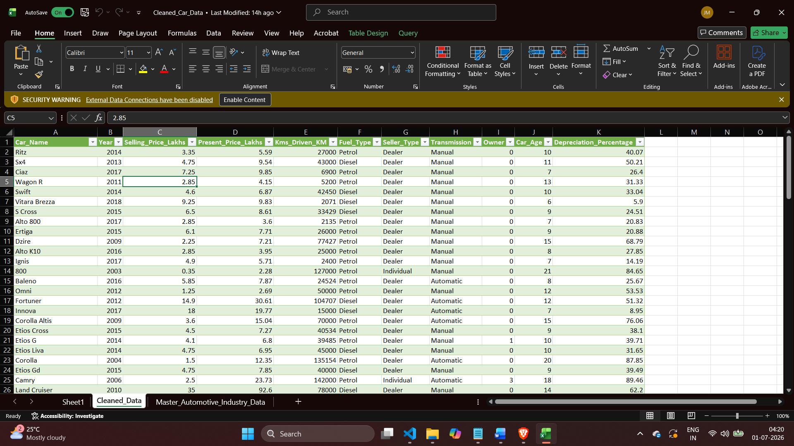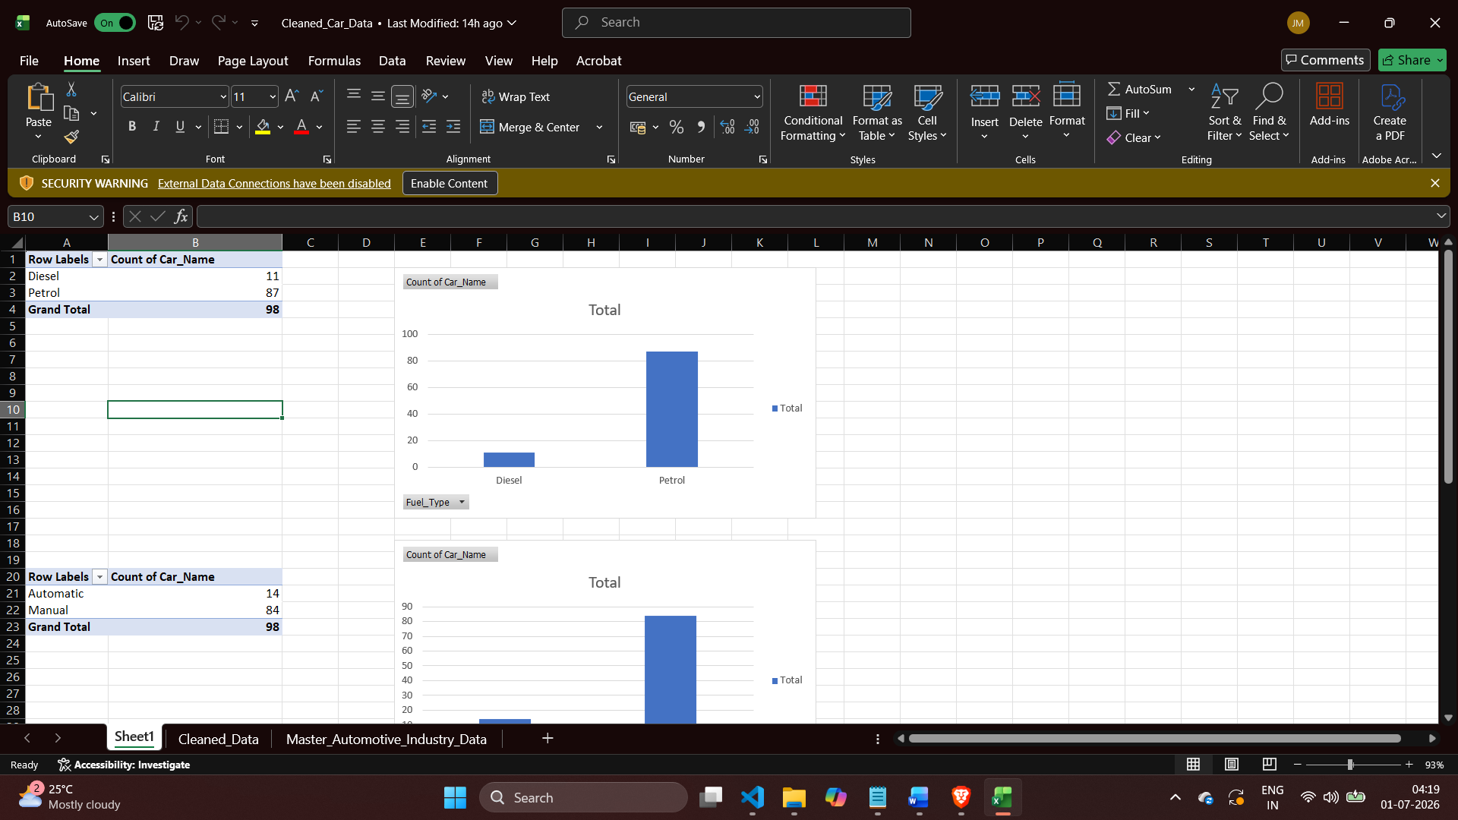
Caption: Excel Power Query output showing the Cleaned_Data sheet with all 98 records, derived Car_Age and Depreciation_Percentage columns

SCREENSHOT 2 — Day 2 – Correlation Heatmap / Distribution Plots
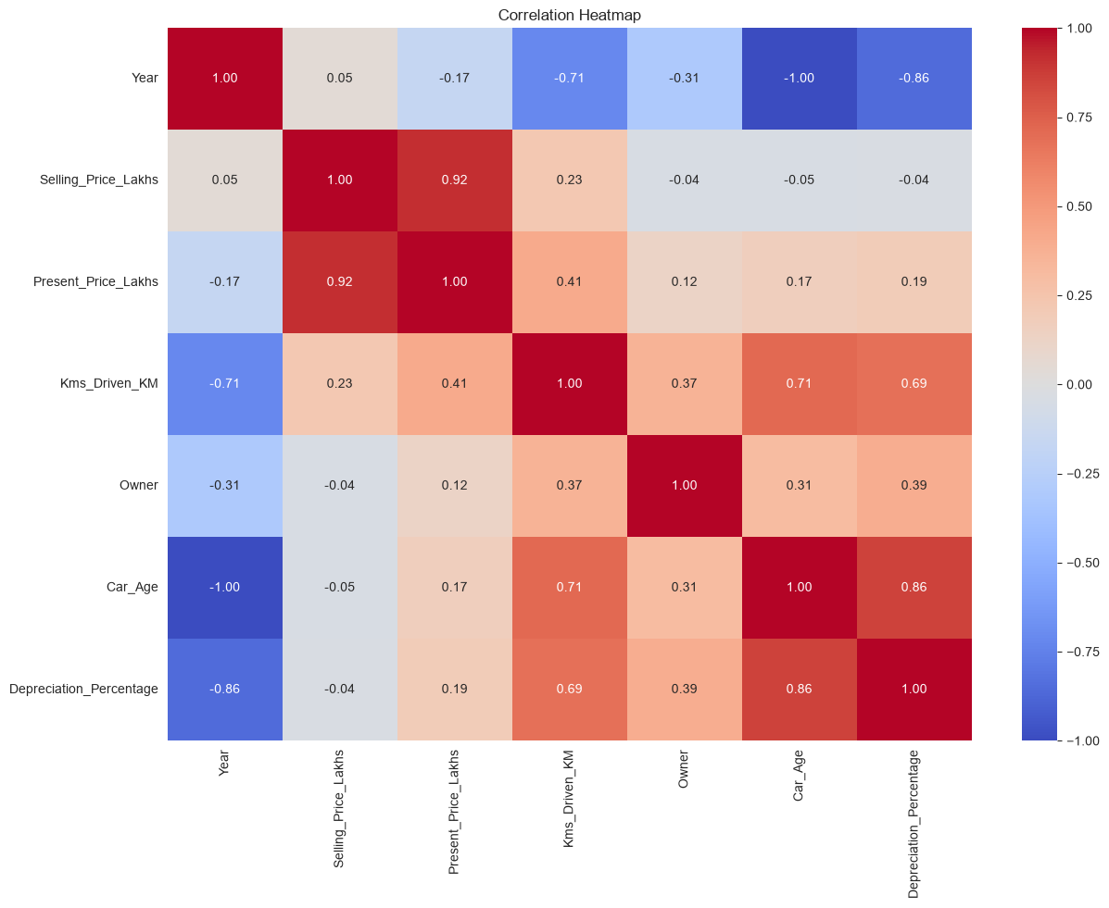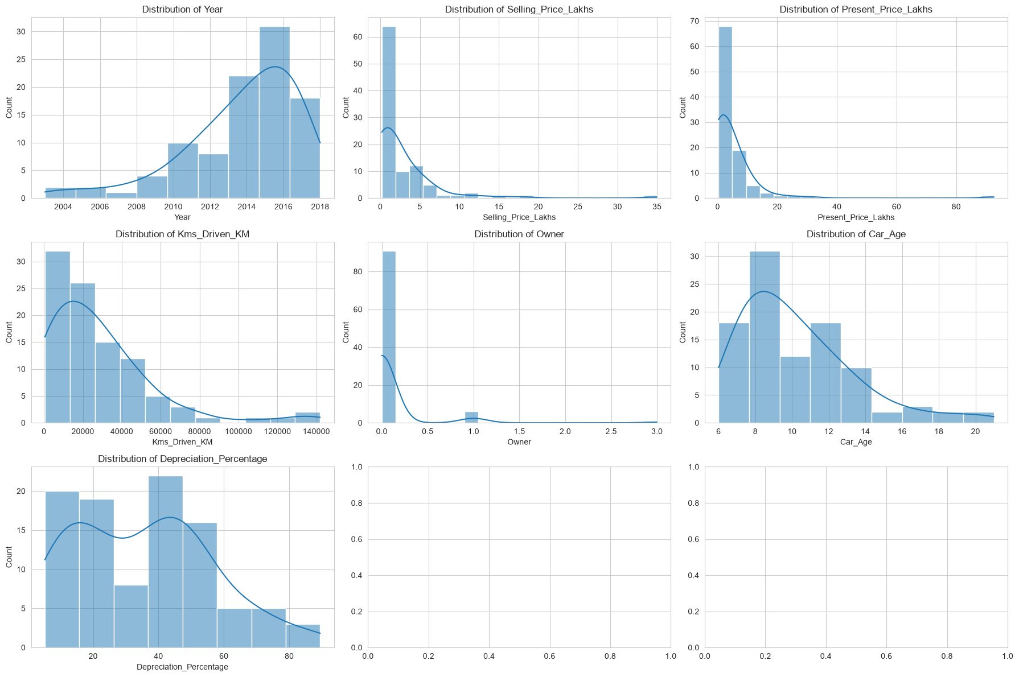
Caption: Seaborn heatmap showing feature correlations; strongest correlates with Selling_Price_Lakhs highlighted

SCREENSHOT 3 — Day 3 – Vehicle Segment Distribution & K-Means Cluster Plot
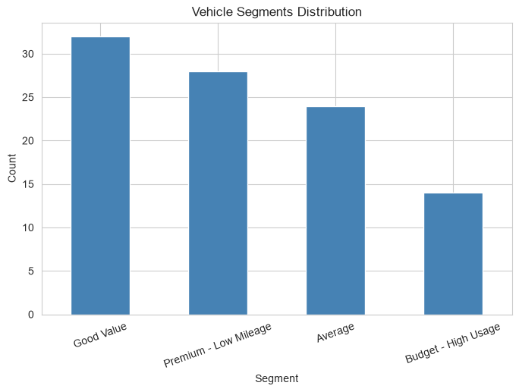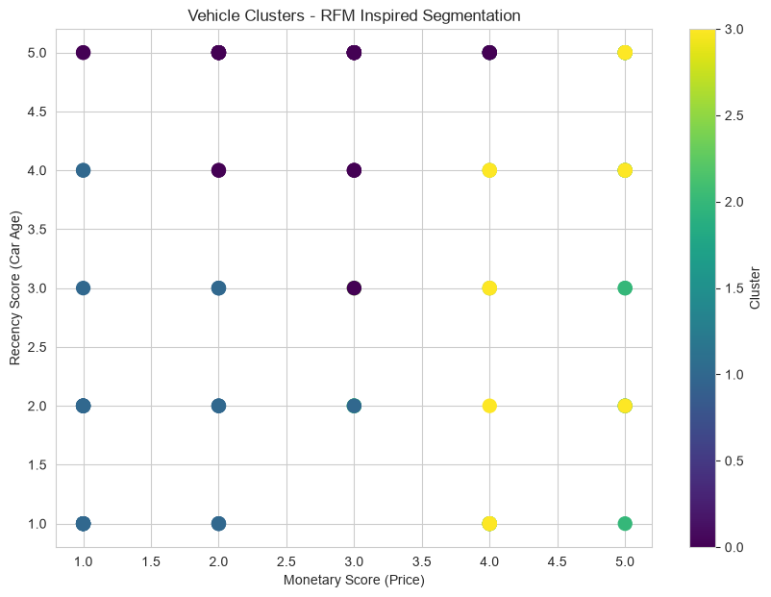
Caption: Bar chart of vehicle segment counts (Premium / Good Value / Average / Budget) and scatter plot of K-Means clusters on RFM scores

STEP 4 GITHUB REPOSITORY
GitHub Repository Link:
https://github.com/jenifermercy7106/Used-Car-Price-Analytics
Note: Ensure the repository is public and contains DA_Day2_EDA.ipynb, DA_Day3_RFM_Segmentation.ipynb, and Cleaned_Car_Data.xlsx

STEP 5 DELIVERABLE CHECKLIST
 | DELIVERABLE ITEM
✅ | Day 1 — Cleaned dataset (Cleaned_Car_Data.xlsx) exported with Cleaned_Data sheet and Pivot summaries
✅ | Day 2 — EDA notebook (DA_Day2_EDA.ipynb) with distribution plots, outlier boxplots, correlation heatmap, and categorical charts
✅ | Day 3 — RFM segmentation notebook (DA_Day3_RFM_Segmentation.ipynb) with vehicle segments, K-Means clusters, and elbow curve
✅ | Code runs successfully without errors
✅ | Screenshots included above showing working outputs
✅ | GitHub repository is linked and accessible
✅ | Report is fully filled before submission

STEP 6 CHALLENGES FACED
DAY | CHALLENGE FACED | HOW IT WAS RESOLVED
Day 1 | The dataset had no explicit Car_Age or Depreciation column; raw Year field was in integer format | Computed Car_Age as a custom column in Power Query (2024 − Year) and derived Depreciation_Percentage using a calculated column formula
Day 2 | Extreme right-skew in Selling_Price_Lakhs made distribution plots hard to interpret | Used KDE overlay on histograms and log-scale reference; supplemented with boxplots to highlight outliers clearly
Day 3 | Traditional RFM requires customer transaction history (repeat purchases); our dataset has one row per vehicle with no customer IDs | Adapted RFM to vehicle-level analysis: Recency → Car_Age, Frequency → Owner count, Monetary → Selling_Price_Lakhs — justified this adaptation in the notebook comments

STEP 7 REVIEWER SECTION
Reviewer Comments:

STUDENT SIGNATURE | REVIEWER APPROVAL — LEVEL 1

