TASK 3 – CRAFTING INTERACTIVE DATA STORIES
Superstore Sales & Profit — Interactive Data Story
Tableau Dashboard Planning, Interactive Design and Data Storytelling

1. Objective
The objective of this task is to transform the Superstore sales analysis into an interactive data story using Tableau. The dashboard communicates overall business performance first, then guides the audience through time trends, category performance, regional contribution, profitability, discount impact and sub-category sales. Interactive filters and dashboard actions allow users to move from a high-level view to focused analysis.

2. Target Audience
- Business managers needing a quick overview of sales and profit performance.
- Sales and regional teams comparing market contribution.
- Analysts exploring category, sub-category and discount patterns.
- Students and decision-makers learning from interactive business dashboards.

3. Data Story and Key Message
The central message is that business performance can be understood by moving from overall results to time, category, region and profitability details. The story begins with three KPIs, uses the time trend to establish performance over the selected period, compares categories and regions, examines discount versus profit, and finishes with sub-category sales contribution.

4. Narrative Flow
Story Stage | Contribution
1. Overall Performance | Total Sales, Total Profit and Total Orders establish the starting point.
2. Sales Trend | The monthly sales line shows changes in performance over time.
3. Category Performance | Sales by Category compares Furniture, Office Supplies and Technology.
4. Regional Performance | Sales by Region compares Central, East, South and West.
5. Profitability | Profit by Category shows category-level profit contribution.
6. Discount Impact | Discount vs Profit supports exploration of discount and profit behaviour.
7. Sub-Category Detail | Sales by Sub-Category provides detailed sales contribution.
8. Interactive Exploration | Filters and selections allow focused investigation.

5. Visualizations and Their Roles
- KPI Cards — Total Sales, Total Profit and Total Orders: provide an immediate executive summary.
- Line Chart — Sales Trend Over Time: shows monthly movement in sales.
- Bar Chart — Sales by Category: compares the three major categories.
- Horizontal Bar Chart — Profit by Category: compares category profitability.
- Bar Chart — Sales by Region: compares geographic contribution.
- Scatter Plot — Discount vs Profit: explores the relationship between average discount and profit.
- Horizontal Bar Chart — Sales by Sub-Category: identifies major detailed sales contributors.

6. Interactive Elements
- Region Filter: users can select Central, East, South, West or All.
- Order Date Filter: users can investigate a selected time period.
- Category Action: selecting a category can filter related dashboard views.
- Highlight Interaction: hover-based highlighting helps focus on selected regional information.
- Clear Selection: restoring selections to All returns the complete business view.

7. Dashboard Design Strategy
- The title and subtitle explain the dashboard purpose immediately.
- The top section contains the sales trend, followed by KPI cards for quick performance reading.
- Category, profit and regional charts form the main comparison section.
- Discount and sub-category analysis provide deeper exploration.
- Light-blue cards separate sections and improve visual hierarchy.
- Distinct category and region colors improve comparison while keeping the design readable.

8. Integration Rationale
The visuals are arranged as a connected story rather than unrelated charts. KPI cards answer how the business is performing. The trend explains when performance changes. Category and region charts show where sales come from. Profit and discount analysis move the story from sales volume to business value, while the sub-category chart provides deeper detail. Filters and actions connect these stages so the audience can investigate a region, category or time period.

9. Implemented Dashboard
The screenshot below shows the implemented interactive dashboard with KPI cards, color-coded comparison charts, filters and the planned narrative structure.
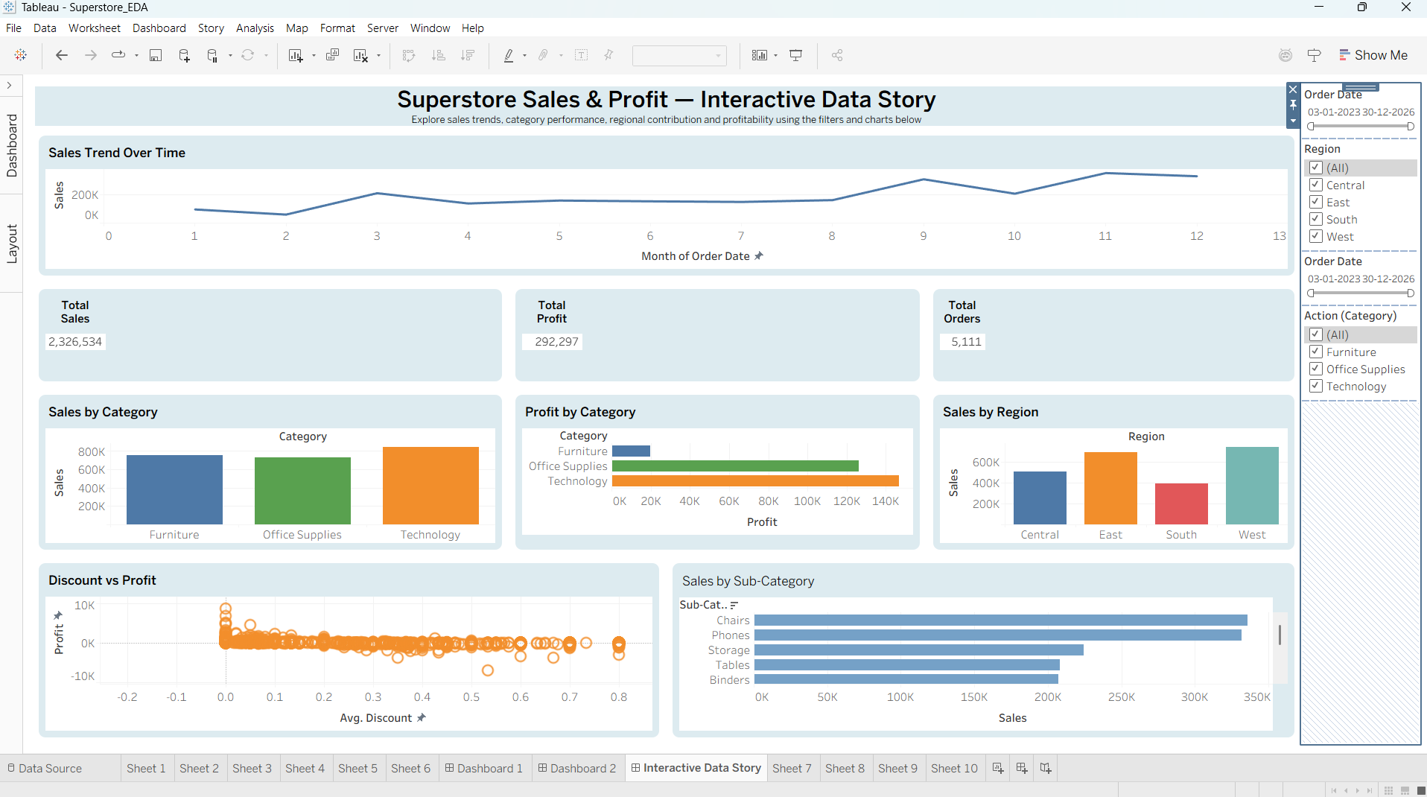

10. Key Insights Communicated
- Technology is the strongest category by sales in the displayed full-period dashboard.
- The regional bars allow quick comparison of Central, East, South and West sales contribution.
- Profit by Category adds profitability context beyond sales volume.
- The Discount vs Profit scatter plot supports investigation of discount-related profit variation.
- The Sub-Category view identifies major sales contributors.
- Interactive filters allow the same story to be explored for different regions and time periods.

11. Interaction Testing
The dashboard was tested with the Region filter, Order Date range and category interaction. The final view was restored to the complete-data state. The final KPI values were Total Sales = 2,326,534, Total Profit = 292,297 and Total Orders = 5,111.

12. Conclusion
The completed Tableau dashboard converts Superstore data into an interactive and visually organized data story. The combination of KPIs, trend analysis, comparisons, filters and dashboard interactions helps the target audience move from an overall business view to detailed investigation. The design therefore supports the main goal of Task 3: communicating insights sequentially while allowing users to explore the data interactively.

