WEEK 4 TASK

Advanced Chart Techniques and
Calculation Insights
Tableau – Superstore Sales Analysis
1. Objective
The objective of this Week 4 task is to apply advanced charting techniques and calculated metrics in Tableau to improve the depth, clarity and usability of sales analysis. The Superstore dashboard is extended using a dual-axis chart, regional/category heat map, sales highlight table, profit margin analysis, sales percentage analysis, monthly sales growth and KPI cards.
The final dashboard is designed to communicate relationships, trends and performance differences in a user-centered visual narrative. Calculated fields and table calculations transform raw measures into meaningful business indicators.

2. Expected Deliverables
- A Tableau dashboard containing at least two advanced visualization methods.
- Calculated fields and table calculations that add analytical value.
- A documented explanation of each calculation and its purpose.
- A clear dashboard layout with meaningful titles and visual hierarchy.
- An explanation of interaction and how users can interpret the visualizations.
- A comprehensive technical document describing implementation and design rationale.

3. Dataset and Data Understanding
The project uses the Superstore sales dataset. It contains transactional sales information that supports analysis by date, category, sub-category, region, sales and profit. These fields make the dataset suitable for both time-series and categorical analysis.
Field / Concept | Role | Use in Dashboard
Order Date | Date dimension | Monthly sales and growth trend
Sales | Measure | Sales totals, heat map, dual axis and percentage analysis
Profit | Measure | Profit trend, total profit and profit margin
Category | Dimension | Category comparison and profitability analysis
Sub-Category | Dimension | Detailed sales highlight table
Region | Dimension | Regional contribution and heat map

4. Tools and Technologies
- Tableau Desktop for data visualization and dashboard development.
- Sample Superstore data for sales and profitability analysis.
- Calculated fields for derived business metrics.
- Table calculations for month-over-month sales growth.
- Dashboard layout containers and worksheet integration for user-centered design.

5. Advanced Visualization Techniques

5.1 Dual-Axis Sales Analysis
The dual-axis chart compares Sales and Profit over Order Date. Sales are represented as bars while Profit is represented as a line. Two scales allow measures with different magnitudes to be interpreted together.
- Sales bars show monthly revenue magnitude.
- Profit line shows the movement of profitability over the same period.
- The combined view makes it easier to identify months where high sales are accompanied by strong or weak profit.
- The view supports trend comparison without requiring two separate charts.

Implementation Steps
- Place Order Date at month level on Columns.
- Place Sales on Rows and use a bar representation.
- Add Profit as a second measure and use a line representation.
- Use the dual-axis option so Sales and Profit share the same time dimension but retain separate scales.
- Format axes and titles to clearly distinguish Sales from Profit.

5.2 Regional Category Heat Map
The Regional Category Heat Map uses color intensity to communicate Sales performance across Category and Region. Darker cells indicate higher sales and lighter cells indicate lower sales.
- Category is placed on Rows.
- Region is placed on Columns.
- Sales is used for Color and Label.
- A square mark type creates the heat-map structure.
- Color intensity makes high- and low-performing combinations immediately visible.

5.3 Sales Highlight Table
The Sales Highlight Table provides a detailed view by combining Category, Sub-Category and Region. It supports deeper investigation of individual product groups while the heat map provides a high-level summary.

5.4 Profit Margin Analysis
Profit Margin Analysis compares profitability across categories. A ratio view is more useful than absolute profit alone when comparing categories with different sales volumes.

5.5 Sales Percentage Analysis
Sales Percentage Analysis communicates each category's contribution to overall sales. It provides a composition-oriented view rather than only showing raw sales totals.
6. Calculated Fields and Table Calculations

6.1 Profit Margin
Calculated field:
SUM([Profit]) / SUM([Sales])
This calculation measures the proportion of sales retained as profit. It supports category comparison because profit is normalized by sales volume. In the current dashboard view, the overall KPI displays approximately 12.56%.

6.2 Sales Growth %
Calculated field:
(SUM([Sales]) - LOOKUP(SUM([Sales]), -1)) / ABS(LOOKUP(SUM([Sales]), -1))
This table calculation compares the current month's sales with the previous month's sales and expresses the change as a percentage. LOOKUP(..., -1) retrieves the previous value in the table calculation direction. The first month may display NULL because there is no previous month.

6.3 Sales Percentage / Percent of Total
The Sales Percentage Analysis uses a percentage-of-total calculation to express each category's sales contribution relative to the total sales in the selected view. This supports composition analysis and helps identify the categories contributing most strongly to revenue.

6.4 KPI Measures
- Total Sales: SUM([Sales])
- Total Profit: SUM([Profit])
- Profit Margin KPI: SUM([Profit]) / SUM([Sales])
KPI cards provide an immediate summary before users move into detailed charts. This improves dashboard scanability and establishes overall business context.

7. Dashboard Design and Layout
The dashboard follows a top-to-bottom visual hierarchy. KPI cards communicate headline performance first. Advanced charts occupy the central area, while the monthly growth chart provides a time-based analytical conclusion.
Dashboard Area | Visualization | Design Purpose
Top | Total Sales / Total Profit / Profit Margin | Quick KPI summary
Upper-middle | Dual Axis Sales Analysis | Compare sales and profit trends
Upper-middle | Regional Category Heat Map + Sales Highlight Table | Regional and detailed category analysis
Middle | Profit Margin + Sales Percentage | Profitability and contribution comparison
Bottom | Monthly Sales Growth | Month-to-month trend and dynamic calculation

Design Rationale
- The most important metrics are placed first to reduce the time needed to understand overall performance.
- Different visual forms answer different analytical questions: bars/lines for trends, heat maps for comparison, tables for detail and KPI cards for summary.
- Consistent section titles improve navigation and reduce cognitive load.
- The dashboard uses complementary views rather than relying on one complex chart.
- The heat map is high-level while the highlight table retains Sub-Category detail, giving the two views distinct purposes.

Dashboard Screenshot
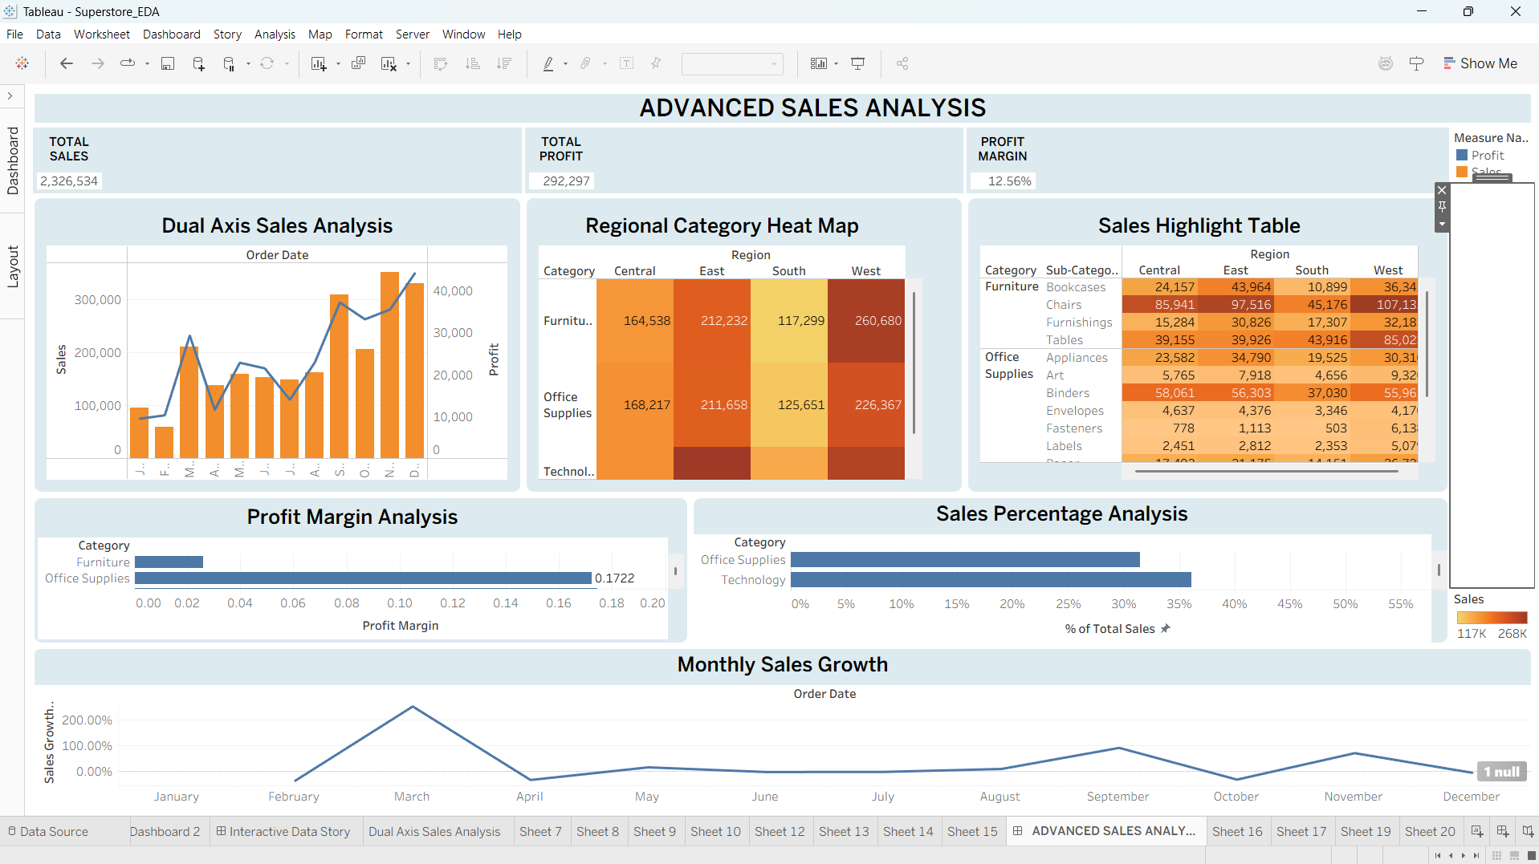
Figure 1. Final Advanced Sales Analysis dashboard implemented in Tableau.

8. Interaction and User-Centered Design
The dashboard is designed so that users can move from summary to explanation. KPI cards provide an initial overview; the dual-axis chart explains time-based movement; the heat map reveals regional/category patterns; and the detailed table supports deeper investigation.

Interaction Strategy
- Date-based analysis supports exploration of changes across months.
- Category and region views support comparison of business performance across segments.
- Descriptive titles allow users to understand the purpose of each visualization.
- Color intensity in the heat map acts as a visual cue for high and low sales.
- Multiple complementary views reduce the need to interpret a single complex chart.

Calculation Insights Text
Profit Margin = SUM(Profit) / SUM(Sales): measures overall profitability relative to sales.
Sales Growth % compares the current month with the previous month using a table calculation.
Heat Map uses Sales by Category and Region to highlight high and low performing areas.
Dual Axis analysis compares Sales and Profit trends over time.

9. Analytical Insights
- The monthly sales pattern varies across the year, demonstrating the value of time-series analysis.
- The dual-axis chart allows users to observe whether profit movement follows or diverges from sales movement.
- The heat map makes regional differences within each category easy to identify.
- The sales highlight table provides detailed sub-category context.
- Profit margin reveals efficiency rather than only absolute profit.
- Sales percentage analysis identifies relative category contribution.
- KPI cards provide a concise summary before detailed interpretation.

10. Evaluation Against Task Criteria
Evaluation Criterion | Implementation | Outcome
Innovative advanced charting | Dual axis, heat map, highlight table and trend analysis | Multiple complementary analytical views
Calculated field correctness | Profit Margin and Sales Growth % formulas documented | Derived metrics have clear business meaning
Table calculation | LOOKUP-based month-over-month growth | Dynamic comparison across months
Documentation quality | Formula, rationale, implementation and impact documented | Reproducible technical approach
User-centered design | KPI-first hierarchy, descriptive titles and visual grouping | Faster understanding and easier exploration
Technical depth | Multiple sheets, calculations, formatting and dashboard composition | Demonstrates advanced Tableau skills

11. Impact of Calculated Fields on Data Analysis
The calculated fields increase analytical depth because the dashboard is no longer limited to raw Sales and Profit. Profit Margin converts two measures into an efficiency indicator, while Sales Growth % adds a dynamic temporal comparison. These calculations help answer whether sales are increasing, whether higher sales are producing proportionally higher profit, and which categories or regions contribute most strongly.

12. Challenges and Solutions
Challenge | Solution
Different scales for Sales and Profit | Used a dual-axis visualization with separate axes.
Large number of sub-categories | Used a high-level heat map for Category × Region and retained detail in the highlight table.
Month-to-month comparison | Used a LOOKUP-based table calculation.
Dashboard density | Applied a hierarchy: KPI cards → advanced charts → detailed analysis → growth trend.
Calculation interpretation | Used clear titles and calculation explanations.

13. Conclusion
The Week 4 Tableau implementation demonstrates how advanced visualization techniques and calculated metrics can transform a basic sales dashboard into a deeper analytical tool. The combination of dual-axis analysis, heat mapping, detailed highlighting, profitability analysis, percentage contribution, KPI cards and month-over-month growth provides multiple levels of insight.
The design emphasizes clarity as well as technical capability. Each visualization has a distinct purpose, and the calculated fields provide context that cannot be obtained from raw measures alone. The resulting dashboard is suitable for exploring sales performance, regional contribution, category profitability and temporal trends.
End of Week 4 Documentation

