WEEK 5 TASK
Performance Optimization and
Interactive Feature Enhancement
Tableau – Superstore Sales Analysis

1. Objective
This Week 5 task focuses on optimizing the performance, scalability and usability of the Tableau dashboard developed in the previous weeks. Building on the Week 4 Superstore Sales Analysis, the dashboard is assessed for possible bottlenecks related to data volume, calculations, filters, worksheets, visible marks and dashboard complexity. The objective is to reduce unnecessary processing while preserving the analytical depth of the dashboard.
The task also extends the dashboard with purposeful interactive features. Dynamic filters, parameter controls, drill-down capabilities, highlight interactions, navigation and reset controls are proposed so users can move from summary information to detailed analysis without overloading the initial dashboard view.

2. Expected Deliverables
- A documented performance assessment of the existing Superstore dashboard.
- Identification of potential bottlenecks related to data volume, calculations, filters and visual complexity.
- Performance optimization strategies covering extracts, filters, calculations and dashboard design.
- Interactive enhancements including dynamic filters, drill-downs, parameters and dashboard actions.
- Before-and-after dashboard performance comparison.
- A comprehensive technical document explaining implementation steps and expected outcomes.

3. Dataset and Data Understanding
The project continues to use the Superstore sales dataset used in Week 4. The existing analysis contains Order Date, Sales, Profit, Category, Sub-Category and Region, with calculated Profit Margin and Sales Growth %. The Week 4 dashboard already uses KPI cards, dual-axis analysis, a Regional Category Heat Map and a Sales Highlight Table. This Week 5 task therefore focuses on improving the performance and interaction of that analytical structure rather than replacing it.
Field / Concept | Role | Week 5 Use
Order Date | Date dimension | Date filtering and time analysis
Sales | Measure | KPI, trend and performance comparison
Profit | Measure | KPI and profitability analysis
Category | Dimension | Filtering and drill-down
Sub-Category | Dimension | Detail analysis
Region | Dimension | Regional comparison and filtering
Profit Margin | Calculated metric | Performance KPI
Sales Growth % | Table calculation | Time-based performance insight

4. Tools and Technologies
- Tableau Desktop for dashboard development, performance testing and interactive actions.
- Sample Superstore data for sales and profitability analysis.
- Tableau extracts / optimized data source configuration where appropriate.
- Calculated fields and table calculations for analytical metrics.
- Dashboard containers, filters, parameters, actions and navigation controls.

5. Current Dashboard Performance Assessment
The Week 4 dashboard provides multiple complementary views and a KPI-first layout. This structure is analytically useful, but the number of worksheets, filters and detailed marks can increase rendering and query workload as the data grows. The baseline assessment therefore examines the dashboard before optimization.

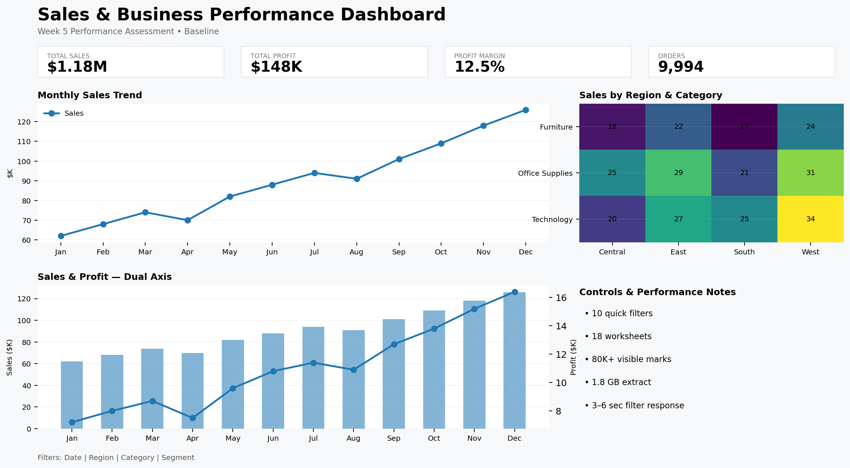

Performance Area | Baseline Observation | Risk
Dashboard load | Multiple visualizations load together | High
Filters | Several independent filters can trigger additional processing | Medium/High
Worksheets | Approx. 18 worksheets in the hypothetical assessment | Medium
Visible marks | Detailed views can create a high mark count | High
Data volume | Full transactional history may be larger than required | High
Calculations | Profit Margin and Sales Growth are useful but should be reviewed for repeated processing | Medium
Detail table | Sub-Category detail can increase rendering workload | Medium

6. Potential Performance Bottlenecks

6.1 Data Volume
Using unnecessary historical records, unused columns and detailed transactional rows can increase extract size and query workload.

6.2 Complex or Repeated Calculations
Repeated expressions, expensive calculations or unnecessary table calculations can add processing work.

6.3 Excessive Filters
Too many quick filters, especially high-cardinality fields, can create a less predictable and less responsive experience.

6.4 Too Many Worksheets
Every worksheet contributes to the amount of work Tableau must coordinate and render.

6.5 High Mark Counts
Detailed tables, labels and dense charts can require Tableau to render many marks.

6.6 Dashboard Density
Loading summary charts, detailed tables and all analytical views at the same time can reduce responsiveness.

7. Performance Optimization Strategies

7.1 Data Source and Extract Optimization
- Remove fields that are not used in the dashboard, filters, calculations or tooltips.
- Restrict the extract to the business-required time period where full history is unnecessary.
- Use aggregation for views that do not require transaction-level detail.
- Use incremental refresh when the source and business process support it.
- Validate joins and relationships to avoid accidental record duplication.
- Move repeatable data preparation logic upstream when that simplifies workbook processing.

7.2 Filter Optimization
- Keep Date, Region and Category as primary filters because they support the main analytical questions.
- Use sensible default values, such as the most recent reporting period.
- Avoid exposing every available field as a quick filter.
- Use dependent or context filtering where it reduces the data processed by subsequent filters.
- Use parameters or actions when one control can replace multiple similar filters.

7.3 Calculation Optimization
- Keep Profit Margin as SUM([Profit]) / SUM([Sales]) and reuse the calculation instead of duplicating the logic.
- Review Sales Growth % table calculation and ensure the calculation direction is appropriate to the view.
- Move stable transformations upstream where practical.
- Avoid unnecessary nested calculations and repeated expressions.
- Test expensive LOD or table calculations on realistic data volume.

7.4 Visualization and Dashboard Optimization
- Keep the KPI-first hierarchy from Week 4.
- Use summary views first and load detail through interaction.
- Reduce unnecessary labels and marks.
- Remove redundant worksheets that answer the same question.
- Use navigation to separate overview and detailed analysis.
- Keep maps and dense detail tables off the initial landing view when they are not essential.

8. Interactive Feature Enhancements

8.1 Dynamic Filters
Dynamic filters allow users to focus the Superstore dashboard on Date, Region, Category and other relevant dimensions. They improve usability by reducing the amount of information shown at one time and allow users to answer focused questions quickly.

Implementation Steps
- Add Date, Region and Category as the primary dashboard filter controls.
- Set useful default values.
- Apply the filters to only the worksheets that need to respond.
- Test common filter combinations for both usability and performance.

8.2 Drill-Down Capability
A hierarchy such as Category → Sub-Category allows users to begin with a summary and investigate detail only when required. This complements the Week 4 heat map and highlight table without requiring every detail level to be visible simultaneously.

8.3 Parameter Controls
A Metric parameter can allow the user to switch between Sales, Profit, Quantity or Profit Margin using one analytical view. This reduces the need to maintain separate charts for each metric and gives users controlled flexibility.

8.4 Highlight and Set Actions
Highlight actions can emphasize selected categories or regions across related worksheets. Set actions can support group-versus-rest comparisons and allow users to create temporary analytical selections.

8.5 Navigation and Reset Controls
Navigation can separate an overview dashboard from detailed analysis. A Reset Filters control provides a predictable way to return to the default view after exploration.

9. Optimized Dashboard Design
The optimized version retains the Week 4 analytical narrative but introduces a summary-first structure. The landing view emphasizes KPI cards, a focused trend view, a compact regional comparison and an interactive heat map. Detailed analysis is available through drill-down and navigation.

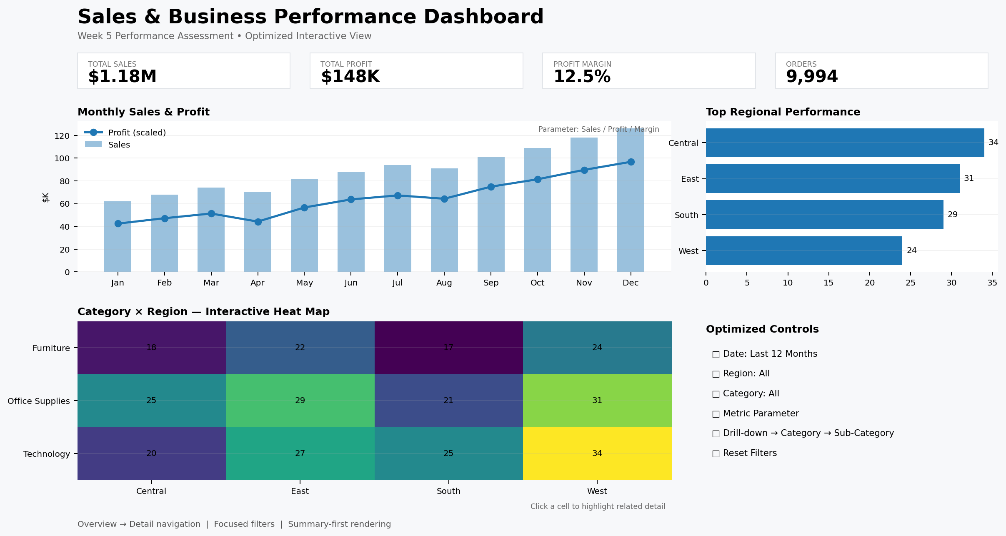

Dashboard Area | Optimization / Interaction | Purpose
KPI Cards | Retained from Week 4 | Immediate summary
Filter Bar | Focused Date / Region / Category | Controlled filtering
Monthly Trend | Metric parameter | Switch analytical measure
Regional View | Compact comparison | Fast regional assessment
Heat Map | Highlight interaction | Category × Region exploration
Detail View | Drill-down / navigation | Load detail on demand
Reset | Reset control | Return to default state

10. Performance Optimization Implementation Steps
- Record the Week 4 dashboard baseline performance.
- Audit the data source and remove unnecessary fields.
- Review the extract scope and refresh strategy.
- Review joins, relationships and potential duplication.
- Review calculated fields and repeated logic.
- Reduce unnecessary worksheets and visual marks.
- Optimize the main filters and their default values.
- Implement parameters, drill-down and highlight interactions.
- Separate overview and detail analysis through navigation.
- Retest the same scenarios and compare results.
- Validate dashboard totals and calculated metrics.
- Document the final design and optimization decisions.

11. Performance Comparison and Validation
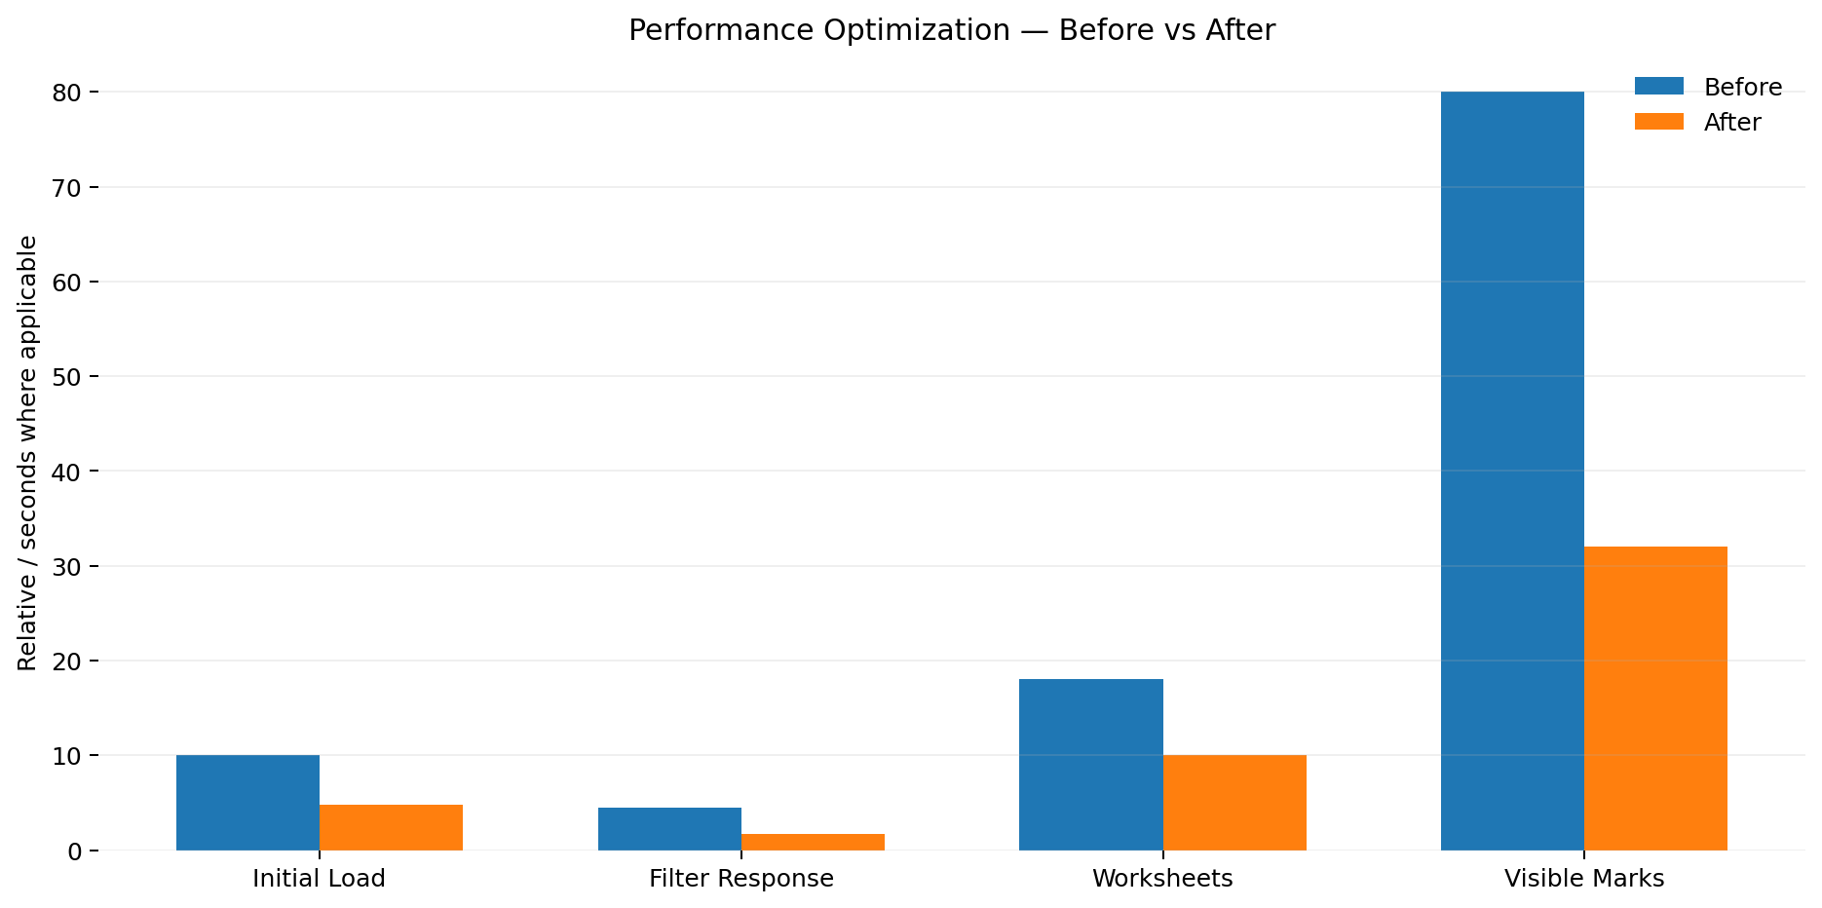
The comparison is an illustrative assessment for the hypothetical dashboard and should be replaced with measured Tableau timings when the final workbook is tested. The important principle is to repeat identical test scenarios before and after optimization.
Test Case | Baseline | Target / Optimized Direction | Validation Method
Initial load | Approx. 8–12 sec | Lower than baseline | Open from clean session
Filter response | Approx. 3–6 sec | Lower than baseline | Apply common filters
Worksheet count | Approx. 18 | Reduce redundant sheets | Workbook audit
Visible marks | 80K+ possible | Reduce unnecessary detail | Review dense views
Navigation | All views loaded together | Detail on demand | Overview → Detail → Back
Metric switching | Separate views | One parameterized view | Switch measures

12. Dashboard Design and Layout
The Week 4 design follows a top-to-bottom hierarchy where KPI cards communicate headline performance first and advanced charts occupy the central analytical area. Week 5 preserves this hierarchy while reducing the amount of detail rendered immediately. This follows the same user-centered design rationale used previously: different visual forms answer different analytical questions, while navigation and interaction prevent the dashboard from becoming overloaded.
Dashboard Area | Visualization / Control | Week 5 Purpose
Top | Total Sales / Total Profit / Profit Margin | Fast KPI summary
Upper-middle | Monthly Sales & Profit | Trend comparison
Upper-middle | Regional comparison | Fast regional scan
Middle | Category × Region Heat Map | Interactive pattern detection
Bottom / Detail | Sub-Category detail | On-demand investigation
Controls | Date / Region / Category / Metric | Focused interaction
Navigation | Overview / Detail | Reduce initial workload

13. Interaction and User-Centered Design
The interaction strategy is designed so users can move from summary to explanation. KPI cards provide the initial context; filters focus the dataset; the trend view explains time movement; the heat map reveals regional/category patterns; and drill-down provides detail. This continues the Week 4 principle of complementary views while making the dashboard more responsive.
- Date-based filtering supports focused time analysis.
- Region and Category filters support comparison across business segments.
- Metric parameters allow one chart to answer multiple measure-based questions.
- Heat-map selection can highlight related information.
- Drill-down reduces the need to display all detail simultaneously.
- Reset controls provide a predictable return to the starting state.
- Navigation separates overview and detail analysis.

14. Analytical Insights
- Reducing unnecessary data and visual marks can improve dashboard responsiveness without reducing the analytical purpose of the main views.
- The summary-first structure allows users to understand overall sales and profitability before exploring detailed records.
- Dynamic filters make regional and category comparisons easier to focus and interpret.
- Drill-down provides access to Sub-Category detail without forcing Tableau to display every detail level at the same time.
- Metric parameters can reduce dashboard duplication by allowing users to switch measures in one analytical view.
- Interactive highlighting can connect high-level selections with supporting detail and reduce manual comparison effort.
- Performance optimization and user-centered design reinforce each other when interactions are introduced selectively.

15. Evaluation Against Task Criteria
Evaluation Criterion | Implementation | Outcome
Depth of performance analysis | Baseline, bottleneck identification and test methodology | Clear performance assessment
Practical optimization | Data, extract, filter, calculation and layout strategies | Actionable recommendations
Interactive enhancement | Filters, drill-down, parameters, actions and navigation | Improved user control
Documentation quality | Implementation steps, tables, screenshots and validation | Reproducible technical approach
Scalability | Summary-first design and detail-on-demand | Better readiness for data growth
User-centered design | Focused controls and clear navigation | Easier dashboard exploration

16. Challenges and Solutions
Challenge | Solution
Large data volume | Reduce unnecessary rows and fields; use appropriate extract strategy
Many dashboard filters | Keep only high-value controls and use parameters/actions where appropriate
High visual density | Use summary-first layout and detail-on-demand navigation
Detailed Sub-Category analysis | Retain detail through drill-down/highlight table rather than always displaying it
Calculation workload | Reuse and simplify calculated fields; validate table calculation direction
Need for flexibility | Use parameter controls instead of duplicate worksheets
User getting lost after exploration | Provide reset and clear navigation controls

17. Expected Outcomes
- Improved initial dashboard response time.
- Faster and more predictable filter interactions.
- Reduced unnecessary query and rendering workload.
- Better scalability as the dataset grows.
- Cleaner dashboard layout with less visual clutter.
- More purposeful user interaction through parameters and actions.
- Easier movement from overview to detailed analysis.
- Improved maintainability through documented calculations and design decisions.

18. Conclusion
The Week 5 Tableau implementation extends the Superstore Sales Analysis by focusing on performance optimization and interactive feature enhancement. The previous dashboard already provided advanced analytical views such as KPI cards, dual-axis analysis, heat mapping, highlight tables, profitability analysis and sales growth. The Week 5 approach preserves these analytical strengths while reducing unnecessary processing and improving the way users interact with the dashboard.
The recommended solution combines data-source optimization, extract management, calculation review, filter optimization, reduced visual complexity and summary-first dashboard design. Interactive filters, drill-downs, parameters, highlight actions, navigation and reset controls provide users with flexible analysis while keeping the landing view focused. The final result is a dashboard strategy that aims to be faster, more scalable, easier to use and easier to maintain.

