TABLEAU VIRTUAL INTERNSHIP
FINAL INTEGRATION, EVALUATION & REPORTING
Tasks 1–6 | Exploratory Analysis → Dashboard Design → Interactive Storytelling → Advanced Analytics → Performance Optimization → Final Integration

Project Theme
A progressive Tableau learning project built around the Superstore dataset, moving from exploratory data analysis to dashboard planning, interactive storytelling, advanced calculations, performance optimization, and final professional evaluation.

Stage | Primary Focus | Evidence Used
Task 1 | Exploratory Data Analysis | Superstore exploratory dashboard
Task 2 | Dashboard Planning & Design Strategy | Layout, hierarchy and interaction plan reflected in later dashboard builds
Task 3 | Interactive Data Stories | Interactive Data Story dashboard
Task 4 | Advanced Charts & Calculations | Advanced Sales Analysis dashboard
Task 5 | Performance & Interactivity | Performance assessment scenario + optimized interaction strategy
Task 6 | Final Integration & Reporting | Integrated learning journey and final evaluation

Table of Contents
- 1. Executive Summary
- 2. Project Context and Dataset
- 3. Integrated Learning Journey
- 4. Task 1 – Exploratory Data Analysis and Insight Generation
- 5. Task 2 – Dashboard Planning and Design Strategy
- 6. Task 3 – Crafting Interactive Data Stories
- 7. Task 4 – Advanced Chart Techniques and Calculation Insights
- 8. Task 5 – Performance Optimization and Interactive Feature Enhancement
- 9. Task 6 – Final Integration, Evaluation and Reporting
- 10. Cross-Task Critical Evaluation
- 11. Lessons Learned
- 12. Challenges and Solutions
- 13. Recommendations for Future Tableau Practice
- 14. Professional / Portfolio Value
- 15. Reflective Conclusion
- 16. Report Description for Submission (200+ Words)
- 17. GitHub Project URL
Navigation Note
The report is intentionally organized in the same progression as the six internship tasks so that the reviewer can trace the project from raw exploration to the final integrated Tableau practice.

1. Executive Summary
This final report consolidates the six-week Tableau virtual internship journey into one coherent project narrative. The work uses the Superstore dataset as the central analytical context and demonstrates a progression from understanding data to communicating business insights through increasingly structured, interactive and technically refined dashboards.
Task 1 established the exploratory foundation by examining sales, profit, orders, category, sub-category, region, discount and time-based patterns. Task 2 translated those observations into a dashboard blueprint by defining audience needs, key metrics, layout hierarchy and interaction points. Task 3 developed the data-storytelling layer, using filters, category actions and a sequence of visuals to let a user move from high-level performance to detailed drivers. Task 4 introduced advanced analytical techniques including dual-axis analysis, heat maps, highlight tables, profit-margin analysis, sales contribution and monthly growth calculations. Task 5 then addressed performance and usability by identifying potential bottlenecks and proposing extract, filter, calculation and dashboard-complexity improvements together with stronger interactive controls. Task 6 integrates these outcomes, evaluates their effectiveness and defines future Tableau practices.
Overall Outcome
The strongest outcome of the internship is not a single chart; it is the development of a repeatable Tableau workflow: understand the data → define the audience question → design the visual story → add analytical depth → optimize the experience → evaluate and iterate.

1.1 Consolidated Evidence
Evidence | What it demonstrates
Exploratory dashboard | Time trends, category comparison, regional comparison, sub-category performance and discount/profit relationship.
Interactive Data Story | KPI cards, filters, date controls, category actions and multiple coordinated views.
Advanced Sales Analysis | Dual-axis chart, regional-category heat map, highlight table, profit margin, sales percentage and monthly sales growth.
Performance assessment | A structured baseline scenario covering filters, worksheet count, visible marks, extract size and filter response.

2. Project Context and Dataset
The project is centered on the Superstore dataset visible in the Tableau workbooks and screenshots supplied for this report. The dataset supports business-oriented analysis across order dates, sales, profit, quantity/orders, region, category, sub-category and discount. These dimensions are rich enough to support both exploratory analysis and interactive dashboard design.

2.1 Main Variables Used
Variable / Metric | Role in the analysis | Typical visual use
Order Date | Time dimension for trend analysis | Line chart, monthly growth
Sales | Primary revenue measure | KPI, bar chart, line chart, dual axis
Profit | Profitability measure | KPI, bar chart, scatter, dual axis
Orders | Volume / activity indicator | KPI
Region | Geographic business dimension | Bar chart, heat map, filter
Category | High-level product dimension | Bar chart, filter, highlight table
Sub-Category | Detailed product dimension | Horizontal bar chart, drill/detail
Discount | Pricing/promotion factor | Scatter plot against profit
Profit Margin | Derived profitability KPI | Calculated metric / bar
Sales % | Contribution to total sales | Percentage analysis
Monthly Sales Growth | Period-over-period change | Line chart / table calculation

2.2 Visible Project-Level Metrics
The supplied Tableau screenshots visibly show an overall view with Total Sales of 2,326,534, Total Profit of 292,297 and Total Orders of 5,111. A separate advanced-analysis view shows Profit Margin of 12.56%. These values are reported here as screenshot-visible dashboard outputs, not as independently recalculated source-data totals.

3. Integrated Learning Journey
The Tableau Virtual Internship was completed through a progressive six-task learning journey. Each task focused on a specific stage of data analytics and visualization, and the learning from one task was used as the foundation for the next task.

4. Task 1 – Exploratory Data Analysis and Insight Generation
Task 1 established the analytical baseline. The objective was to select a public dataset, understand its variables, explore trends and relationships in Tableau, and document potential business insights. The Superstore dataset was a suitable choice because it contains multiple measures and dimensions that support time, category, regional and profitability analysis.

4.1 Exploratory Approach
- Connect the Superstore data to Tableau and inspect the available dimensions and measures.
- Begin with time-based sales analysis to identify periods of growth, decline and fluctuation.
- Compare sales and profit across product categories and regions.
- Move from category to sub-category to identify detailed contributors.
- Examine the relationship between discount and profit using a scatter plot.
- Capture the most relevant patterns as candidate insights for later dashboard design.

4.2 Visual Evidence
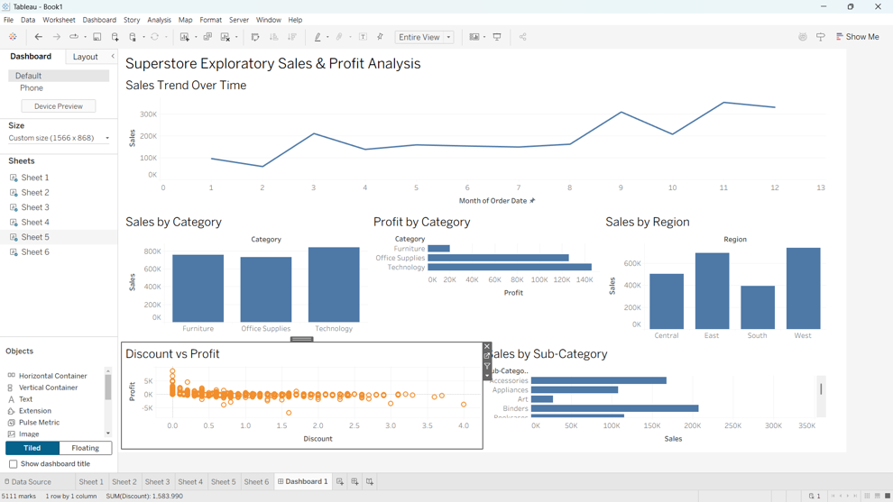

4.3 Key Observations
- Sales vary meaningfully across the monthly sequence, with visible increases and decreases rather than a flat trend.
- Technology appears as a strong sales category in the exploratory view, while Office Supplies and Furniture remain substantial contributors.
- Regional performance differs, with East and West appearing stronger than South in the displayed regional comparison.
- Sub-category analysis exposes a more detailed ranking than category-level analysis and therefore provides a route for drill-down investigation.
- The Discount vs Profit scatter plot suggests that higher discount levels can be associated with weaker profitability for a number of observations, making discount an important variable for further investigation.
Task 1 Insight
The exploratory phase showed that the most useful dashboard questions are not limited to “How much did we sell?” They also include “Where are sales strongest?”, “Which categories drive profit?”, “Which sub-categories deserve attention?”, and “How does discount relate to profitability?”

4.4 Task 1 Outcome
The outcome of Task 1 was a prioritized set of business questions and visual candidates that could be carried into dashboard planning. This created the analytical foundation for the subsequent weeks rather than treating dashboard design as a purely visual exercise.

5. Task 2 – Dashboard Planning and Design Strategy
Task 2 shifted the focus from discovering patterns to deciding how those patterns should be communicated. The planning logic was to place the most important business indicators first, then provide trend context, comparative views and deeper analytical detail.

5.1 Target Audience and Questions
Audience need | Dashboard question | Planned response
Executive overview | How is the business performing? | Sales, Profit and Orders KPI cards
Trend monitoring | How has sales changed over time? | Monthly sales trend
Product analysis | Which categories/sub-categories contribute most? | Category and sub-category bars
Regional analysis | Which regions contribute most? | Regional comparison / heat map
Profitability | Where is profit strongest or weakest? | Profit comparison and margin analysis
Diagnostic analysis | Does discount relate to profit? | Discount vs Profit scatter plot

5.2 Layout Strategy
- Top area: dashboard title and a clear time trend to establish context.
- Second area: KPI cards for rapid recognition of overall performance.
- Middle area: category, profit and regional comparisons for business-level diagnosis.
- Lower area: discount/profit relationship and sub-category detail for deeper investigation.
- Side panel: filters and interaction controls so users can narrow the analysis without obscuring the main story.

5.3 Design Principles
- Visual hierarchy: place high-value information before detailed diagnostics.
- Consistency: use repeated titles, labels and measure conventions across views.
- Comparison first: prefer charts that make differences easy to compare.
- Controlled interactivity: filters should support the story rather than create unnecessary complexity.
- Progressive detail: move from summary to category/region to sub-category and diagnostic views.

5.4 Design-to-Build Connection
The later Tableau screenshots demonstrate that this planning stage was translated into actual dashboard structures. The final interactive views contain the planned trend, KPI, category, region, sub-category and profitability components, showing a clear connection between conceptual planning and implementation.

6. Task 3 – Crafting Interactive Data Stories
Task 3 introduced the narrative layer. Instead of presenting isolated charts, the dashboard was structured so that a user could begin with overall performance and then investigate time, category, region and sub-category drivers.

6.1 Story Sequence
- Start with the overall performance context using Sales, Profit and Orders.
- Use the sales trend to understand when performance changes.
- Compare category-level sales and profit to identify major product groups.
- Compare regional sales to understand geographic contribution.
- Use sub-category detail to locate specific product areas.
- Use Discount vs Profit to investigate a possible profitability driver.
- Apply filters and actions to test the story from different regional, date and category perspectives.
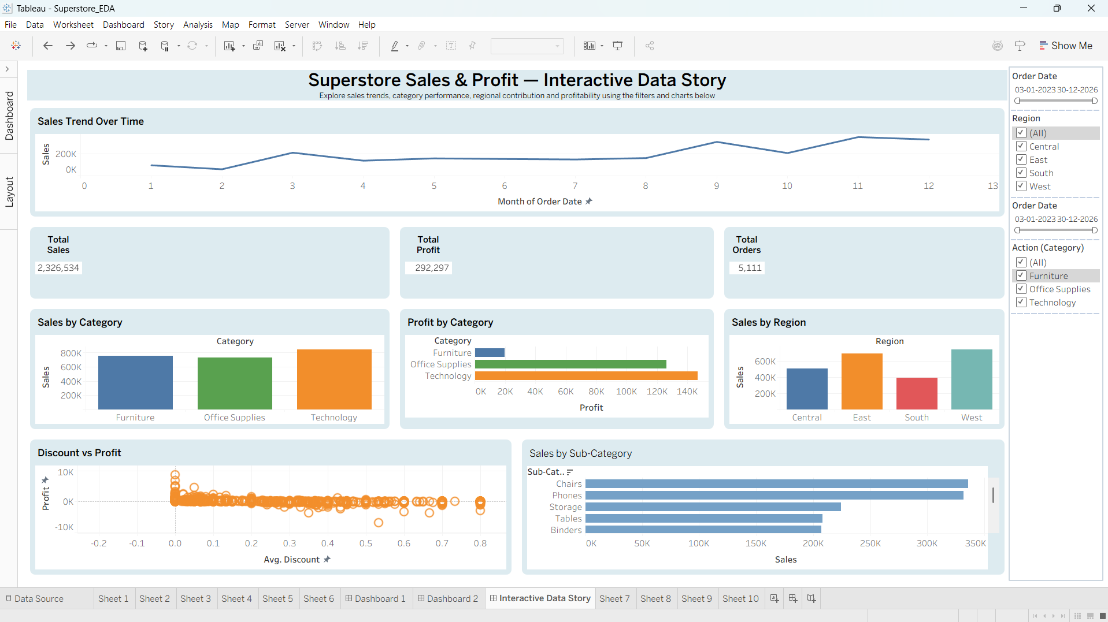

6.2 Interactive Elements
Interactive element | Purpose | Storytelling value
Order Date filter | Limit the time period | Lets the user compare periods without rebuilding the view.
Region filter | Focus on a geography | Supports regional investigation.
Category action/filter | Focus on product groups | Connects high-level category choices to detailed views.
KPI cards | Show selected-scope totals | Provides immediate context for filtered analysis.
Coordinated charts | Compare multiple dimensions | Turns separate charts into a connected analytical story.

6.3 Example of Filtered Story
The supplied Tableau screenshot also shows a filtered state where the West region is selected. In that state, the KPI values change to Total Sales 676,713, Total Profit 102,914 and Total Orders 1,504. This demonstrates how the same dashboard can move from an overall view to a region-specific narrative without changing the underlying dashboard structure.
Task 3 Insight
Interactivity is most valuable when it changes the question being answered. A filter that updates KPIs and multiple charts together is more useful than an isolated control that affects only one visual.

7. Task 4 – Advanced Chart Techniques and Calculation Insights
Task 4 deepened the technical analysis by adding advanced charting methods and calculated metrics. The supplied Advanced Sales Analysis screenshot demonstrates several techniques that go beyond basic bar and line charts.
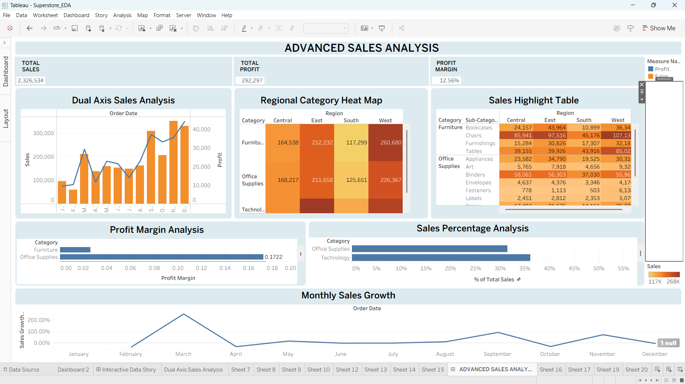

7.1 Advanced Visualization Techniques
Technique | Purpose | Analytical benefit
Dual-axis Sales & Profit | Combine two measures with different scales | Shows sales volume and profit movement together.
Regional Category Heat Map | Compare two categorical dimensions using color intensity | Makes strong/weak regional-category combinations easier to spot.
Sales Highlight Table | Show detailed values across Region and Category/Sub-Category | Supports precise lookup while retaining visual emphasis.
Profit Margin Analysis | Compare profit relative to sales | Separates high sales from genuinely efficient profitability.
Sales Percentage Analysis | Show category contribution to total sales | Communicates relative importance rather than raw volume only.
Monthly Sales Growth | Show period-to-period change | Adds momentum/context to absolute sales levels.

7.2 Calculated Metrics
Calculated metric | Conceptual formula | Why it matters
Profit Margin | SUM(Profit) / SUM(Sales) | Shows profitability efficiency relative to sales.
Sales Percentage | SUM(Sales) / TOTAL(SUM(Sales)) | Shows each category's share of total sales.
Monthly Sales Growth | (Current Period Sales - Prior Period Sales) / Prior Period Sales | Highlights acceleration or decline over time.

The formulas above document the analytical logic represented in the dashboard. The screenshot visibly reports an overall Profit Margin of 12.56%, while the category margin view shows different profitability levels by category. The exact table-calculation configuration can vary with Tableau's addressing and partition settings, so the report focuses on the analytical intent rather than assuming an unseen workbook configuration.

7.3 Technical and User-Centered Impact
- Dual-axis analysis reduces the need to switch between separate Sales and Profit views.
- Heat maps provide rapid pattern recognition across two dimensions.
- Highlight tables preserve exact values for users who need detail.
- Profit margin prevents a high-sales category from being automatically interpreted as the most profitable.
- Sales percentage and monthly growth add context to raw totals and make the dashboard more analytical.

8. Task 5 – Performance Optimization and Interactive Feature Enhancement
Task 5 focused on the practical question of how a feature-rich Tableau dashboard can remain responsive and usable. The task specification explicitly frames the assessment as a hypothetical dashboard design. The supplied performance screenshot therefore serves as a documented baseline scenario rather than a claim of independently benchmarked workbook performance.
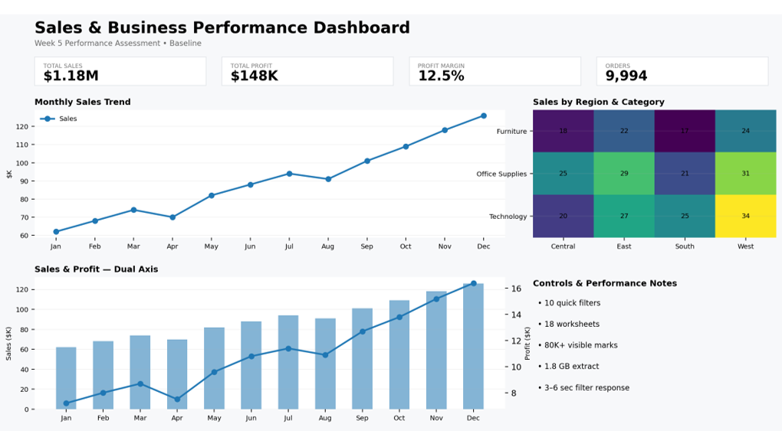

8.1 Baseline Performance Risks Identified
Potential bottleneck | Baseline scenario shown | Why it matters
Quick filters | 10 quick filters | Many independent filters can increase query activity and user complexity.
Worksheet count | 18 worksheets | More sheets can increase dashboard rendering and maintenance cost.
Visible marks | 80K+ visible marks | High mark counts can slow rendering and visual interpretation.
Extract size | 1.8 GB | Large extracts may increase storage, refresh and query workload.
Filter response | 3–6 sec shown | Slow feedback interrupts exploratory flow.

8.2 Optimization Strategies
- Reduce unnecessary fields and rows before analysis where the business question does not require them.
- Prefer extracts when appropriate and keep extracts focused on required data.
- Limit the number of worksheets on a single dashboard when multiple sheets repeat the same information.
- Avoid unnecessarily dense mark displays; use aggregation and focused detail views.
- Review calculated fields and avoid repeated expensive logic when a simpler expression or prepared field can achieve the same result.
- Use filters intentionally and place the most useful controls first.
- Use dashboard actions and drill-down patterns to reveal detail only when requested.
- Validate responsiveness after changes instead of assuming that an optimization is effective.

8.3 Interactive Feature Enhancements
Feature | Implementation idea | Expected usability benefit
Dynamic filters | Date, Region and Category controls | Fast segmentation of the dashboard.
Drill-down | Category → Sub-Category | Progressive detail without overwhelming the first view.
Parameters | User-selected analytical control | Lets users change the analysis without rebuilding sheets.
Highlight / set actions | Emphasize selected data points | Improves focus and comparison.
Navigation / reset | Move between analytical views and return to default | Creates a more guided user experience.

8.4 Optimization Outcome
The key outcome of Task 5 is a performance-aware design mindset: interactivity should be purposeful, visual density should be controlled, and technical optimization should be considered together with user experience. The goal is not simply to make Tableau faster; it is to make the analytical workflow smoother.

9. Task 6 – Final Integration, Evaluation and Reporting
Task 6 brings the earlier work together and evaluates the project as a complete Tableau learning journey. The final integration is based on the supplied task definitions and the Tableau screenshots, with the goal of showing how each stage contributes to the next.

9.1 Integrated Workflow
Stage | Question answered | Output carried forward
Task 1 – Explore | What is happening in the data? | Trends, comparisons, relationships and candidate insights
Task 2 – Plan | How should the story be communicated? | Audience, metrics, layout and interaction blueprint
Task 3 – Story | How can users explore the message? | Interactive narrative and coordinated controls
Task 4 – Deepen | How can analysis become more informative? | Advanced charts and calculated metrics
Task 5 – Optimize | How can the experience remain responsive? | Performance strategy and purposeful interactivity
Task 6 – Integrate | What was learned and what comes next? | Evaluation, reflection and future recommendations

9.2 Final Integrated Dashboard Evidence
The final dashboard concept combines the major components developed across the internship: time trend, KPI cards, category analysis, profit analysis, regional comparison, discount/profit diagnostics, sub-category detail and interactive filters. The advanced analysis view adds further depth through dual-axis, heat-map, highlight-table, margin, sales-share and growth techniques.

9.3 Critical Evaluation of Effectiveness
Area | What worked well | What could be improved
EDA | Multiple dimensions were explored before dashboard design. | Add more formal statistical validation and anomaly investigation.
Dashboard design | Clear hierarchy from KPIs to details. | Further simplify dense lower-level views on smaller screens.
Storytelling | Filters and coordinated views allow guided exploration. | Add stronger annotation or guided story captions for first-time users.
Advanced visuals | Several advanced techniques add analytical depth. | Use advanced charts only when they answer a distinct question.
Performance | Potential bottlenecks were explicitly identified. | Benchmark the actual workbook with Tableau performance tools before and after each change.
Documentation | The project is organized as a progressive learning journey. | Future reports can include exact workbook versioning and measured optimization results.

10. Cross-Task Critical Evaluation
The six tasks form a logical development cycle rather than six unrelated assignments. The strongest evidence of integration is the way the same business questions recur at increasing levels of sophistication.
Business question | Task 1 | Task 3 | Task 4 | Task 5
How are sales changing? | Trend exploration | Interactive trend | Monthly growth | Responsive filtering
Which products matter? | Category/sub-category comparison | Interactive category view | Sales share + highlight table | Drill-down
Where is performance strongest? | Regional comparison | Region filter | Regional-category heat map | Focused filtering
Where is profitability strongest? | Profit comparison | Interactive profit view | Profit margin + dual axis | Reduce unnecessary detail / calculations
Does discount affect profit? | Scatter exploration | Interactive diagnostic | Analytical context | Keep detail on demand

10.1 Evaluation Against the Final Task Criteria
Criterion | Assessment | Evidence
Completeness and integration | Strong | All five technical areas are explicitly connected in the final workflow.
Clarity and professionalism | Strong | Structured sections, tables, screenshots and consistent terminology.
Reflective depth | Good | Lessons, limitations, challenges and improvement areas are documented.
Forward-thinking recommendations | Strong | Future practices cover performance, accessibility, storytelling and governance.
Logical structure | Strong | The report follows Tasks 1–6 in sequence and ends with integrated evaluation.

11. Lessons Learned
- Exploration should come before dashboard decoration. Understanding the data creates a stronger basis for visual choices.
- A dashboard should answer a defined set of business questions instead of trying to display every available field.
- Interactivity is useful when it helps users investigate a question; excessive controls can create cognitive and technical overhead.
- Advanced charts should add analytical meaning. Dual-axis, heat maps and highlight tables are valuable when their comparison purpose is clear.
- Calculated fields turn raw measures into business metrics such as margin, contribution and growth.
- Performance is part of dashboard design, not a final afterthought. Worksheet count, mark density, extract size, calculations and filters can all affect the experience.
- Documentation improves technical thinking because it forces each design decision to be explained rather than chosen visually without rationale.
- A strong Tableau portfolio should show not only the final dashboard but also the reasoning, iterations and trade-offs behind it.

12. Challenges and Solutions
Challenge | Response
Large amount of information available in Superstore | Prioritized sales, profit, orders, category, region, sub-category, discount and time.
Risk of dashboard overcrowding | Used a hierarchy: KPI → trend → comparisons → diagnostic detail.
Need for deeper analysis than basic charts | Introduced dual-axis, heat map, highlight table, margin, sales percentage and growth.
Potential performance issues from interactivity | Considered extract optimization, fewer worksheets, controlled filters and reduced mark density.
Maintaining a coherent story across multiple views | Used consistent business questions and connected filters/actions.
Limited evidence for actual performance benchmarking | Kept Week 5 numbers clearly labeled as a baseline assessment scenario and recommended real workbook benchmarking.

13. Recommendations for Future Tableau Practice
- Use Tableau Performance Recording and workbook-level measurement to compare actual response times before and after optimization.
- Build a small number of reusable dashboard templates for executive, operational and analytical audiences.
- Use parameters and set actions selectively for scenario analysis rather than adding controls by default.
- Add annotations and explanatory text where an insight may not be obvious from the chart alone.
- Test dashboards at multiple screen sizes, especially desktop and laptop resolutions.
- Improve accessibility through readable font sizes, sufficient contrast, meaningful titles and non-color-only encoding where practical.
- Document calculated fields with clear business definitions so another analyst can maintain the workbook.
- Use version control or structured workbook naming so major dashboard iterations can be traced.
- Where possible, validate insights with additional business context before presenting them as recommendations.
- Continue developing portfolio projects that show the full workflow: data preparation → analysis → visualization → interaction → optimization → communication.

14. Professional / Portfolio Value
This internship provides a portfolio story that demonstrates more than the ability to create charts. It shows an end-to-end analytical workflow: problem framing, exploratory analysis, visual planning, storytelling, advanced Tableau techniques, performance awareness and professional documentation. For an employer, this progression demonstrates that visualization is being treated as a communication and decision-support tool rather than only as a design task.

15. Reflective Conclusion
The most important learning from the internship is the shift from simply making a visualization to designing an analytical experience. At the beginning of the workflow, the priority is understanding what the data contains and what patterns deserve attention. The next step is deciding what the audience needs to know and how the dashboard should guide them through that information. Advanced calculations and chart techniques then add analytical depth, while performance optimization ensures that the experience remains practical.
The project also highlighted the importance of iteration. A chart can be technically correct but still be ineffective if it does not support the intended question. Similarly, an interactive dashboard can become less useful when too many controls compete for attention. The final approach therefore balances analytical richness with clarity, and interactivity with performance.
Going forward, the next stage would be to move from a strong internship prototype to a production-quality Tableau workflow: measure performance objectively, improve accessibility, validate business assumptions with stakeholders, document data definitions, and build reusable design patterns. This creates a foundation for more advanced portfolio work in business intelligence and data analytics.

