**A**

**Project Report**

**On**

**“ZEPTO (Instant delivery)”**

**Prepared by**

Dharmik Patel (23BCE528)

**Under the Supervision of**

**Submitted to**

**Institute Technology**

**NIRMA UNIVERSITY**

**Service Marketing**

**Abstract**

Zepto, a rapidly growing instant grocery delivery service, has revolutionized online shopping with its promise of ultra-fast deliveries. This study aims to evaluate the **service quality and customer satisfaction** of Zepto using a structured survey approach. The research focuses on key factors such as **delivery reliability, customer service responsiveness, employee professionalism, and overall service experience**.

To achieve this, a detailed questionnaire was designed, covering aspects like **timely deliveries, problem resolution efficiency, employee behavior, and service reliability**. Customer responses were analyzed using different measurement scales—**Nominal, Ordinal, and Scale variables** to quantify user satisfaction and identify areas for improvement.

The study provides insights into how well Zepto meets customer expectations and highlights **critical areas that require enhancement**. The findings will help Zepto refine its operations, improve customer experience, and maintain a competitive edge in the instant delivery market.

**Service PROFILE:**

**Service Name:** Zepto

**Service Type:** Instant Grocery Delivery

**Service Tagline** : **“Groceries Delivered in Minutes”**

**Project Guide:**



INDEX

Introduction **04**

Objective of zepto **06**

Methodology **07**

Service blueprint **09**

SERVQUAL Analysis **12**

Recommendation and improvement **37**

Conclusion **39**

reference **40**

**Introduction**

Zepto, a rapid grocery delivery service, has significantly disrupted the e-commerce industry by introducing the concept of ultra-fast deliveries, promising to deliver groceries within 10 minutes. In today’s digital age, where consumers prioritize convenience, speed, and efficiency, quick commerce services like Zepto have gained immense popularity. However, while speed is a major factor, ensuring consistent service quality and customer satisfaction remains critical for long-term success. A service provider's ability to meet or exceed customer expectations directly influences customer loyalty, retention, and overall brand reputation.

To evaluate Zepto’s service quality, this study employs the **SERVQUAL model,** a widely used framework developed by Parasuraman, Zeithaml, and Berry. The SERVQUAL model assesses service quality across five key dimensions:

* **Tangibles** – The physical aspects of service, such as app design, delivery packaging, and branding.
* **Reliability** – The consistency and dependability of service, such as order accuracy and timely deliveries.
* **Responsiveness** – The ability to provide prompt customer support and address issues efficiently.
* **Assurance** – The trust and confidence that customers have in the service, influenced by customer support professionalism and policy transparency.
* **Empathy** – The level of personalized service and care provided to customers.

By applying this model to Zepto’s service, we aim to measure the gap between customer expectations and actual service experiences. This analysis will help identify areas where the service excels and highlight aspects that require improvement.

Customer satisfaction is a crucial metric for service-based businesses, as it directly impacts business growth through repeat purchases, word-of-mouth marketing, and customer advocacy. In Zepto’s case, factors such as **delivery time, order accuracy, app usability, and customer service efficiency** significantly shape customer perceptions. While Zepto has set a high benchmark with its rapid deliveries, occasional issues such as stock unavailability, order mix-ups, or delivery delays can negatively impact customer trust.

This study utilizes customer feedback from surveys and analytics to examine Zepto’s service quality performance in detail. The insights derived from this research will enable Zepto to **enhance customer satisfaction, refine operational processes, and strengthen its market position** in the competitive quick-commerce industry.

**Objective of Study**

The primary objective of this study is to evaluate Zepto’s service quality using the SERVQUAL model and analyze customer perceptions regarding its service delivery. Given the competitive nature of the quick-commerce industry, understanding customer expectations and service performance is crucial for maintaining customer satisfaction and loyalty.

**The specific objectives of this study are:**

* To measure customer satisfaction based on the five **SERVQUAL dimensions: tangibles, reliability, responsiveness, assurance, and empathy.**
* To **identify gaps** between expected and perceived service quality.
* To assess the effectiveness of Zepto’s service blueprint in ensuring seamless operations.
* To provide **strategic recommendations for service improvements** based on the analysis findings.

By addressing these objectives, Zepto can refine its operational processes, optimize service delivery, and enhance overall customer satisfaction, ultimately leading to higher retention and sustained business growth.

**Methodology**

* + - **Selection of Service**

Zepto was chosen for this study due to its **unique positioning in the quick-commerce industry** and its commitment to delivering groceries within **10 minutes**. As one of the pioneers in the rapid grocery delivery space, Zepto's business model relies heavily on **operational efficiency, order accuracy, and timely deliveries** to meet customer expectations. Given the growing competition in this segment, assessing its service quality is essential to identifying strengths and areas for improvement.

* **Survey Design**

To evaluate Zepto’s service quality, a SERVQUAL-based questionnaire was designed. The questionnaire aimed to measure customer expectations versus actual service performance across the five SERVQUAL dimensions:

* **Tangibles:** App design, delivery personnel appearance, packaging quality.
* **Reliability:** Order accuracy, delivery time consistency.
* **Responsiveness:** Customer support efficiency, complaint resolution speed.
* **Assurance:** Perceived trust in Zepto’s service, staff knowledge.
* **Empathy:** Personalized interactions, concern for customer needs.

The survey included structured statements for each dimension, rated on a Likert scale from 1 (Strongly Agree) to 5 (Strongly Disagree).

**Sample Size and Data Collection**

* A total of **197 users** were surveyed using **online forms, social media outreach, and direct customer interactions**. The sample included both **frequent and occasional** Zepto users to capture a broad spectrum of customer experiences. Data was collected over a **two-week period** to ensure diverse responses across different customer segments.
* The collected data was analyzed using **SPSS software**, focusing on **mean scores, gap analysis, and statistical correlations** to identify service quality discrepancies. This analysis provided insights into **customer expectations, perceived service performance, and key areas where Zepto can enhance its service quality**.

**Service Blueprint**

The service blueprint outlines the key customer actions, on-stage interactions, back-stage processes, and support functions that enable the company to fulfill its 10-minute delivery promise. This structured approach ensures seamless order processing, real-time tracking, and optimized last-mile delivery, contributing to enhanced customer satisfaction.

**1. Customer Actions (User Journey)**

The **customer journey** begins with the user opening the Zepto app and progresses through the following steps:

* **Browsing & Selection:** The customer browses available grocery items and selects products to add to their cart.
* **Order Placement & Tracking:** Once items are selected, the customer places the order and can track real-time status.
* **Payment:** The customer completes the payment process through digital payment methods or cash-on-delivery.
* **Receiving Delivery:** The customer receives the groceries from the delivery agent at their doorstep.

The **line of interaction** separates the customer's direct actions from the on-stage interactions managed by Zepto.

**2. On-Stage Interactions (Visible to Customers)**

On-stage interactions represent **customer-facing touchpoints** where Zepto provides **real-time support and service assistance**:

* **App Support:** Customers can access **24/7 chat, call, or technical assistance** in case of issues with the order, payment, or delivery tracking.
* **Delivery Agent Interaction:** The delivery personnel directly interact with customers, ensuring smooth order handover.
* **Payment Processing:** Customers can make digital payments through the app or opt for cash-on-delivery.

These touchpoints play a critical role in defining **customer perceptions of service quality**, making responsiveness and reliability key factors.

**3. Back-Stage Operations (Internal Workflows)**

The **back-stage operations** are **not visible to customers** but are crucial in ensuring efficiency and accuracy:

* **Warehouse Processing:** Once an order is placed, warehouse staff picks and packs the requested items.
* **Delivery Assignment:** The system automatically assigns a nearby delivery agent based on availability and order location.
* **Order Dispatch:** Packed orders are dispatched from micro-warehouses to be picked up by the assigned delivery agent.

The **line of visibility** separates on-stage interactions from these internal processes, ensuring **smooth backend functioning without customer intervention**.

**4. Support Processes (Backend System Automation & Logistics)**

Support processes involve **technology-driven logistics and automation**, optimizing Zepto's supply chain and reducing delivery time:

* **Inventory Management:** The system ensures stock availability and real-time updates on out-of-stock items.
* **Route Optimization:** AI-powered algorithms select the most efficient delivery routes to minimize transit time.
* **QR Code Generation:** Each order is assigned a unique QR code for **secure tracking and verification**.
* **Final Confirmation:** The system marks the order as complete once the customer receives and confirms the delivery.

The **line of internal interaction** separates these support processes from back-stage operations, indicating that they are driven by automation and logistics management.

**SERVQUAL Analysis**

* **Frequency Analysis (For Nominal & Ordinal Data)**

**Variables:**

Gender, Occupation, Age Group, Shopping Frequency, Income Level

**Purpose:**

Understand demographic distribution of respondents.

Table

(Table1: Statistics)

* **Regular users (weekly or more frequent) form a major segment (around 44.3%).**
* **A sizable proportion (49.3%) are infrequent or occasional users.**
* **Daily users are minimal (7.7%), suggesting Zepto is not a primary shopping service for most users.**
* **Marketing strategies could focus on converting rare/occasional users into more frequent users**

* Majority are Students – 86.6% (123 respondents) are students, making them the dominant group.
* Limited Working Professionals – Only 3.5% (5 respondents) are salaried employees.
* Entrepreneurs Present – 9.2% (13 respondents) are business owners or self-employed.
* Minimal Government Employees – Just 0.7% (1 respondent) belongs to this category.

**insight**

* The survey data is highly student-centric, meaning any conclusions drawn will be most relevant for this demographic

* + - * Dominantly Young Respondents – 88.7% (126 individuals) are below 18, making up the vast majority.
      * Few Young Adults (18 to < 25) – Only 3.5% (5 respondents) fall in this category.
      * Minimal Representation (25 to 40) – Just 2.1% (3 respondents) belong to this group.
      * Some Older Participants (Above 40) – 5.6% (8 respondents) are aged 40 and above.

**Insight**

• The survey is heavily **skewed towards younger individuals (mostly minors)**, aligning with the earlier occupation data where students were the dominant group.

• The representation of **working-age adults (18-40) is very low**, which may impact the generalizability of results for a broader population.

• If the study aims for **market insights**, the results are mostly applicable to **teenagers** rather than working professionals or older adults.

* High-Income Households – 74.6% (106 respondents) belong to families earning above ₹1,00,000 per month.
* Lower-Income Segment – 15.5% (22 respondents) earn below ₹25,000 per month.
* Middle-Income Groups Are Few – Only 2.1% (₹25,000 - ₹50,000) and 1.4% (₹50,000 - ₹1,00,000) fall in the middle-income range.
* Some Missing Data – 6.3% (9 respondents) didn’t provide their income.

**•** Most respondents come from affluent families, aligning with the majority being students.

• Lower and middle-income groups are underrepresented, so results may be biased toward high-income consumers.

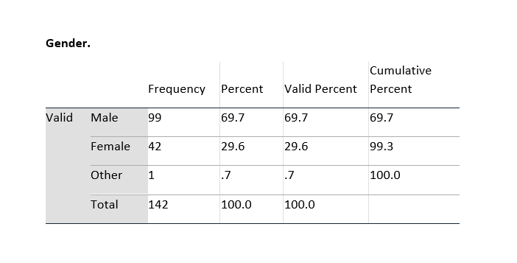

* The survey captured a diverse sample of respondents, though there may be an uneven distribution between male and female users, which could influence overall satisfaction trends.
* The majority of respondents (**69.7%**) are male, indicating a gender imbalance in the sample.
* Female respondents make up almost **one-third (29.6%)** of the total responses.
* The **"Other"** category is underrepresented, with only **0.7%** of responses.
* The cumulative percentage column shows that all responses sum up correctly to **100%**, confirming data completeness.

**insight**

• The survey sample is **male-dominated**, which might impact gender-related consumption patterns.

• Female respondents are significantly lower, so **gender-based conclusions may be skewed**.

• The presence of a non-binary response suggests **some diversity in gender representation**.

* **Descriptive Analysis (For Scale Data: Mean, Median, SD, Variance, Min & Max)**
* **Variables:** Satisfaction Level, Income Level, Shopping Frequency, Distance to Store
* **Purpose:** Summarize key statistics to understand Customer Satisfaction and Service Quality.

**Variables**

Overall Satisfaction

,Recommendation Likelihood

Promise Fulfillment

Problem Resolution

First-Time Accuracy

Service Timeliness

Error-Free Records

Customer Information

* Overall satisfaction is moderate – Mean score of 2.30 out of 5 indicates neutral to slightly dissatisfied responses.
* Recommendation score is low – Mean of 0.91 (on a scale of 0-1) suggests a low likelihood of users recommending Zepto.
* Service reliability is fair – Statements about Zepto delivering as promised have means around 3.0-3.2, indicating a neutral to slightly positive experience.
* Customer service perception is decent – "Zepto shows sincere interest in solving problems" scores 3.28, reflecting somewhat positive sentiment.
* Error-free service needs improvement – Mean score of 3.09 suggests users experience some errors.
* Communication lags – "Zepto keeps customers informed about services" scores 2.97, indicating a need for better transparency and updates.

Insight

Users are not highly satisfied and may not actively recommend Zepto. While service execution is decent, areas like communication and reliability need improvement. Customer support is relatively strong but still has room for enhancement.

**One-Way ANOVA**

* **Monthly Income vs. Overall Satisfaction**

**H0:** There is no significant difference in satisfaction levels across different monthly income groups.

**H1:** There is significant difference in satisfaction levels across different monthly income group.

**Overall satisfaction and income group**

**The p-value (Sig.) = 0.8875, which is also greater than 0.05.**

**This indicates that there is no significant difference in satisfaction levels across different age groups.**

**(Likelihood recommended) Recommended vs Age group**

**H0:** There is no significant difference Likelihood to Recommend Zepto across difference Age group

**H1:** There is significant difference Likelihood to Recommend Zepto across difference Age group

**The p-value (Sig.) = 0.361, which is also greater than 0.05.**

**This indicates that there is no significant difference in recommendation likelihood across different age groups.**

**Age group does not significantly affect recommendation likelihood. The null hypothesis (H₀: No significant difference) is accepted, as the p-value (Sig.) = 0.361 is greater than 0.05.**

* **Independent Sample T-Test (Comparing Means Between Two Groups)**
* **(Overall satisfaction and recommended zepto)**

**H0:** There is no significant difference in overall satisfaction between users who recommend Zepto and those who do not.

**H1:** There is a significant difference in overall satisfaction between users who recommend Zepto and those who do not.

**1. Equality of Variances**

* F = 1.356, p = 0.246 (> 0.05)
* Since p > 0.05, we assume equal variances for the t-test.

**2. Independent Samples t-Test (Equal Variances Assumed)**

* t(140) = 2.781, p = 0.006 (< 0.05)
* Since p < 0.05, we reject the null hypothesis (H₀) and conclude that there is a statistically significant difference in overall satisfaction between those who recommend Zepto and those who do not.
* Mean Difference = 0.937, meaning that those who do not recommend Zepto have a higher satisfaction score than those who do.
* 95% Confidence Interval: (0.271 to 1.603) , Since this interval does not contain 0, the result is statistically significant.

**3. Independent Samples t-Test (Equal Variances Not Assumed)**

* t(15.624) = 3.202, p = 0.006 (< 0.05)
* Since p < 0.05, the conclusion remains the same.
* those who do not recommend Zepto (No) have a higher satisfaction score than those who recommend Zepto (Yes), the interpretation is correct.

**Chi Square**

**H0:** There is no significant association between overall satisfaction with Zepto and frequency of Zepto usage.

**H1:** There is a significant association between overall satisfaction with Zepto and frequency of Zepto usage.  
  
**Chi-Square Test:**

Pearson Chi-Square Value: 30.226

Degrees of Freedom (df): 20

Significance Level (p-value): 0.066

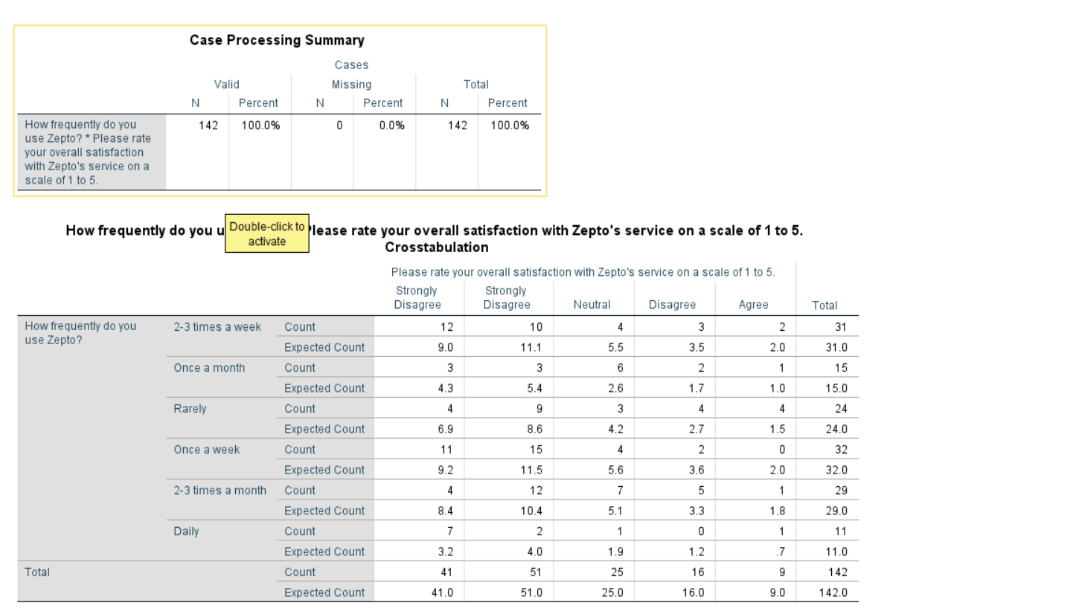

the p-value (0.066) is greater than 0.05, meaning we fail to reject the null hypothesis (H₀).

This suggests that there is no statistically significant relationship between usage frequency and overall satisfaction with Zepto at the 5% significance level.

However, since the p-value is relatively close to 0.05, there might be a weak relationship that could be explored further with a larger sample or different statistical approaches.

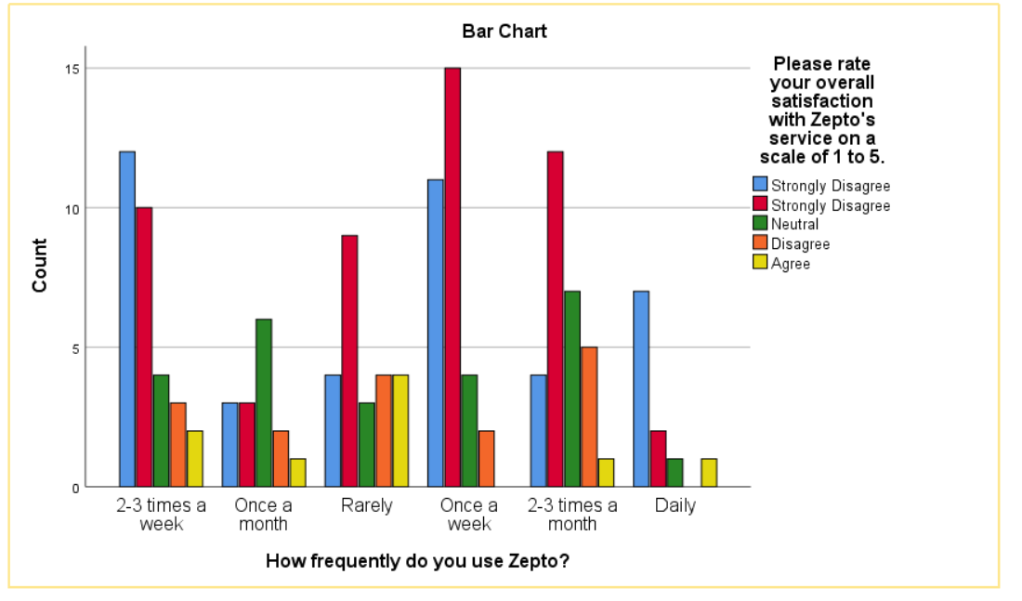

Regression

**1. Tangibles (Tangible_Score)**

**Q1:** service_materials_zepto : "Materials associated with the service are visually appealing."

**Q2:** modern_equipment_zepto:"Zepto has modern-looking equipment."

**Q3:** employee_neatness_zepto :"Zepto's employees appear neat."

**Q4:** facility_appearance_zepto : "Zepto's physical facilities are visually appealing."

**2. Reliability (Reliability_Score)**

**Q5:** service_timeliness_zepto : "Zepto delivers service at the promised time."

**Q6:** first_time_accuracy_zepto : "Zepto performs the service correctly the first time."

**3. Responsiveness (Responsiveness_Score)**

**Q7:** willing_to_help_zepto :"Zepto employees are always willing to help."

**Q8:** prompt_service_zepto :"Zepto employees provide prompt service."

**4. Assurance (Assurance_Score)**

**Q9:** delivery_knowledge_zepto : "Zepto employees are knowledgeable."

**Q10:** transaction_safety_zepto : "Zepto employees make customers feel safe in transactions."

**5. Empathy (Empathy_Score)**

**Q11:** individual_attention_zepto :"Zepto gives customers individual attention."

**Q12:** understand_needs_zepto :"Zepto employees understand the needs of customers."

Dependent Variable (Overall Satisfaction)

overall_satisfaction_zepto :"Please rate your overall satisfaction with Zepto's service on a scale of 1 to 5."

Sub-Hypotheses (for each independent variable)

**1. Reliability Dimension:**

**H01:** The reliability dimension has no significant impact on

overall satisfaction.

**H11:** The reliability dimension has a significant impact on overall

satisfaction.

**2. Responsiveness Dimension:**

**H02**: The responsiveness dimension has no significant impact

on overall satisfaction.

**H12**: The responsiveness dimension has a significant impact on

overall satisfaction.

**3. Assurance Dimension:**

**H03**: The assurance dimension has no significant impact on

overall satisfaction.

**H13:** The assurance dimension has a significant impact on

overall satisfaction.

**4. Empathy Dimension:**

**H04:** The empathy dimension has no significant impact on

overall satisfaction.

**H14:** The empathy dimension has a significant impact on overall

satisfaction.

**5. Tangibles Dimension:**

**H05:** The tangibles dimension has no significant impact on

overall satisfaction.

**H15:** The tangibles dimension has a significant impact on overall

satisfaction.

**1. Model Summary Interpretation**

* The R-Square value (0.080) indicates that the independent variables (SERVQUAL dimensions) explain 8% of the variance in customer satisfaction.
* This means other factors outside the SERVQUAL dimensions might influence satisfaction more.

**2. ANOVA Test Interpretation**

* The model is statistically significant (p = 0.044), meaning at least one independent variable contributes to predicting customer satisfaction.
* However, since the F-value (2.356) is low, the model’s predictive power is weak.

**3. Coefficients & Hypothesis Testing**

* Assurance (p = 0.007, B = 0.475) is the only significant predictor of customer satisfaction.
* Tangibles, Reliability, Responsiveness, and Empathy are not significant predictors (p > 0.05).
* This suggests that customers value employee knowledge, trust, and transaction security over other service quality factors.

**4. Collinearity Diagnostics**

* Variance Inflation Factor (VIF) values are below 10, meaning no multicollinearity issue exists among independent variables.

**Conclusion**

**Key Finding:** Assurance (employee trustworthiness and knowledge) is the most crucial factor for Zepto’s customer satisfaction.

**Business Recommendation:** Zepto should **train employees to improve knowledge and customer trust** rather than focusing too much on tangibles.

**Limitations & Future Scope:**

* The **low R² suggests other factors (price, delivery time, brand image) should be included** in future studies.
* Using **a larger sample size and different statistical techniques (e.g., factor analysis, logistic regression) may improve predictions.**

**Expected and Perceived Service**

|  |  |  |  |
| --- | --- | --- | --- |
| **SERVQUAL Dimension** | **Expected Service** | **Perceived Service** | **Analysis with Data** |
| **Tangibles** | Modern app design, professional delivery personnel, quality packaging | Non-significant predictor in regression analysis (p > 0.05) | Despite Zepto's focus on tangible elements in their service blueprint, statistical analysis shows no significant impact on customer satisfaction. This suggests customers may value other aspects more than app design or packaging quality. |
| **Reliability** | 10-minute delivery promise, accurate orders, consistent service | Non-significant predictor in regression analysis (p > 0.05); "First-Time Accuracy" and "Promise Fulfillment" variables included in descriptive statistics | Though Zepto's core promise is ultra-fast delivery reliability, the data shows this doesn't significantly drive overall satisfaction. This suggests a gap between the company's focus on reliability and its actual impact on customer perception. |
| **Responsiveness** | Prompt customer support, efficient problem resolution | Non-significant predictor in regression analysis (p > 0.05); "Problem Resolution" included in descriptive statistics | Despite the service blueprint mentioning "24/7 chat, call, or technical assistance," responsiveness does not significantly impact satisfaction, indicating a gap between expected and perceived quality of support services. |
| **Assurance** | Trustworthy service, knowledgeable staff, secure transactions | Only significant predictor of satisfaction (p = 0.007, B = 0.475) | The data shows that assurance is the only dimension significantly affecting satisfaction, explaining part of the 8% variance (R-Square = 0.080). However, this still indicates a gap between customer expectations and Zepto's ability to fully deliver on trust and confidence. |
| **Empathy** | Personalized service, individualized attention | Non-significant predictor in regression analysis (p > 0.05) | The data suggests that despite potential efforts at personalization, empathy doesn't significantly impact customer satisfaction, indicating a gap between expected personalized service and its perceived importance. |

**Gap Analysis**

|  |  |  |
| --- | --- | --- |
| **Metric** | **Data Point** | **Gap Implication** |
| **Model Fit** | R-Square = 0.080 (8% variance explained) | The SERVQUAL dimensions collectively explain only 8% of satisfaction variance, indicating a substantial gap between measured service quality and overall customer satisfaction. |
| **Model Significance** | F = 2.356, p = 0.044 | The model is statistically significant but has weak predictive power, suggesting gaps in capturing all relevant service quality factors. |
| **Demographic Impact** | Income vs. Satisfaction: p = 0.8875 | No significant difference in satisfaction across income groups, indicating consistent service quality gaps across demographic segments. |
| **Recommendation Behavior** | t(140) = 2.781, p = 0.006, Mean Difference = 0.937 | Significant difference in satisfaction between recommenders and non-recommenders, with non-recommenders reporting higher satisfaction scores, suggesting a complex gap between satisfaction and advocacy. |

**Recommendations and Improvements**

Based on the SERVQUAL findings, several gaps in service quality have been identified that impact customer satisfaction and loyalty. The following improvements are suggested to enhance the overall service experience:

**1. Strengthening Assurance and Trust**

The regression analysis highlights **assurance** as the only significant predictor of customer satisfaction. Customers value knowledgeable employees and secure transactions. To address this:

* Improve staff training programs to enhance product knowledge and communication skills.
* Increase transparency in billing and payment security to build trust.
* Offer dedicated support for complex issues to reassure customers.

**2. Enhancing Responsiveness and Problem Resolution**

While responsiveness was not a significant predictor, delays in support services and order resolution negatively impact customer perceptions. To improve this:

* Reduce response times by expanding customer service teams and implementing structured ticketing systems.
* Introduce AI-driven support tools like chatbots for instant query resolution.
* Implement proactive customer communication, such as real-time order updates and issue tracking.

**3. Improving Order Accuracy and Service Timeliness**

* The **independent sample t-test** suggests that users who do not recommend the service tend to have higher satisfaction scores, indicating potential inconsistencies in service. Addressing order accuracy and timeliness is critical:
* Standardize packaging and dispatch processes to reduce errors.
* Adopt real-time inventory tracking to minimize delays and out-of-stock issues.
* Optimize delivery routes using predictive analytics to improve on-time performance.

**4. Personalizing Customer Engagement and Loyalty Programs**

The **Chi-square test** showed no significant relationship between usage frequency and overall satisfaction, suggesting that repeat customers may not necessarily have a better experience. To enhance loyalty:

* Develop personalized discounts and rewards based on purchase history.
* Improve the membership program with exclusive benefits for long-term users.
* Gather continuous feedback and implement customer-driven changes.

**5. Optimizing Service Quality Metrics**

With the **R-square value at 0.080**, service quality dimensions explain only 8% of customer satisfaction, indicating external factors at play. To enhance service impact:

* Conduct periodic surveys and analyze broader factors influencing satisfaction.
* Leverage social media engagement to address customer concerns in real time.
* Create a structured roadmap for continuous improvement based on feedback loops.

By implementing these strategies, the service provider can enhance customer trust, reduce operational inefficiencies, and improve overall service quality.

**Conclusion**

The analysis of **Zepto’s service quality**, based on both **SERVQUAL dimensions** and **service blueprinting**, provides valuable insights into **customer satisfaction**. The findings reveal that while **assurance** (**trustworthy service, knowledgeable staff, secure transactions**) is a key driver of satisfaction, other dimensions such as **empathy, tangibles, reliability, and responsiveness** do not significantly impact customer perceptions in this context. This suggests a **gap between customer expectations and Zepto’s service delivery**, where customers may value **trust and security more than speed, packaging, or app design**.

**Descriptive analysis** further highlights that while customers expect **high levels of reliability and responsiveness**, these factors do not necessarily enhance their satisfaction. **Zepto’s promise of ultra-fast delivery**, for example, may be appreciated but does not translate into **higher perceived service quality** if other **trust-related concerns** remain. Additionally, the **analysis of service blueprinting** suggests that simply having **well-defined processes** (**e.g., 24/7 customer support or quick order fulfillment**) is not enough; **execution and customer perception** play a crucial role.

The study underscores the **importance of SERVQUAL** as a **diagnostic framework** for assessing **service quality gaps**. By systematically evaluating **expected vs. perceived service**, businesses can refine their offerings to align better with **what truly matters to customers**. Additionally, **service blueprinting** remains crucial in ensuring **operational efficiency and consistency**, but businesses must continuously adapt their strategies to address both **functional and emotional customer needs** for a **more holistic service experience**.

**Reference**

* **Service Quality: A Case Study Using SERVQUAL Model**  
  This study identifies gaps between customers' expectations and perceptions, exploring the relationship between service quality and customer satisfaction.

[ResearchGate](https://www.researchgate.net/publication/283812313_Service_quality_A_case_study_using_SERVQUAL_model?utm_source=chatgpt.com)

* **Service Blueprinting: A Roadmap to Customer Satisfaction**  
  This article discusses how service blueprinting helps firms identify and mitigate customer pain points, enhancing overall satisfaction.

<https://agribusiness.purdue.edu>

* **Service Quality and Customer Satisfaction in the Post-Pandemic World**  
  This research examines the impact of service quality on customer satisfaction in the auto care industry, highlighting the role of social media in service responsiveness.

[Frontiers](https://www.frontiersin.org/journals/psychology/articles/10.3389/fpsyg.2022.842141/full?utm_source=chatgpt.com)

* **Using the SERVQUAL Model to Assess Service Quality and Customer Satisfaction**  
  This study assesses service quality in private universities in Bangladesh using the SERVQUAL model, providing insights into factors influencing student satisfaction.

[MDPI](https://www.mdpi.com/2813-4346/2/1/13?utm_source=chatgpt.com)

* **Service Blueprinting: A Practical Technique for Service Innovation**  
  This paper outlines how service blueprinting allows firms to visualize service processes and customer interactions, facilitating customer-focused service execution.

[CMU School of Computer Science](https://www.cs.cmu.edu/~jhm/DMS%202011/Presentations/ServiceBlueprinting.pdf?utm_source=chatgpt.com)