**Lab 7 - Database Connection with JDBC in Java Swing**

* **Screenshots**

1. **Registration Form**

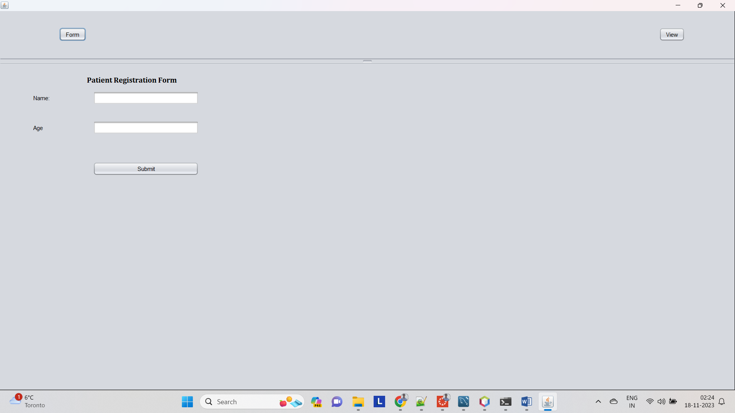

1. **Read (Before Registering any new User)**

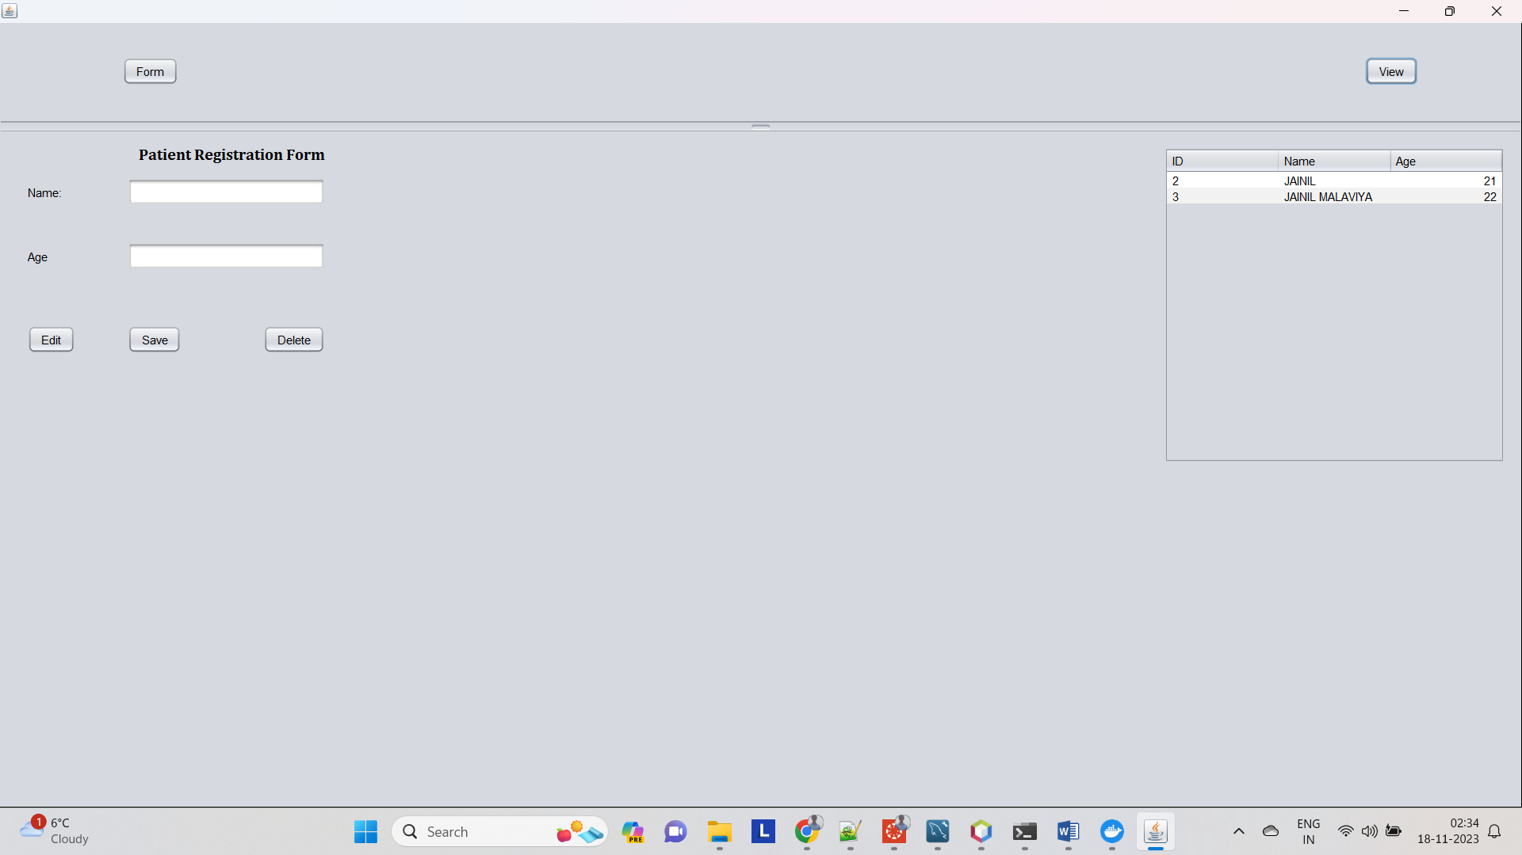

1. **Create (New Registration)**

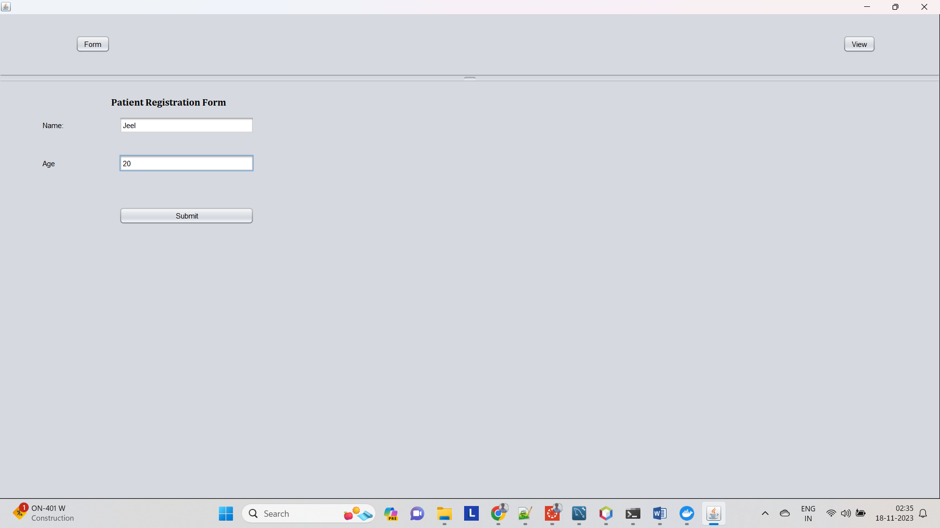

1. **Create (Successfully Registered Dialog Box)**

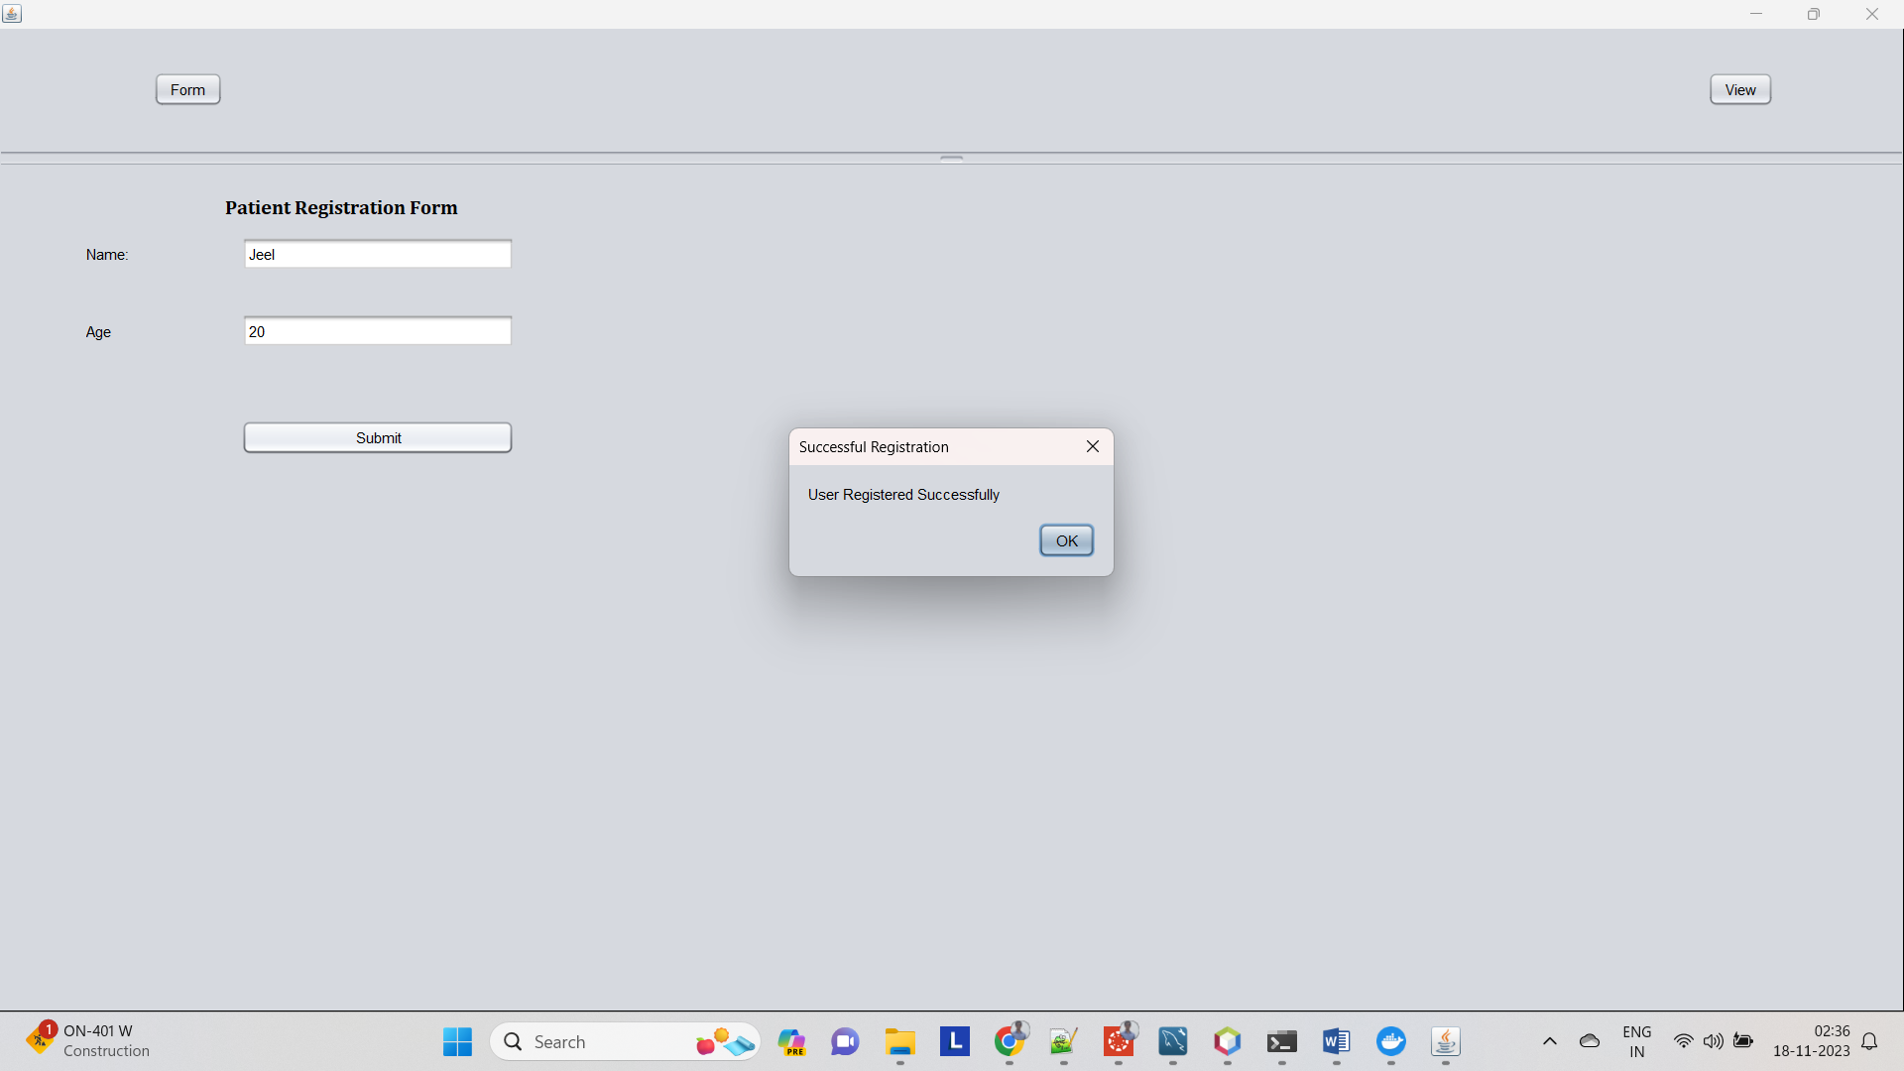

1. **Read (After Registering new user)**

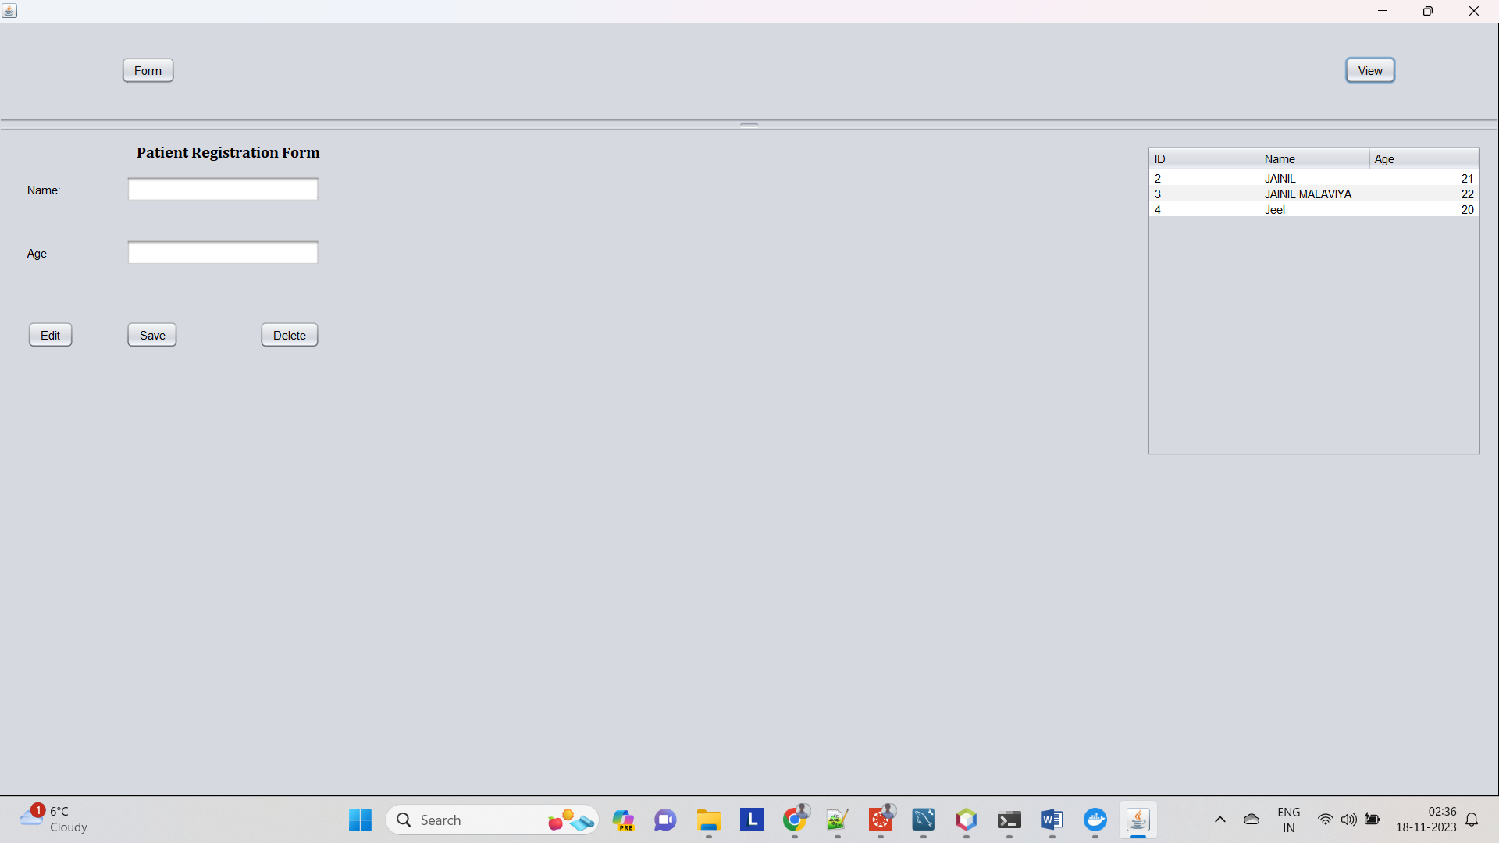

1. **Update (Editing details of ID 3)**

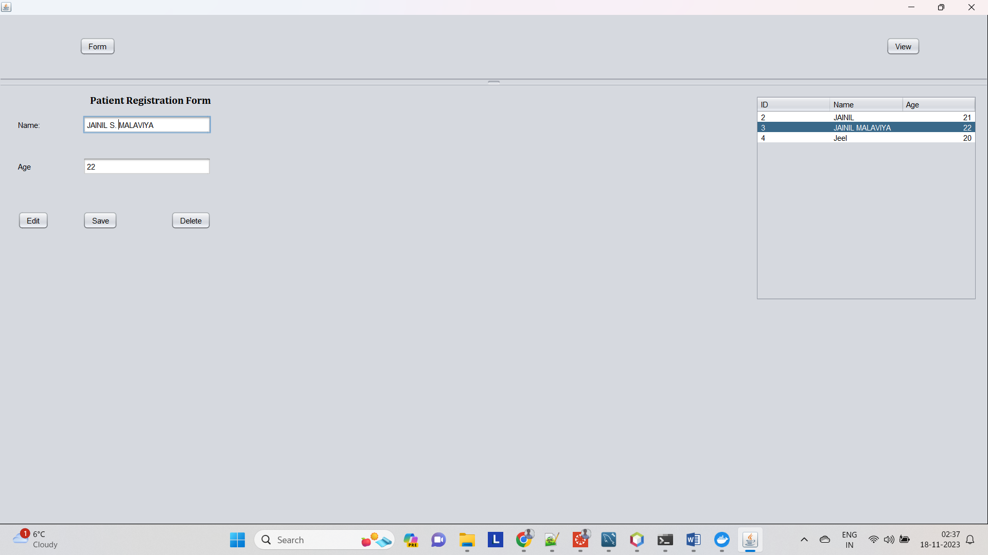

1. **Read (After updating Details)**

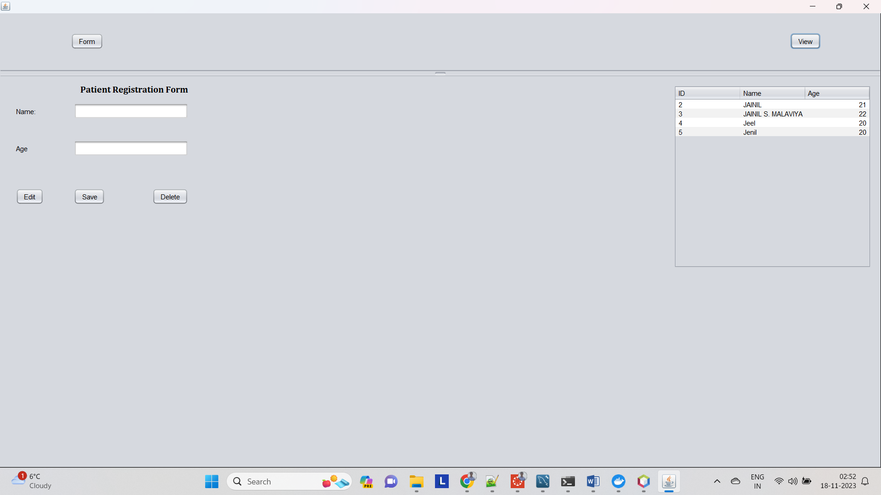

1. **Delete (ID 3)**

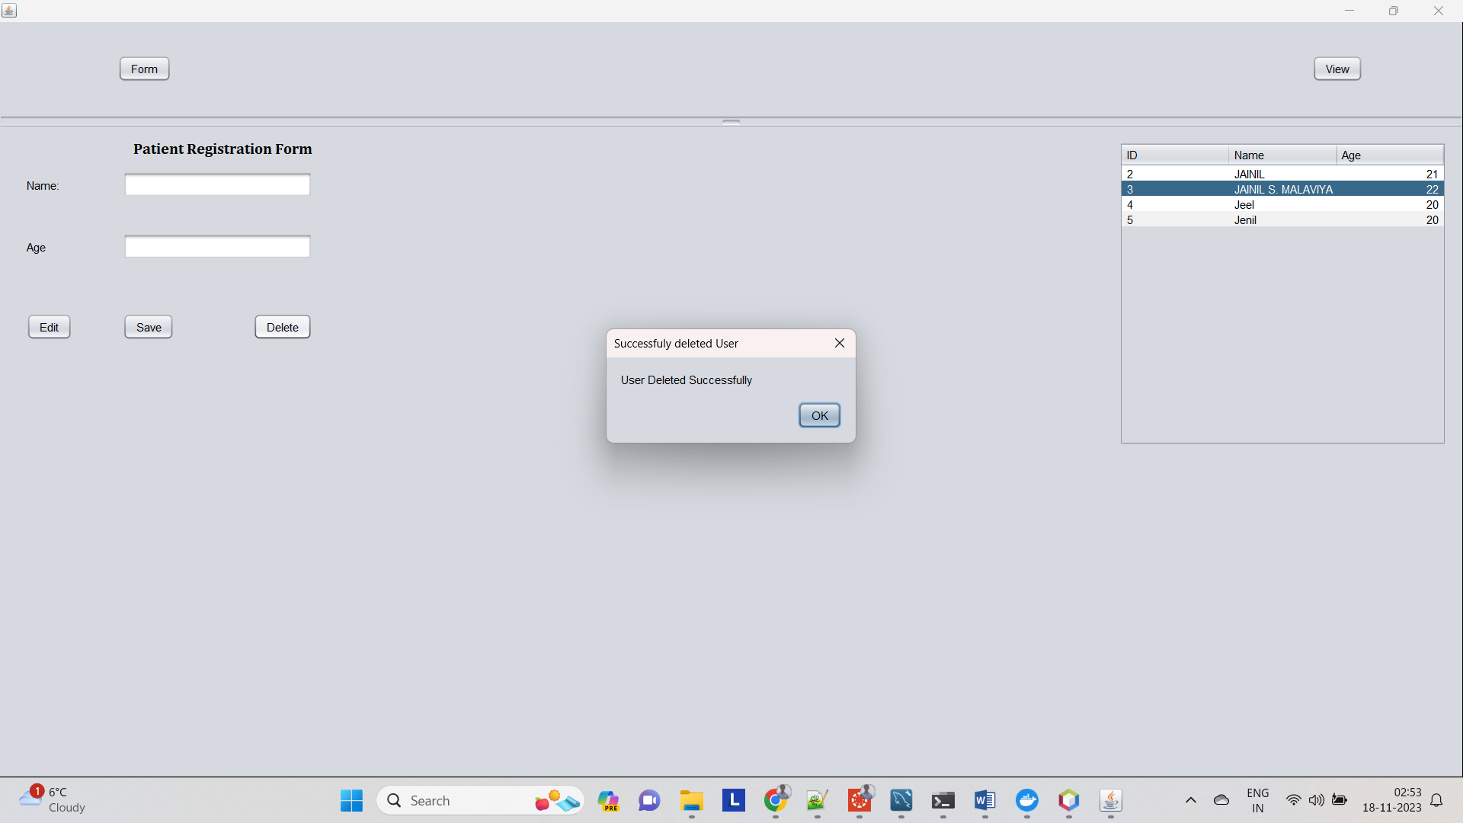

1. **Read (After Deleting ID 3)**

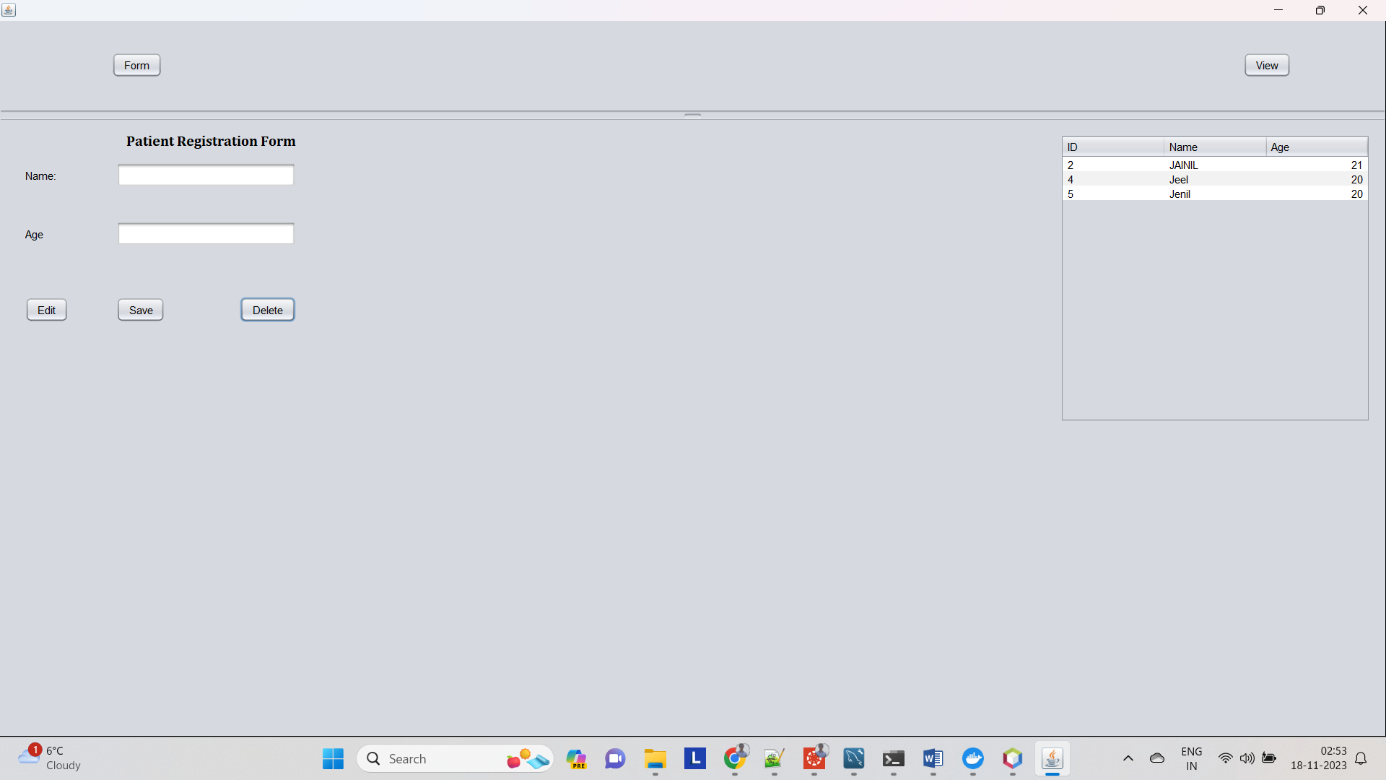

1. **Database in MySQL Workbench**

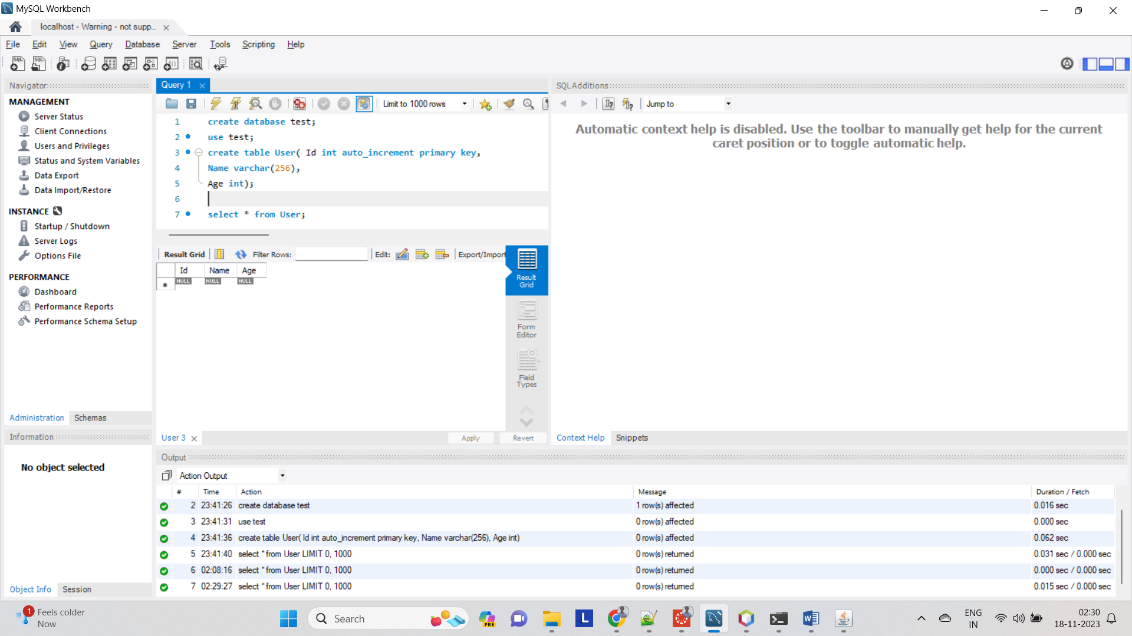

1. **Docker MySQL running screenshot**

