# CPS 561 VR Final Report

Jenil Sanjaykumar Pandya

Pratham Ramkripal Yadav

Vinit Kirit Jain

Vishal Dugyala

Assignment1. Capsule Collider Mario Like Game (Jenil / Pratham)

In this Assignment we must learn the logic behind Unity Engine and C# scripts and implement a Mario Like Game using Unity with Capsule Colliders and Obstacles, so in this game player must collect some objects to gain his score and traverse through some obstacles to do so.

For this Project we Didn’t use any external assets other than Maximo engine to Spawn Characters and their Animations.

Mixamo Inc., a San Francisco-based 3D computer graphics technology company, offers web-based services for 3D character animation, using machine learning methods to automate the process.

[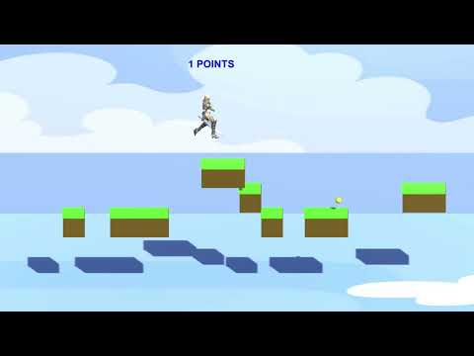](https://www.youtube.com/embed/BsbQCE_530w?feature=oembed)

Assignment1. Capsule Collider Mario Like Game (Vinit / Vishal)

For this assignment, we used various assets from the unity assets store like low poly textures for the ground, power up and enemy characters and used the yellow dummy animated character as our main character. Implemented the animations when the character moves forward or backwards or jump. we have also added the scoring system when the character collects the powerups.

[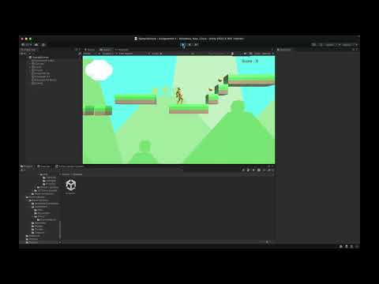](https://www.youtube.com/embed/WeufWl9sW78?feature=oembed)

Assignment2. Sea Dragon Multiplayer Game

We must Create a Working Multiplayer Sea dragon game, in which each dragon must fight to collect 10 food objects, win condition: collect 10 food or kill the other dragon.

After collecting 10 food items the dragon must dance to show that it won.

To do this we used Photon PUN to implement multiplayer. We used forest, flowers, waterfall, lavafall, water pond medieval houses and Castle, fire, trees etc.

Assets listed:

Low Poly Forest

<https://assetstore.unity.com/packages/3d/environments/landscapes/free-low-poly-nature-forest-205742>

The Ultimate Low Poly Nature Pack offers a free pack with 1% of assets, including terrain tiles, mountains, flowers, grass, rocks, mushrooms, and trees, with suggestions for future releases.

Stylised Lava <https://assetstore.unity.com/packages/2d/textures-materials/stylized-lava-materials-180943>

Low Poly Fire <https://assetstore.unity.com/packages/vfx/particles/fire-explosions/low-poly-fire-244190>

AQUAS Lite - Built-In Render Pipeline <https://assetstore.unity.com/packages/vfx/shaders/aquas-lite-built-in-render-pipeline-53519>

PBR medieval houses pack <https://assetstore.unity.com/packages/3d/environments/fantasy/pbr-medieval-houses-pack-71546>

Low Poly Waterfall <https://www.dropbox.com/s/0zcnhdhmhvir4g1/LowPolyWaterfall.unitypackage?e=1&dl=0>

[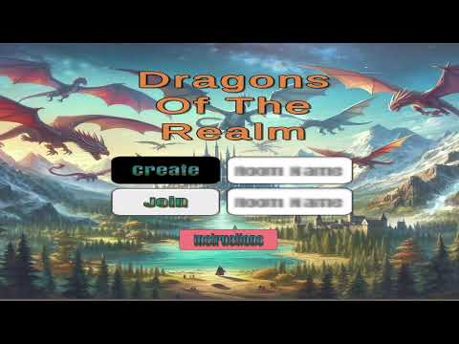](https://www.youtube.com/embed/ND6tA-MzzPQ?feature=oembed)

Original Repository Link when We Were working on it!

<https://github.com/Vnitjain/CPS-563-VR-HW2-Sea-Dragon>

Assignment3. Roller Coaster Implementation

In this Assignment We Implemented a Roller Coaster in a Fully Populated village that we Created using Characters from [Mixamo.com](https://www.mixamo.com/#/) and their animations as well. Rollercoaster tracks were put in place using Spline Element, and we also Implemented Character movements and Camera rotations with Spline as well.

Assets Listed

Viking Village, a 3D Unity environment, has been updated for Unity 2020.2 and above, featuring custom shader graph, vegetation, and water replacements. Players can switch between two cameras using the C key.

<https://assetstore.unity.com/packages/essentials/tutorial-projects/viking-village-urp-29140>

Medieval Cart <https://assetstore.unity.com/packages/3d/environments/fantasy/pbr-fantasy-village-cart-118111>

[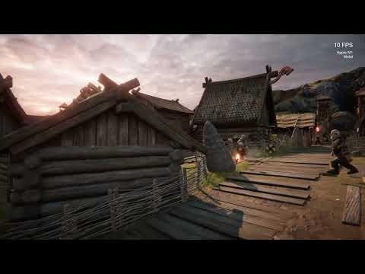](https://www.youtube.com/embed/F6wo0ScWjks?feature=oembed)

Assignment3. Roller Coaster Implementation (Vishal)

Using physics, splines, and careful landscape planning, i created an exciting experience from beginning to end. Dive into designing complex coaster courses and creating environments that heighten the thrill. I build a customised cart that reacts authentically to every turn, paying close attention to every little detail. I ensured that the camera records every heart-pounding moment from the ideal viewing position, guided by our professor's knowledge.

[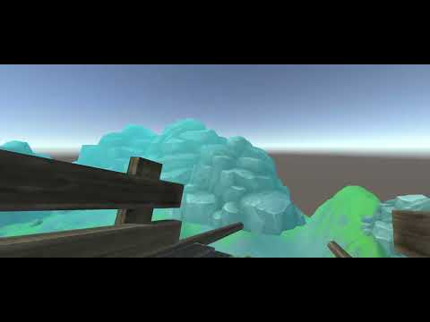](https://www.youtube.com/embed/BWqhbFU9YUY?feature=oembed)

Assignment4. VR Implementation of the Roller Coaster

In this Assignment we did VR Mobile Implementation of the Roller Coaster Assignment, we followed each and every Step provided to us by our teacher and TA, assets are same for this as assignment 3.

For this step, we included the camera movement script for free camera movement on the phone and we used the Unity Mock HMD settings build setting and enabled the stereoscopic view and then built the project again to get the split screen working.

[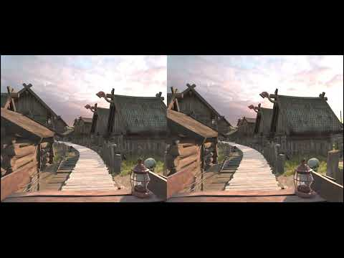](https://www.youtube.com/embed/M5pKqzk1G6A?feature=oembed)

Assignment4. VR Implementation of the Roller Coaster (Vishal)

[](https://www.youtube.com/embed/BWqhbFU9YUY?feature=oembed)

Assignment5. Augmented Reality Implementation (Pratham / Jenil)

For this AR project Assignment, We Had to Create a Augmented Reality objects based on the Famous Paintings. With Vuforia Engine Embedding we were able to achieve this with the Help of AR camera.

For this Assignment we used Michael Jackson Asset, and Character Animation from Mixamo.com

<https://sketchfab.com/tags/michael-jackson>

[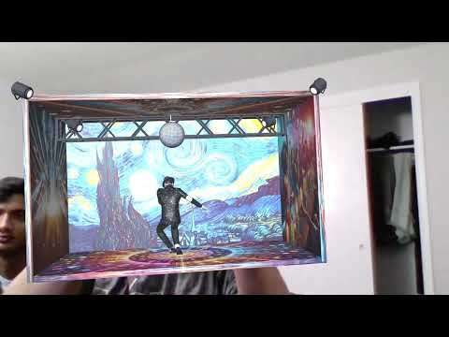](https://www.youtube.com/embed/3CQkOodx4Oc?feature=oembed)

Assignment5. Augmented Reality Implementation (Vinit / Vishal)

We used Vuforia engine to load an image and impose the 3d design of a beach scene on a famous painting. Here we used Adobe after effects to add some animated color changing effects in the background and some splines to animated the shark, bird and people game object to show them moving.

**[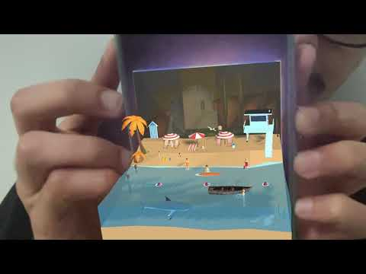](https://www.youtube.com/embed/zCUOhESOkv0?feature=oembed)**