**Lab-06**

**Name:** Jenil J Gandhi

**Roll-No:** CE047

**Subject:** Computer Networks

**Default Routing:**

**Definition:** A default route is the route that takes effect when no other route is available for an IP destination address.

**How Default routing works.**In the case of default routing if a packet is received on the router . The router checks all the IP destination address in one of the subnet address ( If local ). If the address is not local it checks in the routing table and if that remote address is not listed then the packet is forwarded to the next hop towards the destination using the default route. So we can say that if the router does not find any matching route it simply just forwards to the default route.  
The Next device can also perform the same steps if the route is not found and this is repeated until the packet reaches its destination.

The default route by default is 0.0.0.0 in IPV/4 headers.

It must be the last entry in the routing table.

**Hub:**

A hub is a networking device used to connect multiple devices in a network. The feature of a hub is that it broadcasts the packet It received to all other ports. Hence it could be said it is a non-intelligent device. It works in half-duplex mode. Number of ports are generally between 4 to 12.

  
Example of a hub in cisco packet tracer.

**Switch:**

A switch is also a networking device which is used to connect multiple device on a network also it uses packet switching to transmit data. It is an intelligent device and sends the data to only destination node . It works in full-duplex mode. No of ports in a switch are generally between 24 to 48.

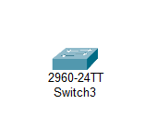Example of a switch in cisco packet tracer.

**Difference between hub and switch.**

|  |  |
| --- | --- |
| **Hub** | **Switch** |
| It is a non intelligent network. | It is an intelligent network. |
| It works in half-duplex mode. | It works in full-duplex mode |
| Contains upto 4 to 12 ports | Contains upto 24 to 48 ports |

**Demo of default routing in packet tracer.**

**Step-1** Setting up the pc in the workspace

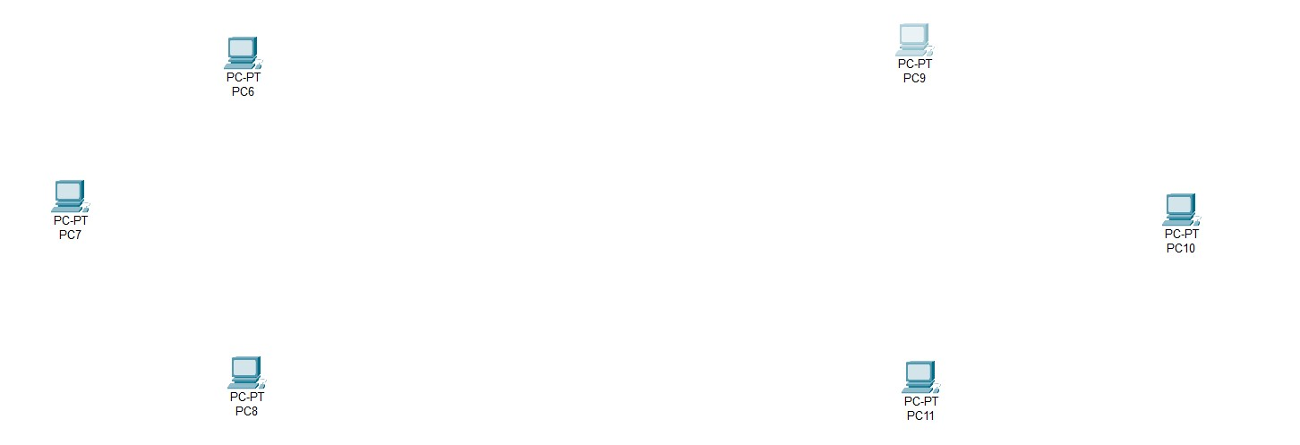

**Step-2** Setting up the switches to connect the PC’s

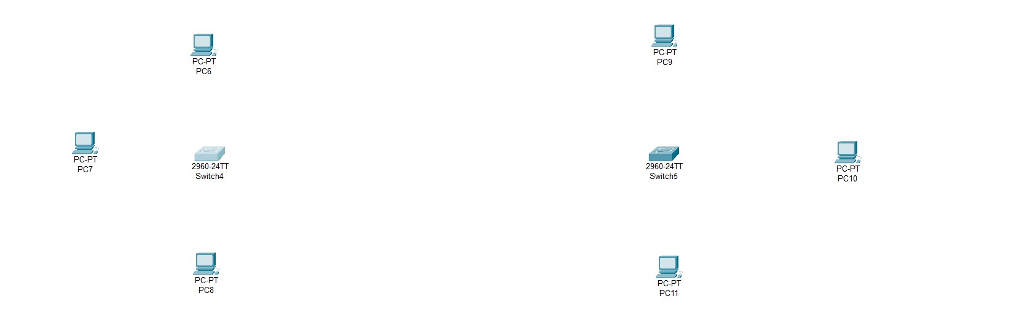

**Step-3** Adding router to connect the local networks

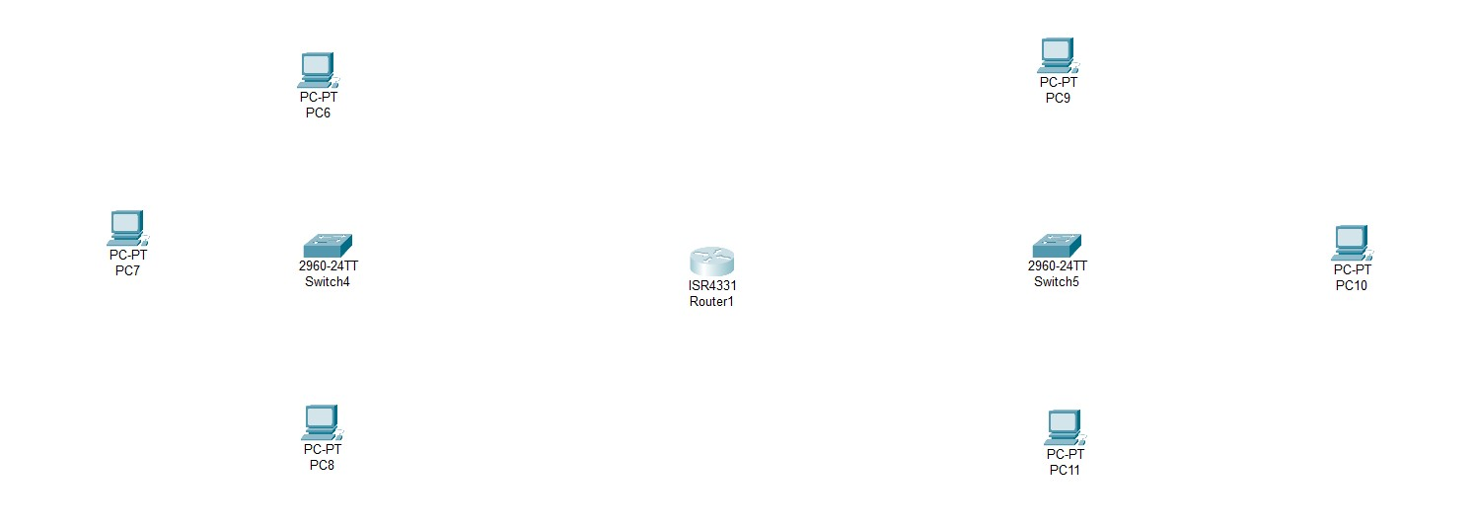

**Step-4** Connecting all pcs to switch

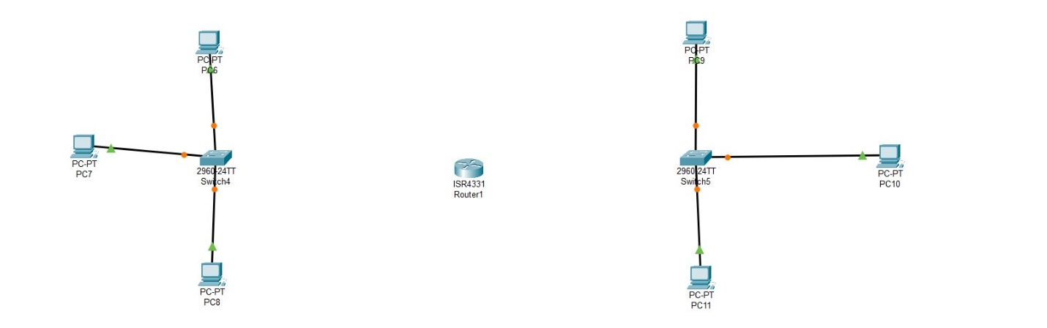

**Step-5** Connecting Everything in place

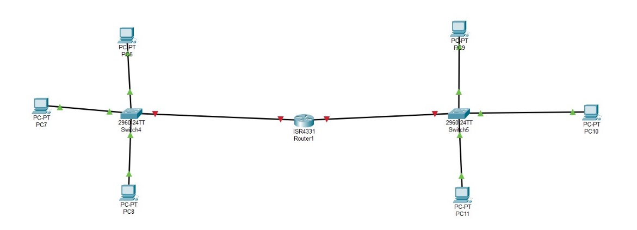

**Step-6** Configuring Ip address in all the pcs

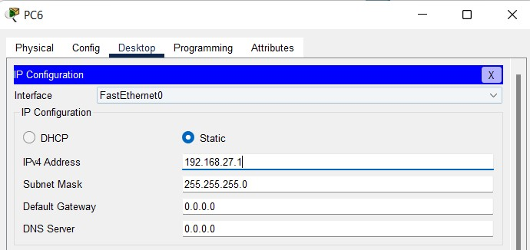

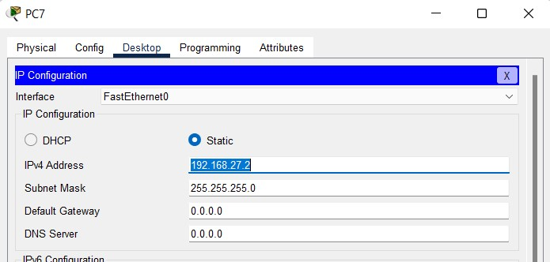

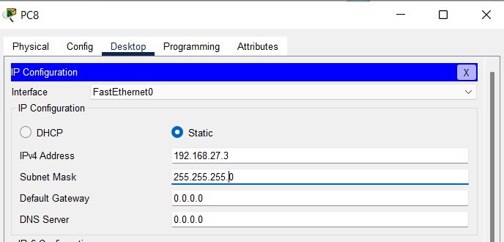

Left Network Configured.

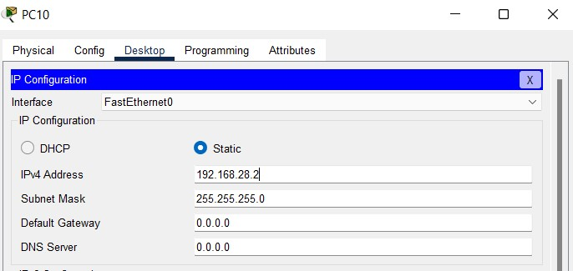

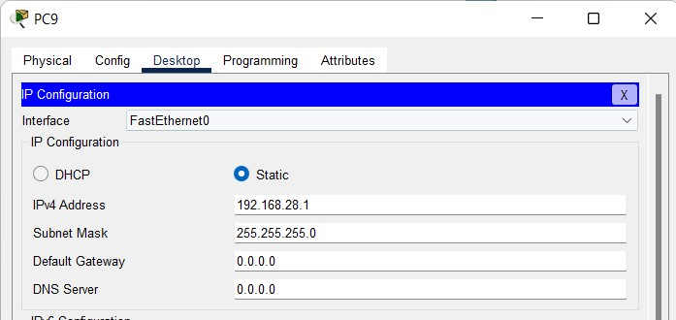

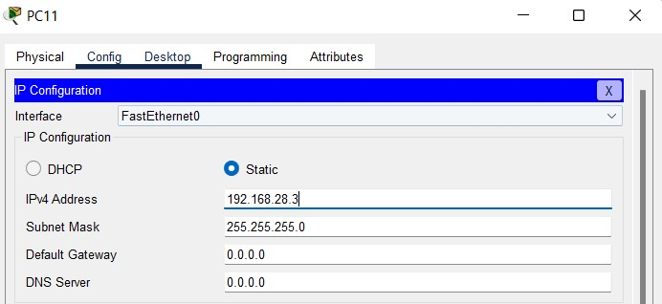

Right network configured.

**Step-7** Router left network configured.

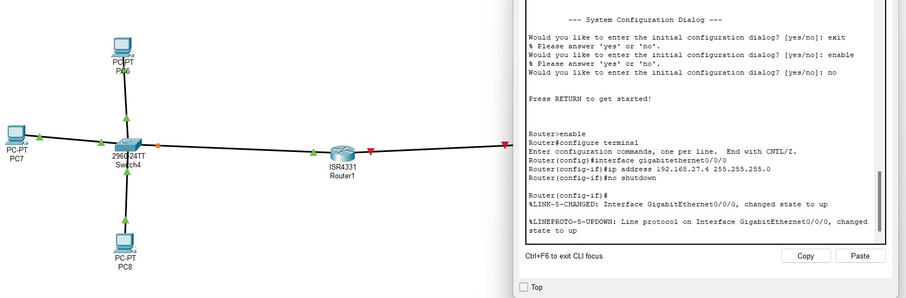

**Step-8** Router right network configured.

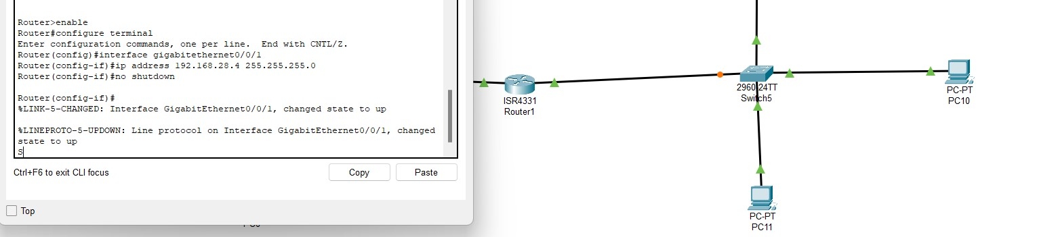

**Step-9** Adding default gateway in all pcs.

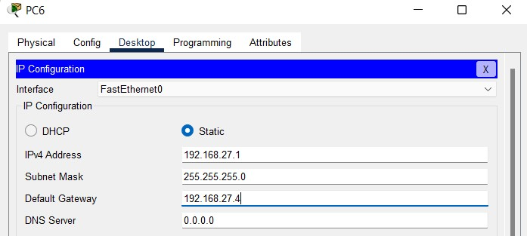  
Same default gateway in left network.

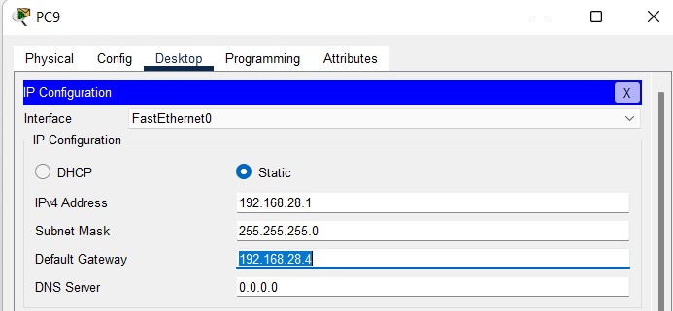  
same default gateway in right network

**Step-10** Fully configured network. (all connections are up and running).

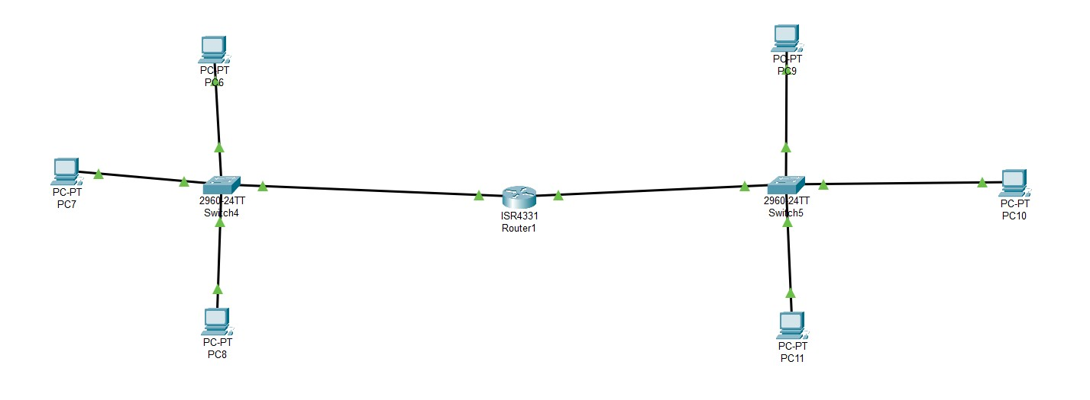

**Step-11** Sending message between 2 networks.

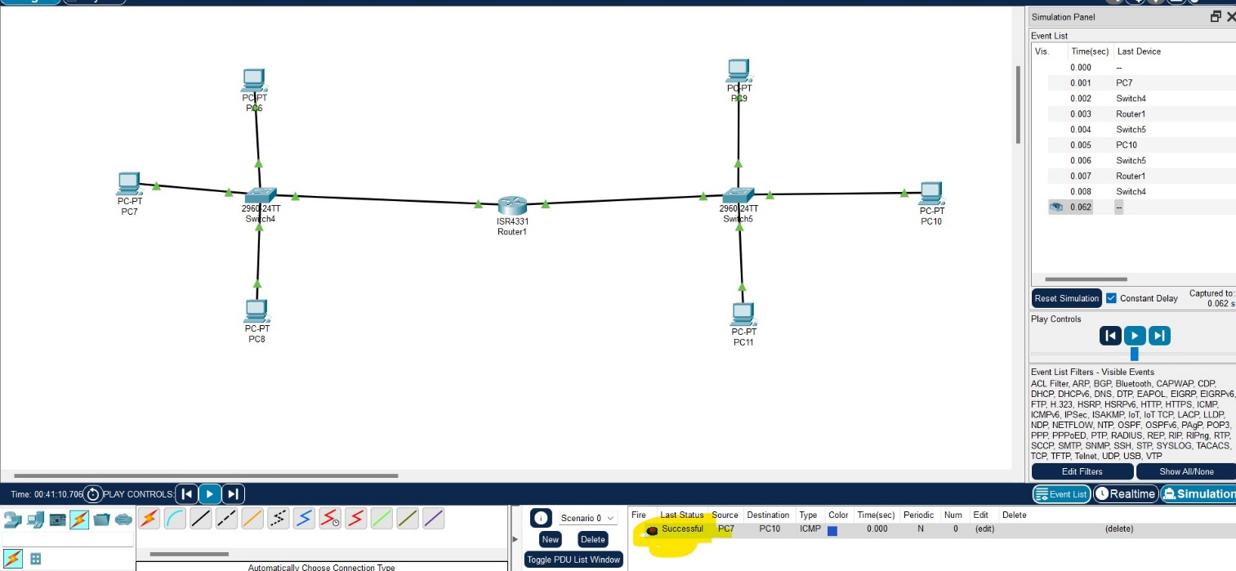

** sorry for inconvenience but the photo did not enlarged mam.

**Step-12** Sending message in internetwork:

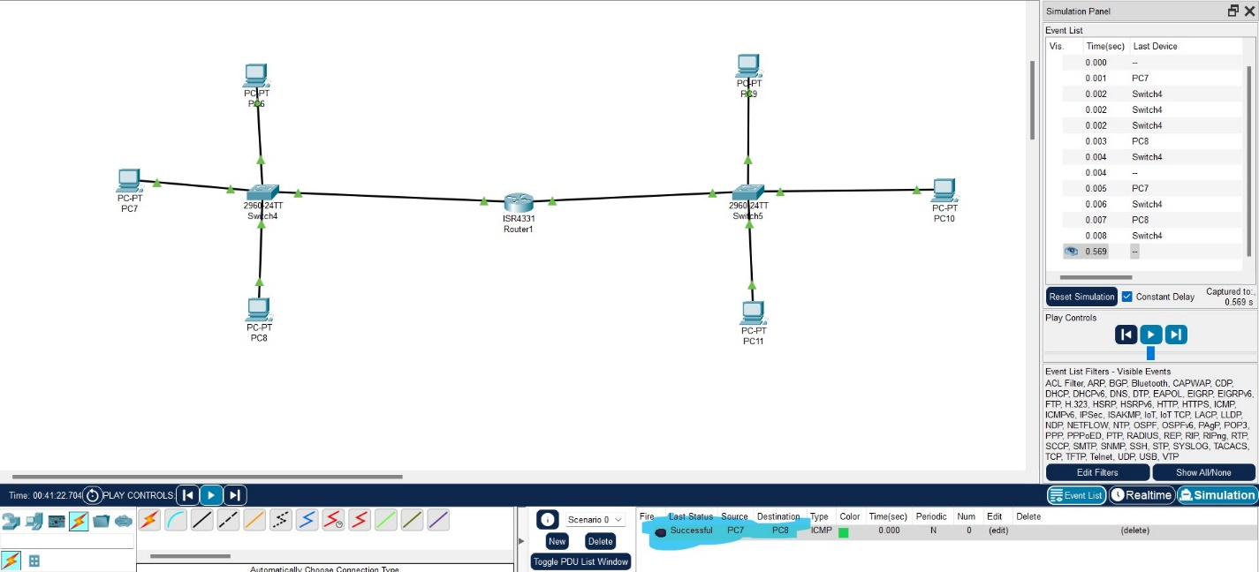

END