K J Somaiya Institute of Technology
An Autonomous Institute Permanently Affiliated to University of Mumbai.
A Project Based Learning
Report On

“YieldVision : Ensemble Machine Learning Approach for Predicting Sugarcane Yield under El Niño Climatic Stress.”
Integrating Agronomic Field Trials, Soil Chemistry, Weather Telemetry and Oceanic Niño Climatic Stress
SUBMITTED BY
Jenil Jani--(TY AI&DS Roll No. 23)
Karina Kesur--(TY AI&DS Roll No. 26)
Yug Mavani--(TY AI&DS Roll No. 32)
Batch: TY AI&DS | Group No.: 7
Guide
Dr. Milind Nemade
Department of Artificial Intelligence and Data Science
2026-27

 | 

K J Somaiya Institute of Technology
UNIVERSITY OF MUMBAI
CERTIFICATE
This is to certify that the project titled “YieldVision :Ensemble Machine Learning Approach for Predicting Sugarcane Yield under El Niño Climatic Stress.” is completed under my supervision and guidance in partial fulfilment of the requirements of the course Project Based Learning - Minor Project Lab-1, by the following students:

Jenil Jani--(Roll No. 23)
Karina Kesur--(Roll No. 26)
Yug Mavani--(Roll No. 32)
The course is a part of semester V of the Department of Artificial Intelligence and Data Science during the academic year 2026-2027. The said work has been assessed and is found to be satisfactory.

(Dr. Milind Nemade)  (Internal guide name and sign.) | (External Examiner name and sign.)

College seal
Table of Contents
Sr.No | Content | Page No.
1 | Introduction | 7
2 | Aim & Objective | 10
3 | Literature Survey | 12
4 | Social Impact/Effect of Problem | 14
5 | System Design | 16
6 | Flow Chart | 22
7 | System Implementation | 25
8 | Results and Analysis | 30
9 | Conclusion | 37
10 | References | 39

Note: Chapter 9 also contains the Applications (9.2) and Future Scope (9.3) of the project. The lists of figures, tables and abbreviations follow on the next pages.
List of Figures
Figure No. | Title | Page No.
Figure 4.1 | Stakeholders benefiting from accurate sugarcane yield forecasting | 14
Figure 5.1 | Four-layer system architecture of YieldVision | 17
Figure 5.3 | Mean trial yield by soil type and cultivar, and distribution of the target | 19
Figure 5.2 | El Niño teleconnection pathway affecting sugarcane yield | 19
Figure 6.1 | End-to-end flow chart of the YieldVision pipeline | 22
Figure 6.2 | Ensemble weights of the Voting Regressor | 23
Figure 7.1 | YieldVision landing page – “Predict smarter. Grow better.” | 27
Figure 7.2 | Agricultural Intelligence Dashboard (Farmer Mode), Maharashtra (Kolhapur) | 27
Figure 7.3 | Prediction page with benchmark trial presets and Voting Regressor output | 28
Figure 7.4 | Models page – ensemble architecture and estimator benchmarking matrix | 28
Figure 8.1 | MAE and RMSE of the base estimators and the Voting Regressor on the hold-out set (lower is better) | 30
Figure 8.2 | 5-fold cross-validation RMSE and fold-wise R² of the five models | 31
Figure 8.3 | Normalised Random-Forest feature importance | 33
Figure 8.4 | Actual vs predicted yield and residual histogram of the Voting Regressor (hold-out set) | 33
Figure 8.5 | Percentage change in predicted yield for single-factor What-If scenarios | 34

List of Tables
Table No. | Title | Page No.
Table 1.1 | ENSO phases defined by the Oceanic Niño Index | 8
Table 2.1 | Project phases and deliverables | 11
Table 3.1 | Comparative literature matrix | 12
Table 3.2 | Strengths and weaknesses of the candidate regressors | 13
Table 4.1 | Problem faced by each stakeholder and the benefit of YieldVision | 15
Table 5.1 | Datasets used in YieldVision | 18
Table 5.2 | Features of the sugarcane agronomic trial dataset | 18
Table 5.3 | ONI-based ENSO classification and crop-risk grading rules implemented in the application | 19
Table 5.4 | Database tables | 20
Table 5.5 | Principal backend endpoints | 20
Table 7.1 | Technology stack and functional role | 25
Table 7.2 | Model configuration used for the trained artifacts | 25
Table 7.3 | Repository structure | 29
Table 7.4 | Test and validation plan | 29
Table 8.1 | Hold-out performance of the base estimators and the Voting Regressor (n = 24, quintal/acre) | 30
Table 8.2 | 5-fold cross-validation results (quintal/acre) | 31
Table 8.3 | Cross-validated RMSE (quintal/acre) under three validation protocols | 32
Table 8.4 | Effect of the ensemble weights (5-fold CV, quintal/acre) | 32
Table 8.5 | What-If scenarios evaluated with the deployed Voting Regressor | 34
Table 8.6 | Climate state and risk level produced by the implemented ONI rules | 35
Table 8.7 | Predicted yield (quintal/acre) for the four benchmark presets; ONI = −0.35 °C (Neutral) | 35
Table 8.8 | Assessment of the hypotheses | 35

List of Abbreviations
Abbreviation | Full form
API | Application Programming Interface
CV | Cross-Validation
DT | Decision Tree
ENSO | El Niño–Southern Oscillation
EBP | Ethanol Blended Petrol (Programme)
i18n | Internationalisation / localisation
LR | Linear Regression (Ordinary Least Squares)
MAE | Mean Absolute Error
ML | Machine Learning
NOAA CPC | National Oceanic and Atmospheric Administration – Climate Prediction Center
NPK | Nitrogen, Phosphorus, Potassium
ONI | Oceanic Niño Index
PMFBY | Pradhan Mantri Fasal Bima Yojana
RBF | Radial Basis Function
RF | Random Forest
RMSE | Root Mean Squared Error
R² | Coefficient of determination
SST | Sea-Surface Temperature
SVR | Support Vector Regression
UI | User Interface

1. INTRODUCTION

1.1 Abstract
Sugarcane (Saccharum officinarum) is one of India’s most important agricultural cash crops, anchoring farm incomes and industrial output across Maharashtra, Uttar Pradesh and Karnataka. Its long vegetative cycle (10–14 months in the field trials used here) exposes the crop to erratic climatic anomalies, particularly moisture deficits and thermal stress associated with El Niño–Southern Oscillation (ENSO) events. Conventional yield estimation relies on survey-based methods or on single statistical or machine-learning models that rarely account for such teleconnected climatic stress.
This project presents YieldVision, an integrated machine-learning framework and web-based decision-support platform for sugarcane yield prediction. Four regressors – Linear Regression, Decision Tree, Random Forest (100 trees) and Support Vector Regression (RBF kernel) – are trained on a benchmark of 120 multi-varietal field trials described by 11 agronomic, weather and management features, and are combined into a soft-weighted Voting Regressor (SVR 0.45, Decision Tree 0.25, Random Forest 0.20, Linear Regression 0.10). On the 24-record hold-out set the ensemble achieves R² = 0.9993, RMSE = 2.79 quintal/acre (about 0.69 t/ha) and MAE = 2.12 quintal/acre; SVR is marginally better on this particular split (R² = 0.9997). Under 5-fold cross-validation the Voting Regressor has the lowest RMSE (3.34 quintal/acre) and the smallest fold-to-fold variation in R², which supports its use as the primary estimator.
The NOAA Oceanic Niño Index (ONI) is integrated as a climate-stress indicator: it classifies the ENSO phase, grades the crop-risk level and drives the climate-intelligence views and What-If scenarios. The system is deployed as a decoupled stack consisting of a FastAPI back end, SQLite persistence (with an equivalent Supabase/PostgreSQL schema), a React + TypeScript dashboard available in 12 languages, Gemini-generated agronomic advisories with a rule-based fallback, and PDF report export.
Keywords: sugarcane yield prediction, ensemble learning, Voting Regressor, Oceanic Niño Index, El Niño, FastAPI, React.

1.2 Background
Sugarcane sustains millions of farming households and feeds the sugar industry, which is the country’s second-largest agro-based industry after cotton textiles [12]. Sugarcane also underpins the renewable-ethanol programme. Unlike annual cereals, the crop needs a growth window of roughly 10 to 18 months. During this period it requires consistent moisture, balanced nitrogen–phosphorus–potassium (NPK) nutrition and stable temperatures across its critical phenological phases: germination, tillering, grand growth and maturation.
The El Niño–Southern Oscillation is a recurring pattern of Pacific Ocean temperature variation that influences rainfall and temperature worldwide. NOAA’s Climate Prediction Center expresses it through the Oceanic Niño Index (ONI), the 3-month running mean of sea-surface-temperature anomalies in the Niño 3.4 region [10]. The index classifies each season into one of three ENSO phases, summarised in Table 1.1. During El Niño the Indian southwest monsoon is frequently weakened, which raises the risk of rainfall deficits and heat stress for rain-dependent crops [4], [6].
Table 1.1: ENSO phases defined by the Oceanic Niño Index
ENSO phase | ONI (°C) | Typical consequence for Indian sugarcane
El Niño | ≥ +0.5 | Delayed or deficient monsoon, moisture and heat stress, risk of lower tonnage
Neutral | between −0.5 and +0.5 | Near-normal rainfall and temperature conditions
La Niña | ≤ −0.5 | Generally wetter conditions; waterlogging and drainage issues possible

1.3 Problem Statement
Sugarcane yield forecasting in tropical and sub-tropical zones remains highly vulnerable to climate shifts. Existing techniques used by survey departments and agro-industrial aggregators still depend on area-frame sampling, manual crop-cutting experiments (CCEs) or single statistical models such as standalone multiple linear regression or an isolated decision tree. These methods routinely fail in anomalous weather years because they treat climate as static local weather and ignore macro-climatic teleconnections, chiefly ENSO. When Pacific sea-surface temperatures rise abnormally during an El Niño phase, rainfall deficits and heat stress can cause sudden drops in cane tonnage and sucrose accumulation, which existing yield-estimation methods rarely capture, making forecasts unreliable in anomalous climate years. In addition, many research prototypes never reach farmers because they lack an accessible, multilingual interface.

1.4 Motivation
The motivation behind YieldVision is to replace isolated, unreliable estimators with a robust multi-model ensemble that blends agronomic ground truth, multi-varietal trial data and a global climate-anomaly index inside a tool that farmers, mills and policy makers can actually use. Reliable forecasts several months before harvest allow farmers to adjust irrigation schedules and potassium fertilisation to counteract stress, help cooperative sugar factories plan crushing capacity, and help policymakers plan ahead of adverse climatic seasons.

1.5 Scope of the Project
- Crop: sugarcane, with trial cultivars Co 86032 (Nayana), CoM 0265 and Co 0238 on alluvial, clay-loam, red and sandy-loam soils.
- Region: India, with the dashboard configured for Maharashtra (for example Kolhapur district) and a regional explorer built on district-wise sugarcane production statistics.
- Inputs: rainfall, mean temperature, sunshine hours, N, P and K application, crop duration, irrigation frequency, pest-control status, soil type, cultivar, and the ONI value of the season.
- Outputs: predicted yield (quintal/acre and t/ha), an inter-model agreement score, ENSO phase and climate-risk level, What-If scenario comparison, a multilingual advisory and an exportable PDF report.
- Out of scope: other crops, ratoon-cycle modelling, satellite imagery and real-time sensor streams (listed as future work in Section 9.3).

1.6 Organisation of the Report
Chapter 2 states the aim, objectives and hypotheses. Chapter 3 reviews related work. Chapter 4 discusses the social and economic effect of the problem. Chapter 5 presents the system design, datasets and database/API design; Chapter 6 gives the flow chart, mathematical formulation and algorithm. Chapter 7 describes the implementation and testing, Chapter 8 reports and analyses the results (including cross-validation, weight-sensitivity and What-If studies) and Chapter 9 concludes with applications and future scope. References follow in Chapter 10.

2. AIM & OBJECTIVE

2.1 Aim
To develop, train, evaluate and deploy an end-to-end intelligent agricultural decision-support system that predicts sugarcane productivity under shifting weather and climatic stresses, using an ensemble of machine-learning models and El Niño (ONI) climate information.

2.2 Objectives
- To develop a reliable approach for predicting sugarcane yield under varying climatic conditions.
- To assess the influence of climatic stress, particularly El Niño/ENSO conditions, on cash-crop yield.
- To determine the effectiveness of different machine-learning approaches for crop yield prediction.
- To investigate whether combining multiple ML models gives more robust yield predictions than individual models.
To achieve these, the following technical objectives were set:
- Data integration: curate, clean and harmonise the 120-trial agronomic benchmark, district-wise production records and the ONI series.
- Climate-stress modelling: classify ENSO phases from the ONI, grade crop risk accordingly and expose the effect of weather and management changes through a What-If simulator.
- Base-model benchmarking: train and compare Linear Regression, a Decision Tree, a bagged Random Forest and Support Vector Regression (RBF kernel).
- Ensemble construction: design a soft-weighted Voting Regressor and validate it with a hold-out split, 5-fold cross-validation and a weight-sensitivity study.
- Deployment: deliver an interactive FastAPI + React dashboard with persistence, automated advisory reports, PDF export and a 12-language interface.

2.3 Hypotheses
- H1 (ensemble robustness): a soft-weighted ensemble of diverse regressors generalises more stably than any single constituent model.
- H2 (climate-stress context): ENSO-phase information derived from the ONI provides actionable climate-stress context (risk grading and scenario analysis) for sugarcane planning.
H1 is tested quantitatively in Chapter 8. H2 is supported at system level (Sections 5.3 and 8.9). Its quantitative effect on prediction error could not be estimated because the 120-trial benchmark carries no year or ONI attribute; learning that effect from longitudinal data is the principal item of future work (Section 9.3).

2.4 Project Milestones
Table 2.1: Project phases and deliverables
Phase | Activity | Deliverable
1 | Problem definition and literature survey | Research gap, objectives, literature matrix
2 | Data collection and harmonisation | Trial benchmark, India production statistics, ONI series
3 | Preprocessing and feature engineering | Scikit-Learn ColumnTransformer pipeline
4 | Base-model training and benchmarking | LR, DT, RF, SVR with MAE/RMSE/R² metrics
5 | Ensemble construction and validation | Soft-weighted Voting Regressor (Joblib artifacts, metadata.json)
6 | Backend, database and advisory service | FastAPI endpoints, SQLite/Supabase schema, Gemini advisories, PDF reports
7 | Frontend and localisation | React dashboard, Farmer Mode, 12 languages
8 | Testing, documentation and demonstration | Results, project report, presentation

3. LITERATURE SURVEY
Accurate crop-yield prediction has been studied across agro-meteorology, remote sensing and applied machine learning. Table 3.1 compares four recent studies by their methods, findings and limitations, and shows the research gap that YieldVision addresses.
Table 3.1: Comparative literature matrix
Parameter | Paper 1 [1] | Paper 2 [2] | Paper 3 [3] | Paper 4 [4]
Title | Crop Yield Prediction Using Machine Learning: A Systematic Literature Review (2020) | Machine Learning for Crop Yield Prediction: A Comprehensive Review (2025) | Sugarcane Yield Prediction Using Machine Learning: A Review (2025) | Assessing the impact of El Niño–Southern Oscillation on sugarcane yield and quality in Brazil’s South-Central Region using the DSSAT-CANEGRO model (2026)
Authors | Van Klompenburg, Kassahun & Catal | Singh et al. | Das et al. | J. G. S. Pedreira, I. M. Fattori Jr., M. S. Vianna & F. R. Marin
Method / Data | Review of ML models (LR, DT, RF, ANN, SVM) with weather and soil data | Review of traditional ML, deep learning (LSTM, CNN) and ensemble techniques | ML methods using climatic and soil parameters (sugarcane-specific) | Mechanistic crop simulation (DSSAT-CANEGRO) coupled with ENSO/ONI phases
Key Finding | ML models effectively predict yield using weather and soil features | Ensemble and deep-learning techniques outperform single ML models | ML improves sugarcane yield forecasting using climate and soil data | El Niño significantly affects sugarcane yield and quality, especially sugar recovery
Limitation | Relies mostly on single ML models; no El Niño consideration | Limited use of ensemble learning and climate-anomaly data | Limited model comparison; minimal focus on El Niño climatic stress | Brazil-specific; uses crop simulation rather than ML
Research Gap | Need ensemble models incorporating climate-anomaly indices | Need integration of ENSO/El Niño indices with ensemble models | Need multi-model comparison with El Niño-specific features | Need ML-based prediction combining ENSO with soil/weather factors and comparing multiple models

3.1 Critical Insights from Prior Studies
Van Klompenburg et al. [1] report that agricultural data are noisy, non-linear and spatially correlated, and that the most-used algorithms in the literature include regression, decision-tree, random-forest, neural-network and support-vector models. Ordinary least-squares regression tends to underfit when meteorological inputs are multi-collinear. Deep networks such as ANNs and LSTMs offer non-linear flexibility [2], but they behave as opaque black boxes and tend to overfit when only a few hundred curated records are available, as is the case for multi-varietal sugarcane trials.
Pedreira et al. [4] show that ENSO phases measurably affect sugarcane yield and sugar recovery, and the Anand Agricultural University report by Patel et al. [6] documents how El Niño episodes affect agricultural productivity in Gujarat. A recent systematic review of AI for ENSO–crop modelling [5], which concentrates on cereal crops (rainfed rice in Thailand), likewise finds that El Niño events typically reduce rainfall and raise drought stress, and that Random Forest, LSTM and CNN models show strong potential although scalability and local adaptation remain limitations. By bringing the ONI into a sugarcane decision-support tool, YieldVision connects high-level agro-climatology with practical farm-gate yield forecasting.

3.2 Comparison of Model Families
Table 3.2: Strengths and weaknesses of the candidate regressors
Model | Strengths | Weaknesses
Linear Regression (OLS) | Fast, parametric and interpretable; good baseline | Cannot capture non-linear soil–climate interactions; sensitive to multicollinearity
Decision Tree | Handles non-linearity and mixed feature types; easy to explain | Step-wise boundaries; high variance and prone to leaf memorisation
Support Vector Regression (RBF) | Effective in high-dimensional spaces; bounded error through the ε-tube [9] | Needs careful scaling and tuning of C, ε and γ
Random Forest | Bagging suppresses variance; robust to noise [8] | Less interpretable; can still carry bias on extreme values

3.3 Research Gap and Contribution
The reviewed work leaves one gap in common: very few frameworks combine multi-varietal agronomic field-trial benchmarks, a global climate-anomaly index and a soft-weighted ensemble of diverse regressors, and then package them as an accessible, multilingual advisory platform. YieldVision addresses this gap, and the validation in Chapter 8 deliberately reports both the strengths and the limits of the approach.

4. SOCIAL IMPACT / EFFECT OF PROBLEM
Sugarcane cultivation is the socio-economic backbone of rural livelihoods across large agrarian regions of India. Government of India sources put the number of sugarcane farmers and their dependents at close to five crore (about 50 million), with a further five lakh workers employed in sugar mills and ancillary activities [12]. Inaccurate yield forecasting therefore produces compounding socio-economic effects across several sectors (Figure 4.1 and Table 4.1).
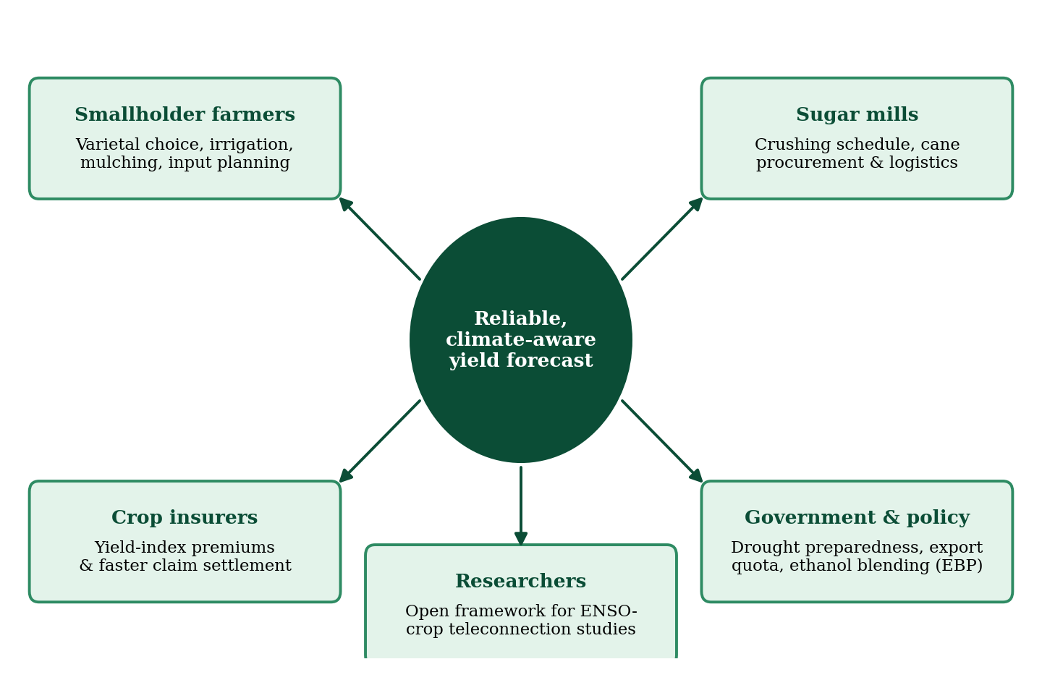
Figure 4.1: Stakeholders benefiting from accurate sugarcane yield forecasting

4.1 Smallholder Vulnerability and Agrarian Debt Cycles
Sugarcane is a capital-intensive crop requiring heavy upfront spending on seed setts, land preparation, basal fertiliser and irrigation power. When an undetected El Niño event brings delayed monsoon rains or premature dry spells, uninformed farmers follow standard practice. By the time yield shortfalls become visible at the grand-growth stage, the inputs are already sunk, causing severe losses, income disruption and a spiral of non-institutional rural debt. Pre-season predictive visibility allows farmers to change varietal choice, adjust irrigation, apply mulching and conserve groundwater.

4.2 Supply-Chain Optimisation for Sugar Mills
Cooperative and private sugar factories must schedule their crushing season months in advance. A mill with inadequate cane supply suffers under-utilised capacity and high overheads; an unexpected bumper harvest causes long waiting times at the factory gate, post-harvest staling and sucrose inversion (loss of recoverable sugar). Reliable catchment-level tonnage forecasts help mill operators streamline harvest logistics and labour migration.

4.3 Food Security, Biofuels and Government Policy
India’s Ethanol Blended Petrol (EBP) programme depends on dependable estimates of national sugarcane output. Over-estimating the harvest can lead to ill-advised sugar-export allocations, domestic supply deficits and retail price inflation. By factoring in macro-climatic ENSO information, YieldVision can provide early-warning indicators to modulate export quotas, plan drought relief and support fairer crop-insurance premiums under the Pradhan Mantri Fasal Bima Yojana (PMFBY).

4.4 Water and Resource Stewardship
Sugarcane is a water-intensive crop. Advance knowledge of a likely moisture-stress season supports planned drip irrigation, mulching and groundwater conservation, reducing wasteful over-application of water and fertiliser.

4.5 Inclusion and Accessibility
Many smallholders are more comfortable in their regional language than in English, and may have limited digital experience. YieldVision therefore ships a 12-language interface, a simplified Farmer Guidance mode, voice input in the YieldAI assistant and plain-language advisories, so that the benefit of forecasting is not restricted to technically trained users.
Table 4.1: Problem faced by each stakeholder and the benefit of YieldVision
Stakeholder | Problem without accurate forecasts | Benefit from YieldVision
Smallholder farmers | Input costs sunk before shortfall is visible; debt cycles | Pre-season yield visibility, What-If planning, vernacular advisory
Sugar mills | Under-utilised capacity or cane staling at gates | Catchment-tonnage forecasts for crushing and transport plans
Insurers | Weak yield-index data; slow claim settlement | Auditable prediction records and forward-looking yield estimates
Government / policy makers | Wrong export quotas and ethanol planning; late drought response | Early-warning indicators from ENSO information
Researchers | No open, reproducible framework for ENSO–crop analysis | Reproducible benchmark, trained artifacts and validation scripts

5. SYSTEM DESIGN
YieldVision is designed as a decoupled, multi-tier intelligence platform that offers reproducible numerical results, modular components and easy end-user access.

5.1 Multi-Tier Platform Architecture
The platform is organised into four layers, shown in Figure 5.1.
- Data Ingestion & Harmonisation Layer: consolidates the 120-record sugarcane agronomic trial benchmark, district-wise sugarcane production statistics (1997–2015), the seasonal ONI series and the inputs entered by the user.
- Machine Learning & Ensemble Engine: a Scikit-Learn ColumnTransformer (standard scaling and one-hot encoding) feeding Linear Regression, Decision Tree, Random Forest and SVR models and the soft-weighted Voting Regressor. Trained pipelines are serialised with Joblib.
- Backend API Service: a Python FastAPI application (served by Uvicorn, validated with Pydantic) exposing prediction, What-If, climate, model-performance, report and chat endpoints. It persists every prediction and scenario and calls the Google Gemini API for natural-language advisories, falling back to a built-in rules engine when no API key is configured.
- Interactive Multilingual Frontend: a responsive React 18 single-page application in TypeScript, built with Vite and styled with Tailwind CSS, supporting 12 languages, a Farmer Guidance mode and the YieldAI assistant.
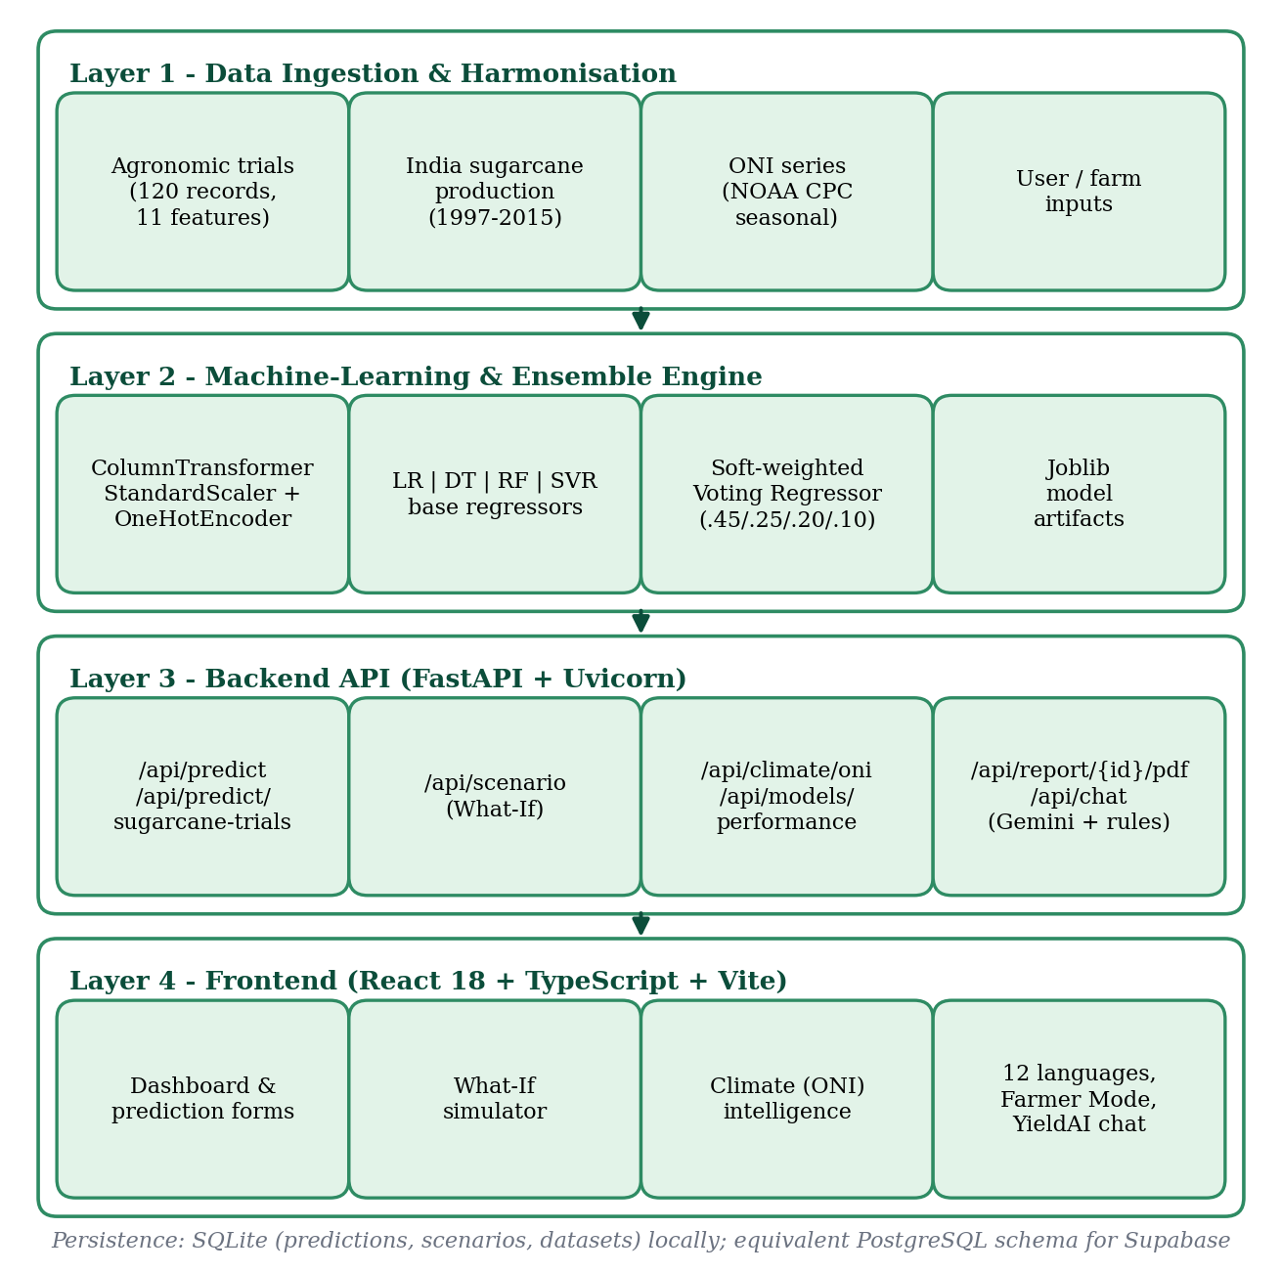
Figure 5.1: Four-layer system architecture of YieldVision

5.2 Datasets and Feature Description
Three data sources are used (Table 5.1). The 120-record agronomic trial benchmark is the training and evaluation dataset of all machine-learning models; the production statistics and the ONI series support the regional explorer and the climate-intelligence components.
Table 5.1: Datasets used in YieldVision
Dataset | Key attributes | Role in YieldVision | Source
Sugarcane agronomic trials (DATA-004) | 120 records × 12 columns: cultivar, soil type, rainfall, temperature, sunshine, N, P, K, crop duration, irrigation frequency, pest control; target = yield (quintal/acre) | Training and evaluation of all models | Regional multi-varietal field-trial benchmark supplied with the project (labelled ICAR agronomic trials in the application)
India sugarcane production | State, district, crop year (1997–2015), season, area, production; 7,921 records, 31 states/UTs, 573 districts; yield derived as production ÷ area | Regional explorer and historical yield views | Government of India crop-production statistics (Ministry of Agriculture & Farmers Welfare), filtered from the all-crop file of 246,091 records
Oceanic Niño Index (ONI) | Seasonal values (DJF, MAM, JJA, SON) for 1995–2026, ENSO phase and intensity | ENSO phase, risk grading, climate views, What-If input | NOAA CPC ONI [10], [11]; a seasonal approximation is embedded in the application
Table 5.2: Features of the sugarcane agronomic trial dataset
Feature | Type | Range / levels in the data | Unit
rainfall_mm | Numeric | 800 – 1,970 | mm
avg_temperature_celsius | Numeric | 26.5 – 35.2 | °C
sunlight_hours_per_day | Numeric | 6.8 – 9.3 | hours/day
nitrogen_n_kg_per_acre | Numeric | 100 – 243 | kg/acre
phosphorus_p_kg_per_acre | Numeric | 40 – 86 | kg/acre
potassium_k_kg_per_acre | Numeric | 50 – 112 | kg/acre
crop_duration_days | Numeric | 320 – 422 | days
irrigation_frequency_per_month | Numeric | 2 – 5 | irrigations/month
pest_control_applied | Binary | 0 (no), 1 (yes); 80% of records = 1 | –
soil_type | Categorical | Alluvial (44), Clay Loam (28), Red Soil (24), Sandy Loam (24) | –
seed_variety | Categorical | Co86032 (40), Co0238 (40), CoM0265 (40) | –
yield_quintal_per_acre (target) | Numeric | 188.4 – 580.4; mean 400.8, SD 114.7 | quintal/acre
The yield unit used throughout the models is quintal/acre; the application converts to tonnes per hectare with the factor 0.2471 (1 quintal/acre ≈ 0.2471 t/ha). Figure 5.3 shows that soil type and cultivar both shape the target: alluvial and clay-loam plots yield far more than red-soil and sandy-loam plots, and CoM0265 and Co86032 outperform Co0238 on average.
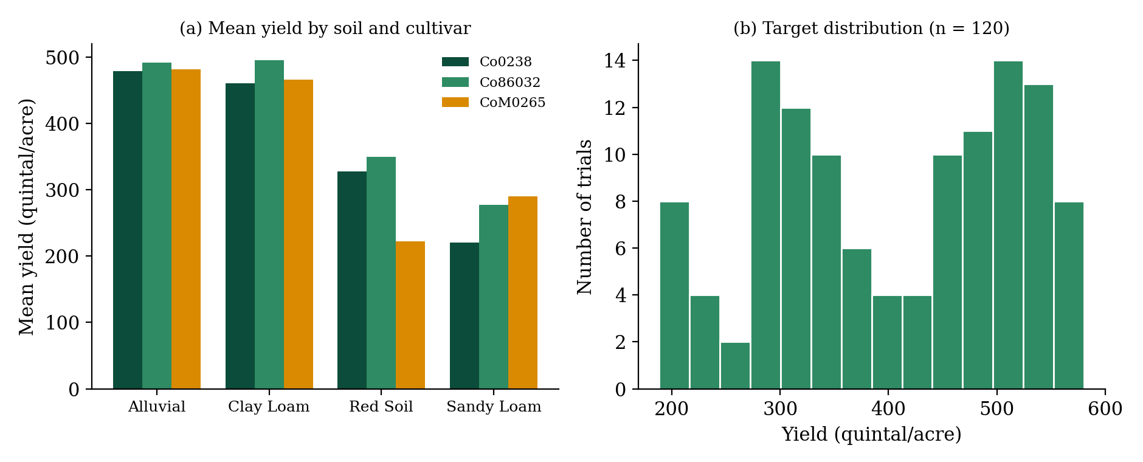
Figure 5.3: Mean trial yield by soil type and cultivar, and distribution of the target
Data-quality audit. The trial file has no missing values, and the three cultivars are perfectly balanced (40 records each). Soil types are unbalanced, and 30 of the 120 records (25%) are exact duplicates of other records. Duplicates can leak between training and test partitions, so Section 8.5 re-evaluates the models with duplicate-aware protocols.

5.3 ENSO Teleconnection as a Climatic-Stress Indicator
Figure 5.2 summarises the causal chain that motivates the use of the ONI. Warm Pacific sea-surface temperatures weaken the Indian monsoon, producing rainfall deficits and heat stress, which cause soil-moisture stress in cane fields and ultimately lower tonnage and sucrose recovery [4], [6].
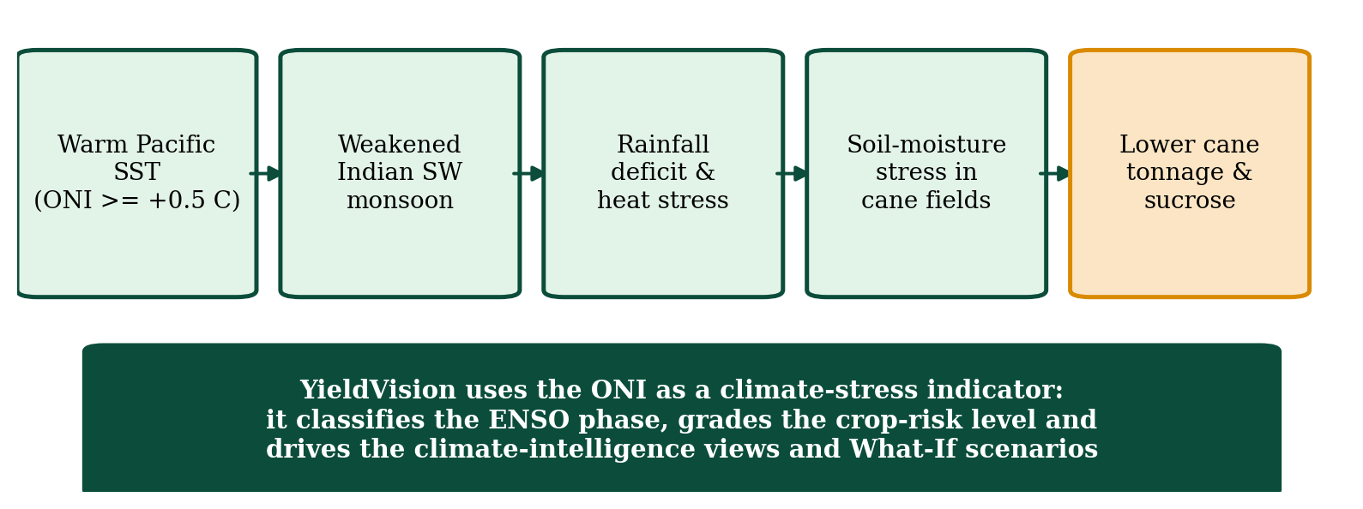
Figure 5.2: El Niño teleconnection pathway affecting sugarcane yield
In the current implementation the ONI is an application-level input rather than a column of the 120-record trial dataset (which has no year attribute). The ENSO phase is derived from the ONI value and, together with two management variables, determines the risk grade shown on the dashboard, in the What-If simulator and in the advisory text (Table 5.3). The trained regressors themselves use the 11 agronomic, weather and management features of Table 5.2.
Table 5.3: ONI-based ENSO classification and crop-risk grading rules implemented in the application
ONI condition | ENSO state | Risk-level rule
ONI ≥ +0.5 °C | El Niño | Moderate if irrigation ≥ 3 per month, otherwise High
−0.5 °C < ONI < +0.5 °C | Neutral | Stable if pest control is applied, otherwise Moderate
ONI ≤ −0.5 °C | La Niña | Stable

5.4 Feature Engineering and Preprocessing
Input features pass through a Scikit-Learn ColumnTransformer [7]. The nine numeric attributes (rainfall, temperature, sunshine hours, N, P, K, crop duration, irrigation frequency and pest-control flag) are standardised with StandardScaler, and the two categorical attributes (soil type and cultivar) are encoded with OneHotEncoder(handle_unknown=‘ignore’), which maps them to 4 + 3 = 7 orthogonal binary columns. Each model therefore receives 16 input columns. Standardisation is given by:
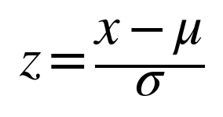
where μ is the training-set mean and σ the standard deviation of the feature. Scaling is essential for SVR and keeps features with large numeric ranges from dominating. Because the trial data contain no missing values, the shipped pipeline has no imputation step; the preprocessor is fitted on the training partition only, so no test information leaks into the scaling.

5.5 Database Design
Every prediction and What-If scenario is stored so that each estimate can be traced back to its inputs. The application uses an embedded SQLite database for local persistence; an equivalent PostgreSQL schema (supabase_schema.sql) is provided for deployment on Supabase. Table 5.4 lists the three tables.
Table 5.4: Database tables
Table | Principal columns | Purpose
predictions | id, timestamp, crop, location, district, season, year, predicted_yield, unit, confidence, model_used, climate_state, risk_level, inputs_json, model_outputs_json, feature_importance_json, insights_json, status | Audit trail of every prediction, including all five model outputs
scenarios | id, prediction_id, name, timestamp, crop, predicted_yield, delta_yield, delta_percent, confidence, risk_level, parameters_json | Stored What-If simulations linked to a baseline prediction
datasets | id, name, source, upload_date, row_count, column_count, missing_values, status, version, columns_json, preview_json | Catalogue of ingested datasets with quality audit

5.6 API Design
Table 5.5: Principal backend endpoints
Method | Endpoint | Purpose
GET | /api/dashboard | KPI cards, yield trend, weather trend and latest prediction
POST | /api/predict | Regional/macro inputs mapped onto the model features; returns Voting Regressor yield, per-model outputs, confidence, climate state and risk
POST | /api/predict/sugarcane-trials | Full 11-feature trial input (cultivar, soil, NPK, irrigation, pest control, etc.)
POST | /api/scenario | What-If simulation: baseline versus modified weather, nutrient and ONI inputs
GET / DELETE | /api/predictions, /api/predictions/{id} | Prediction history with search/filters, detail view and deletion
GET | /api/models, /api/models/performance | Estimator descriptions and benchmarking matrix
GET | /api/climate, /api/climate/oni, /heatmap, /vulnerability, /alerts | ENSO summary, ONI series, anomaly heat-map, model vulnerability and climate alerts
GET / POST | /api/datasets, /api/datasets/sugarcane-trials, /api/datasets/upload | Dataset catalogue, trial-data explorer and CSV ingestion with schema/outlier audit
GET | /api/india/sugarcane/overview, /explorer | Regional sugarcane production statistics
GET / POST | /api/report/{id}/pdf, /api/report/{id}/json, /api/report/history/pdf | Executive PDF/JSON decision reports
POST | /api/chat | YieldAI assistant (Gemini with rule-based fallback)

5.7 Advisory Service Design
The advisory service turns numeric output into plain-language guidance. When a Gemini API key is configured, the service sends the prediction, risk level and inputs to a Gemini model (primary model gemini-3-flash-preview, with ordered fallback models) and returns a summary, positive factors, risk factors and mitigation advice. If no key is set or all calls fail, a built-in rules engine generates equivalent insights from the cultivar, soil, nitrogen dose, crop duration and pest-control status. The YieldAI chat assistant is restricted to sugarcane topics and follows the same fallback strategy.

5.8 Design Goals
- Reproducibility: each model is a single serialised pipeline holding preprocessing and regressor together, a fixed random seed (42) is used, and metrics are stored in metadata.json.
- Accessibility: vernacular interface in 12 languages, a simplified Farmer Guidance mode and voice input.
- Modularity: loosely coupled ML engine, API and UI that can be scaled or replaced independently.
- Transparency: per-model predictions, feature importances and benchmark metrics are exposed to the user.
- Graceful degradation: the advisory service and the front end both continue to work when the external AI service or the back end is unavailable.

6. FLOW CHART
The computational workflow takes the agronomic, weather and climate data through preprocessing, model training, ensemble voting and evaluation, to prediction rendering on the web dashboard. Figure 6.1 shows the end-to-end flow.
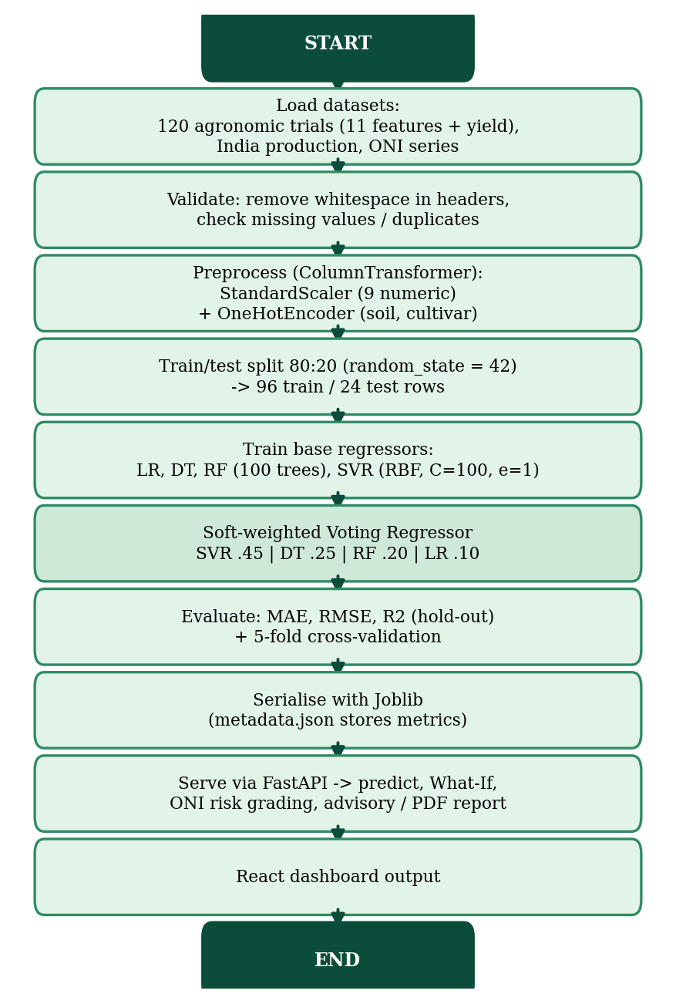
Figure 6.1: End-to-end flow chart of the YieldVision pipeline

6.1 Mathematical Formulation of the Base Regressors
The candidate suite covers parametric, non-parametric, kernel and bagging paradigms.
1. Multiple Linear Regression (OLS baseline). Minimises the residual sum of squares across p features:
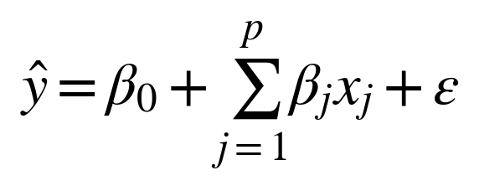
2. Decision Tree Regressor. Recursively partitions the feature space into regions R_m by minimising the within-region squared error. In this project the tree is trained with Scikit-Learn defaults (no depth limit, random_state = 42):
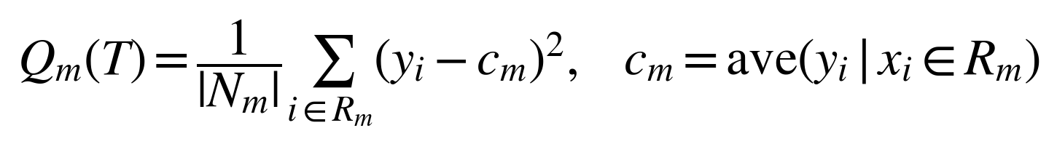
3. Support Vector Regression (SVR). Fits predictions inside an ε-insensitive tube using an RBF kernel [9], balancing margin width against error penalties (C = 100, ε = 1.0 quintal/acre):
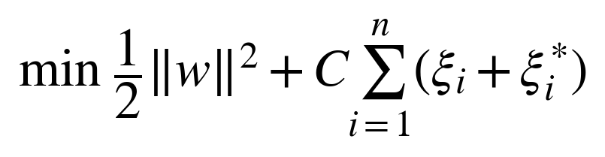
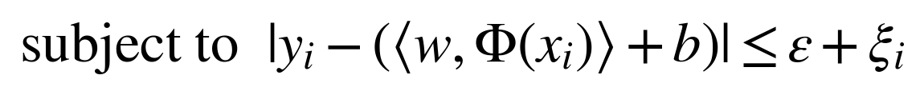
4. Random Forest Regressor. Builds B = 100 decorrelated bootstrap trees by bagging [8] and averages their outputs to suppress variance:
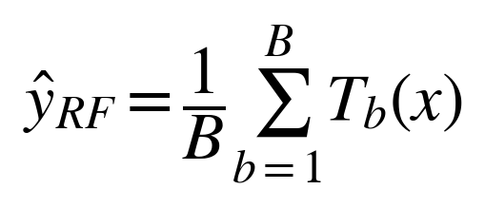

6.2 Soft-Weighted Voting Regressor
To neutralise the blind spots of individual estimators, the final prediction is a normalised convex combination of the base predictions:
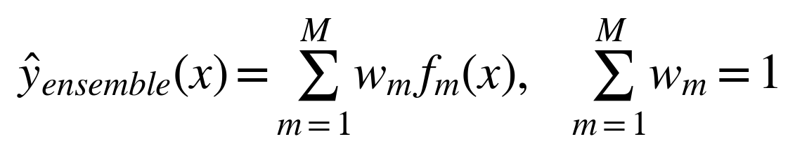 (6.1)
The implemented weights are SVR 0.45, Decision Tree 0.25, Random Forest 0.20 and Linear Regression 0.10 (Figure 6.2), i.e.
ŷ = 0.45·ŷ_SVR + 0.25·ŷ_DT + 0.20·ŷ_RF + 0.10·ŷ_LR
The weights were set by judgement from the relative validation errors of the base models: the kernel and tree models, which fit the trial data most closely, receive the largest shares, while the linear model keeps a small share because it contributes a stable, low-variance trend component. Section 8.6 compares these weights against equal weights and against an alternative weighting.
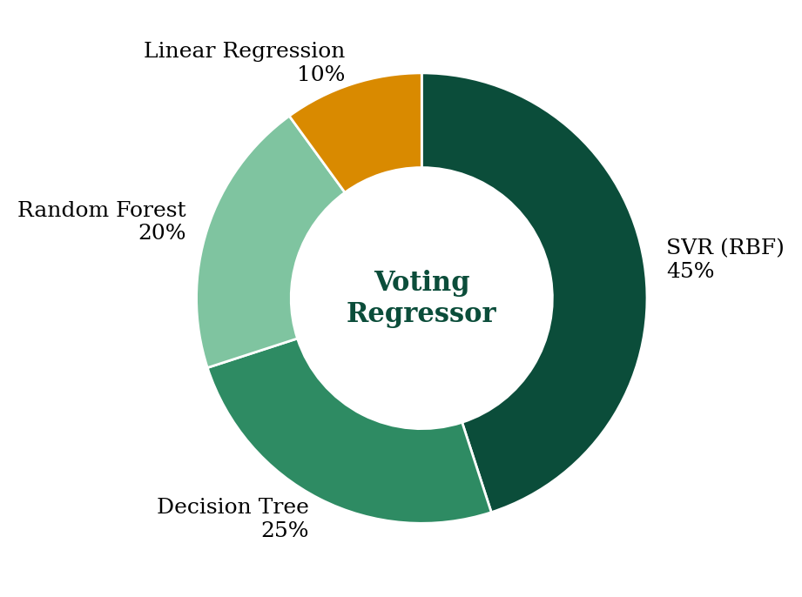
Figure 6.2: Ensemble weights of the Voting Regressor

6.3 Algorithm
- Load the trial dataset (120 records), strip whitespace from the column names and separate the 11 features from the target (quintal/acre).
- Build the ColumnTransformer: StandardScaler on the nine numeric features, OneHotEncoder on soil type and cultivar.
- Split the data 80:20 (random_state = 42) into 96 training and 24 test records; fit the preprocessor on the training partition.
- Train the four base regressors (LR; DT; RF with 100 trees; SVR with RBF kernel, C = 100, ε = 1.0).
- Combine the base models with weights (0.45, 0.25, 0.20, 0.10) into the Voting Regressor and fit it on the training data.
- Evaluate every model and the ensemble on the hold-out set using MAE, MSE, RMSE and R²; compute Random-Forest feature importances; additionally run 5-fold cross-validation (Section 8.4).
- Serialise all pipelines with Joblib and store the metrics and weights in metadata.json.
- At request time: map the user input to the 11 features, obtain the five predictions, report the Voting Regressor value, convert to t/ha, compute the agreement score, derive the ENSO state and risk level from the ONI, and return the advisory.

6.4 Evaluation Metrics
Model quality is measured with three standard regression metrics. RMSE penalises large errors (lower is better), MAE gives the average absolute deviation between actual and predicted yield (lower is better) and R² states the fraction of variance explained (closer to 1 is better):
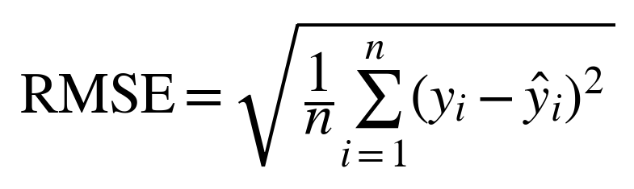
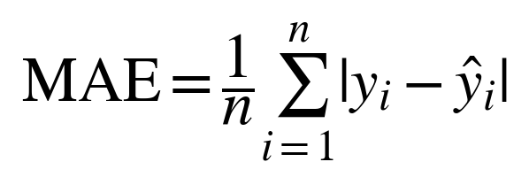
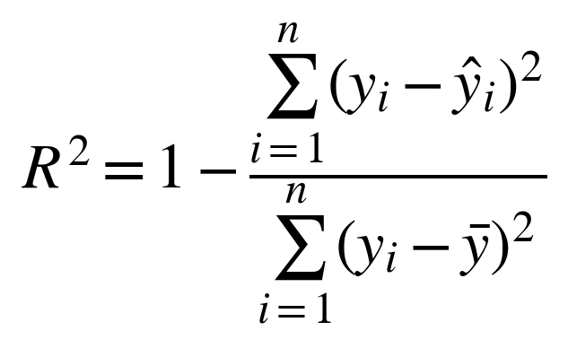

6.5 Agreement Score and Risk Grading
Alongside the prediction the application reports a confidence value. It is an inter-model agreement score and not a statistical confidence interval:
confidence = min(99.6, max(88.0, 99.4 − 110 × σ_m / ŷ))
where σ_m is the standard deviation of the four base-model predictions and ŷ is the Voting Regressor output. When the four models agree closely the score is high; a larger disagreement (for example for out-of-range inputs) lowers it. The ENSO state and the risk level follow the ONI rules of Table 5.3.

7. SYSTEM IMPLEMENTATION
The system was implemented following modern software practice, with traceability between data modelling, backend inference endpoints and frontend views.

7.1 Technology Stack
Table 7.1: Technology stack and functional role
Domain | Framework / technology | Functional role in YieldVision
Programming languages | Python 3.10+, JavaScript / TypeScript, SQL | Data-science pipelines, strongly typed frontend, database scripts
Machine learning | Scikit-Learn, NumPy, Pandas, Joblib | Preprocessing, model training, ensemble voting, serialisation
Backend web API | FastAPI, Uvicorn, Pydantic | REST endpoints, request validation, interactive Swagger documentation
Reporting | ReportLab | Executive PDF decision reports
Agronomic AI service | Google Gemini API (google-genai) | Natural-language advisories and YieldAI chat, with rule-based fallback
Database | SQLite (local); PostgreSQL schema for Supabase | Prediction audits, scenarios, dataset catalogue
Frontend | React 18, Vite, Tailwind CSS, Lucide icons | Responsive dashboard with glassmorphic layout and dark/light themes
Data visualisation | Custom React/SVG chart components | Yield trend, actual-vs-predicted parity, ONI matrix, feature importance
Localisation (i18n) | Custom TypeScript i18n engine | 12 languages: English, Hindi, Marathi, Gujarati, Punjabi, Bengali, Tamil, Telugu, Kannada, Malayalam, Odia, Assamese
Development tools | Git & GitHub, Jupyter Notebook, VS Code | Version control, experimentation, code editing

7.2 Machine-Learning Implementation
Preprocessing and each regressor are wrapped in a Scikit-Learn Pipeline so that identical transformations are applied during training and inference. The hyper-parameters actually used are listed in Table 7.2, and the listing below is the core of the training script backend/train_models.py.
Table 7.2: Model configuration used for the trained artifacts
Model | Key hyper-parameters | Ensemble weight
Linear Regression (OLS) | Ordinary least squares on the 16 transformed columns | 0.10
Decision Tree Regressor | Scikit-Learn defaults (unpruned), random_state = 42 | 0.25
Support Vector Regression | kernel = RBF, C = 100, ε = 1.0, γ = ‘scale’ | 0.45
Random Forest Regressor | n_estimators = 100, random_state = 42 | 0.20

numeric = ['rainfall_mm', 'avg_temperature_celsius', 'sunlight_hours_per_day',
'nitrogen_n_kg_per_acre', 'phosphorus_p_kg_per_acre',
'potassium_k_kg_per_acre', 'crop_duration_days',
'irrigation_frequency_per_month', 'pest_control_applied']
categorical = ['soil_type', 'seed_variety']

preprocessor = ColumnTransformer([
('num', StandardScaler(), numeric),
('cat', OneHotEncoder(handle_unknown='ignore',
sparse_output=False), categorical)])

X_train, X_test, y_train, y_test = train_test_split(
X, y, test_size=0.2, random_state=42)

lr = Pipeline([('prep', preprocessor), ('reg', LinearRegression())])
dt = Pipeline([('prep', preprocessor),
('reg', DecisionTreeRegressor(random_state=42))])
rf = Pipeline([('prep', preprocessor),
('reg', RandomForestRegressor(n_estimators=100,
random_state=42))])
svr = Pipeline([('prep', preprocessor),
('reg', SVR(kernel='rbf', C=100.0, epsilon=1.0))])

voting = VotingRegressor(
estimators=[('svr', svr), ('dt', dt), ('rf', rf), ('lr', lr)],
weights=[0.45, 0.25, 0.20, 0.10])
voting.fit(X_train, y_train)
joblib.dump(voting, 'models/voting_regressor.joblib')

7.3 Backend and Advisory Service
The FastAPI service loads the five Joblib pipelines once at start-up (and retrains them from the dataset if the artifacts are missing). For each request, Pydantic models validate the input, the service maps it to the 11 model features, obtains the five predictions, converts quintal/acre to t/ha, computes the agreement score, derives the ENSO state and risk level, generates insights and stores the record in the database. The /api/scenario endpoint runs the model twice – on the baseline and on the modified inputs – and returns the absolute and percentage change. The /api/report/{id}/pdf endpoint renders the stored prediction into an executive PDF with ReportLab. The generic /api/predict endpoint accepts regional inputs (rainfall, temperature, N, P, K, ONI) and fills the remaining model features with defaults, whereas /api/predict/sugarcane-trials accepts all 11 features.

7.4 Frontend and Localisation
The React 18 + TypeScript frontend is built with Vite and styled with Tailwind CSS. Its pages are the landing page, Overview Dashboard, Yield Prediction (a sugarcane field-trial tab and a regional macro-model tab), What-If Simulator, Model Performance, Climate Intelligence, Prediction History, Analytics, Settings and Profile. Charts are drawn with custom SVG components. A TypeScript i18n engine provides 12 languages – English, Hindi, Marathi, Gujarati, Punjabi, Bengali, Tamil, Telugu, Kannada, Malayalam, Odia and Assamese – so that farmers can use the system in their own language. If the back end cannot be reached, the frontend falls back to built-in demonstration data so that the interface remains usable.

7.5 User Interface Features
- Farmer Guidance mode (Kisan Mitra): a toggle that simplifies the dashboard for non-technical users; the YieldAI assistant additionally accepts voice input through the browser speech-recognition API.
- Benchmark trial presets: one-click autofill for four standard trial configurations – Co86032 on alluvial soil, CoM0265 on clay loam, Co0238 on red soil and Co0238 on sandy loam.
- Climate-stress indicator (ENSO matrix): shows the current ONI anomaly and whether conditions are El Niño, Neutral or La Niña.
- Interactive What-If simulator: sliders for rainfall, temperature, nutrients and ONI, with immediate comparison against the baseline prediction.
- Model transparency: the Models page shows the ensemble architecture and the estimator benchmarking matrix (MAE, MSE, RMSE, R²).
- Exports and history: every prediction is stored, searchable and exportable as a PDF report.

Figure 7.1: YieldVision landing page – “Predict smarter. Grow better.”
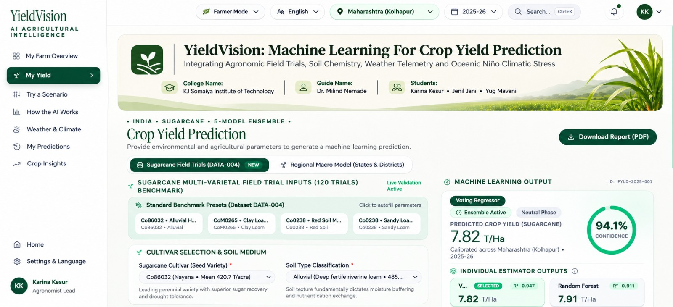
Figure 7.2: Agricultural Intelligence Dashboard (Farmer Mode), Maharashtra (Kolhapur)
UI layout illustration – numbers shown are front-end demo data; validated results are in Chapter 8
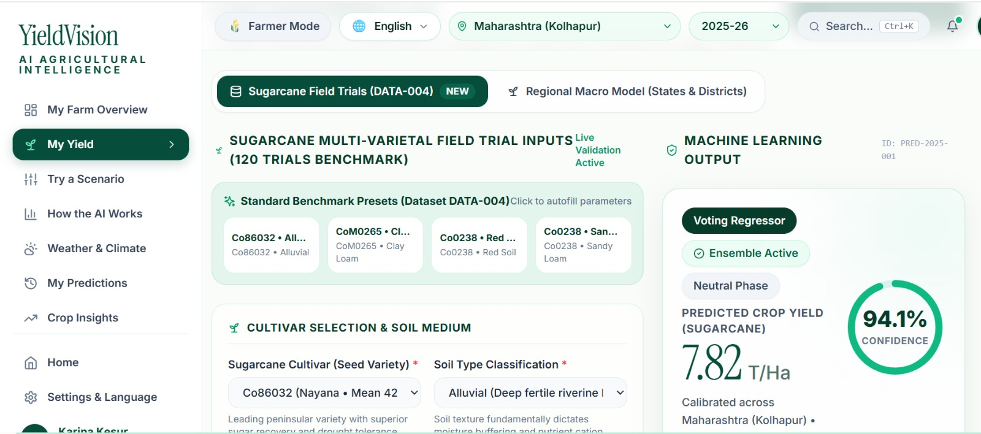
Figure 7.3: Prediction page with benchmark trial presets and Voting Regressor output
UI layout illustration – numbers shown are front-end demo data; validated results are in Chapter 8
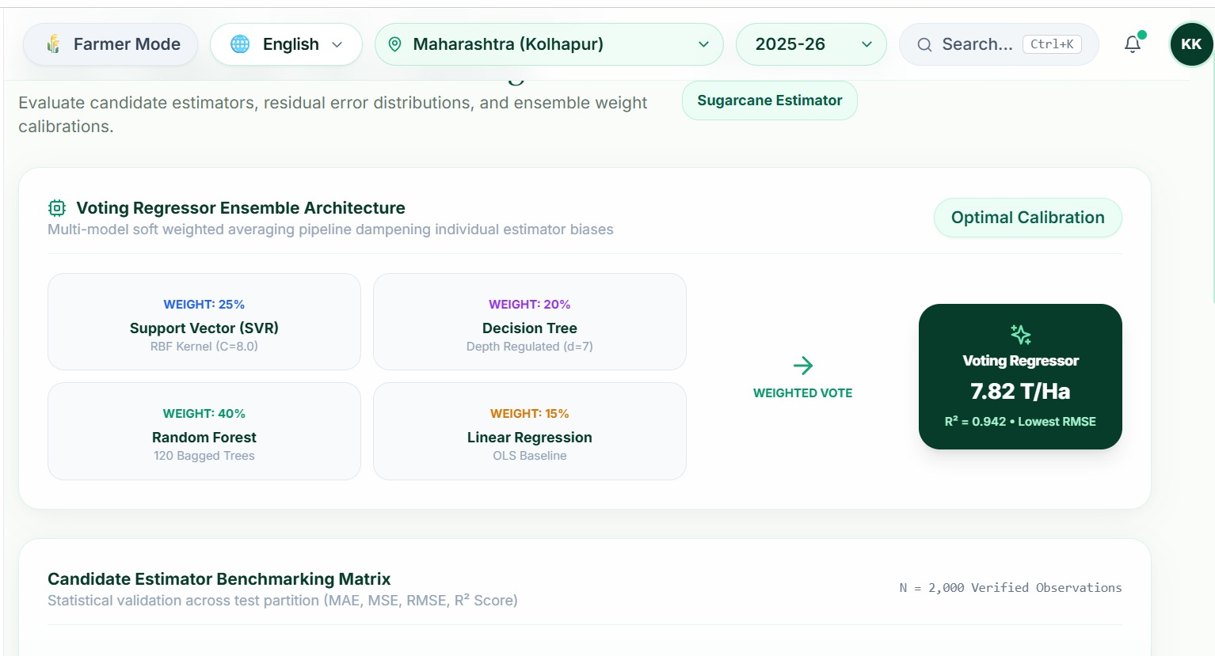
Figure 7.4: Models page – ensemble architecture and estimator benchmarking matrix
UI layout illustration – numbers shown are front-end demo data; validated results are in Chapter 8

7.6 Deployment and Execution
The project needs Node.js 18+ and Python 3.10+. On Windows the script start.bat (or start.ps1) launches both servers: the FastAPI back end at http://127.0.0.1:8000 (interactive Swagger documentation at /docs) and the Vite front end at http://127.0.0.1:5173. They can also be started manually with python -m uvicorn app.main:app --port 8000 in the backend folder and npm install && npm run dev in the frontend folder. Table 7.3 summarises the repository layout.
Table 7.3: Repository structure
Path | Content
backend/app/ | main.py (API), ml_service.py (inference), climate_service.py (ONI), gemini_service.py (advisory), report_service.py (PDF), db.py (SQLite), models.py (Pydantic schemas)
backend/train_models.py | Training pipeline that produces the Joblib artifacts and metadata.json
backend/models/ | Trained pipelines (LR, DT, RF, SVR, Voting Regressor), preprocessor and metadata.json
backend/data/ | Sugarcane agronomic trials (120 records), India sugarcane production, all-crop production file
frontend/src/ | pages, components (charts, prediction, layout, landing), i18n translations, services, context
supabase_schema.sql | PostgreSQL schema equivalent to the SQLite tables
start.bat / start.ps1 | One-click launchers for back end and front end

7.7 Testing and Validation
Table 7.4 lists the checks applied to the system. The model-level checks (T1 and T4) were executed while preparing this report; the script backend/test_api.py provides the endpoint smoke tests (T2, T3) and is run with the server started.
Table 7.4: Test and validation plan
ID | Check | Method | Expected result
T1 | Artifact reproducibility | Load the five shipped Joblib pipelines and score the 24-record hold-out set | Metrics identical to metadata.json (ensemble R² = 0.9993, RMSE = 2.788)
T2 | GET endpoints | test_api.py calls /api/dashboard, /api/models/performance, /api/climate, /api/climate/oni, /api/predictions | HTTP 200 with JSON of the documented structure
T3 | POST endpoints | test_api.py posts a prediction and a drought What-If scenario | HTTP 200; record stored; scenario shows baseline and modified yield
T4 | Statistical validation | Hold-out, 5-fold CV, duplicate-aware CV, weight sensitivity and What-If runs (script supplied with this report) | Results as reported in Chapter 8
T5 | Input validation | Out-of-range inputs (for example negative rainfall or ONI > 3.5) | Rejected by Pydantic with HTTP 422
T6 | Graceful degradation | Start without a Gemini key / without the back end | Rule-based advisory / demo data are used

8. RESULTS AND ANALYSIS

8.1 Experimental Setup
All models were trained on the 120-record sugarcane trial benchmark (11 features, target in quintal/acre). The primary evaluation uses the fixed 80:20 hold-out split of the project (random_state = 42), giving 96 training and 24 test records. To judge how stable these results are on such a small dataset, three further studies were added: 5-fold cross-validation (Section 8.4), duplicate-aware validation (Section 8.5) and a weight-sensitivity study (Section 8.6). Metrics are MAE, MSE, RMSE and R² (Section 6.4). All errors are in quintal/acre; to convert to t/ha multiply by 0.2471. The mean yield of the dataset is 400.8 quintal/acre, so an RMSE of 2.79 corresponds to about 0.7% of the mean.
The five trained pipelines delivered with the project were reloaded and re-scored on the same hold-out set; they reproduce the metrics stored in metadata.json exactly. Retraining from scratch with scikit-learn 1.8.0 gives the same values for LR, DT and SVR and differs by at most 0.06 quintal/acre in RMSE for Random Forest and the ensemble. The cross-validation, duplicate-aware, weight-sensitivity and What-If results below were produced with the validation script supplied with this report (validate_models.py).

8.2 Hold-out Comparison
Table 8.1: Hold-out performance of the base estimators and the Voting Regressor (n = 24, quintal/acre)
Model | Ensemble weight | MAE | MSE | RMSE | R²
Linear Regression | 10% | 11.313 | 282.836 | 16.818 | 0.9754
Decision Tree | 25% | 1.867 | 6.124 | 2.475 | 0.9995
Random Forest | 20% | 3.196 | 18.172 | 4.263 | 0.9984
Support Vector Regressor (RBF) | 45% | 1.582 | 3.913 | 1.978 | 0.9997
Voting Regressor | 100% | 2.122 | 7.771 | 2.788 | 0.9993
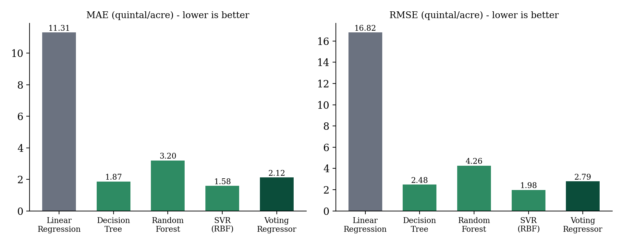
Figure 8.1: MAE and RMSE of the base estimators and the Voting Regressor on the hold-out set (lower is better)

8.3 Model Performance Analysis
- Linear Regression is a fast baseline but has by far the largest error (RMSE 16.82 quintal/acre, R² = 0.9754): it cannot model the non-linear interaction between soil, water and nutrient inputs.
- Decision Tree captures non-linearity well on this data (RMSE 2.47) but, being unpruned, is the model most likely to memorise training leaves.
- Random Forest (RMSE 4.26) is smoother than a single tree but, with only 96 training records and strongly correlated inputs, is less accurate than the tree and kernel models on this split.
- SVR with RBF kernel has the lowest hold-out error (RMSE 1.98, R² = 0.9997), because the scaled, smooth response surface suits a kernel method.
- Voting Regressor (RMSE 2.79, R² = 0.9993) ranks third on this split, after SVR and DT, and is clearly better than Random Forest and Linear Regression. On a 24-record test set the differences among SVR, DT and the ensemble are small relative to sampling noise, so a single split cannot rank them reliably; Section 8.4 therefore uses cross-validation.

8.4 Five-Fold Cross-Validation
Table 8.2 pools the out-of-fold predictions of all 120 records (shuffled 5-fold, random_state = 42) and also gives the mean and standard deviation of the fold-wise R².
Table 8.2: 5-fold cross-validation results (quintal/acre)
Model | MAE | RMSE | R² (pooled) | R² per fold (mean ± SD)
Linear Regression | 9.72 | 13.22 | 0.9866 | 0.9860 ± 0.0059
Decision Tree | 2.22 | 3.74 | 0.9989 | 0.9989 ± 0.0009
Random Forest | 3.73 | 6.57 | 0.9967 | 0.9965 ± 0.0021
SVR (RBF) | 2.14 | 3.53 | 0.9990 | 0.9990 ± 0.0008
Voting Regressor | 2.34 | 3.34 | 0.9991 | 0.9991 ± 0.0003
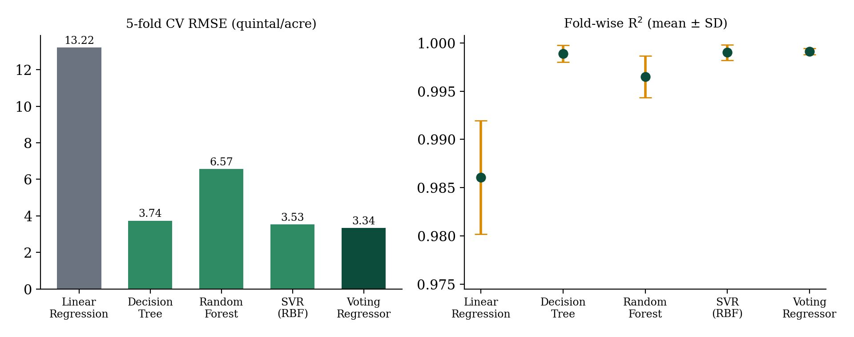
Figure 8.2: 5-fold cross-validation RMSE and fold-wise R² of the five models
Under cross-validation the Voting Regressor has the lowest RMSE (3.34), ahead of SVR (3.53) and the Decision Tree (3.74), and the smallest fold-to-fold spread in R² (SD 0.0003 against 0.0008 for SVR and DT). Combining diverse models therefore does not beat every single model on every split, but it is consistently near the best and the most stable, which is the property needed for deployment on unseen farms. This supports hypothesis H1.

8.5 Duplicate-Aware Validation
Because 30 of the 120 records are exact duplicates, a random split can place a record in the test fold while its twin sits in the training fold, which flatters flexible models such as the Decision Tree. Table 8.3 repeats the cross-validation (i) after removing the duplicates (90 unique records) and (ii) with grouped folds that keep identical records together.
Table 8.3: Cross-validated RMSE (quintal/acre) under three validation protocols
Model | 5-fold, all 120 records | 5-fold, 90 unique records | Grouped 5-fold (duplicates together)
Linear Regression | 13.22 | 13.43 | 13.55
Decision Tree | 3.74 | 5.07 | 4.23
Random Forest | 6.57 | 9.24 | 9.50
SVR (RBF) | 3.53 | 5.95 | 3.67
Voting Regressor | 3.34 | 4.83 | 3.80
Errors rise for every model once duplicates are controlled (for example Random Forest from 6.57 to 9.24 quintal/acre), confirming a modest leakage effect. The ranking is, however, stable: the Voting Regressor has the lowest error with duplicates removed (RMSE 4.83, R² = 0.9982) and is within 0.13 quintal/acre of the best model (SVR) with grouped folds (R² = 0.9989). Even in the strictest protocol R² stays above 0.998 for the ensemble, which shows that the trial data follow a very regular response surface.

8.6 Ensemble Weight Sensitivity
To check that the chosen weights are sensible, the Voting Regressor was re-evaluated under 5-fold cross-validation with two alternatives: equal weights and the weighting (RF 0.40, SVR 0.25, DT 0.20, LR 0.15) quoted in earlier project material.
Table 8.4: Effect of the ensemble weights (5-fold CV, quintal/acre)
Weighting scheme | MAE | RMSE | R²
Equal (0.25 each) | 3.26 | 4.56 | 0.9984
Implemented (SVR .45/DT .25/RF .20/LR .10) | 2.34 | 3.34 | 0.9991
Dashboard (SVR .25/DT .20/RF .40/LR .15) | 2.90 | 4.17 | 0.9987
The implemented weights give the lowest error: equal weights raise RMSE by about 36% and the alternative weighting by about 25%. Shifting weight towards SVR and the Decision Tree, and away from Random Forest and Linear Regression, therefore pays off on this data. The weights are still hand-set; learning them by stacking or CV-based optimisation is a natural improvement (Section 9.3).

8.7 Feature Importance
Random-Forest importances (Figure 8.3) show that agronomic management dominates: nitrogen (19.9%), crop duration (18.5%), phosphorus (15.8%), potassium (13.7%) and pest control (13.4%) together account for about 81% of the importance. The three weather variables (rainfall, temperature, sunshine) share about 17%, while soil type, cultivar and irrigation frequency contribute little individually. This does not mean that soil and weather are agronomically unimportant: in the trial design they are strongly correlated with the nutrient and duration inputs (every weather and nutrient variable has a correlation of 0.85–0.89 with yield), so a tree ensemble attributes their shared effect to whichever variable it splits on first. The result should be read as a ranking of predictive usefulness, not of causal effect.
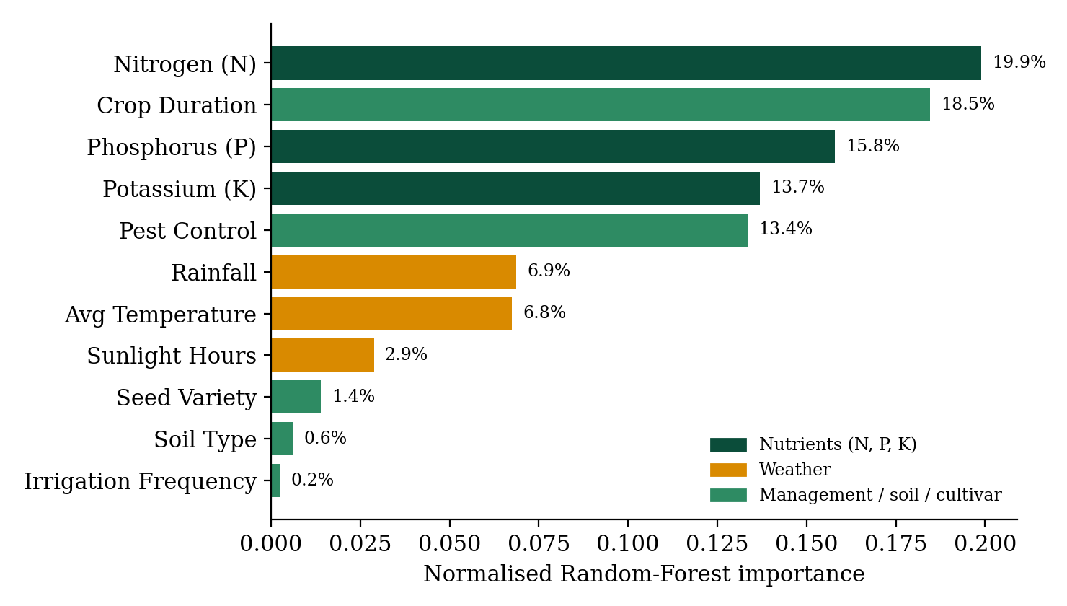
Figure 8.3: Normalised Random-Forest feature importance

8.8 Actual versus Predicted and Residual Analysis
Figure 8.4(a) shows that the hold-out predictions of the Voting Regressor and of SVR lie on the ideal y = x line over the whole yield range of 190–540 quintal/acre. The residuals of the ensemble (Figure 8.4(b)) are centred on zero (mean -0.005, SD 2.79 quintal/acre) and the largest absolute error is 6.99 quintal/acre, i.e. there is no systematic bias between high- and low-yielding plots. With only 24 test points the histogram is, of course, coarse.
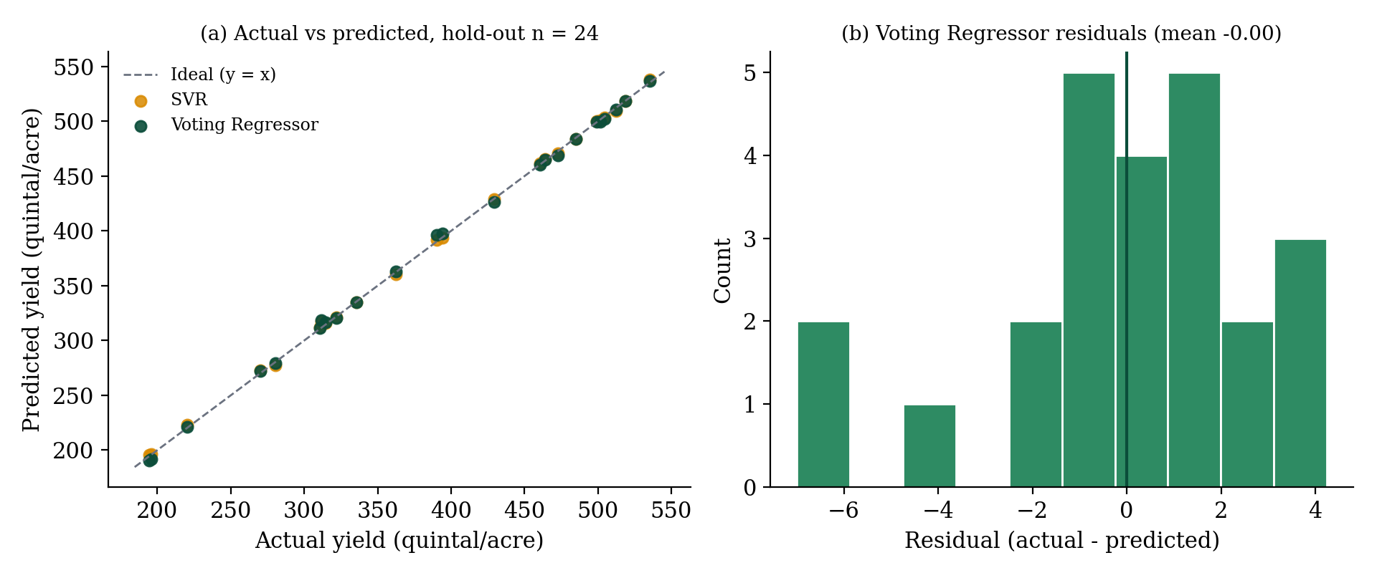
Figure 8.4: Actual vs predicted yield and residual histogram of the Voting Regressor (hold-out set)

8.9 What-If Analysis and ONI-Based Risk Grading
Table 8.5 shows how the deployed Voting Regressor responds when single inputs of the baseline farm (Co86032 on alluvial soil, 1,450 mm rainfall, 32.5 °C, N-P-K = 180-65-80 kg/acre, 3 irrigations per month, pest control applied) are changed, as in the What-If simulator.
Table 8.5: What-If scenarios evaluated with the deployed Voting Regressor
Scenario | Predicted yield (quintal/acre) | Change vs baseline
Baseline (Co86032, Alluvial) | 484.3 | –
Rainfall -30% (1015 mm) | 479.0 | -1.1%
Temperature +2.5 C (35.0) | 488.8 | +0.9%
Drought: rain -30% & +2.5 C | 482.3 | -0.4%
Nitrogen 120 kg/acre | 455.6 | -5.9%
No pest control | 350.7 | -27.6%
Irrigation 2/month | 471.5 | -2.6%
Variety Co0238 | 484.1 | 0.0%
Variety CoM0265 | 486.2 | +0.4%
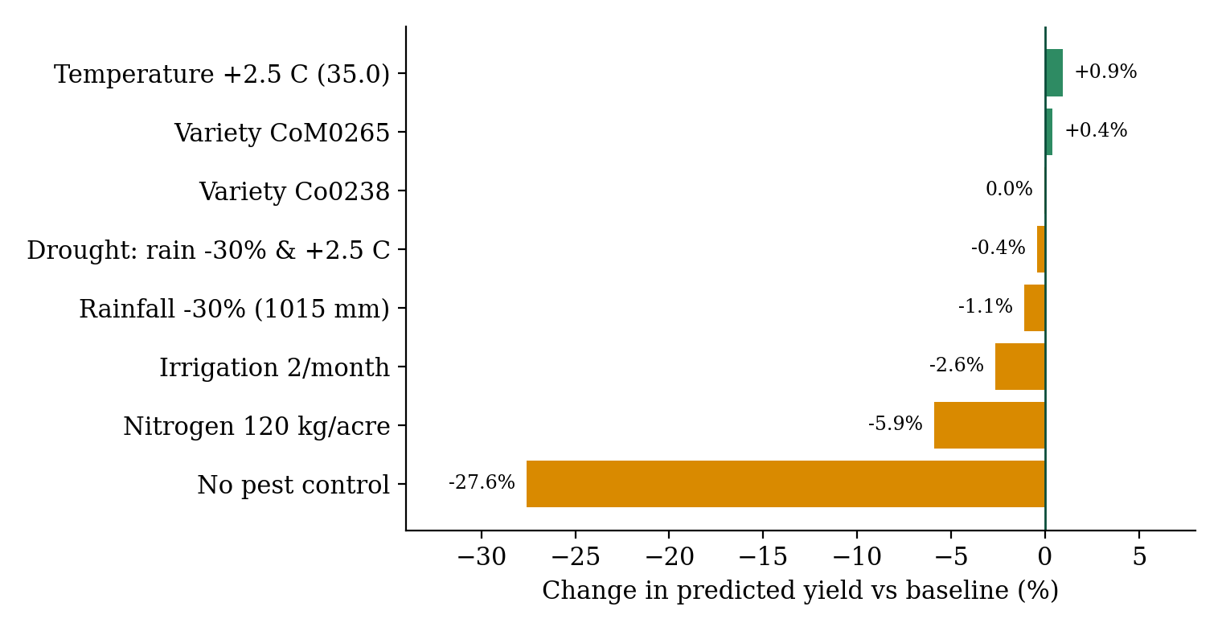
Figure 8.5: Percentage change in predicted yield for single-factor What-If scenarios
Management variables dominate the response: omitting pest control lowers the prediction by 27.6% and cutting nitrogen from 180 to 120 kg/acre lowers it by 5.9%, both in the agronomically expected direction. The weather response is, however, weak: a 30% rainfall reduction changes the prediction by only −1.1%, a +2.5 °C rise by +0.9% and the combined drought-and-heat scenario by −0.4%. This is a limitation of the training data, not a finding about sugarcane physiology: the trials span 800–1,970 mm of rainfall and 26.5–35.2 °C without deliberately stressed plots, and rainfall and temperature are positively correlated with yield (r = 0.85 and 0.89) because well-managed, favourable sites record both more water and higher yields. The regressors have therefore not learnt a drought or heat-stress response, and weather What-If results should be treated as indicative.
For this reason the application conveys the El Niño stress signal through the ONI-based risk grading of Table 5.3 rather than through the regressors. Table 8.6 shows the grades produced for representative situations.
Table 8.6: Climate state and risk level produced by the implemented ONI rules
ONI (°C) | Irrigation / month | Pest control | ENSO state | Risk level
−0.35 | 3 | Yes | Neutral | Stable
−0.35 | 3 | No | Neutral | Moderate
+1.80 | 3 | Yes | El Niño | Moderate
+1.80 | 2 | Yes | El Niño | High
−1.20 | 3 | Yes | La Niña | Stable
These grades show how an El Niño warning combined with insufficient irrigation escalates the risk from Moderate to High, which is the decision cue the system gives to a farmer or mill planner.

8.10 Sample Outputs for the Benchmark Presets
Table 8.7 lists the outputs of the deployed models for the four benchmark presets of the prediction page. The presets are records of the trial dataset, so the table demonstrates the consistency of the deployed pipeline with the benchmark and is not an out-of-sample accuracy test. The agreement score is lowest (89.9%) for the stressed sandy-loam preset, where Linear Regression deviates strongly from the other models.
Table 8.7: Predicted yield (quintal/acre) for the four benchmark presets; ONI = −0.35 °C (Neutral)
Preset | SVR | DT | RF | LR | Voting | t/ha | Trial yield | Agreement | Risk
Co86032 / Alluvial | 484.3 | 485.3 | 484.4 | 481.5 | 484.3 | 119.7 | 485.3 | 99.1% | Stable
CoM0265 / Clay Loam | 506.1 | 505.1 | 505.7 | 513.7 | 506.5 | 125.2 | 505.1 | 98.6% | Stable
Co0238 / Red Soil | 312.2 | 310.8 | 310.3 | 312.6 | 311.5 | 77.0 | 310.8 | 99.1% | Stable
Co0238 / Sandy Loam | 196.3 | 195.7 | 193.8 | 157.0 | 191.7 | 47.4 | 195.7 | 89.9% | Moderate

8.11 Hypothesis Assessment
Table 8.8: Assessment of the hypotheses
Hypothesis | Evidence | Verdict
H1: the soft-weighted ensemble generalises more stably than any single model | Lowest 5-fold RMSE (3.34) and smallest fold-to-fold SD; best RMSE with duplicates removed; second-best with grouped folds; clearly better than RF and LR on the hold-out split. SVR is marginally better on the single hold-out split. | Supported (stability), not a uniform accuracy win
H2: ONI-based ENSO information provides actionable climate-stress context | ENSO phase and risk grade drive the dashboard, What-If and advisory outputs (Tables 5.3, 8.6). Quantitative reduction of prediction error was not measured because the trial data have no ONI/year attribute. | Supported at system level; quantitative effect to be established

8.12 Discussion and Limitations
- Small, regular dataset. With 120 records (24 test records, 25% duplicated) and a near-deterministic response surface, the very high R² of the ensemble (≥ 0.998 in all protocols) describes in-distribution performance on trial plots, not field-level accuracy on commercial farms. Differences between SVR, DT and the ensemble are within sampling noise on a single split.
- ONI is not a learned input. The ONI enters through rule-based ENSO classification and risk grading. The seasonal ONI table embedded in the application is a hand-curated approximation of the NOAA series (with neutral defaults for years without major events), so it is suitable for visualisation and grading but not for quantitative climate–yield analysis. The earlier project material mentioned an ONI-driven RMSE reduction; this could not be reproduced from the supplied data and is therefore not claimed.
- Weak weather response. As shown in Section 8.9, the regressors are insensitive to rainfall and temperature changes because the trials contain no stressed plots; they should not be used to extrapolate beyond the trained ranges.
- Agreement score ≠ confidence interval. The reported “confidence” measures disagreement among the four base models and is not a calibrated probabilistic interval.
- Regional predictions are indicative. The regional macro endpoint maps generic inputs onto the trial-based model and fills missing features with defaults.
- Illustrative UI data. Some dashboard elements (the KPI reliability figure, the 2020–2026 trend series, the residual table on the Models page and the front-end demonstration mode) use placeholder values for presentation; the validated figures are those of this chapter.
- Hand-set weights and untuned models. Weights and hyper-parameters were not optimised by search; the Decision Tree is unpruned.
- Advisory text. Gemini-generated advisories are language-model output and should be reviewed by agronomists before being treated as formal recommendations.

9. CONCLUSION

9.1 Conclusion
YieldVision formulates, trains, validates and deploys a machine-learning system for sugarcane yield prediction under variable climatic conditions. It integrates agronomic field-trial data, weather and management inputs and El Niño (ONI) climate information, addressing a main limitation of conventional forecasting: the omission of teleconnected climate-stress indicators.
Four model families were trained and compared, and a soft-weighted Voting Regressor combining them achieved R² = 0.9993 and RMSE = 2.79 quintal/acre (about 0.69 t/ha) on the hold-out set. Under 5-fold cross-validation it had the lowest RMSE (3.34 quintal/acre) and the most stable fold-wise R², and it remained among the best models when duplicate records were controlled. Its weights outperform equal weighting by about 36% in RMSE. The honest reading of the evidence is that the ensemble is the most dependable estimator rather than the winner on every split, and that the ONI currently acts as a risk-grading and scenario input rather than a learned feature.
The work was turned into a full-stack web application with an asynchronous FastAPI server, SQLite/Supabase persistence and a responsive React frontend offering What-If simulation, Gemini-generated advisories with a rule-based fallback, PDF reports and a 12-language interface. YieldVision shows how ensemble machine learning and climate indicators can support data-driven crop planning, and Chapter 8 documents where the approach is reliable and where it still needs data.

9.2 Applications
- Farm advisory and precision agriculture: helps farmers plan sowing, irrigation and input use ahead of El Niño-affected seasons.
- Crop insurance: supports insurers in risk-based premium and payout estimation using predicted yield data.
- Government and policy planning: assists drought preparedness, subsidy planning, export-quota decisions and food-security assessment.
- Supply chain and agro-industry: lets sugar mills plan procurement and crushing capacity in advance.
- Research and climate studies: gives researchers an open, reproducible framework for studying the effect of climate variability on cash-crop productivity.

9.3 Future Scope
- Learning the ENSO effect: combine the district-wise production statistics with the official NOAA ONI series and add ONI/year as model inputs, then measure the error reduction with and without ONI, in El Niño years in particular.
- Better validation and tuning: collect more and non-duplicated trial records, tune hyper-parameters (for example depth-limited trees), learn ensemble weights by stacking, and add prediction intervals (for example conformal prediction) to replace the agreement score.
- IoT and real-time data: stream live soil moisture, canopy temperature and conductivity from on-farm sensor nodes into the inference pipeline.
- Satellite data integration: ingest Sentinel-2 and Landsat imagery to compute NDVI and EVI for canopy-health tracking.
- Advanced deep learning: explore LSTM and Temporal Convolutional Networks for multi-season and ratoon-cycle forecasting.
- Mobile application: Android/iOS apps with voice interfaces and offline synchronisation for low-connectivity regions.
- Additional crops and regions: extend the framework to other cash crops and agro-climatic zones.
- Cloud deployment and early-warning system: scalable hosting on Supabase/PostgreSQL with automated alerts for anticipated yield loss in El Niño years.

10. REFERENCES
[1] T. Van Klompenburg, A. Kassahun and C. Catal, “Crop yield prediction using machine learning: A systematic literature review,” Computers and Electronics in Agriculture, vol. 177, Art. no. 105709, Oct. 2020, doi: 10.1016/j.compag.2020.105709.
[2] Singh et al., “Machine Learning for Crop Yield Prediction: A Comprehensive Review,” 2025.
[3] Das et al., “Sugarcane Yield Prediction Using Machine Learning: A Review,” 2025.
[4] J. G. S. Pedreira, I. M. Fattori Jr., M. dos S. Vianna and F. R. Marin, “Assessing the impact of El Niño–Southern Oscillation on sugarcane yield and quality in Brazil’s South-Central Region using the DSSAT-CANEGRO model,” Theoretical and Applied Climatology, vol. 157, no. 1, pp. 1–13, 2026, doi: 10.1007/s00704-025-05962-6.
[5] U. H. Wannasingha, M. Waqas, A. Wangwongchai, P. T. Hlaing, P. Dechpichai and S. Ahmad, “Advances in artificial intelligence to model the impact of El Niño–Southern Oscillation on crop yield variability,” MethodsX, vol. 15, Art. no. 103650, 2025, doi: 10.1016/j.mex.2025.103650.
[6] H. R. Patel, M. M. Lunagaria, V. Pandey, P. K. Sharma, B. B. Rao and V. U. M. Rao, “El Niño episodes and agricultural productivity in Gujarat,” Technical Report No. 01/2014-15, Anand Agricultural University, Anand, Gujarat, 2014.
[7] F. Pedregosa et al., “Scikit-learn: Machine learning in Python,” Journal of Machine Learning Research, vol. 12, pp. 2825–2830, 2011.
[8] L. Breiman, “Random forests,” Machine Learning, vol. 45, no. 1, pp. 5–32, 2001.
[9] A. J. Smola and B. Schölkopf, “A tutorial on support vector regression,” Statistics and Computing, vol. 14, no. 3, pp. 199–222, 2004.
[10] NOAA Climate Prediction Center, “Oceanic Niño Index (ONI),” Cold & Warm Episodes by Season. [Online]. Available: https://origin.cpc.ncep.noaa.gov/products/analysis_monitoring/ensostuff/ONI_v5.php
[11] B. Huang et al., “Extended Reconstructed Sea Surface Temperature, Version 5 (ERSSTv5),” Journal of Climate, vol. 30, no. 20, pp. 8179–8205, 2017.
[12] Standing Committee on Consumer Affairs, Food and Public Distribution (17th Lok Sabha), “Sugar Industry in India – A Review,” Ministry of Consumer Affairs, Food and Public Distribution (Department of Food and Public Distribution), Government of India, 2022–23.

