**IFT 458/598 Middleware Prog & Database Security! MW (2022 Fall)**

Jenil Chetan Patel

## Module 5 Assignment****:** Using Node Middleware Users and Authentication**

Dr. Dinesh Sthapit

November 5, 2022

Step 1: Editing each project’s config.env file as per requirements

Figure: Config.env

Step 2: Creating 3 Different Database

Figure: textpassword Database

Figure: encrypted Database

Figure: JWT Token

Step 3: Running Server.js file for User-Start file

Figure:

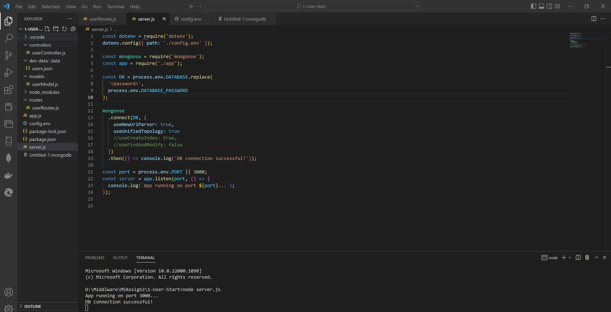

Step 4: Displaying 5 users on Postman

Figure:

Step 5: Running server.js from User-Encryption File

Step 6: Signing Up a new user

Figure:

Step 7: Login a user without Encryption.

Figure:

Step 8: Login a user with Encryption

Figure:

Step 9: Running server.js from User-JWT

Figure:

Step 10: Password Created JWT

Figure:

Step 11: JWT Flowchart

**Github Code:**

[**https://github.com/jeniljz/IFT598Middleware-M5A2**](https://github.com/jeniljz/IFT598Middleware-M5A2)