**IFT 458/598 Middleware Prog & Database Security! MW (2022 Fall)**

Jenil Chetan Patel

## Module 8 Assignment ****: Final Project****

Dr. Dinesh Sthapit

December 3, 2022

Step 1: App(server.js) running without any errors

Step 2: App.js File

Step 3: Config.env file

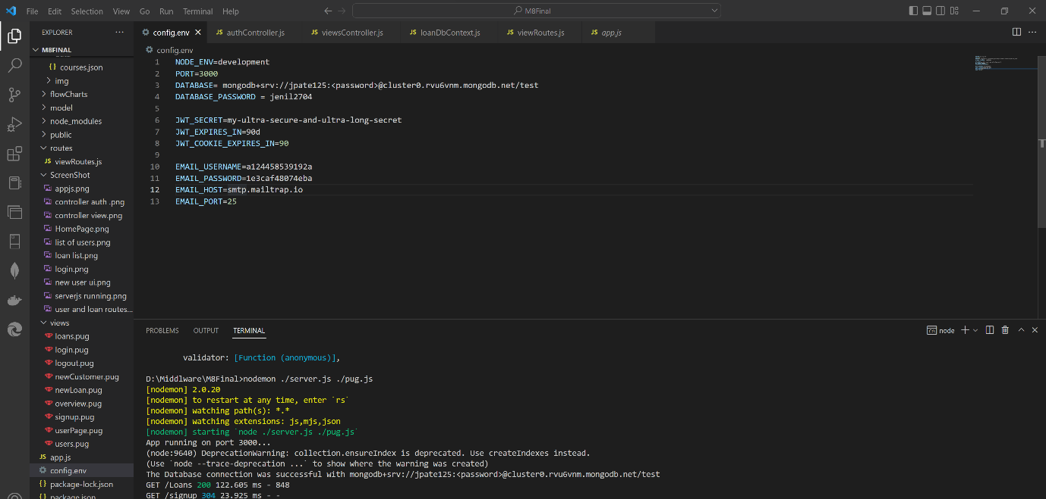

Step 4: View Controller.js

Step 5: Auth Controller.js

Step 6: Loans Routes

Step 7: User Routes

Step 8: Postman Tests

1. Home Page

1. User List

1. Create User

1. Loan List

1. New Loan

Step 9: Home Page

Step 10: List of User

Step 11: Loan List

Step 12: Login

Step 13: New User

Step 14: Mongo Db Database

1. Loan List

1. User List

Step 15: Flow Diagram for new user and loan creation

Step 16: Flow diagram for existing user and loan list

Step 17: Data Model with validations for user and loans

End to End Applications Running

1. Landing Page or Home Page

1. New User ( For a new user who is new to the banking system)

1. Login ( If the current user want to do operations)

1. List of Users( list of user which exist)

1. Loan List(Loans taken by the user)

**Project Estimate and Risks outlined.**

Project estimation includes cost, time, scope, resources, quality and risks.

* Cost: Project should be completed within a budget. This project requires a team of 6-7 developers and 3 testers. This project will also need to have a servers as well. So estimate cost would around 150K USD.
* Time: Project must be scheduled. The servers and apps to launched on time, which required multiple tasks to be completed such as getting right hardware and software services on time.
* Scope: Project’s each and every sub tasks must be done.
* Resources: There are hardware requirements, software requirements and service requirements to complete a project.
* Quality: Project must be delivered with right quality. Such as stable and optimized database software and UI. Server requirements must be at a level of optimal performance as multiple students will access the site or application.
* Risks: Error can occur during the development of the project or any server error can also occur so team have to be prepared for that.

**Github Code:**

<https://github.com/jeniljz/IFT598Middleware-M8A2>