

GUJARAT TECHNOLOGICAL UNIVERSITY
A. D. PATEL INSTITUTE OF TECHNOLOGY
CIVIL ENGINEERING DEPARTMENT

Project I (2170003)

A Project Report on

ROLE OF GEOTECHNICAL INVESTIGATIONS IN
SEISMIC HAZARD ASSESSMENT

Team ID 7967
Sr. No. | Team Members | Enrolment No.
1 | Manthan Baravaliya | 150010106002
2 | Bhingradiya Brijesh | 150010106005
3 | Kajavathanan.P | 150010106067
4 | Shuvam Sharma | 150010106069

Guide: Prof Kumarpal Trivedi
Academic year 2018-19

Index
1. Introduction 3
(A) The role of geotechnical engineers 4
2. Aim and Objective of the Project 5
3. An Overview of Seismic Zonation in India 6
What Is Seismic Zoning? 7
4.Relations between Earthquakes and Faults 8
When is a Fault "Active”? 8
Different types of Faults 9
Faults lines in Gujarat 10
5. Literature Review 11
6. Brief about Visit to INSTITUTE OF SEISMOLOGICAL RESEARCH (ISR) 15
(A) Our Observations during the Technical visit 16
(B) Things we discussed in the visit 18
(C) Significant Contributions of Institute of Seismological Research (ISR) 19
7. Patents Referred 22
8. Work plan summary 23
9. Geotechnical laboratory experiments 24
10. Future Plans 25
11. References 26

1. Introduction

As our final year project we choose to work on the field of Earthquake Engineering after going through various literature reviews and discussion among group members.
Earthquake engineering is wide field and in that we decided to work interrelating the earthquake engineering with Geo-technology. Earthquake is formed on the focus it will transfer to the rest of the places through soil in the form of wave. So the soil strata and soil formation plays an important role in the field of earthquake Engineering.
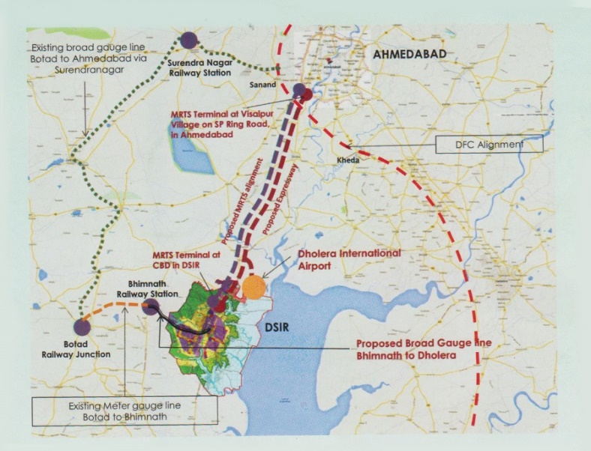
By classifying the soil we can conclude the behaviour of the Earthquake in certain region. The soil study is carried throughout the nation and then the country is dived into five Earthquake zones which is now change in to four zones after revising. When we are going for construction of some important structures we are doing detail study of the soil formation in the certain region by boring hole above 50m and conclude about the behaviour of earthquake which is known as micro zonation. These types of studies carried out during the construction of “Statue of Unity” and Dholera Special Investment Zone. In the region like Gujarat these types of studies will be very much useful.
Dholera SIR Map

(A) The role of geotechnical engineers

Seismic analysis is a typical multidisciplinary study. While the obvious role of a seismic geotechnical engineer is that of detecting and examining the performance of geotechnical structures under dynamic loading, his responsibility in the evaluation of free-field ground response is essential too. Here, it is worth remembering that ground response analyses are used to predict ground surface motion for the development of design response spectra, to evaluate liquefaction hazards or landslide occurrences and to determine the earthquake-induced forces on civil structures. Thus, an essential responsibility of an earthquake geotechnical engineer consists of detecting ground surface motion that is strongly influenced by the soil strata that might lie above the bedrock. This influence, as well as the general behaviour of earth structures, cannot be fully understood without:

1) Proper knowledge of the subsoil stratigraphy;

2) Mechanical behaviour of any Subsoil strata and of the materials constituting the earth structure, including a proper knowledge of experimental techniques,

3) Proper use of numerical models able to simulate the subsoil response, the geotechnical structure response

2. Aim and Objective of the Project

Aim
To Carry out Geotechnical Investigations for Seismic Hazard Assessment

Objectives
- Studying The Relation between Seismology and Geo-technology.
- Studying About Various Soil Formations.
- Studying About Various Soil Structures.
- Studying About Seismic Hazard Assessment.
- Studying About Characteristics of Earthquake In Different Soil Formations.

3. An Overview of Seismic Zonation in India

There is a dire need to integrate all the recent advances in our knowledge to produce the state of the art zoning map, both on large as well as micro scales on which the public can depend. Seism genic zones were classified on the basis of historical seismicity, geology, tectonics, soil types, and seismo-tectonics intensity of ground motion. This review article discusses a brief history of seismic zoning studies in India through chronological order. We discuss the scope for future studies to prepare more realistic seismic zoning maps for India. As there is a wide variation in the intensity of ground motion and also in the frequency of occurrence of earthquakes, there was a need to divide India into broad zones in terms of expected ground motion to represent the seismic hazards
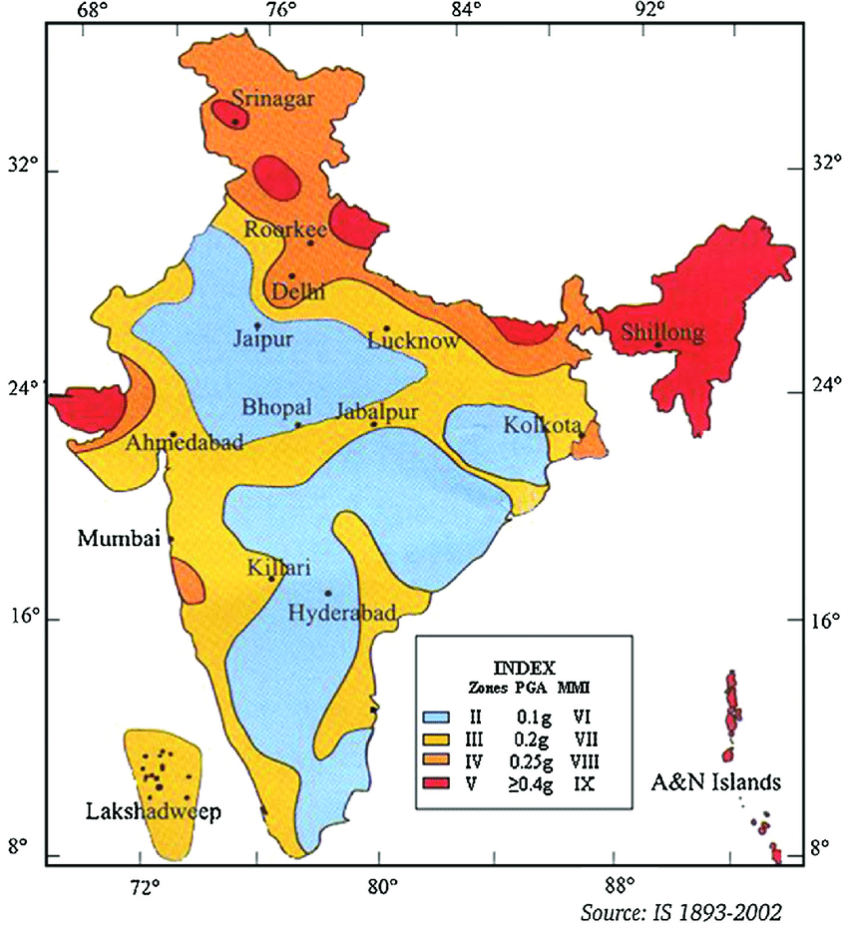

What Is Seismic Zoning?

Seismic Zoning can be defined as a process by which areas are subdivided into seismic zones based on expected of ground motion, which is expressed in terms of peak horizontal ground acceleration (PGA) or peak ground velocity (PGV). On the other way, seismic Zonation demarcates equal hazard with respect to a characteristic of strong ground shaking and of site or structural response. A seismic zoning map differs from seismicity map by the fact that it specifies the levels of force or ground motions for earthquake resistance design, where seismicity map provides location and characteristics of earthquakes.
Need for Seismic Zonation
- These maps identify the regions of a country or province in which various intensities of ground shaking may have occurred or may be anticipated.
- Maps of probabilistic hazard give an idea of the underlying statistical uncertainty, as is done in calculating insurance rates. These maps give, for example, the odds at which specified earthquake intensity would be exceeded at a site of interest within a given time span.
- Seismic zoning is used to reduce the human and economic losses caused by earthquakes, thereby enhancing Economic development and Political stability.
- New probabilistic maps have been developed as the basis of seismic design provisions for building practice. These usually give the expected intensity of ground shaking in terms of peak acceleration. The peak acceleration can be thought of as the maximum acceleration in earthquakes on firm ground at the frequencies that affect sizable structures.

4. Relations between Earthquakes and Faults

A fault line is a fracture along which the crust has moved. Stresses in the crust along New Zealand’s plate boundary have broken it into separate fragments or blocks that move relative to each other along fault lines. The relationship between earthquakes and faults was first established by nineteenth century geologists following the 1855 Wellington Earthquake in New Zealand.
As far as seismologists now understand, all but the very deepest earthquakes (deeper than 600km) occur on faults. Seismic waves are generated when the two sides of the fault rapidly slip past each other. For most earthquakes, the faults do not break the surface, so the faults can be "seen" only through analysing the seismic waves. Faults can be anywhere from metres to a thousand kilometres long. Seismologists still have much to learn about the mechanism that causes the deepest earthquakes. At 600km, the earth is probably too warm for faults to be brittle like glass, so some sort of chemical change might occur very rapid.

When is a Fault "Active”?

Geologists believe that if a fault shows evidence of having moved at least once in the past 100,000 years, it should be regarded as a potential source of earthquakes. If it has moved at least once in the past 5000 years, then it should be considered a potential source of damaging earthquakes to any settlement within a radius of 50km. Once a major fault has formed, future earthquakes are generated along the same line, and after hundreds of thousands or million of years of movement, increasingly large vertical and horizontal displacements of land occur.

Different types of Faults

A close look at faults helps geologists to understand how the tectonic plates have moved relative to one another.
Types of movement of crustal blocks that can occur along faults during an earthquake:

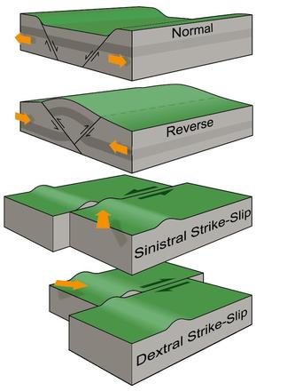
1. Where the crust is being pulled apart, normal faulting occurs, in which the overlying (hanging-wall) block moves down with respect to the lower (foot wall) block.
2. Where the crust is being compressed, reverse faulting occurs, in which the hanging-wall block moves up and over the footwall block – reverse slip on a gently inclined plane is referred to as thrust faulting.
3. Crustal blocks may also move sideways past each other, usually along nearly-vertical faults. This ‘strike-slip’ movement is described as sinistral when the far side moves to the left, and dextral, when the far side moves to the right.
4. An oblique slip involves various combinations of these basic movements, as in the 1855 Wairarapa Fault rupture, which included both reverse and dextral movement.
Faults can be as short as a few metres and as long as 1000km. The fault rupture from an earthquake isn’t always a straight or continuous line. Sometimes there can be short offsets between parts of the fault, and even major faults can have large bends in them.

Faults lines in Gujarat
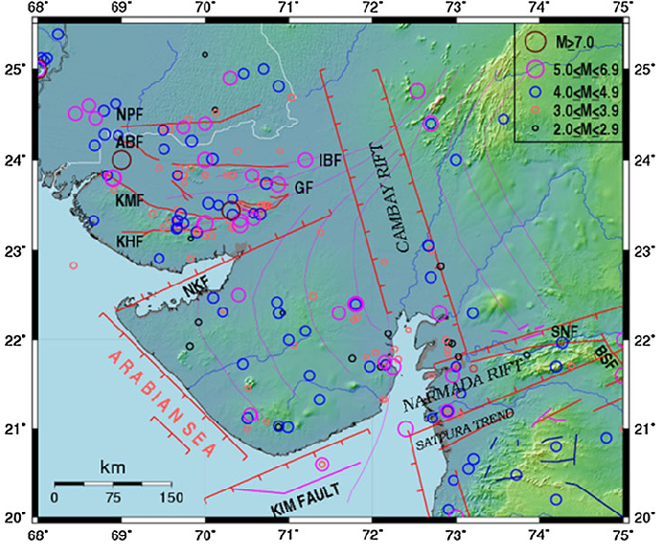

The Kachchh region is considered seismically one of the most active intraplate regions of the World (Rastogi, 2010). It was known to have high hazard but low seismicity in view of the occurrence of several large earthquakes but fewer moderate or smaller shocks Normally, the number of earthquakes increases ten times for every unit of lower magnitude. In Kachchh for two earthquakes of M7.8 and 7.7, earthquakes of M<7 are fewer. In Saurashtra as part of regional seismicity earthquakes of M<6 have occurred on the eastern part and around West Cambay Fault near Bhavnagar. Narmada rift zone has experienced shocks of magnitude M5.4 at Bharuch in 1970, but M6 or more east of Gujarat. The Cambay rift has shown less seismicity which is confined more to its southern part and to M5.7 level.

6. Liquefaction

Soil liquefaction occurs when a saturated or partially saturated soil substantially loses shear strength and stiffness in response to an applied stress such as shaking during an earthquake or other sudden change in stress condition, in which material that is ordinarily a solid behaves like a liquid .The basic definition of liquefaction starts with a soil mass saturated with pore fluid, for typical geotechnical considerations with water as pore fluid, and the excessively large development of this pore water pressure inducing a critical hydraulic gradient to reduce the effective stress to zero in soils naturally or artificially deposited. But the term liquefaction always associates the presence of water in the soil mass as a primary requirement and one cannot usually think of liquefaction without the presence of water. Sandy soils with presence of non plastic fines (silt) posed a problem to the definition of liquefaction because of their higher deformation but failing to produce pore water pressure to make effective stress zero, therefore after this the definition of liquefaction is defined considering the either of two main requirements,
1) The development of pore water pressure to reduce effective stress to zero
2) To undergo a limited but extensive deformation.
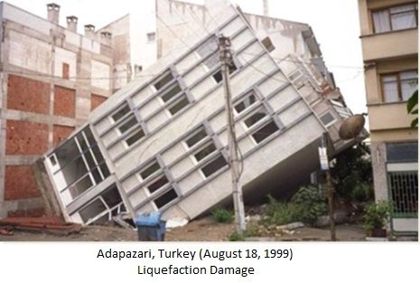
. Mechanism of Soil Liquefaction
It is necessary to understand the mechanism of soil liquefaction, where it occurs and why it occurs so often during earthquakes. Liquefaction of soil is a process by which sediments below water table temporarily loose shear strength and behaves more like a viscous liquid than as a solid. The water in the soil voids exerts pressure upon the soil particles. If the pressure is low enough, the soil stays stable. However, once the water pressure increases, it decreases the effective stress and this will reduce the shear strength of the soil. During an earthquake, the sudden load is taken by the water in the form of excess pore water pressure. If increased pore water pressure cannot be released, it will continue to build up and it will lead to reduction of effective stress to zero. In this state the soil layer losses its shear strength and it behaves like a viscous liquid and it cannot take the load coming from overlying soil or structures. Thus the upper layers of soils move down and this will lead to the collapse of structures on the ground.
Liquefaction Studies
• The factor of safety against liquefaction can be evaluated based on the geotechnical data obtained from the field.
• The liquefaction potential evaluation can be done based on the deterministic or probabilistic methods.
• Liquefaction potential can be reported in terms of SPT and CPT values required to prevent liquefaction can also be developed (if required).
• Liquefaction factor of safety evaluated based on the available geotechnical data and using probabilistic techniques can then be used for the liquefaction hazard assessment.

Liquefaction Evaluation from
Shear Wave Velocity Vs Data

Cyclic stress-based procedures were based on the premise that liquefaction resistance is governed by relative density. Since in-situ penetration test resistance parameters are also strongly influenced by relative density, a correlation between in-situ test parameters and liquefaction resistance should exist. Seismically induced shear strains are more important than seismically-induced stresses in the liquefaction response of soils. To adapt the cyclic strain-based procedures to the well-known simplified cyclic stress based methods, shear stress is related to shear strain using the shear modulus. Since the shear modulus is directly related to shear wave velocity through the fundamental equation
G = r.Vs

As in the case of the SPT, and CPT, a database of field case histories has been developed comparing shear wave velocity at seismically-active sites that have or have not shown surface
manifestations of liquefaction. The database contains over 75 sites subject to 25 earthquakes between 1906 and 1995 (Andrus et al., 1999). Most of the shear wave velocity data is from post earthquake field investigations, so the soil fabric is likely disturbed from its pre-earthquake sate. This may increase shear wave velocity from additional cyclic pre-straining, or reduce shear wave velocity if aging and cementation affects were destroyed by excessive cyclic straining. Since the same shear wave velocity measurements at a site were used for multiple earthquakes, additional scatter is expected when comparing the database results to theoretical curves.

Factors affecting the liquefaction of the soil

Type of Soil (Index Properties of Soil)

The phenomenon of liquefaction is most commonly observed in loose, cohesion less soils. Earlier it was believed that liquefaction was limited to sands only. Fine grained soils were considered incapable of generating the high pore pressure and coarse grained soils were considered too permeable to sustain any generated pore pressure long enough for liquefaction to occur. However, it has been found out that liquefaction takes place in gravelly soils as well (Yoshimi and Kuwabara, 1973). Lab experiments have shown that majority of clays remain unsusceptible to liquefaction. Sensitive clays can exhibit strain softening behaviour which makes it vulnerable to liquefaction. It has been deduced from some major earthquakes that for cohesive soils to liquefy they must fulfil the following conditions
Fraction finer than 0.005 mm ≤ 15%
Liquid limit, LL ≤ 35%
Natural water content ≥ 0.9 LL
Liquidity index ≤ 0.75
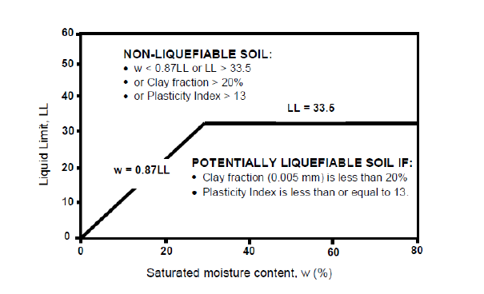
Clay soils are susceptible to liquefaction if:
Fraction finer than 0.002 mm ≤ 10%
Liquid limit, LL ≤ 32%

Clay soils are unlikely to be susceptible to liquefaction if:
Fraction finer than 0.002 mm > 10%
Liquid limit, LL > 32%

Shape of Soil Particles

Rounded particles are known to densify more easily than angular shaped particles. Hence, the l, ease of densification is directly proportional to the susceptibility of soil to liquefaction. This implies that rounded particles are more prone to liquefaction than angular shaped particles, during an earthquake.

Permeability of Soil

Permeability of soil mass leads to dissipation of pore water pressure very quickly. Hence, if this dissipation of pore water pressure occurs very quickly then the soil may not liquefy. Based on the observations, it can be concluded that presence of highly permeable soil layers can reduce liquefaction potential of adjacent soil layers. In other words, the liquefaction susceptibility of a loose sand layer will be reduced if it is surrounded by a highly permeable gravel layer.

Presence of Seismic Waves

An earthquake is characteristically a kind of vibration energy that includes impacts or shocks. The vibration it produces varies according to the characteristics of the ground through which the vibrations transmit. Earthquake on the surface of the ground is strongly dependant on the vibration characteristics of the layers underneath. It is known that the most common cause for liquefaction is the presence of vibration seismic energy released during an earthquake. Based on observations, it has been concluded that the potential for liquefaction increases with the increase in seismic energy. The energy thus produced, is the cause for the cyclic shear stress that acts on the soil mass and this causes the acceleration of the soil mass in the horizontal direction. The acceleration is known as the peak acceleration exerted by earthquake at the ground surface. It has been stated that the shaking threshold required for liquefaction is a local shaking magnitude of about 5 and a peak acceleration of 0.1g.

Age of Soil

The age of the soil plays a pivotal role in determining the liquefaction susceptibility. The liquefaction resistance of a soil increases, with the age of the soil. New soils liquefy more easily than old soil deposits, because the old soil deposits have more stable particle arrangement due to the compression of the soil particles with time. More over the particle bonding in the case of old deposits will be more. Thus old soil deposits have a greater liquefaction resistance comparatively.

Confining Pressure

Soils at depths of more than 15 metre generally do not liquefy due to the high effective confining pressure on it. The higher the effective confining pressure, lesser is the probability of the soil to liquefy. As already mentioned, if the ground water table depth is more than 15 m from the ground surface, the soil lying below the water table generally does not liquefy. But this doesn’t stop us from determining the liquefaction susceptibility of the soil layer that is at a depth of more than 15 m from the ground surface. In case of a sloping dam, the soil deposit has to be analysed for its liquefaction susceptibility even if the depth of deposit is more than 15 m.

Relative Density of Soil

The soil layer which has a low relative density is more susceptible to liquefaction than dense soil. Loose soils densify easily during earthquake and this will cause an increase in pore water pressure which leads to the liquefaction of soil. Where as dense sands will dilate during earthquake and this will reduce the pore water pressure and hence the liquefaction susceptibility will be less.

Natural Soil Deposits in Water Bodies

Soils in lakes, rivers or oceans are highly prone to liquefaction due to their loose and segregated structure. Hence soils which are susceptible to liquefaction are formed in marine depositional environments. Tailing dams are also susceptible to liquefaction.

7. Seismic Microzonation

Seismic microzonation is subdividing a region into smaller areas having different potential for hazardous earthquake effects. The earthquake effects depend on ground geomorphological attributes consisting of geological and geotechnical information. The parameters of geology, soil coverage, thickness, and rock depth are some of the important geomorphological attributes. Other attributes are the earthquake parameters, local site response for an earthquake, The Peak Ground Acceleration (PGA), amplification/ site response, predominant frequency, liquefaction and landslide due to earthquakes are some of the important seismological attributes.
Need for Seismic Microzonation
Seismic microzonation is the first step in earthquake risk mitigation study and requires multidisciplinary approach with major contributions from the fields of geology, seismology, geophysics, geotechnical and structural engineering. This is very important to identify the tectonic and geological formations in the study area which is essential for determining the seismic sources and also for establishing a realistic earthquake hazard models for the investigation. Seismic microzonation involves a very detailed field investigation to evaluate the hazard. They are also useful to evaluate the risk scenarios in the study area. Seismic microzonation maps are very useful in urban planning because they help to predict the impact of future earthquakes and can also be used to locate key facilities like hospitals, fire stations, emergency operation centres etc. Microzonation studies are also very useful to save the heritage and important structures from future major earthquakes.

Role of Geotechnical and Geophysical Investigations
In Seismic Microzonation

In seismic microzonation of urban centres geotechnical /geophysical investigations form an important step. Geotechnical information becomes invaluable in the evaluation of hazards at ground surface, local site effects and liquefaction More accurate the exploration, the greater freedom the planner will have as this will provide an more accurate estimate of hazards. One of the most difficult and controversial aspects of any geotechnical/geophysical investigation is deciding how much exploration to do. An adverse geology might require more investigations than the average.. Investigation spans over several square kilo meters to several hundreds of square kilo meters. Hence, careful planning of testing program is very essential, to obtain representative site characterization with the minimum number of tests. These data will be of very high importance in evaluating the induced earthquake effects such as site amplification, local site effects, liquefaction susceptibility and slope stability. The smaller the grid size the accuracy will be more in evaluating hazard in an area. But this will increase the cost and the man power requirement for field testing, data collection and the analysis.
.
Seismicity of the Study Area and Estimation of
Its Ground Motion Parameters

The first step in the seismic microzonation is to assess the characteristics of ground motion at the bedrock level considering the seismic sources and the path effects. However, If there are any seismic sources which can create a very large earthquake (mega earthquake) the details of the seismic events and the seismic sources need to be identified from this region. The initial estimates of ground motion parameters and bed rock motions should be obtained at the bed rock level using deterministic and probabilistic methods. It is now the responsibility of the geotechnical engineer to estimate the influence of local soil conditions and topography on the earthquake motions and obtain the surface ground motions.

Site Investigation

Site investigation provides samples for visual inspection, index testing. This helps to identify the strata at the site. Subsequent laboratory tests help to obtain index properties as well as engineering properties of the soils. While the general ground exploration process will have different objectives, the following are the main objectives of site investigation carried for the purpose of seismic microzonation.

- To determine ground water conditions
- To carry index tests for classifying soils
- To obtain engineering properties of the soils
- To confirm lateral variability of soils

In-situ Field Testing for Site Characterization

Various in-situ field tests available for site characterization. The most common field tests conducted for site characterization are

- Standard Penetration Test (SPT)
- Cone Penetration Test (CPT)
- Seismic Cone Penetration Test (SCPT)
- Spectral Analysis of Surface Wave (SASW)
- Multichannel Analysis of Surface Wave (MASW)

The widely accepted method for site characterization is based on VS30 values. In the absence of direct shear wave velocity measurement results, these values can be reduced from SPT and CPT values and can be used for site characterization.

Effect of Ground Water ( As Per NDMA Guideline)
The relation between groundwater and earthquakes is not new and is well documented. The Chinese noticed centuries ago that water levels in wells can vary in association with earthquake activity, and used this behaviour with some success to anticipate earthquakes. More recent research in the United States has attempted to use monitoring of groundwater levels in wells to help predict earthquake activity (Moyle, 1980). The 1983 Borah Peak earthquake in southeastern Idaho caused groundwater located near its epicenter to erupt as much as 25 feet into the air (CGER, 1992). However, within the past 50 year researchers have noted that groundwater can play a direct role in earthquake occurrence and earthquake related damage. In addition, it is known that earthquakes such as the 2004 Indonesian quake can cause measurable changes on groundwater levels in places thousands of miles from the epicenter (USGS, 2005). Research on earthquake mechanisms indicates that groundwater likely plays a significant role in many large earthquakes. Furthermore, groundwater can magnify the damaging effects of ground surface. Groundwater can also play a significant role in how earthquakes affect the ground surface when an earthquake occurs. The most well known effect is liquefaction. During the shaking cause by an earthquake, certain types of fluid saturated sediments can lose their structure and become liquefied. These phenomena led to increased structural damage. The geologic and hydrologic factors that affect liquefaction susceptibility are the age and the type of sedimentary deposits, the looseness of cohesions less sediments, and the depth to the ground water table. The liquefaction is mostly limited to water saturated, cohesions less, granular sediments at depths less than 15m.

What is MASW?
MASW is an acronym of Multichannel Analysis of Surface Waves. It is a seismic exploration technique . It evaluates ground stiffness by measuring shear-wave velocity (Vs) of subsurface in 1-D, 2-D, and 3-D for various types of geotechnical engineering projects in the most common depth range of 0-30 meters. MASW first measures seismic surface waves generated from various types of seismic sources—such as sledge hammer—analyses the propagation velocities of those surface waves, and then finally deduces shear-wave velocity (Vs) variations below the surveyed area that is most responsible for the analysed propagation velocity pattern of surface waves. Shear-wave velocity (Vs) is one of the elastic constants and closely related to Young’s and shear moduli. Under most circumstances, Vs is a direct indicator of the ground strength (stiffness) and therefore commonly used to derive load bearing Capacity. .
Overall procedure to produce a typical 2D S-velocity (Vs) cross section consists of collecting multichannel seismic records at multiple locations as
illustrated below. Each record then generates a 1-D (depth) velocity (Vs) profile, multiple of which will construct the final 2D cross section.

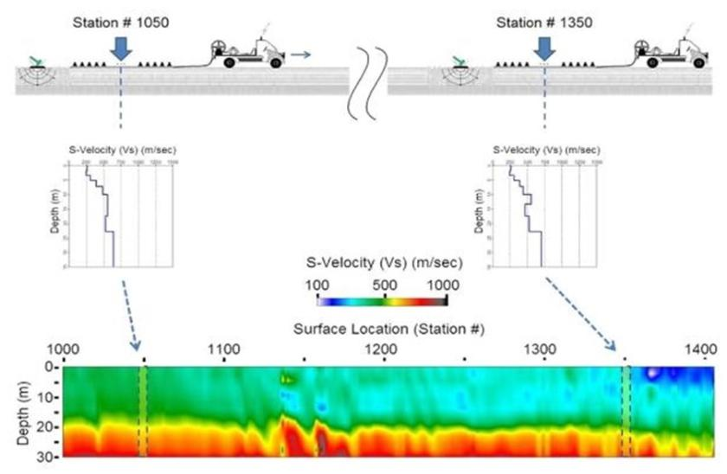

Steps involved in MASW

01. Data Acquisition:
Acquiring multichannel field records (commonly called shot gathers in seismic exploration)

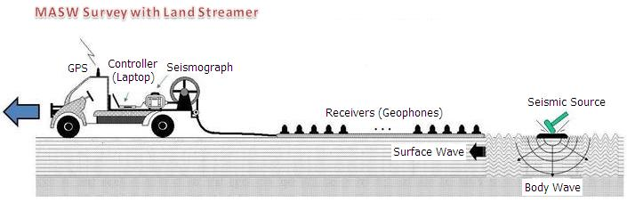

02. Data Analysis:-
By calculating shear-wave velocity (Vs) variation with depth that gives theoretical dispersion curve closest to the measured curve .A 2-D (surface and depth) Vs map is then constructed through an appropriate interpolation scheme by placing each 1-D Vs profile at a surface location corresponding to the middle of the receiver line. A more detailed description including optimum parameters
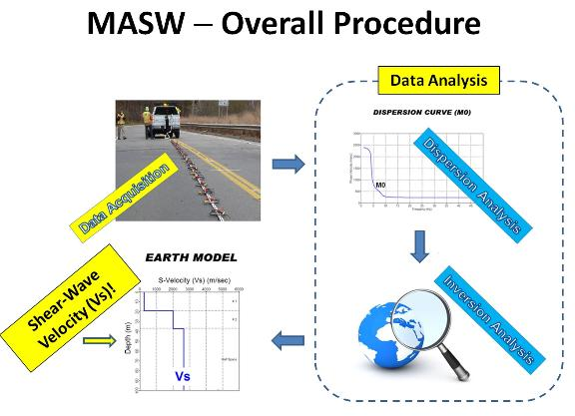

5. Literature Review

01) The state of art in Seismic Hazard Analysis
I.D. Gupta
Central Water & Power Research Station Khadakwasla,
Pune, India

Observations :-
- Information about Seismic hazard assessment.
- The present paper has described the current state-of-the-art approaches for the deterministic and the probabilistic seismic hazard analysis, which include data on past seismicity, knowledge of the tectonic features, information on site soil condition and the underlying geology of the surrounding area.

02) Future trends in earthquake-resistant design of structures
Durgesh C. Rai
Department of Earthquake Engineering,
University of Roorkee, Roorkee , India

Observations :-
- Basic knowledge of earthquake resistant structures.
- A complete probabilistic analysis and design approach that rationally accounts for uncertainties present in the structural system will gradually replace deterministic approaches, especially in the characterization of the loading environment.

03) Soil Dynamics and Earthquake Engineering
Jiro Takagi
Tokyo Metropolitan University
Tokyo, Japan

Observations :-
- Importance of Modern seismic design and construction technologies.

- The existing seismic design approach has been developed to allow for ductility of building structures to resist large earthquakes economically.

- The currently existing seismic design methods allow structures to undergo plastic deformations under large earthquakes, while remaining elastic under small or moderate earthquakes.

04) International Journal of disaster risk reduction
Tanja Kalman sipos
J.J.Strossmayer University of Osijek
Croatia

Observations :-
- Basic knowledge of Rapid seismic risk assessment .
- Important parameters like Vulnerability indicators regarding to global risk.
- The Primary objective of this study was to develop a relative risk assessment in terms of deriving measurement of risk that can be used to examine the variables like Physical and Social.

05) Dynamic analysis of space structures with multiple tuned mass dampers
Y.Q. Guo, W.Q. Chen
Department of Civil Engineering, Zhejiang University,
Hangzhou, China

Observations :-
- Information about provide stability and durability to the modern civil structures.
- The present paper has described Formulations of the reverberation matrix method (RMM) are presented for the dynamic analysis of space structures with multiple tuned mass dampers (MTMD).

06) Seismicity and Earthquake Hazard Studies in Gujarat
B. K. Rastogi*
Institute of Seismological Research
Raisan, Gandhinagar-382 009
(Department of Science & Tech, Govt. of Gujarat)
Observations :-
- Determining Earthquake prediction research and hazard assesment mainly in kachchh region.
- Long-Term Assessment of Earthquake Potential across Different Faults: Though
earthquake prediction is still a matter of research, assessment of long-term earthquake hazard will help builders, architects and engineers to design earthquake resistant buildings to save precious lives.

07) Seismic behaviour of geotechnicalstructures
Stefania Sica, Filippo Santucci de Magistris and Filippo Vinale
Department of geotechnical research
Napoli, Italy
Observations :-
- Information of fundamental considerations regarding the behaviour of geotechnical structures under seismic loading.
- of soil parameters, a crucial point to properly analyze the seismic behaviour of geotechnical structures
- The currently existing seismic design methods allow structures to undergo plastic deformations under large earthquakes, while remaining elastic under small or moderate earthquakes.

08) International Journal of disaster risk reduction
Tanja Kalman sipos
J.J.Strossmayer University of Osijek
Croatia

Observations :-
- Basic knowledge of Rapid seismic risk assessment.
- Important parameters like Vulnerability indicators regarding to global risk.
- The Primary objective of this study was to develop a relative risk assessment in terms of deriving measurement of risk that can be used to examine the variables like Physical and Social.

6. Brief about Visit to
INSTITUTE OF SEISMOLOGICAL RESEARCH (ISR)

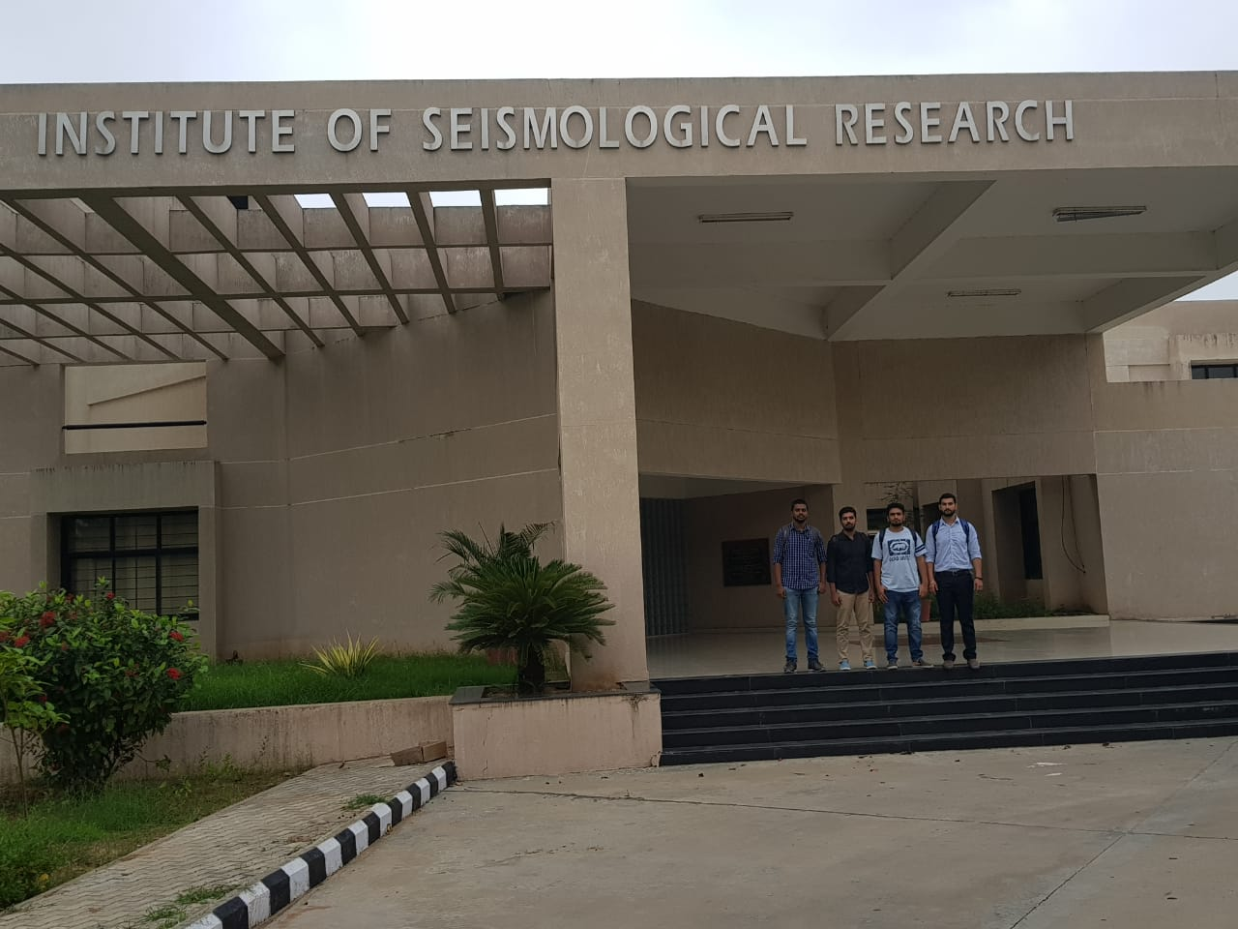

The Institute of Seismological Research (ISR) under the Science and Technology Department, Government of Gujarat was established in 2006. To date, ISR is the only institution in India dedicated exclusively to seismological research and in a short span, it has developed into a premier institution with an international presence.

(A) Our Observations during the Technical visit

1. Earthquake Monitoring that involves, round the clock monitoring of seismic activity of Gujarat through a dense network of 60 broadband seismograph station (36 connected by VSAT) and 50 strong motion accelerograph in Gujarat. These station report earthquake location and their magnitudes within 10 minutes of the arrival of seismic waves. Auto location Programme has been installed to give earthquake parameters in near real time.
2. GPS Monitoring for Crustal Deformation studies with about 25 permanent GPS station for the study of crustal deformation across all geological faults in Gujarat.
3. Site specific Seismic microzonation studies and recommendation to the state on several important seismic safety factors.
4. Earthquake Prediction Research using, three multiparametric Geophysical observatories at Vamka, Desalpar and Badalgarh in Kachchh district. These stations measure 11 physical parameters round the clock for earthquake prediction research.
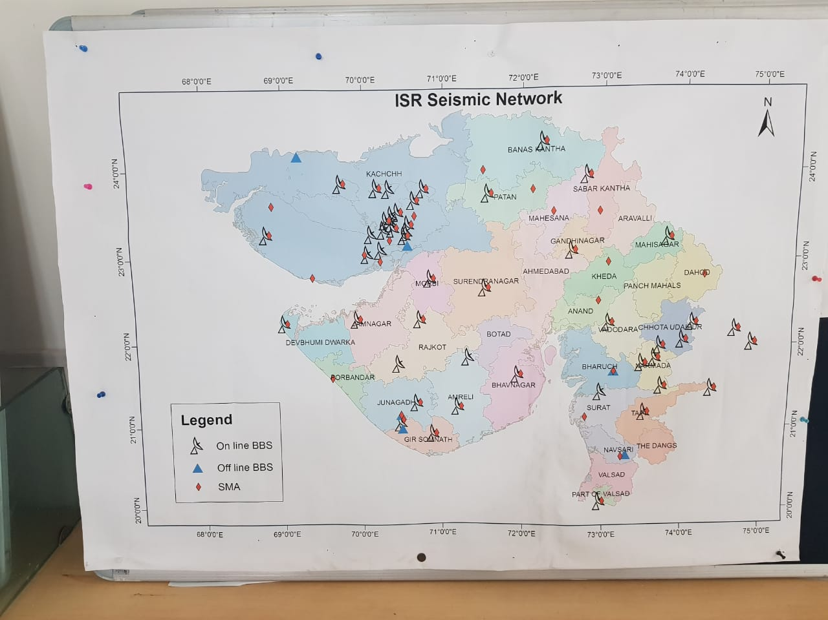 ISR Seismic Network
5. Laboratories for,
i) Seismic data analysis,
ii) Geotechnical analysis,
iii) Global positioning system analysis,
iv) Engineering seismology,
v) Optically Stimulated luminescence dating,
vi) Engineering geophysics,
vii) Gravity and magnetics analysis and
viii) Electrical and electromagnetic studies.

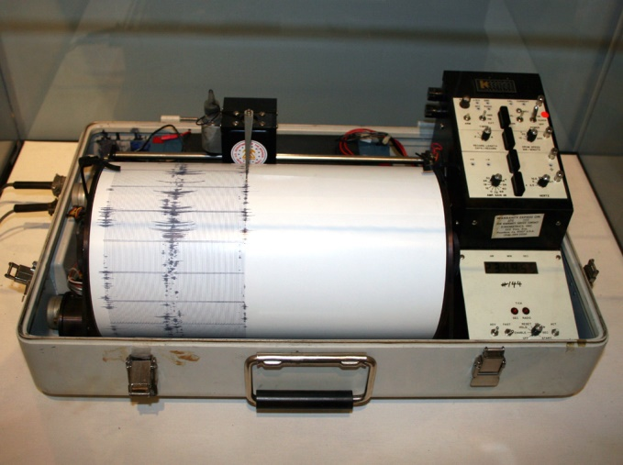
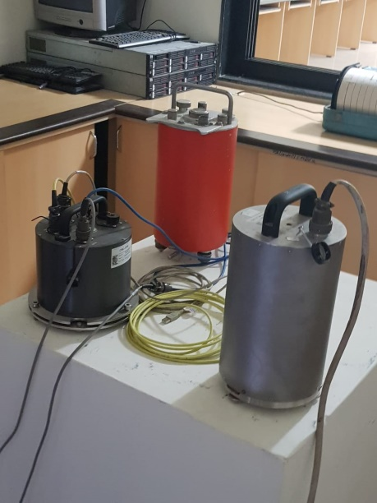
Broadband accelerograph
Seismograph

(B) Things we discussed in the visit
- About the Institute ( Aim and Objective )
- How they are contributing to society?
- Tests and investigations they are carrying out.
- How they interpret the Seismological data?
- How they convey the collected data to people?
- What are the resources they are having.
- How they can help us with our project area?

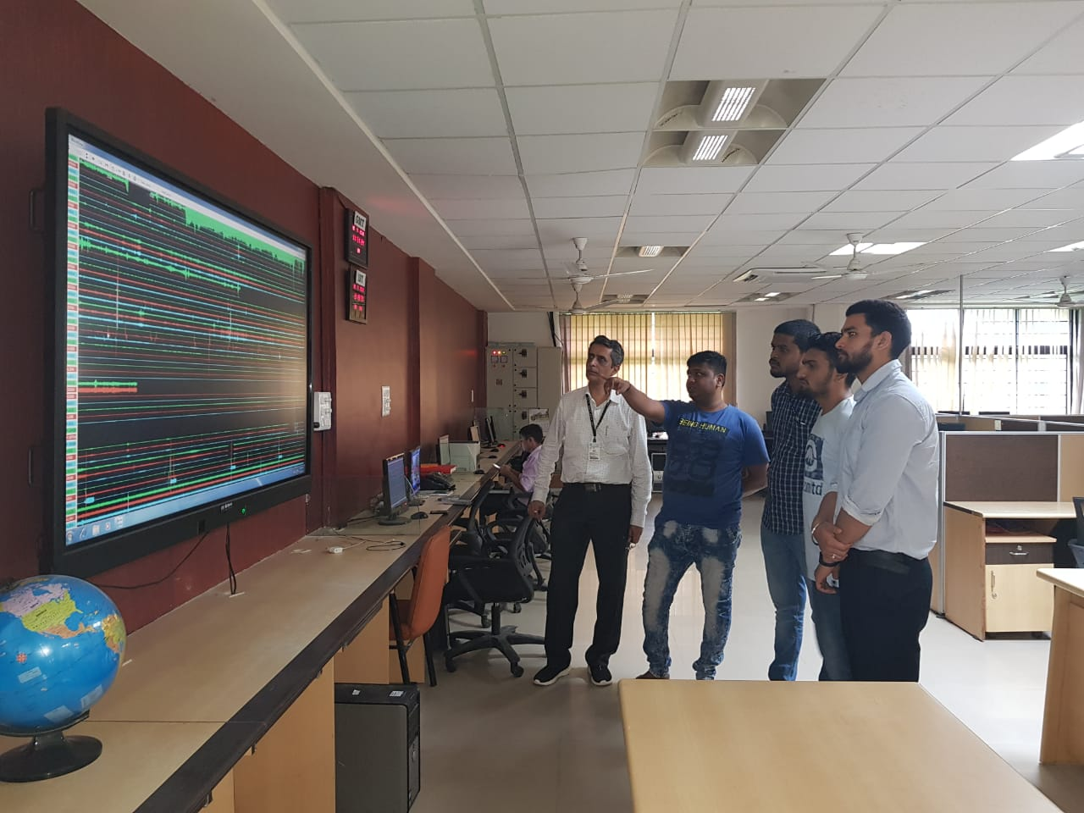

Discussing with ISR officer

(C) Significant Contributions of Institute of Seismological Research (ISR)

1. Probabilistic Seismic Hazard Map of India
A Probabilistic Seismic Hazard Assessment (PSHA) map of India has been prepared and submitted to the Bureau of Indian Standards for recommending it to the nation.
2.Site Specific Response Analysis for Nuclear Power Plants
ISR estimated the site specific response spectra for Kakrapar Nuclear power plant and also given a report on the basis of which the plans for expansion of nuclear power plant was approved.
3.Seismic Hazard Analysis for Proposed National Monument of Sardar Patel at Narmada Dam Site
The Sardar Sarovar Narmada Nigam Limited (SSNNL) plans to build a national monument of Sardar Vallabhbhai Patel, 3 km downstream of the Narmada dam. This statue will be the world’s tallest with a height of 180 m. ISR carried out seismological and geophysical surveys in the study area that included,
(i) Seismic survey using engineering seismograph to determine seismic wave velocity to a depth of 30m
(ii) Operation of broadband seismographs at two places near the site to record ambient vibrations to study the site response for high frequency waves.

Data Interpreting and Earthquake details publishing by ISR
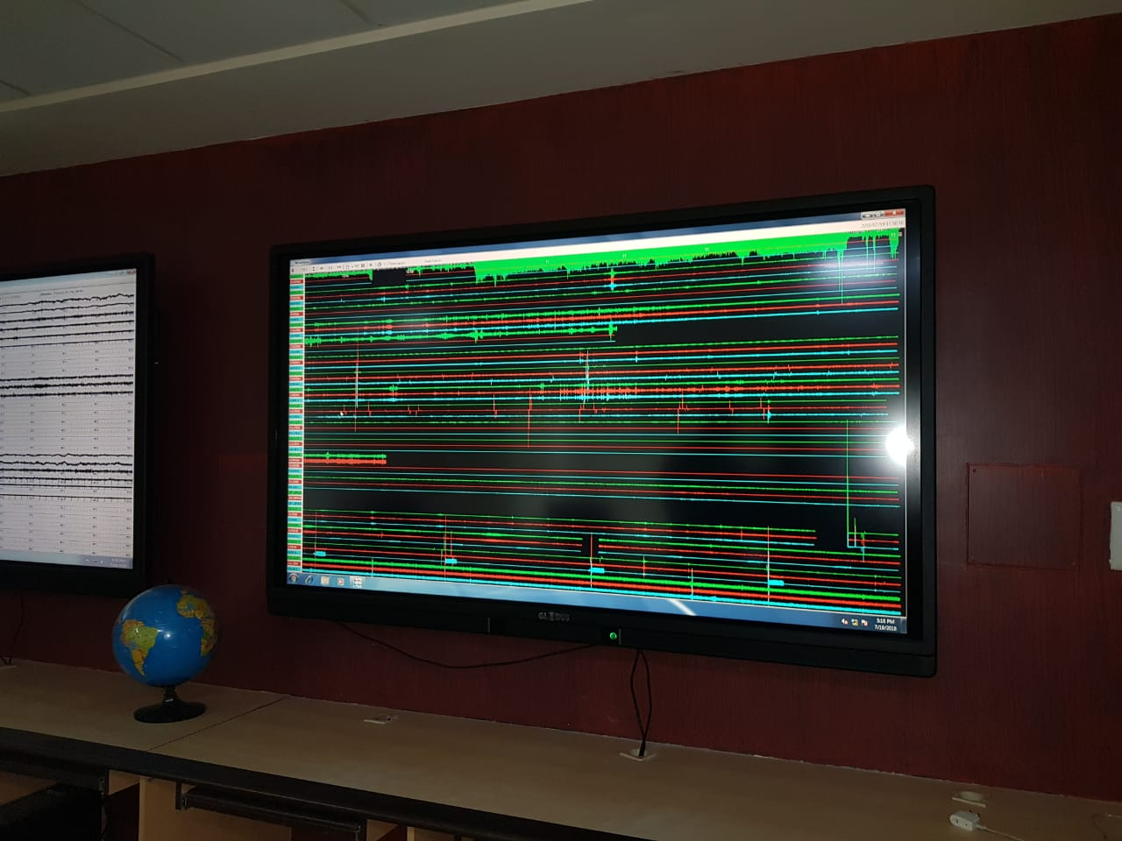
Monitoring of Broadband Seismograph
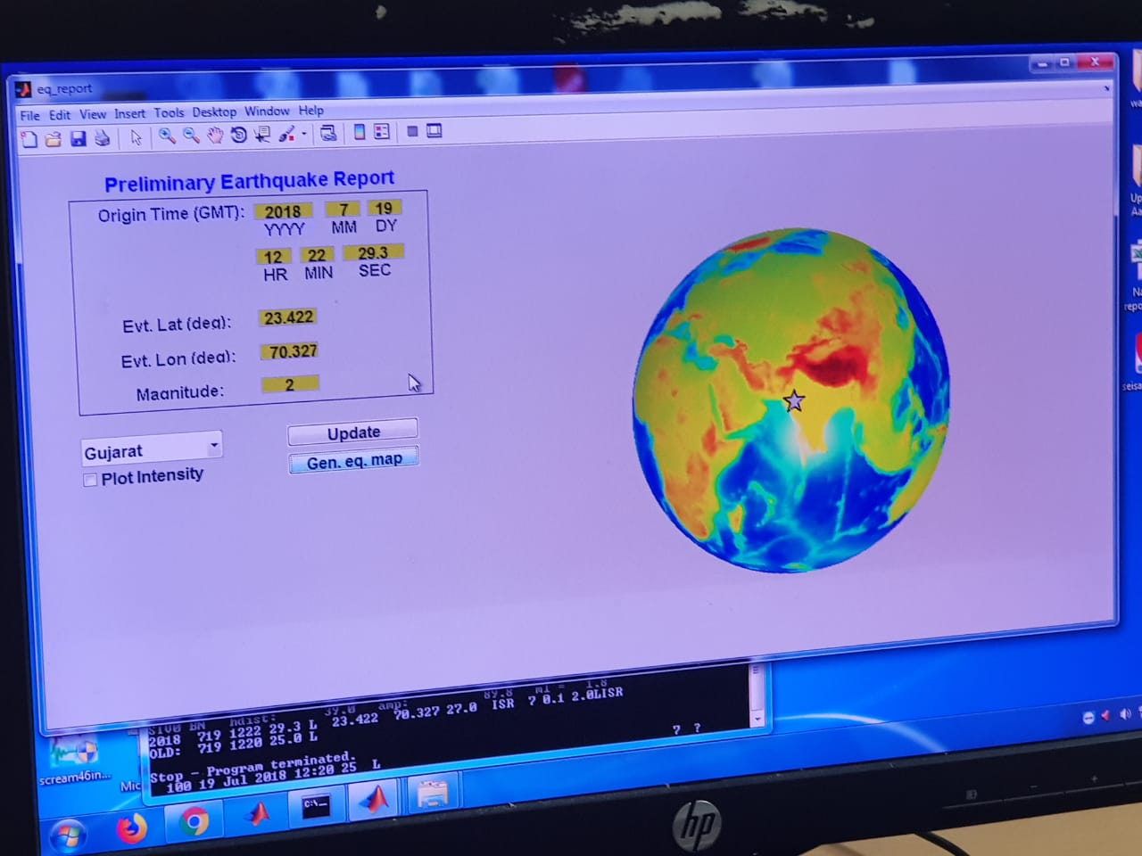Interpreting Collected seismic data

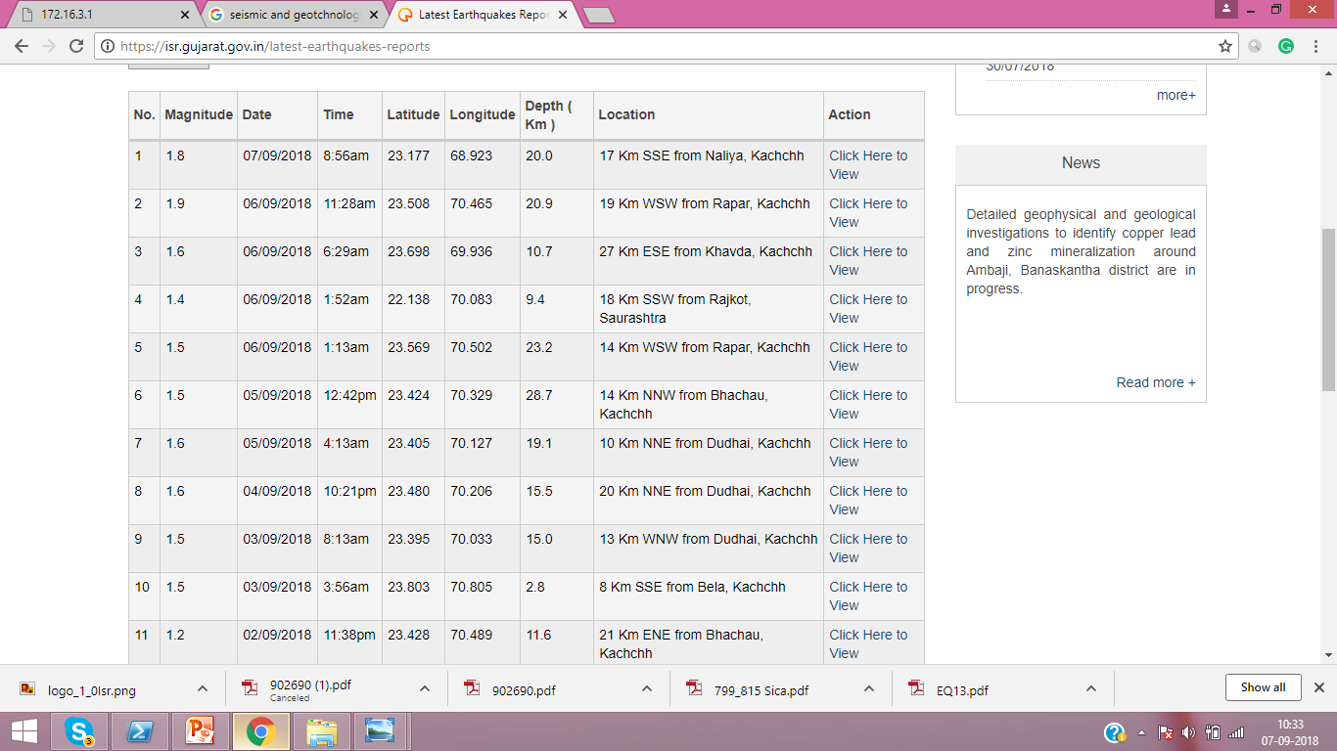
Publishing Interpreted Data in ISR Website

7. Patents Referred

No | Patent Name | patent number
1 | Method for seismic imaging in geologically complex formations | Us 7,095,678 B2
2 | Seismic prediction with decay products | Us 9,201,152 B2
3 | Down hole interpretation techniques using borehole dips | Us 2017/0227675 A1
4 | Seismic data processing | Us 20189/0143334 A1
5 | Interferometric micro-seismic imaging methods and apparatus | Us 2018/0203144 A1
6 | Sensor arrangement for seismic  Waves | US 2005/0105391 A1
7 | Earthquake determination system  And seismic analysis method | US 2012/0078520 A1
8 | Earthquake prediction device | US 2015/0378036A1
9 | Seismic isolator | US 2016/0340924 A1
10 | Seismic sensor and earthquake determination method | US0188396
11 | Model test system for seabed seismic wave detection | US20180101627A1
12 | Seismic Alarm and Warning System | US20140187142
13 | Hazard assessment system | US20080027690A1
14 | Earthquake Detection System and Method | US20150331121A1
15 | Sample extraction apparatus and method for liquefaction assessment | US 2016/0018307 A1
16 | Seismic attributes for structural analysis | US 2011/0046884 A1
17 | System and method for earthquake risk mitigation in building structures | WO/2018/107292
18 | Seismic Acquisition method and apparatus | US 2016/0187517A1
19 | System and method for providing earthquake data | US 2007/0225917 A1
20 | Earthquake hazard evaluation method based on control of three disaster factors | CN104346538A

8. Work plan summary

Task to be performed | June | July | August | September | October
1.Group Formation | √
2.Searching area of project |  | √
3.Work area defined |  | √
4.Collection of literature Review |  | √
5.Collection of patents |  |  | √
6.Literature review |  |  | √
7.AEIOU sheets |  |  |  | √
8.Ideation and product canvas |  |  |  | √
9.To prepare PSAR |  |  | √
10.Report writing |  |  |  |  | √

9. Geotechnical laboratory experiments

1. Determination of moisture content
2. Determination of specific gravity
3. Field density test
4. Grain size analysis
A.sieve analysis
B.hydrometer analysis
5. Determination of consistency limits
6. Density index/relative density test
7. Permeability test
A.constant head method
b.falling head method
8. Proctor test
9. Vane shear test
10. Direct shear test
11. Unconfined compression test
12. Undrained triaxial test
13. Consolidated test
14. California bearing ratio test

10. Future Plans

- We are planning for the field test which is subjected to the convenience of ISR because these types of field tests are specially conducted by ISR. Here they are going for deep excavations and study the soil formations before building any important structures. Specialised Equipment and well trained persons are involved in this as here they analysing the soil strata below 80m.
- We are planning to do the laboratorial experiments related to Geo-technology in upcoming semester which will be more helpful to our project area.
- We want to refer further literatures in detail which would be helpful for us.

11. References

Journal papers
- Seismic behaviour of geotechnical structures- Stefania Sica
- Seismicity and Earthquake Hazard Studies in Gujarat-B. K. Rastogi*
- Down hole interpretation techniques using borehole dips
- Interferometric Micro seismic Imaging Methods and Apparatus

Articles /Reports
- Earthquake Tip - CV MURTY (IITK)
- Guideline for B.E. PMMS Activities
- ISR Brochure
- Geotechnical laboratory experiments
- Rock Physical Property Tests
Websites
  - Https://isr.gujarat.gov.in
  - Http://pib.nic.in/newsite/mberel.aspx?Relid=168661
  - Https://www.uspto.gov/
  - Https://www.google.com/?Tbm=pts

