

Darshan University

A Project Report on

“Online shopping”

Under the subject

Software Engineering (2301CS405)

B. Tech, Semester – IV

Computer Science & Engineering Department

Submitted By
Student Name: vegad jenil ashokbhai | Enrollment No.: 24010101300
Academic Year
(2025-2026)
Internal Guide  Prof. R. B. Gondaliya  Darshan University | Dean-DIET  Dr. Gopi Sanghani  Darshan University

 | Computer Science & Engineering Department  Darshan University

DECLARATION

We hereby declare that the SRS, submitted along with the Software Engineering (2301CS405) for entitled “Online Shopping ” submitted in partial fulfilment for the Semester-5 of Bachelor Technology (B. Tech) in Computer Science and Engineering (CSE) Department to Darshan University, Rajkot, is a record of the work carried out at Darshan University, Rajkot under the supervision of R. B. Gondaliya and that no part of any of report has been directly copied from any students’ reports, without providing due reference.

(Vegad Jenil Ashobhai)

Student’s Signature

Date: __________

 | Computer Science & Engineering Department  Darshan University

CERTIFICATE

This is to certify that the SRS on “Online Shopping” has been satisfactorily prepared by Vegad Jenil Ashokbhai (24010101300) under my guidance in the fulfillment of the course Software Engineering (2301CS405) work during the academic year 2025-202.

Internal Guide  Prof. R. B. Gondaliya  Darshan University |  | Dean-DIET  Dr. Gopi Sanghani  Darshan University

Acknowledgement
I wish to express my sincere gratitude to my project guide Prof. R. B. Gondaliya and all the faculty members for helping me through my project by giving me the necessary suggestions and advices along with their valuable co- ordination in completing this work.

I also thank my parents, friends and all the members of the family for their precious support and encouragement which they had provided in completion of my work. In addition to that, I would also like to mention the Darshan University personals who gave me the permission to use and experience the valuable resources required for the project from the University premises.

Thus, in conclusion to the above said, I once again thank the faculties and members of Darshan University for their valuable support in completion of the project.

Thanking You
Vegad Jenil A

ABSTRACT
The Online Shopping System is designed to digitalize and simplify the complete shopping experience by providing a centralized, computerized platform for product browsing, ordering, and management. This system replaces the limitations of traditional in-store shopping with an easy-to-use online interface accessible from anywhere. The platform includes essential features such as secure user accounts, instant product search, real-time inventory updates, and a streamlined checkout process. It also provides a dedicated admin module that allows administrators to oversee the entire system, manage product listings, track orders, handle user queries, and maintain overall platform performance.
Core functionalities include adding, updating, viewing, and deleting product information, managing user details, monitoring stock availability, and processing customer orders. Customers can log into their accounts to browse products, view detailed descriptions, add items to their cart, track placed orders, manage addresses, and request support when needed. The admin can generate multiple reports such as sales reports, product performance reports, customer reports, and inventory reports for analytical and decision-making purposes.
The primary objective of this system is to minimize manual workload, enhance business efficiency, and provide users with a fast, convenient, and reliable online shopping experience.

Table of Contents
List of Figures I
List of Tables II
1 Introduction 1
1.1 Product perspective 1
1.2 Product features 1
1.2.1 There are three different users who will be using this product: 1
1.2.2 The features that are required for the Admin are: 1
1.2.3 The features that are required for the Buyers are: 1
1.3 Functional Requirement 2
1.3.1 Admin 2
1.3.2 Sellers 2
1.4 Non-Functional Requirement 2
2 Design and Implementation Constraints 3
2.1 Use case diagram 3
2.2 Activity diagram and Swimlane diagram 4
2.3 Sequence diagram 5
2.4 State diagram 6
2.5 Class diagram 6
2.6 Data flow diagram 8
2.6.1 Context diagram (level-0) 8
2.6.2 DFD Level-1 8
2.6.3 DFD Level-2 9
3 External interface requirement (Screens) 10
3.1 Screen-1: Registration Form 10
3.2 Screen-2: Login Form 11
3.3 Screen-3: Add borrower book 12
4 Database design 13
4.1 List of Tables 13
5 Stories and Scenario 14
5.1 Story-1: Add New Book in Library Catalogue 14
5.1.1 Scenario# S1.1 14
5.1.2 Scenario# S1.2 14
5.1.3 Scenario# S1.3 14
5.2 Story-2: Search Book 15
5.3 Story-3: Manage due date for borrowed book 15
5.4 Story-4: Renew book 15
5.5 Story-5: Generate a report on book usage and availability 15
6 Test cases 16
7 References 20

List of Figures

Figure 2.1-1 Use case diagram for library management system 3
Figure 2.2-1 Activity diagram for Book Issue 4
Figure 2.2-2 Swimlane diagram for Book Issue 4
Figure 2.3-1 Sequence diagram for Book Issue 5
Figure 2.4-1 State diagram of Book 6
Figure 2.4-2 State diagram for Librarian 6
Figure 2.5-1 Class diagram for Library management system 7
Figure 2.6-1 Context diagram for Library management system 8
Figure 2.6-2 DFD level-1 for Library management system 8
Figure 2.6-3 DFD level-2 for Issue book 9
Figure 3.1-1 Screen-1: Registration Form 10
Figure 3.2-1 Screen-2: Login Form 11
Figure 3.3-1 Screen-3: Add borrower book 12

List of Tables

Table 3.1-1 Screen element of Registration form 10
Table 3.2-1 Screen element of Login form 11
Table 3.3-1 Screen element of Add borrower book 12
Table 4.1-1 Table: Book 13
Table 4.1-2 Table: Borrower 13
Table 4.1-3 Table: Staff 13
Table 4.1-4 Table: Student 13

Introduction

Product perspective

This project transforms the traditional in-store shopping and manual product management process into a fully web-based application, enabling users to browse items, check availability, place orders, and track their purchases online. The system operates as a multi-user environment that supports both customers and administrators simultaneously. It handles all essential e-commerce functionalities such as product catalog management, order processing, inventory tracking, user authentication, and payment handling. The platform is designed to efficiently support the core operations of a small to medium-scale online retail business and provides a structured, automated approach to managing products, customers, and sales activities.

Product features

There are three different users who will be using this product:
- Admin:
Manages the entire product database, oversees all transactions, and maintains both buyer and seller records. The admin ensures smooth platform operations, verifies users, and handles system-level configurations.
- Buyers:
Can be individual customers or business/industrial clients who purchase products or supplies—either in normal quantities or in bulk. Buyers can browse items, place orders, track deliveries, and manage their shopping activities.
- Sellers / Suppliers:
Can be individual merchants or large-scale manufacturers who list, sell, and manage their products through the platform. They can update stock, modify product details, track orders, and handle customer requests.

The features that are required for the Admin are:
- Monitoring and controlling all product-related information, including quality checks, stock quantity, and customer service standards.
- Handling customer issues efficiently through an integrated support system, including a 24/7 chatbot for quick resolution.
- Providing and supervising the real-time order tracking system to ensure accurate delivery updates.
- Accessing detailed records of every buyer and seller, including their purchases, transactions, and activity history.
- Managing the platform’s key modules such as product catalog management, order processing, and system-wide queries.
- Reviewing and approving high-value or bulk orders whenever necessary to maintain platform security and prevent fraud.

The features that are required for the Buyers are:
• A powerful product search system with filters and instant suggestions.
• Personalized recommendations, including new arrivals and trending products.
• A wishlist feature for saving items for future purchase.
• A shopping cart system that updates product details, pricing, and availability in real time.
• Access to complete product information, including specifications, reviews, and seller details.

Functional Requirement

1.3.1 Admin
• Manages all buyers, sellers, and product data within the system.
• Creates, updates, activates, deactivates, or deletes buyer and seller accounts.
• Verifies seller registration details and approves or rejects seller accounts.
• Controls product approval including quality verification, category assignment, price validation, and stock updates.
• Edits or removes inappropriate, duplicate, or fraudulent product listings.
• Manages payment gateways, transaction monitoring, refund rules, and settlement processes.
• Approves or rejects order cancellation, return, and refund requests.
• Monitors and handles disputes between buyers and sellers.
• Detects and prevents fraudulent activities such as fake accounts, fake reviews, and suspicious transactions.
• Generates and analyzes reports related to sales, orders, revenue, and user activity.
• Configures discount policies, promotional offers, and seasonal sales campaigns.
• Manages shipping policies, delivery charges, and tax configurations (GST).
• Maintains system security policies including user access control and data protection measures.
• Monitors system logs, performance, and overall platform health.
• Performs database backup, recovery, and maintenance operations.
• Manages notifications, banners, and homepage content of the platform.

1.3.2 Seller
• Registers and creates a seller account on the platform.
• Submits business details and required verification documents for approval.
• Adds new products with complete details including name, description, category, price, stock quantity, and images.
• Updates product information such as pricing, stock availability, specifications, and images.
• Deletes or temporarily disables product listings when required.
• Manages inventory levels and receives alerts for low stock.
• Views and manages incoming customer orders.
• Updates order status (Processing, Packed, Shipped, Delivered).
• Generates shipping labels and coordinates product dispatch.
• Views payment status and tracks settlement or payout details.
• Responds to customer queries related to their products.
• Handles return and replacement requests as per platform policies.
• Reviews sales performance reports and revenue summaries.
• Participates in promotional campaigns and discount offers managed by admin.
• Maintains product quality standards and complies with platform rules and regulations.

Non-Functional Requirement
- Security: Encryption, secure payments, OTP login, fraud detection
- Performance: Fast search, low load time, scalable architecture
- Reliability: 99% uptime, backup & recovery system
- Usability: Mobile-friendly UI, simple navigation
- Compatibility: Support Android, iOS, and web browsers
- Localization: Multi-language support (English, Hindi, Gujarati, etc.)
- Data Privacy: GDPR/IT Act compliance, user-data processing transparency

Design and Implementation Constraints

Use case diagram

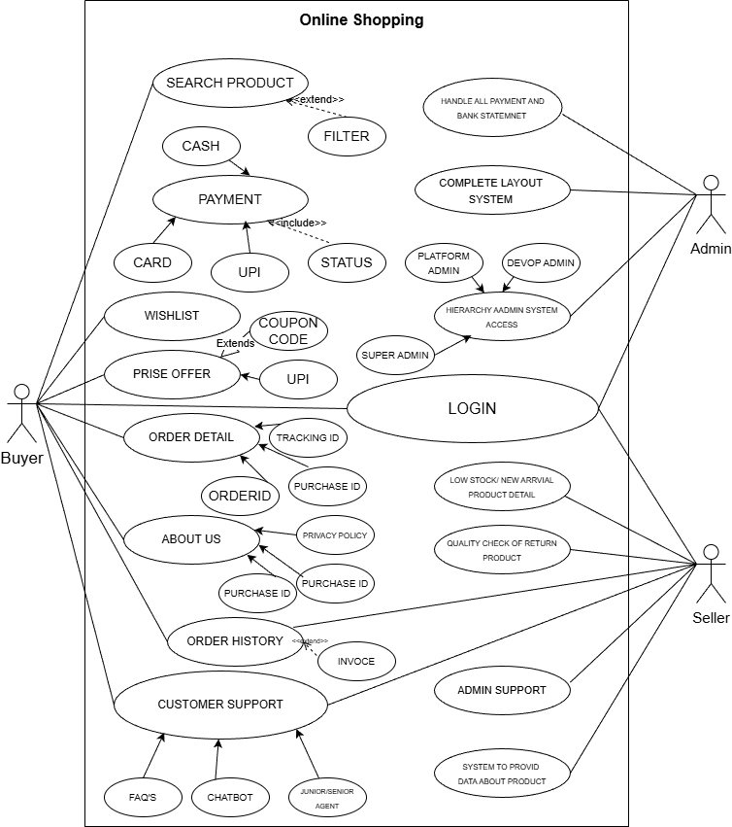

Figure 2.1-1 Use case diagram for Online Shopping system

Activity diagram and Swimlane diagram

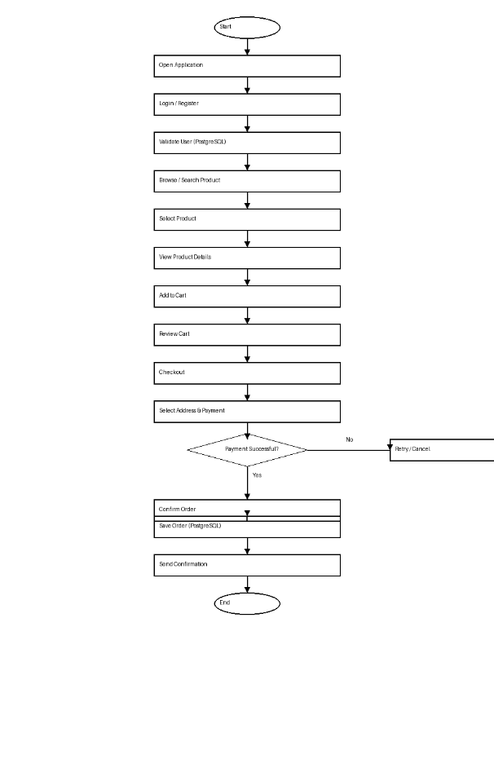c+-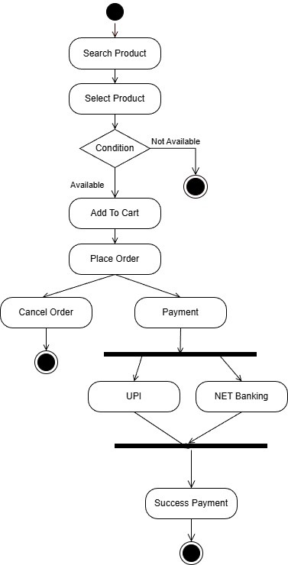
Figure 2.2-1 Activity diagram for Book Issue

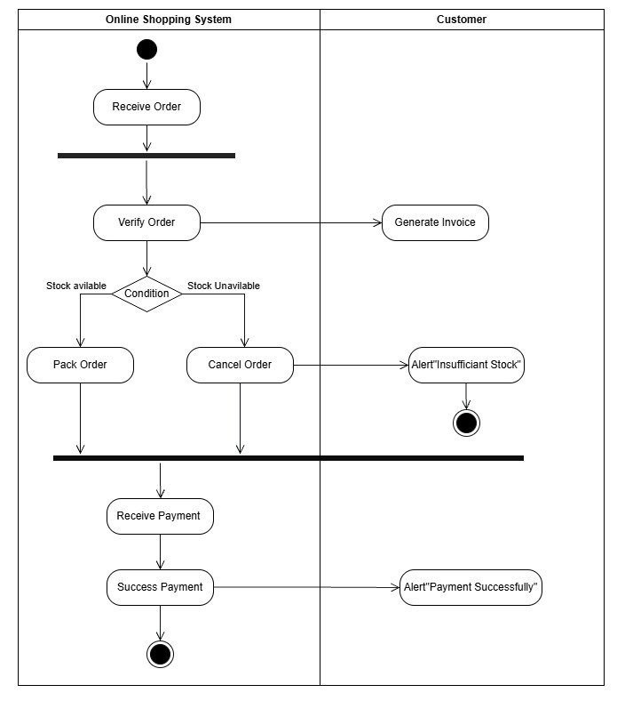
Figure 2.2-2 Swimlane diagram for Book Issue

Sequence diagram

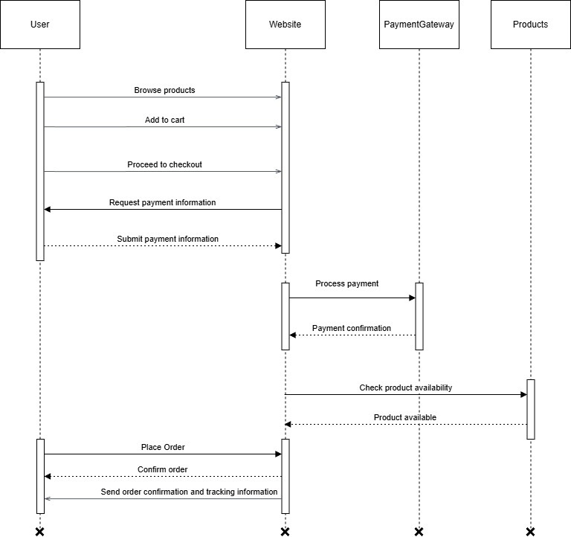
Figure 2.3-1 Sequence diagram for Book Issue

State diagram

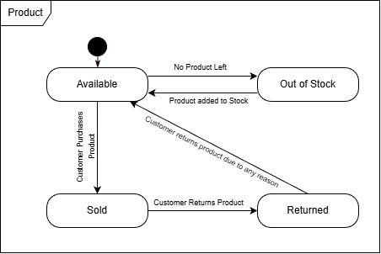
Figure 2.4-1 State diagram of Book

Figure 2.4-2 State diagram for Librarian

Class diagram

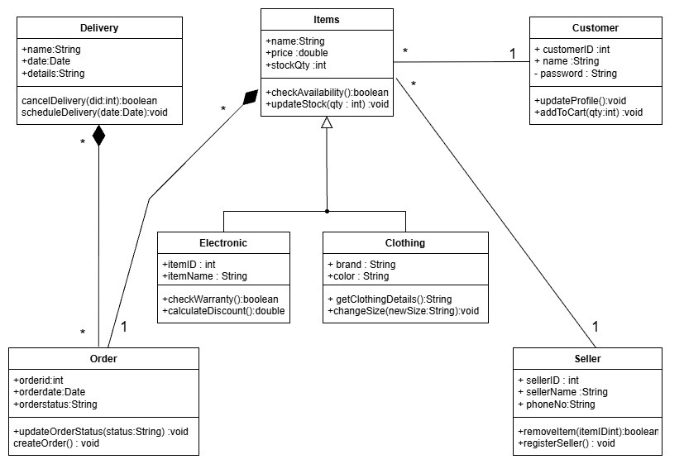
Figure 2.5-1 Class diagram for Library management system
9

Data flow diagram

Context diagram (level-0)
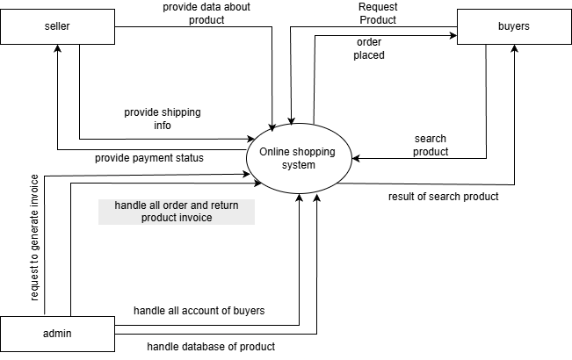
Figure 2.6-1 Context diagram for Library management system
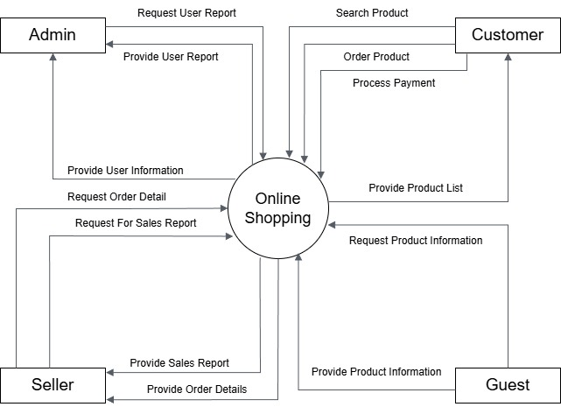

DFD Level-1
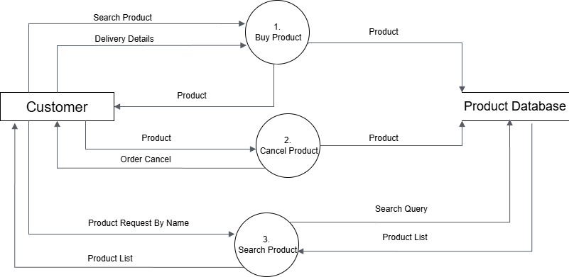
Figure 2.6-2 DFD level-1 for Library management system

DFD Level-2
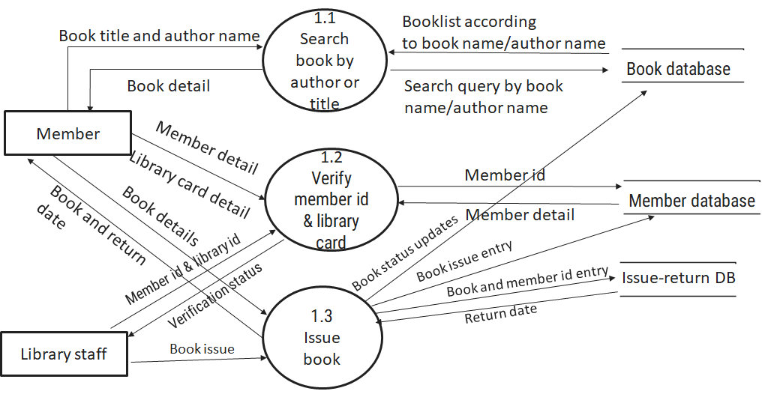
Figure 2.6-3 DFD level-2 for Issue book

External interface requirement (Screens)

Screen-1: Registration Form
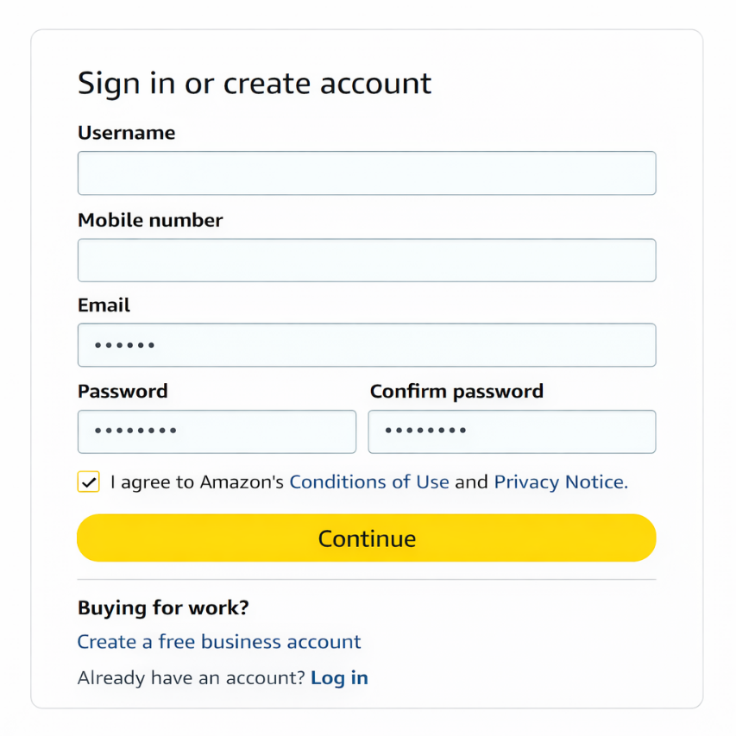
Figure 3.1-1 Screen-1: Registration Form

Purpose: This form will allow the target end-users to register in the system. To register , the following information will be encoded in the system.

Table 3.1-1 Screen element of Registration form
Sr. | Screen Element | Input Type | O/M | 1/N | Description
1 | Username | Textbox | M | 1 | Username field should be editable and accept a valid username for the online shopping account.
2 | Email | Textbox | M | 1 | Email field should be editable and accept the email in proper format for communication and login.
3 | Mobile number | Textbox | M | 1 | Mobile number field should be editable and accept a valid mobile number for user contact and verification.
4 | password | Password | M | 1 | Password field should be editable and accept the password and display as star or dot.
5 | Confirm Password | Password | M | 1 | Confirm password field should be editable and must match the entered password.
6 | I agree to the terms and conditions | Checkbox | M | 1 | Checkbox for accepting terms and conditions of the online shopping system.
7 | Already have an account? Login | Link | ------ | ------ | Link to navigate to the login page for existing users.
8 | Register | Button | ------ | ------ | Register is a button for store the entered data into database.

Screen-2: Online Shopping Dashboard

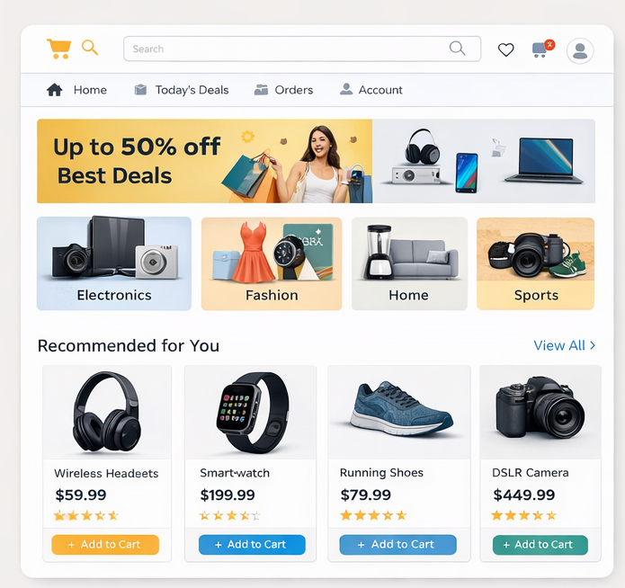
Figure 3.2-1: Screen-2 – Online Shopping Dashboard

Purpose: This screen represents the Dashboard of the Online Shopping System. It allows users to browse different product categories, view ongoing offers, check recommended products, manage orders, and access account-related features. The dashboard serves as the main landing page after successful login and provides quick access to shopping functionalities.
Table 3.2-1 Screen Elements of Online Shopping Dashboard

Sr. | Screen Element | Input Type | O/M | 1/N | Description
1 | Search Bar | Textbox | M | 1 | Allows users to search products by name, category, or keyword.
2 | Product Categories | Button/ Card | M | N | Displays different product genres such as Electronics, Fashion, Home, and Sports for easy navigation.
3 | Offers Banner | Image / Banner | O | 1 | Displays ongoing discounts, deals, and promotional offers.
4 | Product Price | Label | M | 1 | Displays the price of each product listed on the dashboard.
5 | Recommended Products | Card View | O | N | Shows recommended products based on user preferences and browsing history.
6 | Add to Cart | Button | M | N | Allows users to add selected products to the shopping cart.
7 | Orders | Link | O | 1 | Navigates the user to the order history and current orders page.
8 | Account | Link | O | 1 | Provides access to user profile, address, and account settings.
9 | View All Products | Link | O | 1 | Navigates to the complete product listing page.

Screen-3: Cart

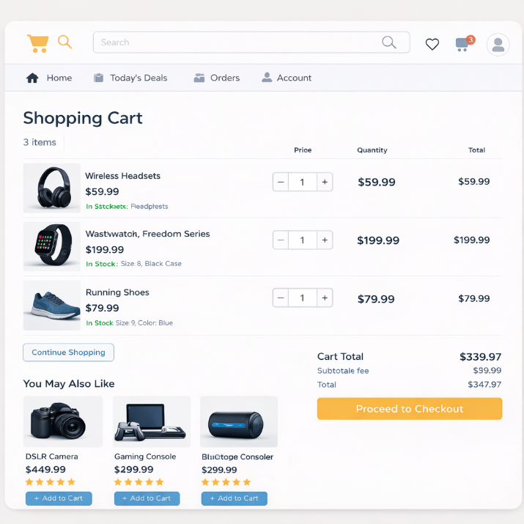
Figure 3.3-1 Screen-3: Add borrower book

Purpose The Cart Page module allows the buyer to review selected products before checkout. The user can update product quantities, remove items, view pricing details including subtotal and total amount, and proceed to the checkout process. This module ensures accurate order calculation and provides the final confirmation step before payment.
Table 3.3-1 Screen element of Add borrower book
Sr. | Screen Element | Input Type | O/M | 1/N | Description
1 | Page Title (Shopping Cart) | Label | M | 1 | Displays the title of the page.
2 | Product Image | Image | M | N | Displays image of each product added to cart.
3 | Product Name | Label | M | N | Displays name of the product.
4 | Product Price | Label | M | N | Displays price of individual product.
5 | Stock Status | Label | M | N | Shows availability status (In Stock / Out of Stock).
6 | Quantity Selector | Numeric Stepper (+ / -) | M | N | Allows user to increase or decrease product quantity.
7 | Remove Item | Button | O | N | Removes selected product from cart.
8 | Subtotal | Label | M | 1 | Displays total cost of all products before tax/shipping.
9 | Shipping Charges | Label | O | 1 | Displays delivery fee (if applicable).
10 | Discount | Label | O | 1 | Displays applied discount amount.
11 | Total Amount | Label | M | 1 | Displays final payable amount.
12 | Continue Shopping | Button | O | 1 | Redirects user back to product listing page.
13 | Proceed to Checkout | Button | M | 1 | Redirects user to checkout page.

Screen-4: Product Detail Page

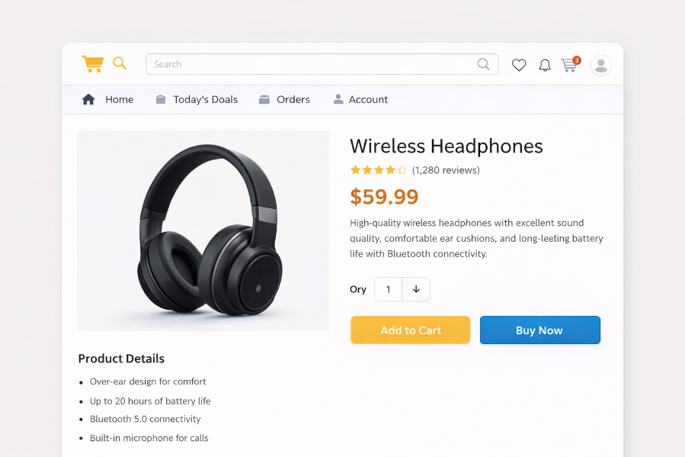
Figure 3.3-1 Screen-3: Add borrower book

Purpose This module allows the system administrator (or seller) to add, edit, update, or delete product details. The admin can manage product information such as pricing, stock, description, and category.

Table 3.3-1 Screen element of Add borrower book
Sr. | Screen Element | Input Type | O/M | 1/N | Description
1 | Product ID | Textbox | M | 1 | Product ID field should be auto-generated and uniquely identify each product.
2 | Product Name | Textbox | M | 1 | Product Name field should be editable and accept string values only.
3 | Category | Dropdown | M | 1 | Category field should allow selection from predefined product categories.
4 | Brand | Textbox | O | 1 | Brand field should accept string values representing product brand.
5 | Price | Textbox | M | 1 | Price field should accept numeric values only and must be greater than zero.
6 | Discount (%) | Textbox | O | 1 | Discount field should accept numeric percentage values (0–100).
7 | Stock Quantity | Textbox | M | 1 | Stock field should accept numeric values and update product availability status.
8 | Product Description | Textarea | M | 1 | Description field should allow detailed product information.
9 | Product Images | File Upload | M | N | Allows uploading one or more product images.
10 | Add to Cart | Button | --- | --- | Adds the selected product to the customer cart.
11 | Buy now | Button | --- | --- | Directly proceeds to checkout process.

Screen-4: Product Detail Page

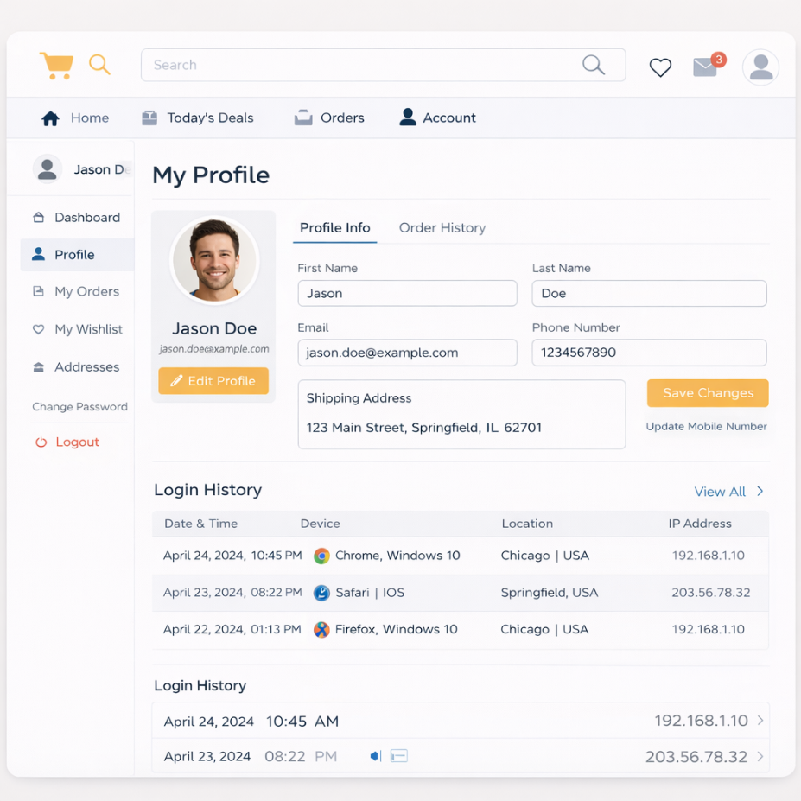
Figure 3.3-1 Screen-3: Add borrower book

Purpose
The User Profile Page allows the registered user to view and manage personal account information. This module enables users to update their profile details, manage shipping addresses, view order history, monitor login activity, and maintain account security settings. It ensures accurate user data management and enhances account security and personalization.

Table 3.3-1 Screen element of Add borrower book
Sr. | Screen Element | Input Type | O/M | 1/N | Description
1 | Page Title (My Profile) | Label | M | 1 | Displays the profile page title.
2 | Profile Picture | Image Upload | O | 1 | Allows user to upload or update profile image.
3 | First Name | Textbox | M | 1 | Editable field to update user first name. Accepts only alphabets.
4 | Last Name | Textbox | M | 1 | Editable field to update user last name. Accepts only alphabets.
5 | Email | Textbox | M | 1 | Displays registered email (editable based on system policy).
6 | Phone Number | Textbox | M | 1 | Accepts valid 10-digit mobile number.
7 | Shipping Address | Textarea | M | N | Allows user to add or update delivery address.
8 | Save Changes | Button | M | 1 | Saves updated profile information to database.
9 | Edit Profile | Button | O | 1 | Enables editing mode for profile details.
10 | Order History Tab | Tab Button | M | 1 | Displays previous orders placed by the user.
11 | Login History Section | Display Table | O | N | Shows previous login records (date, device, location, IP).

Database design

List of Tables
- User
- Admin
- Category
- Product
- Cart
- Order
- Payment

Table 4.1-1 Table: User
Column | Data Type | Null | Keys & Constrains | Default Value & Description
UserID | int | NN | PK (Auto Increment) | Unique user ID
FirstName | varchar(100) | NN | — | User first name
LastName | varchar(100) | NN | — | User last name
Email | varchar(150) | NN | Unique | User email address
Password | varchar(255) | NN | — | Encrypted password
Contact | varchar(10) | NN | — | 10-digit mobile number
Address | varchar(255) | AN | — | Shipping address
CreatedAt | DateTime | NN | — | Account creation date

Table 4.1-2 Table: Admin
Column | Data Type | Null | Keys & Constrains | Default Value & Description
AdminID | int | NN | PK (Auto Increment) | Unique admin ID
AdminName | varchar(100) | NN | — | Admin name
Email | varchar(150) | NN | Unique | Admin email
Password | varchar(255) | NN | — | Encrypted password

Table 4.1-3 Table: category
Column | Data Type | Null | Keys & Constrains | Default Value & Description
CategoryID | int | NN | PK (Auto Increment) | Unique category ID
CategoryName | varchar(100) | NN | — | Product category name

Table 4.1-4 Table: Product
Column | Data Type | Null | Keys & Constrains | Default Value & Description
ProductID | int | NN | PK (Auto Increment) | Unique product ID
ProductName | varchar(150) | NN | — | Product name
CategoryID | int | NN | FK | Reference of Category Table
Price | decimal(10,2) | NN | — | Product price
StockQuantity | int | NN | — | Available stock
Description | text | AN | — | Product details
ImageURL | varchar(255) | AN | — | Product image path
CreatedBy | int | NN | FK | Reference of Admin Table

Table 4.1-5 Table: Cart
Column | Data Type | Null | Keys & Constraints | Default Value & Description
CartID | int | NN | PK (Auto Increment) | Unique cart ID
UserID | int | NN | FK | Reference of User Table
ProductID | int | NN | FK | Reference of Product Table
Quantity | int | NN | — | Number of products added

Table 4.1-6 Table: Order
Column | Data Type | Null | Keys & Constraints | Default Value & Description
OrderID | int | NN | PK (Auto Increment) | Unique order ID
UserID | int | NN | FK | Reference of User Table
OrderDate | DateTime | NN | — | Date of order
TotalAmount | decimal(10,2) | NN | — | Total order amount
Status | varchar(50) | NN | — | Order status (Pending/Shipped/Delivered/Cancelled)

Table 4.1-7 Table: Payment
Column | Data Type | Null | Keys & Constraints | Default Value & Description
PaymentID | int | NN | PK (Auto Increment) | Unique payment ID
OrderID | int | NN | FK | Reference of Order Table
PaymentMethod | varchar(50) | NN | — | UPI / Card / NetBanking / COD
PaymentStatus | varchar(50) | NN | — | Success / Failed / Pending
PaymentDate | DateTime | AN | — | Date of payment

Stories and Scenario

Story-1: Add New Book in Library Catalogue

Story # S1 | : | As a Librarian,  I want to add a new book in library catalogue  So that everyone can easily find and borrow it.
Priority | : | High
Estimate | : | XL
Reason | : | The addition of a new book to the library catalogue is crucial for ensuring that the library's collection is up-to-date and accessible to everyone.

Scenario# S1.1
Scenario# S1.1 | : | Adding a New Book with Valid Information
Prerequisite | : | Librarian is logged in to the Library management system.
Acceptance Criteria | : | Given: The Librarian is navigated to the library catalog management page. Valid book information, including title, author, ISBN, and other relevant details is added.  When:  The librarian selects the "Add New Book" option  And The librarian enters valid book details  The librarian clicks the "Save" button to add the book to the catalog.  Then the system successfully adds the book to the catalog and the librarian receives a confirmation message with the book's identification number.

Scenario# S1.2
Scenario# S1.2 | : | Adding a New Book with Invalid Information.
Prerequisite | : | The librarian is logged into the library management system.
Acceptance Criteria | : | Given: The librarian is on the library catalogue management page  When: The librarian selects the "Add New Book" option and the librarian enters an incomplete or incorrect book details and librarian clicks the "Save" button to add the book to the catalogue.  Then the system displays error messages for the incorrect or missing information and the book is not added to the catalogue.

Scenario# S1.3
Scenario# S1.3 | : | Attempting to Add a Duplicate Book
Prerequisite | : | The librarian is logged into the library management system and the librarian is on the library catalogue management page
Acceptance Criteria | : | Given: The book information, including title, author, ISBN, and other relevant details, is available and the book with the same ISBN is already in the catalogue.  When: User Clicks on “Add book” button. Enter a number of copies with the same book detail mentioned in the field.  Then: Generate unique book id, barcode and spine label for various book of same title.

Story-2: Search Book
Story # S2 | : | As a Librarian or member,  I want to search for books by title, author, or keyword,  So that I can quickly find books that match my interests.
Priority | : | High
Estimate | : | M
Reason | : | Implementing a search functionality is essential for enhancing the user experience, as it allows librarian and member to efficiently discover and access the library's resources.

Story-3: Manage due date for borrowed book
Story # S3 | : | As Librarian,  I want to manage due dates for borrowed books  So that I can ensure that books are returned on time and avoid overdue fines.
Priority | : | High
Estimate | : | M
Reason | : | Proper due date management is crucial for maintaining the library's collection and ensuring that books are available for all members.

Story-4: Renew book
Story # S3 | : | As Librarian,  I want to renew a book that I have borrowed  So that I can extend my borrowing period if needed.
Priority | : | Medium
Estimate | : | M
Reason | : | Book renewal functionality is a convenience feature for librarian, allowing them to keep a book for an extended period if no one else has requested it.

Story-5: Generate a report on book usage and availability
Story # S3 | : | As Librarian,  I want to generate reports on library usage and book availability  So that I can make informed decisions about library’s books.
Priority | : | Medium
Estimate | : | L
Reason | : | Reporting functionality helps librarians track the usage of library resources and make data-driven decisions to improve services and collections.

Test cases
Project Name: | EMI Calculator | Test Designed by: | P. U. Jadeja
Module Name: | Login | Test Designed date: | 01-10-2023
Release Version: | 1.0 | Test Executed by: | R. B. Gondaliya
 |  | Test Execution date: | 15-01-2023

Pre-condition: Web application should be accessible
Test Case ID | Test Title | Test Type | Description | Test Case ID
TC_001 | Login to web application with valid credential | Functional | Login to Library management system web application through valid credential | TC_001
TC_002 | Login to web application with invalid credential | Functional | Login to Library management system web application through invalid credential | TC_002
TC_003 | Varify login page elements | GUI | varify that all elements are availabe on login page | TC_003

Test Case Title | Login to web application with valid credential
Test Type | Functional
Test Priority | High
Pre-condition | Web application should be accessible

Test Step | Test Case Description | Expected Result | Actual Result | Status | Comment | Data | BUG ID
1 | Access Web application URL | The site launched properly | Site launched successfully | Pass |  | https://accounts.google.com/ServiceLogin
2 | Enter valid Username in username field | Username field should be editable and accept the Username | Username input accepted | Pass |  | Username:  Rbgondaliya@gmail.com
3 | Enter valid Password in Password field | Password field should be editable and accept the password and display as star or dot | Password input displayed in dot and accepted | pass |  | Password:  rbgondaliya
4 | Enter valid captcha code in captch field | Captch field should editable and accept captcha and captcha is case sensitive | Captcha input accepted | Pass | Step required when human action validation perform | get captcha from image which is near by captcha field
5 | Click on login button | User should login into site and navigated to dashboard | User navigated to dashboard and username should br display in top of the right side. | pass

Test Case Title | Login to web application with invalid credential
Test Type | Functional
Test Priority | Medium
Pre-condition | Web application should be accessible

Test Step | Test Case Description | Expected Result | Actual Result | Status | Comment | Data | Bug ID
1 | Verify that User is not able to Login with invalid Username and invalid Password | Should be display an error message enter wrong username or password | Display an error of wrong username and password | Pass
2 | Verify that User is not able to Login with Valid Username and invalid Password | Should be display an error message enter wrong password | Display an error of wrong password | Pass
3 | Verify that User is not able to Login with invalid Username and Valid Password | Should be display an error message User not found | Display an error Username not found | Pass
4 | Verify that User is not able to Login with blank Username or Password | Set required field validation message for Username and Password | Display an error of wrong username and password | Fail | Not performa a validation function fix it |  | Bug_002

Test Case Title | Varify login page elements
Test Type | GUI
Test Priority | Medium
Pre-condition | Web application should be accessible

Test Step | Test Case Description | Expected Result | Actual Result | Status | Comment | Data | Bug ID
1 | Launch application with the given url | The site launched properly | Site launched successfully | Pass |  | https://accounts.google.com/ServiceLogin
2 | Verify that the login screen contains elements such as Username, Password, Sign in button, Remember password check box, Forgot password link, and Create an account link. | All listed control displayed properly on the page | Login page loaded successfully | Pass
3 | Verify that cursor is focused on “Username” text box on the page load | Cursor is focused in Username textbox | Cursor focus in Username textbox | Pass
4 | Verify that tab functionality is working properly or not | When tab pressed cursor move in next control | Cursor moving in next control | Pass
5 | Verify that all the fields such as Username, Password has a valid placeholder | All text fields have proper placeholder | All text fields have proper placeholder | Pass
6 | Verify that the labels float upward when the text field is in focus or filled (In case of floating label) | When field is focused or filled, label display on top of the filled | When field is focus or filled, label display on top of the filled | Pass | step required when fields with floating label
7 | verify that forgot password link working properly | when click on forgot password load forgot passworg page | forgot password link not working | Fail

References

- http://www.w3schools.com/html/html_intro.asp
- https://www.w3schools.com/php/default.asp
- https://www.javatpoint.com/uml

