Project Plan

EventRaze



Industry Partner
Primary Instructor | Anjana Shah
Team Member | Diya Patel
Team Member | Jenil Shah
Team Member | Kalp Senghani
Team Member | Neel Kinariwala
Team Member | Leela Krishna Reddy
Team Member | Mathew Pollock

Document Revision History

Revision # | Date
v1.0 | October 07, 2024
v2.0 | February 02, 2025

Table of Contents

1. Executive Summary 4
2. Project Approvers, Reviews and Distribution List 4
3. Scope 5
4. Deliverables 5
5. Assumptions 6
6. Dependencies 6
7. Risk Management 7
8. Communication 9
9. Task Listing (WBS- Work Breakdown Structure) 10
10. Gantt Chart 10
11. Milestones 11
12. RAM – Responsibility Assignment Matrix 12
13. Approval 13

1. Executive Summary

The following describes the project to be executed.

Objective | The objective of the EventRaze project is to build an all-in-one event management platform. This platform will streamline event creation, user registration, secure payment processing, and feedback collection, catering to the needs of organizers, attendees, venue managers, and administrators. By automating processes, providing real-time analytics, and enhancing user engagement, EventRaze will offer a seamless experience for all stakeholders.
Corporate Goals Addressed | - Automation: Streamline event management tasks, such as scheduling and ticketing.  - Security: Provide robust security for payment processing and sensitive data.  - Scalability: Support events of varying sizes, from small to large.  - User Engagement: Enhance user interaction through personalized event recommendations and efficient feedback collection.
Planned Start Date | September 11, 2024
Planned End Date | March 27, 2025

2. Project Approvers, Reviews and Distribution List

Approvers, reviewers and distribution list

Project Role | Name | E-mail | Date

3. Scope

Define the sum total of all of its products and their requirements or features.

In Scope | Out of Scope
Event creation and management: Organizers can create, schedule, and manage events. | Chatbot for real-time event-related queries and support.
User registration and authentication: Secure login and user profile management. | Augmented reality (AR) experiences or virtual event spaces.
Secure payment processing for event tickets and registration fees. | Mobile app development (though optimized for mobile web browsers).
Admin functions: Managing users, approving events, and generating reports. | Live streaming functionality for events.
Feedback and recommendations system based on attendee preferences. | Deep third-party integrations (e.g., social media tools beyond basic sharing).
Venue management: Booking venues, checking availability, and coordinating logistics. | Real-time collaboration and editing tools for multi-user event creation.
Certificate generator for voluntary work. | Advanced marketing tools and integrations beyond event sharing.
Chatbot for real-time event-related queries and support. | Complex gamification or rewards systems.

4. Deliverables

This project will deliver the following.

Deliverable | Description
Event Management Platform | A comprehensive platform allowing organizers to create, schedule, and manage events seamlessly.
User Registration and Authentication | A secure module for attendees and organizers to register, log in, and manage their profiles.
Payment Processing System | A secure system enabling ticket purchasing and event registration payments with encryption protocols.
Admin Dashboard | An interface for administrators to manage users, approve events, and generate performance reports.
Feedback and Recommendations System | A module collecting attendee feedback and offering event suggestions based on preferences and behavior.
Venue Management System | Tools for booking and managing venues, including availability tracking and logistics coordination.
Certificate Generator | A feature for creating and issuing certificates to volunteers or event participants.
Chatbot Support | A chatbot system providing real-time support for event-related queries from attendees and organizers.

5. Assumptions

This project makes the following assumptions:

- Stable Internet Connectivity: The platform assumes that users (both organizers and attendees) will have stable internet access for browsing, registration, and payment processing.

- Availability of Payment Gateways: Payment processing will rely on the availability of third-party payment gateway services, which are assumed to remain operational and secure.

- User Competence: It is assumed that users (organizers, admins, and attendees) will have basic digital literacy to navigate the platform without extensive training.

- Legal Compliance: The project assumes compliance with local laws and regulations regarding data privacy, event hosting, and financial transactions.

- Adequate Resources: It is assumed that the required technical infrastructure, such as hosting servers and databases, will be available and sufficient to handle event traffic and user load.

6. Dependencies

The following are the internal and external dependencies that will have to be acknowledged and addressed;

Internal Dependencies:

- Development Team Availability: The project relies on the availability of the development team to implement the platform within the planned timeline.

- Database Management: Successful event management requires efficient and secure database management for storing user, event, and transaction data.

- Admin Support: The admin team must be available to manage user accounts, approve events, and monitor the system in real-time.

- System Testing: Quality Assurance (QA) teams are needed to conduct thorough testing of the platform before launch to ensure it meets all requirements.

External Dependencies:

- Third-Party Payment Gateway: The payment system relies on third-party providers (e.g., Stripe, PayPal) for secure transaction processing.

- Venue Providers: Collaboration with external venue providers to manage and update venue availability for organizers in real-time.

- Email Services: Reliable third-party email services for sending confirmations, notifications, and reminders to event attendees and organizers.

- Legal and Regulatory Compliance: The platform must comply with evolving data protection and event management regulations, which could affect implementation or require adjustments.

7. Risk Management

Potential Risk | Severity (H/M/L) | Likelihood (H/M/L) | Management Strategy
Data Breach | High | Medium | Implement robust encryption and security measures, conduct regular security audits, and comply with data protection regulations.
Technical Failures (e.g., server downtime) | High | Medium | Establish a reliable hosting service with redundancy, implement regular backups, and have a disaster recovery plan.
User Adoption Challenges | Medium | Medium | Provide training resources and support for users and conduct user feedback sessions to improve the platform's usability.
Payment Processing Issues | High | Low | Partner with reputable payment gateways, regularly test payment processes, and have contingency plans for payment failures.
Compliance with Legal Regulations | Medium | Medium | Stay updated on relevant regulations and engage legal counsel to ensure compliance throughout development.
Competition from Other Event Management Systems | Medium | High | Differentiate through unique features and superior user experience, conduct market research, and adapt marketing strategies accordingly.
Inadequate User Support | Medium | Medium | Develop a comprehensive support system, including FAQs, chatbots, and responsive customer service teams.

8. Communication

Reporting

The following reports will be produced;

Report | Audience | Frequency
Project Status Report | Project Team | Bi-Weekly
User Feedback Summary | Development Team | Monthly
Financial Report | Management, Investors | Quarterly
Risk Management Report | Project Team, Stakeholders | Monthly
Performance Metrics Report | Management, Event Organizers | After Each Event
Compliance Audit Report | Legal Team, Management | Annually

Meetings

The following meetings/communication will be established.

Meeting | Purpose | Attendees | Frequency
Scope Review Meeting | To discuss and refine the project scope | Project Team | As needed
Task Progress Meeting | To check on the progress of assigned tasks | Project Team | Weekly
Issue Resolution Meeting | To address any challenges or roadblocks encountered | Project Team | As needed
Planning Session | To plan for upcoming features and deliverables | Project Team | Bi-weekly

9. Task Listing (WBS- Work Breakdown Structure)
The following resource proposal template summarizes the resource hours committed to this project, upon final approval of this document.

Reference | Tasks | Duration | Dependency
A | Finalize Requirements and Scope | 1 week
B | Design Database Schema | 1 week | A
C | Develop Homepage UI | 1 week | B
D | User Registration and Login System | 1 week | C
E | Implement AJAX and jQuery for Forms | 1 week | D
F | Event Creation and Management Module | 1 week | E
G | Testing Event Listing and Filtering | 1 week | F
H | Deployment Setup | 1 week | G

10. Gantt Chart

Task | Start Date | End Date | Completed
Database Implementation | 2025-01-07 | 2025-01-14 | Yes
Backend API Development | 2025-01-10 | 2025-01-20 | Yes
Payment Gateway Integration | 2025-01-13 | 2025-01-22 | Yes
Backend Development | 2025-01-15 | 2025-01-27 | Yes
Frontend UI Implementation | 2025-01-18 | 2025-02-01 | Yes
Frontend-Backend Integration | 2025-01-23 | 2025-02-05 | No
Frontend Deployment | 2025-01-28 | 2025-01-12 | No
Unit Testing | 2025-02-04 | 2025-02-18 | No
Integration Testing | 2025-02-19 | 2025-02-25 | No
Security Testing | 2025-02-20 | 2025-03-05 | No
Final Review & Deployment | 2025-02-28 | 2025-03-27 | No
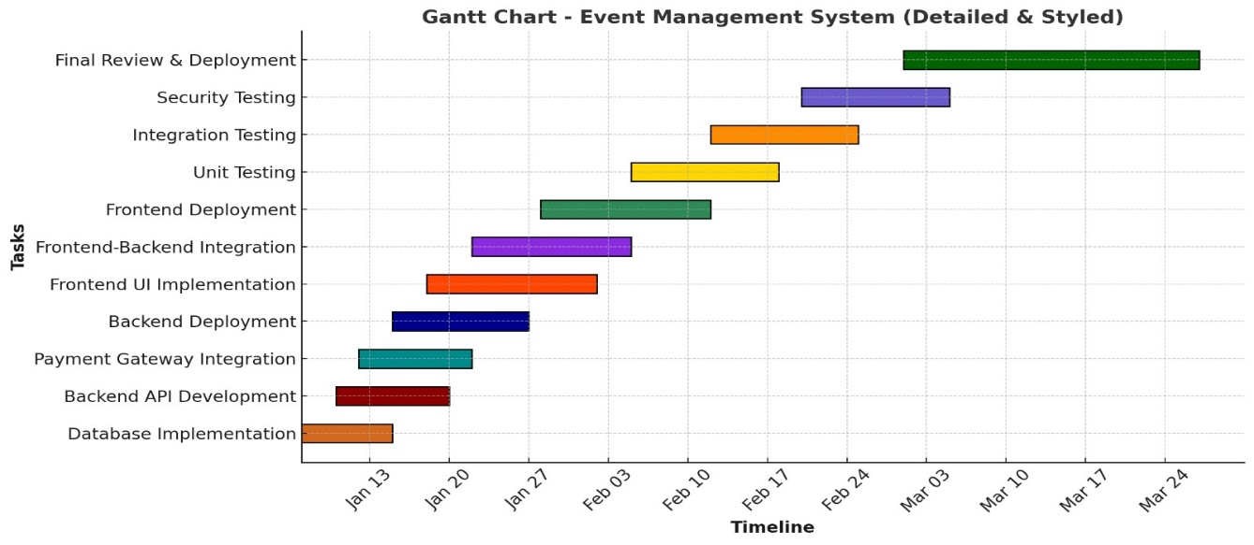

11. Milestones

Major Activity or Milestone | Estimated Milestone Target date | Owner/Reviewer Team Members
Design and finalize database schema (MySQL) | 02/02/2025 | Owner: Jenil Shah, Kalp Senghani  Reviewer: Diya Patel
Develop user interface for the homepage | 26/01/2025 | Owner: Diya Patel, Neel Kinariwala  Reviewer: Mathew Pollock
Create user registration and login system | 18/01/2025 | Owner: Mathew Pollock, Leela Krishna  Reviewer: Jenil Shah
Implement AJAX and jQuery for forms | 11/02/2025 | Owner: Diya Patel, Jenil Shah  Reviewer: Neel Kinariwala
Build event creation and management module | 20/02/2025 | Owner: Kalp Senghani, Mathew Pollock  Reviewer: Leela Krishna
Test event listing and filtering functionality | 03/03/2025 | Owner: Neel Kinariwala, Leela Krishna  Reviewer: Diya Patel
Deployment setup (XAMPP/WAMP/MAMP/LAMP) | 20/03/2025 | Owner: Entire Team  Reviewer: Kalp Senghani

12. RAM – Responsibility Assignment Matrix

Create a RAM from your Task Listing. A sample is shown below:

Project Name: EventRaze

Task | Kalp (P) | Diya (D) | Jenil (J) | Neel (N) | Mathew (M) | Leela (L)
Finalize Requirements and Scope | P | S | S | S | S | S
Design Database Schema | P | S | P | S | S | S
Develop Homepage UI | S | P | S | P | S | S
User Registration and Login System | S | S | P | S | P | S
Implement AJAX and jQuery for Forms | S | P | P | S | S | S
Event Creation and Management Module | P | S | S | S | P | S
Testing Event Listing and Filtering | S | S | S | P | S | P
Deployment Setup | P | S | S | S | S | S

13. Approval

The signatures below indicate their approval of the contents of this document.

Project Role | Name | Signature | Date
Project Coordinator | Senghani, Kalp | Kalp | 02/02/2024
Technical Lead | Patel, Diya | P.Diya | 02/02/2024
Frontend Developer | Kinariwala, Neel | Neel | 02/02/2024
Backend Developer | Shah, Jenil | Jenil | 02/02/2024
QA and Testing Coordinator | Mudiganti, Leelakrishna | L.K | 02/02/2024
Documentation Specialist | Pollock, Matthew | M.P | 02/02/2024

