EventRaze
High Level Requirements Document
Version 1.0
1st October, 2024

Project Identification

Project: | EventRaze (Event Management Web. App.)
Prepared By: | Shah, Jenil  Senghani, Kalp  Patel, Diya  Pollock, Matthew  Mudiganti, Leelakrishna  Kinariwala, Neel
Document Version: | 1.0
Published Date: | 10/01/2024

Contributors
The following individuals contributed to this document.
Name | Title
Patel, Diya | Requirements Scope Statements
Shah, Jenil | Business Context Diagram

Distribution
This document is distributed to all the following people.
Name | Title
Senghani, Kalp
Kinariwala, Neel
Mudiganti, Leelakrishna
Pollock, Matthew

Referenced Documents
This document refers to the following materials
Version number | Title | Author | Date | Source / Location
 |  |  | Tuesday, May 25, 2010 | https://moonchullee2.blogspot.com/2010/05/business-context-diagram.html

Revision History

Version Number | Revision Date | Summary of Changes | Modified by
[Note: It is recommended that drafts be numbered 0.1 to 0.9, and that the first approved version be numbered 1.0. Thereafter, new version numbers will depend upon changes: 1.01, 1.1, etc for minor updates, 2.0, 3.0 etc for major changes.]

TABLE OF CONTENTS
1. Business Context Diagram 4
2. Requirements Scope Statements 5
3. High Level Business Requirements Sign-Off 6

- Business Context Diagram
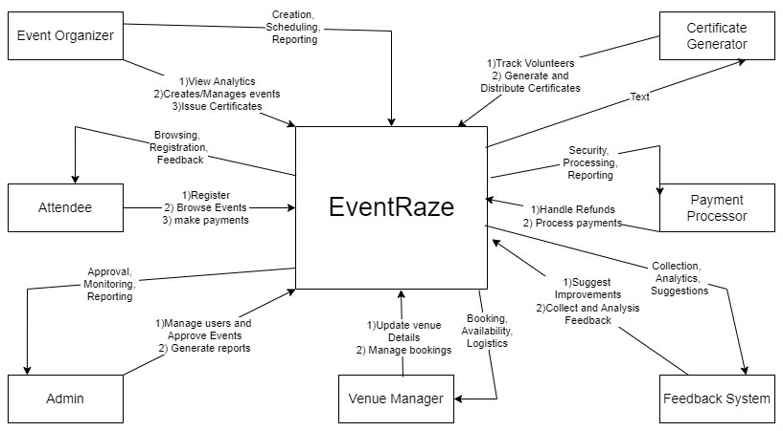

Requirement Scope Area | Description
Event Creation  and Management | The system should allow event organizers to create, edit, and manage events. This includes setting up event details such as name, description, date, time, location, and capacity.
Volunteer Management | The system should enable volunteers to register, select tasks, and coordinate with event organizers. It should also allow event organizers to track volunteer participation.
User Registration and Ticketing | Attendees should be able to register for events, make payments, and receive event tickets. The system should integrate with a payment gateway and provide email confirmations to users.
Payment Processing | The system should securely handle payment processing for event registrations and tickets. This should include integration with external payment processors and the ability to handle refunds.
Venue Management | The system should allow venue managers to input venue details, availability, and manage venue bookings. Event organizers should be able to select and book venues for events.
Feedback System | After events, attendees and volunteers should be able to submit feedback. The system should collect and analyze this feedback, providing reports to event organizers for future improvements.
Table 1.1

External Entity | Description
Attendee | Individuals who register for events, make payments, and provide feedback. They browse the system to find events and make reservations.
Event Organizer | Users who manage the creation and scheduling of events. They use the system to upload event details, monitor registrations, and handle logistics.
Volunteers | People who offer assistance during events. They sign up to help organize or manage various tasks during the event and coordinate through the system.
Payment Processor | Third-party systems or services (like PayPal or Stripe) that manage transactions for event ticketing or registration fees. They facilitate secure payments and refunds if needed.
Venue Manager | The external entity responsible for managing the availability and scheduling of venues. They interact with the system to confirm or adjust bookings.
Admin | The administrator of the system who oversees user accounts, event approvals, and the overall health of the system.

Information Flows | Description
Attendee | Attendees provide personal information (name, email, payment details) and receive event details, ticket confirmations, and updates through the system.  Input: User registration details, payment, feedback.  Output: Event confirmation emails, updates, payment receipts.
Event Organizer | Organizers input event details (name, date, venue, capacity) into the system. They receive reports on registrations, volunteer assignments, and event feedback.  - Input: Event creation information.  - Output: Registration reports, feedback summaries.
Volunteer | Volunteers input availability and task preferences, and they receive task assignments and event schedules from the system.  - Input: Availability, preferences.  - Output: Task assignments, event schedules.
Payment Processor | The system sends payment requests to the processor, and the processor sends payment confirmation or errors back to the system.  - Input: Payment details (from system to processor).  - Output: Payment confirmation or error (from processor to system).
Venue Manager | Venue managers provide availability and booking confirmations to the system.  - Input: Venue availability, venue booking confirmations.  - Output: Event booking updates, venue change notifications.
Admin | Admins input user approvals, event approvals, and manage system health. They receive system reports, user issues, and event performance data.  - Input: System configurations, user management.  - Output: Reports, user alerts, performance data.
- | -
- Requirements Scope Statements
HLR# | Description | Priority  (H, M, L)
 | -Event Creation and Management: The system should allow event organizers to create, edit, and delete events. The event data should include details like event name, description, date, time, venue, and capacity. | High
 | - Volunteer Management: The system should include a volunteer management feature where volunteers can register for events, track their tasks, and communicate with event organizers. | Medium
 | - User Registration and Ticketing: Users should be able to register for events, purchase tickets, and receive confirmation via email. This feature should also integrate with payment gateways. | High

- High Level Business Requirements Sign-Off
The undersigned acknowledge their agreement with the contents of Version 1.0 of the High-Level Requirements document for Event Raze.

Following approval of this document, requirements changes will be governed by the project’s change management process, including impact analysis and appropriate reviews and approvals, under the general control of the Project Plan and according to company policy. Approved Change Request Documents, if present, will be attached to this Requirements Document as updates.

Name | Project Role and  Functional Area | Date Signed
Shah, Jenil | Business Context Diagram | 10/02/2024
Senghani, Kalp | Project Vision Document | 10/02/2024
Patel, Diya | High Level Requirements | 10/02/2024
Kinariwala, Neel | User Stories | 10/02/2024
Pollock, Matthew | Editing and formatting word documents | 10/02/2024
Mudiganti, Leelakrishna | User Personas | 10/02/2024

* Note: physical signatures are not required. Email approvals are acceptable and should be appended to project documents.

