

MINOR PROJECT REPORT
AeroDex – Real-Time Airfare Price Index for India
Submitted in partial fulfilment of the Requirements for the award of
Degree of Master of Science in Data Science

Submitted By
Jenil Chiragbhai Soni (25MSC04008)
M.Sc. Data Science (Sem III)

Submitted To
Department of Data Science, School of Chemical and Industrial Science,
GSFC University, Vadodara, Gujarat

Faculty Mentor
Dr. Surabhi Pareek
Assistant Professor,
School of Chemical and Industrial Science, GSFC University, Vadodara, Gujarat

Date of Report Submission : 30 October 2026

ACKNOWLEDGEMENT
I would like to express my sincere gratitude to everyone who contributed to the successful completion of my minor project, “AeroDex – Real Time Airfare Price Index for India.” This project provided me with valuable practical experience in web scraping, flight data collection, data processing, airfare price analysis, and dashboard development. It also helped me understand how data-driven technologies can address real-world challenges in the aviation industry by providing insights into flight fares across different platforms.
I would like to extend my heartfelt gratitude to my faculty mentor, Dr. Surabhi Pareek, Assistant Professor, for her continuous guidance, valuable suggestions, and encouragement throughout the project. Her support and insights helped me strengthen my understanding of the concepts involved and improve the overall quality of the project.
I am also grateful to GSFC University for providing the academic support, resources, and learning environment necessary to undertake this project. Working on AeroDex allowed me to apply my knowledge of data science, web scraping, data analytics, and visualization to develop a practical solution for airfare data collection and price analysis.
Finally, I would like to thank everyone who directly or indirectly contributed to the successful completion of this project. Their support, encouragement, and assistance played an important role in making this project a valuable learning experience.
Sincerely,


Jenil Chiragbhai Soni
25MSC04008
M.Sc. Data Science Sem III
Department of Data Science, School of Chemical and Industrial Science,
GSFC University, Vadodara, Gujarat
Date: 30 October 2026

TABLE OF CONTENT

ACKNOWLEDGEMENT i
TABLE OF CONTENT ii
LIST OF FIGURES iii
Chapter 1: Introduction to Project 1
Chapter 2: Problem Statement 2
Chapter 3: Objectives of the Project 4
Chapter 4: Major Components of the Project 6
Chapter 5: Methodology Adopted to Carry Out the Project 8
Chapter 6: Tools and Technologies used 11
Chapter 7: Data on the Project 14
Chapter 8: Snapshots 17
Chapter 9: Observations 28
Chapter 10: Results and Discussions 30
Chapter 11: Conclusion & Future Scope 32
References 33
Curriculum Mapping 34
Usefulness of the Project 35

LIST OF FIGURES

Figure 8.1: Overall Architecture of JobLytix Platform 14
Figure 8.2: Automated Web Scraping of Job Data 15
Figure 8.3: Interactive Job Analytics Dashboard 16
Figure 8.4: Most In-Demand Skills Analysis 17
Figure 8.5: Resume Upload and ATS Analysis 18
Figure 8.6: Skill Extraction and Career Intelligence 19
Figure 8.7: Skill Gap Analysis 20
Figure 8.8: Career Recommendations and Learning Roadmap 21
Figure 8.9: Job Matching and ATS Comparison 22
Figure 8.10: Skill Gap Analysis and Recommendation System 23
Figure 8.11: Smart Job Filtering and Search Functionality 24

Chapter 1: Introduction to Project
Airfares vary constantly depending on many things, for example, the number of travelers, seasons, pre-booking period, competitive situation among the airlines, and price of fuel. It takes much time to compare the airfares from different places via different websites that specialize in travel services. Therefore, proper data gathering and analysis can help users analyze airfare variability and tendencies.
AeroDex: Real Time Airfare Price Index for India is a data analytics tool used to analyze the domestic airfares in real time. It works by collecting data regarding the flights using automatic web scraping from the supported flight search websites and travel websites. The collected data is analyzed to provide comparisons and price fluctuations regarding the same.
The portal comes with several options including Live Fare Verifier, National Airfare Price Index, Pricing Heatmaps, Forward Nowcast, Macroeconomic Alignment, and DGCA Route Basket. With the above-listed options, the user can explore the price of flights, investigate the differences in fares on a particular route, evaluate the future trends in the price of flights, and also compare the fluctuations in the price of flights with CPI/ATF prices.
A key component of AeroDex is its Laspeyres-style weighted price index, which represents airfare movements across selected domestic routes using route-level weights. The platform combines web scraping, data processing, statistical analysis, forecasting, and data visualization to convert flight-fare information into understandable insights.
The primary objective of AeroDex is to improve airfare transparency and demonstrate how data science can support flight-price monitoring and aviation market analysis in India. By integrating fare comparisons, index calculations, forecasting, and interactive visualizations, the project provides a unified platform for studying domestic airfare trends and price fluctuations.

Chapter 2 : Problem Statement
2.1 Problem Statement
The pricing of airfares in India is constantly fluctuating due to the changing levels of demand for travel from passengers, seasonal trends, pricing policies of airlines, and fuel prices. Yet, getting a comprehensive picture of the fluctuations in prices is difficult as information on flights and their fares is scattered all over various online travel agencies (OTAs) and search websites dedicated to flights. The manual gathering of the data on prices takes too much time and effort.
One other huge problem is the absence of a platform which offers analysis of domestic airfare movements using a price index. It could be that the individual ticket prices may not reflect the overall trends in the market, making it hard to analyze changes from one route to another. However, analyzing historical changes in airfares, comparing fares from different routes, detecting possible fare surges, and analyzing the relationship between airfare movements and economic indicators need proper data analysis.
To solve this problem, AeroDex – Real Time Airfare Price Index for India seeks to create a unified platform that will automatically gather flight-fare data from the specified sources via web scraping and convert the collected data into insights. The platform is designed to process the collected data, compare fares on chosen routes, calculate the weighted airfare price index, and deliver the results via the interactive dashboard. Additionally, some other features like fare verification, pricing heat maps, airfare forecasting, and comparison to the economic indices will be included in the system.
The suggested system is targeted at simplifying the process of airfare analysis and making it easier to get access to the flight-price information.

2.2 Key Problems Addressed
- Fragmented Data: Flight-fare information is distributed across multiple online platforms.
- Manual Comparison: Comparing prices across routes and airlines requires considerable time and effort.
- Limited Price Trend Analysis: Individual fares do not provide a comprehensive view of overall airfare movements.
- Lack of a Unified Index: A structured, weighted index is needed to represent price changes across selected domestic routes.
- Limited Forecasting and Visualization: Users need accessible tools to explore fare variations, projected trends, and relationships with economic indicators.
AeroDex addresses these challenges by integrating airfare data collection, index calculation, analytical processing, forecasting, and interactive visualization into a single platform.

Chapter 3 : Objectives of the Project

3.1 Main Objective
The primary objective of AeroDex – Real Time Airfare Price Index for India is to develop an integrated aviation analytics platform that collects, processes, analyzes, and visualizes domestic airfare data to monitor price fluctuations, identify trends, and provide meaningful insights into India's aviation market.
3.2 Specific Objectives
- Automated Data Collection: To collect flight-fare information from supported online travel agencies (OTAs) and flight-search platforms using web scraping techniques.
- Data Processing and Cleaning: To clean, organize, and transform the collected data into a structured format suitable for analysis.
- Airfare Price Comparison: To compare flight fares across selected domestic routes, airlines, and travel dates.
- Airfare Price Index Development: To calculate a Laspeyres-style weighted airfare price index to represent price movements across a selected basket of domestic routes.
- Fare Trend Analysis: To analyze airfare variations and identify potential price increases and fluctuations through historical data and visualizations.
- Interactive Dashboard Development: To develop a user-friendly dashboard that presents flight fares, route comparisons, pricing heatmaps, and analytical results.
- Airfare Forecasting: To incorporate forecasting techniques to examine potential future airfare trends based on available data.
- Economic Indicator Analysis: To examine airfare movements alongside selected economic indicators, such as the Consumer Price Index (CPI) and Aviation Turbine Fuel (ATF) prices.
- Fare Transparency: To make airfare information easier to explore and understand, supporting informed travel planning and aviation market analysis.

3.3 Expected Outcome
The expected outcome is a unified platform that combines automated data collection, airfare index calculation, trend analysis, forecasting, and interactive visualization. AeroDex aims to simplify airfare monitoring and provide a structured understanding of domestic flight-price movements in India.

Chapter 4 : Major Components of the Project

The AeroDex system is made up of different components that work together in order to gather, process, analyze, and visualize information on domestic airline fares. These different components perform certain functions that are essential towards realizing the main purpose of the system.
1. Web Scraping Automation
This feature gathers relevant data about flights from supported online travel agents (OTAs) and flight search engines via automation of web scraping. Information gathered could be an airline name, airport sources and destinations, departure dates, flights schedule, and prices. This approach is more convenient compared to collecting information manually.

2. Information Processing and Storage
Information processing part of this project helps organize gathered information for reliable analysis. The process includes data cleaning, normalization of records, missing value imputation, and structuring of information. Information storage part helps preserve gathered information for future analyses and visualizations.
3. Live Fare Verifier
With Live Fare Verifier, users can discover and analyze various options for flights and find out about their costs. It shows relevant data related to flights, such as airlines, flights' details, and costings. This component will help users to analyze options of flights and their costs.
4. National Airfare Price Index
National Airfare Price Index is one of the components which are used in the analysis process of AeroDex. This component uses the Laspeyres-type weighted price index to show changes in the airfare on the chosen set of domestic routes. Using route-level weighting, this index shows more informative results compared to individual fare indices.
6. Forward Nowcast
This component looks into the possible airfare trend movements in the future through forecasting methods and using the available data. Projected trends will be made to allow users to understand any possible changes in the cost of tickets. These predictions are dependent on the available data quality and forecasting method used.

7. Macroeconomic Alignment
This component compares the movements of the airfare index to some selected economic indicators. Selected economic indicators include the Consumer Price Index (CPI) and the Aviation Turbine Fuel (ATF) price. Users can use this component to analyze the correlation between the movement of the airfares and any economic movement.
8. DGCA Route Basket
DGCA Route Basket is the source of route level data used in airfare index analysis. Data sources include passenger weight and airline market share data when available.
9. Interactive Dashboard
Interactive dashboard becomes the main interface of AeroDex where all the components and their outputs are combined into one place. Users will be able to analyze flight prices, study changes in price-index values, compare different routes, and see heat maps and forecasts' output. The information is presented in form of charts, tables, indicators, etc., which makes it easier to comprehend.
Conclusion
The described components of the system are used in order to create an integrated analytics platform for airfare analysis. The combination of automatic data gathering, processing of the data, weighted index creation, forecasting and economic comparison allows us to provide a structured way to analyze domestic airfare changes in India.

Chapter 5: Methodology Adopted to Carry Out the Project

5.1 Introduction
The methodological framework used to develop AeroDex – Real Time Airfare Price Index for India involves the following steps in sequence: data collection, data preprocessing, data storage, data analysis, calculation of index, forecasting, and visualization. This project utilizes web scraping and data science approaches to derive insights from flight-fare data. The methodological framework aims to organize the airfare data, analyze the prices on selected domestic routes, and visualize the results using a web-based dashboard.

5.2 Requirement Analysis
This was the first phase that involved recognizing the objectives and requirements of the project. The main requirements of the project include collection of flight-fare data from supported websites, comparison of prices on selected routes, analysis of price fluctuations, calculation of airfare price index, and visualization of the results using a dashboard.
The process stuck to a structured plan: from spotting problems and gathering data to analytics, understanding resumes, and generating advice. Overall, the project shows how web scraping, data analysis, natural language processing, and web dev can tackle real-world career issues.

5.3 Data Gathering
The process of gathering data is executed by means of an automated web scraping technology that enables the extraction of flight-related data from various OTAs and flight search websites. Depending on the source, the gathered information may involve airlines, departure and destination airports, travel dates, times of flights, and available prices.

The gathered records constitute the base for further processing and analysis. The availability of data can differ by source and the accuracy of the results will depend on the completeness and currency of the gathered data.

5.4 Data Preprocessing
Raw data extracted from various sources is preprocessed to increase consistency and readiness for processing and analysis. This stage includes the examination of data formats, standardization of the fields, identification of duplicates and processing of missing and incorrect data. Dates, flight data, and prices are structured consistently wherever possible.
Preprocessing helps to decrease inconsistencies in the dataset.

5.5 Data Storage and Management
Data that has been preprocessed will be organized and stored via the implementation of the storage process by the project. Effective data management enables the software to retrieve flight data for analysis and dashboard presentations. In cases where data for past observation periods exists, the stored data can be used for comparisons and analyses of fare movements over time.

5.6 Airfare Analysis and Index Calculation
The data is then analyzed to compare fares on selected domestic routes and to evaluate differences in ticket fares. A Laspeyres price index is calculated to capture airfare movements on selected baskets of domestic routes. A route weight is applied in the process to capture changes in price levels in relation to a certain base period.
Such an approach captures more insight into airfare movements compared to analyzing the fares of individual flights. Interpretation of the index is based on the routes selected, weighting method, fares, and base period.
5.7 Forecasting and Economic Analysis
The approach involves the analysis of possible future airfare trends using forecasting methods and data. The forecasting part is based on the use of information in order to make predictions about possible future airfares trends.
The project also analyzes possible connections between airfare index movements and certain economic variables such as CPI and ATF price indices.

5.8 Data Visualization and Dashboard Development
The final results of the analysis are provided using an interactive online dashboard that includes such features as the Live Fare Verifier, National Airfare Price Index, Pricing Heatmaps, Forward Nowcast, Macroeconomic Alignment, and DGCA Route Basket.
Charts, tables, summary indicators and other visualization tools allow users to analyze airfares of flights, compare routes, understand changes in prices and interpret analysis results.
5.9 Testing and Validation
Testing of the developed system will ensure that data collection, preprocessing, computations, and dashboards operate as expected. The validation process will entail analyzing the consistency of the collected data, index computations, values presented, and verification that visualizations represent the data correctly. The forecasts generated will have to be evaluated with the help of the data available and the constraints of the adopted technique.

5.10 Conclusion
The approach used in developing AeroDex encompasses data collection, data preprocessing, data storage, statistical analysis, index computation using weights, forecasting, and visualization. The combination of these processes makes it possible to turn flight fare data into analytical results. The final platform represents a systematic way of analyzing changes in airfare rates and domestic flight prices in India.

Chapter 6: Tools and Technologies used

6.1 Introduction
The development of AeroDex – Real Time Airfare Price Index for India involves various programming languages, libraries, database technologies, and development tools. These technologies work together to support automated flight-data collection, data processing, airfare index calculations, forecasting, and interactive dashboard development. The selection of these tools enables the project to integrate web scraping and data science techniques into a unified aviation analytics platform.
6.2 Programming Language
- Python: Python is the primary programming language used in AeroDex. It supports web scraping, data processing, statistical calculations, database operations, and forecasting. Its extensive library ecosystem makes it suitable for implementing the project's data collection and analytical components.
6.3 Web Scraping Technologies
- Playwright: Playwright is used for browser automation and extracting flight-related information from supported online travel platforms. It can interact with dynamic web pages, navigate flight-search interfaces, and retrieve information displayed through browser-based applications.
- Requests: The Requests library supports HTTP communication and retrieving information from web services. It can be used to access supported online resources and obtain data required by the application.
- RobotGuard and urllib.robotparser: These technologies support the project's web-scraping compliance process by checking website crawling rules and helping determine whether particular paths are permitted for automated access.
6.4 Machine Learning and Data Analysis
- Scikit-learn: Scikit-learn provides machine learning tools for developing forecasting models and performing analytical tasks. In AeroDex, it supports the machine-learning functionality associated with predicting potential airfare movements.
- NumPy: NumPy supports numerical computations and array-based operations. It helps perform mathematical calculations required for data analysis and airfare index processing.
- Joblib: Joblib is used to save and load trained machine-learning models. It enables the application to reuse a previously trained forecasting model without retraining it for every prediction.
6.5 Database Management
- SQLite: SQLite is used for storing and managing structured flight-related information. It provides a lightweight database solution that supports data retrieval, record management, and access to information required by the application.
The database supports the storage and retrieval of information used in fare comparisons, historical analysis, index calculations, and dashboard presentation.
6.6 Backend and API Development
- Python HTTP Server: The project uses Python's built-in HTTP server functionality to handle web requests and serve the dashboard. The server coordinates application components and provides endpoints for retrieving flight information and analytical results.
- REST APIs: API endpoints enable communication between the application interface and backend functionality. They support the exchange of flight-search results, airfare information, and other analytical outputs.
6.7 Frontend Technologies
- HTML: HTML provides the structural foundation of the web interface, organizing content such as navigation sections, information panels, tables, and dashboard elements.
- CSS: CSS is used to style the interface, including layouts, typography, spacing, colors, and responsive elements. It helps create a consistent and user-friendly dashboard.
- JavaScript: JavaScript supports client-side interactions and dynamic updates. It helps retrieve information from backend endpoints and display flight details, charts, and other analytical results within the dashboard.

6.8 Artificial Intelligence Integration
- Google Gemini API: The project includes optional integration with Google's Gemini AI services through the Google GenAI SDK. This integration supports selected AI-assisted analytical functionality, depending on configuration and API availability.
6.9 Development and Version Control Tools
- Visual Studio Code: Visual Studio Code provides an environment for writing, editing, debugging, and managing the project's source code.
- Git and GitHub: Git supports source-code version control, while GitHub provides a platform for hosting the project repository, tracking code changes, and collaborating on development.
6.10 Conclusion
AeroDex combines Python, Playwright, Scikit-learn, NumPy, Joblib, SQLite, and web technologies to implement its major functionalities. These tools support automated data collection, structured data management, airfare index calculation, forecasting, and interactive visualization. Together, they provide the technical foundation for developing an integrated platform to monitor and analyze domestic airfare movements in India.

Chapter 7 : Data on the Project

7.1 Introduction
Data is the foundation of AeroDex – Real Time Airfare Price Index for India. The project uses flight-fare information, route-level statistics, airline market-share information, and economic indicators to analyze domestic airfare movements. These datasets are collected from supported online sources or maintained as reference datasets and are processed to generate price comparisons, airfare index values, forecasting outputs, and dashboard visualizations.

7.2 Types and Sources of Data
The project uses the following major categories of data:
1. Flight-Fare Data: Flight-related information is collected from supported airline websites and online travel platforms, including Google Flights, EaseMyTrip, Cleartrip, and SpiceJet. Depending on availability, the data may contain airline names, departure and destination airports, travel dates, flight timings, and ticket prices.

2. DGCA Route Data: Route-level passenger weights and aviation statistics are used to support the construction of the airfare index. These reference datasets help represent the relative importance of selected domestic routes in the overall analysis.

3. Airline Market-Share Data: Airline market-share information provides additional context for comparing airfare movements across carriers and calculating weighted indicators where applicable.

4. Economic Data: The project includes Consumer Price Index (CPI) airfare-related data and Aviation Turbine Fuel (ATF) price information. These datasets support comparisons between airfare movements and selected economic indicators.

5. Forecasting Data: Historical and available fare observations, along with relevant model inputs, support the forecasting component. The system may also use fallback or benchmark estimates when live data cannot be retrieved; such estimates should be distinguished from actual scraped fares.

7.3 Data Attributes
The main attributes used in the project may include:
- Flight Information: Airline name, flight details, departure airport, destination airport, and travel date.
- Fare Information: Available ticket price and fare components, such as base fare, fuel surcharge, airport charges, and applicable taxes where available.
- Route Information: Route identifiers, passenger weights, and other relevant route-level statistics.
- Time Information: Collection timestamps and travel or observation dates used for comparisons.
- Economic Indicators: CPI airfare observations and ATF prices.
- Forecasting Information: Historical observations, estimated values, and projected airfare trends.
The availability of individual attributes depends on the data source and the records retrieved.

7.4 Data Storage and Processing
AeroDex uses an SQLite database to store and manage flight-related records. Supporting datasets are also maintained in structured formats, including CSV and JSON files. These formats help organize route weights, airline market shares, fuel prices, and CPI-related information.
The collected data is processed to improve consistency and suitability for analysis. The process includes standardizing fields, checking records for missing or invalid values, identifying duplicate entries, and organizing fare observations for comparison. Data timestamps and source information are important for understanding whether a displayed fare represents a live observation or a fallback estimate.

7.5 Application of Data in AeroDex
The processed data supports the major analytical features of the project. Flight-fare records enable route-wise price comparisons, while route weights support the calculation of a Laspeyres-style weighted airfare price index. Historical observations support trend analysis and forecasting, whereas CPI and ATF datasets provide an economic context for interpreting airfare changes.
The resulting information is presented through the interactive dashboard using tables, charts, pricing heatmaps, index indicators, and forecasting visualizations.

7.6 Conclusion
The project combines flight-fare observations, route-level reference data, airline market-share information, and economic indicators to study domestic airfare movements in India. By organizing and analyzing these different data sources, AeroDex provides a structured approach to airfare comparison, weighted index calculation, trend analysis, and forecasting. The reliability of its findings depends on data quality, source availability, collection frequency, and the distinction between actual observations and estimated values.

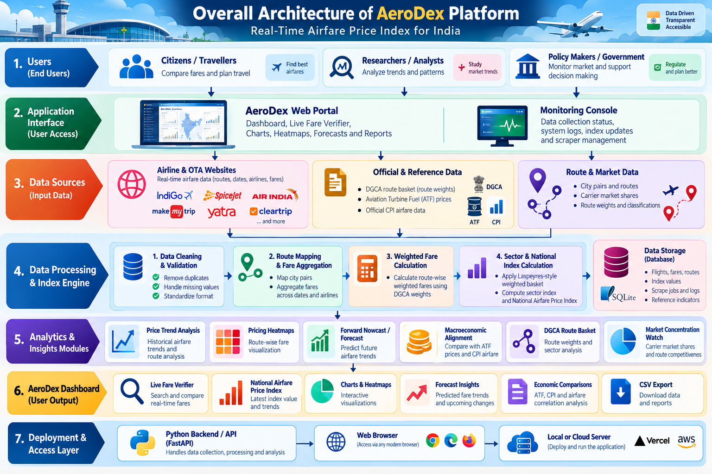
Chapter 8: Snapshots

Figure 8.1: Overall Architecture of AeroDex Platform
- This figure illustrates the AeroDex architecture, showing data collection, processing, storage, analytics, machine learning, and user interface layers.

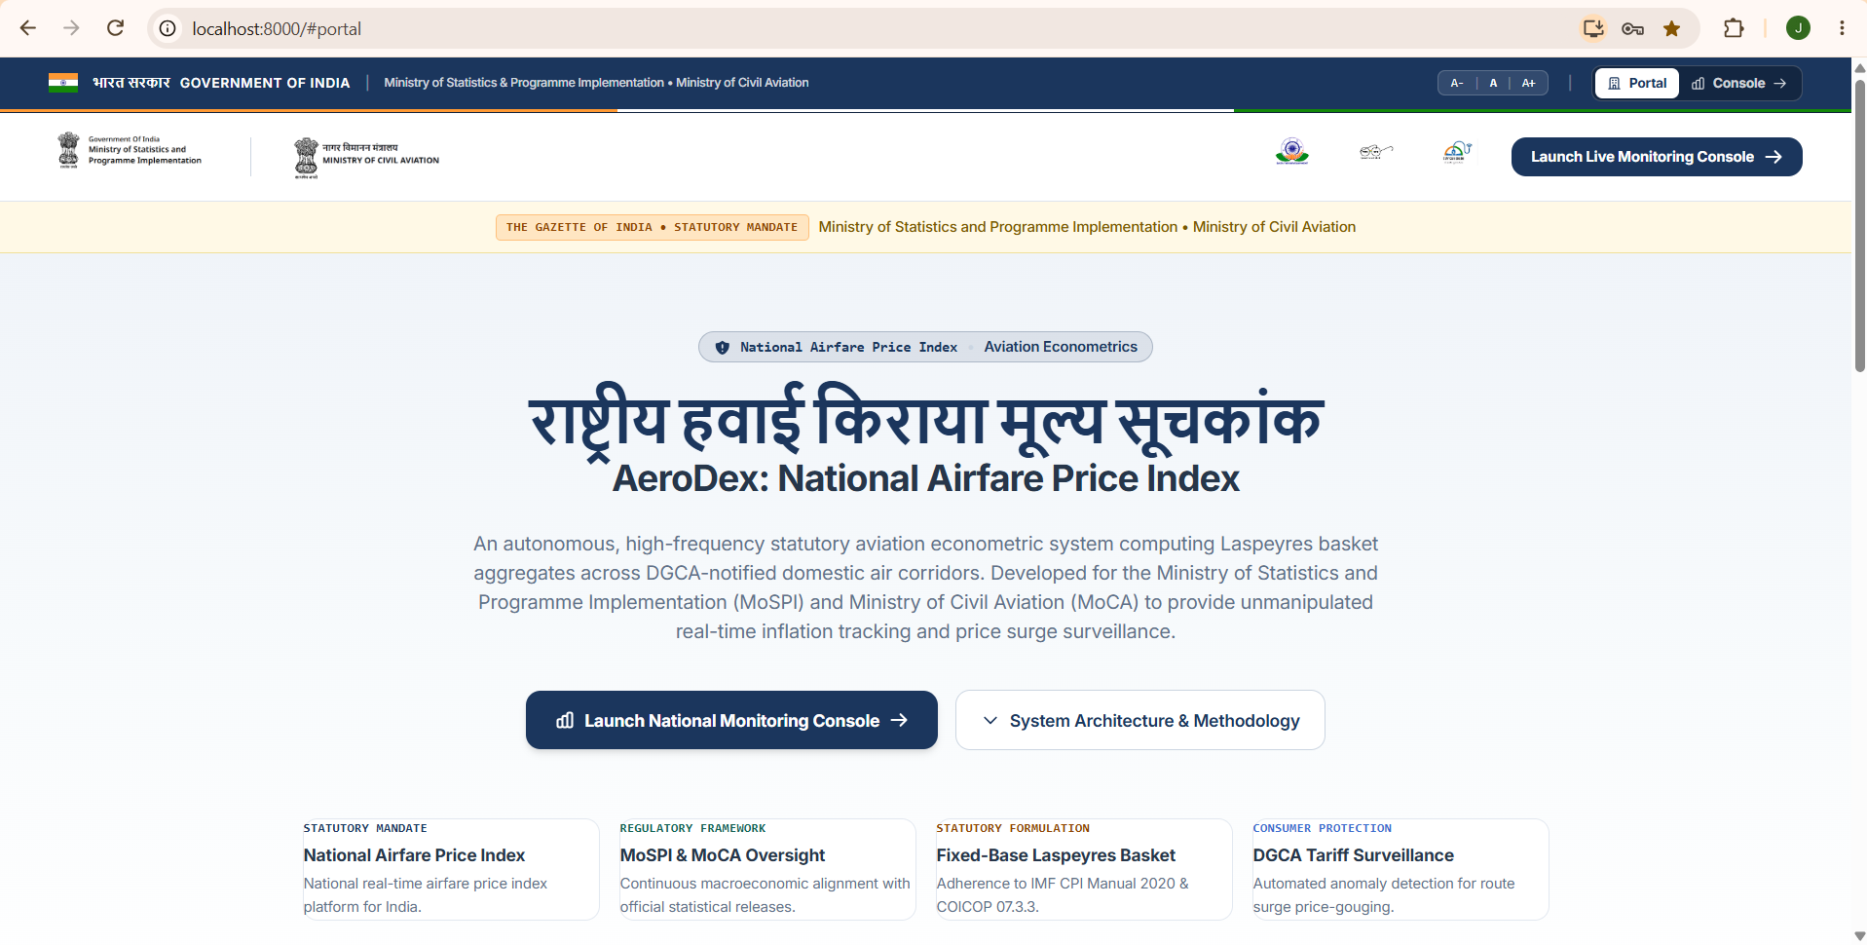
Figure 8.2: AeroDex National Airfare Price Index Home Page
- This figure presents the AeroDex platform introduction, highlighting its purpose, statutory framework, and role in monitoring airfare price trends across India.
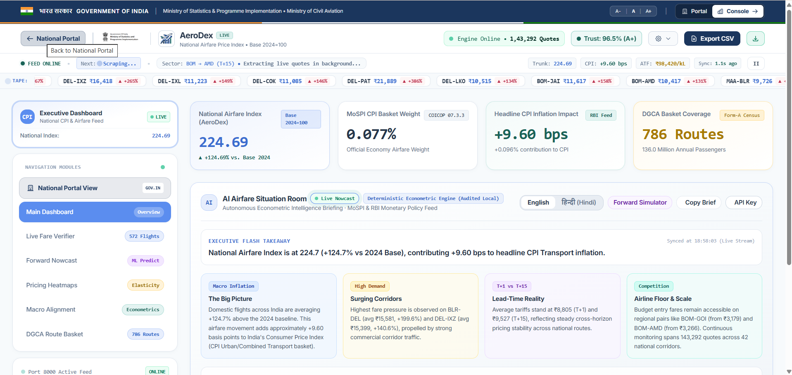

Figure 8.3 AeroDex Executive Dashboard
- This figure displays key airfare index metrics, CPI impact, DGCA route coverage, and AI-generated insights for monitoring domestic airfare trends.

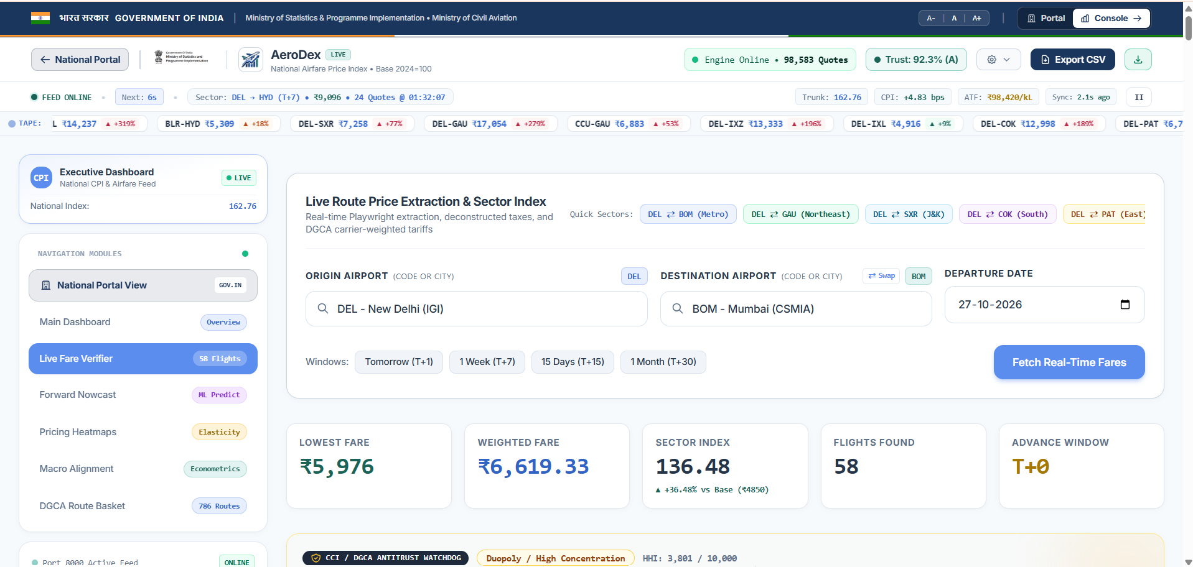

Figure 8.4: Live Fare Verifier Dashboard
- This figure shows the live fare verification interface for comparing flight prices, weighted fares, and sector indices across selected domestic routes.

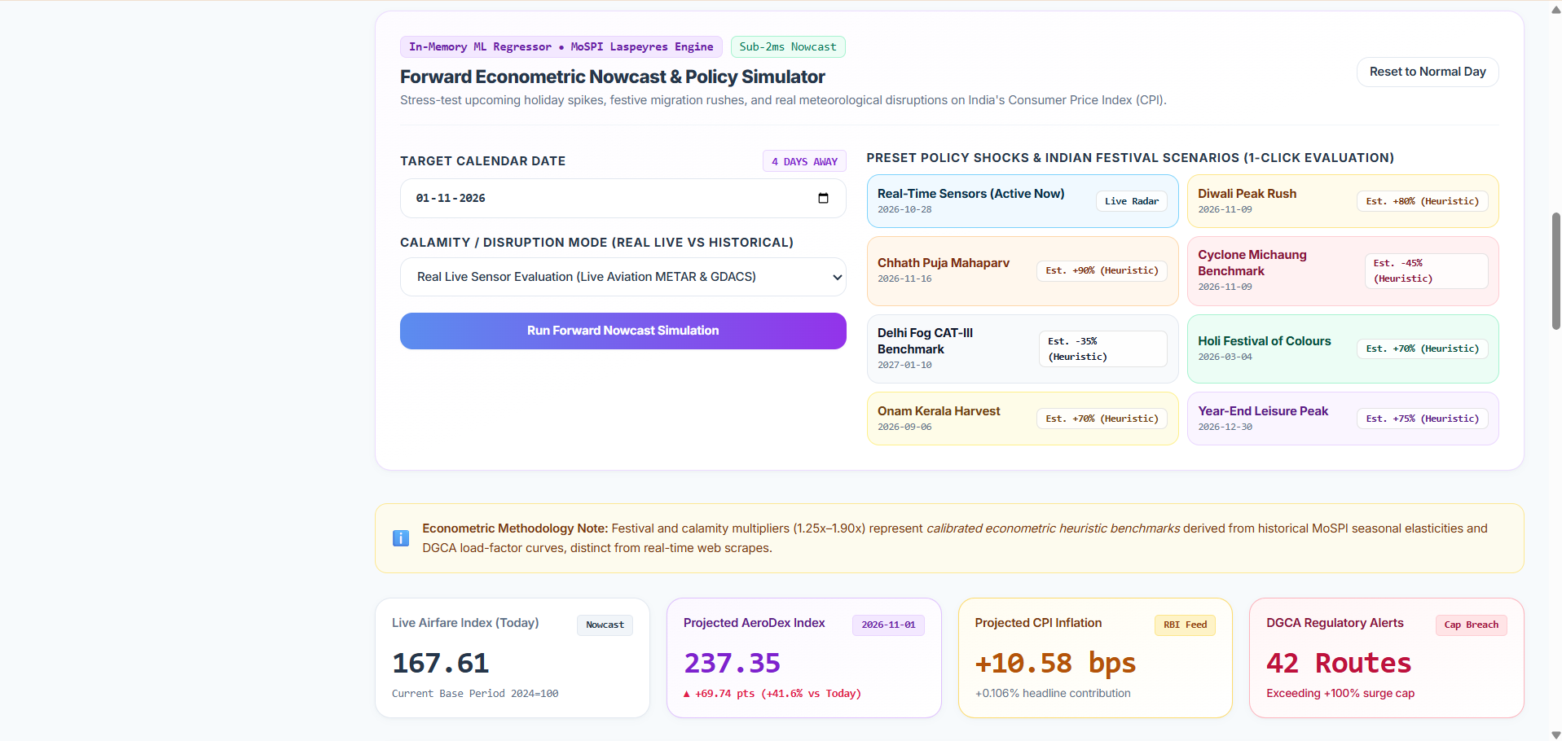
Figure 8.5: AeroDex Forward Nowcast and Policy Simulation Dashboard
- This figure illustrates the airfare forecasting module, featuring festival scenarios, disruption simulations, projected airfare index values, and estimated CPI inflation impacts.

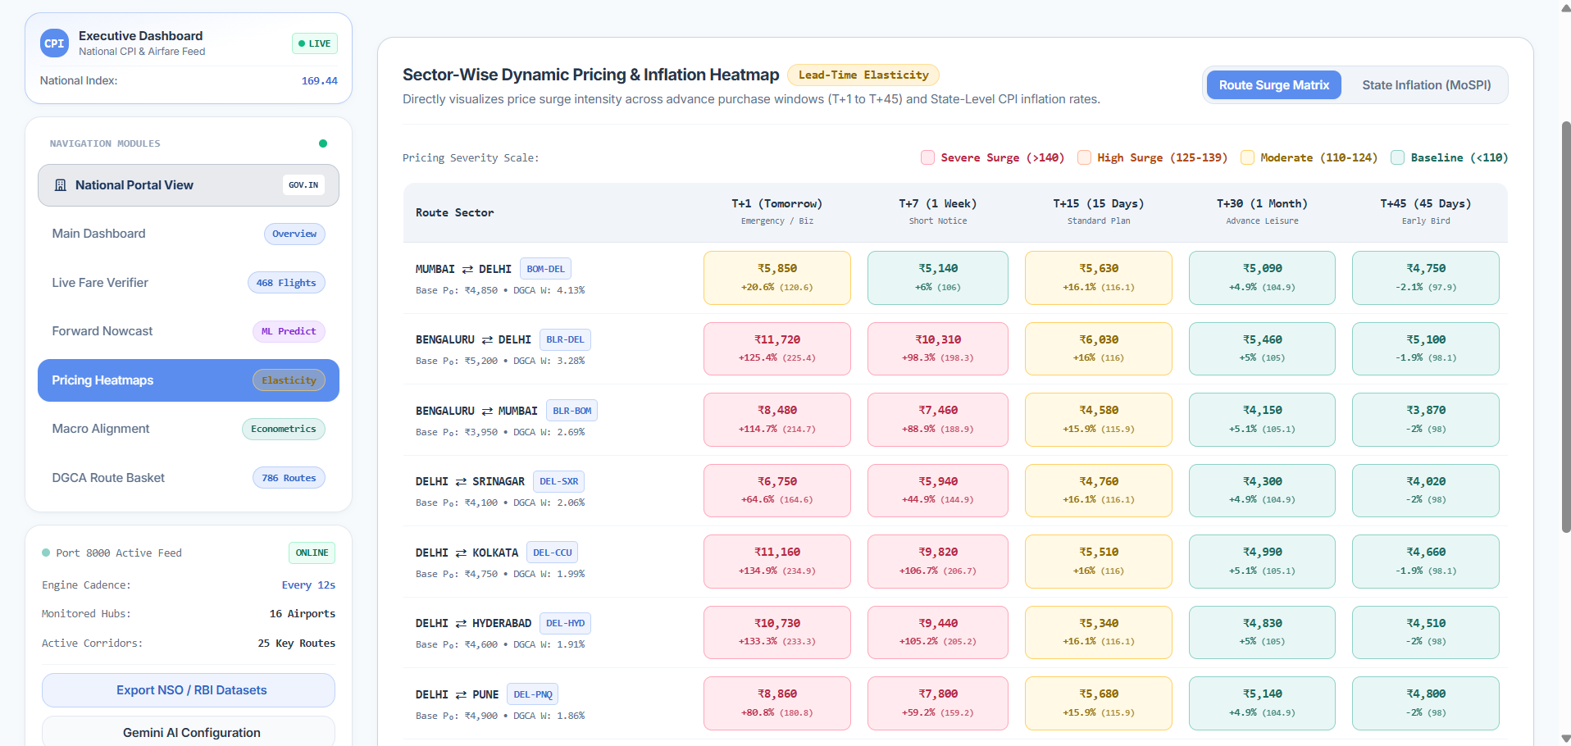
Figure 8.6: AeroDex Sector-Wise Airfare Pricing Heatmap
- This figure presents route-wise airfare variations across different time windows, highlighting price surges and trends to support airfare analysis.

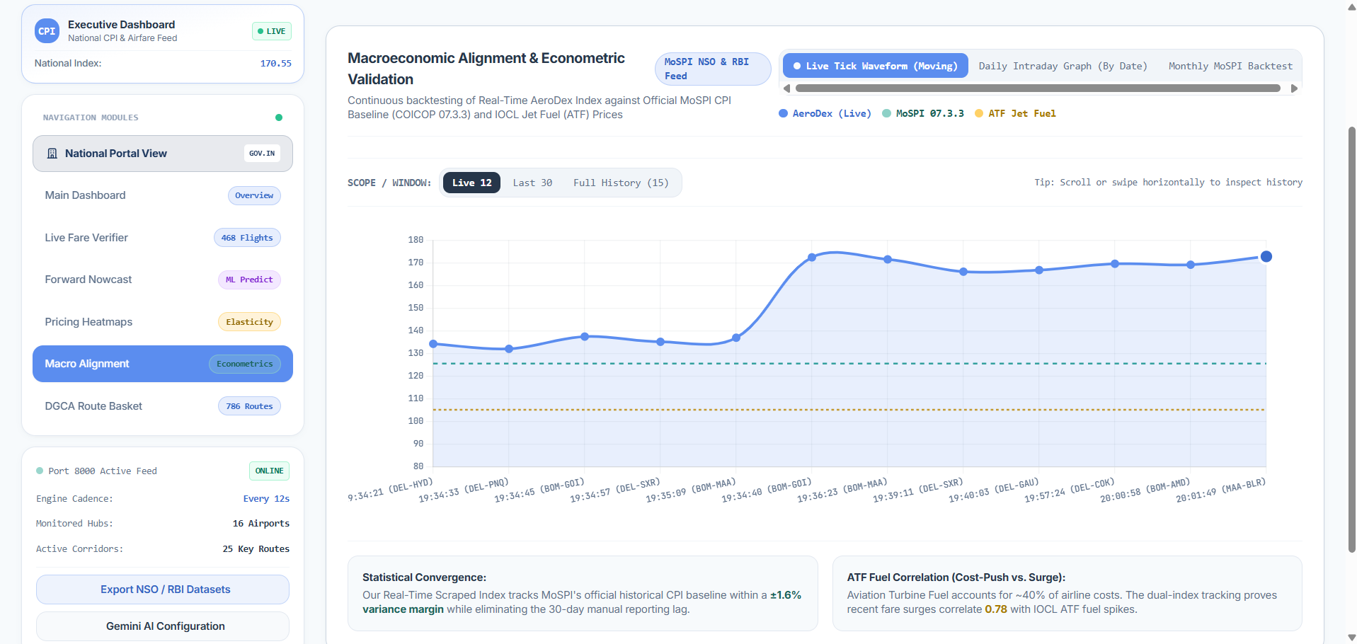
Figure 8.7: AeroDex Macroeconomic Alignment and Econometric Validation Dashboard
- This figure compares the AeroDex airfare index with official CPI and ATF fuel price data to analyze trends, inflation impact, and economic relationships.
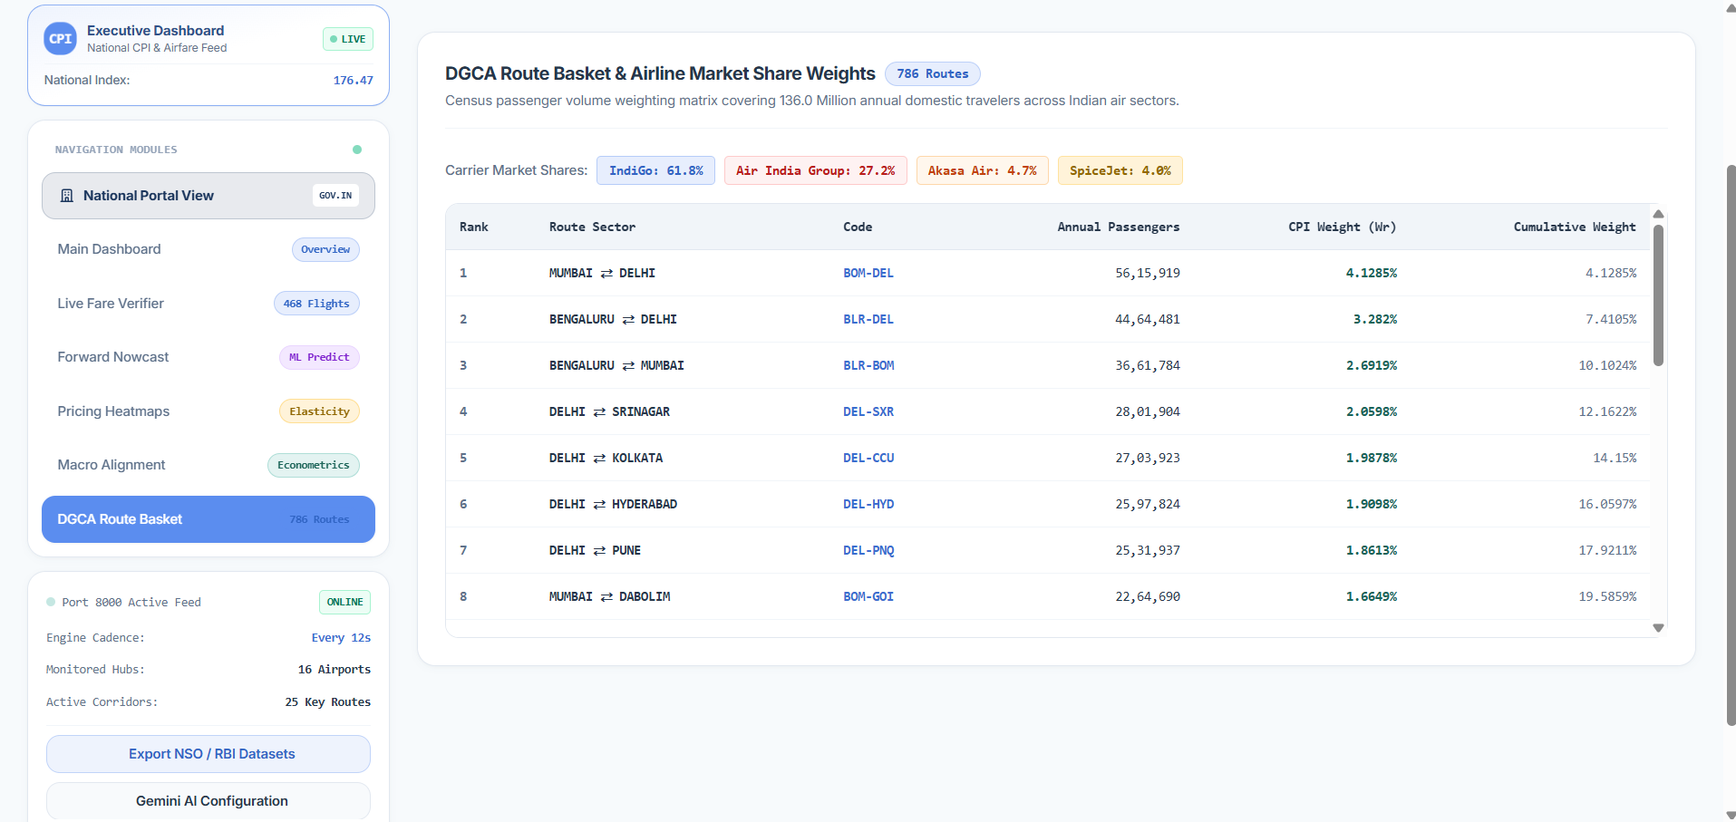

Figure 8.8: AeroDex DGCA Route Basket and Airline Market Share Analysis
- This figure displays domestic route sectors, annual passenger volumes, airline market shares, and route weights used in airfare index calculations.

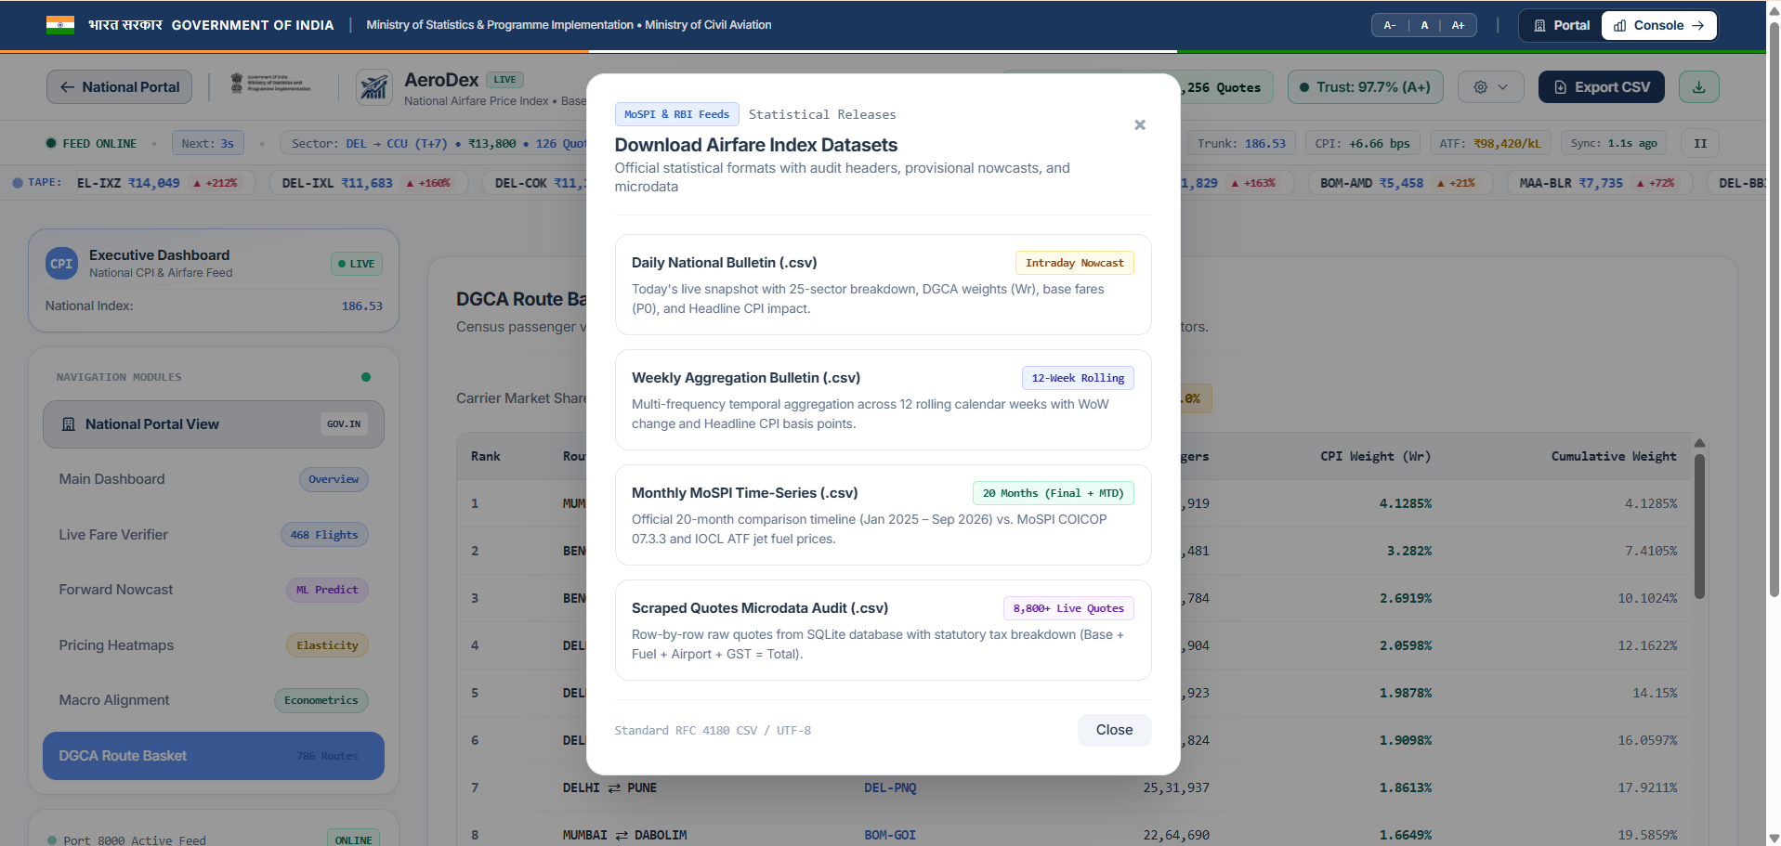
Figure 8.9: AeroDex Airfare Index Dataset Export Interface
- This figure shows the dataset export interface for downloading daily, weekly, and monthly airfare index reports and raw fare data in CSV format.

Chapter 9 : Observations

During the development of AeroDex – Real-Time Airfare Price Index for India, several observations were made regarding airfare fluctuations, data collection, index calculation, and visualization.
- Airfare Fluctuations: Airfares vary across routes, airlines, and travel dates. Comparing multiple fare records provides a better understanding of pricing differences than considering a single fare.
- Data Collection and Processing: Automated data collection reduces manual effort. However, source accessibility, missing values, and inconsistent data formats can affect data quality. Actual observed fares must be distinguished from fallback or estimated values.
- Airfare Price Index: The project uses a Laspeyres-style weighted index to summarize fare movements across selected domestic routes. Route weights and the availability of fare observations influence the index results.
- Dashboard and Visualization: The interactive dashboard integrates fare verification, the National Airfare Price Index, pricing heatmaps, forecasting, and route-basket information. These visualizations make airfare data easier to understand and compare.
- Forecasting and Economic Analysis: The Forward Nowcast provides estimated future airfare movements, while Macroeconomic Alignment supports comparisons with indicators such as Aviation Turbine Fuel (ATF) prices and official Consumer Price Index (CPI) airfare data. Forecasts and observed relationships should be interpreted carefully.
- Data Management: Structured CSV, JSON, and SQLite storage supports data organization and retrieval. Consistent data formats and clear identification of observed, estimated, and predicted values are important for reliable analysis.
- Limitations: Results depend on data availability, source accessibility, route coverage, and the accuracy of the underlying observations. Forecasts are estimates and do not guarantee actual future prices.

Conclusion: AeroDex demonstrates how automation, data analytics, weighted index calculation, forecasting, and interactive visualization can be combined to analyze domestic airfare trends. The platform provides a consolidated view of selected routes, while its usefulness depends on data quality, transparent methodology, and careful interpretation of results.

Chapter 10: Results and Discussions

10.1 Results
The creation of AeroDex – Real-Time Airfare Price Index for India is a result of creating an integrated platform that collects, analyzes, and visualizes the airfare data in one repository. The key functionality of the platform allows the user to comprehend the airfare changes in the selected domestic routes, namely through the implementation of:
- Airfare Data Collection: This platform has components that allow to collect airfare data in the form of scraping of flights’ fares.
- National Airfare Price Index: The weighted index that reflects airfare changes in a defined set of domestic routes.
- Interactive Dashboard: Dashboard shows airfare data through the means of charts, price heat maps, and route comparison.
- Forward Nowcast: This function gives estimates of possible airfare changes in the future according to the existing data.
- Macroeconomic Alignment: The platform allows to align airfare indicators with economic data (ATF prices and CPI airfare data).
- Data Management: The data are organized and stored in the format of CSV, JSON and SQLite.
10.2 Discussion
AeroDex shows that the use of data analytics and automation can help in improving the discovery and understanding of airfare information. Instead of analyzing fares individually, users will be able to access their pricing data and indexed results from a single dashboard. The indexed weighting gives a general picture of how the fares in the selected basket move while graphs and heatmaps make comparison between routes possible.
The prediction and economic comparison tools also provide alternative means for investigating airfare trends. But the effectiveness of these tools will be determined by the quality and amount of underlying data. The real-time data gathering might not always be successful and estimated or fallback values have to be considered as such. Likewise, the predicted fares should be taken as estimates and not necessarily future prices.

In summary, the system has met the main purpose of bringing the data gathering, analysis and visualization processes of airfare trends under one hood. It has also offered valuable experience in web scraping, Python programming, database handling and data analytics. With more data coverage and testing, AeroDex could be used as a useful tool for airfare trend investigation in India.

Chapter 11: Conclusion & Future Scope

11.1 Conclusion
AeroDex – Real-Time Airfare Price Index for India is a system that has been designed to simplify data gathering, understanding and analysis of airfare data. The main goal of the project is to combine the airfare data gathering, price analysis and visualization process into one application.

The system consists of such components as web scraping, data processing, weighted airfare price index, forecasting and interactive dashboard. There are some functions included in the system like National Airfare Price Index, Live Fare Verifier, Pricing Heatmaps and Forward Nowcast that allow users to analyze changes in airfares in specific domestic flights. Comparison of airfares with economic indices like Aviation Turbine Fuel (ATF) prices and CPI airfare data is also possible.

Development of this project helped to gain practical skills in working with Python, web scraping, databases, data analytics and web development technologies. Although there are some limitations concerning availability and forecasting accuracy of the system, the project gives a good start for analyzing Indian airfares.
11.2 Future Scope
In the future, AeroDex can be improved by adding more airlines and websites for providing data on airfares. Automatic data update can maintain freshness of data, whereas machine learning approaches can be explored for enhancing forecast accuracy.

The introduction of mobile application along with customized price alerts would help in making the system more convenient for the users. The project can be expanded to include domestic routes, increase accuracy of the airfare index as well as include other economic variables.
11.3 Final Remarks
AeroDex is a step towards making airfare analysis more organized and data-driven. The project demonstrates how different technologies can be combined to address a real-world problem. With further improvements in data quality, route coverage, and forecasting, AeroDex has the potential to become a more comprehensive platform for monitoring airfare trends in India.

References

- Directorate General of Civil Aviation. (n.d.). Official website. https://www.dgca.gov.in/
- Google. (n.d.). Gemini API documentation. Google AI for Developers. https://ai.google.dev/api
- NumPy Developers. (n.d.). NumPy documentation. https://numpy.org/doc/stable/
- Playwright. (n.d.). Playwright for Python documentation. https://playwright.dev/python/docs/intro
- Python Software Foundation. (n.d.). Python 3 documentation. https://docs.python.org/3/
- Requests. (n.d.). Requests: HTTP for humans. https://requests.readthedocs.io/en/latest/
- Scikit-learn developers. (n.d.). Scikit-learn documentation. https://scikit-learn.org/stable/
- SQLite Consortium. (n.d.). SQLite documentation. https://www.sqlite.org/docs.html
- Ministry of Statistics and Programme Implementation. (n.d.). Official website. https://mospi.gov.in/

Curriculum Mapping
Subject Code | Subject Name | Weightage | Topic Name
MSDS211 | Advanced Python Programming | 30% | Web Scraping, Data Processing, Data Cleaning, Automation
MSDS213 | Fundamentals of AI & ML | 20% | Airfare Forecasting, Predictive Analysis, Machine Learning
MSDS216 | Statistics II | 20% | Airfare Price Index, Trend Analysis, Statistical Analysis
MSDS214 | Numerical Methods & Analysis using MATLAB | 15% | Numerical Calculations, Mathematical Modelling, Index Computation
MSDS113 | Database Management System | 15% | SQLite Database, Data Storage, Data Retrieval, Database Management
Total |  | 100%

Usefulness of the Project

AeroDex - Real Time Airfare Price Index for India aims to help understand the difference in airfares and to perform analysis on flights and their prices over certain domestic routes in India. The system involves the process of data collection, analysis, forecasting, and presentation of the airfare data in one package.
Advantages of AeroDex are listed below:
- Airfare Comparison: Provides users with the ability to compare differences in the fares over certain chosen routes and flight options.
- Airfare Trend Analysis: Provides users with understanding on airfare movements through use of charts, heatmaps and National Airfare Price Index.
- Decision Making Using Information: Provides information on airfares in structured manner helping the user understand airfare trends.
- Airfare Forecasting: Provides forecasts of future movements in airfares for future analysis.
- Economic Analysis: Provides the ability to compare different indicators of airfares, Aviation Turbine Fuel prices and CPI airfares.
- Automation: Reduces amount of manual work in terms of data collection and processing.
- Educational Application: Shows how programming language Python, web scraping, statistics, machine learning, and databases can be used to solve practical problems.
In summary, AeroDex provides an integrated solution for investigating the cost of flights and the trends in pricing. Furthermore, it sets the groundwork for future developments in aviation data analytics, provided that data is available and the underlying information is accurate.

