  
**Birzeit University**

**Faculty of Engineering and Technology**

**Electrical and Computer Engineering Department**

**ENCS4370**

**COMPUTER ARCHITECTURE**

**Project 1**

**Prepared by: Jenin Mansour 1200540**

**:Masa Emwas 1203359**

**Instructor: Dr. I Aziz Qaroush**

**Date of submission: 8/12/2023**

**2022-2023**

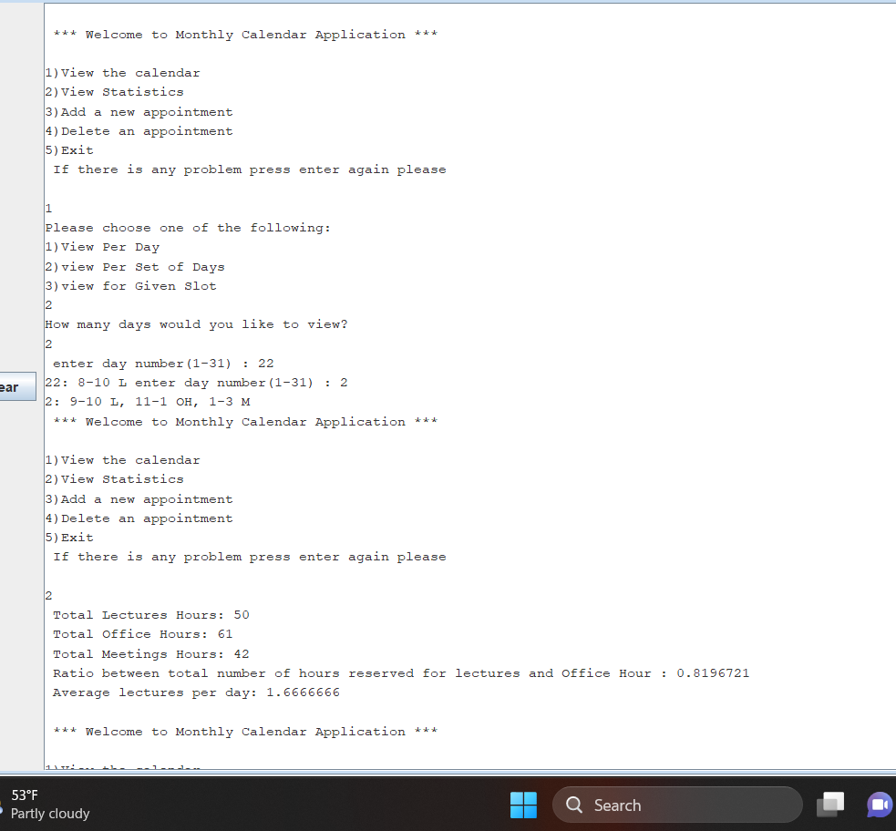

**After adding an appointment**



