Measurement of sex and gender identity in BRFSS

Jenine K Harris, Odalis Hernandez

9/15/2021

### Background

In 2021, a Gallup poll found that .6% or 60 out of every 1000 Americans, reported that they identify as transgender (Jones 2021). The percentage varied by age group, with the cohort born in 1997-2002 reporting 1.8% of survey participants identified as transgender compared to 1.2% in the previous cohort and just .3% in the cohort born before 1946. Transgender people are individuals whose biological sex, or sex recorded at birth, differs from their gender identity (Galupo, Henise, and Mercer 2016; Howerton and Harris 2021). Gender identity is how a person identifies and conceptualizes their own gender and is different from biological sex and sexual orientation (Galupo, Henise, and Mercer 2016; Charlotte Chucky Tate, Hagai, and Crosby 2020). Sex, sexual orientation, and gender identity all have implications for health, health care, and health outcomes (Legato, Johnson, and Manson 2016; Agénor et al. 2016; Gonzales, Przedworski, and Henning-Smith 2016; McClure et al. 2022).

Conducting research to understand factors that influence health, health care, and health outcomes is important for the development of policy and programs that protect and improve health. Given the roles of sex, sexual orientation, and gender identity in health, many social science and health surveys seek to measure sex, and a growing number also collect sexual orientation and gender identity information. Until recently, measurement of gender identity was unusual and measurement of sex was often done by an interviewer recording the sex they thought the participant was based on voice or other physical cues (Bauer et al. 2017) or asking “what is your sex?” and recording either male or female. In addition, researchers have frequently treated gender as a synonym for sex (Krieger 2003; Johnson, Greaves, and Repta 2009; Charlotte Chuck Tate, Ledbetter, and Youssef 2013).

For decades there have been calls and attempts to improve the measurement of sex, gender, and sexual orientation (Krieger 2003; Charlotte Chuck Tate, Ledbetter, and Youssef 2013). In the meantime, researchers are utilizing data sets that include less accurate ways of measuring these concepts. For example, the Behavioral Risk Factor Surveillance Survey (BRFSS) collects data on health behaviors, health conditions, and the use of health-related services from U.S residents. The Centers for Disease Control and Prevention collect BRFSS participant data each month over telephone. It is considered the world’s largest health survey system, collecting data from over 400,000 individuals yearly (Disease Control and Prevention, n.d.).

Until 2015, BRFSS did not ask participants about gender identity. In 2015 the BRFSS added an optional question about gender identity to the survey and states could decide whether or not to include the gender identity question when conducting data collection. The gender identity question that was included in the BRFSS from 2015 until 2020 (the most recent year of data released) was: “Do you consider yourself to be transgender?” The follow-up question for those who answered yes was, “Do you consider yourself to be 1. Male-to-female, 2. Female-to-male, or 3. Gender nonconforming?”

Although a gender identity question was added, the wording of the sex question did not make any distinction between sex recorded and gender for several years. In 2015, the interviewer selected the sex of the participant given the prompt: “Indicate sex of respondent. Ask only if necessary.” In 2016, the prompt changed to, “Are you…” with the options of Male, Female, and Refused and a note, “Note: This may be populated from information derived from screening, household enumeration. However, interviewer should not make judgement on sex of respondent.” So, 2016 was the first year of the BRFSS that the interviewer was not permitted to guess the sex of the participant.

In 2017 the question remained, “Are you…” with responses of Male, Female, and Refused. The note for interviewers changed to all capital letters, presumably for emphasis, “INTERVIEWER NOTE: THIS QUESTION MUST BE ASKED EVEN IF INTERVIEWER HAD PREVIOUSLY ENTERED SEX IN THE SCREENING QUESTIONS. IT WILL NOT BE ASKED OF PERSONS WHO HAVE SELF-IDENTIFIED SEX IN LL HOUSEHOLD ENUMERATION.” There was also a second note, “CATI NOTE: THIS QUESTION MAY BE POPULATED BY LANDLINE HOUSEHOLD ENUMERATION ONLY. IT MAY NOT BE POPULATED BY INTERVIEWER ASSIGNMENT OF SEX DURING THE SCREENING FOR CELL PHONE OR PERSONS LIVING IN COLLEGE HOUSING.”

In 2018, the interviewer asked, “What is your sex? or What was your sex at birth? Was it…” and gave the possible responses of Male and Female. It is unclear from the BRFSS documentation how interviewers selected one of the two questions. In 2019, the interviewer asked, “Are you male or female?”. In 2019 there was also a separate “Sex at Birth Optional Module” that included the question, “What was your sex at birth? Was it male or female?” The separate sex at birth question was asked of a subset of about 65 thousand participants and a combined sex variable was created that classified people based on their response to the sex at birth question if asked and, if sex at birth was not asked or if the reply was “Don’t know/Not Sure” or “Refused,” used the response to the sex question. In the 2020 survey administration, the 2019 sex at birth prompt was adopted as the sex question for all participants, “What was your sex at birth? Was it male or female?”

In a recent paper (Howerton and Harris 2021), Howerton and Harris found that BRFSS participants from 2015 to 2019 who reported having the same transgender gender identity sometimes had different answers for the sex question. For example, some participants who identified as female-to-male transgender identity reported their sex as male and others reported their sex as female. Likewise, among those who identified as male-to-female transgender identity, some reported their sex to be male and others reported their sex to be female. This has likely led to numerous published scientific papers examining sex differences or using sex as a covariate and potentially including participants whose sex recorded at birth was something other than their sex as recorded in the BRFSS.

The implications of how sex is measured also impacts multiple computed variables in the BRFSS that rely on the sex variable as part of the calculation. For example, the BRFSS variable for heavy drinking codes a male as a heavy drinker at 14 or more alcoholic drinks per week and a female as a heavy drinker at 7 or more alcoholic drinks per week. Questions related to pregnancy and pregnancy or birth-related health conditions are only asked of those who report being female and questions about human papilloma virus (HPV) screening and vaccination and birth control type and behavior differ for those who select male or female sex. Likewise, questions about mammograms, breast exams, and prostate specific antigen tests are only asked of people who report being in a specific sex category.

We sought to better understand the relationship between sex and gender identity responses in the BRFSS data from 2015 (the first year of the gender identity question) to the most recently released year of data in 2020. Specifically we answer three questions: (1) What is the relationship between sex and gender identity responses for participants over this six year period?; (2) How has the relationship between measured sex and gender identity changed as the sex question changed over this six year period?; and (3) Did the versions of the question that specified “at birth” result in different patterns of sex and gender identity reporting compared to other years?

### Methods

We imported the BRFSS data sets from 2015 through 2020 directly from the Centers for Disease Control and Prevention website. We used R statistical software version 4.1.1 (R Core Team 2021), the RStudio (version 1.4.1717) interactive development environment (RStudio Team 2020), and a function from version 2.4.3 of the haven package (Wickham and Miller 2021) to import the data. We used the tidyverse (Wickham 2017) software package to manage and visualize the data and the table1 package to compute descriptive statistics (Rich 2021).

### Results

##### What is the relationship between sex and gender identity responses for participants over this six year period?

The majority of those who reported being male-to-female transgender also reported their sex as male each year (Figure 1). Likewise, the majority of those who reported being female-to-male transgender reported their sex as female. With the exception of 2017, there was a higher percentage of male-to-female transgender participants reporting themselves to be male sex compared to the percentage of female-to-male transgender participants reporting themselves to be female.

*Figure 1. Distribution of reported sex among BRFSS participants who reported being transgender (2015-2020).*

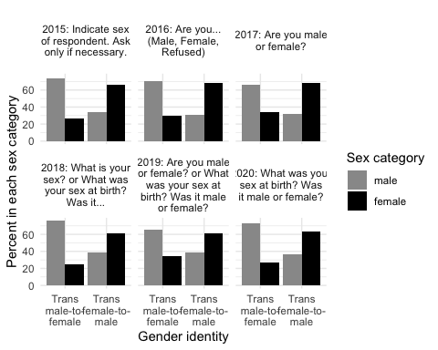

##### How has the relationship between measured sex and gender identity changed as the sex question changed over this six year period?

Although the sex question asked of participants changed multiple times from 2015 to 2020, the percentage in each transgender group choosing male and female did not change notably for either group (Figure 2).

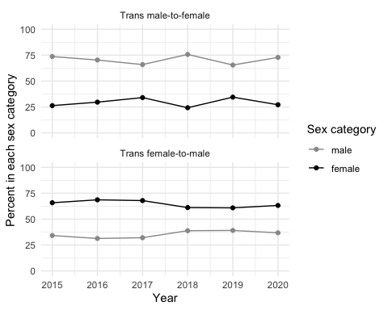

##### Did the versions of the question that specified “at birth” result in different patterns of sex and gender identity reporting compared to other years?

For the transgender male-to-female group, the 2018 and 2020 had a slightly different pattern of responses compared to the years just before these (more in line with the 2015 responses), with more participants selecting male sex in 2018 than in 2017 and in 2020 compared to 2019. For the transgender female-to-male group, 2018 question also marked a shift in responses with more participants choosing male sex than previous years. This small change was maintained in 2019 but there was a slight increase in female sex responses in 2020. The “at birth” wording appears to have had more of an impact on participants identifying as male-to-female transgender than on those identifying as female-to-male transgender. It is notable that, for both of the transgender groups (female-to-male and male-to-female) there was an increase in selection of male in response to the sex question in 2018.

The structure of the 2019 survey provides some additional information about differences in response patterns when including or not including “at birth” in a sex question. In 2019, there was more variability in responses among participants who were asked their sex (A) compared to participants who were asked their sex at birth (B). However, when the sex at birth version of the question was adopted in 2020 (Figure 3C), the distribution of responses was somewhere between the responses from those who responded to the sex question in 2019 ans those who responded to the sex at birth question in 2019.

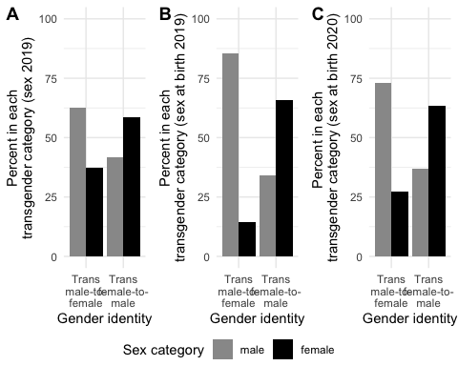

### Discussion

We found that about 75% of participants in the 2015 to 2020 BRFSS who identify as transgender male-to-female report male sex while about 25% report female sex. For participants during the same time frame who identify as transgender female-to-male report female sex a little over 60% of the time and report male sex just under 40% of the time. These values were relatively consistent over the six administrations of the survey despite multiple changes in how sex was measured. The one exception to this was in the group of transgender male-to-female participants who answered the optional module in 2019. When asked their sex at birth, about 85% of this group chose male. The value of the sex variable is used in computing some health related variables (e.g., heavy drinking) and in routing participants to questions about birth control, HPV vaccines, cancer screenings, and other preventive health behaviors. In order to better understand and protect the health of transgender people, accurate measurement of biological sex could be useful.

[paragraph about evidence-based measurement of bio sex]

[paragraph about calculated variables and routing, can BRFSS route trans-male-to-female to breast cancer screen]

[paragraph suggesting researchers pay attention]

### References

Agénor, Madina, S Bryn Austin, Daniel Kort, Erika L Austin, and Christina A Muzny. 2016. “Sexual Orientation and Sexual and Reproductive Health Among African American Sexual Minority Women in the US South.” *Women’s Health Issues* 26 (6): 612–21.

Bauer, Greta R, Jessica Braimoh, Ayden I Scheim, and Christoffer Dharma. 2017. “Transgender-Inclusive Measures of Sex/Gender for Population Surveys: Mixed-Methods Evaluation and Recommendations.” *PloS One* 12 (5): e0178043.

Disease Control, Centers for, and Prevention. n.d. “"Behavioral Risk Factor Surveillance System".” <https://www.cdc.gov/brfss/>.

Galupo, M Paz, Shane B Henise, and Nicholas L Mercer. 2016. “‘The Labels Don’t Work Very Well’: Transgender Individuals’ Conceptualizations of Sexual Orientation and Sexual Identity.” *International Journal of Transgenderism* 17 (2): 93–104.

Gonzales, Gilbert, Julia Przedworski, and Carrie Henning-Smith. 2016. “Comparison of Health and Health Risk Factors Between Lesbian, Gay, and Bisexual Adults and Heterosexual Adults in the United States: Results from the National Health Interview Survey.” *JAMA Internal Medicine* 176 (9): 1344–51.

Howerton, Isabelle, and Jenine K. Harris. 2021. “Transgender Identity and Cardiovascular Disease.” *Transgender Health*, August. <https://doi.org/10.1089/trgh.2020.0188>.

Johnson, Joy L, Lorraine Greaves, and Robin Repta. 2009. “Better Science with Sex and Gender: Facilitating the Use of a Sex and Gender-Based Analysis in Health Research.” *International Journal for Equity in Health* 8 (1): 1–11.

Jones, Jeffery. 2021. “"LGBT Identification Rises to 5.6.” *Gallup*. <https://news.gallup.com/poll/329708/lgbt-identification-rises-latest-estimate.aspx>.

Krieger, Nancy. 2003. “Genders, Sexes, and Health: What Are the Connections—and Why Does It Matter?” *International Journal of Epidemiology* 32 (4): 652–57.

Legato, Marianne J, Paula A Johnson, and JoAnn E Manson. 2016. “Consideration of Sex Differences in Medicine to Improve Health Care and Patient Outcomes.” *Jama* 316 (18): 1865–66.

McClure, Robert C, Caroline L Macumber, Clair Kronk, Chris Grasso, Robert J Horn, Roz Queen, Steven Posnack, and Kelly Davison. 2022. “Gender Harmony: Improved Standards to Support Affirmative Care of Gender-Marginalized People Through Inclusive Gender and Sex Representation.” *Journal of the American Medical Informatics Association* 29 (2): 354–63.

R Core Team. 2021. *R: A Language and Environment for Statistical Computing*. Vienna, Austria: R Foundation for Statistical Computing. <https://www.R-project.org/>.

Rich, Benjamin. 2021. “Table1: Tables of Descriptive Statistics in HTML.” <https://CRAN.R-project.org/package=table1>.

RStudio Team. 2020. *RStudio: Integrated Development Environment for r*. Boston, MA: RStudio, PBC. <http://www.rstudio.com/>.

Tate, Charlotte Chuck, Jay N Ledbetter, and Cris P Youssef. 2013. “A Two-Question Method for Assessing Gender Categories in the Social and Medical Sciences.” *Journal of Sex Research* 50 (8): 767–76.

Tate, Charlotte Chucky, Ella Ben Hagai, and Faye J Crosby. 2020. *Undoing the Gender Binary*. Cambridge University Press.

Wickham, Hadley. 2017. “The Tidyverse.” *R Package Ver* 1 (1).

Wickham, Hadley, and Evan Miller. 2021. *Haven: Import and Export ’SPSS’, ’Stata’ and ’SAS’ Files*. <https://CRAN.R-project.org/package=haven>.