Name : 林樱
Student ID : 2462710034L
Shopping Cart Calculation

- Source code:
<script setup>
import { ref } from 'vue'

const products = ref([
{ name: 'cola', price: 3, number: 10 },
{ name: 'chips', price: 6, number: 8 },
])

function compute() {
let total = 0
for (let i = 0; i < products.value.length; i++) {
total += products.value[i].price * products.value[i].number
}
return total
}

function deleteProduct(index) {
products.value.splice(index, 1)
}
</script>

<template>
<div class="cart">
<h2>Shopping Cart</h2>
<table>
<thead>
<tr>
<th>Product</th>
<th>Price</th>
<th>Quantity</th>
<th>Subtotal</th>
<th>Action</th>
</tr>
</thead>
<tbody>
<tr v-for="(product, index) in products" :key="index">
<td>{{ product.name }}</td>
<td>{{ product.price }}</td>
<td>{{ product.number }}</td>
<td>{{ product.price * product.number }}</td>
<td>
<button @click="deleteProduct(index)">Delete</button>
</td>
</tr>
</tbody>
<tfoot>
<tr>
<td colspan="3"><strong>Total Amount</strong></td>
<td colspan="2"><strong>{{ compute() }} yuan</strong></td>
</tr>
</tfoot>
</table>
</div>
</template>

<style scoped>
.cart {
max-width: 600px;
margin: 2rem auto;
font-family: Arial, sans-serif;
}

table {
width: 100%;
border-collapse: collapse;
}

th,
td {
border: 1px solid #ddd;
padding: 10px 14px;
text-align: center;
}

th {
background-color: #f0f0f0;
color: #333;
}

button {
background-color: #3498db;
color: white;
border: none;
padding: 6px 14px;
border-radius: 4px;
cursor: pointer;
}

button:hover {
background-color: #2980b9;
}
</style>
- Running screenshots
- The initial shopping cart page
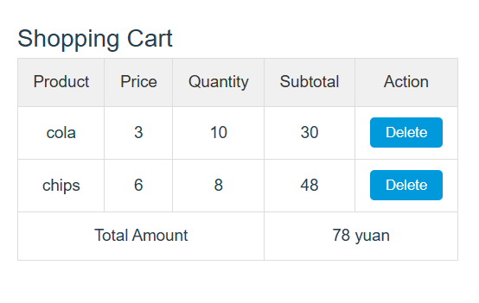
- The calculated total amount

- The result after deleting a product
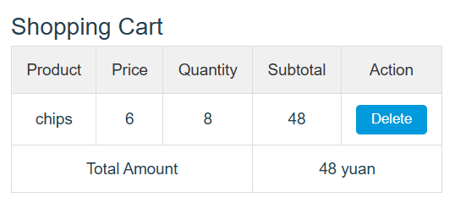
- Personal reflection
In this practice, I learned how to build a simple shopping cart calculator using Vue 3. One difficulty I encountered was understanding how to properly remove items from the reactive array using splice, since Vue's reactivity system tracks mutations on the array. I solved this by passing the correct index from the v-for loop into the deleteProduct function, which made the deletion clean and predictable.

