Taizhou University
School of Artificial Intelligence
Laboratory Report

班级 24计算机（英） 学号 2462710034L 姓名 林樱

实验课程： Java EE Enterprise Development Technology
实验项目： Experiment 2: Simple Diary Application Based on Servlet

Experiment Date: 2026 年 3 月 25 日

1. Experiment Objectives
- To learn how Servlet works in a simple web application
- To implement Servlet programming in a CRUD application

2. Development Environment
- JDK version: JDK 21
- IDE: Intellij IDEA
- Server: Apache Tomcat 10
- Browser: Chrome
- Framework: Bootstrap 5

3. Main Operation Steps
- Create a new project and setup the project structure within the IDE
- Install Bootstrap and configure the file path inside the project structure
- Create the main page
- Create New Diary entry
- Create View showing added entry
- Create Edit for editing the entry
- Create Delete button for deleting the entry

4. Key Code
After configuring the project structure, create index.html as follows:
<!DOCTYPE html>
<html lang="en">
<head>
<meta charset="UTF-8">
<title>Diary Notebook</title>

<link rel="stylesheet" href="static/bootstrap/css/bootstrap.rtl.css">
</head>
<body class="bg-light">

<div class="container mt-5">
<h1 class="text-center mb-4">📔 Diary Notebook</h1>

<!-- create button -->
<div class="text-end mb-3">
<a href="create.html" class="btn btn-primary">+ New Diary</a>
</div>

<!-- diary list -->
<table class="table table-striped table-hover shadow">
<thead class="table-dark">
<tr>
<th>Date</th>
<th>Title</th>
<th>Actions</th>
</tr>
</thead>
<tbody>
<tr>
<td>2026-04-04 10:30</td>
<td>My First Diary</td>
<td>
<a href="#" class="btn btn-sm btn-success">View</a>
<a href="#" class="btn btn-sm btn-warning">Edit</a>
<a href="#" class="btn btn-sm btn-danger">Delete</a>
</td>
</tr>

</tbody>
</table>
</div>

<script src="static/bootstrap/js/bootstrap.bundle.js"></script>
</body>
</html>

And then create create.html, this page is for creating a new diary:
<!DOCTYPE html>
<html lang="en">
<head>
<meta charset="UTF-8">
<title>Diary Notebook</title>

<link rel="stylesheet" href="static/bootstrap/css/bootstrap.rtl.css">
</head>
<body class="bg-light">

<div class="container mt-5">
<h1 class="text-center mb-4">📔 Diary Notebook</h1>

<!-- create button -->
<div class="text-end mb-3">
<a href="create.html" class="btn btn-primary">+ New Diary</a>
</div>

<!-- diary list -->
<table class="table table-striped table-hover shadow">
<thead class="table-dark">
<tr>
<th>Date</th>
<th>Title</th>
<th>Actions</th>
</tr>
</thead>
<tbody>
<tr>
<td>2026-04-04 10:30</td>
<td>My First Diary</td>
<td>
<a href="#" class="btn btn-sm btn-success">View</a>
<a href="#" class="btn btn-sm btn-warning">Edit</a>
<a href="#" class="btn btn-sm btn-danger">Delete</a>
</td>
</tr>

</tbody>
</table>
</div>

<script src="static/bootstrap/js/bootstrap.bundle.js"></script>
</body>
</html>
To store a diary, we do the mapping in the Servlet to redirect the main page to create page create CreateDiaryServlet.java:
package com.diary;

import jakarta.servlet.ServletException;
import jakarta.servlet.annotation.WebServlet;
import jakarta.servlet.http.*;
import java.io.*;
import java.text.SimpleDateFormat;
import java.util.Date;

@WebServlet("/createDiary")
public class CreateDiaryServlet extends HttpServlet {

@Override
This is where we receive the parameter from user and store it in the list or main page
protected void doPost(HttpServletRequest request, HttpServletResponse response)
throws ServletException, IOException {

request.setCharacterEncoding("UTF-8");

Validation logic is needed to store the data, we retrieve the data using below codes
String title = request.getParameter("title");
String content = request.getParameter("content");

// get current time
String time = new SimpleDateFormat("yyyyMMdd_HHmmss").format(new Date());
String displayTime = new SimpleDateFormat("yyyy-MM-dd HH:mm:ss").format(new Date());

// get user IP
String ip = request.getRemoteAddr();

The files can be stored locally, following codes are to store them in the web application of Tomcat and show them in the list when it’s stored
// get real path to store files
String path = getServletContext().getRealPath("/diary");
File dir = new File(path);
if (!dir.exists()) {
dir.mkdir();
}

// file name
File file = new File(dir, time + ".txt");

// write content to file
BufferedWriter writer = new BufferedWriter(new FileWriter(file));
writer.write("Title: " + title + "\n");
writer.write("Date: " + displayTime + "\n");
writer.write("IP: " + ip + "\n");
writer.write("Content:\n" + content);
writer.close();

After the data is stored, redirect to main page or the list
// redirect back to main page
response.sendRedirect("index");
}
}

Do for the following features for reading, update, and delete as follows:
DiaryListServlet.java:
package com.diary;

import jakarta.servlet.ServletException;
import jakarta.servlet.annotation.WebServlet;
import jakarta.servlet.http.*;
import java.io.*;
import java.util.*;

@WebServlet("/index")
public class DiaryListServlet extends HttpServlet {

@Override
protected void doGet(HttpServletRequest request, HttpServletResponse response)
throws ServletException, IOException {

response.setContentType("text/html;charset=UTF-8");
PrintWriter out = response.getWriter();

// get diary folder
String path = getServletContext().getRealPath("/diary");
File dir = new File(path);

if (!dir.exists()) {
dir.mkdir();
}

File[] files = dir.listFiles();

// sort files by name DESC (newest first)
if (files != null) {
Arrays.sort(files, (f1, f2) -> f2.getName().compareTo(f1.getName()));
}

// start HTML
out.println("<!DOCTYPE html>");
out.println("<html><head>");
out.println("<meta charset='UTF-8'>");
out.println("<title>Diary Notebook</title>");

// bootstrap
out.println("<link rel='stylesheet' href='static/bootstrap/css/bootstrap.rtl.css'>");

out.println("</head><body class='bg-light'>");

out.println("<div class='container mt-5'>");
out.println("<h1 class='text-center mb-4'>📔 Diary Notebook</h1>");

// create button
out.println("<div class='text-end mb-3'>");
out.println("<a href='create.html' class='btn btn-primary'>+ New Diary</a>");
out.println("</div>");

// table
out.println("<table class='table table-striped table-hover shadow'>");
out.println("<thead class='table-dark'>");
out.println("<tr><th>Date</th><th>Title</th><th>Actions</th></tr>");
out.println("</thead><tbody>");

if (files != null) {
for (File file : files) {

BufferedReader reader = new BufferedReader(new FileReader(file));

String title = "";
String date = "";

String line;
while ((line = reader.readLine()) != null) {
if (line.startsWith("Title: ")) {
title = line.substring(7);
}
if (line.startsWith("Date: ")) {
date = line.substring(6);
}
}
reader.close();

out.println("<tr>");
out.println("<td>" + date + "</td>");
out.println("<td>" + title + "</td>");
out.println("<td>");
out.println("<a href='view?file=" + file.getName() + "' class='btn btn-sm btn-success'>View</a> ");
out.println("<a href='edit?file=" + file.getName() + "' class='btn btn-sm btn-warning'>Edit</a>"); out.println("<a href='delete?file=" + file.getName() + "' ");
out.println("class='btn btn-sm btn-danger' ");
out.println("onclick=\"return confirm('Delete this diary?')\">Delete</a>");
out.println("</td>");
out.println("</tr>");
}
}

out.println("</tbody></table>");
out.println("</div>");

out.println("<script src='static/bootstrap/js/bootstrap.bundle.js'></script>");
out.println("</body></html>");
}
}

ViewDiaryServlet.java:
package com.diary;

import jakarta.servlet.ServletException;
import jakarta.servlet.annotation.WebServlet;
import jakarta.servlet.http.*;
import java.io.*;

@WebServlet("/view")
public class ViewDiaryServlet extends HttpServlet {

@Override
protected void doGet(HttpServletRequest request, HttpServletResponse response)
throws ServletException, IOException {

response.setContentType("text/html;charset=UTF-8");
PrintWriter out = response.getWriter();

String fileName = request.getParameter("file");

String path = getServletContext().getRealPath("/diary");
File file = new File(path, fileName);

BufferedReader reader = new BufferedReader(new FileReader(file));

String title = "", date = "", ip = "", content = "";
String line;

boolean isContent = false;

while ((line = reader.readLine()) != null) {
if (line.startsWith("Title: ")) {
title = line.substring(7);
} else if (line.startsWith("Date: ")) {
date = line.substring(6);
} else if (line.startsWith("IP: ")) {
ip = line.substring(4);
} else if (line.startsWith("Content:")) {
isContent = true;
} else if (isContent) {
content += line + "<br>";
}
}
reader.close();

// HTML output
out.println("<html><head>");
out.println("<link rel='stylesheet' href='static/bootstrap/css/bootstrap.rtl.css'>");
out.println("<title>View Diary</title>");
out.println("</head><body class='bg-light'>");

out.println("<div class='container mt-5'>");
out.println("<h2>" + title + "</h2>");
out.println("<p><strong>Date:</strong> " + date + "</p>");
out.println("<p><strong>IP:</strong> " + ip + "</p>");
out.println("<hr>");
out.println("<p>" + content + "</p>");

out.println("<a href='index' class='btn btn-secondary mt-3'>Back</a>");
out.println("</div>");

out.println("</body></html>");
}
}

EditDiaryServlet.java:
package com.diary;

import jakarta.servlet.ServletException;
import jakarta.servlet.annotation.WebServlet;
import jakarta.servlet.http.*;
import java.io.*;

@WebServlet("/edit")
public class EditDiaryServlet extends HttpServlet {

@Override
protected void doGet(HttpServletRequest request, HttpServletResponse response)
throws ServletException, IOException {

response.setContentType("text/html;charset=UTF-8");

String fileName = request.getParameter("file");

String path = getServletContext().getRealPath("/diary");
File file = new File(path, fileName);

BufferedReader reader = new BufferedReader(new FileReader(file));

String title = "", content = "";
String line;
boolean isContent = false;

while ((line = reader.readLine()) != null) {
if (line.startsWith("Title: ")) {
title = line.substring(7);
} else if (line.startsWith("Content:")) {
isContent = true;
} else if (isContent) {
content += line + "\n";
}
}
reader.close();

PrintWriter out = response.getWriter();

out.println("<html><head>");
out.println("<link rel='stylesheet' href='static/bootstrap/css/bootstrap.rtl.css'>");
out.println("</head><body class='bg-light'>");

out.println("<div class='container mt-5'>");
out.println("<h2>Edit Diary</h2>");

out.println("<form action='edit' method='post'>");

out.println("<input type='hidden' name='file' value='" + fileName + "'>");

out.println("<div class='mb-3'>");
out.println("<label>Title</label>");
out.println("<input type='text' name='title' class='form-control' value='" + title + "'>");
out.println("</div>");

out.println("<div class='mb-3'>");
out.println("<label>Content</label>");
out.println("<textarea name='content' class='form-control' rows='6'>"
+ content + "</textarea>");
out.println("</div>");

out.println("<button type='submit' class='btn btn-success'>Update</button>");
out.println("<a href='index' class='btn btn-secondary'>Back</a>");

out.println("</form>");
out.println("</div>");

out.println("</body></html>");
}

@Override
protected void doPost(HttpServletRequest request, HttpServletResponse response)
throws ServletException, IOException {

request.setCharacterEncoding("UTF-8");

String fileName = request.getParameter("file");
String title = request.getParameter("title");
String content = request.getParameter("content");

String path = getServletContext().getRealPath("/diary");
File file = new File(path, fileName);

BufferedReader reader = new BufferedReader(new FileReader(file));

String date = "";
String ip = "";
String line;

while ((line = reader.readLine()) != null) {
if (line.startsWith("Date: ")) {
date = line.substring(6);
} else if (line.startsWith("IP: ")) {
ip = line.substring(4);
}
}
reader.close();

BufferedWriter writer = new BufferedWriter(new FileWriter(file));

writer.write("Title: " + title + "\n");
writer.write("Date: " + date + "\n");
writer.write("IP: " + ip + "\n");
writer.write("Content:\n" + content);

writer.close();

response.sendRedirect("index");
}
}

DeleteDiaryServlet.java:
package com.diary;

import jakarta.servlet.ServletException;
import jakarta.servlet.annotation.WebServlet;
import jakarta.servlet.http.*;
import java.io.*;

@WebServlet("/delete")
public class DeleteDiaryServlet extends HttpServlet {

@Override
protected void doGet(HttpServletRequest request, HttpServletResponse response)
throws ServletException, IOException {

String fileName = request.getParameter("file");

String path = getServletContext().getRealPath("/diary");
File file = new File(path, fileName);

if (file.exists()) {
file.delete();
}

response.sendRedirect("index");
}
}

5. Running Results
[Insert screenshots of the input page, submitted form, result page, and error page if applicable.]
- Project structure
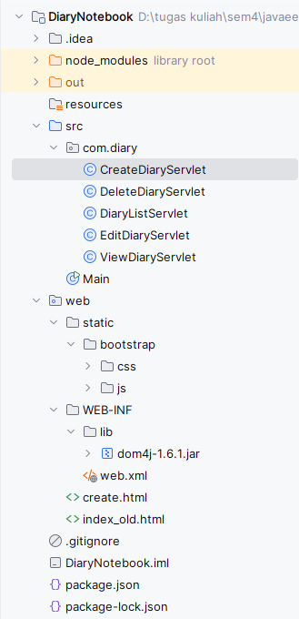
- Main page
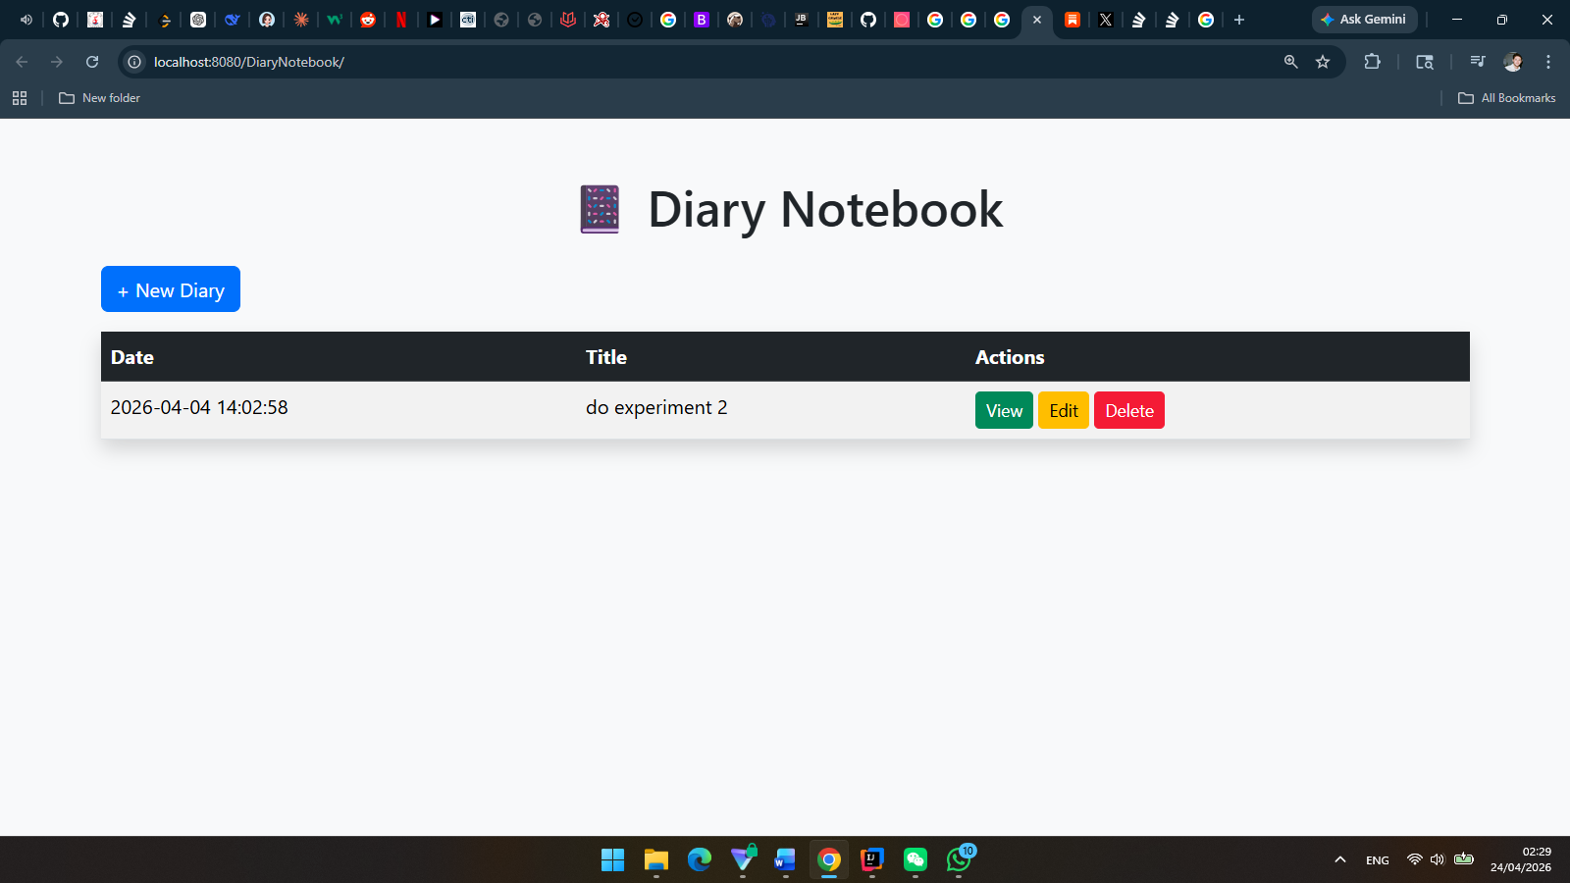
- Input page
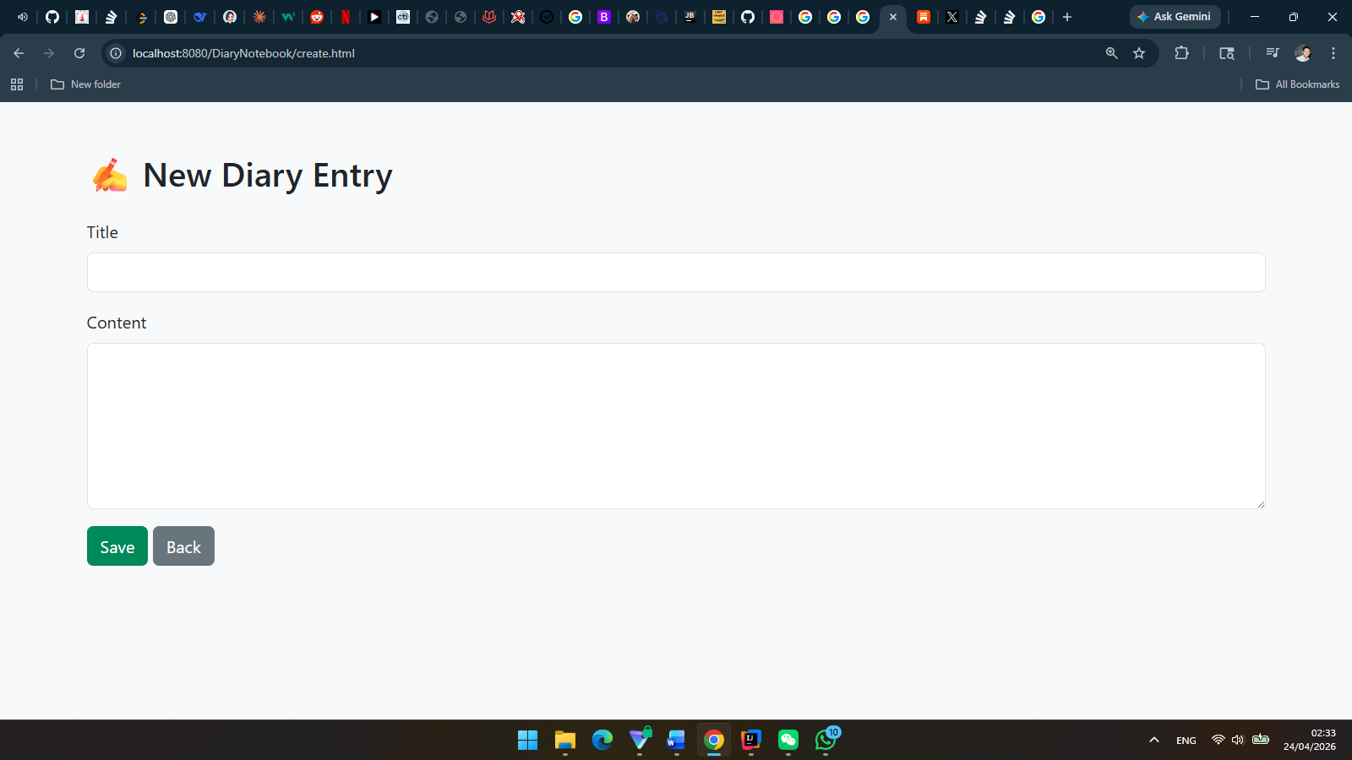
- Submitted form
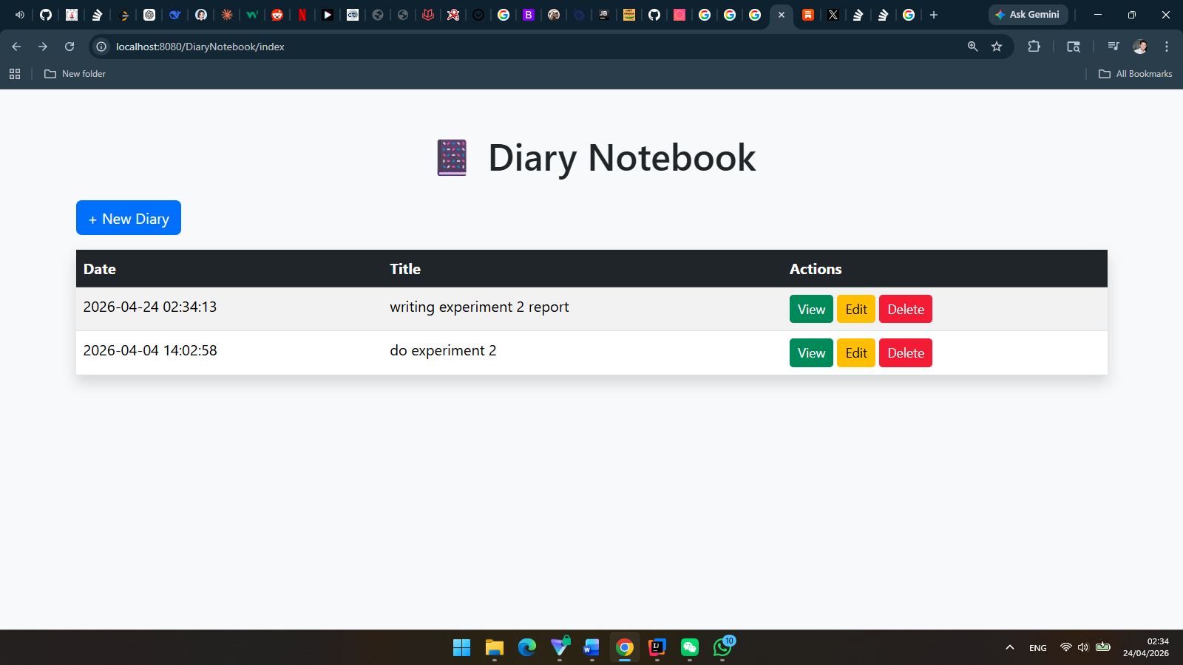
- Result page
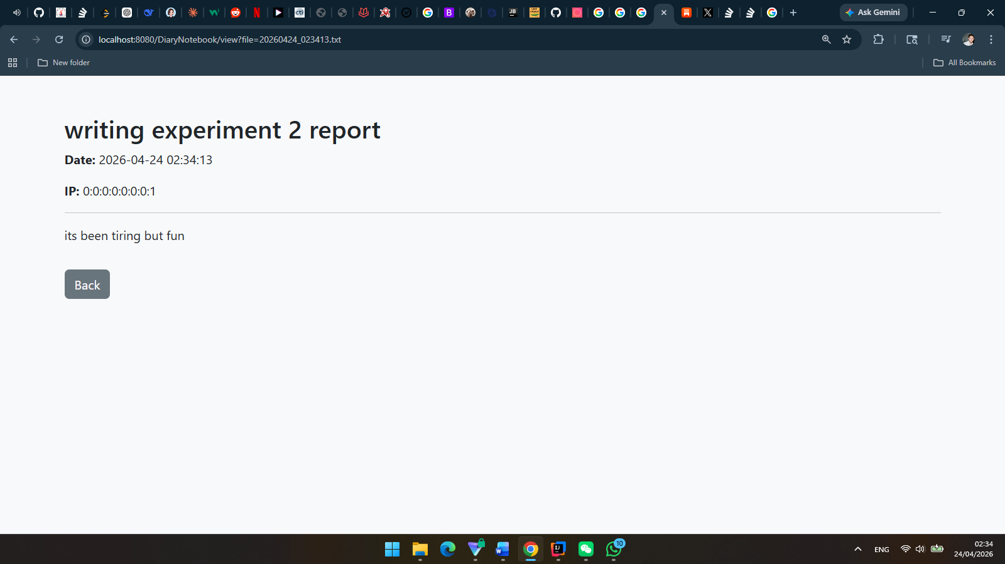
- Edit page
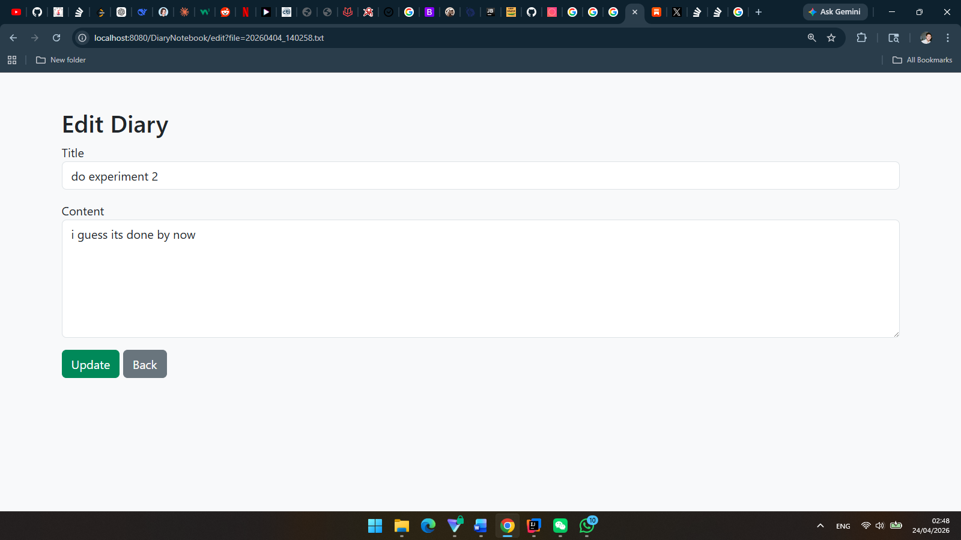
- Delete page
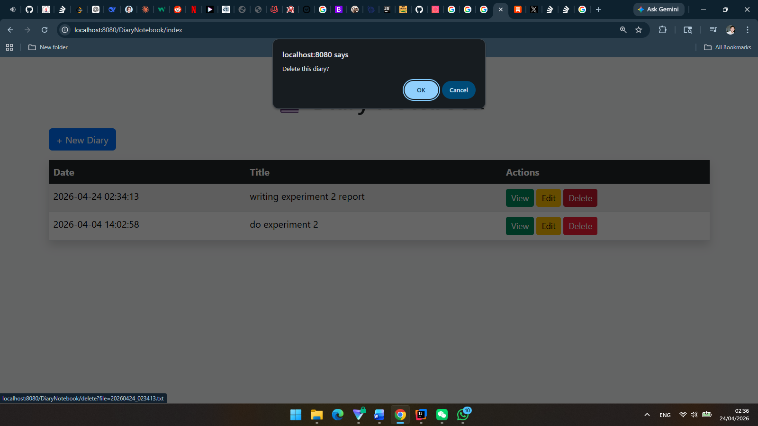
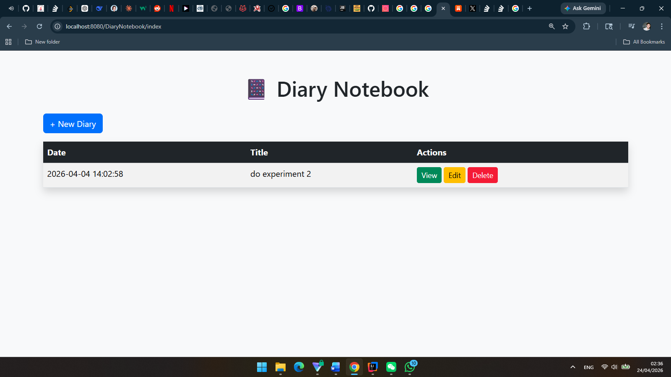

6. Problems Encountered and Solutions
Bug views where the elements like buttons are not well aligned, fixed it by using correct Bootstrap alignment class attribute. Delete button didn’t work, fixed it by taking a look at the console in web browser and the response in the code there was a misspell for the ID. Cannot retrieve the data, there was a typo in the parameter of getParameter() method.

7. Personal Reflection
Through this experiment, I have deepened my understanding about Servlet implementation in the web development. I have also acknowledged that the best strength of Java is in the web development by using Servlet programming, advanced web development can be done in this way.

Appendix: Required Screenshot Checklist
No. | Required Screenshot | Inserted?
1 | Project structure / Tomcat configuration | [Yes / No]
2 | HTML input page | [Yes / No]
3 | Form filled with sample data | [Yes / No]
4 | Result page after submission | [Yes / No]
5 | Error message page (if validation fails) | [Yes / No]
6 | Any additional page you want to show | [Yes / No]

Submission Notes
• Please keep your screenshots on a white background.
• Make sure all screenshots are clear and readable.
• Do not paste excessive repeated code; include only key parts.
• Write your explanations in complete sentences.

