Taizhou University
School of Artificial Intelligence
Laboratory Report

班级 24计算机（英） 学号 2462710034L 姓名 林樱

实验课程： Java EE Enterprise Development Technology
实验项目： Experiment 3: Session Technology Application

Experiment Date: 2026 年 8 月 5 日

1. Objective
- To understand the basic principles of session technology in Java Web applications.
- To learn how to use HttpSession to maintain user login status across multiple requests.
- To practice separating request processing from page presentation by using Servlet for business logic and HTML for page display.
- To implement conditional page behavior based on whether the user is logged in.
2. Experiment Task
- Based on the previous Diary assignment, improve the application by adding session-based user state management.
- This experiment should not use JSP, EL, or JSTL. Use Servlet, HttpSession, and HTML only.
- The diary application should respond differently according to whether the user is logged in.
3. Functional Requirements
- Use HttpSession to store and read the user login state.
- When the user is logged in, display a Delete button on the diary list page.
- When the user is not logged in, do not display the Delete button.
- After login, show the current username in an appropriate place on the page.
- Keep the request processing logic in Servlet and keep the page output clear and readable.
4. Student Report Content
4.1 Main Steps
- Describe the major steps of the experiment, such as project preparation, login design, session storage, login-state checking, page modification, and browser testing.
- Suggested length: 1-2 paragraphs or a numbered list.
[Write here]
4.2 Key Code
- Paste the most important code only, for example: login Servlet, session creation, session reading, conditional display logic, and username display.
- Add short explanations below each code block.
[Write here]
4.3 Screenshots of Results
- Insert screenshots of the diary list page before login, after login, the username display area, and any other important result pages.
- Keep screenshots clear and readable.
[Write here]
4.4 Difficulties and Solutions
- Briefly explain the main problems you encountered and how you solved them, such as session loss, wrong URL mapping, or incorrect login-state judgment.
[Write here]
5. Student Writing Pages
5.1 Main Steps
The experiment was done by following steps:
- Project preparation — the existing DiaryNotebook IntelliJ IDEA project (Jakarta EE, Tomcat) was opened and the web.xml welcome file was confirmed as the /index servlet.
- Login form design — a static login.html page was created with a username input field submitting via POST to the /login URL. No password field was required for this experiment.
- Session creation in LoginServlet — the doPost() method reads the username parameter, obtains or creates the HttpSession with request.getSession(), stores the username using session.setAttribute("user", username), then redirects to /index.
- Session reading in DiaryListServlet — at the top of doGet(), session.getAttribute("user") is called. If the result is non-null the user is treated as logged in; otherwise they are treated as a guest.
- Conditional page output — the DiaryListServlet generates different HTML depending on login state: the welcome message and Logout/Login button change, and the Delete button for each diary entry is only rendered when the user session is active.
- Logout implementation — LogoutServlet.doGet() calls session.invalidate() then redirects to /index, clearing all session data.
- Browser testing — the full CRUD cycle was tested both as a guest and after login to verify that session state controls button visibility correctly.
5.2 Key Code
LoginServlet.java — creates the session and stores the username

@WebServlet("/login")
public class LoginServlet extends HttpServlet {

protected void doPost(HttpServletRequest request,
HttpServletResponse response)
throws IOException {

String username = request.getParameter("username");

// Obtain or create the session for this user
HttpSession session = request.getSession();
// Store the username so other servlets can read it
session.setAttribute("user", username);

response.sendRedirect("index");
}
}

request.getSession() returns an existing session or creates a new one. session.setAttribute("user", username) makes the username available to every subsequent request within the same browser session.

DiaryListServlet.java — reads the session and controls conditional output

// 1. Read the session attribute
HttpSession session = request.getSession();
String user = (String) session.getAttribute("user");

// 2. Conditional header: show username or 'Not logged in'
if (user != null) {
out.println("<div>Welcome, <strong>" + user + "</strong></div>");
out.println("<a href='logout' class='btn btn-danger'>Logout</a>");
} else {
out.println("<div>Not logged in</div>");
out.println("<a href='login.html' class='btn btn-primary'>Login</a>");
}

// 3. Conditional Delete button inside the diary list loop
if (user != null) {
out.println("<a href='delete?file=" + file.getName() + "' ");
out.println("class='btn btn-sm btn-danger' ");
out.println("onclick=\"return confirm('Delete this diary?')\">Delete</a>");
}

session.getAttribute("user") returns null when no session exists or when the session was invalidated by logout. This single null-check drives all conditional display logic on the page.

LogoutServlet.java — invalidates the session

@WebServlet("/logout")
public class LogoutServlet extends HttpServlet {

protected void doGet(HttpServletRequest request,
HttpServletResponse response)
throws IOException {

HttpSession session = request.getSession();
session.invalidate(); // destroy all session data

response.sendRedirect("index");
}
}

session.invalidate() removes the session from the server's memory and causes the JSESSIONID cookie to become invalid. On the next request the list page will show 'Not logged in' and hide the Delete buttons.

DeleteDiaryServlet.java — server-side session guard

@WebServlet("/delete")
public class DeleteDiaryServlet extends HttpServlet {

protected void doGet(HttpServletRequest request,
HttpServletResponse response)
throws IOException {

HttpSession session = request.getSession();
String user = (String) session.getAttribute("user");

// Guard: redirect unauthenticated users away
if (user == null) {
response.sendRedirect("login.html");
return;
}

String fileName = request.getParameter("file");
String path = getServletContext().getRealPath("/diary");
File file = new File(path, fileName);
if (file.exists()) { file.delete(); }

response.sendRedirect("index");
}
}

Hiding the Delete button in HTML is a UI convenience only — it can be bypassed by crafting a direct URL. The session check in DeleteDiaryServlet is the real security guard: unauthenticated users who attempt direct access are redirected to the login page
5.3 Screenshots of Results
The following screenshots demonstrate the four key states of the running application:

Screenshot 1 | Guest view — diary list loads without login. No Delete buttons are shown. The top bar displays 'Not logged in' and a Login button.  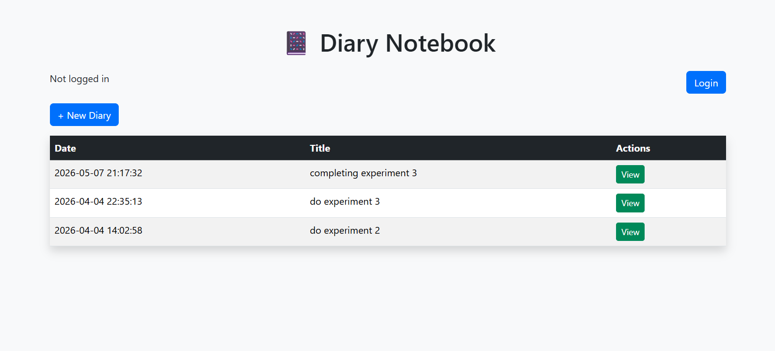
Screenshot 2 | Login page — static login.html with Bootstrap styling. Username field submits via POST to /login.  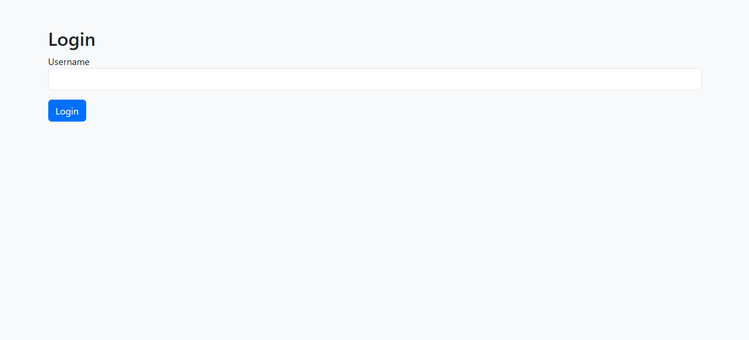
Screenshot 3 | Logged-in view — after login the top bar shows 'Welcome, [username]' and a Logout button. Each diary row now includes the red Delete button.  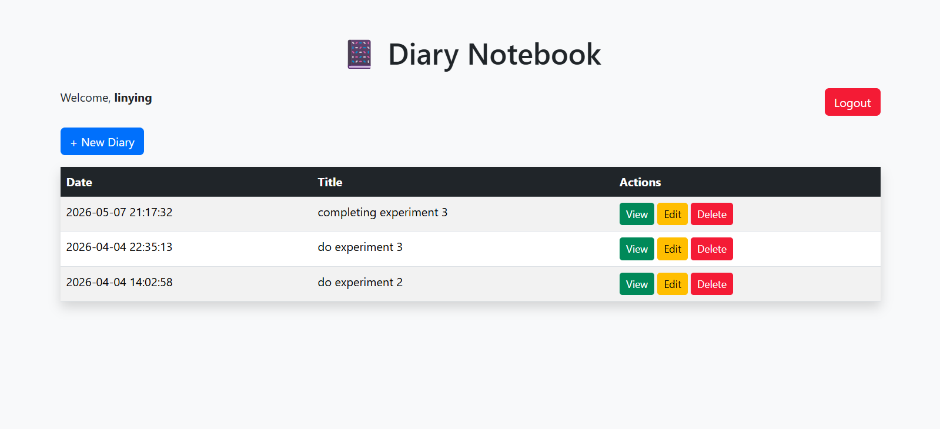
Screenshot 4 | After logout — session invalidated; page returns to the same appearance as Screenshot 1.  

5.4 Difficulties and Solutions
Problem 1: Delete button was always visible regardless of login state.
Cause: The conditional if (user != null) block in DiaryListServlet was commented out during early testing and never re-enabled.
Solution: Uncommented the if-block so the Delete button HTML is only emitted when session.getAttribute("user") returns a non-null value.

Problem 2: Unauthenticated users could still delete entries by typing the URL directly.
Cause: The original DeleteDiaryServlet had no session check — hiding the button in HTML is purely cosmetic.
Solution: Added a session guard at the top of doGet(): if user == null, redirect to login.html and return immediately before any file operation occurs.

Problem 3: Chinese characters in diary titles appeared as garbled text (mojibake).
Cause: request.setCharacterEncoding("UTF-8") was missing in CreateDiaryServlet and EditDiaryServlet, and the response content-type charset was not set in DiaryListServlet.
Solution: Added request.setCharacterEncoding("UTF-8") before reading any parameters, and set response.setContentType("text/html;charset=UTF-8") at the top of doGet() in DiaryListServlet.

Problem 4: The create.html Back button linked to index_old.html (the static prototype) instead of the live /index servlet.
Cause: The static HTML was written during the prototype stage before the servlet was implemented.
Solution: Changed the href from index_old.html to index so the Back button goes to the servlet-rendered diary list.
6. Teacher Check Area
Assessment Item | Result | Remarks
Session technology is used correctly | □ Good □ Pass □ Revise
Login state is maintained correctly | □ Good □ Pass □ Revise
Delete button display logic is correct | □ Good □ Pass □ Revise
Username display is correct | □ Good □ Pass □ Revise
Report is complete and clear | □ Good □ Pass □ Revise
Teacher Signature: ____________________
Date: ____________________

