Name : 林樱
Student ID : 2462710034L
Front-End Schedule Management System

Experiment Contents

Project structure
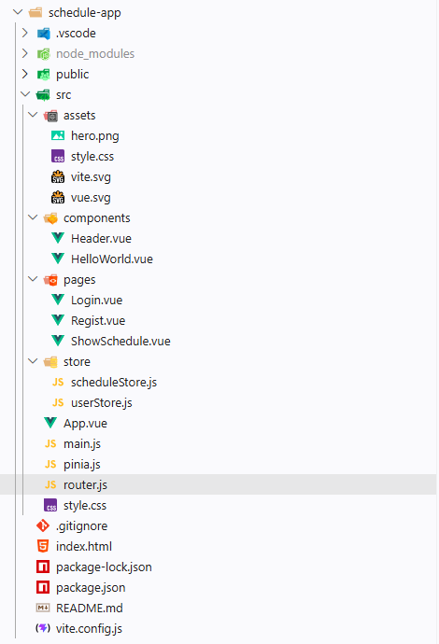

Running results
- Registration page
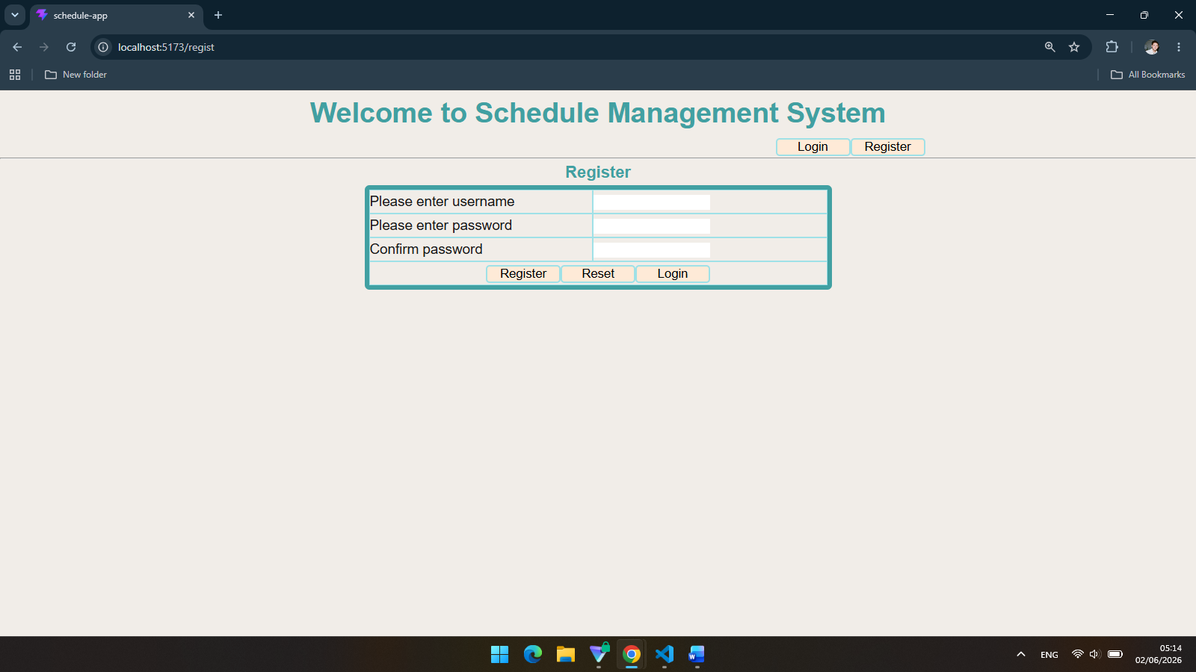
- Login page
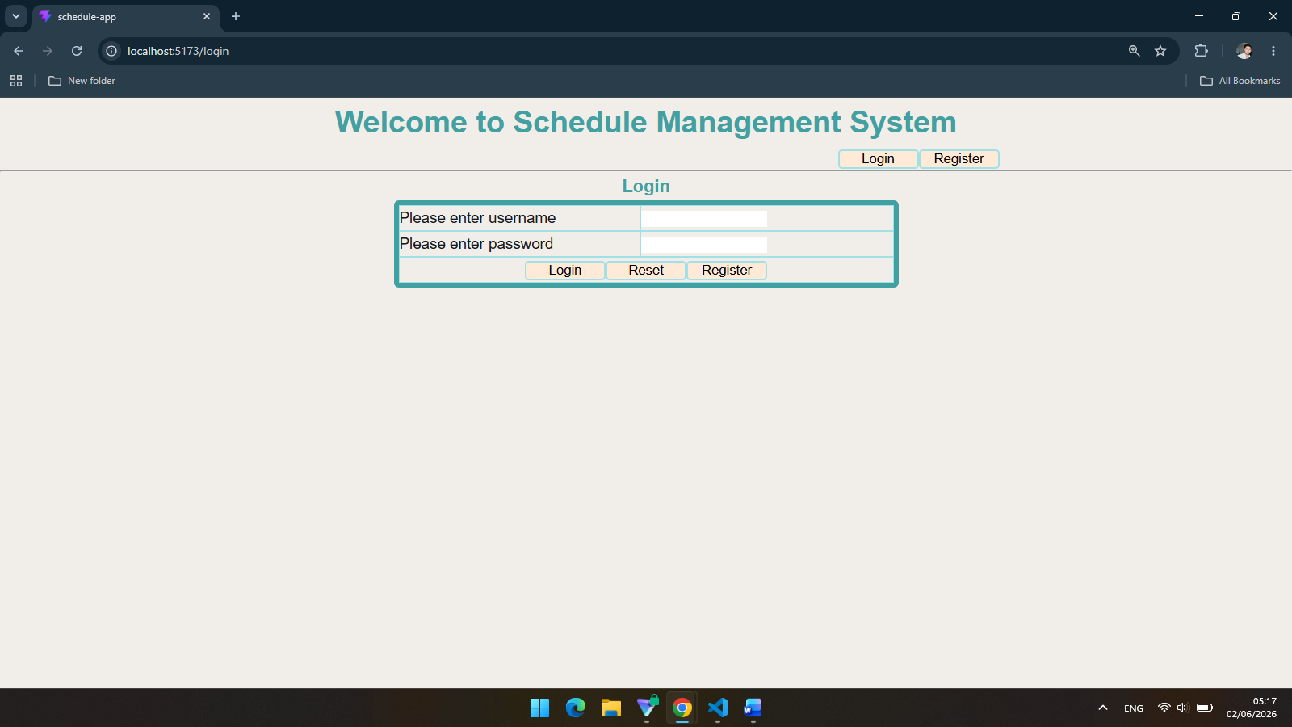
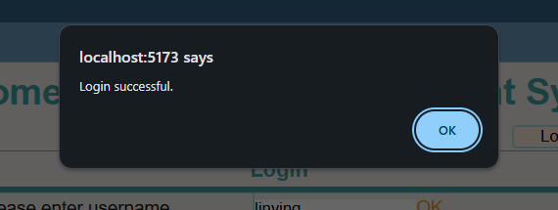
- Schedule list
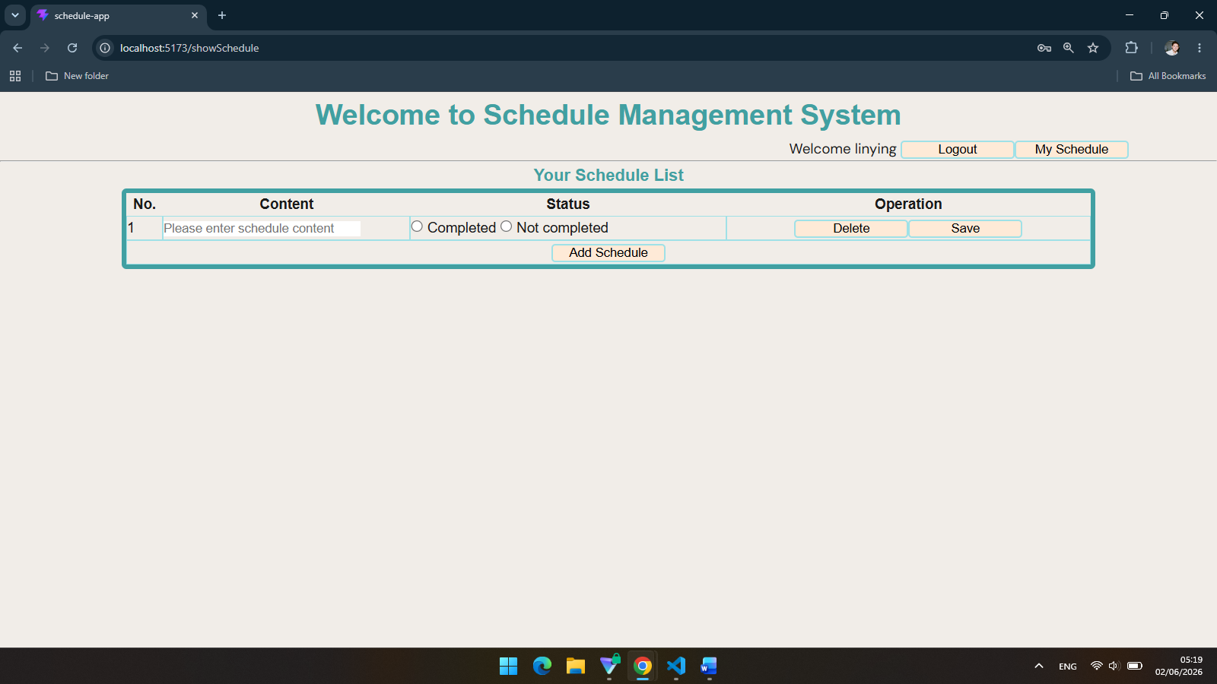

- Add schedule operation
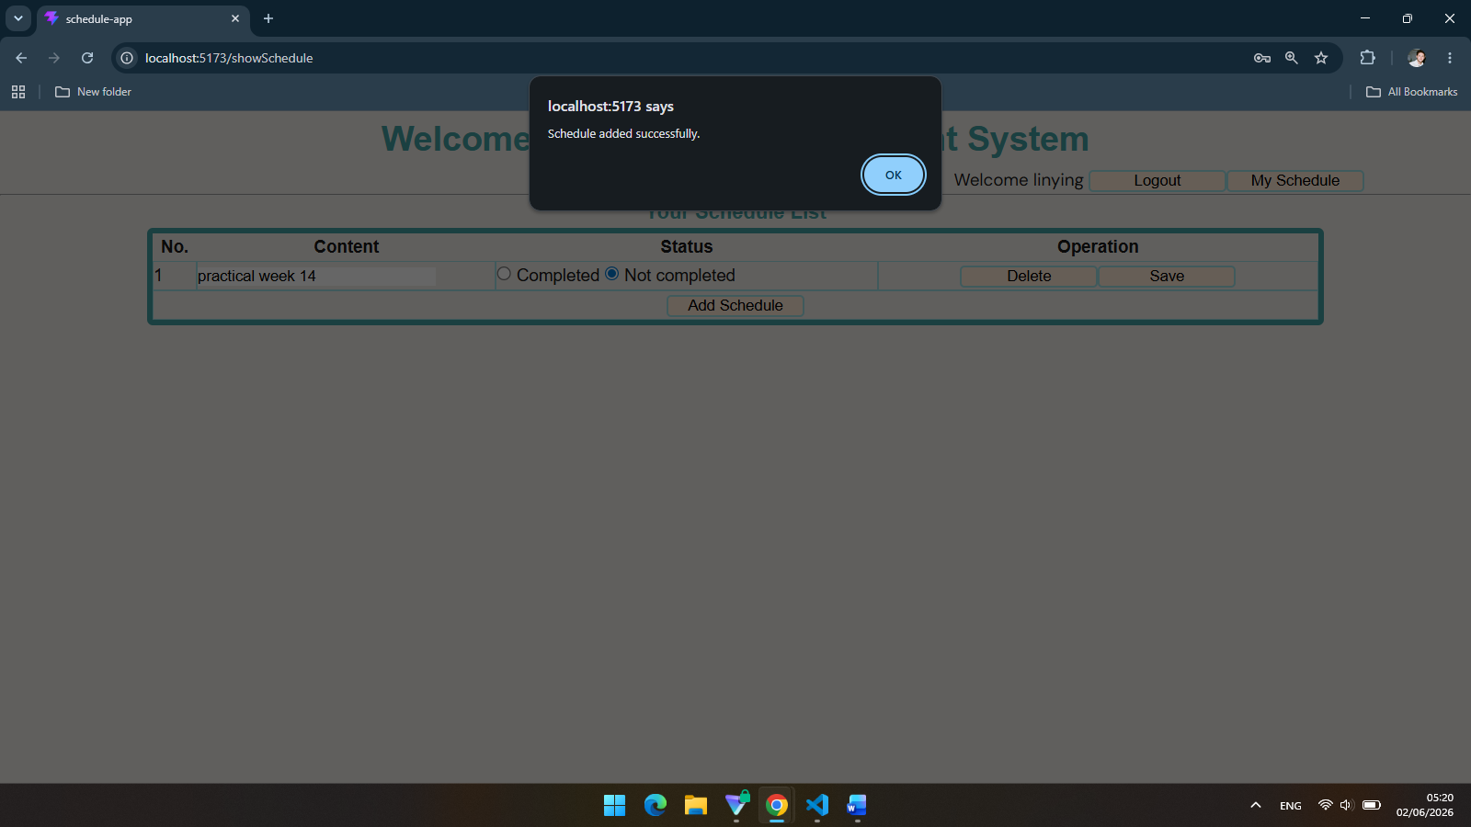
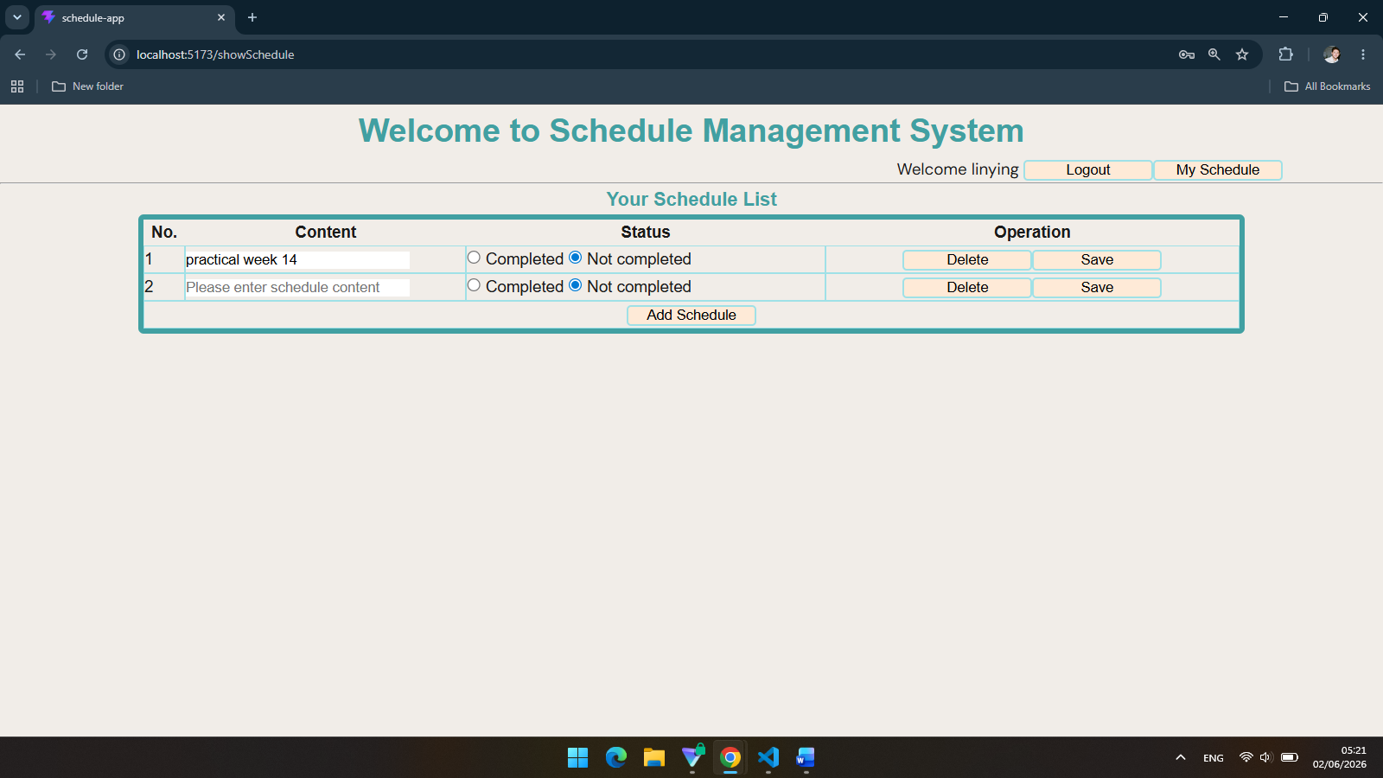

- Modify schedule operation
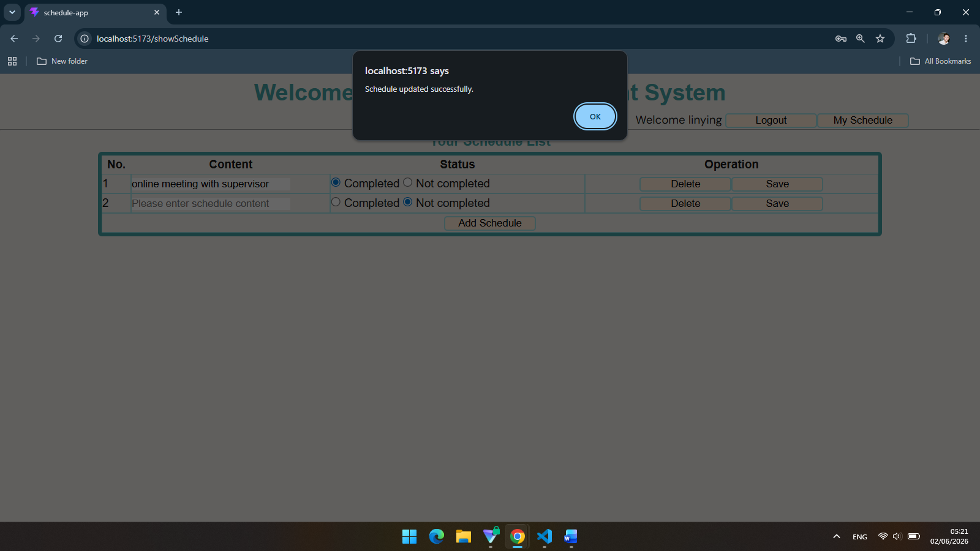
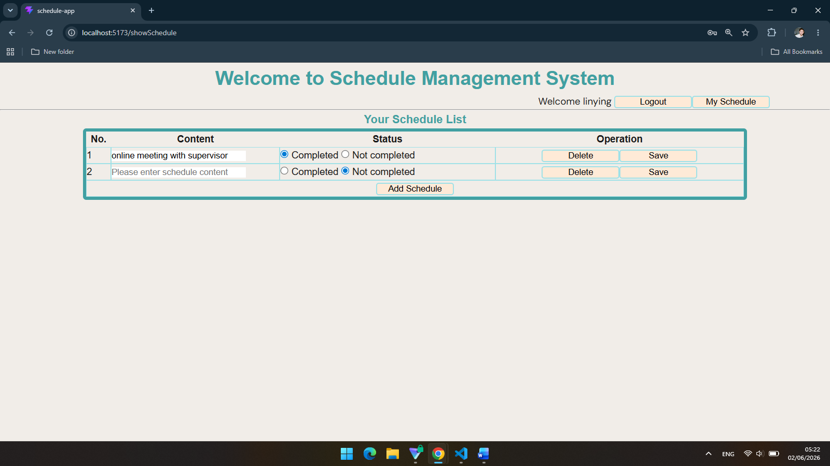

- Delete schedule operation
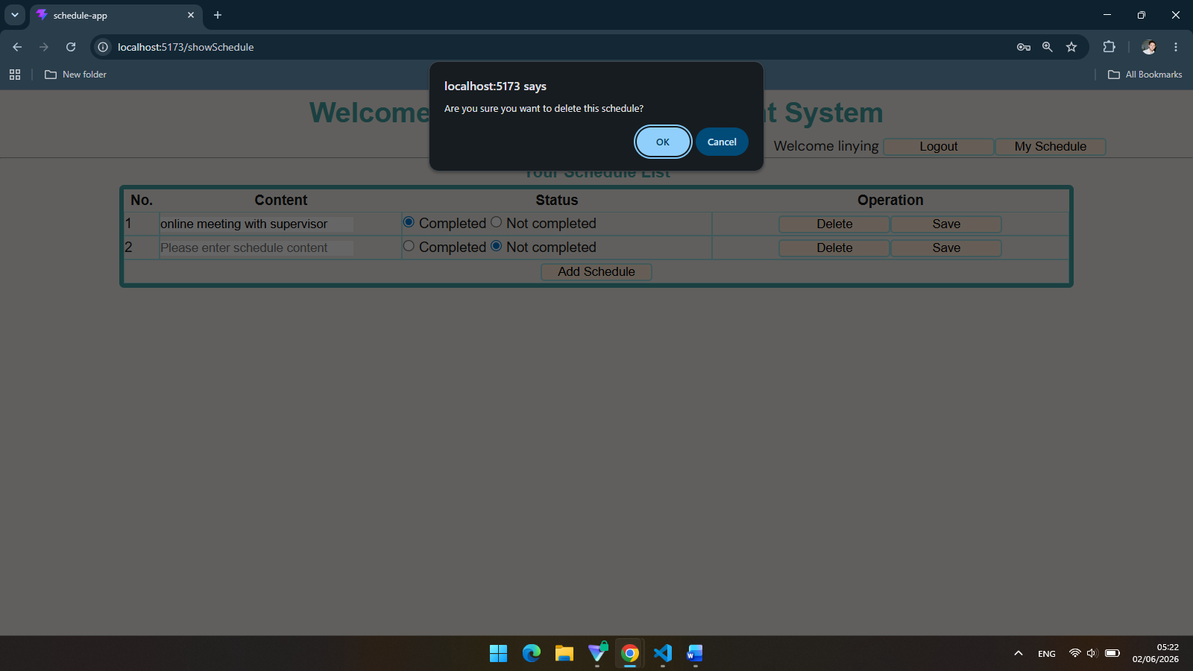
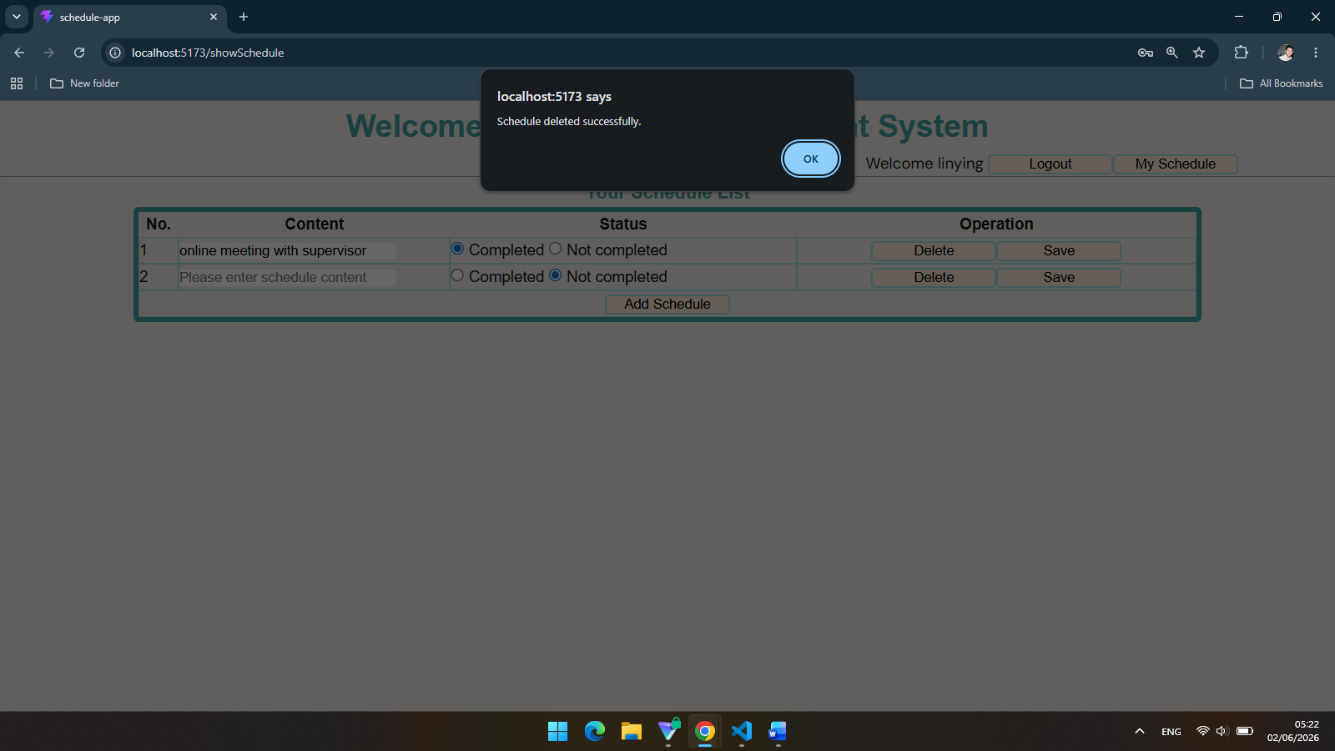
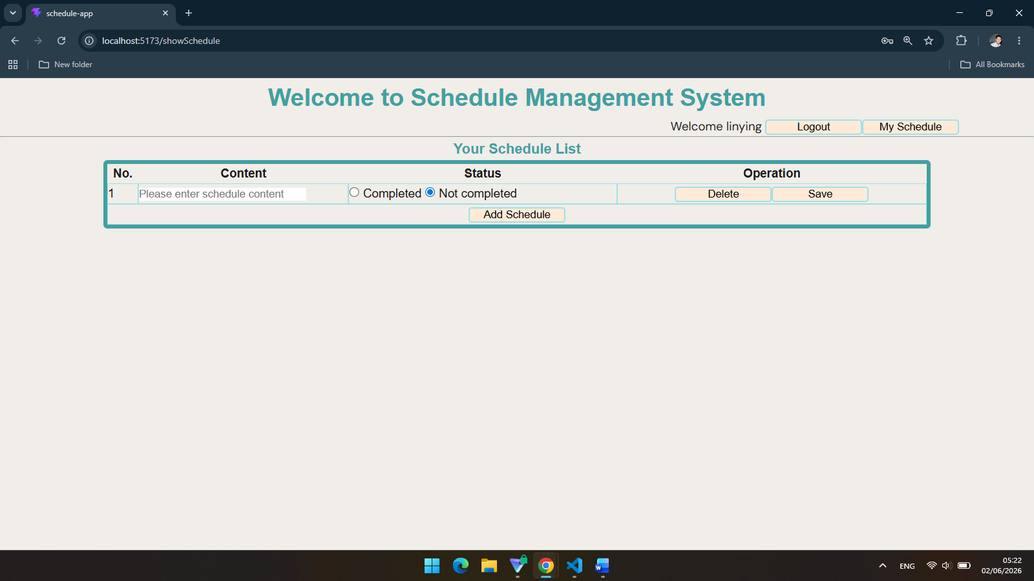

Problems and solutions
- Confusing between main.js with router.js that causing routing problem
Solution: created a new file router.js as the routers.
- The page didn’t load
Solution: there was a mistake for importing in router.js file for each views files, fixed it by changing to the correct directory.
- Inside the views files such as Login.vue, Regist.vue, ShowSchedule.vue, <tr> tag cannot be a child of <table> tag
Solution: putting <tr> tag inside <tbody> tag
- Pushed back to the login page after login successful.
Solution: newest version of Vue (Vue 4) recommends a different approach for routing which to use return a value instead of using next() method.

