DATA ANALYTICS

An Internship Report
Submitted by

VISHAL N Roll.no:963523243063

in partial fulfillment for the award of the degree of
Bachelor of Technology
in

B.Tech Artificial Intelligence and Data Science

STELLA MARY’S COLLEGE OF ENGINEERING
(An Autonomous Institution) Aruthenganvilai, Azhikal – 629202.

ANNA UNIVERSITY:: CHENNAI 600025

NOVEMBER 2025

- | P a g e

STELLA MARY’S COLLEGE OF ENGINEERING
(An Autonomous Institution) Aruthenganvilai, Azhikal – 629202. BONAFIDE CERTIFICATE
Certified that this Industrial Internship Training titled “Data Analytics: Turning Data into Decisions using python” undergone at “CSRBOX and IBM collaboration” is the bonafide work of “Vishal N (Reg. No: 963523243063)” who carried out the training work under my supervision. Certified further, that to the best of my knowledge the work reported here in does not form part of any other project report or dissertation on the basis of which a degree or award was conferred on an earlier occasion on this or any other candidate.

Period of Training: 23-12-2024 to 06-01-2025

SIGNATURE SIGNATURE
A.Selva Reegan R.Robert
HEAD OF THE DEPARTMENT INTERNSHIP COORDINATOR
Artificial Intelligence And Data Science Artificial Intelligence And Data Science Stella Mary’s College of Engineering, Stella Mary’s College of Engineering,
Aruthenganvilai,Azhikal – 629202 Aruthenganvilai,Azhikal - 629202

Submitted for the Industrial Internship Training viva-voce examination held at Stella Mary’s College of Engineering on ……..........

Internal Examiner External Examiner

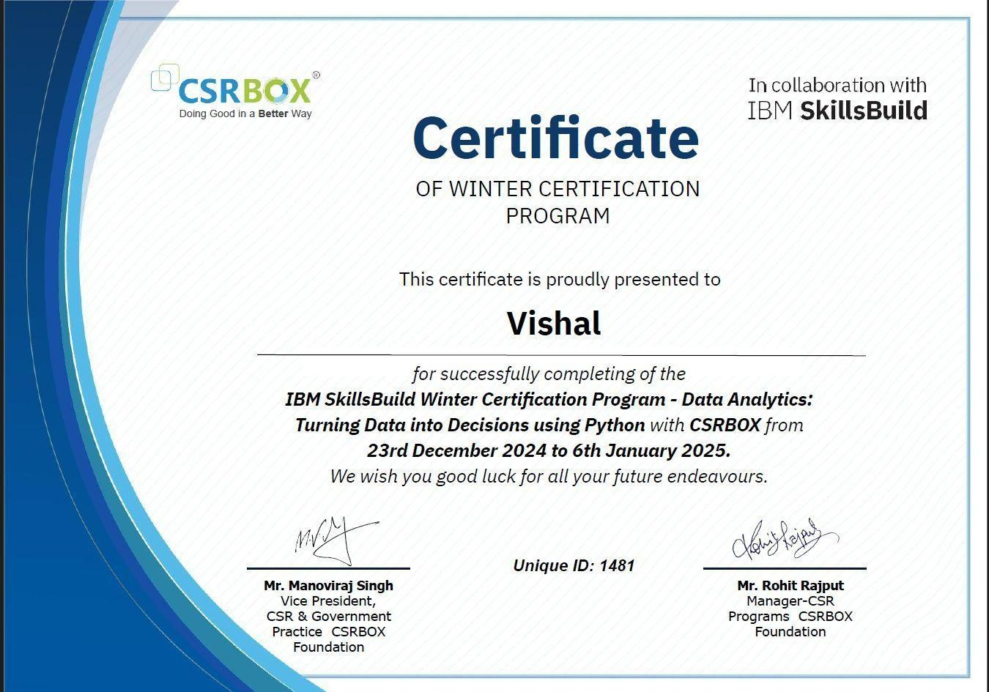
INTERNSHIP CERTIFICATE

DECLARATION

I “Vishal N (Reg. No: 963523243063)” hereby declare that the internship entitled “Data Analytics: Turning Data into Decisions using python” undergone at “CSRBOX and IBM collaboration (Online Mode)” being submitted in partial fulfilment of the requirements for the award of the Degree of “Data Analytics” is the original work carried out by me. It has not formed the part of any other project work submitted for award of any degree or diploma, either in this or any other Institution.
Period of Training: 23-12-2024 to 06-01-2025

Signature

Place: Aruthenganvilai Name: Vishal N
Date: 17-11-2025 Reg.No.: 963523243063

CO- PO & PSO MAPPING

CO1: Industry Practices, Processes, Techniques, technology, automation and other core aspects of Software industry
CO2: Analyze, Design solutions to complex business problems
CO3: Build and deploy solutions for target platform
CO4: Preparation of Technical reports
CO5: Preparation of Technical presentation

 | PO1 | PO2 | PO3 | PO4 | PO5 | PO6 | PO7 | PO8 | PO9 | PO10 | PO11 | PO12
CO1 | 1 | 1 | 1 | - | 1 | - | - | 2 | 2 | 2 | - | -
CO2 | 1 | 1 | 2 | 2 | 1 | 1 | 1 | 2 | 2 | 2 | - | -
CO3 | 1 | 1 | 2 | 2 | - | - | - | 1 | - | 2 | 1 | -
CO4 | 1 | 1 | - | - | 2 | - | - | - | - | - | - | -
CO5 | 1 | 1 | - | - | 2 | - | - | - | - | - | - | -

 | PSO1 | PSO2 | PSO3
CO1 | 2 | 3 | 1
CO2 | 2 | 2 | 3
CO3 | 1 | 2 | 2
CO4 | 2 | - | -
CO5 | 2 | 1 | -

EXECUTIVE SUMMARY

IBM, in collaboration with CSRBOX, runs the SkillsBuild Winter Internship Program, a national initiative designed to empower students with industry- relevant skills in technology and data-driven fields. As a global leader in enterprise technology, IBM provides the technical curriculum, tools, and training resources, while CSRBOX, one of India’s leading social impact consulting organizations, facilitates structured learning, mentoring, and real- world project exposure for students. Together, the two organizations offer a comprehensive virtual internship program that focuses on practical knowledge, employability, and hands-on skill development in data analytics.

I participated in this virtual Data Analytics Internship, which included two weeks of lecture-based training followed by two weeks of hands-on practical work. During the training phase, I learned core concepts of data analytics, Python programming, data preprocessing, exploratory data analysis (EDA), and working with structured and unstructured datasets through guided sessions and industry-oriented modules.

In the practical phase of the internship, I worked with real-time datasets, applying Python functions, performing data cleaning, handling missing values, visualizing trends, and identifying meaningful insights. These tasks helped me understand how data behaves in real-world scenarios and how analytical techniques are applied in professional environments.

As part of the program, I developed a final data analytics project, where I implemented the complete workflow from loading the dataset and preprocessing to analysis, visualization, and conclusion. I documented the entire process and presented my findings through a PowerPoint presentation to the program facilitators as part of the internship completion requirement.

Through this internship, I gained valuable experience in Python for data analytics, data handling, visualization, analytical thinking, documentation, and professional presentation skills. I also improved my time management, virtual collaboration skills, and understanding of how industrial data analytics pipelines operate. Overall, the SkillsBuild Winter Internship Program has given me a strong foundation and boosted my confidence to take on future data-driven projects in academic and organizational environments.

ACKNOWLEDGMENT

I wish to express my sincere thanks to our parents and almighty, the supreme guide whose continuous grace and mercy see me through each day and have given courage in the undertaking of this internship training.

My sincere thanks goes to the Chairman Dr.Nazereth Charles Ex.Indian Navy, for his encouragement and for rendering a platform for completing the internship in the successful manner.

I wish to record my sincere gratitude to Dr.J.Jenix Rino M.E., M.B.A., PhD,
Director for his constant encouragement and kind support in all our endeavors.

My grateful to thank Dr.R.Suresh Premil Kumar M.E, PhD., principal for giving a source of inspiration throughout our study in the college.

It's our solace to thank Dr.Selva Reegan, Head of the Department for his continuous encouragement and sustained interest in completion of my internship.

I extend my thanks to Mohamour Internal Guide for his inspiring guidance and valuable advices in doing this internship.

I also thank our institution and our faculty members without whom this internship would have been a distant reality.

Last but not least I thank all our friends and well-wishers who helped us during the internship duration.

TABLE OF CONTENT

CHAPTER NO. | TITLE | PAGE NO.
 | Certificate | i
 | Company Certificate | ii
 | Declaration | iii
 | CO- PO & PSO Mapping | iv
 | Executive Summary | v
 | Acknowledgment | vi
1. | Introduction | 1
 | 1.1 Background | 2
 | 1.2 Objectives | 3
 | 1.3 Scope
2. | Profile
 | 2.1 Industry Profile
 | 2.2 Industry Culture
3. | Internship Details
 | 3.1 Internship Duration, Department &Industry Supervisor Details
 | 3.2 Responsibilities
4. | Project **
4.1 Work 1: ( Project Overview, Technologies Used, Project Implementation, Challenges Faced, Key Takeaways and screen
shots/photos )
 | 4.2 Work 2: ( Project Overview, Technologies Used, Project Implementation, Challenges Faced, Key Takeaways and screen shots/photos )

5. | Skills Acquired ( Technical Skills, Soft Skills)
6. | Conclusion
 | References (Chronological Order)

CHAPTER 1 : INTRODUCTION

Background
Internships serve as a vital bridge between academic learning and real-world industrial exposure, particularly in rapidly evolving domains such as Artificial Intelligence, Data Science, and Data Analytics. As organizations across the world increasingly rely on data-driven decision-making, students must develop industry- ready analytical skills, familiarity with practical tools, and an understanding of real-time workflows beyond classroom concepts. Internships help students gain this essential exposure by engaging them in structured tasks, professional environments, collaborative learning, and hands-on problem solving aligned with industry expectations.

The IBM–CSRBOX SkillsBuild Winter Internship Program is a nationally recognized initiative that empowers students by providing high-quality training in trending technologies. IBM, a global leader in enterprise technology, AI systems, and cloud solutions, provides the technical curriculum, while CSRBOX, India’s largest development sector platform, facilitates structured learning, mentoring, and project evaluation. The collaboration ensures that students gain both theoretical understanding and practical exposure to real-world datasets, analytical workflows, and professional documentation practices.
The Data Analytics internship conducted under this program introduced me to essential analytics concepts, data preprocessing methods, problem-solving strategies, and Python-based data manipulation activities. The guided sessions, combined with real-time tasks and a final project, helped me understand the life cycle of data analytics, the importance of accuracy in datasets, and the relevance of visualization in business and research environments. Through this internship, I developed strong analytical thinking, technical discipline, and an improved understanding of how data science functions inside an organizational and industrial ecosystem.

Objectives
The main objectives of this internship are:
    - To gain real-world exposure to analytical workflows, data handling procedures, and Python-based data analysis.
    - To understand the fundamentals of data preprocessing, visualization, and dataset exploration using modern tools.
    - To apply theoretical knowledge of Python programming in practical data-related tasks.
    - To learn how to interpret datasets and extract meaningful insights through Exploratory Data Analysis (EDA).

    - To develop professional documentation skills by preparing structured reports and project presentations.
    - To become familiar with virtual collaboration models followed in modern industries.
    - To build confidence, analytical clarity, and readiness to handle data-centric projects independently.

Scope

The scope of this internship includes structured learning and application of core data analytics processes. It covers:
    - Introduction to analytic thinking and problem-solving approaches.
    - Python programming concepts relevant to data handling.
    - Working with datasets involving numerical, categorical, and real-time values.
    - Data cleaning techniques such as handling missing values, converting types, and removing duplicates.
    - Exploratory Data Analysis (EDA) using descriptive statistics and visualizations.
    - Creation of data insights through graphs, correlations, and pattern observations.
    - Preparation of a complete final project covering end-to-end workflow from dataset loading to insight generation.
    - Presentation of project findings through a professionally structured PowerPoint.

CHAPTER 2 : PROFILE

Industry Profile

IBM (International Business Machines Corporation) is one of the world’s most established and globally recognized technology enterprises. With more than a century of innovation, IBM leads in emerging technologies such as artificial intelligence (IBM Watson), cloud computing, data analytics, cybersecurity, and enterprise systems. IBM has significantly contributed to shaping the global digital economy through research-driven development and large-scale technology solutions used by governments, industries, and organizations worldwide.
CSRBOX is India’s largest social impact consulting and skill development organization. It partners with multinational companies, government bodies, education institutions, and training agencies to provide scalable learning and capacity-building programs. Together with IBM, CSRBOX implements the SkillsBuild Internship, a structured national-level program that equips students with job-ready technical skills and hands-on project experience.

Industry Culture

The internship program followed a professional, structured, and industry-simulated

culture. The environment emphasized:
    - Self-learning and independent task execution, similar to modern data analytics roles.
    - Clear communication and documentation, ensuring every activity is well tracked.
    - Consistency in workflow, guiding students to complete tasks within defined timeframes.
    - Analytical clarity and accuracy, focusing on correct interpretation and clean data handling.
    - Collaborative virtual learning, facilitating interactions through online platforms, mentor instructions, and shared study resources.

CHAPTER 3 : INTERNSHIP DETAILS

Internship Duration, Department & Supervisor Details
This internship was conducted under the Data Analytics Department of the IBM– CSRBOX SkillsBuild Winter Internship Program.
    - Mode: Virtual (Online)
    - Duration: 4 Weeks
      - 2 Weeks – Technical lectures and concept-based training
      - 2 Weeks – Practical hands-on project work
    - Platform: IBM SkillsBuild Portal, CSRBOX Learning Environment
    - Domain: Data Analytics using Python

Responsibilities
    - Attending technical training sessions on Python and data analytics concepts.
    - Completing module-wise assessments and tasks.
    - Loading, inspecting, and cleaning datasets using Python.
    - Applying preprocessing techniques to manage missing values and inconsistencies.
    - Performing Exploratory Data Analysis (EDA) to understand dataset patterns.
    - Generating visualizations such as bar charts, line graphs, scatter plots, and correlation maps.
    - Documenting findings, observations, and analysis results in a structured format.
    - Preparing a complete final project covering methodology, analysis, insights, and conclusion.
    - Presenting the final project via PowerPoint to the evaluation panel.

CHAPTER 4 : PROJECT WORK

Work 1: Data Analytics Mini Tasks Project Overview:

The first part of the internship involved introductory data analysis tasks designed to help develop familiarity with basic Python operations, dataset structures, and preprocessing logic.
Technologies Used:
Python, Pandas, NumPy, Matplotlib, Seaborn, Jupyter.
Challenges:
- Handling missing data.
- Identifying suitable plots.
- Ensuring structured and readable code.
Key Takeaways:
Improved Python usability, clarity in data cleaning, and enhanced analytical thinking.

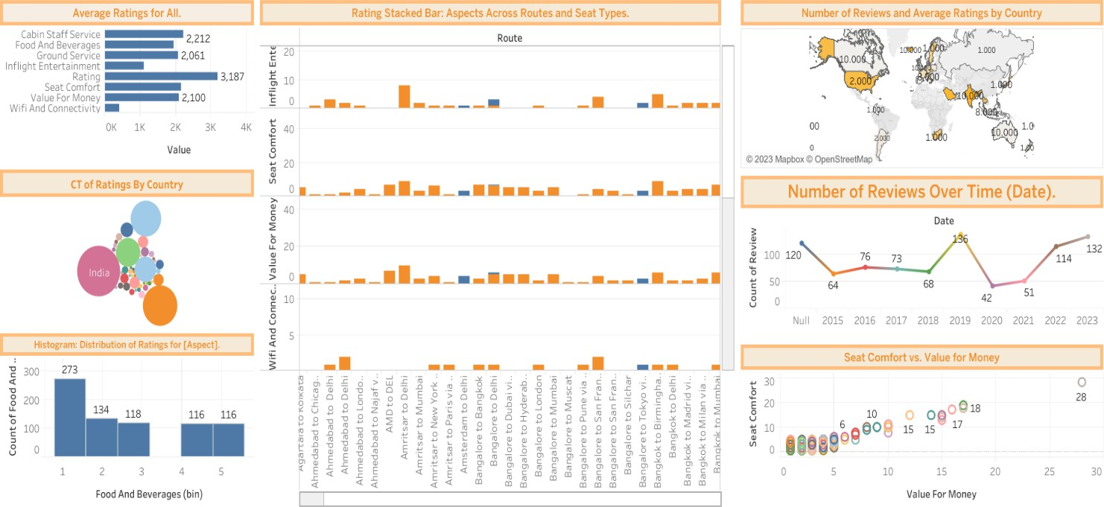

Work 2: Final Data Analytics Project Project Overview:
The final project focused on analyzing a real-world dataset and performing complete data analytics workflow from data loading to visualization and insight extraction.

Implementation Steps:
    - Dataset loading and inspection
    - Data cleaning and preprocessing
    - Exploratory Data Analysis
    - Visualization
    - Insights and interpretations
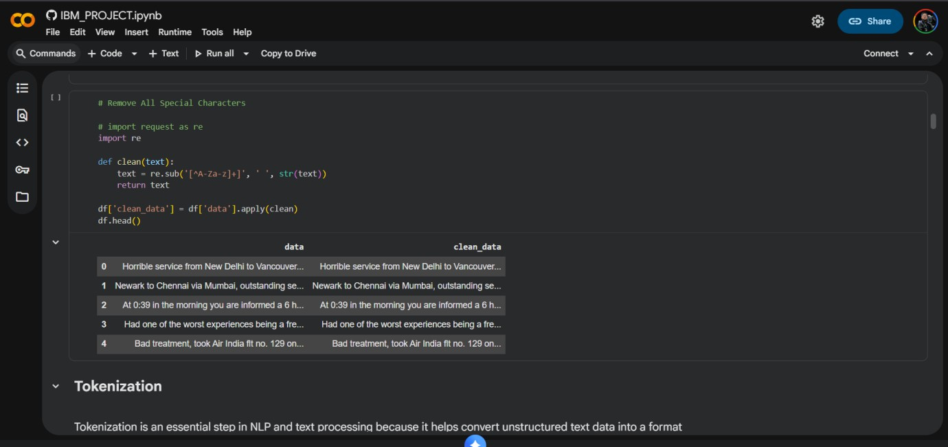
    - Project documentation and PPT presentation

CHAPTER 5 : SKILLS ACQUIRED
Technical Skills:
    - Python Programming
    - Data Cleaning
    - Exploratory Data Analysis
    - Data Visualization
    - Documentation & Reporting
Soft Skills:
    - Time Management
    - Analytical Reasoning
    - Communication

- Professional Discipline
- Adaptability

6 Conclusion
The IBM–CSRBOX Data Analytics Internship was a valuable learning experience that enhanced my technical, analytical, and professional capabilities. It helped me gain confidence in real-world data handling and prepared me for future opportunities in the field of Data Science and AI.

References:

- IBM SkillsBuild – Data Analytics Learning Modules, 2024
- CSRBOX Program Resources and Training Materials, 2024
- IBM Python-Based Data Analytics Reference Guides, 2024
- SkillsBuild Webinar & Mentor Instructions, 2024
- Final Project Evaluation Templates – IBM–CSRBOX Internship Program, 2024
- Orientation session of this Internship Program - https://www.youtube.com/live/C8eud91gD1Q?si=abuvOJTf8yNRJjiK

