**Team Details :**

* Daksh Aghera (ET22BTIT001)
* Jenish Barvaliya (ET22BTIT005)
* Jay Chaudhari (ET22BTIT011)
* Harshil Gajipara (ET22BTIT030)
* Bautik Gauswami (ET22BTIT033)

# ABSTRACT

Our project **Hospital Management system** includes registration of patients, storing their details into the system, and also booking their appointments with doctors.

Our software has the facility to give a unique id for every patient and stores the details of every patient and the staff automatically. User can search availability of a doctor and the details of a patient using the id. The Hospital Management

System can be entered using a username and password. It is accessible either by an administrator or receptionist. Only they can add data into the database. The data can be retrieved easily. The interface is very user-friendly. The data are well protected for personal use and makes the data processing very fast.

It is having mainly two modules. One is at Administration Level and other one is of user I.e. of patients and doctors. The Application maintains authentication in order to access the application. Administrator task includes managing doctors information, patient’s information. To achieve this aim a database was designed one for the patient and other for the doctors which the admin can access. The complaints which are given by user will be referred by authorities.

The Patient modules include checking appointments, prescription. User can also pay doctor’s Fee online.

**Table of Contents**

|  |  |  |
| --- | --- | --- |
| **SNO** | **TOPIC** | **Page No** |
| 1. | PROBLEM STATEMENT | 9 |
| 2. | PROCESS MODEL | 11 |
| 3. | SOFTWARE REQUIREMENTS  SPECIFICATION | 15 |
| 4. | CONTEXT LEVEL DIAGRAM | 18 |
| 5. | DFD LEVEL 1 | 19 |
| 6. | DFD LEVEL 2 | 20 |
| 7. | USE CASE DIAGRAM | 24 |
| 8. | USE CASE DESCRIPTION | 25 |
| 9. | DATA DICTIONARY | 35 |
| 10. | ER DIAGRAM | 36 |
| 11. | DATA DESIGN | 37 |
| 12. | COMPONENT LEVEL DIAGRAM | 40 |
| 13. | PROJECT SCHEDULING | 44 |
| 14. | TIMELINE CHART | 45 |
| 15. | FUNCTION POINT METRICS | 46 |
| 16. | COCOMO MODEL | 52 |
| 17. | SAMPLE SCREENSHOTS | 56 |
| 18. | RISK ANALYSIS | 68 |
| 19. | TESTING | 69 |
| 20. | CONCLUSION | 74 |

**LIST OF FIGURES USED IN THE PROJECT**

|  |  |  |
| --- | --- | --- |
| **FIGURE_NO** | **NAME** | **PAGE No** |
| 2.1 | CONTEXT LEVEL DFD | 18 |
| 2.2 | LEVEL – 1 DFD | 19 |
| 2.3 | LEVEL – 2 REGISTRATION | 20 |
| 2.4 | LEVEL – 2 LOGIN | 20 |
| 2.5 | LEVEL – 2 MAKE APPOINTMENT | 21 |
| 2.6 | LEVEL – 2 ADD DESCRIPTION | 21 |
| 2.7 | LEVEL – 2 DOCTOR MODULE | 22 |
| 2.8 | LEVEL – 2 PAYMENT | 22 |
| 2.9 | LEVEL – 2 CANCEL APPOINTMENT | 23 |
| 2.10 | LEVEL – 2 PAITENT MODULE | 23 |
| 6.1 | HOME PAGE | 57 |
| 6.2 | SELECT LOGIN | 57 |
| 6.3 | PATIENT LOGIN PAGE | 58 |
| 6.4 | REGISTRATION | 58 |
| 6.5 | PATIENT PROFILE | 59 |
| 6.6 | PATIENT UPDATE DETAILS | 59 |
| 6.7 | PATIENT BOOK APPOINTMENT | 60 |
| 6.8 | PATIENT APPOINTMENT STATUS | 60 |
| 6.9 | PATIENT CANCEL APPOINTMENT | 61 |
| 6.10 | PAYMENT | 61 |
| 6.11 | PATIENT PAYMENT RECIPET | 62 |
| 6.12 | PATIENT VIEW PAYMENT HISTORY | 62 |
| 6.13 | PATIENT VIEW DOCTORS | 63 |
| 6.14 | DOCTOR LOGIN PAGE | 63 |
| 6.15 | DOCTOR PROFILE | 64 |
| 6.16 | DOCTOR VIEW APPOINTMENT | 64 |
| 6.17 | DOCTOR ADD DESCRIPTION | 65 |
| 6.18 | ADMIN LOGIN PAGE | 65 |
| 6.19 | ADMIN ADD DOCTOR | 66 |
| 6.20 | ADMIN UPDATE DOCTOR DETAILS | 66 |
| 6.21 | ADMIN PAYMENT REQUEST | 67 |
| 6.22 | ADMIN VIEW RECORDS | 67 |

**LIST OF TABLES USED IN THE PROJECT**

|  |  |  |
| --- | --- | --- |
| **TABLE NO** | **NAME** | **PAGE NO** |
| 4.1 | DATA DICTIONARY | 38 |
| 4.2 | PATIENT | 40 |
| 4.3 | APPOINTMENT | 40 |
| 4.4 | DOCTOR | 41 |
| 4.5 | PRESCRIPTION | 41 |
| 4.6 | ADMIN | 42 |
| 4.7 | BILL | 42 |
| 5.1 | PROJECT SCHEDULING | 44 |
| 5.2 | TIMELINE CHART | 45 |
| 5.3 | FUNCTION POINT COMPLEXITY WEIGHTS | 49 |
| 5.4 | COCOMO II COMPLEXITY WEIGHTS | 52 |
| 5.5 | PRODUCTIVITY RATE FOR OBJECT POINT COUNTS | 53 |
| 7.1 | RISK ANALYSIS | 68 |

# PROBLEM STATEMENT

In this busy world we don’t have the time to wait in infamously long hospital queues. The problem is, queuing at hospital is often managed manually by administrative staff, then take a token there and then wait for our turn then ask for the doctor and the most frustrating thing - we went there by traveling a long distance and then we come to know the doctor is on leave or the doctor can’t take appointments.

HMS will help us overcome all these problems because now patients can book their appointments at home, they can check whether the doctor they want to meet is available or not. Doctors can also confirm or decline appointments, this help both patient and the doctor because if the doctor declines’ appointment then patient will know this in advance and patient will visit hospital only when the doctor confirms’ the appointment this will save time and money of the patient.

Patients can also pay the doctor’s consultant fee online to save their time.

HMS is essential for all healthcare establishments, be it hospitals, nursing homes, health clinics, rehabilitation centers, dispensaries, or clinics. The main goal is to computerize all the details regarding the patient and the hospital. The installation of this healthcare software results in improvement in administrative functions and hence better patient care, which is the prime focus of any healthcare unit.

**Benefits of implementing a hospital management system:**

* ***Appointment booking***o Helps patients cut the long queue and saves their time o Is equipped with features like automated email and text message reminders
* ***Role-Based Access Control***o Allows employees to access only the necessary information to effectively perform their job duties
  + Increases data security and integrity

* ***Overall cost reduction***o Cuts down paper costs as all the data are computerized o No separate costs for setting up physical servers

* ***Data accuracy***o Removes human errors
  + Alerts when there’s a shortage of stock

* ***Data security***o Helps to keep patients records private o Restricts access through role-based access control

* ***Revenue management***
  + Makes daily auditing simple
  + Helps with statistics and other financial aspects

**PROCESS MODEL**

**Hospital Management System follows INCREMENTAL MODEL** because initially software requirements are reasonably well defined but the overall scope of development effort is a purely linear process. There may be other requirements of the user which will be known later. So, those requirements can the implemented and delivered in the following next increments. Our project is a short term project of 3 months and 3 weeks only and staffing available is also low (3 persons).

# CHAPTER 1 INTRODUCTION

1.1 PURPOSE

1.2 SCOPE

1.3 DEFINITIONS, ACRONYMS, and ABBREVIATIONS

1.4 REFERENCES

1.5 OVERVIEW

## 1.1 PURPOSE

This software will help the company to be more efficient in registration of their patients and manage appointments, records of patients. It enables doctors and admin to view and modify appointments schedules if required. The purpose of this project is to computerize all details regarding patient details and hospital details.

## 1.2 SCOPE

The system will be used as the application that serves hospitals, clinic, dispensaries or other health institutions. The intention of the system is to increase the number of patients that can be treated and managed properly.

If the hospital management system is file based, management of the hospital has to put much effort on securing the files. They can be easily damaged by fire, insects and natural disasters. Also could be misplaced by losing data and information.

## 1.3 DEFINITIONS, ACRONYMS, and ABBREVIATIONS

1. **Cardiologist** - treats heart disease.
2. **Pediatrician** - treats infants, toddlers, children and teenagers.
3. **Plastic Surgeon** - restores, reconstructs, corrects or improves in the shape and appearance of damaged body structures, especially the face.
4. **Psychiatrist** - treats patients with mental and emotional disorders. **5.** Ophthalmologist - treats eye defects, injuries, and diseases

**6. ENT**- Ear, Nose and Throat Specialist.

* **SRS**: Software Requirement Specification.
* **DFD:** Data Flow Diagram.
* **ENT**- Ear, Nose and Throat Specialist.
* **BG** - Blood group

* **Appt –** Appointment.
* **Sign up -** Creating New User.
* **Log in -** Logging in Existing User.
* **PhNo** - Mobile number.
* **Addr** – Address.
* **Expr** – Experience.

### 1.4 REFERENCES

* https://www.officetimeline.com/make-gantt-chart/excel
* [https://medium.com/@datamateuaecrescent/hospital-management-systemfeatures-objectives-62eeb13f4fc4](https://medium.com/@datamateuaecrescent/hospital-management-system-features-objectives-62eeb13f4fc4)
* R.S Pressman, Software Engineering: A Practitioner’s Approach, Mc-Graw-Hill, Edition-7 (2010).
* P. Jalote, an Integrated Approach to Software Engineering, Narosa publication house, Edition -3 (2011).

## 1.5 OVERVIEW

Our application contains two modules – the admin module and the user module. Our application will not only help the admin to preview the monthly and/or yearly data but it will also allow them to edit, add or update records. The software will also help the admin to monitor the transactions made by the patients and generate confirmations for the same. The admin will be able to manage and update information about doctors.

The user module can be accessed by both the doctors and the patients. The doctor can confirm and/or cancel appointments. The doctors can even add prescriptions for their patients using our application. The patients will be able to apply for the appointment and make transaction for the same, and can even cancel appointments with the doctors. They can track details about the previous transactions made by them.

### Advantages

* The system automates the manual procedure of managing hospital activities.
* Doctors can view their patients’ treatment records and details easily.
* It even generates an instant bill.
* The system is convenient and flexible to be used.
* It saves their time, efforts, money and resources.

### Disadvantages

* Requires large database.
* The admin has to manually keep updating the information by entering the details in the system.
* Need Internet connection.

# CHAPTER 2 SOFTWARE REQUIREMENT SPECIFICATION

2.1 Product Perspective

## 2.1.1 System Interfaces 2.1.2 System Specifications

### 2.1.2.1 H/W Requirement 2.1.2.2 S/W Requirement

2.1.3 Communication Interfaces

2.2 Product functions

2.3 Data Flow Diagram (DFD)

## 2.3.1 Context Level Diagram 2.3.2 DFD Level – 1 2.3.3 DFD Level – 2

2.4 Use Case Diagram

2.5 Use Case Description

2.6 User characteristics

2.7 Constraints

2.8 Assumptions and dependencies

### 2.1 Product Perspective

This Hospital Patient Info Management System is a self-contained system that manages activities of the hospital.

Due to improperly managed details medical center faces quite a lot of difficulties in accessing past data as well as managing present data. The fully functional automated hospital management system which will be developed through this project will eliminate the disadvantages caused by the manual system by improving the reliability, efficiency and performance. The usage of a database to store patient, employee, stock details etc. will accommodate easy access, retrieval, and search and manipulation of data. The access limitations provided through access privilege levels will enhance the security of the system. The system will facilitate concurrent access and convenient management of activities of the medical center.

#### **2.1.1 System Interfaces**

* ***User Interfaces*** 
  + This section provides a detailed description of all inputs into and outputs from the system. It also gives a description of the hardware, software and communication interfaces and provides basic prototypes of the user interface.
  + The **protocol used** shall be **HTTP**.
  + The Port number used will be 80.
  + There shall be logical address of the system in IPv4 format.

* ***Hardware Interfaces*** 
  + **Laptop/Desktop PC**-Purpose of this is to give information when Patients ask information about doctors, medicine available lab tests etc. To perform such Action it need very efficient computer otherwise due to that reason patients have to wait for a long time to get what they ask for.
  + **Laser Printer (B/W)** - This device is for printing patients’ info etc.
  + **Wi-Fi router** - Wi-Fi router is used to for internetwork operations inside of a hospital and simply data transmission from pc’s to sever.

* ***Software Interfaces*** 
  + **JDK 1.8** - Java is fast, secure, and reliable. From laptops to data centers, game consoles to scientific supercomputers, cell phones to the Internet,
  + **Mysql server** - Database connectivity and management
  + **OS Windows 7/8/8.1**- Very user friendly and common OS
  + **JRE 1.8** - JAVA Runtime Environment for run Java Application and System

#### **2.1.2 System Specifications**

**2.1.2.1 H/W Requirement**

* Core i5 processor  2GB Ram.
* 20GB of hard disk space in terminal machines
* 1TB hard disk space in Server Machine

**2.1.2.2 S/W Requirement**

* Windows 7 or above operating system
* JRE 1.8
* Mysql server

#### **2.1.3 Communication Interfaces**

* **NIC (Network Interface Card)** – It is a computer hardware component that allows a computer to connect to a network. NICs may be used for both wired and wireless connections.
* **CAT 5 network cable**- for high signal integrity
* **TCP/IP protocol**- Internet service provider to access and share information over the Internet
* **Ethernet Communications Interface**- Ethernet is a frame-based computer network technology for local area networks (LANs)
* Ubiquitous, easy to set up and easy to use. Low cost and high data transmission rate.

### 2.2 Product functions

* Provide access to registered users only.
* Registration of new patients. o Enable patient to view their record. o Enable patient to update their record. o Generate appointment date and timing.
* Confirmation by doctor. o Patients can do Payment. o Modification in schedule by patient. o Admin access to patient’s record.
* Admin Verify Payment and Generate Bill/Receipt.
* Admin can view monthly/yearly records.

## 2.3 DATA FLOW DIAGRAM (DFD)

### CONTEXT LEVEL DIAGRAM

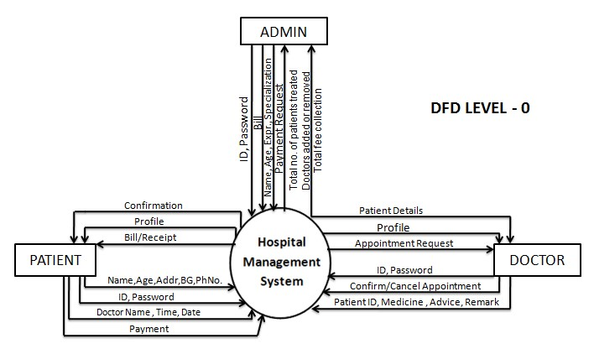

FIGURE 2.1 CONTEXT LEVEL DFD

**DFD LEVEL – 1**

FIGURE 2.2

LEVEL

–

1

DFD

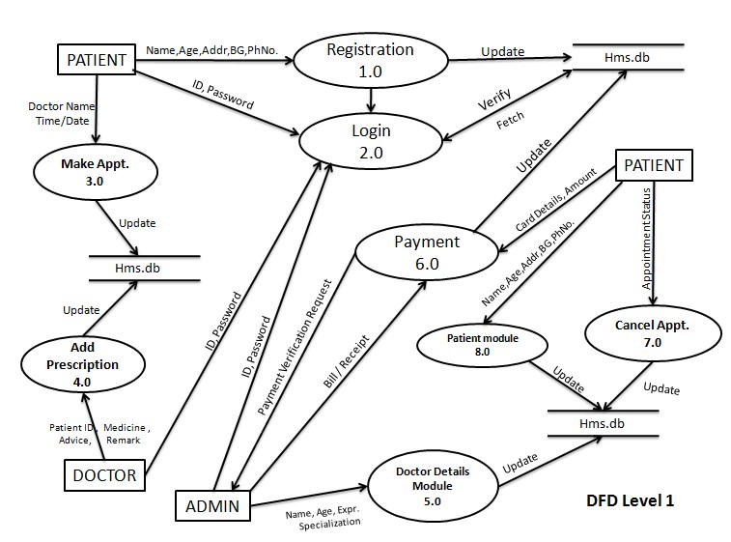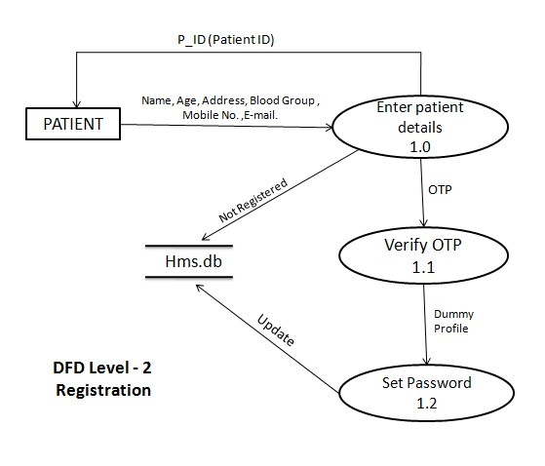

FIGURE 2.3 LEVEL – 2 Registration

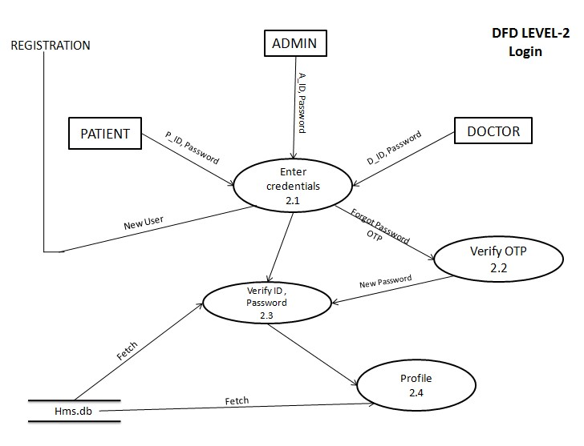

FIGURE 2.4 LEVEL – 2 Login

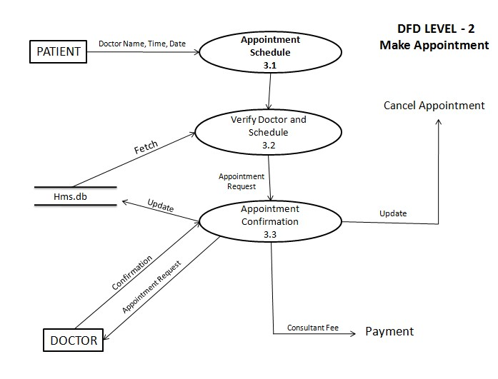

#### FIGURE 2.5 LEVEL – 2 Make Appointment

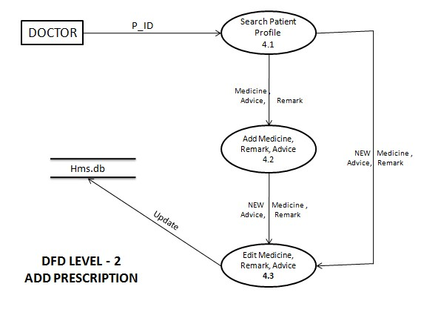

#### FIGURE 2.6 LEVEL – 2 Add Description

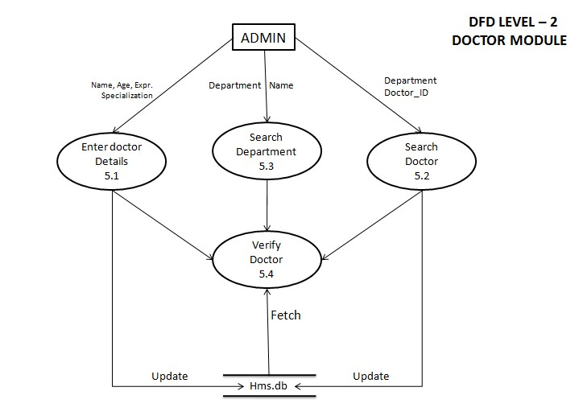

#### FIGURE 2.7 LEVEL – 2 Doctor Module

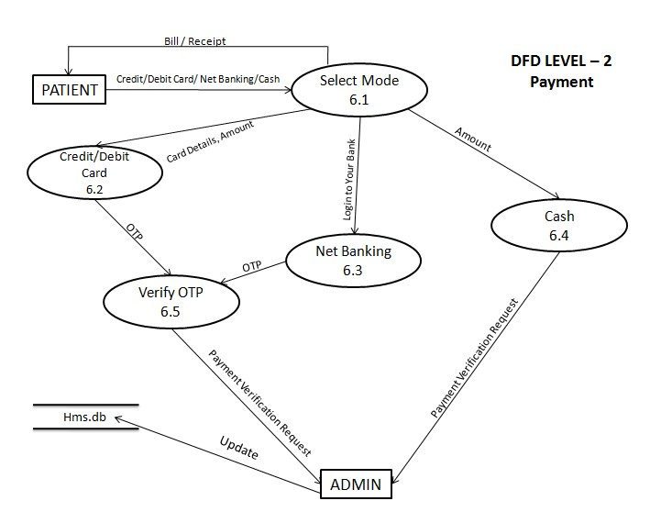

#### FIGURE 2.8 LEVEL – 2 Payment

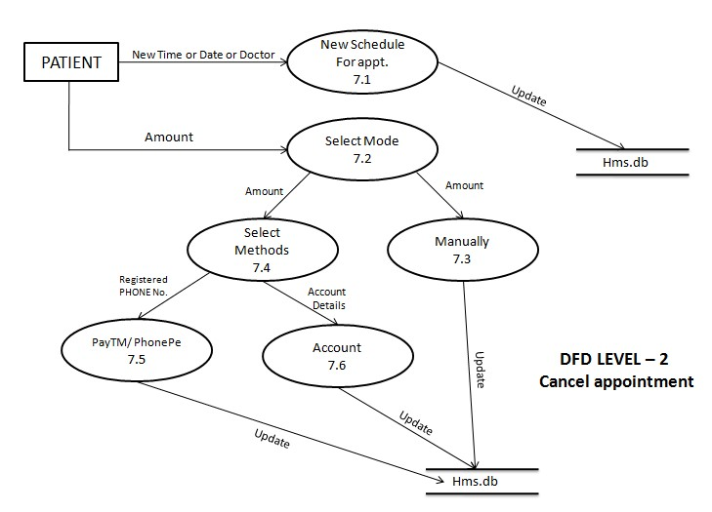

FIGURE 2.9 LEVEL – 2 Cancel Appointment

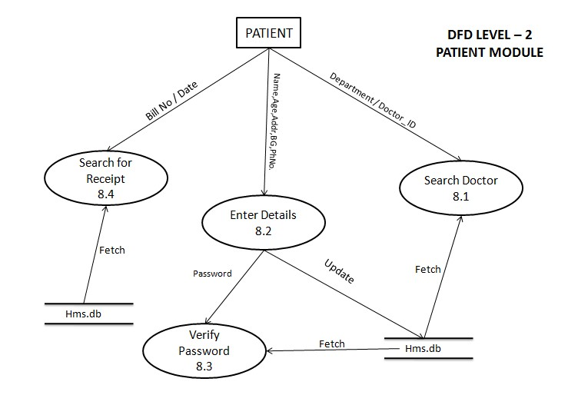

FIGURE 2.10 LEVEL – 2 Patient Module

## 2.4 USE CASE DIAGRAM

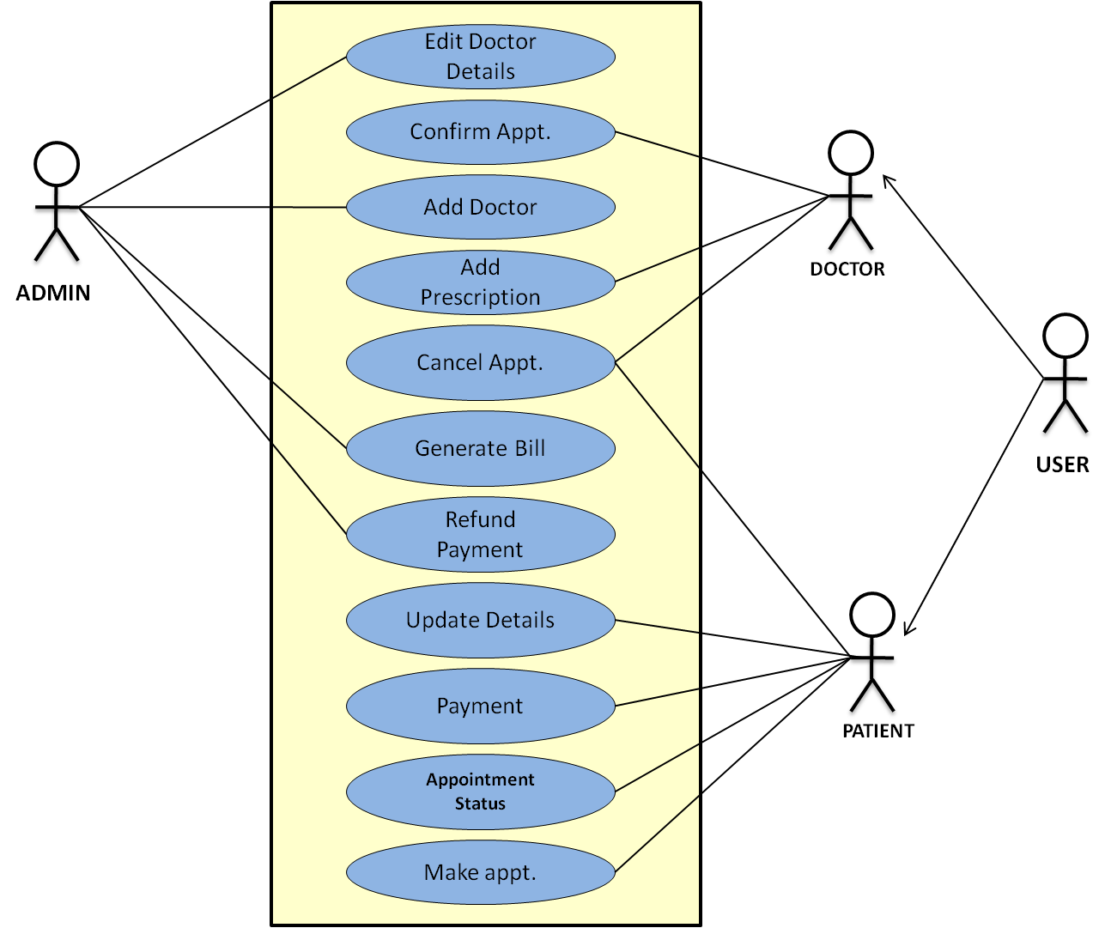

## 2.5 USE CASE DESCRIPTION

### (1) PATIENT

**\* REGISTRATION**

DESCRIPTION - The new patient can register themselves and add their details like name, age , gender, blood group etc. The patient entry will be made in the hms database.

PRE -CONDITION – The patient must be a new patient, If necessary fields left by user then prompt user to fill the necessary fields.

MAIN FLOW OF EVENTS

1. Patient selects sign up in login module. 2. A registration form get displayed

3. Patient fills the required details.

POST CONDITIONS - Patient record is added to hms database.

**\* UPDATION**

DESCRIPTION-The patient should be enabled to update his/her details and the changes should reflect in hms database.

PRE-CONDITION – The patient must be a registered patient, The patient cannot update details after treatment starts.

MAIN FLOW OF EVENTS

1. Patient logs in to the system.
2. Patient view his record
3. Patient selects update details.
4. Now patient may change the necessary fields.
5. Pop of update details.

POST CONDITION - The record of patient is updated in hms database.

**\*APPOINTMENT**

DESCRIPTION - It shows users a list of available doctors, timings, dates and enables patients to select the most suitable appointment date and doctor. The patient may also the cancel the appointment.

PRE-CONDITION - The patient must be a registered patient, Patient can fix only one appointment for a particular department.

MAIN FLOW OF EVENT

1. Patient first logs in to system.
2. View his/her record.
3. Create a new appointment or cancel the appointment..

POST CONDITIONS - patient details are displayed and a new appointment is fix or a existing appointment is cancelled. The hms database is updated.

\***PAYMENT**

DESCRIPTION – It enables user to pay the consultant fee of Doctor online.

PRE-CONDITION - The patient must be a registered patient, If Patient don’t wants to pay online he/she can pay by cash also.

MAIN FLOW OF EVENT

1. Patient first logs in to system.
2. View his/her record.
3. Appointment confirmed by the Doctor then go for Payment.

POST CONDITIONS – A Reciept will be displayed. The hms database is updated

### (2) DOCTOR

DESCRIPTION- The doctor view patient record/ update his details and add description of the treatment given to patient.

PRE-CONDITION – The doctor must be a registered doctor, System does not allow the doctor to modify the qualification, hospital managed details.

MAIN FLOW OF EVENTS

1.Doctor logs in to the system.

1. Doctor may select view patient.
   1. Patient record is displayed with treatment history.
2. Doctor add description of patient treatment.
3. Doctor may select appointment details
   1. Appointment Requests is displayed with schedule.
4. Doctor confirm or cancel appointment.

POST CONDITION – The patient and doctor ‘s database are updated.

### (3) ADMIN

DESCRIPTION - The admin add doctor, update docotr details and verify payment and generate Bill/Reciept for the same.

MAIN FLOW OF EVENTS

1. Admin logs in the system.
2. Admin may add doctor new doctor.
   1. admin fills the doctor’s details.
3. Admin view Doctor record.
   1. Admin enters the doctor id in the system.
   2. Doctor details are displayed, Admin can update details.
4. Admin Verify the payment submited by the Patient.
   1. Generate Bill/Reciept and confirmation message for the same.

PRE –CONDITION - Admin must first log in with his/her credentials.

POST CONDITION - The hms database is updated.

### 2.6 User characteristics

#### **ADMIN**

Admin has the full access to the system which means he is able to manage any activity with regard to the system. He is the highest privileged user who can access to the system.

***Key functions:***

•Access patient record, doctor Record.

•Add new doctor entry in system database.

* Confirm Payment and Generate Bill.
* View Records.(Total no of patients treated, doctor added/remove, consultant fee).

#### **PATIENT**

Patients can choose the best preferred appointments from the options provided and can also change the appointment schedule or cancel it. After appt. is confirmed by the respective doctor they can pay their consultant fee online. Patients have access to only their records.

***Key functions:***

* Make appointment.
* Cancel appointment.
* Update Details.
* Payment.
* View Payment History.

#### **DOCTOR**

Doctors can view the patient appointment list and provide the confirmation or make changes in the appointment list if required. Doctors have access to only records of those patients whom they are treating.

***Key functions***:

* Confirmation of appointment.
* Cancellation of appointment.
* Modification of appointment list.
* Add Prescription.

### 2.7 Constraints

* System is wirelessly networked with an encryption.
* System is only accessible within the hospital’s website only.
* Database is password protected.
* Should use less RAM and processing power.
* Each user should have individual ID and password.
* Only administrator can access the whole system.

### 2.8 Assumptions and dependencies

* Each user must have a valid user id and password ▪ Server must be running for the system to function ▪ Users must log in to the system to access any record.
* Only the Administrator can delete records.

# CHAPTER 3 SPECIFIC REQUIREMENTS

## 3.1 Performance requirements 3.2 Safety requirements 3.3 Security constraints 3.4 Software system attributes

3.4.1 Usability 3.4.2 Availability 3.4.3 Correctness 3.4.4 Maintainability 3.4.5 Accessibility

3.5 Functional Requirements

## 3.1 PERFORMANCE REQUIREMENTS

o **Response time**- The system will give responses within 1 second after checking the patient information and other information. o **Capacity**-The system must support 1000 people at a time o **User interface**- User interface screen will response within 5 seconds

## 3.2 SAFETY REQUIREMENTS

If there is extensive damage to a wide portion of the database due to catastrophic failure, such as a disk crash, the recovery method restores a past copy of the database that was backed up to archival storage and reconstructs a more current state by reapplying or redoing the operations of committed transactions from the backed up log, up to the time of failure. All the administrative and data entry operators have unique logins so system can understand who is login in to system right now no intruders allowed except system administrative nobody cannot change record and valuable data.

## 3.3 SECURITY REQUIREMENTS

1. Want take the responsibility of failures due to hardware malfunctioning.
2. Warranty period of maintaining the software would be one year.
3. Additional payments will be analyzed and charged for further maintenance.
4. If any error occur due to a user’s improper use. Warranty will not be allocated to it.
5. No money back returns for the software.

## 3.4 SOFTWARE SYSTEM ATTRIBUTES

**3.4.1 Usability:** Software can be used again and again without distortion.

**3.4.2 Availability:** The system shall be available all the time.

**3.4.3 Correctness:** Bug free software which fulfills the correct need/requirements of the client.

**3.4.4 Maintainability:** The ability to maintain, modify information and update fix problems of the system.

**3.4.5 Accessibility:** Administrator and many other users can access the system but the access level is controlled for each user according to their work scope.

## 3.5 FUNCTIONAL REQUIREMENTS

|  |  |  |  |
| --- | --- | --- | --- |
| **S.No.** | **MODULE NAME** | **APPLICABLE ROLES** | **DESCRIPTION** |
| 1. | LOGIN | PATIENT  DOCTOR  ADMIN | **PATIENT:** Can login using unique Id and Password after this system shall show his/her profile.    **DOCTOR:** Can login using unique Id and Password after this system shall show his/her profile.    **ADMIN:** Can login using unique Id and Password after this system shall show a profile with links to maintain the website. |
| 2. | REGISTRATION | PATIENT | **PATIENT:** Can Register by filling all the required details, after this the system will verify the details and check if already registered or not. |
| 3. | MAKE APPT. | PATIENT | **PATIENT:** Can Select doctor, date time and make an appointment request after this system shall show a confirmation for appointment request. |
| 4. | CANCL APPT. | PATIENT  DOCTOR | **PATIENT :** Can Cancel appointment if want to by just one click after this system shall ask for re-schedule or refund of payment.    **DOCTOR :** Can Cancel appointment if want to by just one click after this system shall send a message to the patient. |
| 5. | PAYMENT | PATIENT | **PATIENT :** Enter payment details and make payment after this system shall show the generated bill by the hospital. |
| 6. | DOCTOR MODULE | ADMIN | **ADMIN :** Can add a new doctor by filling all the details after this system shall show a confirmation message.  Can Remove a doctor by just one click after this system shall show confirmation message. |
| 7. | PATIENT MODULE | PATIENT | **PATIENT :** Can view payment history or can search for a particular bill also after this system shall show a bill or history.    Can also See or search for a doctor by entering dept. name or doctor id if known after this system will check for the doctor if found shall show doctor’s profile.    Can also update details after this system shall ask for re-enter password and after verifying password shall update details. |
| 8. | ADD  PRESCRIPTION | DOCTOR | **DOCTOR :** Enter Patient Id and after this all the treatment details and medicine, remark and advice for the patient after this system shall show a message for update. |

# CHAPTER 4 DESIGN

4.1 Data Dictionary

4.2 ER Diagram

4.3 Data Design

4.4 Component Level Diagram

## 4.1 DATA DICTIONARY

|  |  |  |
| --- | --- | --- |
| 1. | legal_character | [a-z| A-Z] |
| 2. | Dig it | [0-9] |
| 3. | special_ch | [@|$|#|+|-] |
| 4. | Blood | [A|B|AB|O] |

|  |  |  |
| --- | --- | --- |
| 1. | Name | first_name + (middle_name) + last_name |
| 2. | first_name | {legal_character}* |
| 3. | middle_name | {legal_character}* |
| 4. | last_name | {legal_character}* |
| 5. | P_ID | {legal_character + digit}* |
| 6. | D_ID | {legal_character + digit}* |
| 7. | A_ID | {legal_character + digit}* |
| 8. | Password | {legal_character + digit + special_ch}* |
| 9. | Address | House_no + (Street) + City |
| 10. | House_no | {legal_character + digit}* |
| 11. | Street | {legal_character}* |
| 12. | City | {legal_character}* |
| 13. | Mobile No. | { digit }* |
| 14. | Blood_Group | {Blood + special_ch}* |
| 15. | Specialization | {legal_character}* |
| 16. | Consultant Fee | { digit }* |
| 17. | Medicine | {legal_character + digit}* |
| 18. | Advice | {legal_character + digit}* |
| 19. | Remark | {legal_character + digit}* |

Table 4.1 Data Dictionary

### 4.2 ER DIAGRAM

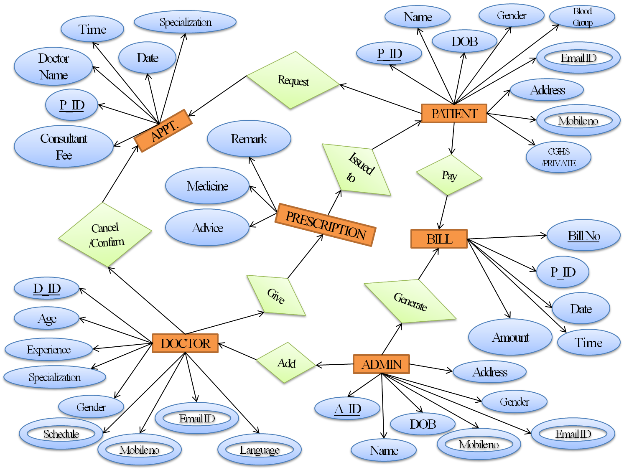

### 4.3 DATA DESIGN

|  |  |  |  |  |
| --- | --- | --- | --- | --- |
| **S NO.** | **COLUMN**  **NAME** | **DATA**  **TYPE** | **CONSTRAINTS** | **DESCRIPTION** |
| 1. | P_ID | Varchar(50) | Primary Key | Contains Unique Id |
| 2. | Name | Varchar(50) | **-** | Contains Name |
| 3. | DOB | Varchar(50) | **-** | Contains Date Of Birth |
| 4. | Gender | Varchar(50) | **-** | Contains Gender |
| 5. | Blood Group | Varchar(50) | **-** | Contains Blood Group |
| 6. | Email ID | Varchar(50) | **-** | Contains Email Id |
| 7. | Address | Varchar(50) | **-** | Contains Address |
| 8. | Mobile No. | Integer | **-** | Contains Mobile No. |
| 9. | CGHS/Private | Varchar(50) | **-** | Contains Category |

Table 4.2 Patient

|  |  |  |  |  |
| --- | --- | --- | --- | --- |
| **S NO.** | **COLUMN NAME** | **DATA TYPE** | **CONSTRAINTS** | **DESCRIPTION** |
| 1. | P_ID | Varchar(50) | Primary Key | Contains Unique Id Patient |
| 2. | Specialization | Varchar(50) | **-** | Contains Name of the  Department in which  Patient wants to visit |
| 3. | Doctor’s Name | Varchar(50) | **-** | Contains Doctor  Name Patient Wants  To Visit |
| 4. | Consultant Fee | Integer | **-** | Contains Consultant Fee Of Doctor |
| 5. | Date | Date | **-** | Contains Date For The Appointment |
| 6. | Time | Time | **-** | Contains Time For The Appointment |

Table 4.3 Appointment

|  |  |  |  |  |
| --- | --- | --- | --- | --- |
| **S NO.** | **COLUMN NAME** | **DATA TYPE** | **CONSTRAINTS** | **DESCRIPTION** |
| 1. | D_ID | Varchar(50) | Primary Key | Contains unique ID |
| 2. | Age | Integer | **-** | Contains age |
| 3. | Gender | Varchar(50) | **-** | Contains gender |
| 4. | Specialization | Varchar(50) | **-** | Contains specialization |
| 5. | Experience | Varchar(50) | **-** | Contains experience of the doctor (In months) |
| 6. | Language | Varchar(50) | **-** | Contains in how many languages doctor can speak. |
| 7. | Mobile No. | Integer | - | Contains mobile number |
| 8. | Email ID | Varchar(50) | **-** | Contains Email Id |
| 9. | Schedule | Varchar(50) | **-** | Contains day and time for which the doctor is available |

Table 4.4 Doctor

|  |  |  |  |  |
| --- | --- | --- | --- | --- |
| **S NO.** | **COLUMN NAME** | **DATA TYPE** | **CONSTRAINTS** | **DESCRIPTION** |
| 1. | D_ID | Varchar(50) | - | Contains unique ID |
| 2. | P_ID | Varchar(50) | Primary Key | Contains unique ID |
| 3. | Medicine | Varchar(50) |  | Contains name of the medicine. |
| 4. | Remark | Varchar(50) |  | Contains Remark given by the doctor for the patient. |
| 5. | Advice | Varchar(50) |  | Contains any advice for the patient. |

Table 4.5 Prescription

|  |  |  |  |  |
| --- | --- | --- | --- | --- |
| **S NO.** | **COLUMN NAME** | **DATA TYPE** | **CONSTRAINTS** | **DESCRIPTION** |
| 1. | A_ID | Varchar(50) | Primary Key | Contains unique ID. |
| 2. | Name | Varchar(50) | **-** | Contains Name |
| 3. | DOB | Varchar(50) | **-** | Contains Date Of Birth |
| 4. | Gender | Varchar(50) | **-** | Contains Gender |
| 5. | Email ID | Varchar(50) | **-** | Contains Email Id |
| 6. | Mobile No. | Integer | **-** | Contains Mobile No. |
| 7. | Address | Varchar(50) | **-** | Contains Address |

**Table 4.6 Admin**

|  |  |  |  |  |
| --- | --- | --- | --- | --- |
| **S NO.** | **COLUMN NAME** | **DATA TYPE** | **CONSTRAINTS** | **DESCRIPTION** |
| 1. | P_ID | Varchar(50) | - | Contains unique ID. |
| 2. | Bill No. | Varchar(50 | Primary Key | Contains number of the bill. |
| 3. | Date | Varchar(50 | - | Contains Date of The bill. |
| 4. | Time | Varchar(50 | - | Contains Time of the bill generated. |
| 5. | Amount | Int | - | Contains amount of the bill. |

**Table 4.7 Bill**

### 4.4 COMPONENT LEVEL DIAGRAM

#### **Book Appointment Module**

enum Status { confirm , cancel} ;

int Department, Date , Time, mode, ch; char Dr_Name(50);

cout<< Enter The Information :

cin>> Department;

cin>>Dr_Name;

cin>> Date; cin>> Time;

bool Appointment = cancel;

cout<<Mode; cout<<1.Cash; cout<<2.Debit Card/Credit Card

cout<<3.Net Banking cout<<Enter mode of payment; cin>>mode;

if(mode==1)

{

Generate a Receipt and send confirmation message;

}

else if(mode == 2)

{

Enter Card Details

Make Payment

Send confirmation message

}

else

{

Enter Account Details

Make Payment

Send confirmation message

} //end if

Send appointment Request to the doctor

Doctor will check the Appointment Requests; cout<<Mode; cout<<1.Confirm;

cout<<2.Cancel;

cout<<Enter Your choice; cin>>ch;

if(ch==1)

{

Appointment = Confirm;

Send a Confirm Message to the patient.

}

else

{

Send a Cancel Message to the patient.

}//end if

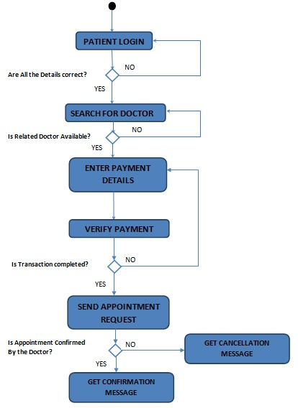

# CHAPTER 5

**ESTIMATION AND SCHEDULING**

5.1 Project Scheduling

5.2 Timeline chart

5.3 Size Estimation (FUNCTION BASED METRICS)

## 5.4 Cost Estimation (COCOMO II MODEL)

### 5.1 Project Scheduling

|  |  |  |  |  |  |
| --- | --- | --- | --- | --- | --- |
| TASK ~> | Planned Start | Actual Start | Planned complete | Actual complete | Assigned person |
| PROBLEM STATEMENT | Jan W1 | Jan W1 | Jan W1 | Jan W1 | Esha, Akansha, Monica |
| SOFTWARE MODEL | Jan W2 | Jan W2 | Jan W2 | Jan W3 | Akansha, Monica |
| PROJECT  SCHEDULING | Jan W2 | Jan W2 | Jan W3 | Jan W3 | Esha, Akansha |
| SRS | Jan W3 | Jan W3 | Feb W1 | Feb W1 | Esha, Monica |
| CONTEXT LEVEL DIAGRAM | Feb W1 | Feb W1 | Feb W1 | Feb W2 | Esha, Monica |
| DFD LEVEL - 1 | Feb W2 | Feb W2 | Feb W2 | Feb W3 | Akansha, Monica |
| DFD LEVEL - 2 | Feb W3 | Feb W3 | Feb W3 | Feb W4 | Esha, Akansha, Monica |
| DATA DICTIONARY | Mar W1 | Mar W1 | Mar W1 | Mar W1 | Esha, Akansha |
| ER DIAGRAM | Mar W1 | Mar W1 | Mar W2 | Mar W2 | Esha |
| DATA DESIGN | Mar W2 | Mar W2 | Mar W2 | Mar W2 | Akansha |
| USE CASE DIAGRAM | Mar W3 | Mar W3 | Mar W3 | Mar W3 | Akansha |
| USE CASE  DISCRIPTION | Mar W4 | Mar W4 | Mar W4 | Mar W4 | Akansha, Esha |
| FUNCTION POINT MATRIX | Mar W3 | Mar W3 | Mar W3 | Mar W4 | Esha, Akansha, Monica |
| COCOMO MODEL | Apr W1 | Apr W1 | Apr W1 | Apr W1 | Esha, Akansha, Monica |
| RISK ANALYSIS | Apr W2 | Apr W2 | Apr W2 | Apr W2 | Esha, Akansha |
| TESTING | Apr W2 | Apr W2 | Apr W2 | Apr W2 | Esha, Akansha |

Table 5.1 Project Scheduling

Jan – January Feb – February Mar – March Apr – April W - Week

### 5.2 Timeline chart

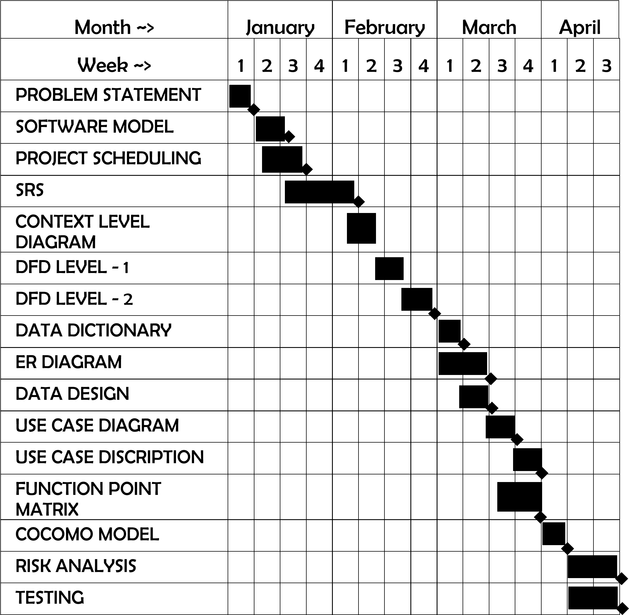

Table 5.2 Timeline Chart

## 5.3 Size Estimation (FUNCTION BASED METRICS)

Information domain values are defined in the following manner:

* **Number of external inputs (EIs)** - Each external input originates from a user or is transmitted from another application and provides distinct application-oriented data or control information. Inputs are often used to update internal logical files (ILFs). Inputs should be distinguished from inquiries, which are counted separately.

* **Number of external outputs (EOs) -** Each external output is derived data within the application that provides information to the user. In this context external output refers to reports, screens, error messages, etc. Individual data items within a report are not counted separately.

* **Number of external inquiries (EQs) -** An external inquiry is defined as an online input that results in the generation of some immediate software response in the form of an online output (often retrieved from an ILF).

* **Number of internal logical files (ILFs) -** Each internal logical file is a logical grouping of data that resides within the application’s boundary and is maintained via external inputs.

* **Number of external interface files (EIFs)**. - Each external interface file is a logical grouping of data that resides external to the application but provides information that may be of use to the application.

### SIZE ESTIMATION FOR THIS PROJECT

|  |  |  |  |  |  |
| --- | --- | --- | --- | --- | --- |
| **Screen No** | **EIs** | **EOs** | **EQs** | **ILFs** | **EIFs** |
| **1.** | 1.Select Language | - | 1.Doctor’s On Leave  2.Visitors on Website | Hospital File | - |
| **2.** | - | - | - | - | - |
| **3.** | 1.Username  2. Password | - | - | Hospital File | - |
| **4.** | 1. .Name 2. .Dob   3. Gender  4 .Email  5. Blood Group   1. .Mobile No 2. .Address 3. .CGHS / Private   9.Card Picture | - | - | Hospital File | - |
| **5.** | **-** | 1.Profile | **-** | HF | - |
| **6.** | 1. Department   1. .Date 2. .Time 3. .Doctor Name | **-** | **-** | Hospital File | - |
| **7.** |  |  | 1.Appointment Status | Hospital File | - |
| **8.** | 1 .Card Holder  Name   1. Card number 2. Expire Date 3. CVC Number | **-** | **-** | Hospital File | - |
| **9.** | 1.Registered Mobile No.  2.Edit Appt.  Schedule | - | - | Hospital File | - |
| **10.** | **-** | **-** | 1.Payment History | Hospital File | - |
| **11.** | - | 1.Profile | - | HF | - |
| **12.** | 1.Doctor ID | 1.Doctor Details |  | Hospital File | - |
| **13.** | - | 1.Bill | - | Hospital File | - |
| **14.** | 1.Username  2. Password | - | - | Hospital File | - |
| **15.** | - | 1. Profile |  | Hospital File | - |
| **16.** | - | - | 1.appt. Details | Hospital File | - |
| **17.** | 1. Treatment Name   1. .Medicine 2. .Advice 3. .Remark   5.Patient ID | 1.Patient Profile | - | Hospital File | - |
| **18.** | 1.Username 2. Password | - | - | Hospital File | - |
| **19.** | 1.Payment  Verify | - | - | Hospital File | - |
| **20.** | 1. Name 2. Age 3. Gender 4. Specialization 5. Experience 6. Language 7. Mobile No 8. Email Id 9. Schedule | - | - | Hospital File | - |
| **21.** | 1.Doctor Id | 1.Doctor Profile | - | Hospital File | - |
| **22.** | 1.Select  Monthly/Yearly  2.Select Year  3.Select Month | - | 1.Records | Hospital File | - |

**TABLE 5.3 Function Point Complexity Weights**

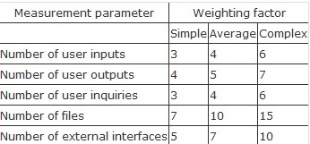

**TOTAL EXTERNAL INUPUTS =** 41

**TOTAL EXTERNAL OUTPUTS =** 7

**TOTAL LOGICAL INTERNAL FILES =** 1

**TOTAL EXTERNAL INQUIRIES =** 6

**TOTAL EXTERNAL INTERFACE FILES =** 0

**Function point = FP = UFP x CAF = Count Total * (0.65 + (0.01 \***∑ 𝒇𝒊**)** UFP (Count Total) = Sum of all the complexities i.e. the 5 parameters provided in the question,

CAF = Complexity Adjustment Factor i.e. 0.65 + (0.01 * ∑fi), **CALCULATING (** ∑ 𝒇𝒊 **)**

Total Degree of Influence of the 14 General System Characteristics

|  |
| --- |
| **1.** How many communication facilities are there to aid in the transfer or exchange of information with the application or system? |
| **2.** How are distributed data and processing functions handled? |
| **3.** Did the user require response time or throughput? |
| **4.** How heavily used is the current hardware platform where the application will be executed? |
| **5.** How frequently are transactions executed daily, weekly, monthly, etc.? |
| **6.** What percentage of the information is entered online? |
| **7.** Was the application designed for end-user efficiency? |
| **8.** How many ILFs are updated by online transaction? |
| **9.** Does the application have extensive logical or mathematical processing? |
| **10.**  Was the application developed to meet one or many user’s needs? |
| **11.**  How difficult is conversion and installation? |
| **12.**  How effective and/or automated are start-up, back-up, and recovery procedures? |
| **13.**  Was the application specifically designed, developed, and supported to be installed at multiple sites for multiple organizations? |
| **14.**  Was the application specifically designed, developed, and supported to facilitate change? |

**Considering all adjustment factors of average influence** ∑ 𝒇𝒊 **= 14 * 3 = 42 TOTAL EXTERNAL INUPUTS =** 41

**TOTAL EXTERNAL OUTPUTS =** 7

**TOTAL LOGICAL INTERNAL FILES =** 1

**TOTAL EXTERNAL INQUIRIES =** 6

**TOTAL EXTERNAL INTERFACE FILES =** 0

**Assuming all the parameters are of SIMPLE COMPLEXITY.**

UFP (Count Total) = {41 * 3} + {7 * 4} + {1 * 3} + {6 * 7} + {0 * 5} = 196

**Considering all adjustment factors of average influence** ∑ 𝒇𝒊 **= 14 * 3 = 42**

**Function point = FP = Count Total + (0.65 + (0.01 \***∑ 𝒇𝒊**)**

= 196 * (0.65 + (0.01 * 42)

= 196 * (0.65 + (0.42)

= 196 * (1.07)

= 209.72

**FUNCTION POINT = 209.72**

## 5.4 Cost Estimation (COCOMO II MODEL)

The original COCOMO model became one of the most widely used and discussed software cost estimation models in the industry. It has evolved into a more comprehensive estimation model, called COCOMO II.

COCOMO II models require sizing information. Three different sizing options are available as part of the model hierarchy:- o Object Points o Function Points o Lines Of Source Code

The COCOMO II application composition model uses object points.

Like function point, the **object point is an indirect software measure** that is computed using counts of the number of

1. **screens** (at the user interface),
2. **reports,**
3. **components** likely to be required to build the application.

Each object instance (e.g., a screen or report) is classified into one of three complexity levels (i.e. ,simple ,medium, or difficult).

Once complexity is determined, the number of screens, reports, and components are weighted according to the table illustrated in Table 5.4 .

**TABLE 5.4 COCOMO II Complexity Weights**

|  |  |  |  |
| --- | --- | --- | --- |
| **OBJECT TYPE** | **C** | **OMPLEXITIY WEIGHT** | |
| **SIMPLE** | **MEDIUM** | **DIFFICULT** |
| **SCREEN** | 1 | 2 | 3 |
| **REPORT** | 2 | 5 | 8 |
| **3GL COMPONENT** |  |  | 10 |

The object point count is then determined by multiplying the original number of object instances by the weighting factor in the figure and summing to obtain a total object point count.

When component-based development or general software reuse is to be applied, the percent of reuse (%reuse) is estimated and the object point count is adjusted:

**NOP = (Object Point) * [ (100 - %reuse) / 100 ]**

where NOP = defined as new object points.

To derive an estimate of effort based on the computed NOP value, a **“productivity rate”** must be derived.

|  |
| --- |
| 𝐍𝐎𝐏  **PROD =**  𝐏𝐞𝐫𝐬𝐨𝐧−𝐌𝐨𝐧𝐭𝐡 |

Table 5.5 presents the productivity rate for different levels of developer experience and development environment maturity. Once the productivity rate has been determined, an estimate of project effort is computed using

|  |
| --- |
| 𝐍𝐎𝐏  **ESTIMATED EFFORT =**  𝐏𝐑𝐎𝐃 |

**TABLE 5.5 Productivity Rate For Object Point Counts**

|  |  |  |  |  |  |
| --- | --- | --- | --- | --- | --- |
| Developer’s experience/capability | Very Low | Low | Normal | High | Very high |
| Environment maturity/capability | Very Low | Low | Normal | High | Very high |
| PROD | 4 | 7 | 13 | 25 | 50 |

### COST ESTIMATION FOR THIS PROJECT

**(1) SCREENS**

1. Home Page.
2. Select Login.
3. Login Page For Patient .
4. Registration For Patient.
5. Patient Profile.
6. Patient Update Details.
7. Book Appointment .
8. View Appointment Status .
9. Cancel Appointment.
10. Payment By Patient.
11. Receipt Of Payment .

**(2) REPORTS**

1. Total Visitors on Website.
2. Total Patients Treated.
3. Total Appointments Taken.
4. Total Appointments Cancelled.
5. Total Doctors on Leave.
6. Total Doctors Added.
7. Total Doctors Removed.
8. Total Consultant Fee Collected .

1. Login Page For Doctor.
2. Doctor Profile.
3. Appointment Details.
4. View Patient by Doctor.
5. Add Prescription.
6. Login Page For Admin.
7. Generate Bill.
8. Update Doctor Details.
9. Add Doctor.
10. View doctor By Admin.
11. View Records.

**TOTAL SCREENS =** 22

**TOTAL 3GL MODULES =** 0

**TOTAL REPORTS =** 8

**CONSIDERING ALL OF THE ABOVE HAVE MEIDEM COMPEXITY, 0% OF COMPONENTS ARE REUSED AND TAKING THE DEVELOPER EXPERIENCE AND ENVIRONMENT MATURITY AS LOW.**

**PRODUCTIVITY RATE**  =  = 7.

**OBJECT POINT** = {22 * 2} + {8 * 5} = 84.

NOP 84

**ESTIMATED EFFORT =**  = = **12 Person-Months.**

PROD 7

# CHAPTER 6

**SAMPLE SCREENSHOTS**

**FIGURE 6.1 HOME PAGE**



**FIGURE 6.2 SELECT LOGIN**

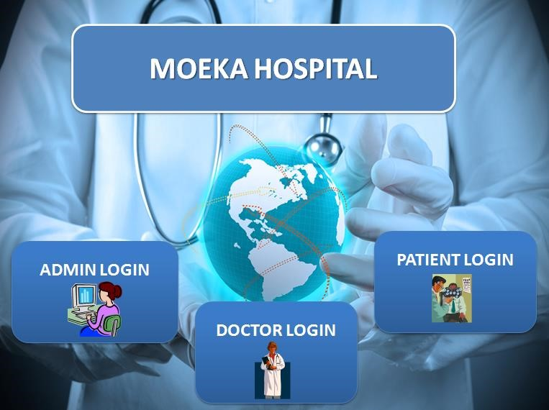

**FIGURE 6.3 PATIEN LOGIN PAGE**

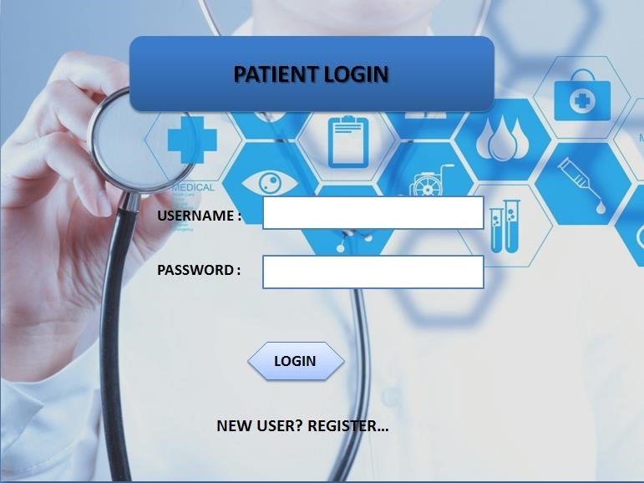

**FIGURE 6.4 REGISTRATION**

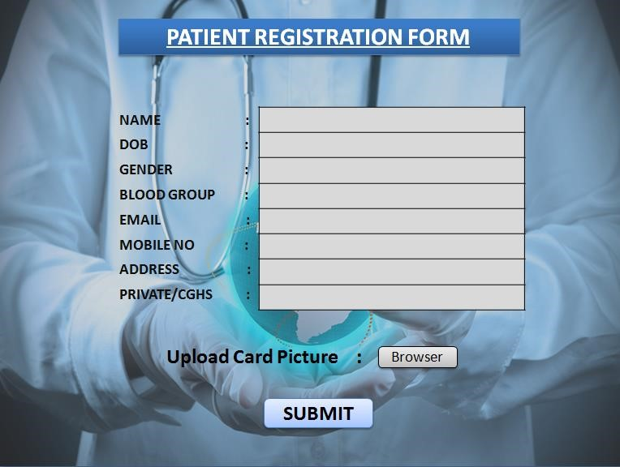

**FIGURE 6.5 PATIENT PROFILE**

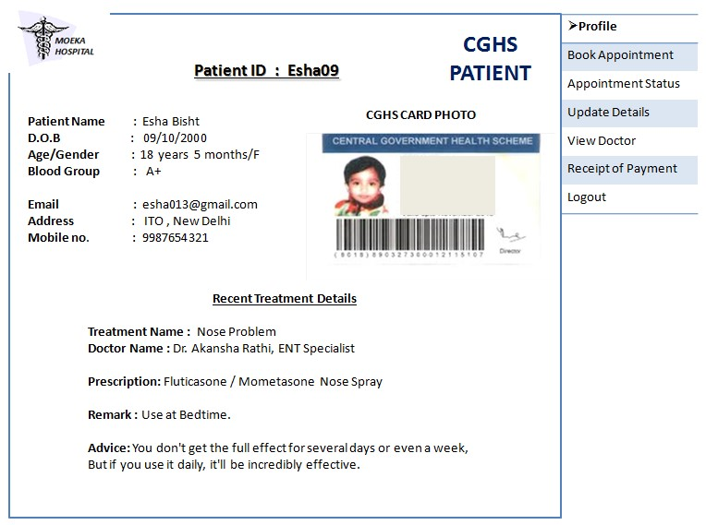

**FIGURE 6.6 PATIENT UPDATE DETAILS**

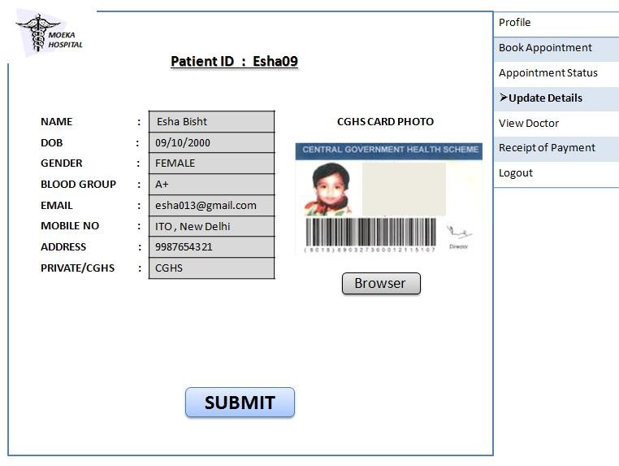

**FIGURE 6.7 PATIENT BOOK APPOINTMENT**

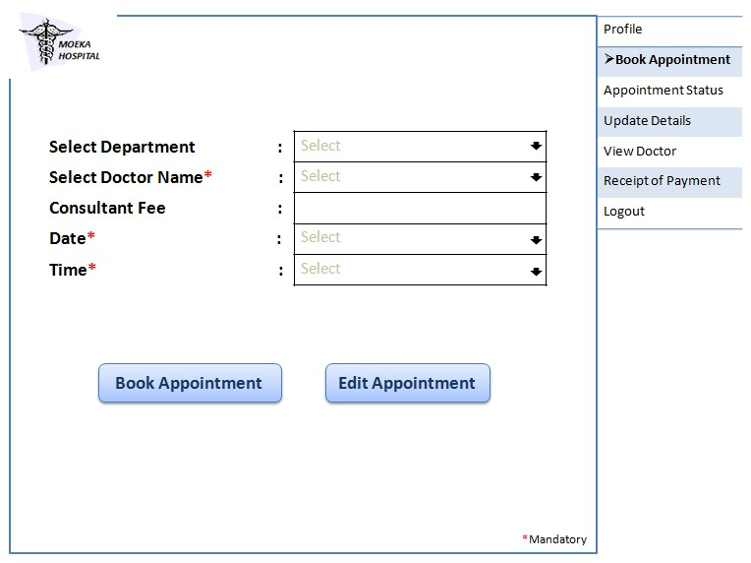

**FIGURE 6.8 PATIENT APPOINTMENT STATUS**

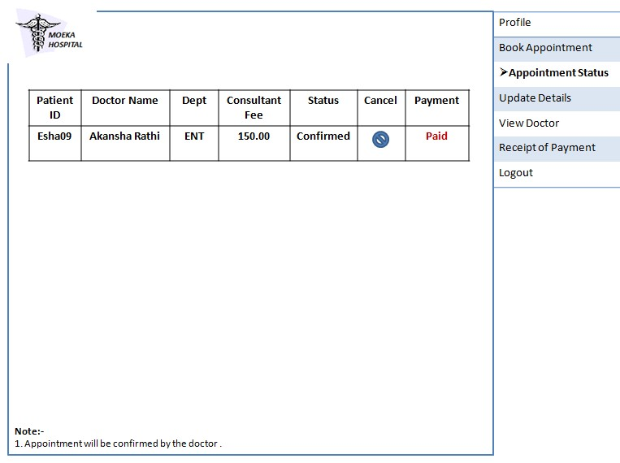

**FIGURE 6.9 PATIENT CANCEL APPOINTMENT**

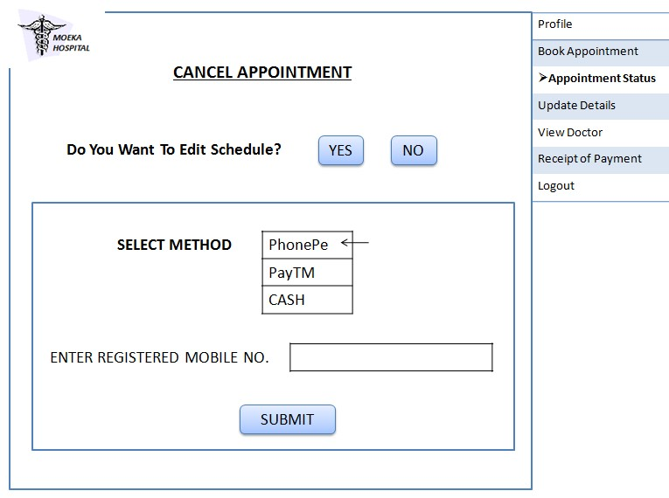

**FIGURE 6.10 PAYMENT**

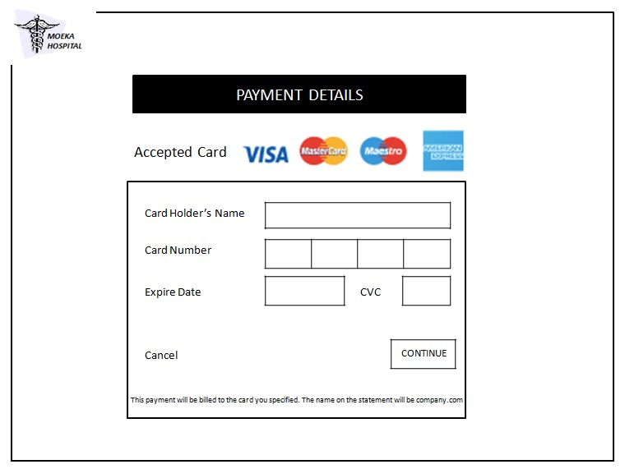

**FIGURE 6.11 PATIENT PAYMENT RECIPET**

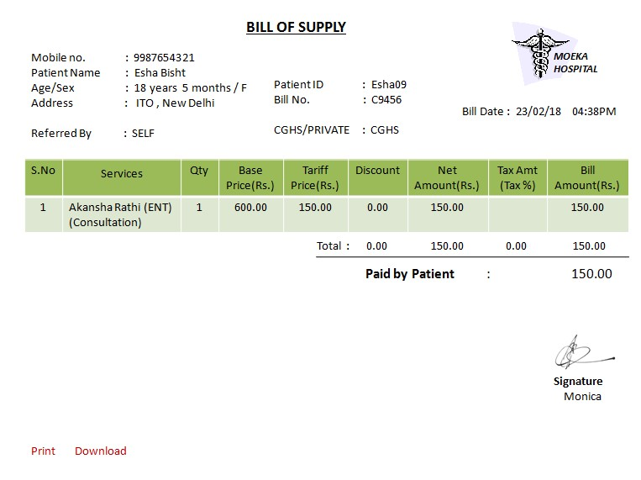

**FIGURE 6.12 PATIENT VIEW PAYMENT HISTORY**

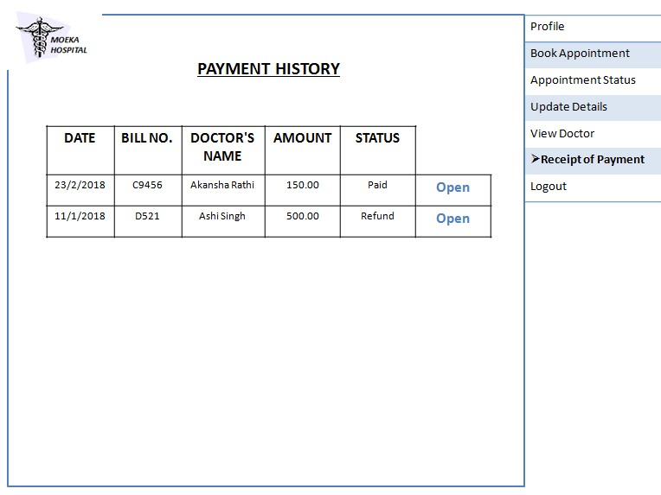

**FIGURE 6.13 PATIENT VIEW DOCTORS**

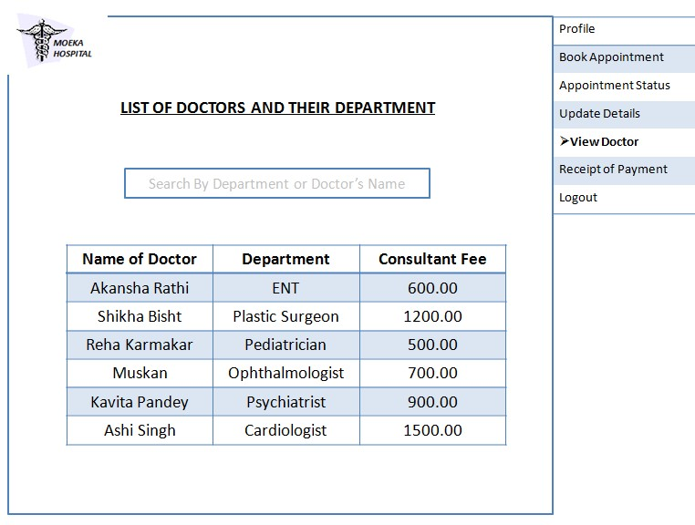

**FIGURE 6.14 DOCTOR LOGIN PAGE**

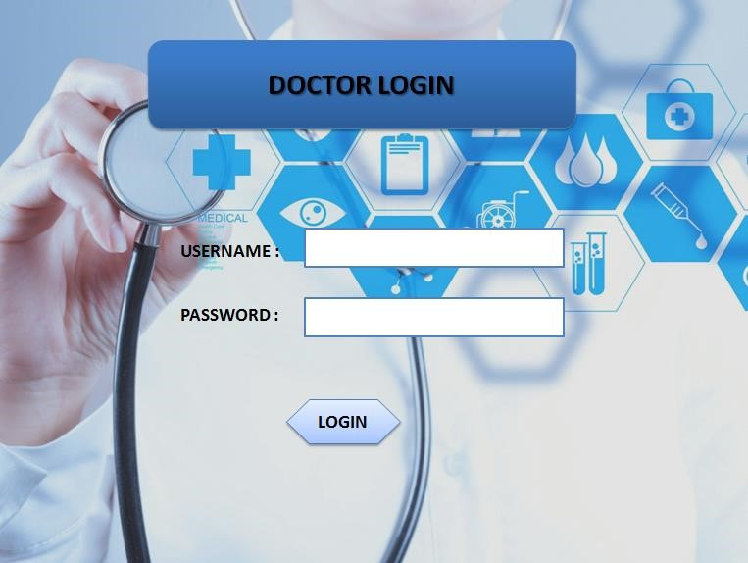

**FIGURE 6.15 DOCTOR PROFILE**

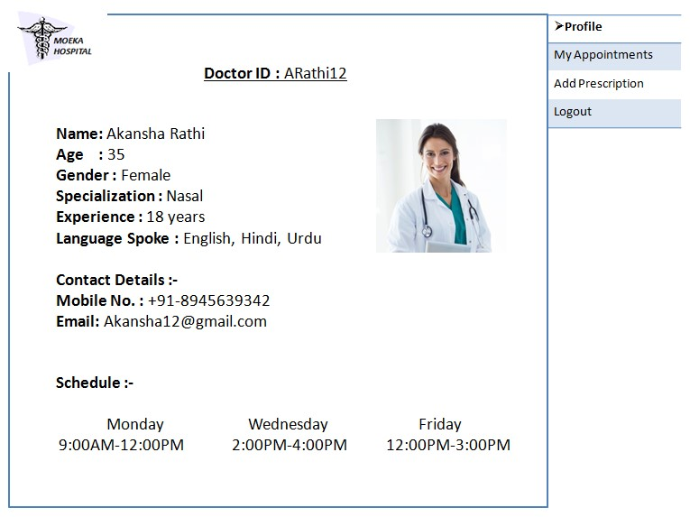

**FIGURE 6.16 DOCTOR VIEW APPOINTMENT**

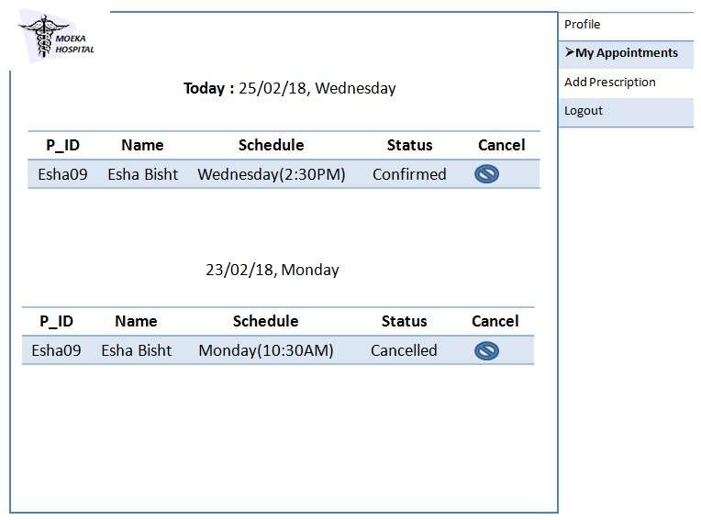

**FIGURE 6.17 DOCTOR ADD DESCRIPTION**

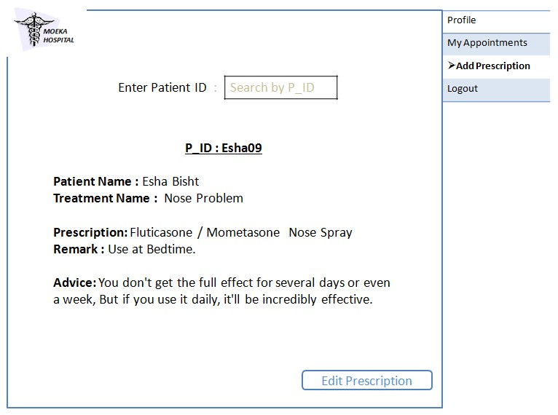

**FIGURE 6.18 ADMIN LOGIN PAGE**

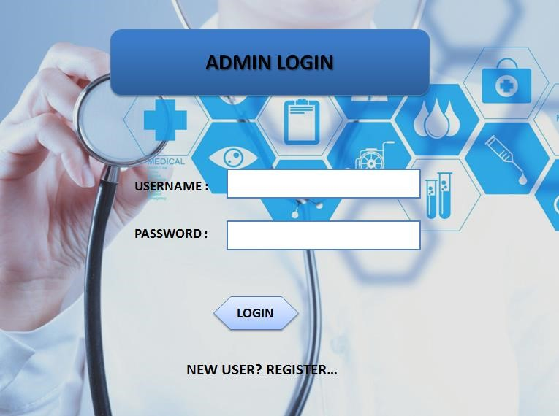

**FIGURE 6.19 ADMIN ADD DOCTOR**

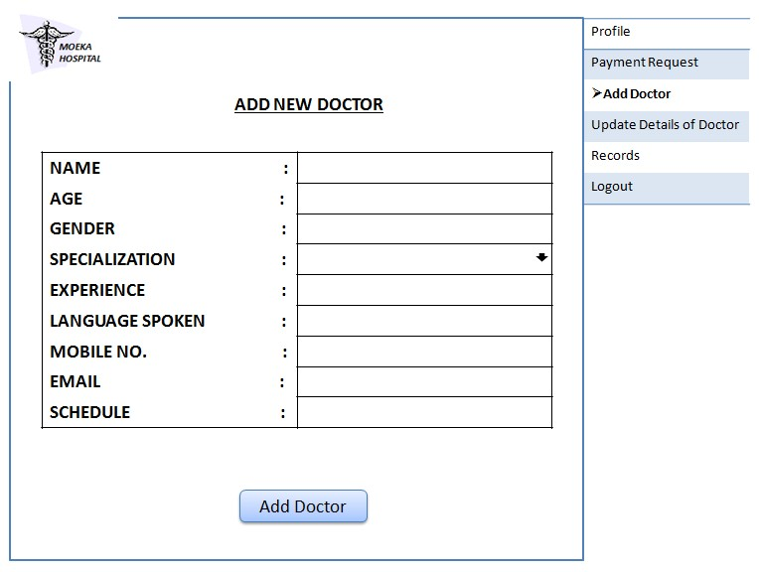

**FIGURE 6.20 ADMIN UPDATE DOCTOR DETAILS**

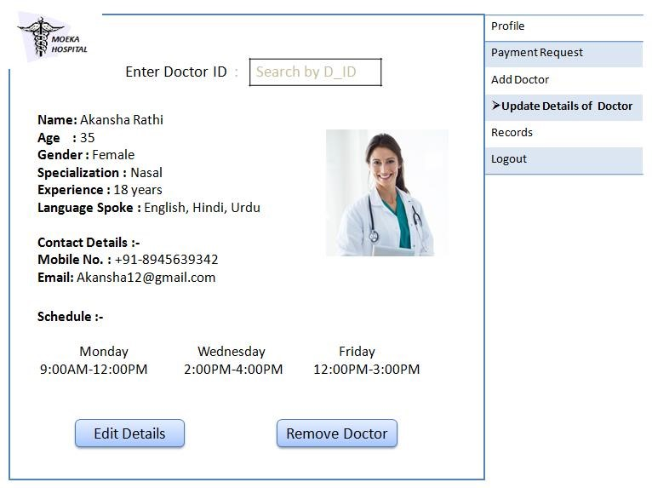

**FIGURE 6.21 ADMIN PAYMENT REQUEST**

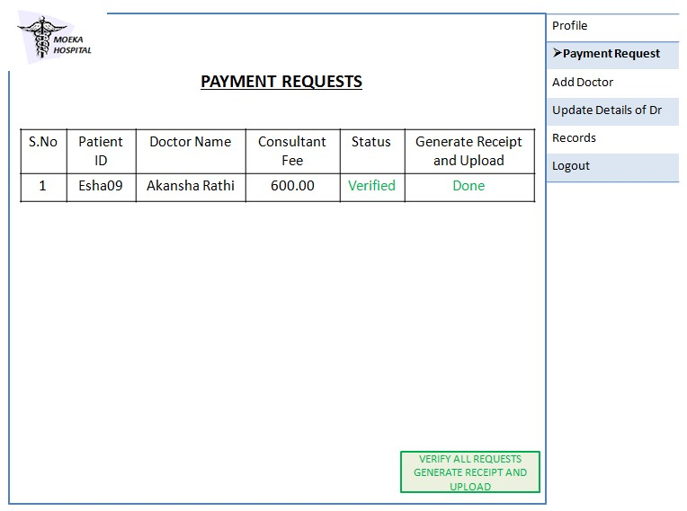

**FIGURE 6.22 ADMIN VIEW RECORDS**

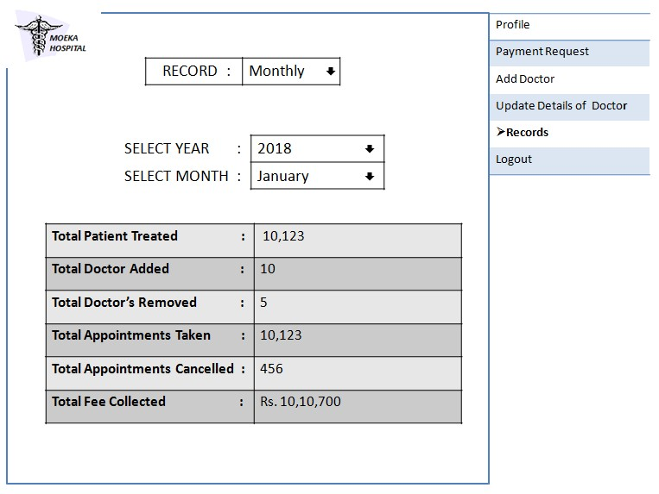

**CHAPTER 7**

**RISK ANALYSIS**

|  |  |  |  |  |  |
| --- | --- | --- | --- | --- | --- |
| S.No | RISK | CATEGORY | PROBABLITY  (P) | IMPACT  (I) | RMMM  PLAN |
| 1. | SOME TEAM  MEMBER  BECOME SICK IN  BETWEEN | TECHNICAL RISK | **20%** | 2 | OTHER TEAM  MEMBERS  DISTRIBUTE THE  WORK IN  BETWEEN THEM |
| 2. | DELIVERY  DEADLINE  TIGHTENED | PROJECT RISK | **30%** | 1 | TEAM MAY USE  EXTRA MEMBERS  TO DO JOB ON  SCHEDULED TIME |
| 3. | LOSING OF ALL  PROJECT DATA  THIS MAY  HAPPEN DUE TO  HARD DISK  FAILURE | PROJECT RISK | **20%** | 2 | BACK UP THE  PROJECT ONLINE  OR IN EVERY  SYSTEM OF EVERY  MEMBER |
| 4. | TEAM  DISTENTION /  LACK OF  COHESION | PROJECT RISK | **10%** | 3 | WE MAKE SOME  RULES HOW WE  CONSULT EACH  OTHER |

**TABLE 7.1**

# CHAPTER 8 TESTING

8.1 WHITE BOX TESTING

8.1.1 Basic Path ( Pseudo code )

8.1.2 Flow Graph

## 8.1.3 Cyclomatic Complexity 8.1.4 Independent Paths

### BASIS PATH TESTING FOR BOOK APPOINTMENT MODULE

enum Status { confirm , cancel} ;

int Department, Date , Time, mode, ch; char Dr_Name(50);

cout<< Enter The Information :

cin>> Department;

cin>>Dr_Name;

cin>> Date; cin>> Time;

bool Appointment = cancel; 1

cout<<Mode; cout<<1.Cash; cout<<2.Debit Card/Credit Card

cout<<3.Net Banking cout<<Enter mode of payment; cin>>mode;

if(mode==1) 2

{

Generate a Receipt and send confirmation message; 3

}

else if(mode == 2~~)~~  4

{

Enter Card Details

Make Payment 5

Send confirmation message

}

else

{

Enter Account Details 6

Make Payment

Send confirmation message

} //end if 7

Send appointment Request to the doctor 8

Doctor will check the Appointment Requests; cout<<Mode; cout<<1.Confirm;

cout<<2.Cancel; 9

cout<<Enter Your choice; cin>>ch;

if(ch==1)  10

{

Appointment = Confirm;

Send a Confirm Message to the patient. 11

}

else

{

Send a Cancel Message to the patient. 12

}//end if 13

**FLOW GRAPH NOTATION**

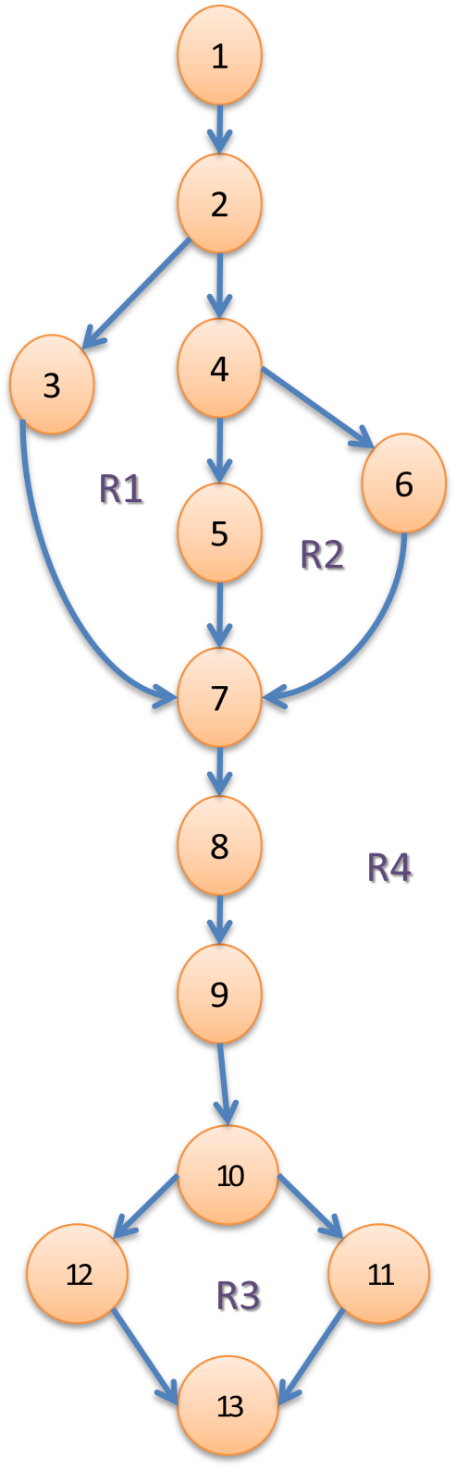

#### **2) CYCLOMATIC COMPLEXITY V(G)**

1. Cyclomatic complexity V(G) = Total number of Regions.  **V(G) = 4.**

1. Cyclomatic complexity V(G) = (E – N) + 2 where E = the number of flow graph edges. i.e. 15 N = the number of flow graph nodes. i.e. 13 **V(G) = (15 – 13) + 2 = 4.**

1. Cyclomatic complexity V(G) = P + 1 where P = the number of predicate nodes contained in the flow graph G. **V(G) = 3 + 1 = 4.**

There will be 4 independent Paths.

#### **3) INDEPENDENT PATHS**

**Path A :** 1 – 2 **–** 3 – 7 – 8 – 9 – 10 – 11 – 13

**Path B :** 1 – 2 **–** 4 – 5 – 7 – 8 – 9 – 10 – 12 – 13

**Path C :** 1 – 2 **–** 4 – 6 – 7 – 8 – 9 – 10 – 11 – 13

**Path D :** 1 – 2 **–** 3 – 7 – 8 – 9 – 10 – 12 – 13

**CHAPTER – 9**

## CONCLUSION

Working on the project was an excellent experience. It helped us to understand the importance of planning, designing and implementation so far we have learnt in our theory books. It helped us unleashing our creativity while working in a team. It also realized the importance of team working, communication as a part of this project.

The project was successfully completed after a lot of efforts and work hours. This project underwent number of compiling, debugging, removing errors, making it bug free, adding more facilities in Hospital Management System and interactivity making it more reliable and useful.

This project focused that scheduling a project and adhering to that schedule creates a hard sense of time- management. It has also let us known that co-operative teamwork always produce effective results.

The entire project has been developed and deployed as per the requirements stated by the user. It is found to be bug free as per the testing standards that are implemented.

The estimated cost of the project is (efforts) 12 and the estimated size of the project is (FP) 209.72.

There are also few features which can be integrated with this system to make it more flexible. Below list shows the future points to be consider :

* Getting the current status of patient.
* Including a different module for pharmacy, LAB, Bed Allotment and many more.
* Including a Frequently Asked Questions Section.

Finally, we like to conclude that we put all our efforts throughout the development of our project and tried to fulfill most of the requirements of the user.